UNITED  NATIONS |  | E
 | Economic and Social  Council | Distr.  GENERAL  ECE/TRANS/WP.15/AC.1/2007/21  8 January 2007  ENGLISH  Original: FRENCH
ECONOMIC COMMISSION FOR EUROPE
INLAND TRANSPORT COMMITTEE
Working Party on the Transport of Dangerous Goods
Joint Meeting of the RID Committee of Experts and the
Working Party on the Transport of Dangerous Goods
Bern, 26-30 March 2007
Agenda item 5

PROPOSALS FOR AMENDMENTS TO RID/ADR/ADN*

Carriage of used lithium batteries

Transmitted by the European Battery Recycling Association (EBRA)

Introduction
1. To facilitate the transport of used cells, their packing has been subject to certain exemptions. The cells may be transported in bulk, and need not be individually insulated, but may be carried in plastic drums or crates, which must include cushioning material.
2. In addition, there is an even more extensive exemption for collection and transport from the primary collection point to the first collection centre, provided the collection containers used do not hold more than 30 kg.
3. These provisions are applicable only to cells of less than 250 g gross mass.

Problems encountered
4. While these provisions do facilitate transport of used cells for recycling, the members of EBRA still encounter practical problems in implementing them.
5. The use of exclusively plastic packaging has proved to be inadvisable. Experiments with metal drums have shown that they are both easier to use and safer. Conduction by the metal can be easily avoided through the use of plastic lining sacks.
6. The cushioning material has proved to be difficult to use. It is unnecessary, as the density of the cells limits their movement in relation to one another.
7. The unit weights of the cells and rechargeable batteries that we process in such collections can be as high as 500 g (laptop batteries).
8. Primary collection understandably benefits from broader RID/ADR exemptions, as the operators in question (shops, etc.) are not in a position to follow the rules. In practice, however, their collection bins are only exceptionally used for transport. Currently, the procedure is as follows: the collection bins are emptied into drums that are in conformity with instruction P903b at the collection site, and the drum is then transported to the collection centre.
9. Use of the drums ensures greater safety during both handling and transport.
10. EBRA would like to benefit from the broader exemption set out in special provision 636 while being able to use drums, but for a limited total vehicle load.

Proposal
(See also ECE/TRANS/WP.15/AC.1/2006/35, p. 3)
11. Amend special provision 636 to read as follows:
“636 (a) Used lithium cells and batteries collected and presented for carriage for
disposal between the consumer collecting point and the intermediate processing facility, together with other non-lithium cells or batteries or alone, are not subject to the other provisions of ADR if they meet the following conditions:
- The gross mass of each lithium cell or battery does not exceed 500 g (this proposal has already been adopted, see the report of the session held from 11 to 15 September 2006);
- The provisions of packing instruction P903b (2) are complied with;
- Cells and rechargeable batteries that are collected together with other cells not subject to RID/ADR may also benefit from the above exemptions, provided the conditions of instruction P903b (1) are complied with and their gross load mass does not exceed 10 tons;
(b) Cells contained in equipment shall not be capable of being discharged during carriage to the extent that the open circuit voltage falls below 2 volts or two thirds of the voltage of the undischarged cell, whichever is the lower;
(c) Packages containing used cells or batteries in unmarked packagings shall bear the inscription: ‘Used lithium cells’.”
12. Recast the P903b packing instruction as follows:
P903b | PACKING INSTRUCTION | P903b
This instruction applies to used cells and batteries of UN Nos. 3090 and 3091.
Used lithium cells and batteries, with a gross mass of not more than 500 g collected for disposal, together with other used non-lithium batteries or alone, may be carried, without being individually protected, under the following conditions:
(1) In 1H2 drums or 4H2 boxes or in 1A2 drums or 4A crates fitted with a plastic lining sack conforming to the packing group II performance level for solids and having the following technical specifications:
Watertightness;
Electrical surface resistivity: > 10 M ohms;
Elastic limit before tear: > 350%;
Traction resistance: from 7 to 20 MPa;
Surface resistivity at 25° C: >10¹² ohm/cm²;
Volume resistivity at 25° C: minimum 10¹² ohm-cm;
Water adsorption rate over 24 hours at 25° C: < 0.01%;
Chemically inert for battery and cell components.
(2) In collecting trays with a gross mass of less than 30 kg made from non-conducting material meeting the general conditions of 4.1.1.1, 4.1.1.2 and 4.1.1.5 to 4.1.1.8.
Additional requirement:
The empty space in the packaging shall be filled with appropriate cushioning material so as to restrict the relative movements of the batteries during carriage. Hermetically sealed packagings shall be fitted with a venting device according to 4.1.1.8. The venting device shall be so designed that an overpressure caused by gases does not exceed 10 kPa.

Justification - safety problems
13. The use of metal packing is safer, and the problem of conduction by the metal is avoided with the use of non-conductive plastic lining sacks.
14. The sizing of the sacks so that they are longer than the drums makes it possible to fill the empty space above the load (see annex 1). The plastic sacks are selected to meet the following specifications:
- Material: polyethylene;
- Minimum thickness: 100 microns;
- Electrical insulation: very high electrical surface resistivity;
- Very good tear resistance.
15. The film is extremely stable in respect of cell and battery and substances electrolytes, and has a very low water adsorption rate over 24 hours.
16. Its main specifications appear in annex 2. The increase of the cells' mass to 500 g does not entail a significant added risk. In any case, consumers dump such rechargeable batteries in the collection bins, and it is not always possible to sort them out.
17. Collection bins generally contain an average of 0.2-1.5% lithium cells. A high of 3% may occasionally be observed.
These values are based on the primary collection sorting done in several countries by recycling companies responsible for collecting and recycling used cells and batteries.
18. A load of 10 tons thus contains a maximum of 300 kg of lithium cells. This quantity of cells is covered under exemption 1.1.3.6. In our view, by the same reasoning, only the packing and labelling requirements need apply to such loads, and these would ensure sufficient safety.

Annex 1

Photographs showing the position of the plastic
lining sack before and after folding and closing
of the drum

Current lining sack
(during filling)

Current lining sack
(before being filled),
approximately 20 cm additional length

Current lining sack
(closed)

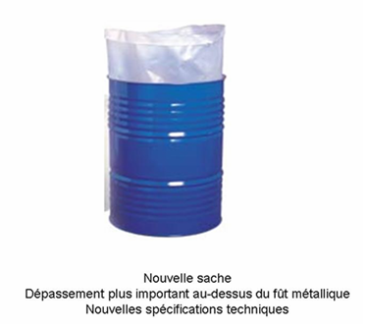

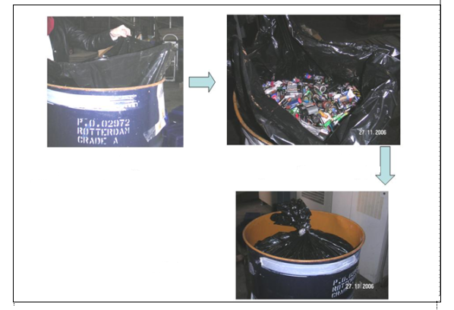

Current lining sack
(before being filled),
approximately 20 cm additional length

New lining sack, with additional length
above the metal drum and new
technical specifications

Annex 2

Technical specifications for the plastic lining
Material: LDPE
Density: 0.9-1.1
Elastic limit before tear: > 350%
Traction resistance: from 7 to 20 MPa
Surface resistivity at 25° C: > 10¹² ohm/cm²
Volume resistivity at 25° C: minimum 10¹² ohm-cm
Water adsorption rate over 24 hours at 25° C: < 0.01%

Annex 3

Determination of applicability of ADR requirements
Mixed primary collection of batteries, including
some lithium batteries
Packaging as
defined, > 30 kg
Packaging as
defined, < 30 kg
No ADR application
< 333 kg of
lithium batteries
in the load
> 333 kg of
lithium batteries
in the load
All requirements under 1.1.3.6.3 apply, for example in respect of:
Packaging labels;
Transport documents;
Fire extinguishers.
All ADR requirements
apply

Annex 4

primary collection statistics of recycling companies
January-December 2005 (total sorted: ~2,620 tons)
Categories of cells and batteries sorted | %
Mercury-free alkaline and saline cells | 75.443%
Special prismatic cells > 7 cm (fences, headlights) | 13.128%
Lithium cylinder batteries | 0.788% | 0.903%
Lithium button cells | 0.115% | 0.903%
NiCd rechargeable batteries | 3.774%
Li-ion rechargeable batteries | 3.774%
Ni-MH rechargeable batteries | 3.774%
Mercury cells > 500 ppm | 0.063%
Button cells (various) | 0.172%
Lead batteries | 5.844%
Tainted water | 0.133%
Special wastes | 0.415%
Unsortable cells | 0.125%
Total | 100.000%

January-October 2006 (total sorted: ~ 2,300 tons)
Categories of cells and batteries sorted | %
Mercury-free alkaline and saline cells | 78.018%
Special prismatic cells > 7 cm (fences, headlights) | 8.429%
Lithium cylinder batteries | 0.805% | 0.990%
Lithium button cells | 0.184% | 0.990%
NiCd rechargeable batteries | 4.211%
Li-ion rechargeable batteries | 0.277%
Ni-MH rechargeable batteries | 0.497%
Mercury cells > 500 ppm | 0.081%
Button cells (various) | 0.274%
Lead batteries | 6.238%
Tainted water | 0.327%
Special wastes | 0.489%
Unsortable cells | 0.169%
Total | 100.000%
-----

* Circulated by the Intergovernmental Organisation for International Carriage by Rail (OTIF) under the symbol OTIF/RID/RC/2007/21.

