UNITED

NATIONS
STSTE


Distr.
Secretariat

GENERAL

ST/SG/AC.10/C.3/2007/17
12 April 2007

Original: ENGLISH

COMMITTEE OF EXPERTS ON THE TRANSPORT OF

DANGEROUS GOODS AND ON THE GLOBALLY

HARMONIZED SYSTEM OF CLASSIFICATION

AND LABELLING OF CHEMICALS

Sub-Committee of Experts on the

Transport of Dangerous Goods

Thirty-first session

Geneva, 2-6 July 2007

Item 3 of the provisional agenda

LISTING, CLASSIFICATION AND PACKING

Classification as a consequence of Net Explosive Quantity (NEQ)

Transmitted by the expert from Australia

SCOPE

This proposal aims at recommending that fireworks of divisions 1.2, 1.3, 1.4 and 1.4S be considered as division 1.1 in a transport unit when a given NEQ is exceeded.

Introduction

1. On 6 March 2002 a series of explosions occurred at a fireworks storage facility in Carmel, Western Australia. These explosions destroyed the facility and caused damage to buildings over 4.5 km from the facility. The items involved were aerial shells classified 1.1G and 1.3G and ground packs (fountains, shot tubes and candles) classified 1.3G and 1.4G, and were stored in freight containers and re-locatable magazines of stronger construction than a standard freight container. Two magazines and one freight container exploded.

2. While there was some discussion in respect of the contents, the type of fireworks in each container/magazine that exploded was determined, and an estimated blast effect calculated. While one of the magazines that exploded carried a small proportion of division 1.1 goods, the other two were used to store division 1.3 and 1.4 and also exploded.

Sequence of events

3. The incident was precipitated by the initiation of a ground pack in a work shed located 16 metres from Freight Container FC4. As a result of the subsequent fire a burning star was projected into FC4 causing the container to detonate a few minutes later (8 minutes from the initiation of the ground pack in the shed to detonation). The detonation of FC4 caused damage to magazine M3 located within 6 metres and magazine M2 located some 31 metres away, and as a result M2 exploded 4 minutes later and M3 a further 10 minutes later. The blast from M3 was 21 times greater than that from FC4 or M2, which is consistent with the nature of the contents as shown in table 1.

Table 1: Contents of the Container and Magazines

Container/  Magazine | Fireworks stored | Claimed  NEQ (kg) | Estimated NEQ of blast
Container FC4 | 75mm aerial shells 1.3G (72 per carton) | 63 | 52 to 175 kg NEQ
 | 100mm aerial shells 1.3G (36 per carton) | 63 | 52 to 175 kg NEQ
Magazine M2 | 30mm 25 shot ground pack 1.3G (4 per carton) | 725 | Similar to FC4
 | 20mm 25 shot ground pack 1.4G (12 per carton) | 725 | Similar to FC4
Magazine M3 | 75mm salutes 1.3G (72 per carton) | 300 | 1000 to 3000kg NEQ
 | 75mm aerial shells 1.3G (72 per carton) | 300 | 1000 to 3000kg NEQ
 | 100mm aerial shells 1.3G (36 per carton) | 300 | 1000 to 3000kg NEQ
 | 125mm aerial shells 1.3G (24 per carton) | 300 | 1000 to 3000kg NEQ
 | 150mm aerial shells 1.3G (9 per carton) | 300 | 1000 to 3000kg NEQ
 | 200mm aerial shells 1.1G (6 per carton) | 300 | 1000 to 3000kg NEQ
 | 300mm aerial shells 1.1G (2 per carton) | 300 | 1000 to 3000kg NEQ

4. While the large detonation of magazine M3 may be explained by the presence of some division 1.1 goods, this does not explain the behaviour of the explosions with FC4 and M2 as these were loaded with 1.3G and 1.4G goods. The explosion in FC4 was sufficient to penetrate the side of M2 with shrapnel some 31 metres away and project 24kg parts of the container over 338 metres from its original location. Similarly the explosion of magazine M2 (which was of stronger construction than the freight container) was sufficient to project the 1616kg roof structure 21.7 metres, the 230kg rear door 50.5 metres and a 900kg section of wall 36.4 metres from the original location of the magazine. The entire 2384kg floor structure was displaced 3.3 metres from its original location.

5. Noting that the classification of these items has been applied on the basis of the default classification table in the 14th edition of the UN Recommendations on the Tranport of Dangerous Goods, Model Regulations, both FC4 and M2 should not have suffered the damage they did. Division 1.3 items only have a ‘minor blast or explosion hazard’ while the items of division 1.4 should have presented ‘no significant hazard’.

Conclusions

6. This situation may have resulted from a range of factors related to the operation of the facility but also suggests that the NEQ of items such as fireworks, when confined within a transport unit, particularly a freight container, may be a factor in determining the risk during transport. This incident would appear to support the conclusion that a large volume of relatively benign Class 1 goods confined in a transport unit present a greater risk than their classification would suggest.

Issues

7. If this conclusion is correct, then the increased risk of a high NEQ mass in a transport unit needs to be recognised to allow the appropriate stowage on ships, or appropriate precautions during land transport to be applied. This is supported by incidents such as the explosions on the container vessels MV Hanjin Pennsylvania and the Hyundai Fortune where it was suggested fireworks were involved. In noting this it must also be recognised that the National Fireworks Association (NFA) in the United States of America concluded that the fireworks were not responsible for the explosion, although they noted that 1.4G and 1.4S goods were being carried and it was possible that some of the fireworks had been inappropriately classified, some could have been 1.2G or 1.3G and some may have been carried below decks. The behaviour of the 1.3G and 1.4G fireworks at Carmel suggests that these goods have the potential to cause such damage (see images in the annex).

8. In view of this, the expert from Australia is of the view that the classification of fireworks of divisions 1.2, 1.3, 1.4 and 1.4S should be subject to a maximum NEQ in a transport unit if they are to retain their assigned classification. While it is difficult to determine an effective limit, it is noted the explosion of Magazine M3 was considered to be equivalent to an NEQ of between 1000 and 3000kg of fireworks composition. This explosion blew a 380kg roof section 295.2 metres from the original site and projected other shrapnel out to 510 metres. Noting the mass of division 1.1 in this magazine was proportionally very low, then a NEQ limit of 1000kg appears to have merit.

Proposal

9. The expert from Australia invites the members of the Sub-Committee to consider this issue and provide feedback on both the content of this document and the issues involved with large NEQ of fireworks compositions in a transport unit, with a view to developing a definitive proposal for the next session.

Annex

Images of Hyundai Fortune and Hanjin Pennsylvania Explosions

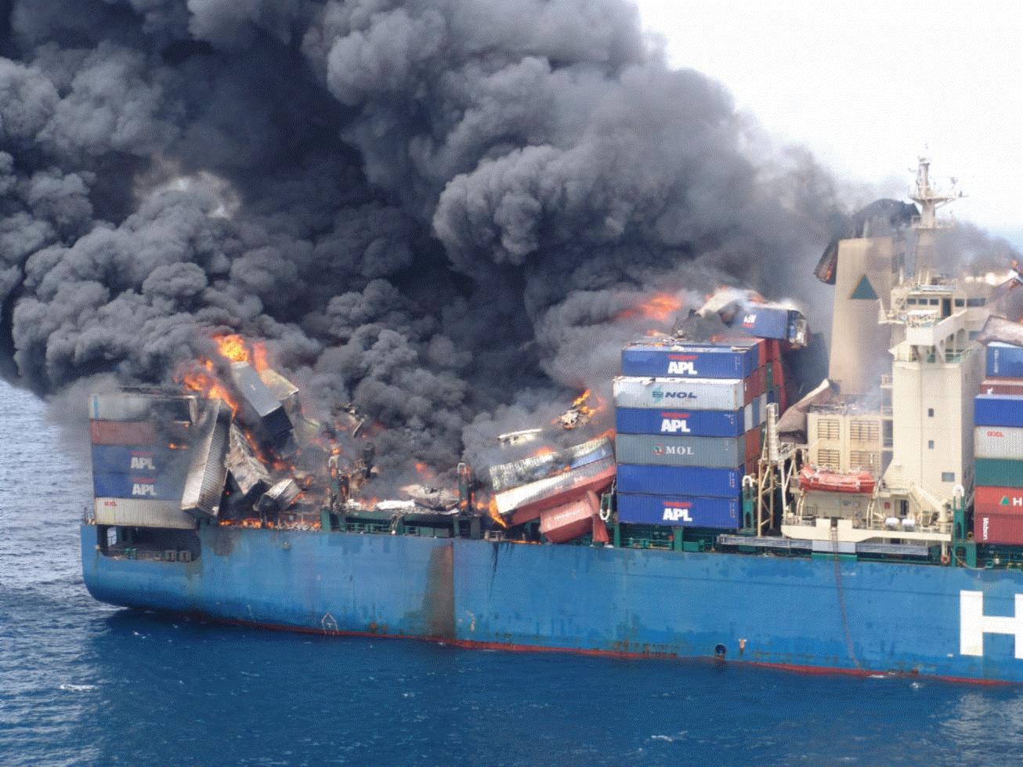

Image 1: MV Hyundai Fortune Burning

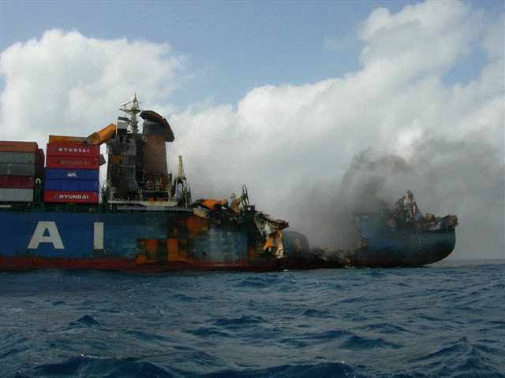
Image 2: MV Hyundai Fortune damage aft
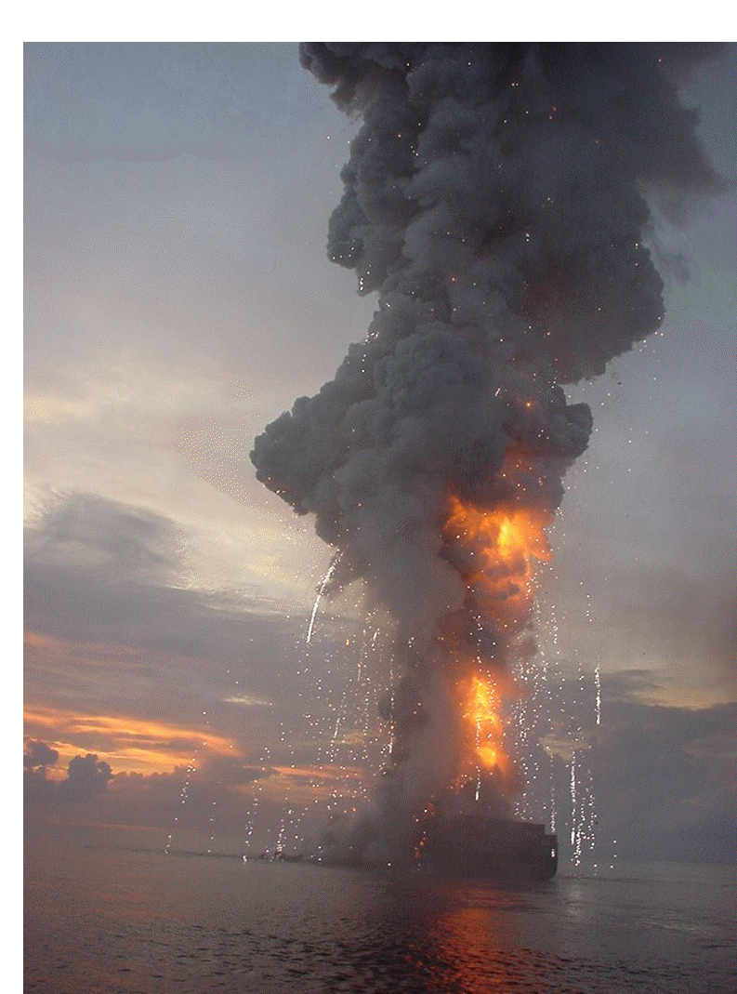
Image 3: MV Hanjin Pennsylvania explodes
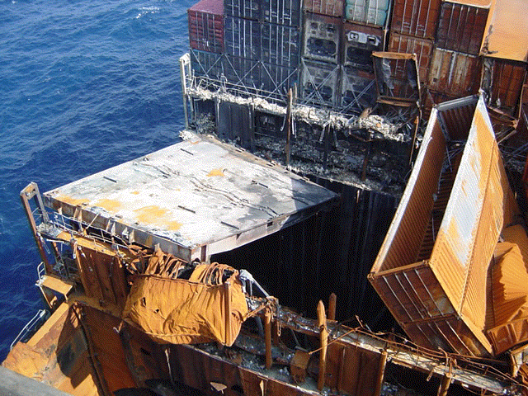
Image 4: MV Hanjin Pennsylvania – damage to hatch covers

________________

MV Hanjin Pennsylvania – Explosions at sea. Final Report - Weeth & Associates, LLC – Prepared on behalf of the National Fireworks Association.

