A. Investigations into the 800 mm Horizontal Plane Requirement in Regulation No. 44/03

Introduction

The 800 mm horizontal plane requirement is described in paragraph 7.1.4.4. in UNECE Regulation No. 44*. It requires that for both rear facing and forward facing child restraints the dummy’s head should move bellow this plane for the entire duration of the test (300ms). The 800 mm limit plane was introduced in Regulation No. 44 at the time where no specifications existed for roll over test, called also overturning. The background data was generated from measurements on vehicles in order to establish a zone for which a contact between the child’s head and the vehicle interior can be avoided.

The subject of the present study is to highlight some problems generated by this requirement, which with present technology of vehicles and CRS’s seems to be outdated and is generating important limitations in designing child restraint systems.
*See Annex 1 of this paper where the requirement of Regulation No. 44 is reproduced

Limitation of design in the case of Group 1 rear facing CRS

In car evaluation was carried out on products used in Scandinavian countries. The seat was installed in the rear seat of a European family car with 2 positions as shown in Figure 1: Position A with the CRS in full contact with the vehicle seat back (no room for the child’s legs) and position B where the CRS was moved 100 mm forward. This last position represents in fact a 100 mm space for the child’s legs. In both positions the available space between the top of the CRS and the 800 mm plane was measured. The values are 80 and 55 mm respectively for position A and B. This type of seat is approved for Group 2 (P6) with the top of the dummy’s head normally protruding by 25 mm, which again reduces the distance of the head with respect to the 800 mm plane.

In case of rear impact the dummy, while moving rearward, can rotate within the harness this can cause the head to become close to the 800 mm limit. This shows the reduction of available head clearance against the effects of adding room for the child’s feet. Due to this constraint the foot clearance for this type of CRS is limited. Thus an extension of the 800 mm plane will help to address this problem.

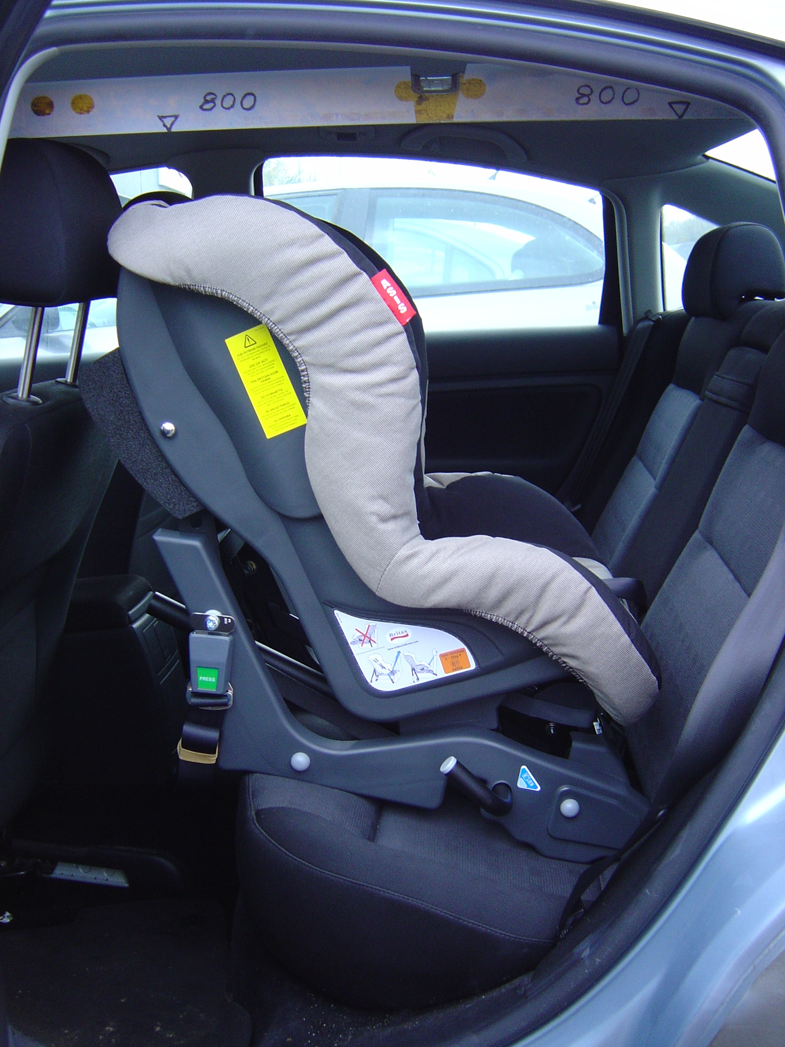 |  | 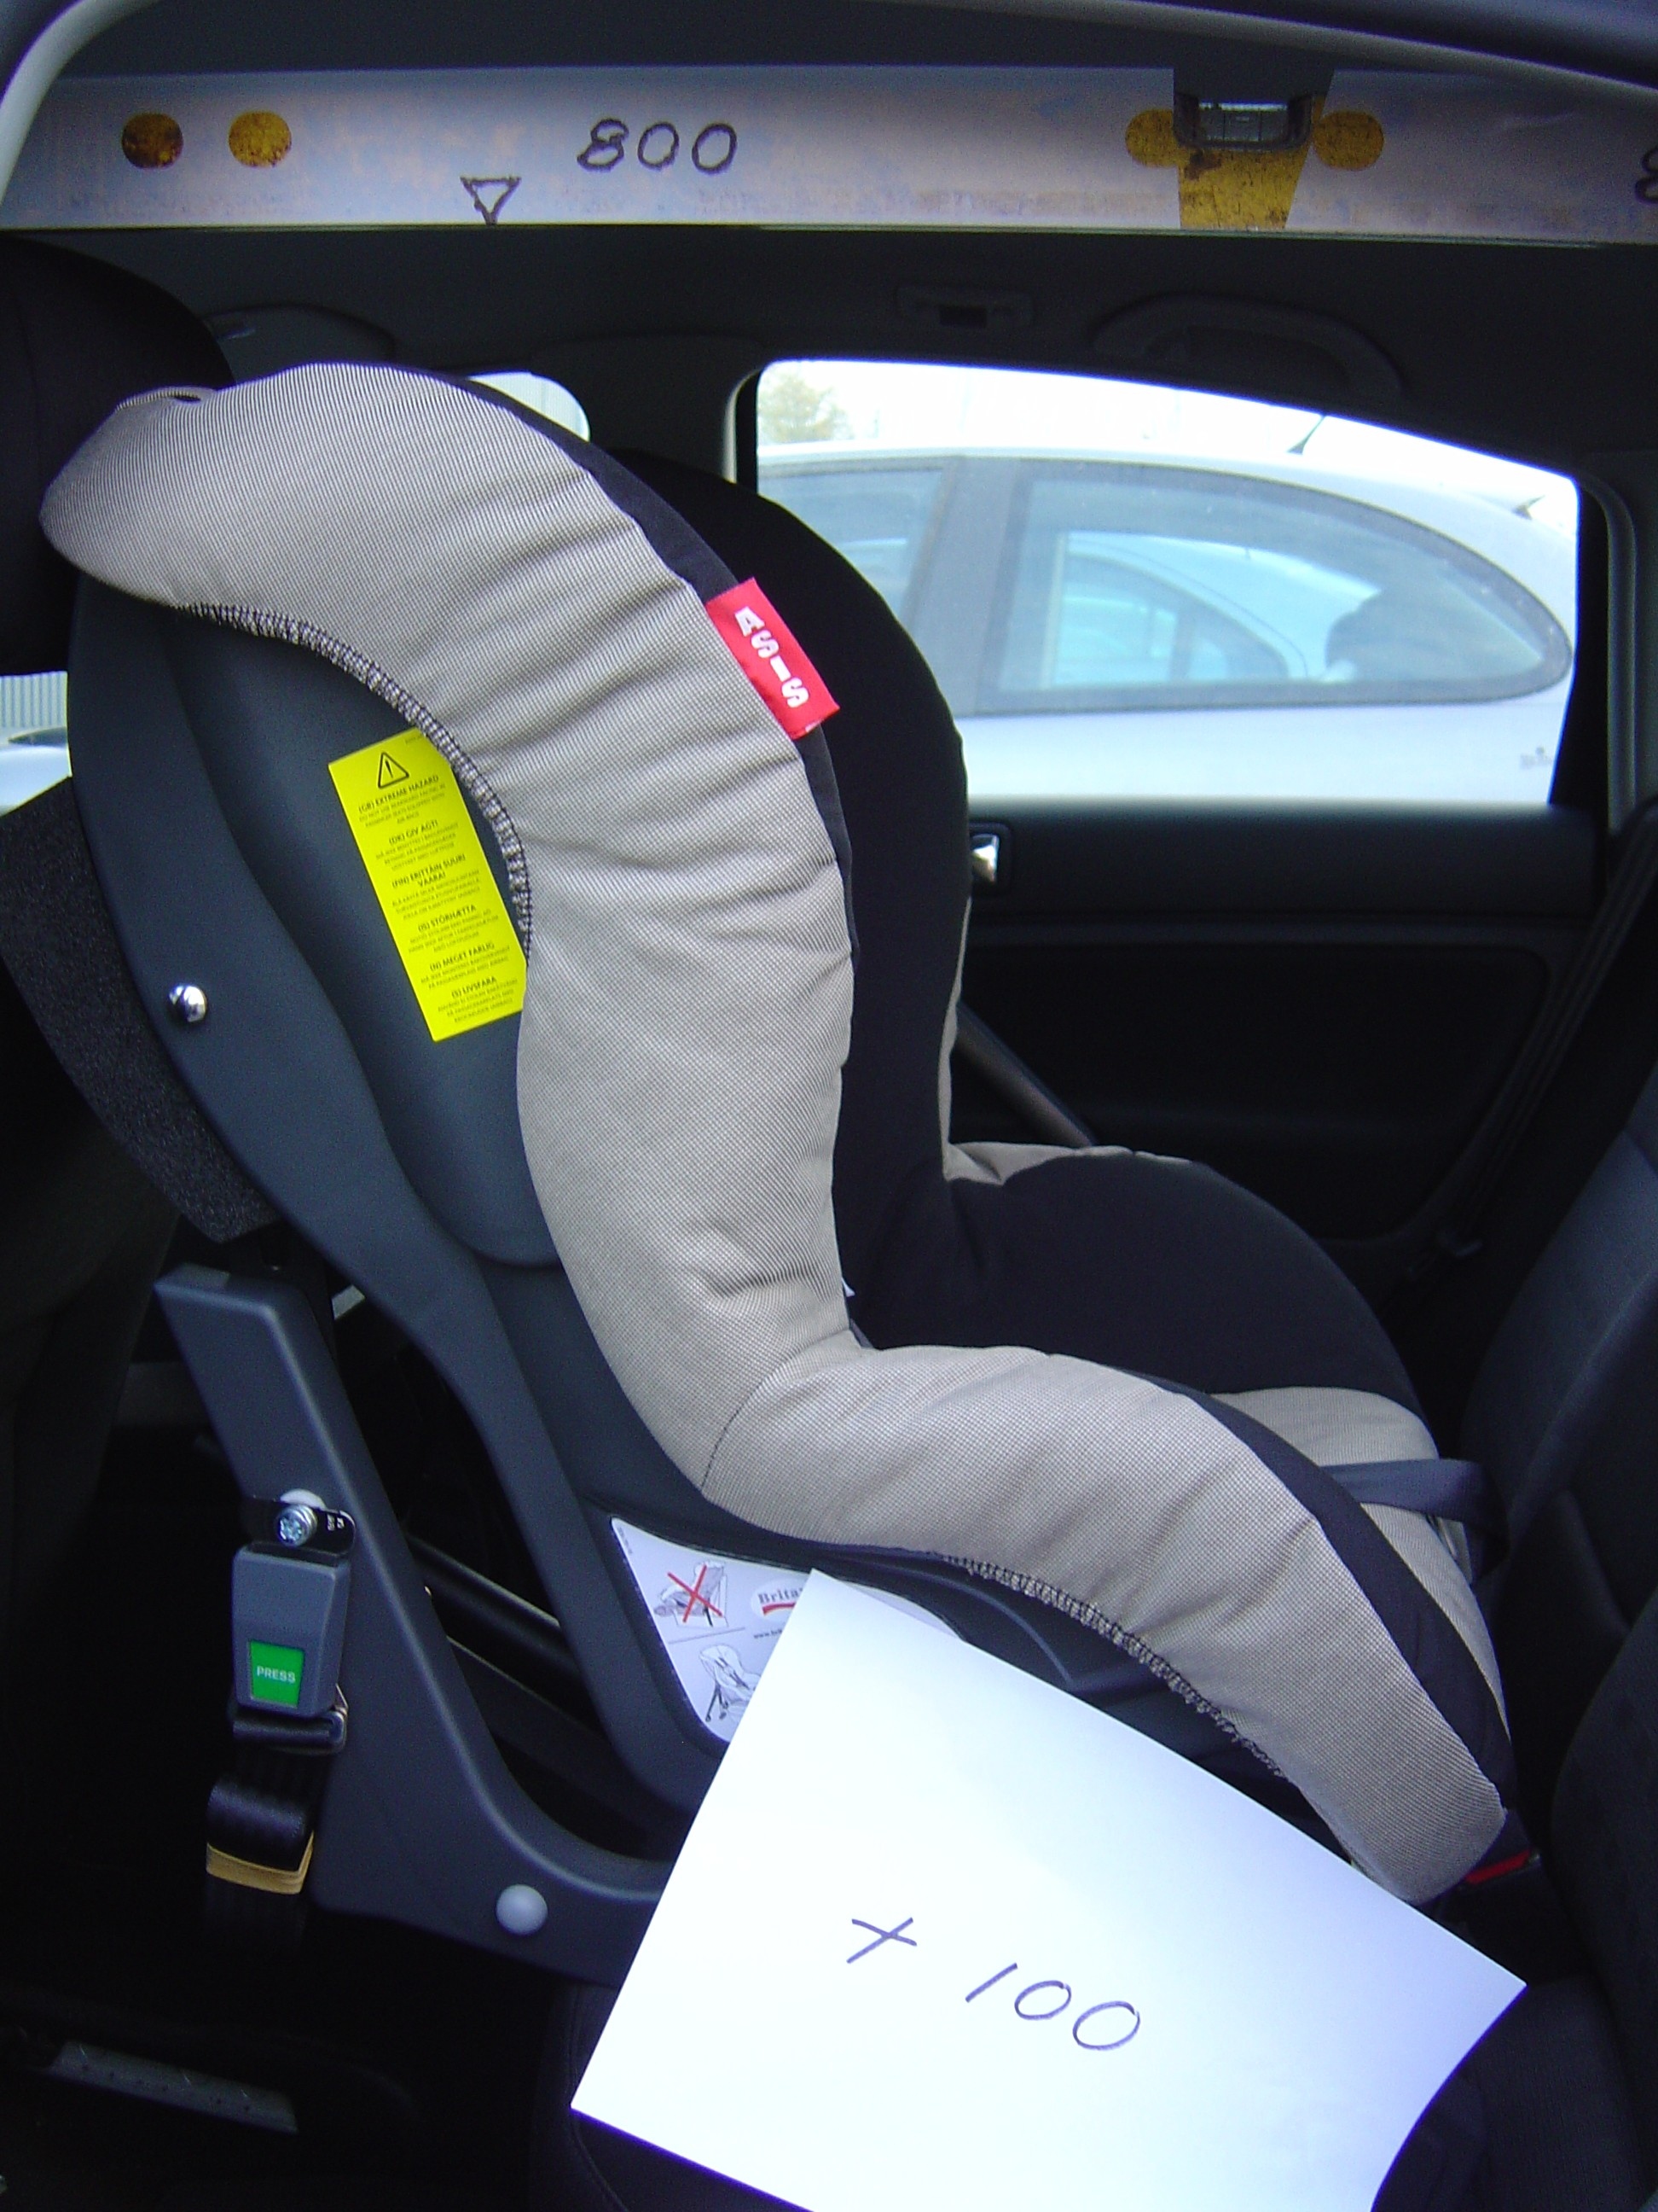
CRS position A  The CRS is positioned in full contact with the vehicle seat back. The resulting distance between the top of the CRS and the 800mm limit is 80mm. |  | CRS position B  The CRS is positioned 100mm forward from the vehicle seat back. The resulting distance between the top of the CRS and the 800mm limit is 55mm.
Figure 1: Positions of a Group 1,2 rear facing child seat with respect to 800 mm horizontal plane.

800 mm plane and the 50 percentile adult dummy
A physical study using test manikins on the ECE R44-03 defined test bench was then conducted to compare the relative head positions of the Hybrid II 50th percentile and the P10 dummies with respect to the 800 mm plane. This plane was materialized using a laser pointer as shown in Figure 2.

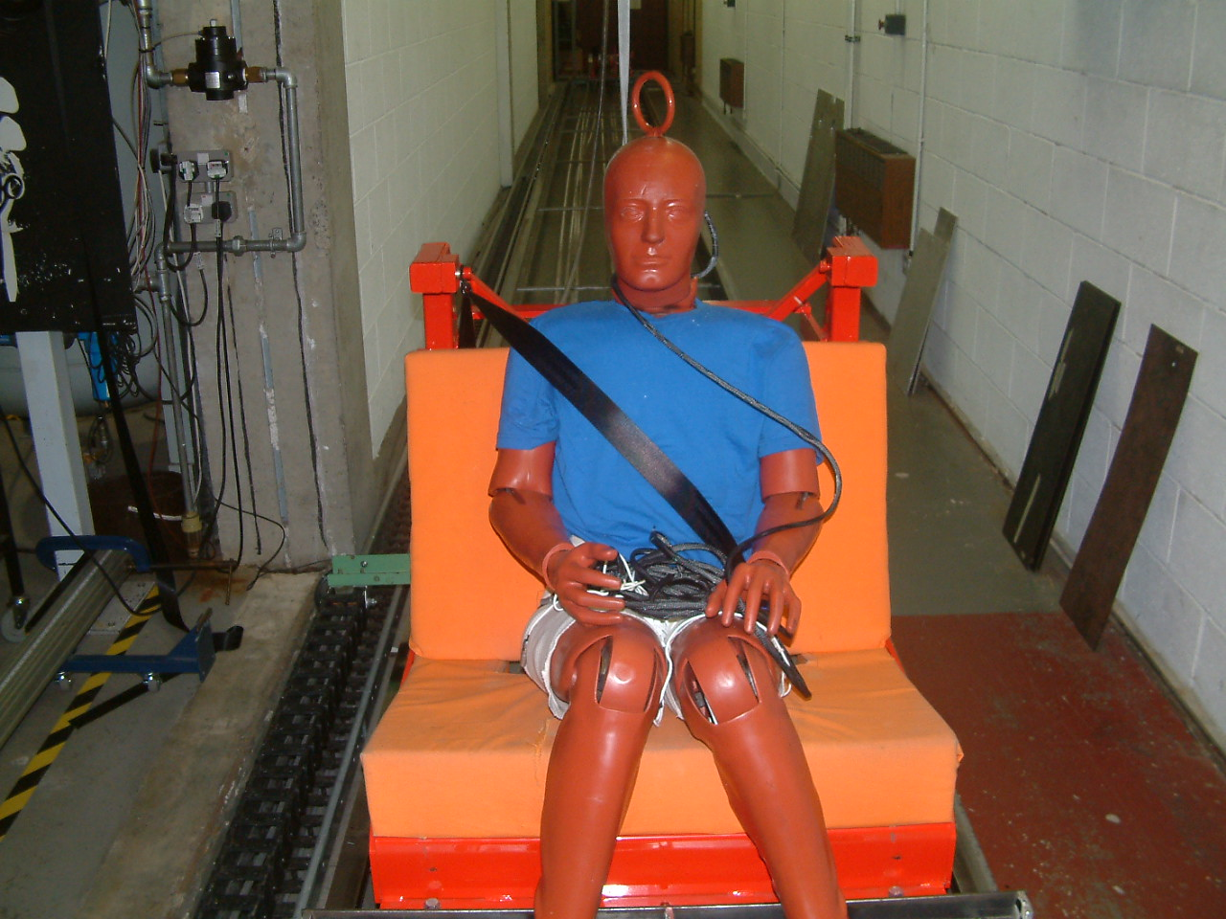 | 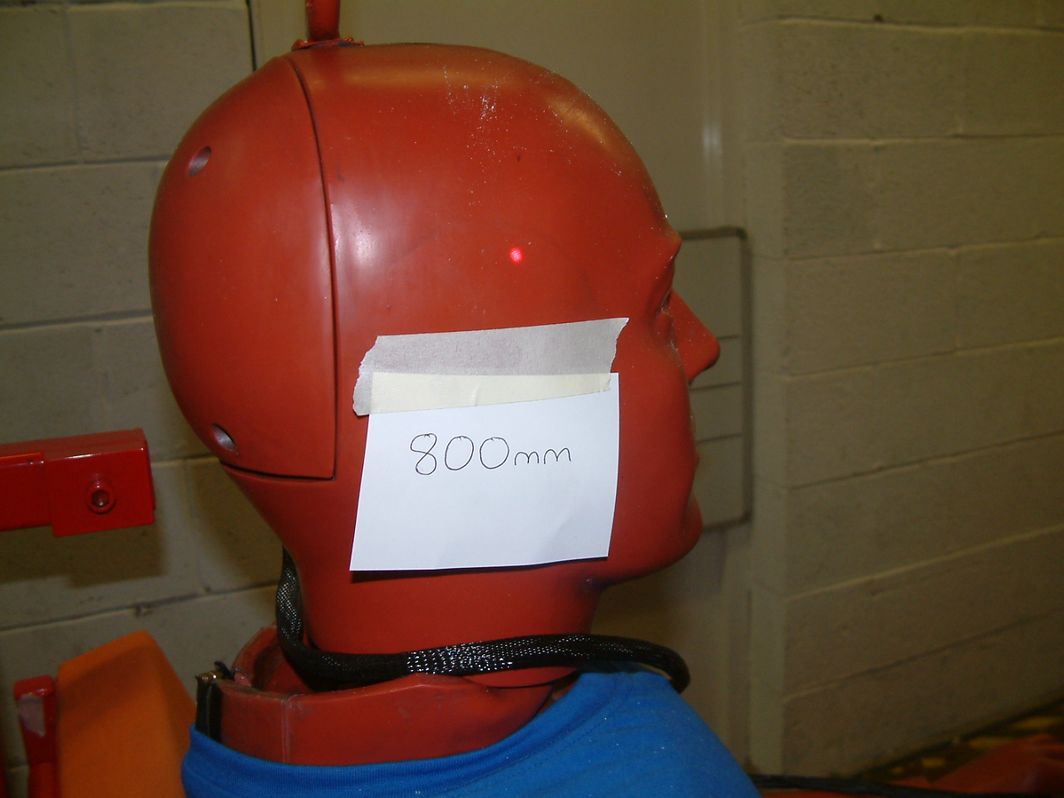 | Laser point indicating the 800 mm height
Installation of the Hybrid II dummy on the R44 sled test bench. | Red Laser point sets to 800mm from Cr. Maximum vertical height from Cr top of 50th percentile head is 882mm

Figure 2: Measurement of the Hybrid II 50th percentile dummy head position with respect to the 800 mm plane.

It was found that the top of the head of the Hybrid II dummy is located 882 mm above the Cr point, i.e. 82 mm above the 800 mm plane whilst the top of the head of the P10 dummy was 710 mm, without tensioning the belt system. This measurement shows an inconsistency of the 800 mm requirement as it is well below the top of the head of an average adult male. If we consider a 95° percentile male then the situation becomes worst. There is therefore a need to adapt the 800 mm plane to occupant space available in vehicles.

Booster seat design requirements and the 800 mm plane
It is known that one of the primary design goals for a booster seat is to raise the child position, and in particular the pelvic position in order to have an effective restraint with the adult belt in case of an accident. To illustrate this an investigation was carried out including the measurement of the pelvic position for child dummies P3, P6 and P10 and also the Hybrid II 50° percentile dummy, as shown in Figure 3. All measurements were expressed in relation to Cr point along a vertical axis.

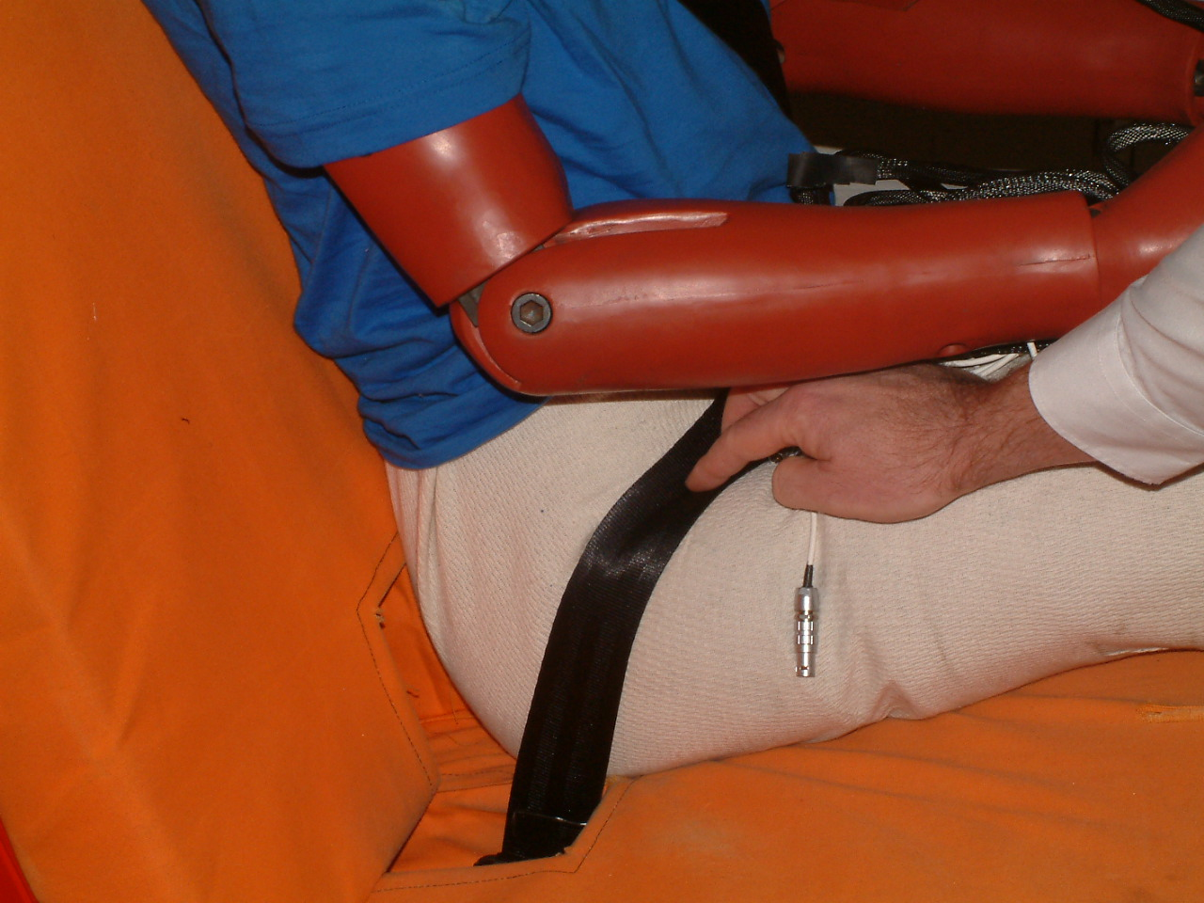 |  | 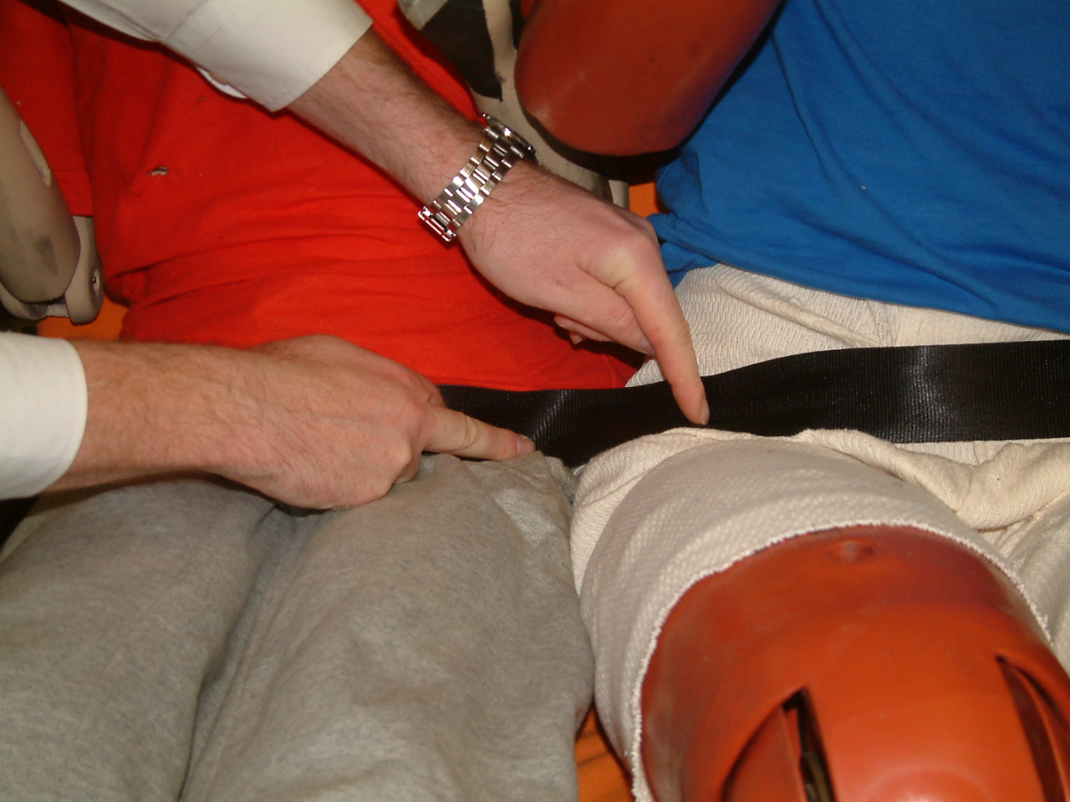
Vertical Pelvic position at load bearing point of Hybrid 2 - 50th from Cr. Recorded distance is (191mm) |  | Comparison of pelvic position of P10 and 50th Percentile Adult Male dummies. Recorded pelvis vertical measurement was 34 mm lower for the P10.

Figure 3: Measurement of vertical distance between belt load bearing point and Cr point of a R44 sled bench for an adult 50° dummy and a 10 year old dummy.

The height of the pelvic load bearing point measured for the Hybrid II and the P10 was 191 mm and 157 mm respectively. The same measurement was carried out with P3 and P6 dummies. The corresponding height of the load bearing point of these dummies was 147 mm and 121 mm respectively for P6 and P3. This indicates for instance that the pelvic position of a 3 year old child with regards to the adult belt can be considered to be 70 mm lower than that of a 50th percentile adult (Figure 4).
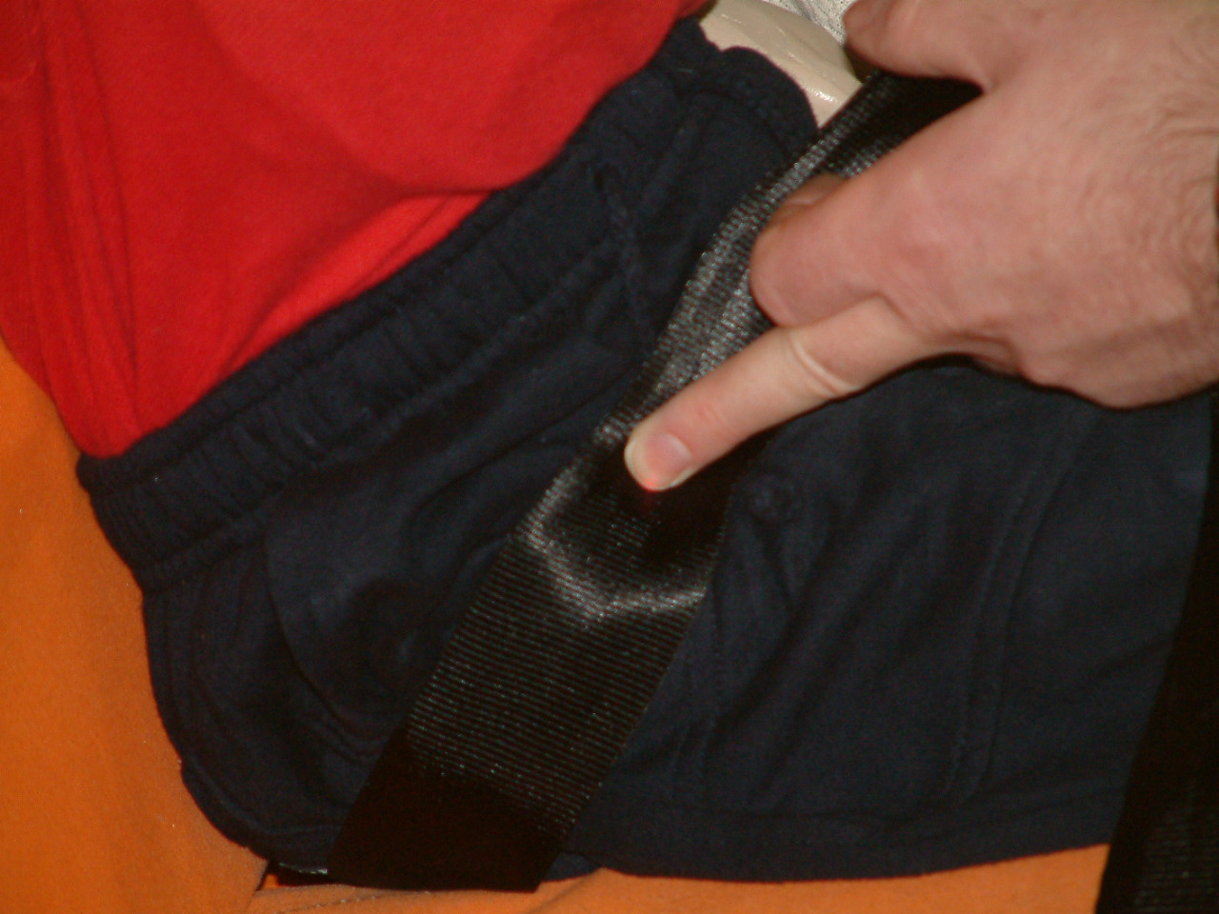

Figure 4: P3 without Booster CRS. Pelvic load bearing point is 122mm above Cr.

As the objective of using a booster seat is to raise the pelvis of a child to the same position of that of an adult the results above show that the minimum distance needed to reach this position is 70 mm for the smallest dummy. For R44 group 2 and 3 type of restraints this shows also the need to raise the P10 dummy by a minimum of 70mm, which means that the top of the head for this dummy will reach 780 mm with respect to Cr point, i.e. 20 mm below the 800 mm plane. This offers a very small margin for design options and innovations for the population covered by P10 dummy. As for the previous cases this investigation also calls for an increase of the 800 mm plane.

Overturning Test
The purpose of this requirement is to provide a control of the occupant’s vertical displacement during a vehicle rollover. It allows for a movement of 300 mm from the initial installed static position. The requirements for this test are described in paragraph 7.1.3.1.:

7.1.3.1. The child restraint shall be tested as prescribed in paragraph 8.1.2.; the manikin shall not fall out of the device and, when the test seat is in the upside down position the manikin's head shall not move more than 300 mm from its original position in a vertical direction relative to the test seat.

If a P10 dummy on a booster CRS records an initial 800mm it can therefore move 300 mm and shows an overall position of 1100 mm and still be considered acceptable. This overturning requirement appears to be in contradiction with the requirement of the dynamic vertical pass/fail threshold.
Therefore there is a need to have consistent requirements between the two aspects, the 800 mm horizontal plane and the overturning test.

Recommendation
Based on the present study it is recommended to extend the 800 mm plane requirement to a value of 900 mm. This would allow:
- More space for the child’s leg for the group 1 rear facing seat, which will enable an extended use of this type of seat.
- A consistency with vehicle space available for adult occupants at or above the 50° percentile population
- More design options for the larger child population and better belt positioning of the smaller child without compromising the safety, as the proposed change (+100 mm) remains consistent with the requirement of paragraph 7.1.3.1. which in fact accepts +300 mm head vertical excursion.

Reference Data
Hybrid II 50th Percentile Information
http://www.ftss.com/pcat/products.cfm?obr=NS&bm=1&pcat=h2-50m

Appendix – Reproduction from R44/03
7.1.4.4. Manikin displacement

7.1.4.4.1. Child restraints of the "universal", "restricted" and "semi-universal" categories:

7.1.4.4.1.1. Forward facing child restraints: the head of the manikin shall not pass beyond the planes BA and DA as defined in Figure 1 below. This shall be judged up to 300ms or the moment that the manikin has come to a definitive standstill whatever occurs first. 5/

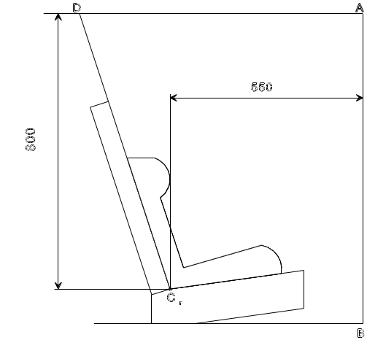
Dimensions
in mm

Figure 1
Arrangement for testing a forward-facing device

7.1.4.4.1.2. Rear-facing child restraints:
7.1.4.4.1.2.1. Child restraints supported by dashboard: the head of the manikin shall not pass beyond the planes AB, AD and DCr, as defined in Figure 2 below. This shall be judged up to 300 ms or the moment that the manikin has come to a definitive standstill whatever occurs first.



