UNITED
NATIONS
 | Secretariat | Distr.  GENERAL  ST/SG/AC.10/C.3/2004/88/Add.3  2 September 2004  ENGLISH  Original: FRENCH
COMMITTEE OF EXPERTS ON THE TRANSPORT OF
DANGEROUS GOODS AND ON THE GLOBALLY
HARMONIZED SYSTEM OF CLASSIFICATION
AND LABELLING OF CHEMICALS

Sub-Committee of Experts on the
Transport of Dangerous Goods

Twenty-sixth session, 29 November-3 December 2004
Item 3 (c) of the provisional agenda

OUTSTANDING ISSUES

Vibration test for design types of packagings intended for
the transport of dangerous goods

Transmitted by the expert from France

Addendum 3

Test report (2004)
This document contains a test report (25 November 2003) prepared by the “Laboratoire National d’Essais” at the request of the French Ministry of Public Works, Transport and Housing (Tourism and the Sea).
Purpose: Evaluation of the resistance of approved packagings to two types of vibration stresses.
Reference for the
test methods: Standard ASTM D 4169-01
Standard ISO 13355-2003.
GE.04-23448 (E) 151004 211004

1. PURPOSE
The purpose of the first part of this study is to evaluate the resistance of approved design type packagings and intermediate bulk containers for the transport of dangerous goods to two types of random vibration tests, namely:
- tests according to ASTM D 4169-01, paragraph 12.4;
- tests according to ISO 13355 (2003).
This first part is also intended to evaluate the resistance of packagings on pallets and stacked in conditions as close as possible to a real transport operation.
The purpose of the second part of the study is to ascertain, from the results of tests, the relevance of including a vibration test for the approval of packagings and intermediate bulk containers (IBCs) in the United Nations Model Regulations for the Transport of Dangerous Goods and to determine the means of implementing it.
2. PRINCIPLE OF THE RANDOM VIBRATION TEST
The random vibration test principle is as follows.
A package, filled and closed as if it were to be transported, is placed on the vibrating table. The package is wedged horizontally and left unsecured vertically.
The stress applied on the package results from movements of the test mechanism plate. These movements are dependent on accelerations (Power Spectral Density). The control signal is the superimposition of different frequency signals defined by the test template as specified by the standard. The angular points of the template are given in the table below. These templates correspond to the spectrum in the signal frequency.
The stress is therefore a superimposition of sinusoidal waves, the frequencies of which range between 1 and 200 Hz for road transport.
The specified effective values are by definition average values, but the instantaneous
time acceleration values show peak values which are up to three times higher than the
effective value. For example, for level I (truck), the effective value 0.731 g leads to peak values of 2.2 g, which appear randomly. This factor of 3, called the peak factor, is recommended by the ASTM D 4728-01 (para. 3.2.11) reference standard of ASTM D 4169-01.
For this study, two references have been used: the standards ISO 13355 and ASTM D 4169.
With regard to the tests according to ASTM D 4169, several stress levels are possible. Assurance level III for road transport-type stresses has been used since tests have already been carried out at the other levels (ST/SG/AC.10/C.3/2004/88/Add.1 and -/Add.2).
Level III is the lowest stress level and corresponds to a good quality road.

Power spectral density (g²/Hz) - Road
Frequency (Hz) | ASTM D 4169  Assurance level III
1 | 0.000 025
4 | 0.005
16 | 0.005
40 | 0.000 5
80 | 0.000 5
200 | 0.000 005
Effective acceleration | 0.37 g
The test period of 180 minutes for which the standard provides was raised to 240 minutes in order to detect any failure occurring just beyond the 180-minute limit.
A single stress profile exists in ISO 13355. This was defined in accordance with measurements made of vehicles travelling on different quality roads:
- “bad roads”: a road type corresponding to approximately 5% of roads in Western Europe and between 10 and 30% of roads in Eastern Europe;
- “average roads”: a road type corresponding to approximately 10 to 30% of roads in Western Europe and between 30 and 50% of roads in Eastern Europe;
- “good roads”: a road type corresponding to approximately 70 to 90% of roads in Western Europe and between 40 and 60% of roads in Eastern Europe.
The profile used in the standard is the “envelope curve” of the vibration curves observed on each of the above-mentioned road types.
The stress profile is as follows:

Power spectral density (g²/Hz)
Frequency (Hz) | ISO 13355
3 | 0.000 5
6 | 0.012
18 | 0.012
40 | 0.001
200 | 0.000 5
Effective acceleration | 0.59 g
The 30-minute test period for which the standard provides was increased to 240 minutes so that the results could be compared with those of ASTM D 4169.
In both cases, the criteria for acceptance are:
- no leak in the packaging;
- no rupture of the packaging;
- no deterioration liable to reduce safety of transport or packaging performance.
No temperature conditioning was carried out before or during the test. The test temperature ranges from 15 to 25° C.

4. COMPARISON OF THE TWO METHODS
The difference between these two methods is the stress profile.
The stress is greatest at low frequencies in accordance with ASTM D 1469 (up to 5 Hz), and decreases beyond them.
Overall, with an equivalent test time, the stress in accordance with ISO 13355 is more severe.
The power spectral density curves are set out in annex 1.

5. TESTS
Initially, tests are made on the packagings alone; subsequently, further tests are made on packagings secured on pallets with stacking so as to reproduce as faithfully as possible actual loading conditions.

5.1 TESTS ON CERTIFIED UN PACKAGINGS ALONE
Certified UN packagings were purchased at random. They were subjected to the two vibration tests.
Two test samples of each type of packaging were subjected to each stress. For the IBCs, only one test sample was used for each stress.
The packagings, all of which were approved for liquids, were filled with water to 98% of capacity.
The test apparatus is shown in annex 2.
The results are as follows:
Drums
Capacity/  material | LNE  Ref. |  | Approval |  | ISO 13355 |  | ASTM D 4169 - Truck level  III
60 litres steel  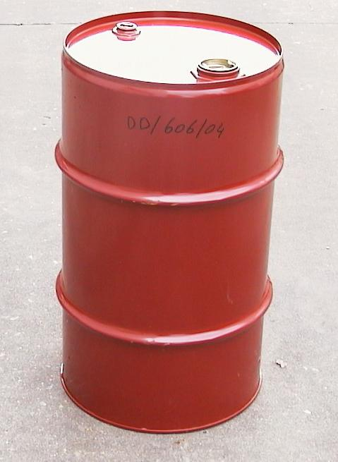 | 606 |  | Y 1,6/150 |  | Nothing of note
220 litres  steel  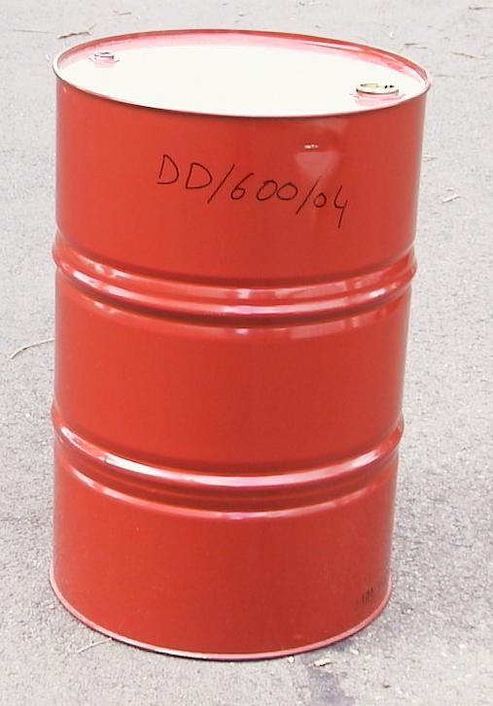 | 600 |  | Y 1,8/270 |  | Leakage in base in both  drums tested after 1 hour and 23 minutes and 1 hour and 55 minutes |  | No leakage, slight deformation  of base
220 litres  steel  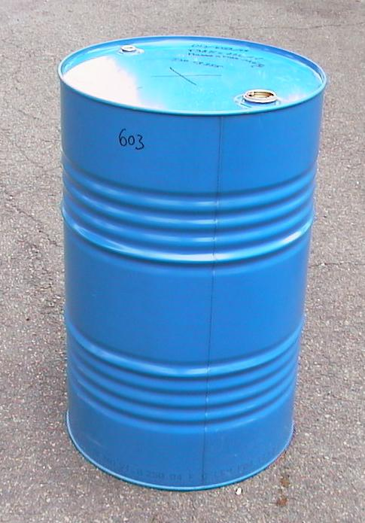 | 603 |  | Y 1,8/250 |  | Leakage in base in both drums tested after 36 and 45 miniutes |  | Leakage in base in both drums tested after 1 hour and 5 minutes and 1 hour and 19 minutes
220 litres plastic  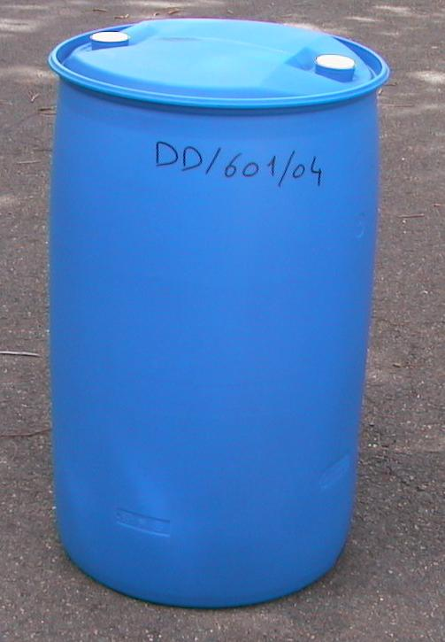 | 601 |  | Y 1,9/200 |  | Nothing of note
Composite IBC 31HA1
Capacity |  | LNE  Ref. |  | Approval |  | ISO 13355 |  | ASTM D 4169 - Truck level III
1,000 litres  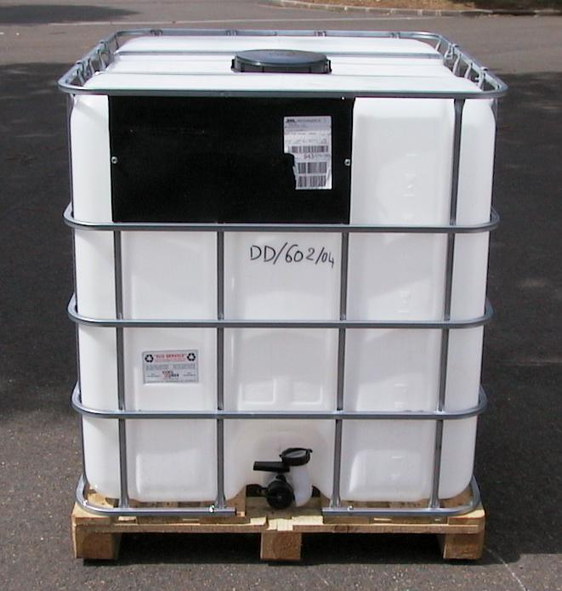 |  | 602 |  | Y 1,6/110 |  | 30 minutes of testing: considerable deformation of the metal cage, no rupture or leakage.  54 minutes of testing: considerable rupture of the metal cage. Test stopped for safety reasons. No leakage.  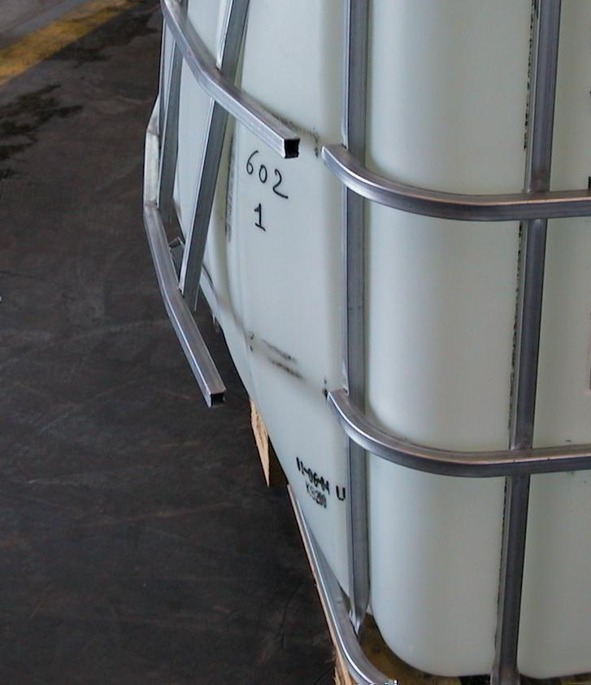 |  | 1 hour of testing: considerable deformation of the metal cage, no rupture or leak.  1 hour and 17 minutes of testing: rupture of a vertical strut.  1 hour and 23 minutes of testing: rupture of a second vertical strut and of a horizontal rod. Test stopped for safety reasons. No leakage.  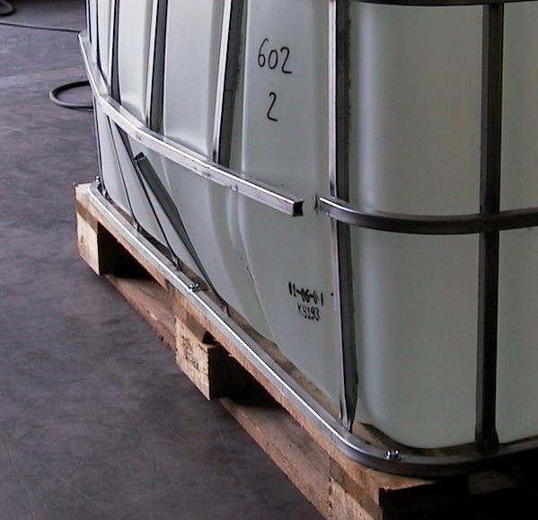
Composite IBC 31HA1
Capacity |  | LNE  Ref. |  | Approval |  | ISO 13355 |  | ASTM D 4169 - Truck level III
1,000 litres  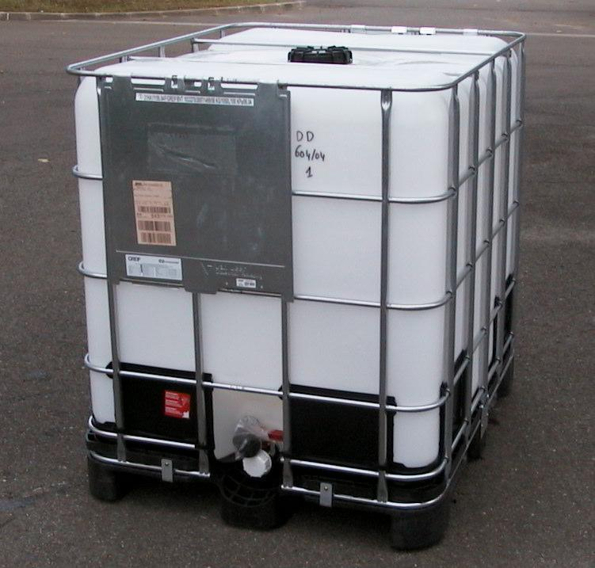 |  | 604 |  | Y 1,4/100 |  | 30 minutes of testing: slight lateral deformation, no rupture or leakage.  1 hour of testing: rupture of one of the two horizontal top tubes linking opposite sides of the IBC.  1 hour and 30 minutes of testing: rupture of the second horizontal top tube.  2 hours and 20 minutes of testing: rupture of a vertical strut weld.  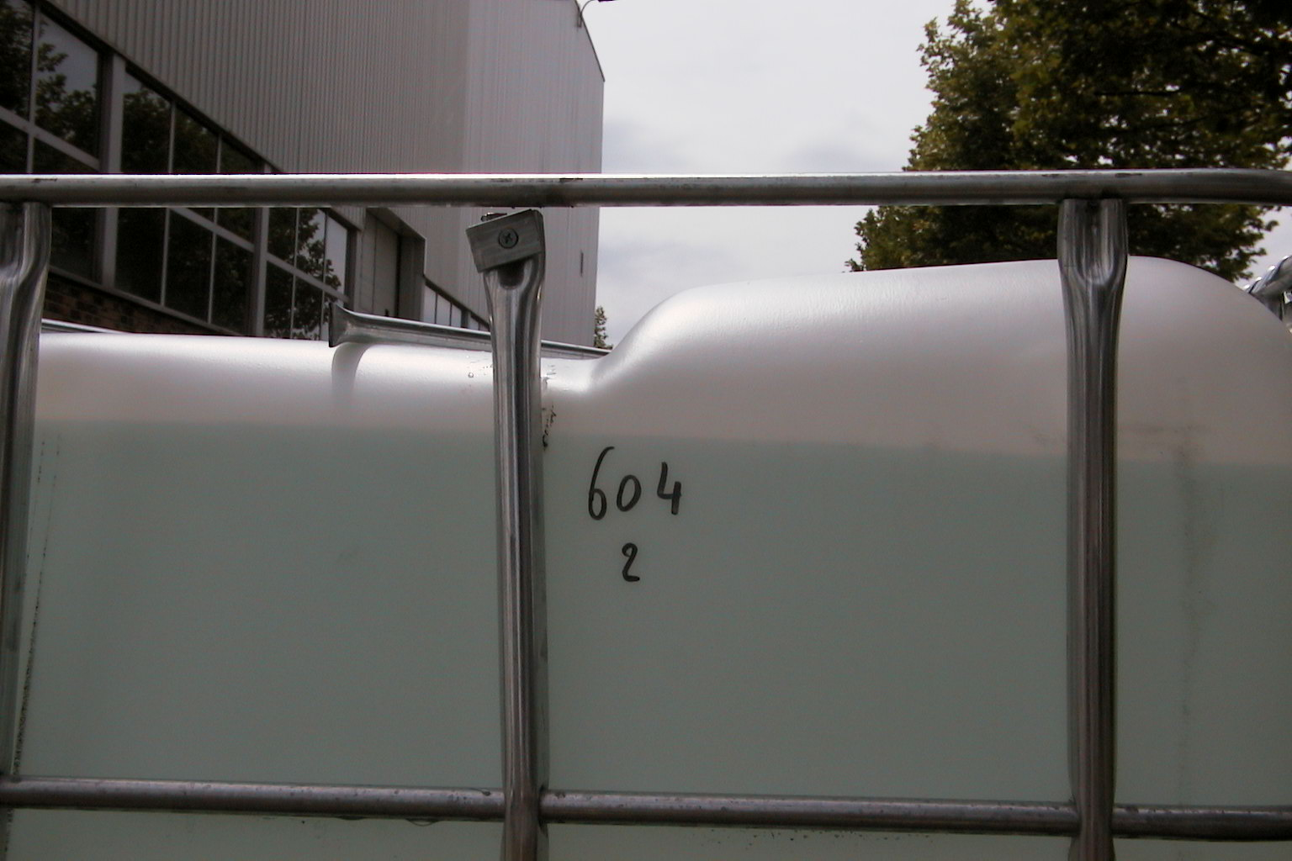  4 hours of testing: no new damage or leakage. Slight permanent lateral deformation.  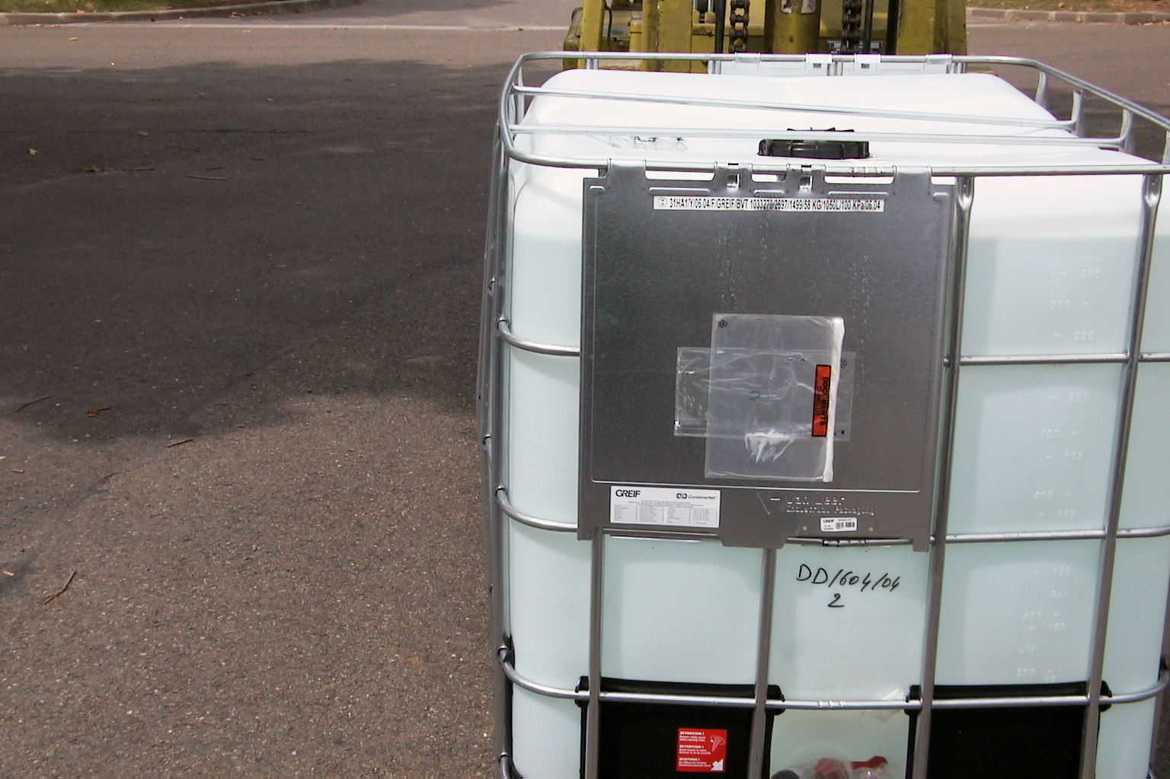 |  | 1 hour of testing: nothing of note.  1 hour and 20 minutes of testing: rupture of one of the two horizontal top tubes linking opposite sides of the IBC.  2 hours and 7 minutes of testing: rupture of the second horizontal top tube.  3 hours and 30 minutes of testing: rupture of three vertical strut welds.  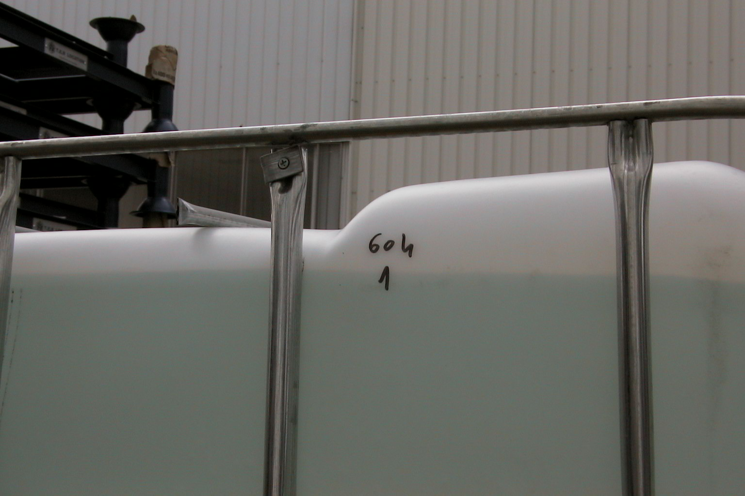  4 hours of testing: no new damage or leakage. Slight permanent lateral deformation.  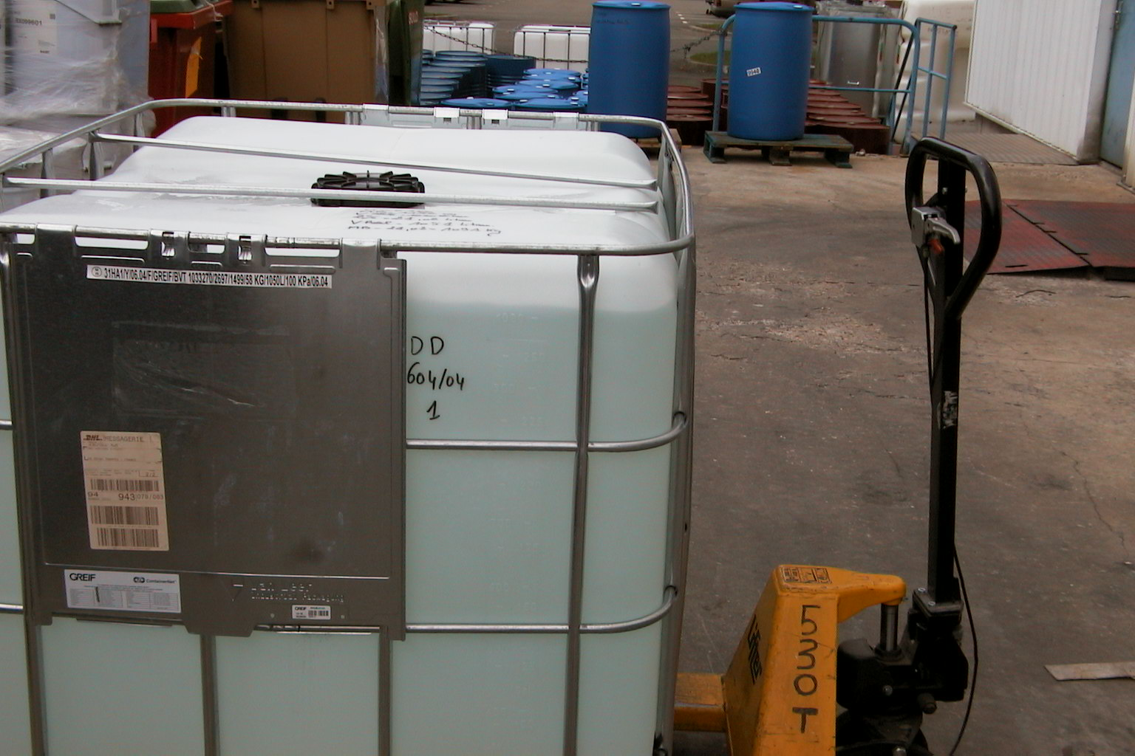

5.1.2 Remarks on tests
Plastic drums
No failure appeared after four hours of tests based on the two methods. The plastic drums perform well in both types of test.
Steel drums
In all cases, there was a relatively important deformation of the base and in numerous cases leaks appeared. The 30-minute test in accordance with ISO 13355 proved less exacting than the 4-hour test in accordance with ASTM D 4169. If a test time of 1 hour had been taken for the ISO standard, keeping the 4-hour period for the ASTM standard, the two tests would have given the same result: a defective design type in the case of both tests.
Composite IBCs
This test has revealed a major difference in performance between the two types of IBCs. In all cases a fairly important lateral deformation appeared with major instances of rupture. As in the case of the steel drums, the 30-minute ISO 13355 test proved less exacting than the 4-hour test in accordance with ASTM D 4169. If a test time of 1 hour is taken for the ISO standard, keeping the 4-hour period for the ASTM standard, the ISO standard is less exacting.

5.2 TESTS OF CARRIAGE USING A PALLET
This second part has been carried out in order to evaluate the influence of securing and stacking on packaging performance.

5.2.1 Tests
Drums were placed on a pallet and secured by means of straps. A second pallet, loaded with a metal block of 1 tonne to simulate a second layer of drums, was placed on top. The whole apparatus was subjected to a random vibration test in accordance with ISO 13355.
The test was carried out twice for each type of packaging; initially, the pallet was left unsecured on the vibrating table and subsequently it was secured to the table plate.
The packagings, all of which were approved for liquids, were filled with water to 98% of capacity.
The test apparatus can be seen in annex 3.

Drums - Tests on a pallet with 1,000 kg stacking

Pallet unsecured on the vibrating table
Capacity/  material | LNE Ref. | Approval | Sample | ISO 13355
 |  |  |  | Leak | Defect
220 litres  steel | 600 | Y 1,8/270 | 1 to 4 | Yes, 2 drums out of 4 after  12 minutes of testing | Deformation and cracking of the base
220 litres  steel | 603 | Y 1,8/250 | 1 to 4 | Yes, 3 drums  out of 4 after  12 minutes of testing | Deformation and cracking of the base

Drums - Tests on a pallet with 1,000 kg stacking

Pallet strapped to the vibrating table
Capacity/  material | LNE Ref. | Approval | Sample | ISO 13355
 |  |  |  | Leak | Defect
220 litres  steel | 600 | Y 1,8/270 | 1 to 4 | Yes, 3 drums  out of 4 after  5 minutes of testing | Deformation and cracking of the base
220 litres  steel | 603 | Y 1,8/250 | 1 to 4 | Yes, 3 drums  out of 4 after  4 minutes of testing | Deformation and cracking of the base

5.2.2 Remarks on tests
The drums resisted the tests for only a few minutes. The more firmly the load is secured to the vibrating table, the shorter the period of resistance of the drum. The type of defect is the same as in the test with a single packaging unsecured vertically, but the phenomenon appears far earlier. Annex 3 shows a leak after testing.
It is important to point out that the ruptures observed are not due to the presence of the stacking load since no rim failure was observed. Securing has an adverse effect on drum performance, probably because there is less dissipation of the vibration energy.

6. CONCLUSION
These tests show that none of the approved packagings satisfy the vibration tests. In the case of low-level random frequency tests (level III), fewer failures appeared, but they nevertheless exist.
Vibration tests would make it possible to improve the safety of packagings, particularly of composite IBCs which proved to be the most fragile.
The guidelines for the amendment of the Model Regulations are the following:
- a random vibration test as most representative of an actual transport operation;
- securing not to be taken into account since it does not improve packaging performance;
- stress profile in accordance with ISO 13355, with a test time of one hour for group II and adapted to the other packing groups;
- test to be carried out on packagings intended for liquids (except for combined packagings) with a capacity of fully 60 litres and IBCs intended for liquids, since only large capacity receptacles for liquids did not pass the tests.

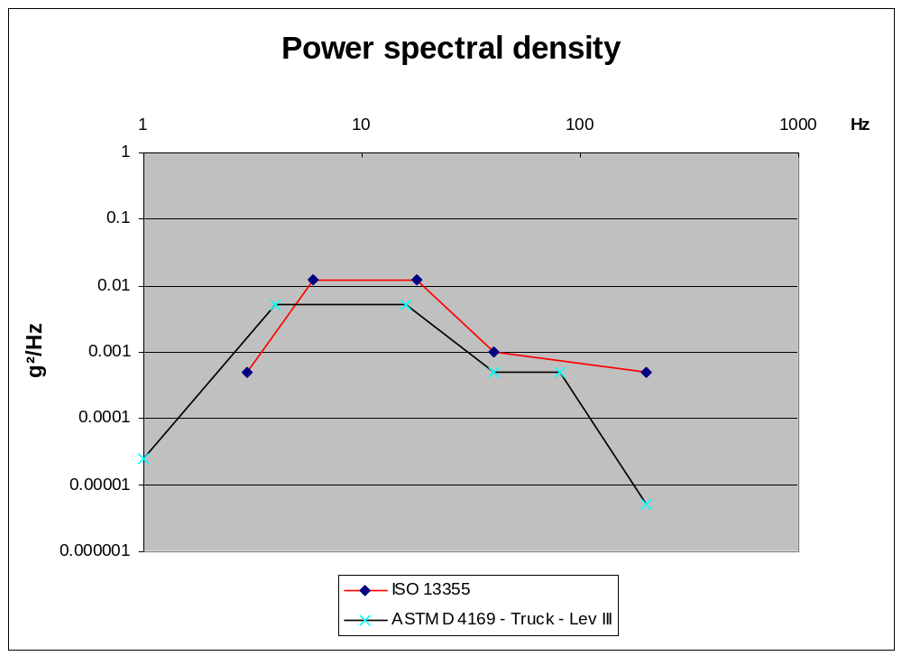Annex 1

Annex 2

Test on packaging alone

Test apparatus
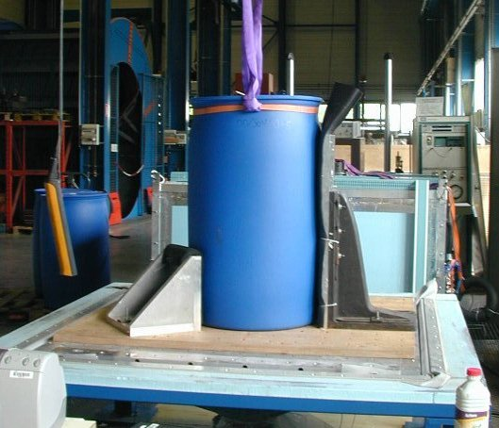
Vertical
wedging

Annex 3

Test apparatus with pallet

Unsecured pallet on the vibrating table
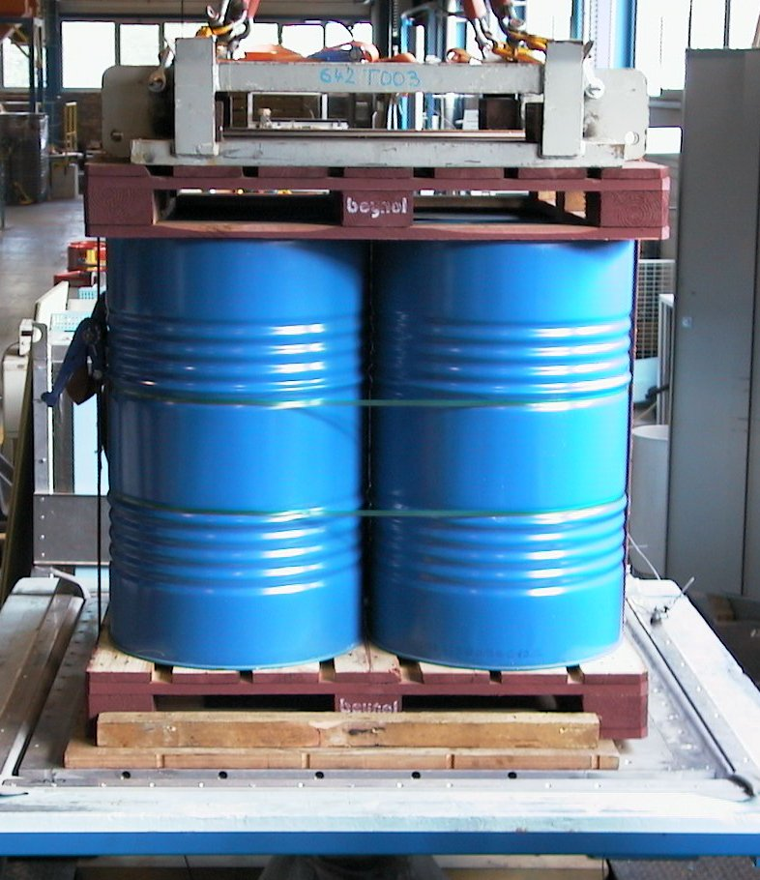
Pallet

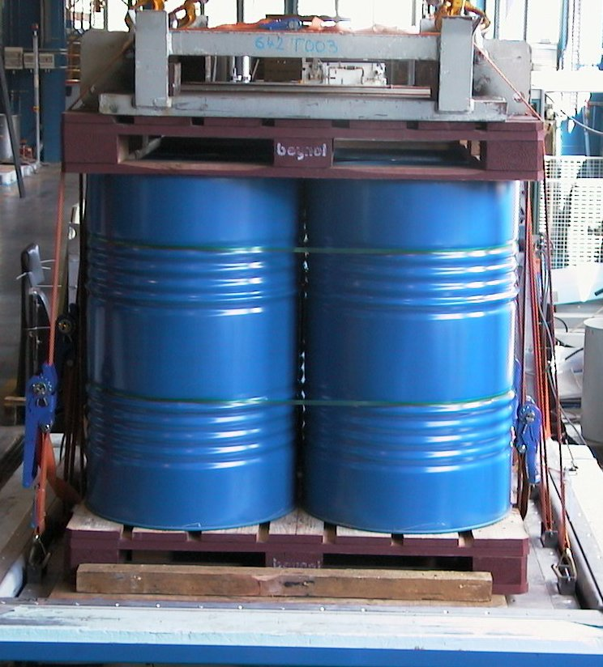
One tonne load
strapped to
the base pallet
Pallet
Pallet secured on the
vibrating table
Entire load secured
on the table

Annex 4

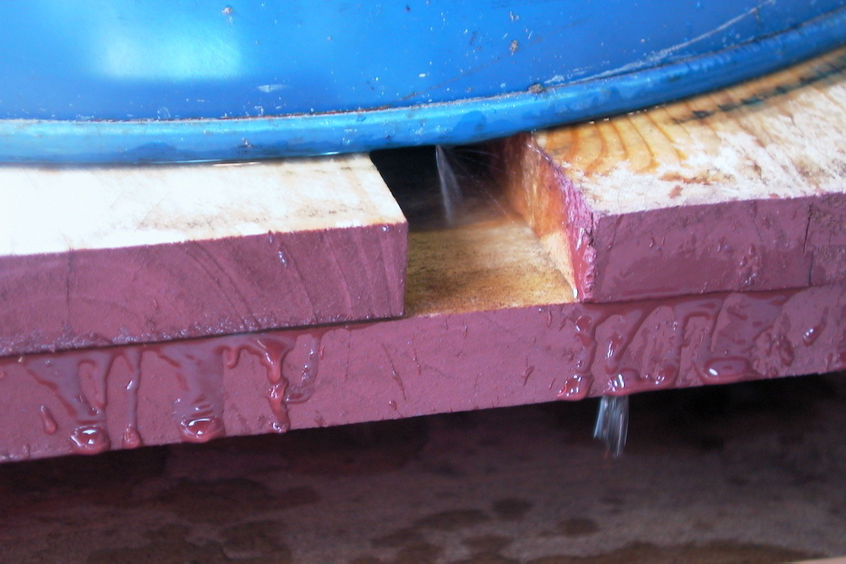
Metal drum failure
-----

Although termed “power …”, this function is not its unit of measurement. This term is used because the square of a fluctuating quantity is frequently a component of the power expression (Joule effect, …). It would be preferable to refer to “acceleration spectral density” or even “acceleration density”.

