UNITED

NATIONS
STSTE

Distr.
Secretariat

GENERAL

ST/SG/AC.10/C.3/2004/88/Add.2
2 September 2004

ENGLISH
ORIGINAL: ENGLISH AND FRENCH

COMMITTEE OF EXPERTS ON THE TRANSPORT OF

DANGEROUS GOODS AND ON THE GLOBALLY

HARMONIZED SYSTEM OF CLASSIFICATION

AND LABELLING OF CHEMICALS

Sub-Committee of Experts on the

Transport of Dangerous Goods

Twenty-sixth session, 29 November-3 December 2004

Item 3 (c) of the provisional agenda

OUTSTANDING ISSUES

Vibration test for design types of packagings intended for the transport of dangerous goods

Transmitted by the expert from France

Addendum 2

Test report (supplement to the 2003)

This document contains a test report (21 November 2003) prepared by the "Laboratoire national d'essais" at the request of the French Ministry of Equipment, Transport , Housing, Tourism and Sea.

Purpose: Evaluation of the resistance of certified packages to vibration-with-stacking test

Reference for
the test method: ASTM D 4169 Standard (random vibrations).

1. PURPOSE

The purpose of this report is to evaluate vibration-resistance performance of packages certified for the transport of hazardous materials, taking into account the stacking effect.

2. RESTRAINTS

The restraints allowed correspond to Levels I and II for road transport provided in the ASTM D4169-01 Standard, § 12.4, except that the test period is 60 instead of 180 minutes.

Testing method is described in ST/SG/AC.10/C.3/2004/88/Add.1.

Fixed displacement vibration test according to Method A1 ASTM D 999-01 has not been performed given that restraint frequency is determined by the delamination of the package and that this is very much affected by the load rebound onto the tested sample.

3. STACKING LOAD

Stacking load applied on each package is calculated taking into account the maximum accredited density and a stacking height of 3m according to hazardous materials transportation regulations.

4. TESTS

2 types of packages were tested, namely:

- A certified 60 litre metallic drum model 1A1 / X 1.2 / 250
- A certified 20 litre plastic jerrican model 3H1 / Y 1.9 / 150.

For each model, three samples were tested.

The stacking load applied on the package is guided. The only degree of freedom for this load is along the vertical axis.

The annex shows the test apparatus.

Test results are presented in the following table.
Random vibrations – Road restraints
Stacking load | Level I |  | Level II
20 litre plastic jerrican (reference LNE 516)
307 kg | Vertical rupture of the package body with significant projection of water after 45mn of test for the first sample. Testing of other samples was stopped after nearly 20 mn, a time when rupture was imminent.  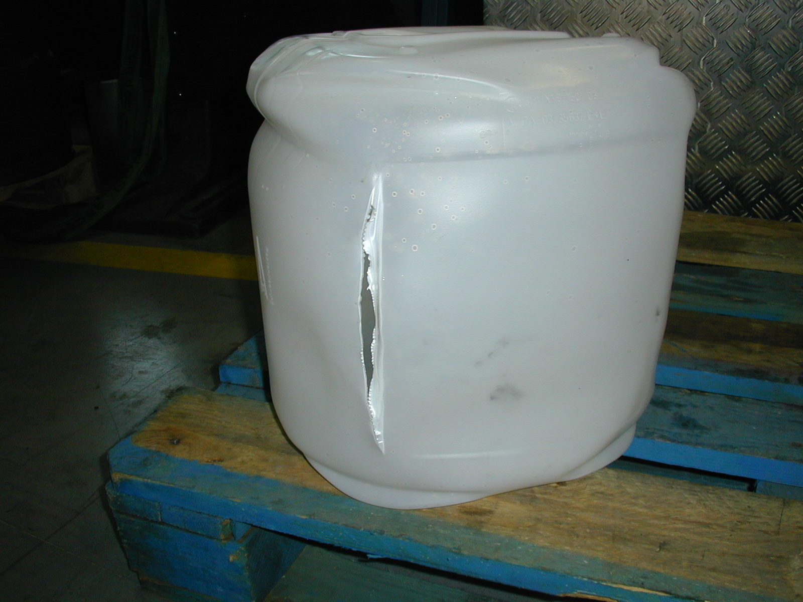 |  | Test carried out right to the end. No leakage, but considerable distortion of the package was seen: 350 mm before the test with load, compared with 307-312 mm after the test. The original package form was not restored, even 24 hours after the test.  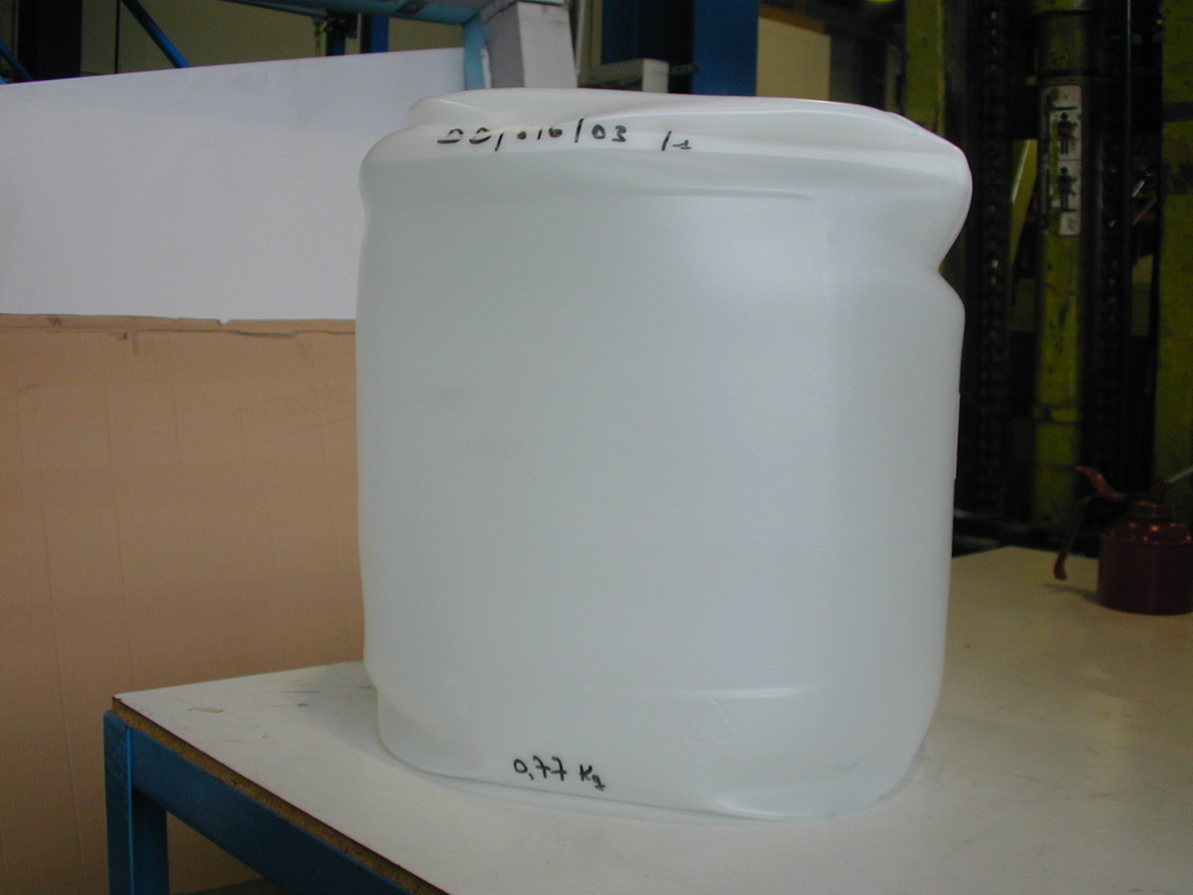
60 litre steel drum (reference LNE 517)
307 kg |  | Not performed given the low resistance experienced with the less strict level II. | Quick buckling of the drum body (max. 6 minutes) with leakages  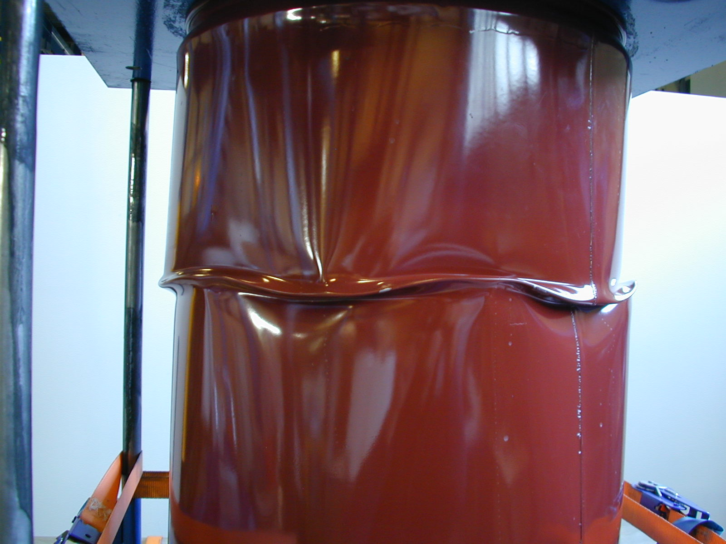  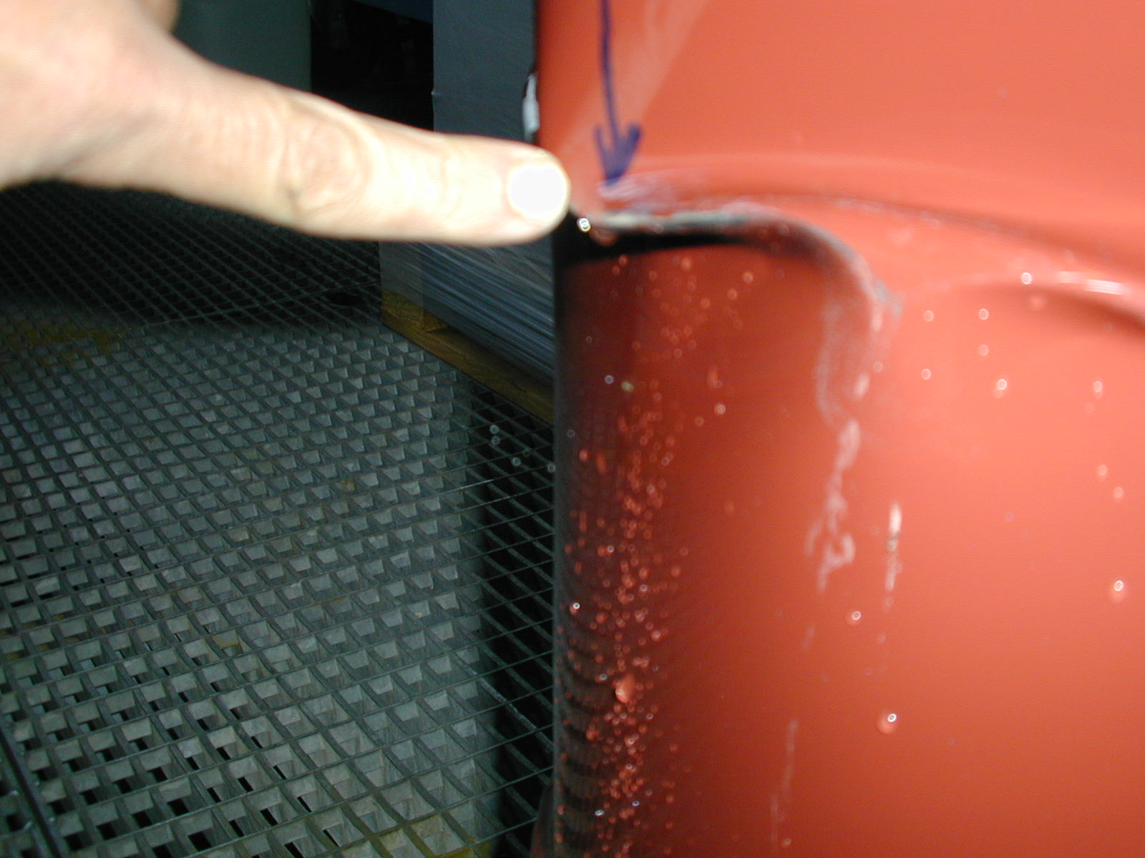

Random vibrations – Road restraints
Stacking load | Level I | Level II
60 litre steel drum (reference LNE 517)
203 kg | / | The third sample was tested with a reduced stacking load equivalent to 2.2 m, which corresponds to a real load in a truck on-road. Same statement as for other drums but after 14 minutes

6. CONCLUSION

The tested metallic drums did not pass the random-with-stacking vibration test, even under a reduced stacking load of 2.2 m of packages.

The tested plastic jerricans did not withstand the strictest test, and for the average restraints defined by the standard, their considerable deformation, leading to instability of stacking, is susceptible to jeopardize the safety during transportation.

ANNEX

Test Apparatus

Stacking load
Vertical guide of the load

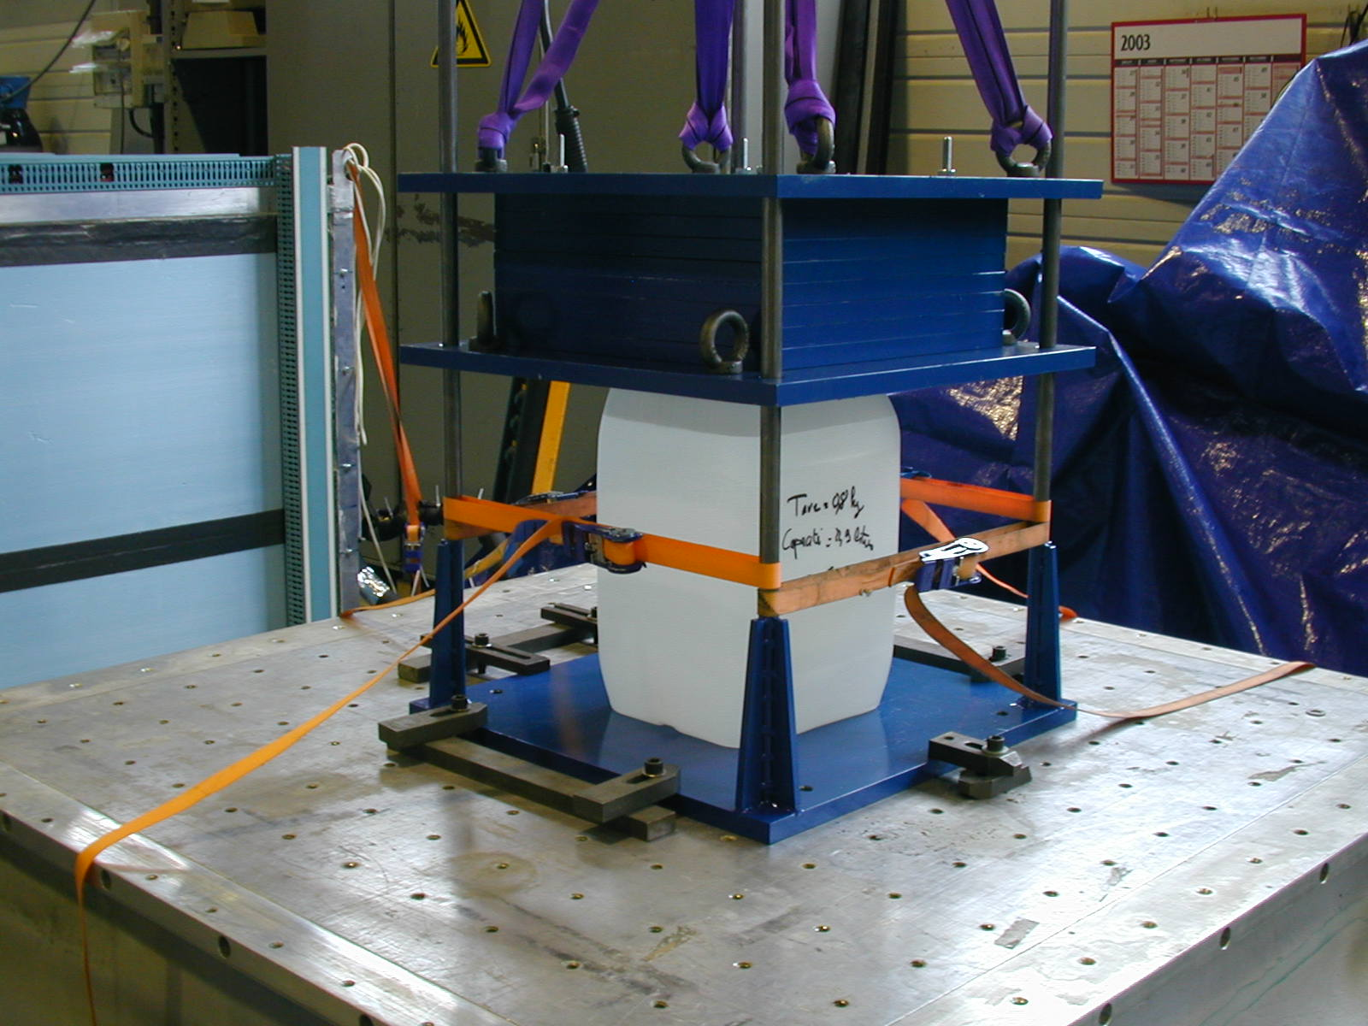
Vibrating platform
Tested sample

_________

