UN/SCETDG/21/INF.17

COMMITTEE OF EXPERTS ON THE TRANSPORT OF
DANGEROUS GOODS AND ON THE GLOBALLY
HARMONIZED SYSTEM OF CLASSIFICATION
AND LABELLING OF CHEMICALS
Sub-Committee of Experts on the
Transport of Dangerous Goods
(Twenty-first session, 1-10 July 2002,
agenda item 3 (c))

EXPLOSIVES, SELF-REACTIVE SUBSTANCES AND ORGANIC PEROXIDES

Development of a new harmonized pressure-vessel test

Transmitted by the Expert from Sweden

Introduction

For many years, the test results of the Dutch-and the US Pressure-Vessel Tests have shown differing figures for the same substance. With retrospect there have probably been several reasons causing this. One reason may be that the same substance but from different manufacturers was tested. Another reason is that the test procedure has been changed several times so that the test parameters, differing between the two methods, have caused different test conditions.

The Swedish Rescue Services Agency and also, at the beginning of the project, TNO in the Netherlands have tried to isolate the differences between both methods. The Japanese Pressure-Vessel test, which is not a UN test method, has also been taken into account. The vessel has the same geometry as the Dutch vessel and therefore no experiments have been done with the Japanese version.

The basic idea for the project has been to prove that, if the same test procedure and the same conditions under test are used for the two vessels the same result will be obtained for the substance tested. If the same test procedure is used for both methods, any of the two vessels may be used to determine the property intended.

PROPOSAL FOR A UN PRESSURE-VESSEL TEST

Introduction

This test is used to determine the sensitiveness of substances to the effect of intense heat under defined confinement.

Apparatus and materials

Description of the vessels

Figures 1-4 show the Dutch and the US apparatus used. The vessels are made from stainless steel, type AISI 316. 8 aperture discs are used, the diameters of the orifices being: 1.0-2.0-3.5-6.0-9.0-12.0-16.0 and 24,0 mm.These discs have a thickness of 2.0±0.2 mm. The bursting discs are made from aluminium conforming to ASTM B 209 having a bursting pressure of 620±50 kPa. Sealing gaskets according to the Japanese method shall be used for both the bursting disc and the aperture.
A sample cup made from aluminium; diameter 30 mm and height 28 mm.

Heating device

The pressure-vessel is heated by technical grade butane taken from a cylinder fitted with a pressure regulator. A Teclu burner is used. The heating rate shall be 0.5 K/s. The heating rate should be checked by heating 10g of dibutyl phtalate in the vessel and measuring its temperature. The time taken for the temperature of the oil to rise from 50 to 200ºC is recorded and the heating rate calculated.

Procedure

A 10.0 g sample of the substance to be tested is weighed accurately into a sample cup. The cup is lowered and positioned with the aid of forceps in the centre of the vessel. The bursting disc, is put in place by means of a manual device which allows the pressure to be evenly applied over the whole surface of the disc. The central orifice plate, sealing gaskets and orifice plate retaining ring are then assembled. The bursting disc is secured by means of the wing nuts and the orifice nut by a spanner. The bursting disc is covered by enough water to keep it at a low temperature. The pressure-vessel is placed on a tripod (with an inside ring diameter suitable for the vessel used). The ring at the middle of the vessel rests on the tripod.

The burner is lit, the flow of the gas is set to the required rate and the flow of air adjusted so that the colour of the flame is blue and the inner cone of the flame is light blue. The tripod should be of such height that the inner cone just touches the bottom of the vessel. The test should be carried out in a bunker laboratory or in another place where the operator is well protected. The vessel is observed from outside eventually through an aperture in a wall fitted with armoured glass. The time to reaction, duration of reaction and residue of sample after reaction provided useful information interpreting the result. Finally the vessel is cooled in water and the test chamber and if possible also the sample cup cleaned with acetone and by saltblasting.

The 16 mm orifice is used first and if there is no rupture of the bursting disc experiments are performed in sequence with the diameters 6.0, 2.0, and 1.0 mm (one experiment at each diameter) until rupture of the disc occurs. In the event of rupture of the disc, the experiments are repeated at the next higher orifice diameter until the level is found at which there are no ruptures in three successive experiments.

Test criteria and method of assessing results

The relative degree of sensitivity of a substance to heating in a pressure-vessel is expressed by the limiting diameter; this being the orifice with the largest diameter in millimeters with which, in three tests, the bursting disc is broken at least once, while having remained unbroken during three tests with the next larger diameter.

The test criteria are as follows:

”Violent”:- rupture of the disc with an orifice of 9 mm or greater
”Medium”:- no rupture of the disc with an orifice of 9 mm but rupture of the disc with an orifice of 3.5 mm or 6 mm
”Low”:- no rupture of a disc with an orifice of 3.5 mm but rupture of the disc with an orifice of 1.0 mm or 2.0 mm
”No”:- no rupture of the disc with an orifice of 1.0 mm

Examples of results (Dutch-and US PVT with sample cup)

Substance | Disc orifice (mm) | Result
Dibensoylperoxide. Conc. 50%, A_{o} 3,25% | 24 | Violent
1.1-Di(tert.-butylperoxy)-3.3.5-thrimethyl-  cyclohexane. A_{o} 10,5% | 3,5 | Medium
Methyl Ethyl Ketone Peroxide A_{o} 9,9% | 1 | Low
2.5-Dimethyl-2.5-di(tert-butylperoxy)hexane.  Conc. 92%, A_{o} 9,9% | 3.5 | Medium

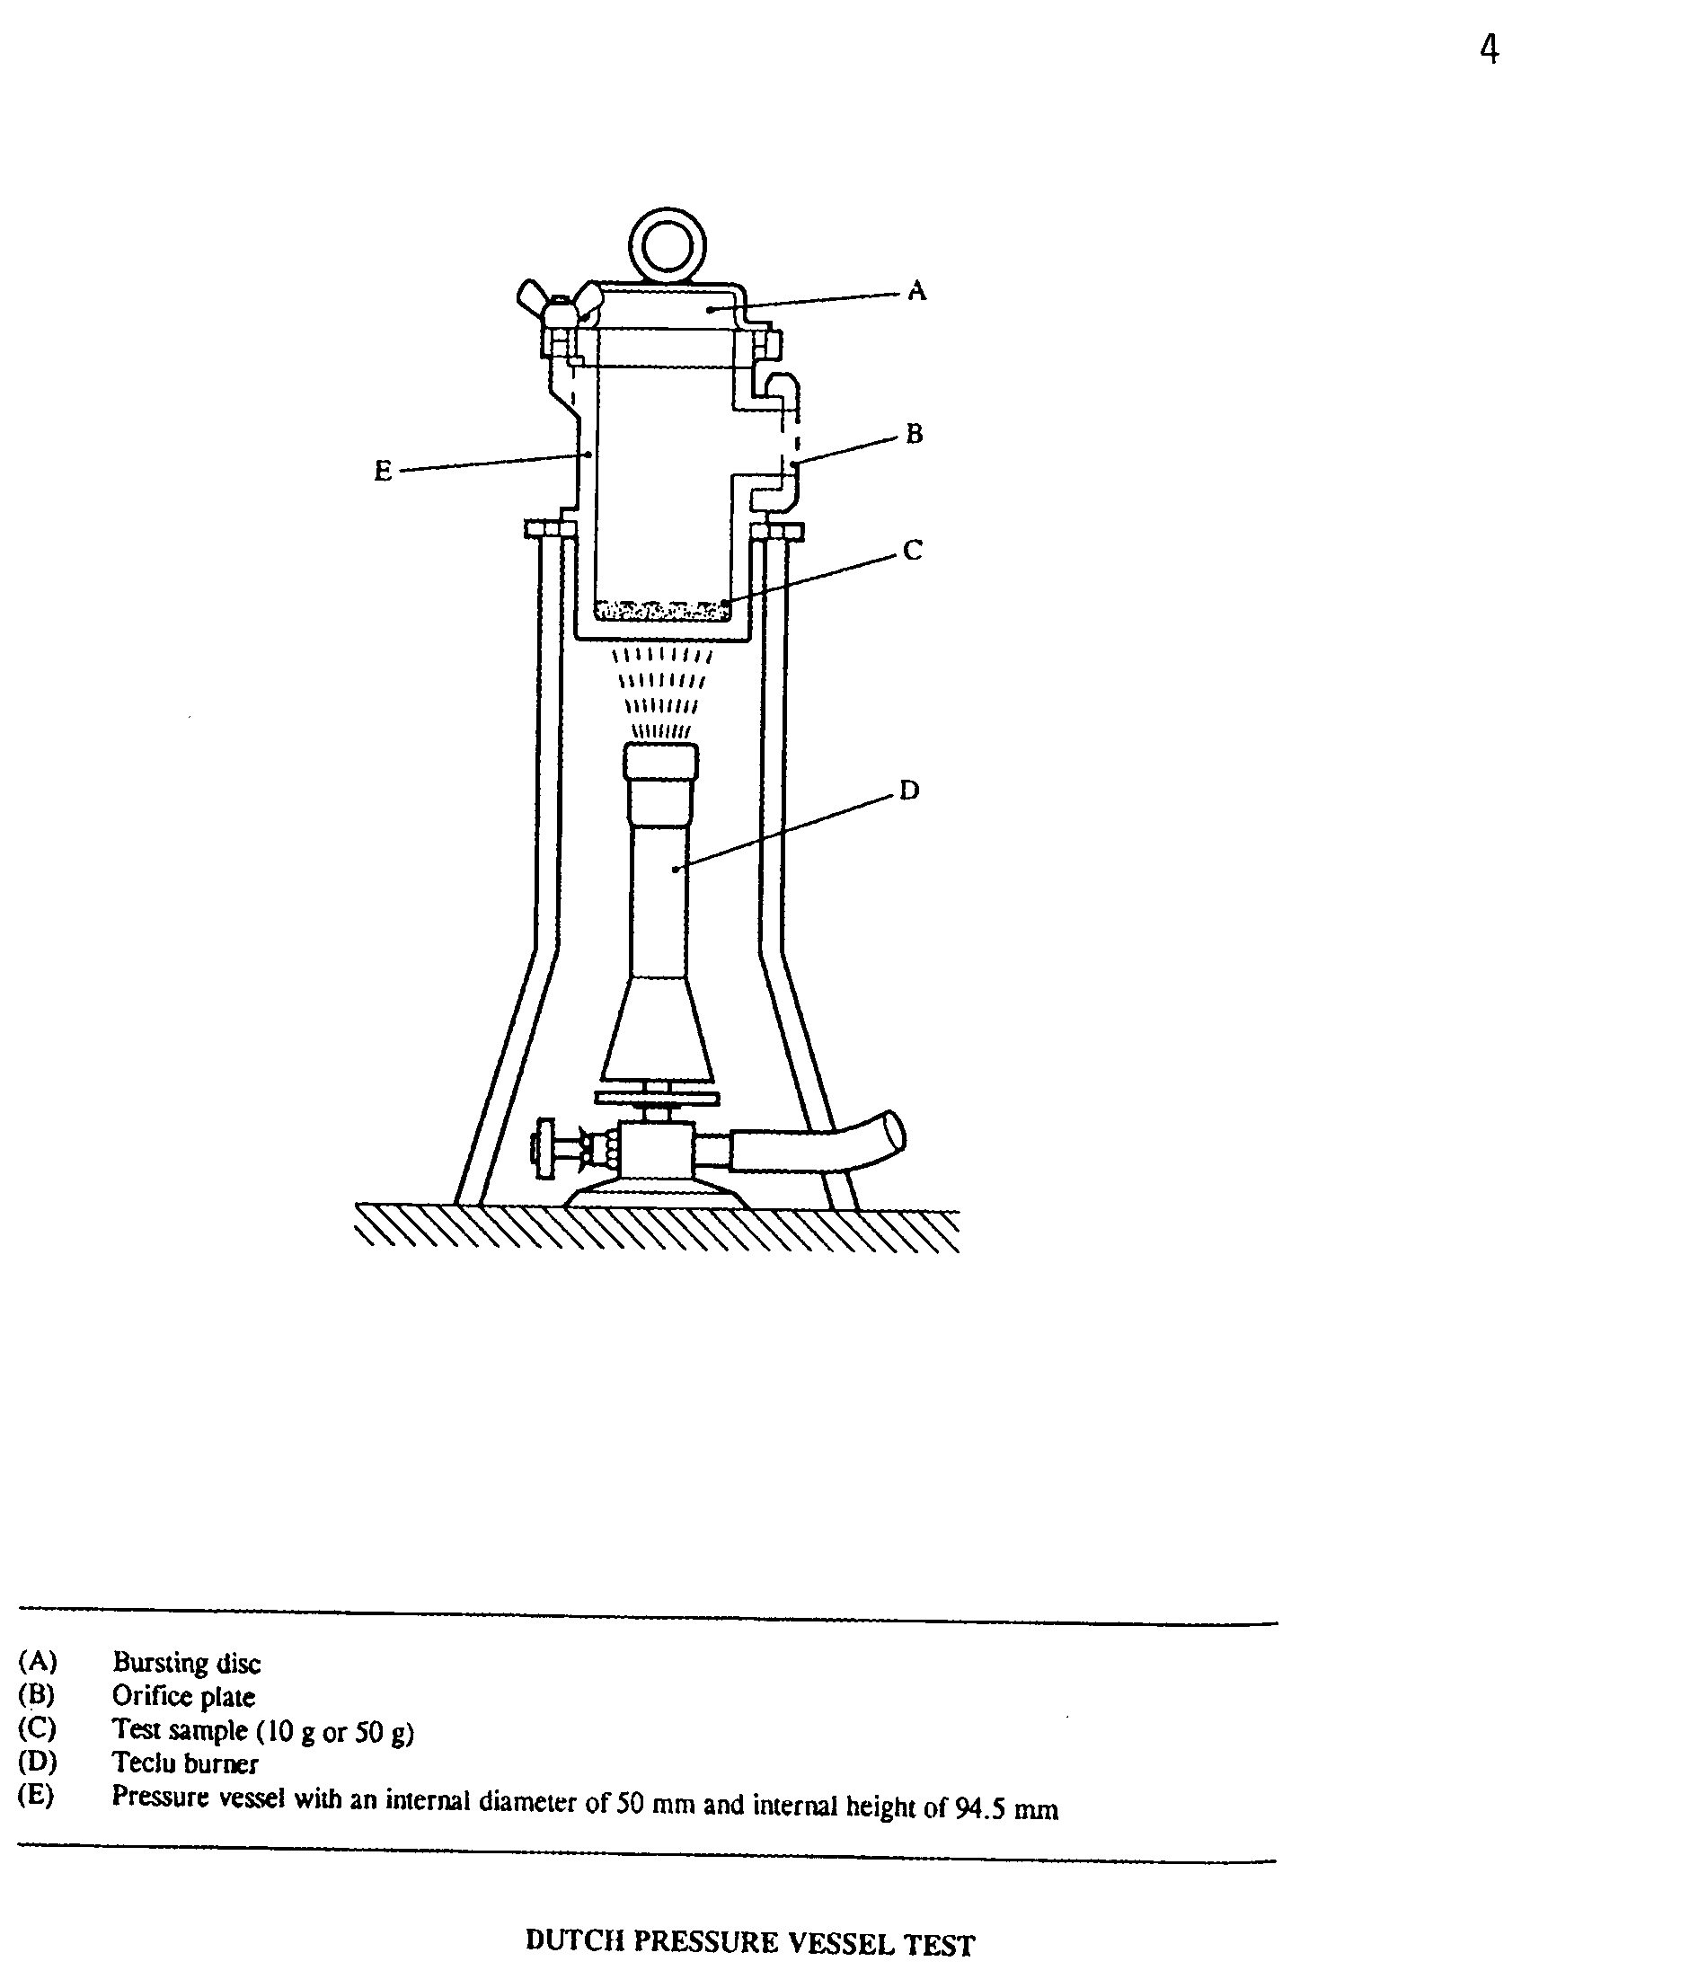

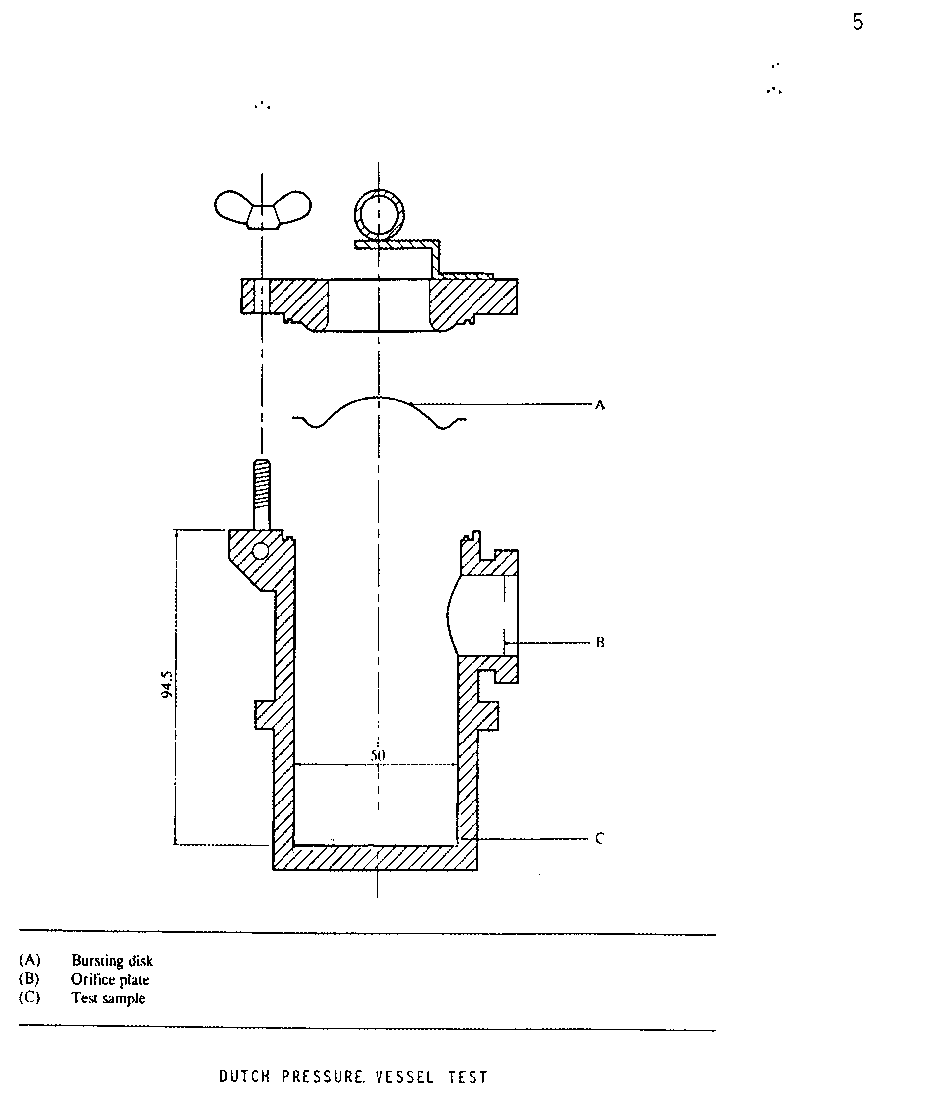
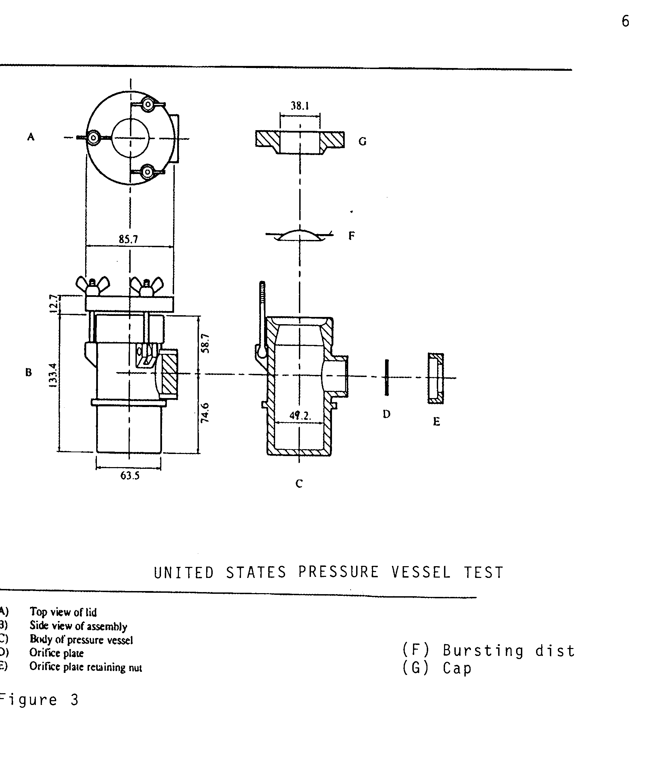

BACKGROUND

Differences between the current Dutch and US Pressure-Vessel Test

Apparatus

- The US vessel has about 20% larger volume of the testchamber.
- The US testchamber has about 25% larger innersurface
- The sidearm on the US vessel is placed somewhat lower than the sidearm on the Dutch vessel
- The testchamber of the US is coneshaped in the upper part. The testchamber of the Dutch vessel is straight
- The US method uses a sample cup. In the Dutch vessel the sample is placed directly
in the testchamber.

Procedure

- The amounts of the sample used are different, DPVT=10g (50g) and USPVT=5.0g
- The heating rates are different, DPVT=3,5±0,3 K/s and USPVT 0,5±0,1 K/s
- The series of orifice diameters are different

Reporting

- The US method gives the smallest diameter at which the bursting disc does not burst.
- The Dutch method gives the largest diameter at which the bursting disc bursts.

Investigations

One Dutch and one US pressure-vessel were manufactured according to approved drawings. Gaskets according to the Japanese method, sample cups according to the US method and bursting discs from TNO were obtained.

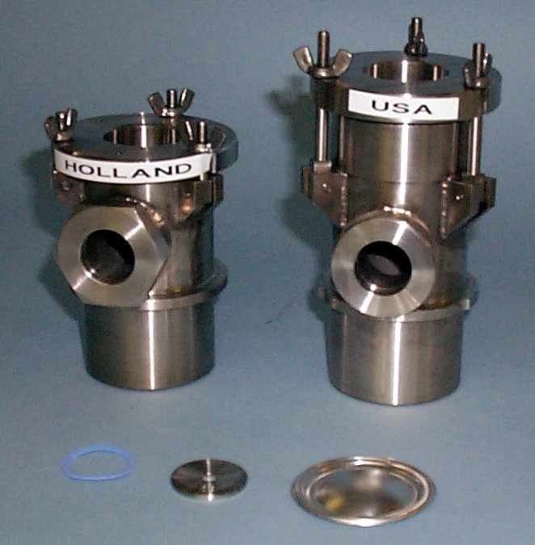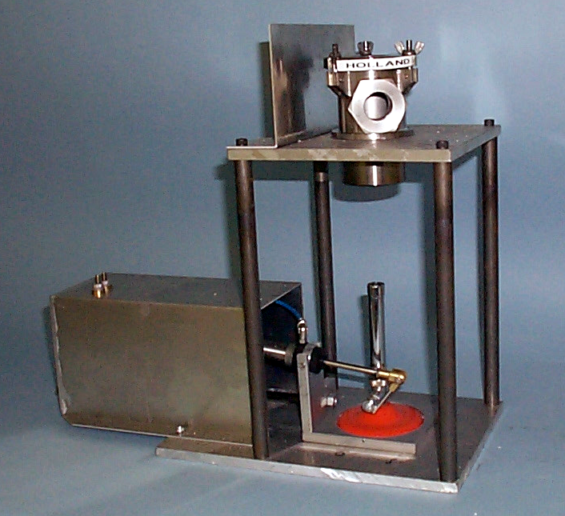

Figure 4

In the first place organic peroxides which were known to give different results in the past were chosen for testing.

Both types of vessels were used in the same manner: without sample cup (in the beginning), with the same heating rate, with same amount of sample, with the same heating device, with sealing gaskets, with the same procedure, with the same criteria and with the same way of reporting the test result.

From the beginning, no sample cup was used. To be sure of the influence of the sample cup there were also made experiments with cup. According to the test results, the influence of the cup seems to be a more severe result than without the sample cup. Generally, when using a cup, it takes longer time to reaction and at large the whole amount of sample is consumed in the test which is not the case when not using a cup. It is possible to draw the conclusion that using a sample cup gives a more uniform heating of the sample, possibly due to the extra heat barrier, caused by the cup and a more severe result because the whole amount of sample is consumed.

Basic test parameters

Table 1
Reference | Method
Nozzle series (nozzle di-  ameter) | 1.0 2.0 3.5 6.0 12.0 16.0 24.0 mm
Sealing | Nozzle washer sealed as per Japanese method.
Warming up agent | Gas.
Warming up rate | 0,5 K/s
Calibrating warming up rate | 10 g dibutylphthalate was used and interval of 50ºC to 200ºC was used for calibrating.
Substance amount | 10 g
Application test substance | Placed directly in the vessel, no sample cup was used.
Test method | Decide the nozzle diameter that gives three “-“, where the nearest smaller nozzle diameter gives at least one “+” at three tries. Time to bursting or final reaction is noted. *
Warming up time | Interrupt warming up after 10 min.
Cleaning | Acetone or cautious blasting after each test.
Evaluation | A substance’s sensitivity is given as the nozzle’s limiting diameter when the bursting disc bursts.

* - :states that the bursting disc is not ruptured
* + states that the bursting disc is ruptured

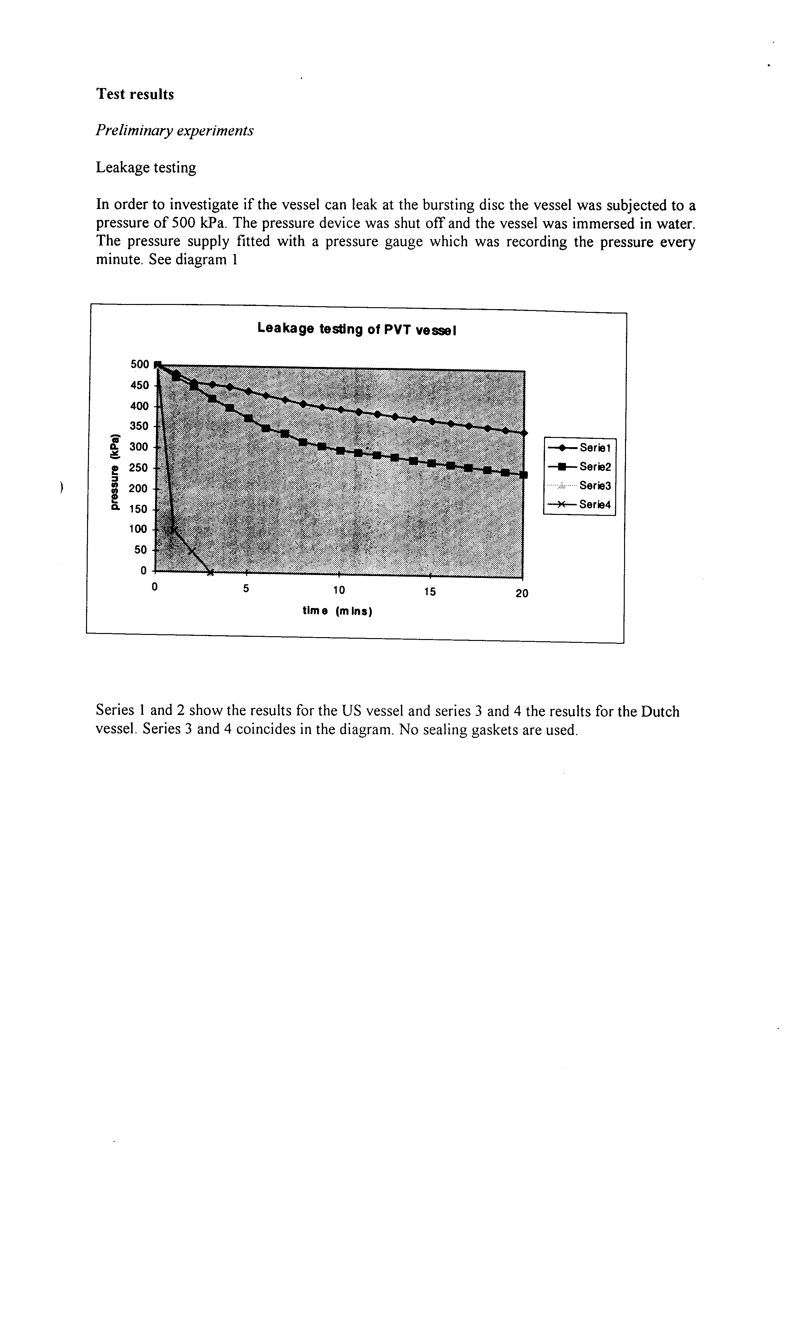
Informative test

Tert. Butylperbensoate was used in this first test with the new procedure

Table 2
Test  No | Type of  Vessel | Nozzle diam.  (mm) | Time  (min.s) | Results*
1 | DPVT | 16 | 2.48 | -
2 | DPVT | 9 | 2.42 | -
3 | DPVT | 6 | 2.44 | +
4 | USPVT | 9 | 2.44 | +
5 | USPVT | 12 | 2.39 | -
6 | USPVT | 9 | 2.28 | +
7 | USPVT | 9 | 2.31 | +
8 | DPVT | 9 | 2.33 | +
9 | DPVT | 9 | 2.41 | +
10 | DPVT | 12 | 2.41 | -
* -: indicates that bursting diaphragm has not burst
+: indicates that bursting diaphragm has burst.

Table 3
Type of  Vessel | Nozzle diam  (mm) | Results
DPVT | 16 | -
DPVT | 12 | -
DPVT | 9 | -++
DPVT | 6 | +
USPVT | 12 | -
USPVT | 9 | +++

In this first simplified test there is no difference in the test results between the two vessels

Experiments with organic peroxides with differing decomposition energy

Substance: tert-butyl peroxyacetate.

Table 4
Nozzle  (mm) | DPVT |  |  | USAPVT
 | Time to visible reaction (s) | Bursting disc | Substance residue after test (g) | Time to visible reaction (s) | Bursting disc | Substance residue after test (g)
6.0 | 220 | Whole | Ca: 2 | - | - | -
3.5 | 225 | Whole | Ca: 2 | - | - | -
2.0 | 218 | Whole | Ca: 2 | - | - | -
2.0 | 205 | Whole | Ca: 2 | - | - | -
2.0 | 210 | Whole | Ca: 2 | - | - | -
1.0 | 263 | Whole | Ca: 2 | 297 | Whole | Ca: 2
1.0 | 259 | Whole | Ca: 2 | 290 | Whole | Ca: 2
1.0 | 262 | Whole | Ca: 2 | 296 | Whole | Ca: 2

Substance: 2,2 di(tert-butylperoxy)butane.
Table 5
Nozzle  (mm) | DPVT |  |  | USAPVT
 | Time to visible reaction (s) | Bursting disc | Substance residue after test (g) | Time to visible reaction (s) | Bursting disc | Substance residue after test (g)
3.5 | - | - | - | 180 | Whole | Ca: 2
2.0 | - | - | - | 166 | Whole | Ca: 2
1.0 | 210 | Whole | Ca: 2 | 178 | Whole | Ca: 2
1.0 | 211 | Whole | Ca: 2 | 188 | Whole | Ca: 2
1.0 | 200 | Whole | Ca: 2 | 178 | Whole | Ca: 2

Substance: Dicumyl peroxide.

Table 6
Nozzle  (mm) | DPVT |  |  | USAPVT
 | Time to visible reaction (s) | Bursting disc | Substance residue after test (g) | Time to visible reaction (s) | Bursting disc | Substance residue after test (g)
9.0 | 171 | Whole | Ca: 2 | 182 | Whole | Ca: 2
9.0 | 173 | Whole | Ca: 2 | 184 | Whole | Ca: 2
9.0 | 168 | Whole | Ca: 2 | 186 | Whole | Ca: 2
6.0 | 168 | Whole | Ca: 2 | 174 | Whole | Ca: 2
6.0 | 166 | Whole | Ca: 2 | 176 | Whole | Ca: 2
6.0 | 162 | Whole | Ca: 2 | 172 | Whole | Ca: 2
3.5 | 172 | Ruptured | Ca: 2 | 174 | Ruptured | Ca: 2
3.5 | 170 | Ruptured | Ca: 2 | 175 | Ruptured | Ca: 2
3.5 | 167 | Ruptured | Ca: 2 | 176 | Ruptured | Ca: 2

Substance: brt. Butyl Peroxy Benzoate

Table 7
Nozzle  (mm) | DPVT |  |  |  | USAPVT
 | Time to visible reaction (s) | Dura-  tion of reac- tion (s) | Burst-ing disc | Sub-stance residue after test (g) | Time to visible reac-tion (s) | Dura- tion of reac- tion (s) | Burst- ing disc | Sub- stance residue after test (g)
12.0 | - | - | - | - | 122 | 1-2 | Whole | 1.1 **
12.0 | - | - | - | - | 122 | 1-2 | Whole | 1.1 **
12.0 | 159 | 1-2 | Whole | 0.7 ** | 125 | 1-2 | Whole | 0.9 **
9.0 | 165 | 1-2 | Whole | 0.9 ** | 154 | 1-2 | Whole | 1.5 **
9.0 | 153 | 1-2 | Whole | 0.7 ** | 148 | 1-2 | Whole | 1.1 **
9.0 | 146 | 1-2 | Whole | 0.7 ** | 134 | 1-2 | Rupt. | 0.8 **
6.0 | 150 | 1-2 | Rupt. | 0.7 ** | 139 | 1-2 | Rupt. | 0.7 **
6.0 | 140 | 1-2 | Rupt. | 0.7 ** | 123 | 1-2 | Rupt. | 0.8 **
6.0 | 153 | 1-2 | Rupt. | 0.7 ** | 125 | 1-2 | Rupt. | 0.8 **

2.5-Dimethyl 2.5 Di(tert-Butyl Peroxy) Hexane.

Table 8
Nozzle  (mm) | DPVT |  |  |  | USAPVT
 | Time to visible reac- tion (s) | Dura-  tion of reac- tion (s) | Burst-ing disc | Sub-stance residue after test (g) | Time to visible reac-tion (s) | Dura- tion of reac- tion (s) | Burst- ing disc | Sub- stance residue after test (g)
6.0 | 226 | 60 | Whole | 3.5 * | - | - | - | -
2.0 | 312 | 64 | Whole | 4.0 * | 220 | 58 | Whole | 3.8 *
2.0 | 224 | 57 | Whole | 3.5 * | 207 | 52 | Whole | 3.6 *
2.0 | 236 | 55 | Whole | 3.8 * | 220 | 79 | Whole | 3.6 *
1.0 | 240 | 65 | Whole | 3.4 * | 222 | 31 | Whole | 3.7 *
1.0 | 229 | 4 | Rupt. | 1.7 ** | 209 | 91 | Whole | 3.6 *
1.0 | 232 | 4 | Rupt. | 1.7 ** | 221 | 87 | Whole | 3.4 *
- solid form **liquid form

Substance: Butyl Peroxy Benzoate

Table 9
Nozzle  (mm) | DPVT |  |  |  | USAPVT
 | Time to visible reac- tion (s) | Dura-  tion of reac- tion (s) | Burst-ing disc | Sub-stance residue after test (g) | Time to visible reac-tion (s) | Dura- tion of reac- tion (s) | Burst- ing disc | Sub- stance residue after test (g)
9.0 | 135 | 1-2 | Whole | 1.0 ** | 139 | 1-2 | Whole | 1.2 **
9.0 | 143 | 1-2 | Rupt. | 1.0 ** | 133 | 1-2 | Whole | 0.9 **
9.0 | 127 | 1-2 | Rupt. | 0.8 ** | 145 | 1-2 | Rupt. | 1.0 **
6.0 | 130 | 1-2 | Rupt. | 1.4 ** | 138 | 1-2 | Rupt. | 0.9 **

2,5 Dimethyl 2,5 Di(tert-Butyl Peroxy) Hexane.

Table 10
Nozzle  (mm) | DPVT |  |  |  | USAPVT
 | Time to visible reac- tion (s) | Dura-  tion of reac- tion (s) | Burst-ing disc | Sub-stance residue after test (g) | Time to visible reac-tion (s) | Dura- tion of reac- tion (s) | Burst- ing disc | Sub- stance residue after test (g)
9.0 | 135 | 1-2 | Whole | 1.0 ** | 139 | 1-2 | Whole | 1.2 **
9.0 | 143 | 1-2 | Rupt. | 1.0 ** | 133 | 1-2 | Whole | 0.9 **
9.0 | 127 | 1-2 | Rupt. | 0.8 ** | 145 | 1-2 | Rupt. | 1.0 **
6.0 | 130 | 1-2 | Rupt. | 1.4 ** | 138 | 1-2 | Rupt. | 0.9 **
* solid form ** liquid form

Comparing tests with and without sample cup

2,5 Bis (tert.-butylperoxy) 2,5 dimethylhexane (liquid)

Table 11
Nozzle  (mm) | USAPVT without sample cup |  |  | USAPVT with sample cup
 | Time to visible reaction (s) | Bursting disc | Substance residue after test (g) | Time to visible reaction (s) | Bursting disc | Substance residue after test (g)
9.0 |  |  |  | 266 | complete | 0
6.0 |  |  |  | 263 | complete | 0
6.0 |  |  |  | 266 | complete | 0
6.0 |  |  |  | 269 | complete | 0
3.5 | 161 | complete | ≈2 | 256 | burst | 0
3.5 |  |  |  | 252 | burst | 0
3.5 |  |  |  | 259 | burst | 0
2.0 | 145 | complete | ≈2
2.0 | 137 | complete | ≈1
2.0 | 165 | complete | ≈1
1.0 | 154 | complete | ≈1 | 252 | burst | 0
1.0 | 144 | complete | ≈2 | 269 | burst | 0
1.0 | 142 | burst | ≈1 | 264 | burst | 0

Methyl ethyl ketone peroxide (liquid)

Table 12
Nozzle  (mm) | USAPVT without sample cup |  |  | USAPVT with sample cup
 | Time to visible reaction (s) | Bursting disc | Substance remaining after test (g) | Time to visible reaction (s) | Bursting disc | Substance remaining after test (g)
6.0 |  |  |  | 240 | complete | ≈3
6.0 |  |  |  | 233 | complete | ≈3
6.0 |  |  |  | 171* | complete | ≈8**
3.5 |  |  |  | 236 | complete | ≈3
3.5 |  |  |  | 243 | complete | ≈2
3.5 |  |  |  | 240 | Burst | ≈12.0
2.0 | 147* | complete | ≈6
1.0 | 134* | complete | ≈7 | 236 | Burst | 0.1
1.0 | 143* | complete | ≈6
1.0 | 135* | complete | ≈6
* continued heating for a total of 10 min.
** same behaviour as without cup

Dibenzoyl peroxide (powder)

Table 13
Nozzle  (mm) | USAPVT without sample cup |  |  | USAPVT with sample cup
 | Time to visible reaction (s) | Bursting disc | Substance remaining after test (g) | Time to visible reaction (s) | Bursting disc | Substance remaining after test (g)
24.0 | 81 | Complete | ≈4 | 172 | Complete | ≈2
24.0 | 81 | Complete | ≈4 | 182 | Complete | ≈3
24.0 | 73 | Complete | ≈5 | 242 | Burst | 0
16.0 | 74 | Complete | ≈5 | 188 | Complete | ≈3
16.0 | 84 | Burst | ≈2 | 190 | Complete | ≈2
16.0 | 91 | Burst | ≈3 | 236 | Burst | ≈2
6.0 | 107 | Burst | ≈4
1.0 | 97 | Burst | ≈2

1,1 – Di(tert-butylperoxy) – 3,3,5 Trimethyl cyclohexane (liquid)

Table 14
Nozzle  (mm) | USAPVT without sample cup |  |  | USAPVT with sample cup
 | Time to visible reaction (s) | Bursting disc | Substance remaining after test (g) | Time to visible reaction (s) | Bursting disc | Substance remaining after test (g)
16 |  |  |  | 247 | complete | 2
16 |  |  |  | 216 | complete | 1
16 |  |  |  | 238 | complete | 1
12 |  |  |  | 254 | complete | 2
12 |  |  |  | 229 | complete | 1
12 | 135 | complete | 1 | 259 | burst | 1
9 | 142 | complete | 1 | 210 | burst | 1
9 | 135 | complete | 1
9 | 144 | complete | 1
6 | 136 | burst | 1 | 244 | burst | 1
6 | 139 | burst | 1
6 | 147 | burst | 1

1,1 – Di(tert-butperoxy) – 3,3,5 trimethyl cyclohexane (liquid)

Table 15
Nozzle  (mm) | USAPVT without sample cup |  |  | USAPVT with sample cup
 | Time to visible reaction (s) | Bursting disc | Substance remaining after test (g) | Time to visible reaction (s) | Bursting disc | Substance remaining after test (g)
16 |  |  |  | 221 | complete | 1
16 |  |  |  | 232 | complete | 1
16 |  |  |  | 207 | complete | 1
12 | 142 | complete | 2 | 192 | complete | 2
12 | 139 | complete | 2 | 216 | complete | 1
12 | 137 | complete | 1 | 208 | burst | 1
9 | 140 | complete | 1 | 201 | burst | 1
9 | 142 | burst | 1
9 | 144 | burst | 1
6 | 139 | burst | 1
6 | 134 | burst | 1
6 | 134 | burst | 1

Methyl ethyl ketone peroxide (liquid)

Table 16
Nozzle  (mm) | USAPVT without sample cup |  |  | USAPVT with sample cup
 | Time to visible reaction (s) | Bursting disc | Substance remaining after test (g) | Time to visible reaction (s) | Bursting disc | Substance remaining after test (g)
9 | 180 | complete | 7
1 | 182 | complete | 7 | 268 | complete | 7
1 | 179 | complete | 7 | 269 | complete | 7
1 | 180 | complete | 7 | 271 | complete | 7

Methyl ethyl ketone peroxide (liquid)

Table 17
Nozzle  (mm) | DPVT without sample cup |  |  | DPVT with sample cup
 | Time to visible reaction (s) | Bursting disc | Substance remaining after test (g) | Time to visible reaction (s) | Bursting disc | Substance remaining after test (g)
3.5 | no reaction | complete | 7
2 | 309 | complete | 6 | 232 | complete | 7
2 | 301 | complete | 6 | 260 | complete | 7
2 | 298 | complete | 6 | 239 | complete | 7
1 | no reaction | complete | 7 | 267 | complete | 6
1 | no reaction | complete | 6 | 221 | complete | 7
1 | 147 | burst | 3 | 240 | Burst | 2

___________________

