Trade Facilitation Implementation Guide (TFIG)  Training Workshop | 2 Day Train the Trainer Workshop  19 – 20 Sept 2016  Or  21-22 Sept 2016  At  Alisa Hotel,  Accra, Ghana | 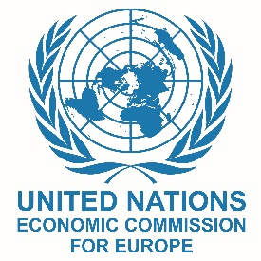 | 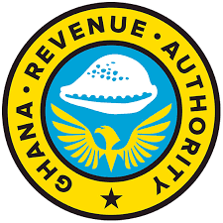

Day 1 |  |  | Day 2
9:00 - 10:30 | 1 | Welcome & Opening  (GRA, UNECE, West Blue)  Trade Facilitation Principles and Benefits  (Tom Butterly - TDAF) | 5 | The Supply Chain Perspective  UN/CEFACT Buy/Ship/Pay Model  (Tom Butterly – TDAF,  Ed Broekema – Ex Dutch Customs)
11:00 - 12:30 | 2 | The Generic Approach to TF  (Julian Fraga-Campos - UNECE)  Creating a Trusted Partnership for TF  (Julian Fraga-Campos - UNECE) | 6 | TF Instruments & Organizations  (Julian Fraga-Campos - UNECE)  (Ed Broekema – Ex Dutch Customs)
13:30 – 15:00 | 3 | Why TF in the WTO?  (Tom Butterly - TDAF)  The Role of the National  Trade Facilitation Committee  (Julian Fraga-Campos - UNECE) | 7 | Single Window Concept  and Implementation  (Valentina Mintah – West Blue  Aminu Aluwatoni – West Blue)
15:30 – 17:00 | 4 | Reducing Delays at Border Crossings  (Implementing smart and efficient border management solutions)  (Ed Broekema – Ex Dutch Customs) | 8 | Workshop Wrap-up and Evaluation  (Tom Butterly – TDAF)  Award of Certificates and  Closing Remarks  (GRA, UNECE, West Blue)

This workshop is sponsored by West Blue Consulting under
The Ghana National Single Window Programme

