Trade Facilitation Implementation Guide (TFIG)  Training Workshop | Executive Level  One Day Training  23 Sept 2016  At  Alisa Hotel,  Accra, Ghana | 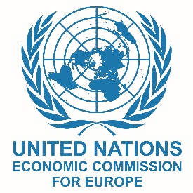 | 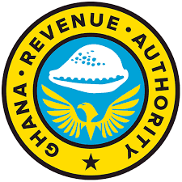

09:00 - 10:15 | 1 | Welcome & Opening  (GRA, UNECE, West Blue)  Trade Facilitation Principles and Benefits  (Julian Fraga-Campos - UNECE)
10:30 – 11:30 | 2 | Why TF in the WTO?  (Tom Butterly - TDAF)
11:30 – 12:30 | 3 | Reducing Delays at Border Crossings  (Implementing smart and efficient border management solutions)  (Ed Broekema – Ex Dutch Customs)
13:30 – 14:30 | 4 | The Supply Chain Perspective  (Tom Butterly – TDAF  and Ed Broekema – Ex Dutch Customs)
14:30 – 15:30 | 5 | Trade Facilitation Instruments and Organizations  (Julian Fraga-Campos – UNECE  and Ed Broekema – Ex Dutch Customs)
15:45 – 16:15 | 6 | Single Window Concept  and Implementation  (Valentina Mintah – West Blue  Aminu Aluwatoni – West Blue)
16:15 – 17:00 | 7 | Workshop Wrap-up and Evaluation  Award of Certificates and  Closing Remarks  (GRA, UNECE, West Blue)

This workshop is sponsored by West Blue Consulting under
The Ghana National Single Window Programme

