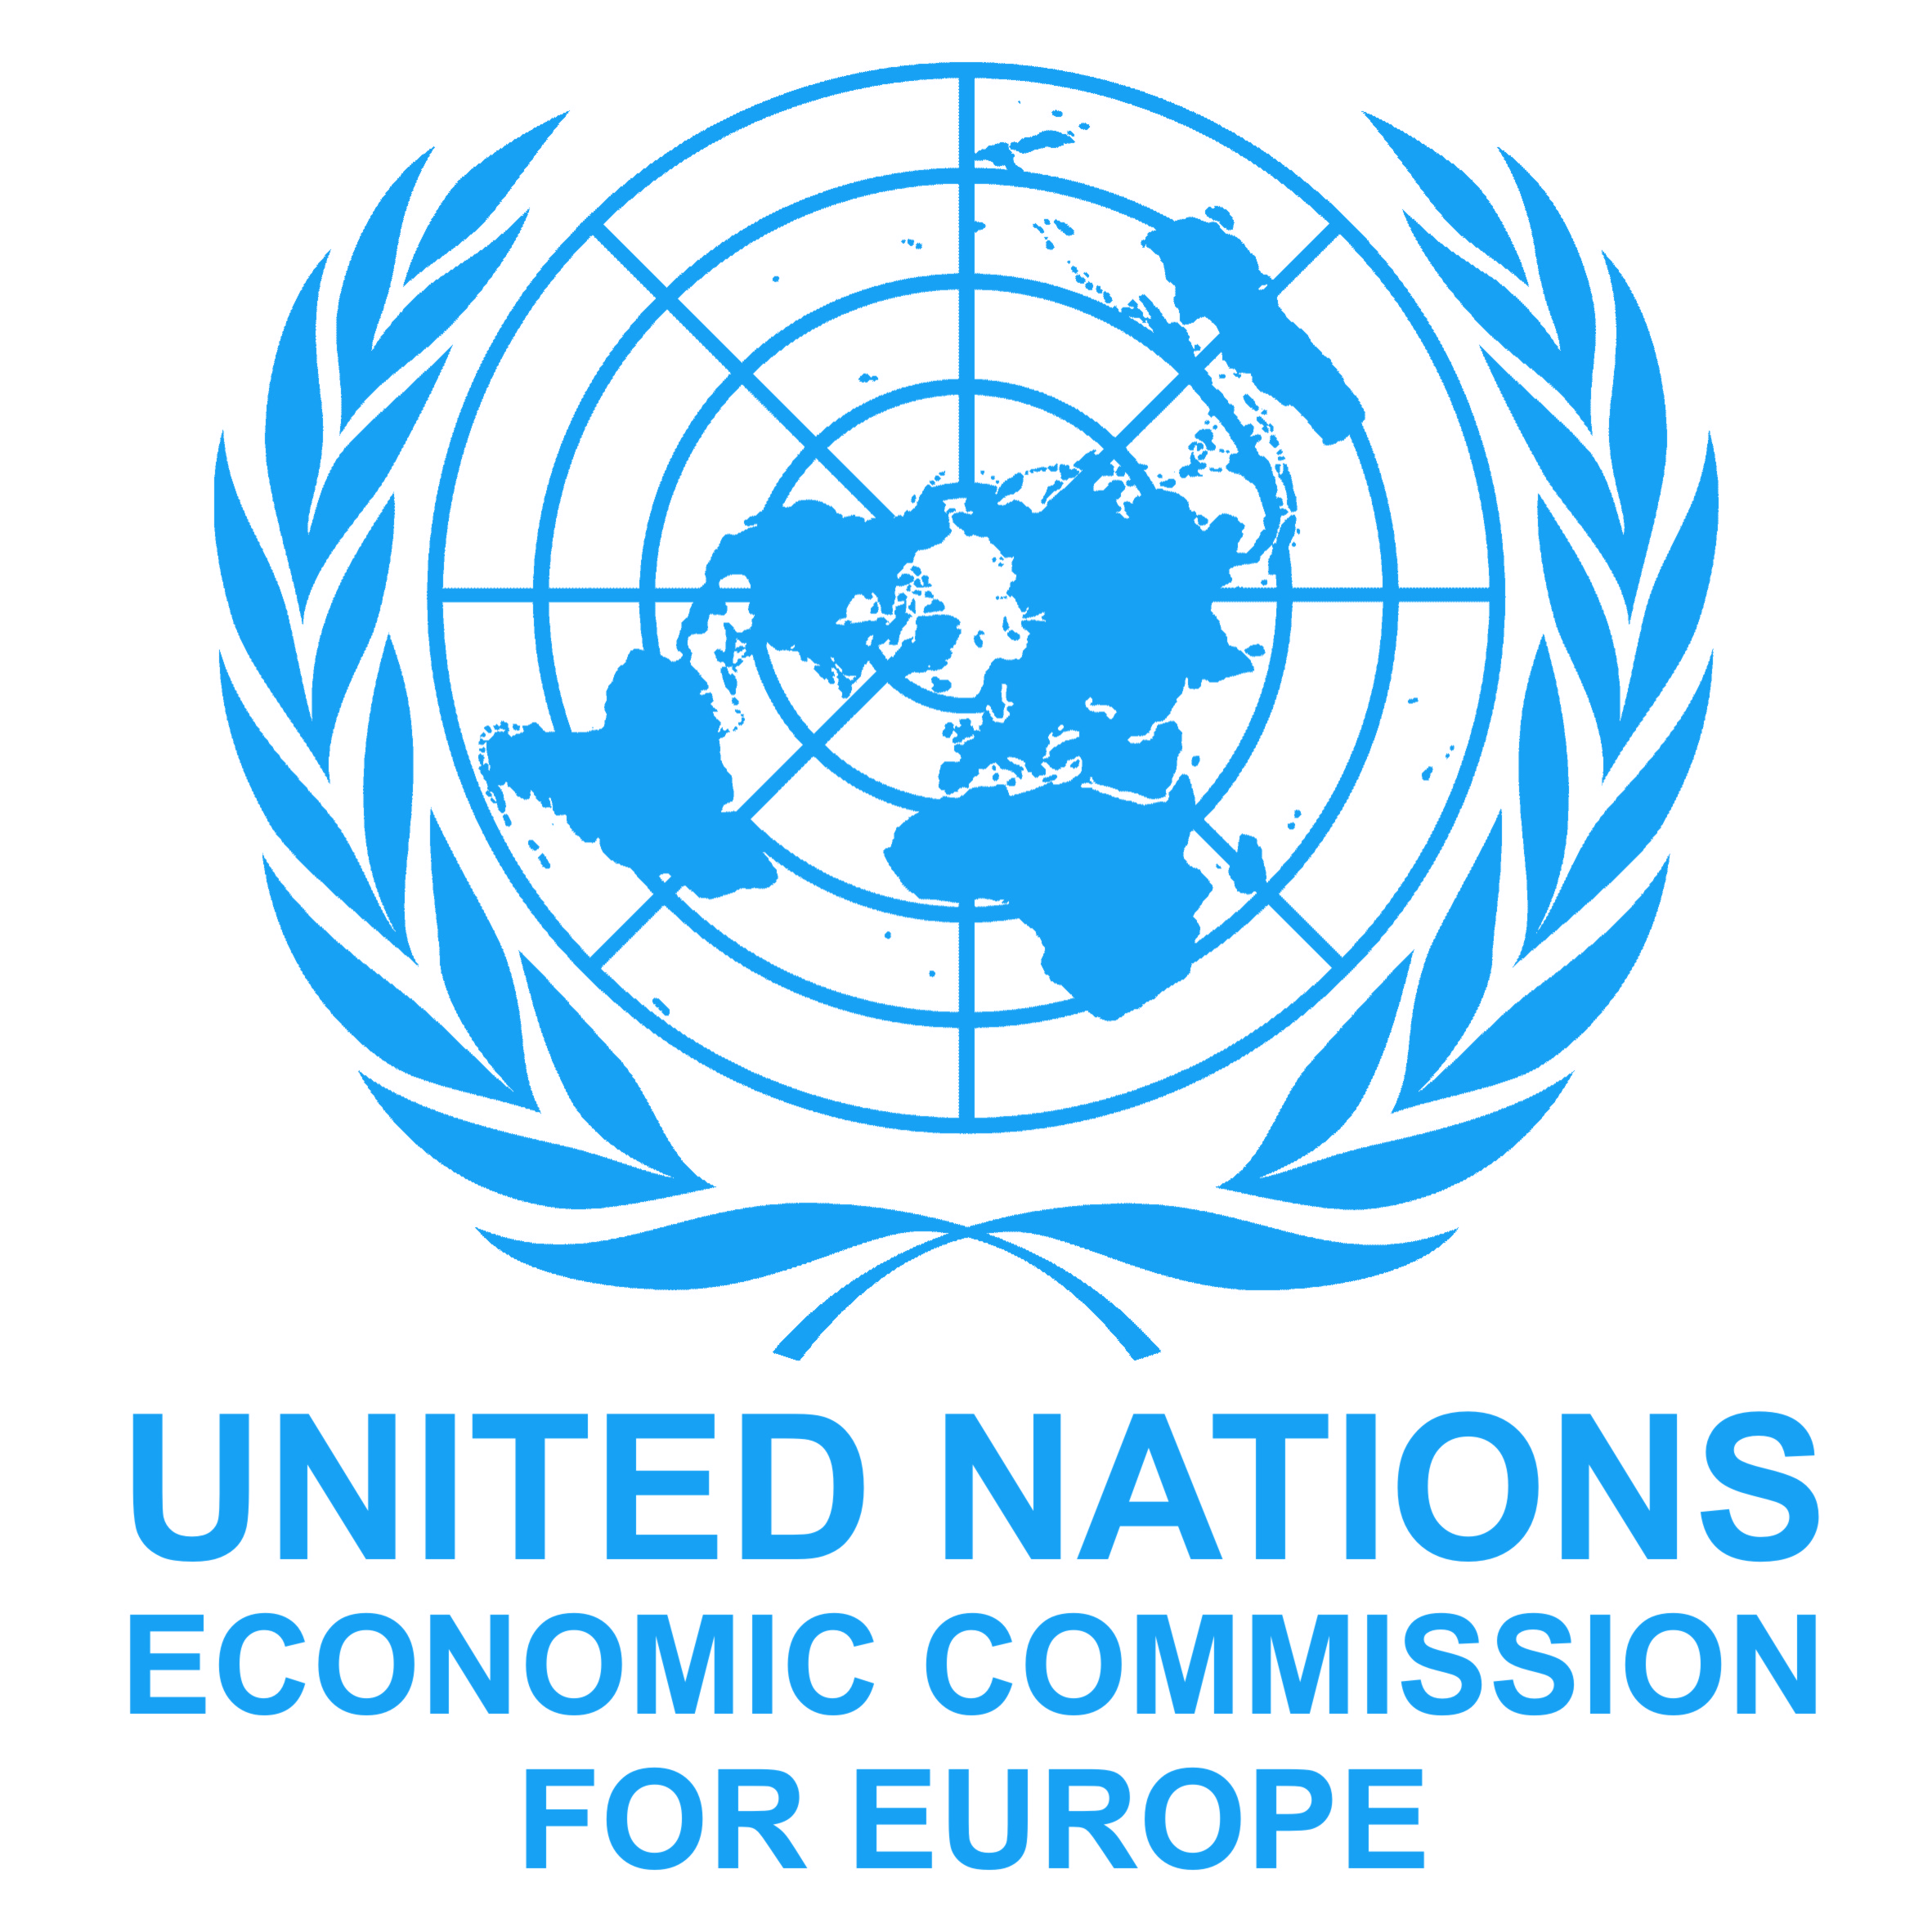
Trade Facilitation Implementation Guide (TFIG)
Training Workshop

Language of the workshop: Russian, English
Venue: … Kiev, Ukraine: 27/08/2014

Time | Wednesday  27.08.2014
9:00 -10:00 | 1 | Welcome & Opening  Mario Apostolov (UNECE)  Ministry of Economy of Ukraine  Interagency Working Group  Structure of seminar “Trade Facilitation Implementation Guide”  Mario Apostolov (UNECE)
Coffee Break
10:15 - 12:30 | 2 | Itineraries: TF Domains, Instruments & Organizations  WTO Agreement on TF  Birgit Viohl (Consultant)  Discussion
Lunch Break
13:30 – 15:00 | 3 | Itineraries: Creating a Trusted Partnerships / National trade facilitation bodies  Birgit Viohl (Consultant)
Coffee Break
15:30 – 17:00 | 4 | Itineraries: Single Window Implementation, reducing delays at border-crossings; development a Trade Facilitation Strategy  Mario Apostolov (UNECE)  Discussion  Workshop Evaluation & Closure

