Codification system

Edition 2013

Codification system

**1. Purpose of the GS1 System**

The GS1 System is widely used internationally to enhance communication between buyers and sellers and third-party conformity assessment entities. It is an identification and communication system standardized for use across international borders. It is managed by GS1 Global Office, together with national GS1 Member Organizations around the world.

The system is designed to overcome the limitations of using company, industry or country-specific coding systems and to make trading more efficient and responsive to trading partners. The use of the GS1 standards improves the efficiency and accuracy of international trade and product distribution by unambiguously identifying trade items, services, parties, and locations. GS1 identification numbers can be encoded in data carriers (e.g. bar code symbols or EPC (Electronic Product Code)/RFID (Radio Frequency Identification) tags) to identify, capture, share transactional data concerning products whenever required in the trading process.

GS1 standards are used in eCommerce messaging such as Electronic Data Interchange (EDI) and the GS1 Global Data Synchronization Network (GDSN) for data alignment. Trading partners use EDI to electronically exchange messages regarding the purchase and shipping status of product lots. Trading partners use GDSN to synchronize trade-item and party information in their back-end information systems. This synchronization enables consistent global product identification and classification, a critical step towards efficient global electronic commerce.

In addition to the efficiency gains from the use of barcodes, EPC/RFID tags, EDI and GDSN there is the added benefit of enhanced traceability of products along the supply chain. In effect it is possible to create real time visibility of product batches which means that a product recall/withdrawal can be more timely, efficient and effective. This improved visibility/traceability comes at no additional cost because it is a by-product of the efficient communication of transactions between trading partners.

GS1 also provides the Global Traceability and Product Recall Standards and the GS1 Fresh Foods solution based on the use of GS1 DataBar. GS1 DataBar enables variable data (batch, expiry) for a pre-packed meat product to be available at the point of sale systems. This facilitates better management of fresh meats in terms of waste reduction through expiry date management, efficient and effective batch recall. Retailers see the availability of GS1 DataBar at consumer pack level as part of the solution to creating a more sustainable meat supply chain.

Diagram 1: The GS1 System

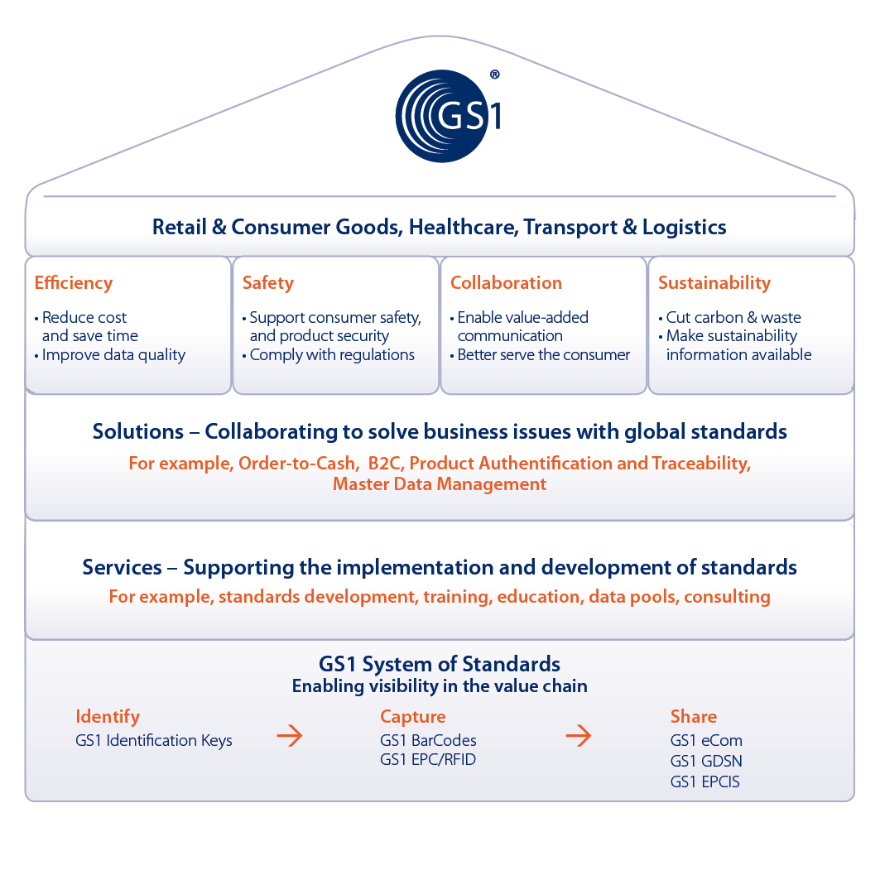

**2. Use of the UNECE code in the GS1 System**

GS1 uses Application Identifiers as prefixes to identify the meaning and format of the data that follow it. It is an open standard, which can be used and understood by all companies in the national and international supply chain, regardless of the company that originally issued the codes.

The UNECE Meat Carcasses and Cuts Classification defined in section 4.1 has been assigned the GS1 Application Identifier **(7002)** to be used in conjunction with a Global Trade Item Number (GTIN) and represented in the GS1-128 Bar Code Symbology. This allows the UNECE code information to be included in GS1-128 Bar Code Symbols on shipping containers along with other product information (see examples 1 and 2).

The UNECE Meat Carcasses and Cuts Classification is also being proposed for use by suppliers as an attribute of the GDSN Global Product Classification system. In this way, suppliers can use the UNECE meat-cut code to globally specify the cut of each product GTIN in the GDSN. Once defined by the supplier, all interested buyers will know the exact UNECE cut of each product published to them via the GDSN (see example 3).

**Example 1:**





(01) Global trade item number (GTIN)

(3102) Net weight, kilograms

(15) Use-by date

(7002) UNECE purchase specification code

(10) Batch number

**Example 2:**



(01) Global Trade Item Number (GTIN)

(3102) Net weight, kilograms

(13) Slaughter/packing date

(21) Serial number

Other data, such as the UNECE code, refrigeration, grade and fat depth can be linked to the GTIN via Electronic Data Interchange (EDI) messages.

**3. Application of the system in the supply chain**

(1) Customers order, using the UNECE Standard and the coding scheme.



(7002)44932211340000145100

(2) On receipt of the order, the suppliers translate the UNECE codes into their own trade item codes (i.e. Global Trade Item Number).

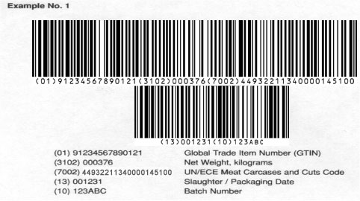

(3) Suppliers deliver the order to the customers. The goods are marked with the GS1-128 bar code symbol.







(4) Customers receive the order and the GS1-128 bar code symbol scanned, thus allowing for the automatic update of commercial, logistics and administrative processes.



(5) The physical flow of goods, marked with GS1 standards, may be linked to the information flow using Electronic Data Interchange (EDI) messages.

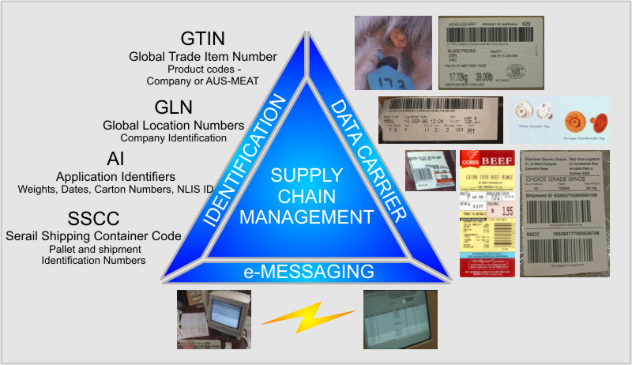

**Example 3**

**4. Use of UNECE meat-cut definitions in the GDSN**

(1) Suppliers publish or update information about a product in the GDSN and use the appropriate UNECE meat-cut definition to define the meat cut of the product using the Global Product Classification (GPC) Meat Cut attribute.

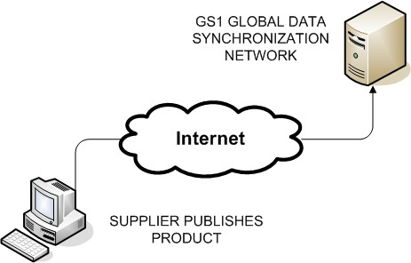

(2) Interested buyers use the UNECE meat-cut and other product information published to them via the GDSN to synchronize product information in their own information systems.

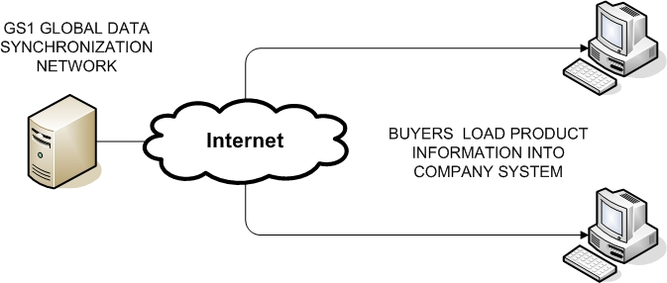

(3) Buyers use UNECE meat-cut information in their information systems to identify by GTIN which products they wish to order.

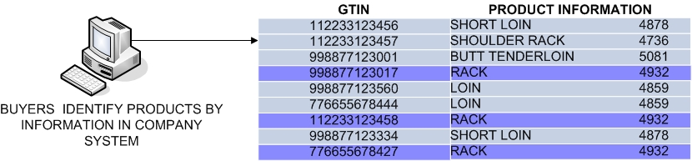

(4) Buyers use product GTIN and related information to order product from supplier using EDI.

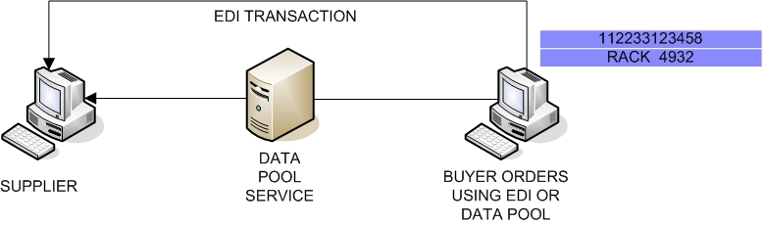

**5. Use of GS1 Visibility Network to improve visibility and traceability of meat products**

The GS1 Supply Chain Visibility Network uses the EPCIS (the Electronic Product Code Information Service) to manage the event data of a product shipment as it moves along the supply chain. The EPCIS can therefore provide answers to questions such as what, where, when and why. The benefits of visibility lie in the value of real time information about shipments and the resulting business processes improvements. In the meat industry, visibility can help provide traceability from the producer all the way to retail store or food service provider. This allows producers and the industry to 1.) meet quality and regulatory requirements, 2.) manage recall more effectively 3.) provide accurate information to consumers on the origin of the product, thereby improving consumer safety as well as enhancing efficiency.

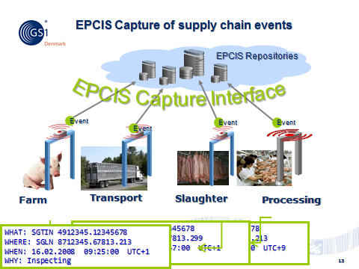

**6. GS1 DataBar its use in improving the management of fresh meats at consumer pack level**

Because GS1 Databar can provide variable data (such as best before and use by dates and batch/lot) information at consumer pack level for meat products this enables retailer point of sale systems to prevent the sale of expired/or recalled products. In addition it enables a more sustainable meat supply chain by reducing waste by encouraging consumers to purchase short shelf life produce at a discount.