UNITED  NATIONS |  | E
 | Economic and Social  Council | Distr.  GENERAL  ECE/TRADE/C/WP.7/2007/2  21 September 2007  ENGLISH  Original: ENGLISH, FRENCH and RUSSIAN

ECONOMIC COMMISSION FOR EUROPE

COMMITTEE ON TRADE

Working Party on Agricultural Quality Standards

Sixty-third session
Geneva, 5-9 November 2007
Item 3 of the provisional agenda

UNECE STANDARD FOR SEED POTATOES

Note by the secretariat

This text is submitted to the Working Party for approval as a revised Standard for Seed Potatoes.

It is based on documents ECE/TRADE/C/WP.7/2006/8 and ECE/TRADE/C/WP.7/GE.6/2007/8. The text was agreed upon at the March 2007 session of the Specialized Section on Standardization of Seed Potatoes.

GE.07-25862
CONTENTS
Page
Introduction………………………………………………………………………… 3

I. DEFINITION OF PRODUCE ………………………………………………………… 8
II. PROVISIONS CONCERNING THE VARIETY………………………………… 8
III. PROVISIONS CONCERNING QUALITY……………………………………… 8
A. Minimum requirements…………………………………………………… 8
B. Classification……………………………………………………………… 9
1. Pre-basic category seed…………………………………………… 9
2. Basic category seed……………………………………………….. 9
3. Certified category seed……………………………………………. 10
4. Field generation…………………………………………………… 10
C. Derogation from classification……………………………………………. 10
D. Sampling………………………………………………………………….. 10
E. Comparative trials………………………………………………………… 10
IV. PROVISIONS CONCERNING SIZING…………………………………………. 10
V. PROVISIONS CONCERNING TOLERANCES FOR SIZING…………………. 11
VI. PROVISIONS CONCERNING PRESENTATION……………………………… 11
VII. PROVISIONS CONCERNING MARKING…………………………………….. 11

Annexes

I. Minimum conditions to be satisfied in the production of
Pre-basic TC seed potatoes………………………………………………………. 13
II. Minimum conditions to be satisfied by the crop…………………………………. 14
III. Minimum quality conditions for lots of seed potatoes…………………………… 16
IV. Minimum conditions to be satisfied by direct progeny of seed potatoes………… 18
V. Label……………………………………………………………………………… 19
VI. Guidelines for organizing comparative trials of crops grown from samples
collected from lots of seed potatoes (certified according to the Standard)………. 20
VII. Definitions of terms applicable to the Standard………………………………….. 21
VIII. Assessment key for percentage tuber surface area coverage
of blemish diseases……………………………………………………………….. 24
IX. Sampling tubers for virus testing…………………………………………………. 26
X. UNECE Standard for Seed Potatoes (Summary table of tolerances)…………….. 31
INTRODUCTION

1. About UNECE

The United Nations Economic Commission for Europe (UNECE) was set up in 1947 by Economic and Social Council. It is one of five regional commissions of the United Nations.

Its primary goal is to encourage greater economic cooperation among its 56 member States. However, all interested United Nations Member States may participate in its work. Over 70 international professional organizations and other non-governmental organizations take part in UNECE activities.

It focuses on economic cooperation and integration, environment, housing and land management, statistics, sustainable energy, trade, timber and transport.

UNECE activities include policy analysis, development of conventions, regulations and standards, and technical assistance.

The UNECE secretariat can be contacted at:

UNECE Trade and Timber Division Phone: +41 22 917 1366
Agricultural Standards Unit Fax: +41 22 917 0629
Palais des Nations Email: agristandards@unece.org
Room 432 Homepage: http://www.unece.org/trade/agr/
1211 Geneva 10
Switzerland

2. History and goals of the Working Party on Agricultural Quality Standards

2.1 History

In October 1949, the UNECE Committee on Agricultural Problems established the Working Party on Standardization of Perishable Foodstuffs to determine common standards for perishable foodstuffs "and to study steps to be taken on the international level in order to secure the general adoption of standards and control systems". Later, the responsibility of the Working Party was extended to cover non-edible horticultural produce and quality development, which is reflected in its present name.

The activities have led to the elaboration of a wide range of UNECE standards for fresh fruit and vegetables, dry and dried produce, seed potatoes, eggs and egg products, meat and cut flowers. Standards for fruit juices and quick frozen foods have been elaborated in Joint ECE/Codex Alimentarius Groups of Experts and are now further developed in the relevant Codex bodies.

2.2 Goals

UNECE standards harmonize existing national commercial quality standards for perishable produce to:

- Facilitate fair international trade and prevent technical barriers to trade;
- Improve producers' profitability and encourage production of high-quality produce;
- Protect consumer interests.

The UNECE Working Party and its four Specialized Sections provide a forum where countries can discuss all issues relating to commercial quality that may arise in their domestic markets and have implications for international trade. The Working Party offers assistance to countries in transition by organizing workshops on the harmonization of national with international commercial standards.

3. History, goals and scope of the UNECE standard for seed potatoes

3.1 History

Work on the UNECE Standard for Seed Potatoes (hereinafter “the Standard”) began in 1958.

At the 9th session of the Working Party some disagreements were raised concerning the nomenclature of the different categories of seed potatoes. The Group of Experts (from the Federal Republic of Germany, the Netherlands and the United Kingdom of Great Britain and Northern Ireland) was charged of preparing an analysis of existing national regulations and drafting recommendations for international standardization.

Provisional recommendations were adopted in 1960 at the 10th session of the Working Party for trial and revision according to the resulting experience.

The first version of the text was adopted by the Working Party in 1963 at its 16th session. The Standard has been regularly updated since then.

3.2 Goals and scope

The goal of the Standard is to act as a world reference intended to facilitate fair international trade by:

- Creating a harmonized certification system
- Promoting its use
- Defining harmonized quality requirements for seed potatoes.

To reach this goal the Standard covers the following requirements controlled by certification:

- Varietal identity and purity
- Genealogy and traceability
- Diseases and pests
- External quality and physiology
- Sizing and labelling.

As a consequence, the Standard considers issues falling under the WTO-TBT agreement as well as under the WTO-SPS agreement.

4. Application of the Standard

4.1 The Standard adopted by the Working Party is recommended to countries for application as defined below.

4.2 Countries applying this Standard should notify the UNECE secretariat of their Designated Authority (DA) responsible for its implementation.

4.3 Application means the use of the UNECE Standard for export and import. This means for

Export: All seed potatoes certified and labelled for export by the DA meet at least the requirements of the Standard.

Import: Seed potatoes certified and labelled according to the UNECE Standard are accepted for import by the DA for parameters covered by the Standard, except where additional or more stringent requirements are applied by the country in respect to diseases and pests, if:

- The same requirement is applied to domestic production, AND
- These requirements are justified to prevent introduction or spread of these diseases and pests which do not exist there or which seem particularly injurious to the crops in that country or in any part of its territory.

4.4 The responsibility of the DA is to ensure the application of the provisions and conditions as specified in the Standard. The responsibility for the quality of the lot remains with the owner.

4.5 The DA shall notify the UNECE secretariat of each additional or more stringent requirement, together with technical or scientific justification for it.

4.6 The application of the Standard is without prejudice of any other legislation concerning industrial or commercial property, protection of crops, and the health of persons and animals.

5. Development of the Standard

For the development of the Standard and the work of the Specialized Section on Seed Potatoes, the Working Procedures of the Working Party on Agricultural Quality Standards and its Specialized Sections apply and can be obtained from the UNECE secretariat. According to these procedures, all United Nations Member States can participate with the same rights.

6. Cooperation with other international organisations

6.1 European Union

In July 1966, the Council of the European Union adopted a Council Directive on the marketing of seed potatoes, applicable to the production with a view to marketing, and to the marketing of seed potatoes within the Community (Directive 2002/56/EC-OJ L 193, 20.07.2002 former 66/403/EEC).

It was stated in the proceedings that "It is desirable to establish a uniform certification scheme for the Community based on the experience gained in the application of schemes in the Member States and that of the Economic Commission for Europe".

The above Directive envisaged that provisions should be made for authorizing the marketing within the Community of seed potatoes harvested in a third country where they afford the same assurances as seed potatoes officially certified within the Community and complying with the Community rules. The last Council Decision (Council Decision 95/513/EC, 0J L 296, 9.12.1995, p. 31) on the equivalence of seed potatoes produced in third countries established that seed potatoes harvested in those countries, as specified and officially controlled by the relevant Authorities, and which belong to the categories specified therein, are equivalent to seed potatoes harvested within the Community. Seed potatoes shall be certified and their containers officially marked and sealed in accordance with the UNECE Standard for Seed Potatoes recommended by the Working Party on Standardization of Perishable Produce and Quality Development of the UNECE. The Decision does not affect the requirements which Member States establish under Council Directive 2000/29/EC (former 77/93/EEC) on protective measures against the introduction into the Member States of organisms harmful to plants or plant products (0J L 169, 10.7.2000, p.1).

6.2 International Plant Protection Convention

The purpose of the International Plant Protection Convention (IPPC) is to secure a common and effective action to prevent the spread and introduction of pests of plants and plant products, and to promote appropriate measures for their control.

The Convention extends to the protection of natural flora. It also includes both direct and indirect damage by pests, thus including weeds. The provisions extend to cover vehicles, containers, storage places, soil and other objects or material capable of harbouring plant pests.

National Plant Protection Organizations (NPPOs) and Regional Plant Protection Organizations (RPPOs) such as the European and Mediterranean Plant Protection Organization (EPPO) (see 6.2.1) and the North American Plant Protection Organization (NAPPO) (see 6.2.2) work together to help contracting parties meet their IPPC obligations. Legal texts are available (1952, 1979 and 1997).

This treaty is managed by the IPPC Secretariat in the FAO Plant Protection Service and is recognized by the WTO-SPS agreement as the standard-setting body on phytosanitary issues.

It is in this context that the phytosanitary certificates are issued. These, in the case of seed potatoes, facilitate international trade, by confirming compliance with the phytosanitary requirements of the importing country.

6.2.1 European and Mediterranean Plant Protection Organization

In 1999, EPPO published a recommended certification scheme for seed potatoes. This scheme focused on micropropagation as the recommended method of initial seed production (nuclear stock) and detailed the organisms, which should be tested for and the appropriate test procedures. Conditions and tolerances for the production of Pre-basic TC (mini-tubers) were also defined. The requirements for the certification of Pre-basic, Basic and Certified category seed potatoes were aligned, as far as possible, with those of the UNECE Standard for Seed Potatoes.

6.2.2 North American Plant Protection Organization

In 1995, NAPPO approved a potato standard: NAPPO Regional Standard for Phytosanitary Measures (RSPM#3), "Requirements for the importation of potatoes into a NAPPO member country”.

The standard identifies a number of pest risk management measures, including federal or state/provincial seed potato certification systems. Also, it established common criteria for limited generation certification systems and diagnostics. It includes lists of quarantine pests for the three NAPPO countries. The pest lists in the standard are reviewed on an annual basis to verify the technical justifications for these pests to remain on quarantine lists and to incorporate new terminology from the IPPC, e.g. regulated non-quarantine pests. The NAPPO standard does not deal with so-called quality pests because they are outside the mandate of the IPPC.

The revised standard will also include an appendix describing Potato virus Y, N strain (PVYn) diagnostics. The next step will be to harmonize protocols among the three countries for nematode identification.

7. Editorial note on this edition

This edition of the Standard includes the following new items/changes:

- Reference to the UNECE Standard on the label of seed potato packages (annex V);
- Revision of the Guidelines for organizing comparative trials of plots (annex VI).
UNECE STANDARD S-1
concerning the certification and
commercial quality control of

SEED POTATOES

I. DEFINITION OF PRODUCE

Seed potatoes are tubers or any other propagation material, other than true seed, of Solanum tuberosum L. acceptable for certification by the DA in accordance with the provisions concerning the variety (see Section II) and which, after regular inspection

1. During growth
2. At sorting
3. During verification inspection

are certified by an officially approved body as suitable for reproduction.

This Standard does not apply to seed potatoes

1. Intended for trials or scientific purposes
2. Intended for selection work.

These, however, shall always be covered by documentary confirmation of quality by the DA.

II. PROVISIONS CONCERNING THE VARIETY

Varieties shall be accepted into the Standard only if an official description and a reference sample are available from the DA.

The variety should be distinct, uniform and stable according to the guidelines of the International Union for the Protection of New Varieties of Plants (UPOV) and have a denomination allowing its identification.

III. PROVISIONS CONCERNING QUALITY

The purpose of the Standard is to define the quality requirements of seed potatoes at the export control point, after preparation and packaging.

A. Minimum requirements

Seed potatoes shall be substantially free from injurious diseases and pests and from any defects likely to impair their quality as seed. They shall be substantially dry outside and, in general, of normal shape for the variety.

These requirements shall be observed in conjunction with the standards and tolerances set out under B on Classification.

Neither growing crops of seed potatoes nor seed potatoes shall be treated with sprout inhibitors.

B. Classification

Seed potatoes shall be classified according to variety and the standards given below. Their classification shall be subject to official control in the producing country. The DA is responsible for the maintenance of all classification data to provide traceability. Seed potatoes shall be placed in two classes within each of three categories as defined below:

1. Pre-basic category seed

These are seed potatoes of generations prior to basic seed.

(a) Pre-basic TC (tissue culture) class seed shall be directly derived by micropropagation and may be tissue culture plantlets or tubers of the first generation meeting the requirements specified in annexes I, II, III and IV.

(b) Pre-basic class seed shall be generations of seed multiplied in the field prior to Basic seed, meeting the requirements specified in annexes II, III and IV.

2. Basic category seed

These are seed potatoes descended directly from Pre-basic or Basic category seed or produced under the special provisions of a national certification scheme and are mainly intended for the production of certified seed potatoes.

Seed shall be classified as either Basic I or Basic II, according to the minimum requirements given in Annexes II, III and IV.

3. Certified category seed

These are seed potatoes descended directly from Pre-basic, Basic or Certified category seed and are mainly intended for the production of potatoes other than seed potatoes.

Seed shall be classified as either Certified I or Certified II, according to the minimum requirements given in Annexes II, III and IV.

4. Field generation

Each class may be additionally classified according to the number of generations (FG1, FG2 etc.). The final designation of a class will therefore contain a class name and may contain a field generation record (e.g. Basic I FG3, Certified I FG3).
C. Derogation from classification

Producing countries are, however, free to create within the categories and classes provided for in subsection B, classes which are subject to specific requirements.

D. Sampling

Sampling of seed potatoes for certification purposes shall be carried out officially or under official supervision. To assess compliance with Annex III, tuber samples, representative of the lot, shall be taken at a minimum rate of 20 kg for each 10 000 kg and may be collected either during grading or from at least two containers. More samples may be taken if one of the initial samples is close to tolerance.

E. Comparative trials

It is recommended that comparative trials be established by the DA to ascertain the condition of seed potatoes certified according to the Standard, taking into account statistical variability outlined in annex IX. The guidelines for organizing such trials, set out in annex VI, should be followed.

The results of such trials shall be treated in confidence, but on request the results relating to individual consignments may be exchanged between the DA of the importing and exporting countries concerned.

IV. PROVISIONS CONCERNING SIZING

Pre-basic TC are exempt from the minimum sizing requirements.

The minimum size of tubers must be such that they do not pass through a square gauge of 25 mm; for varieties having, on average, a length of at least twice the greatest width, the square gauge must not be less than 25 mm. In the case of tubers, which are too large to pass through a square gauge of 35 mm, the difference between the maximum and minimum limits of size should be expressed in multiples of five.

The maximum variation in size between tubers in a lot must be such that the difference between the dimensions of the two square gauges used does not exceed 20 mm unless the buyer and seller agree to deviate from this requirement.

The lot shall conform to the distribution of tuber sizes of the harvested crop within the size specified on the label.

V. PROVISIONS CONCERNING TOLERANCES FOR SIZING

Minimum size tolerances in per cent by weight of tubers
10% | With a maximum deviation of 5 mm from the minimum size indicated for lots with tubers having a length of at least twice their maximum width
3% | For all other lots
Maximum size tolerances in per cent by weight of tubers
3% | Larger than the maximum size indicated

VI. PROVISIONS CONCERNING PRESENTATION

A. Condition of containers

Bags must be new; other containers may be reused provided that they are clean.

B. Closing of containers

Containers shall be closed officially or under official control in such a manner that they cannot be opened without damaging the official sealing device or without leaving evidence of tampering on the official label provided for in section VII (A).
The official system of closing shall comprise either the incorporation into the system of the label mentioned above if it is without a string-hole, or, in all other cases, by the application of an official seal.

Re-closing shall be carried out only by the DA or under its control.

C. Nature of contents of containers

Each container shall contain tubers of the same variety, category, class, size and origin.

A lot should be sufficiently homogeneous which means that seed potatoes within different containers are as uniform as is practical and will not vary excessively in composition and appearance.

VII. PROVISIONS CONCERNING MARKING

A. Official label

Each container shall bear on the outside an official label in accordance with annex V and which has not been previously used; the label shall be white with a diagonal purple line for pre-basic seed, white for basic seed, and blue for certified seed. Reference to the UNECE Standard may be included on the label.

B. Official statement

Each container shall have on the inside an official statement of the same colour and showing at least the particulars indicated under 3, 5 and 7 in annex V. The statement shall be so worded that any confusion with the official label referred to in paragraph A shall be avoided.

This statement is not necessary when an adhesive label or a label of untearable material is used. The particulars given on the label may be indelibly printed on each container in substitution for the official statement provided for above.

C. Re-labelling

If a second check appears necessary, the authority, which carried out the second check, must be stated on the label, as well as the date of the re-closing. If a new label is necessary, this must show the particulars, which appeared on the old label, the date of the re-closing, and the authority concerned.

D. Supplier's label

Each container may be accompanied by a special label of the supplier.

E. Chemical treatment

The nature of the active substance of any chemical treatment of the seed potatoes shall be indicated on the outside of each container, on a tear-resistant or adhesive label being either the official label or a label provided by the supplier, or printed on each container. This information may also appear inside each container.

Adopted 1963, also as European Standard No. 19
Last revised 2007
ANNEXES

Annex I. Minimum conditions to be satisfied in the production of Pre-basic TC seed potatoes

1. The parent material must be true to type for the variety.

2. These seed potatoes must be produced from officially certified initial stock, which shall be free from, at least, the following pests:

Potato Spindle Tuber Viroid
Clavibacter michiganensis spp. sepedonicus (ring rot)
Ralstonia solanacearum (brown rot)
Pectobacterium spp. and Dickeya spp. (syn. Erwinia spp.)
Potato viruses X, Y, S, M and A
Potato Leaf Roll Virus

3. The facilities and procedures used for this production must be subject to official approval by the DA. Measures must be applied to avoid contamination, e.g. protected environment, double door entry, protective clothing, dedicated footwear or disinfection. The record-keeping system should document the source of the material and the volume of production.

4. The growing medium should be pest-free.

5. All reasonable husbandry practices for the prevention or spread of pests and diseases must have been effectively carried out.

6. The growing crop must have been kept free from Synchytrum endobioticum (Schilb) Prc., potato viruses, bacterial diseases and from deviations of variety and type.

The satisfaction of these conditions and the tolerances prescribed for this class in annexes II, III and IV shall be established by official inspection and/or testing.

The satisfaction of the conditions under item 2 shall be established by appropriate tests for those pathogens known to occur in the country.

Confirmation of variety purity or trueness-to-type may be dependent on inspection of the crop derived from the seed potatoes.

Annex II. Minimum conditions to be satisfied by the crop

1. The field shall not be contaminated by Globodera rostochiensis (Woll) nor Globodera pallida (Stone).

2. The proportion of growing plants affected by blackleg shall not exceed:

(a) In crop for the production of Pre-basic category seed, 0 per cent;
(b) In crop for the production of Basic I class seed, 0.5 per cent and of Basic II class seed, 1 per cent;
(c) In crop for the production of Certified I class seed, 1.5 per cent and of Certified II class seed, 2 per cent.

3. The proportion of growing plants showing symptoms of virus diseases shall not exceed:

- In crop for production of Pre-basic TC class seed, 0 per cent;
- In crop for production of Pre-basic class seed, 0.1 per cent;
- In crop for production of Basic I class seed, 0.4 per cent, with no more than 0.2 per cent of plants showing severe virus disease;
- In crop for production of Basic II class seed, 0.8 per cent, with no more than 0.4 per cent of plants showing severe virus disease;
- In crop for production of Certified I class seed, 2 per cent, with no more than 1 per cent of plants showing severe virus disease;
- In crop for production of Certified II class seed, 10 per cent virus disease, with no more than 2 per cent of plants showing severe virus disease.

4. The proportion of growing plants not true to the variety and plants of another variety should not exceed:

- In crop for production of Pre-basic TC class seed, 0 per cent;
- In crop for production of Pre-basic class seed, 0.01 per cent;
- In crop for production of Basic category seed, 0.25 per cent;
- In crop for production of Certified category seed, 0.5 per cent.

5. The crop shall be free from:

(a) Synchytrium endobioticum (Schilb) Perc.;
(b) Clavibacter michiganensis Spp. sepedonicus (Spieck. and Kotth.) Skapt. and Burkh.;
(c) Ralstonia solanacearum;
(d) Potato spindle tuber viroid;
(e) Tomato Stolbur.

6. Depending on the circumstances and character of potato production in the country, there may be considered:

(a) Requirements for isolation of the crop;
(b) Without prejudice to the requirements of annex IV, the establishment of tolerances for virus diseases and varietal purity.

7. The satisfaction of the above-mentioned standards or other conditions shall be established by official inspection and/or testing.

8. Depending on the circumstances and character of potato production in the country, a programme of post-harvest testing for virus diseases may be considered.
Annex III. Minimum quality conditions for lots of seed potatoes

A. Tolerances for defects and diseases allowed for seed potato tubers

1. Presence of earth and extraneous matter

- Pre-basic TC 1 per cent by weight
- Pre-basic 1 per cent by weight
- Basic and Certified 2 per cent by weight

2. Dry and wet rot, where not caused by pests listed under section B below

- Pre-basic TC 0 per cent by weight
- Pre-basic 0.2 per cent by weight
- Basic and Certified l per cent by weight

3. External defects (e.g. misshapen or damaged tubers)

- Pre-basic TC 3 per cent by weight
- Pre-basic 3 per cent by weight
- Basic and Certified 3 per cent by weight

4. Scab caused by Streptomyces spp (common and netted): Tubers affected over a specified per cent of their surface (see annex VIII)

- Pre-basic TC (0% surface cover) 0 per cent by weight
- All other categories (>33.3% surface cover) 5 per cent by weight

5. Powdery scab : Tubers affected over a specified per cent of their surface

- Pre-basic TC (0% surface cover) 0 per cent by weight
- Pre-basic (> 10% surface cover) 1 per cent by weight
- Basic and Certified (> 10% surface cover) 3 per cent by weight

6. Rhizoctonia: Tubers affected over a specified per cent of their surface

- Pre-basic TC (0% surface cover) 0 per cent by weight
- Pre-basic (> 1% surface cover) 1 per cent by weight
- Basic and Certified (> 10% surface cover) 5 per cent by weight

7. Shrivelled tubers: Tubers which have become excessively dehydrated and wrinkled.

- Pre-basic TC 0 per cent by weight
- Pre-basic 0.5 per cent by weight
- Basic and Certified 1 per cent by weight

Total tolerance for items 2 to 7:

- Pre-basic TC 3 per cent by weight
- Pre-basic 5 per cent by weight
- Basic and Certified 6 per cent by weight

B. The seed potatoes shall be free from Globodera rostochiensis (Woll) and Globodera pallida (Stone), Synchytrium endobioticum (Schilb.) Perc., Clavibacter michiganensis Spp. sepedonicus (Spieck. and Kotth.) Skapt. and Burkh., Ralstonia solanacearum (E.F. Smith) E.F. Smith, Potato spindle tuber viroid, Tomato Stolbur and Meloidogyne chitwoodi and fallax and Ditylenchus destructor.

Annex IV. Minimum conditions to be satisfied by direct progeny of seed potatoes

1. Pre-basic seed

(a) The proportion, in direct progeny, of plants of other varieties should be 0 per cent for Pre-basic TC class.

The proportion, in direct progeny, of plants not true to the variety and of other varieties should not exceed 0.01 per cent for Pre-basic class.

- The proportion, in direct progeny, of plants showing symptoms of mild or severe virus diseases should not exceed:

  - 0 per cent for Pre-Basic TC class
  - 0.5 per cent for Pre-Basic class.

2. Basic seed

(a) The proportion, in direct progeny, of plants not true to the variety and of other varieties should not exceed 0.25 per cent.

(b) The proportion, in direct progeny, of plants showing symptoms of virus disease should not exceed 2 per cent, with not more than 1 per cent showing severe virus disease, for Basic I class seed, and 4 per cent, with not more than 2 per cent showing severe virus disease, for Basic II class seed.

3. Certified seed

(a) The proportion, in direct progeny, of plants not true to the variety and of other varieties should not exceed 0.5 per cent.

(b) The proportion, in direct progeny, of plants showing symptoms of virus disease should not exceed 10 per cent, with not more than 5 per cent showing severe virus, for Certified I class seed and 10 per cent showing severe virus for Certified II class seed. Mild mosaic symptoms of discoloration and no leaf deformation should be ignored in categorizing virus for Certified II class seed.

The tolerances allowed under points 1(b), 2(b) and 3 are applicable only where the virus diseases are caused by viruses already prevalent in countries applying the UNECE Standard for Seed Potatoes.

The incidence of the virus in the direct progeny may be determined by inspection and/or testing of tubers or plants derived from a sample of tubers from the crop. Annex IX describes the principles of developing a sampling regime for this purpose.
Annex V. Label

A. Particulars

1. “UNECE Standard”, if appropriate

2. Nature of the contents: "Seed potatoes"

3. The Designated Authority (DA) or its recognized initials

4. Country and/or region of production

5. Reference number of the lot, including where appropriate the producer's identification number

6. Month and year of closing

7. Variety

8. Category and class and, where appropriate, record of field generation

9. Size

10. Declared net weight

B. Minimum dimensions

110 x 67 mm.
Annex VI. Guidelines for organizing comparative trials of plots grown from samples collected from lots of seed potatoes (certified according to the Standard)

I. PURPOSE OF THE COMPARATIVE TRIALS

The examination of seed potatoes in plots enables the assessment of the conditions specified in annex IV for randomly selected seed lots put on the market.

II. ORGANIZATION

1. Responsibility for the sampling

The sampling shall be done under the authority of the DA.

2. Sampling

(a) The lot as defined in annex VII is the unit represented by at least one sample.

(b) A sample consists of 110 tubers, taken at random from the lot.

(c) The sample shall be placed in a sealed sack; its label shall bear the information mentioned in annex V.

3. Trial fields

(a) Planting should be done in plots of 100 plants. The plots should be grouped by variety so as to facilitate comparison.

(b) Fertilization must be moderate, especially N, to facilitate virus expression.

4. Visual examination

To be accurate, the visual examination shall in general be carried out in two stages, with an interval of 10-15 days between them. Laboratory testing may support visual examination. Primary viral infections shall not be taken into consideration.
Annex VII. Definitions of terms applicable to the standards

The definitions provided herein apply specifically to certified seed potatoes moving into international trade under provisions of this Standard and their meaning may therefore differ from their classical meaning.

Incorporation of the terms in this glossary signifies their unique use by countries, which have adopted the Standard.

Blackleg:
Commonly used name of a bacterial disease of potatoes, generally caused by Pectobacterium
atrosepticum (syn. Erwinia carotovora subsp. atroseptica). Similar symptoms may, however, be caused by Pectobacterium carotovorum (syn. E. carotovora subsp. carotovora) and Dickeya spp. (syn. E. chrysanthemi).

Certification:
An official control procedure, which aims at ensuring the production and supply of seed potatoes which satisfy the requirements of this Standard.

Consignment:
A quantity of seed potatoes consisting of one or more lots which have been consigned to one commercial party and is covered by one set of documents.

Contaminated field:
A field made subject to regulatory action because of the presence of a designated pathogenic organism in the soil.

Designated Authority (DA):
Organization(s), agency or agencies designated and empowered by legislation to administer the certification of seed potatoes under the Standard.

Disease:
Any disturbance of a plant caused by pathogenic organisms which interferes with its normal structure, function or economic value.

Field:
A defined area of land used for cultivation of seed potatoes.

Free from:
Not present in numbers or quantities that can be detected by the application of appropriate sampling, inspection and testing procedures.

Generation number:
The generation number is defined by the number of growing cycles since the first introduction in the field after micropropagation or selection.

Homogeneous:
Uniform in composition and appearance.
Initial stock:
The initial pathogen-tested microplants produced and maintained under an official control programme.

Inspection:
Visual examination of plants, tubers, container, equipment or facilities by an authorized person, to determine compliance with regulations.

Lot:
A quantity of seed potatoes bearing the same reference number which has been prepared for marketing, and being of the same variety, category, class, size and origin.

Mild virus diseases:
Diseases which manifest themselves only by leaf discolorations or mottle (mild mosaic) and may not be easily discernible by visual inspection. The following viruses are usually the causes of mild virus diseases: PVX or PVS.

Origin:
Officially defined area where a lot of seed potatoes was grown.

Phytosanitary provisions:
Provisions in accordance with the International Plant Protection Convention.

Potato leaf roll disease:
A severe virus disease caused by potato leaf roll virus (PLRV). Plants are usually smaller than healthy plants and sometimes stunted. The top of the plant is paler and the leaves are more erect than usual. Older lower leaves roll upward and become brittle, such that they can be easily broken (metallic rustling) when squeezed gently. Primary infection may cause a slight rolling of the upper leaves, sometimes accompanied by discoloration.

Primary virus infection:
Infection occurring during the current growing season and not arising from the seed tuber.

Quality:
The sum of all characteristics that determine the acceptance of seed potatoes in relation to the specifications of this Standard.

Quality Control:
The control by the DA of all activities encountered in the process of producing and marketing seed potatoes in conformance with the Standard.

Quality pest:
A pest carried by planting material, subject to official regulatory control, but not a quarantine pest.

Quarantine pest:
A pest of potential national economic importance to the country thereby endangered and not yet present there, or present but not widely distributed and being actively controlled.

Regulated non-quarantine pest:
A non-quarantine pest whose presence in plants for planting affects the intended use of these plants with an economically unacceptable impact and which is therefore regulated within the territory of the importing part.

Sampling:
The procedure of drawing at random a number of tubers, plants or parts of plants, which may be taken as representative of the lot or the field.

Seed Potatoes:
Tubers which are certified by the DA as meeting specified requirements and as being suitable for reproduction.

Severe Mosaic:
Disease symptom caused by a virus, characterized by discolouration and distortion of foliage, and easily discernible by visual inspection.

Severe virus diseases:
Manifest themselves by deformations of the foliage with or without discolouration. Symptoms can be rugosity, crinkle, rolling and brittleness of the leaves or dwarfing of the plant, as with the severe mosaic or/and the potato leaf roll disease.

The following viruses or virus combinations are usually the origin of severe virus diseases:

PLRV, PVY, PVA or PVM,
PVY + PVX, PVA + PVX or PVX + PVS.

Sprout inhibitor:
A chemical substance, applied either to the plants during the growing season or to the tubers after harvest, which suppresses or prevents the normal development of sprouts.

Substantially free:
Not present in numbers or quantities in excess of those that can be expected to result from and be consistent with normal handling and good cultural practices employed in the production and marketing of the commodity.

Testing:
The use of one or more procedures, other than inspection for determining the presence of a pathogenic agent or for varietal identification.

Traceability:
A system of documentation that enables the source and performance of a lot to be tracked during the classification process.

Annex VIII. Assessment key for percentage tuber surface area coverage

Common Scab (estimated 33.3%) 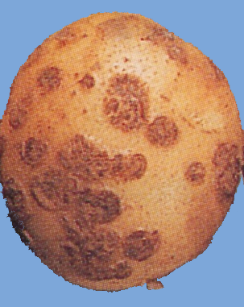 | Netted Scab (estimated 33.3%)  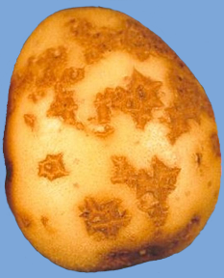
Powdery scab (estimated 10%)
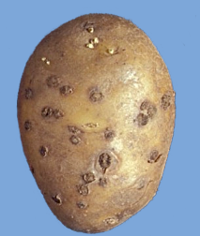

Rhizoctonia

1% surface area coverage
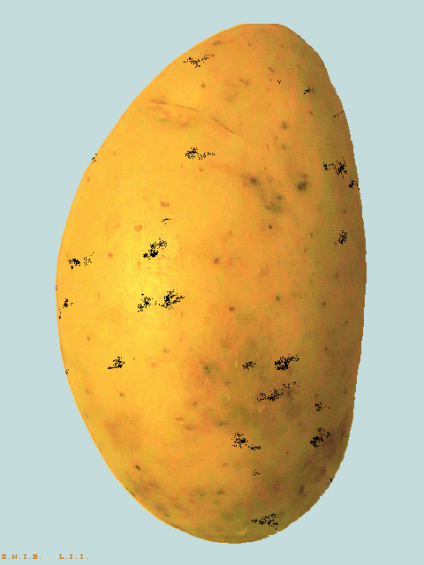
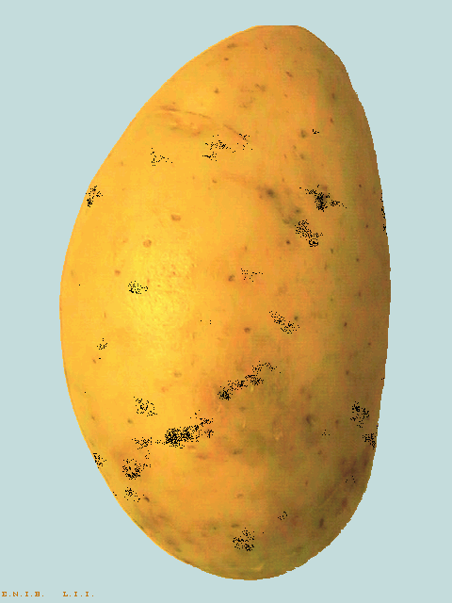

Homogeneous Concentrated

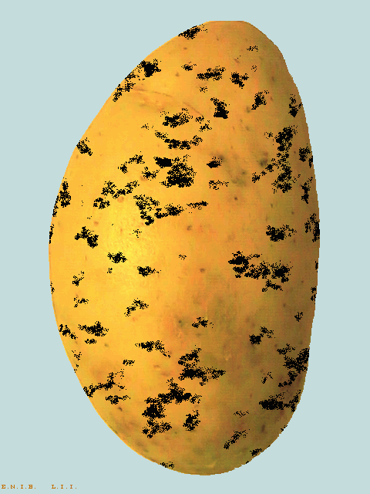
10% surface area coverage
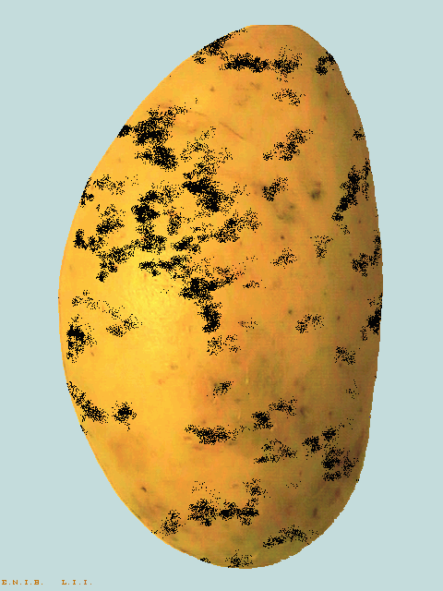

Homogeneous Concentrated

Annex IX. Sampling tubers for virus testing

1. Introduction

In testing seed stocks for the incidence of virus, it is seldom feasible to test the entire stock, so a test is done on a sample from the stock. Ideally, only seed stocks with infection levels below the tolerance would be accepted and those above the tolerance rejected. However, taking a sample from a stock means that only an estimation of the actual incidence of virus can be made.

The reliability of this estimation will vary with the size of the sample relative to the size of the lot and the population standard which is set for the test. Defining an acceptable population standard for any sample entails two types of risk.

The first is that of rejecting a stock containing less virus than the tolerance and is often described as the “grower’s” risk. The risk of accepting a stock containing more virus than the tolerance is known as the “buyer’s” risk. From the point of view of classification authorities, this could also be described as the risk of passing a stock which fails to meet the official tolerances.

Such testing makes a number of important assumptions, which are, primarily, that the infected tubers are distributed homogeneously in the stock and that tubers are sampled randomly. In addition, the choice of the size of sample to be tested will need to be balanced by other practical factors, such as cost, available facilities, labour, logistics of handling samples, seed stock size, etc.

The following tables and graphs illustrate some of the principles involved in sampling tubers for testing for virus.

2. Confidence limits

Testing different samples from the same seed stock will give a range of results which, statistically, will lie within a specific interval with a certain percentage confidence. This interval is known as the confidence interval.

The acceptable level of confidence or probability should be decided before the testing is conducted but 95 per cent confidence/probability is normally used. The accuracy of the estimation can be improved by increasing the sample size and by adjusting the allowable number of infected tubers in the sample, i.e. the sample tolerance (Table 1).

For example, the size of the confidence interval for a sample tolerance of 4 per cent (4 allowable tubers) is 8.8 per cent based on a sample of 100 tubers but, on a sample of 200 tubers, the interval decreases to 6 per cent i.e. 7.7-1.7. The effect on the confidence interval of increasing the sample size does, however, become smaller at the larger sample sizes. Increasing the sample size from 100 to 200 tubers improves the accuracy of the estimation by 32 per cent, i.e. confidence interval reduced from 8.8 to 6.0 per cent, whereas increasing the sample size from 300 to 400 tubers only gives an improvement of 15 per cent.

In practice, therefore, the benefits of increasing the sample size have to be weighed up against the additional cost of the testing. The accuracy of the estimation can also be affected by changing the allowable number of infected tubers in the sample (Table 1). For example, by decreasing the number of allowable tubers from 4 to 3, i.e. changing sample tolerance from 4 to 3 per cent, the confidence interval is decreased from 8.8 to 7.9 per cent and the confidence limits themselves become lower. Decreasing the allowable number of infected tubers in the sample also has a significant effect on the probability of classifying at higher tolerances than those allowed in the sample as illustrated in the next paragraph.

Table 1. Confidence limits, at a probability of 95 per cent, for various sample tolerances of virus in relation to the size of the sample

Tolerance for virus in a seed stock  (per cent) | Size of  sample | Allowable  number of infected tubers | Confidence limits
 |  |  | Lower | Upper
0.5 | 100 | 0 | 0.00 | 2.95
 | 200 | 0 | 0.00 | 1.49
 | 300 | 1 | 0.01 | 1.84
 | 400 | 2 | 0.06 | 1.79
2 | 100 | 1 | 0.03 | 5.45
 | 200 | 3 | 0.31 | 4.32
 | 300 | 5 | 0.54 | 3.85
 | 400 | 7 | 0.71 | 3.57
4 | 100 | 4(3) | 1.1(0.6) | 9.9(8.5)
 | 200 | 8(7) | 1.7(1.4) | 7.7(7.1)
 | 300 | 12(11) | 2.1(1.8) | 6.9(6.5)
 | 400 | 16(15) | 2.3(2.1) | 6.4(6.1)
10 | 100 | 10(8) | 4.9(3.5) | 17.6(15.2)
 | 200 | 20(18) | 6.2(5.4) | 15.0(14.0)
 | 300 | 30 | 6.9 | 13.8
 | 400 | 40 | 7.2 | 13.4

3. Probability of classifying stocks to meet specified tolerances

From the confidence intervals, it can be seen that classifying stocks based on a sample will contain a risk that some stocks, which fail a test, do in fact meet the tolerance, and others, which pass, should fail. Table 2 and Figure 1 show the effect of varying sample size and the number of virus infected tubers allowed in the sample on the probability of classifying seed stocks with different incidences of virus infection. For example, in a test on a sample of 100 tubers where 3 virus infected tubers were allowed, there would be a 14 per cent chance of classifying a stock containing 6 per cent virus as meeting a tolerance of 4 per cent.

Table 2. Probability of classifying seed stocks at two tolerances for virus based on a
laboratory test in relation to the size of sample and the allowable number of virus-infected tubers in the sample

Tolerance for virus in a seed stock  (per cent) | Size of sample | Allowable number of infected tubers | Probability of acceptance or classification
 |  |  | infected tubers in stock (per cent)
 |  |  | 0.5 | 1 | 2 | 4 | 6 | 8 | 10
0.5 | 100 | 0 | 61 | 37 | 13 | 2 | 0 | 0 | 0
 | 200 | 0 | 37 | 13 | 2 | 0 | 0 | 0 | 0
 | 300 | 1 | 56 | 20 | 2 | 0 | 0 | 0 | 0
 | 400 | 2 | 68 | 24 | 1 | 0 | 0 | 0 | 0
2 | 100 | 1 | 91 | 74 | 40 | 9 | 2 | 0 | 0
 | 200 | 3 | 98 | 86 | 43 | 4 | 0 | 0 | 0
 | 300 | 5 | 100 | 92 | 44 | 2 | 0 | 0 | 0
 | 400 | 7 | 100 | 95 | 45 | 1 | 0 | 0 | 0
4 | 100 | 3 | 100 | 98 | 86 | 43 | 14 | 4 | 1
 | 200 | 7 | 100 | 100 | 95 | 45 | 8 | 1 | 0
 | 300 | 11 | 100 | 100 | 98 | 46 | 5 | 0 | 0
 | 400 | 15 | 100 | 100 | 99 | 46 | 3 | 0 | 0
10 | 100 | 8 | 100 | 100 | 100 | 98 | 85 | 59 | 32
 | 200 | 18 | 100 | 100 | 100 | 100 | 97 | 75 | 37
 | 300 | 30 | 100 | 100 | 100 | 100 | 100 | 91 | 55
 | 400 | 40 | 100 | 100 | 100 | 100 | 100 | 94 | 54

Note: The allowable number of tubers is, often, set at a lower level than the overall seed stock tolerance of 4 per cent and 10 per cent respectively, particularly in the case of a relatively small sample size. By lowering the tolerance in a sample, the buyer’s risk is reduced.

Figure 1. Probability of classifying seed stocks with different incidences of virus as meeting a tolerance of 0.5, 2, 4 or 10 per cent for virus in a laboratory test in relation to the size of sample and the allowable number of virus-infected tubers in the sample

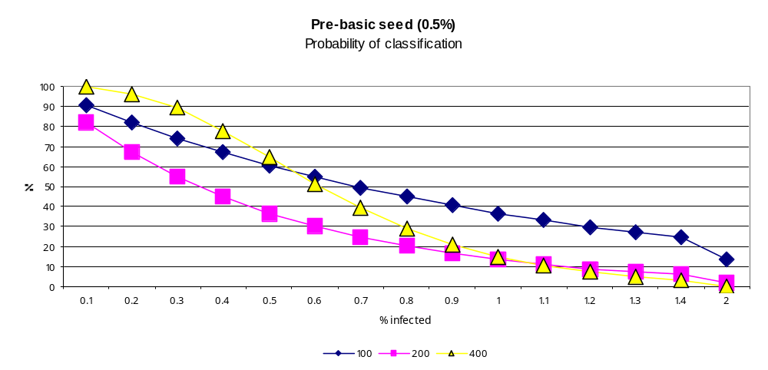Figure 1.a

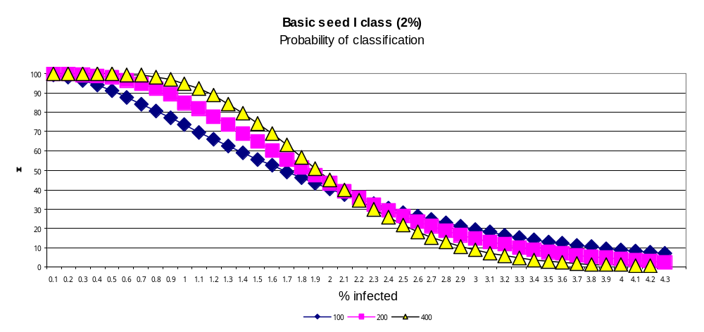Figure 1.b

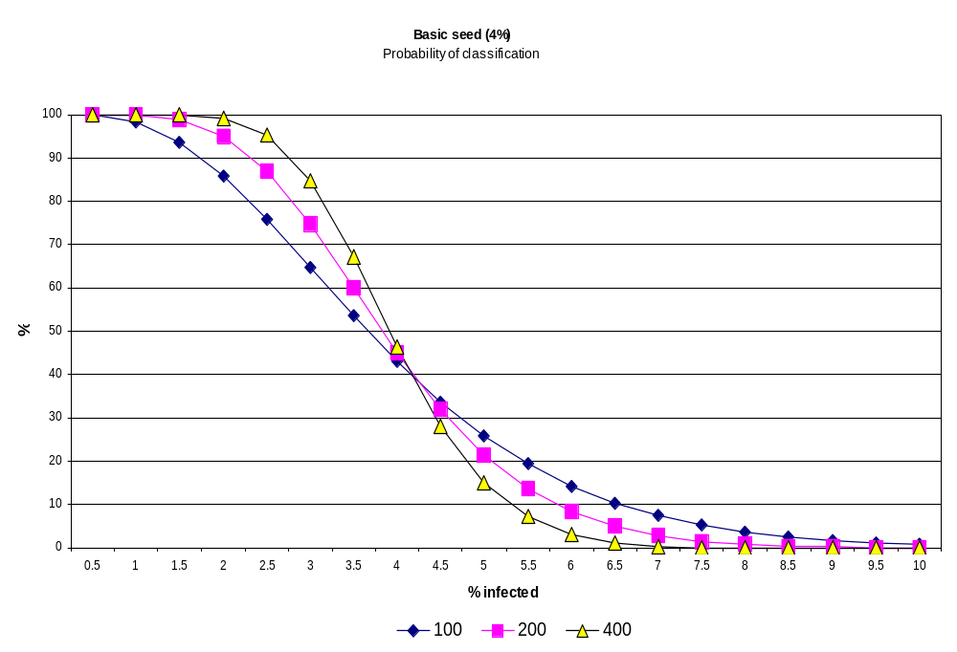Figure 1.c

Figure 1.d
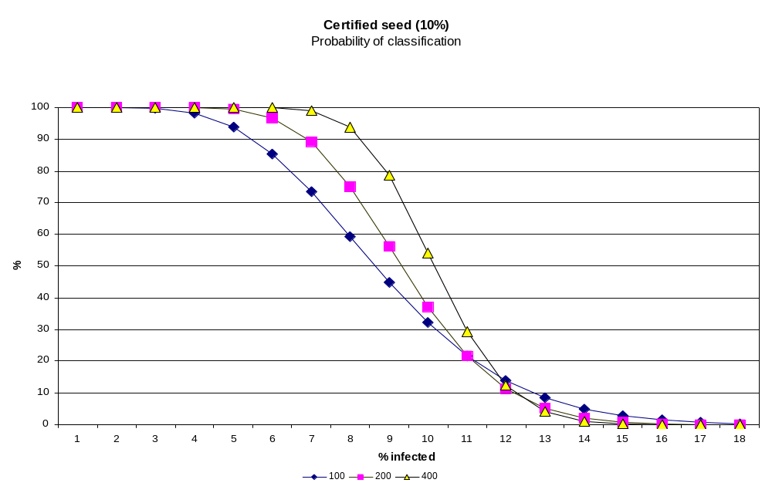

Annex X. UNECE Standard for Seed Potatoes (Summary table of tolerances)

 | Pre-basic TC | Pre-basic | Basic class I | Basic class II | Certified  class I | Certified  class II
1. Crop tolerances
Globodera rostochiensis (soil tolerance) | 0 | 0 | 0 | 0 | 0 | 0
Globodera pallida (soil tolerance) | 0 | 0 | 0 | 0 | 0 | 0
Black leg (%) | 0 | 0 | 0.5 | 1 | 1.5 | 2
Synchytrium endobioticum | 0 | 0 | 0 | 0 | 0 | 0
Clavibacter michiganensis | 0 | 0 | 0 | 0 | 0 | 0
Ralstonia solanacearum | 0 | 0 | 0 | 0 | 0 | 0
Potato spindle tuber viroid | 0 | 0 | 0 | 0 | 0 | 0
Tomato stolbur | 0 | 0 | 0 | 0 | 0 | 0
Virus tolerance | 0 | 0.1 | 0.4  (0.2 severe) | 0.8  (0.4 severe) | 2  (1 severe) | 10  (2 severe)
Other varieties & off types | 0 | 0.01 | 0.25 | 0.25 | 0.5 | 0.5
2. Lot tolerances
Earth & extraneous matter (%) | 1 | 1 | 2 | 2 | 2 | 2
Dry & wet rot (not caused by Synchytrium e. Clavibacter m. Ralstonia s.) (%) | 0 | 0,2 | 1 | 1 | 1 | 1
External defects | 3 | 3 | 3 | 3 | 3 | 3
Shrivelled tubers | 0 | 0,5 | 1 | 1 | 1 | 1
Scab (common and netted) | 0 | 5 (33.3)* | 5 (33.3) * | 5 (33.3) * | 5 (33.3) * | 5 (33.3) *
Powdery scab | 0 | 1 (10) * | 3 (10) * | 3 (10) * | 3 (10) * | 3 (10) *
Rhizoctonia | 0 | 1 (1) * | 5 (10) * | 5 (10) * | 5 (10) * | 5 (10) *
Total tolerances (%) | 3 | 5 | 6 | 6 | 6 | 6
Globodera rostochiensis | 0 | 0 | 0 | 0 | 0 | 0
Globodera pallida | 0 | 0 | 0 | 0 | 0 | 0
Synchytrium endobioticum | 0 | 0 | 0 | 0 | 0 | 0
Clavibacter michiganensis | 0 | 0 | 0 | 0 | 0 | 0
Potato spindle tuber viroid | 0 | 0 | 0 | 0 | 0 | 0
Tomato stolbur | 0 | 0 | 0 | 0 | 0 | 0
Meloidogyne chitwoodi and fallax | 0 | 0 | 0 | 0 | 0 | 0
Ditylenchus destructor | 0 | 0 | 0 | 0 | 0 | 0

3. Direct progeny tolerances
Other varieties and off types | 0 | 0.01 | 0.25 | 0.25 | 0.5 | 0.5
Virus (%) | 0 | 0.5 | 2 (1 severe) | 4 (2 severe) | 10 (5 severe) | 10
* The figure in brackets is the allowable % surface area covered: a tuber is deemed to be affected by the disease only if surface area affected exceeds the specified allowable surface tolerance.

Reservation from the United States to allow for further consultation.
The representatives of the European Commission and France reserved their position on this issue.
Reservations: Romania needs further consultations with the trade on tolerances for basic and certified.

