GE.1 POST-SESSION DOCUMENT 4 July 2016
Open for consultation until 30 June 2016
2nd round: Open for consultation until 29 July 2016.

NOTE: A reference annex on aubergine shapes has been added.

UNECE standard FFV-05 concerning the marketing and commercial quality control of aubergines
I. Definition of produce
This standard applies to aubergines of varieties (cultivars) grown from Solanum melongena L. to be supplied fresh to the consumer, aubergines for industrial processing being excluded.
According to their shape a distinction is made between:
- elongated aubergines (including club shaped, cylindrical, ellipsoid and pear shaped), and
- round aubergines (including oval shaped).
II. Provisions concerning quality
The purpose of the standard is to define the quality requirements for aubergines at the export-control stage after preparation and packaging.
However, if applied at stages following export, products may show in relation to the requirements of the standard:
- a slight lack of freshness and turgidity
- a slight deterioration due to their development and their tendency to perish.
The holder/seller of products may not display such products or offer them for sale, or deliver or market them in any manner other than in conformity with this standard. The holder/seller shall be responsible for observing such conformity.
A. Minimum requirements
In all classes, subject to the special provisions for each class and the tolerances allowed, the aubergines must be:
- intact
- sound; produce affected by rotting or deterioration such as to make it unfit for consumption is excluded
- clean, practically free of any visible foreign matter
- practically free from pests
- free from damage caused by pests affecting the flesh
- fresh in appearance
- firm
- sufficiently developed without the flesh being fibrous or woody and without over-development of the seeds
- provided with a calyx and peduncle which may be slightly damaged
- free of abnormal external moisture
- free of any foreign smell and/or taste.

The development and condition of the aubergines must be such as to enable them:
- to withstand transportation and handling
- to arrive in satisfactory condition at the place of destination.
B. Classification
Aubergines are classified in three classes, as defined below:
(i) “Extra” Class
Aubergines in this class must be of superior quality. They must be characteristic of the variety and/or commercial type.
They must be firm. The stalk must be intact and the flesh must be perfectly sound..
They must be free from defects, with the exception of very slight superficial defects, provided these do not affect the general appearance of the produce, the quality, the keeping quality and presentation in the package.
(ii) Class I
Aubergines in this class must be of good quality. They must be characteristic of the variety and/or commercial type.
They must also be practically free from sun-scorch.
The following slight defects, however, may be allowed, provided these do not affect the general appearance of the produce, the quality, the keeping quality and presentation in the package:
- a slight defect in shape
- slight defects in colouring but not greenish in case of violet varieties
- slight skin defects including slight bruising and/or slight healed cracks provided thatthey do not exceed a total surface area of 3 cm².
(iii) Class II
This class includes aubergines that do not qualify for inclusion in Class I but satisfy the minimum requirements specified above.
The following defects may be allowed, provided the aubergines retain their essential characteristics as regards the quality, the keeping quality and presentation:
- defects in shape
- defects in colouring but not greenish in case of violet varieties
- skin defects including slight bruising, slight healed cracks and/or slight sunscorch provided that they do not exceed a total surface area of 4 cm².
III. Provisions concerning sizing
Size is determined by either:
- the maximum diameter of the equatorial section on the longitudinal axis, or
- by weight, or
- by count
To ensure uniformity in size, the range in size between produce in the same package shall not exceed:
(a) For sizing by diameter
- 20 mm for elongated aubergines
- 25 mm for round aubergines.
(b) For sizing by weight
- 10 g for aubergines between 20-50 g
- 20 g for aubergines between 50-100 g
- 75 g for aubergines between 100 to 300 g
- 100 g for aubergines between 300 to 500 g
- 250 g for aubergines above 500 g.
(c ) For sizing by count
- The difference in size should be consistent with point (a) or (b).
Uniformity in size is compulsory for Extra Class and Class I.
IV. Provisions concerning tolerances
At all marketing stages, tolerances in respect of quality and size shall be allowed in each lot for produce not satisfying the requirements of the class indicated.
A. Quality tolerances
(i) “Extra” Class
A total tolerance of 5 per cent, by number or weight, of aubergines not satisfying the requirements of the class but meeting those of Class I is allowed. Within this tolerance not more than 0.5 per cent in total may consist of produce satisfying the requirements of Class II quality.
(ii) Class I
A total tolerance of 10 per cent, by number or weight, of aubergines not satisfying the requirements of the class but meeting those of Class II is allowed. Within this tolerance not more than 1 per cent in total may consist of produce satisfying neither the requirements of Class II quality nor the minimum requirements, or of produce affected by decay.
(iii) Class II
A total tolerance of 10 per cent, by number or weight, of aubergines satisfying neither the requirements of the class nor the minimum requirements is allowed. Within this tolerance not more than 2 per cent in total may consist of produce affected by decay.
B. Size tolerances
For all classes (if sized): a total tolerance of 10 per cent, by number or weight, of aubergines not satisfying the requirements as regards sizing is allowed.
V. Provisions concerning presentation
A. Uniformity
The contents of each package must be uniform and contain only aubergines of the same origin, variety or commercial type, quality, size (if sized), and appreciably the same degree of development and colouring.
However, a mixture of aubergines of distinctly different commercial types and/or colours may be packed together in a package, provided they are uniform in quality and, for each commercial type and/or colour concerned, in origin.
The visible part of the contents of the package must be representative of the entire contents.
B. Packaging
Aubergines must be packed in such a way as to protect the produce properly.
The materials used inside the package must be clean and of a quality such as to avoid causing any external or internal damage to the produce. The use of materials, particularly of paper or stamps bearing trade specifications, is allowed, provided the printing or labelling has been done with non-toxic ink or glue.
Stickers individually affixed to the produce shall be such that, when removed, they neither leave visible traces of glue nor lead to skin defects.
Packages must be free of all foreign matter.
VI. Provisions concerning marking
Each package must bear the following particulars, in letters grouped on the same side, legibly and indelibly marked, and visible from the outside:
A. Identification
Packer and/or dispatcher/shipper:
Name and physical address (e.g. street/city/region/postal code and, if different from the country of origin, the country) or a code mark officially recognized by the national authority.
B. Nature of produce
- “Aubergines” if the contents are not visible from the outside
- Name of the variety (optional)
- “Mixture of aubergines”, or equivalent denomination, in the case of a mixture of distinctly different commercial types and/or colours of aubergines. If the produce is not visible from the outside, the commercial types and/or colours and the quantity of each in the package must be indicated.
C. Origin of produce
- Country of origin and, optionally, district where grown, or national, regional or local place name.
- In the case of a mixture of distinctly different commercial types and/or colours of aubergines of different origins, the indication of each country of origin shall appear next to the name of the commercial type and/or colour concerned.
D. Commercial specifications
- Class
- Size (if sized) expressed
- as minimum and maximum diameters when sizing is by diameter
- as minimum and maximum weights when sizing is by weight.
- as count followed by the minimum and maximum size when sizing is by count.
E. Official control mark (optional)
Adopted 1970
Last revised 2016

REFERENCE ANNEX – AUBERGINE SHAPES

Club-shaped
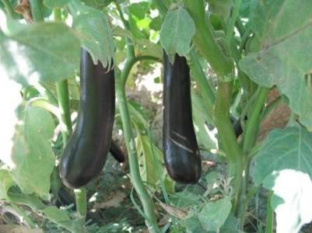
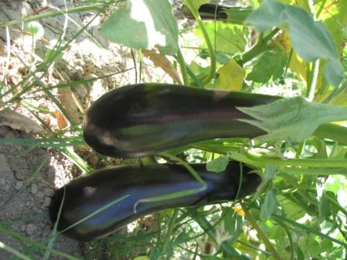

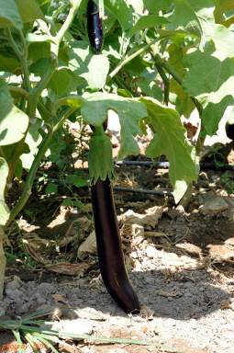
Cylindrical

Ellipsoid

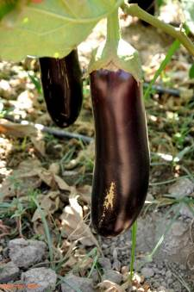
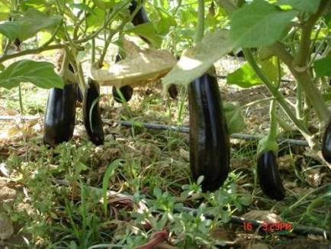

Pear-shaped
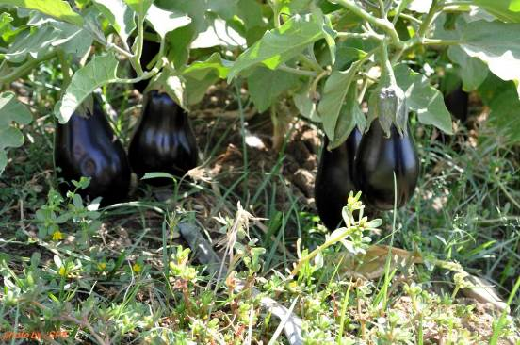

These marking provisions do not apply to sales packages presented in packages.
The national legislation of a number of countries requires the explicit declaration of the name and address. However, in the case where a code mark is used, the reference “packer and/or dispatcher (or equivalent abbreviations)” has to be indicated in close connection with the code mark, and the code mark should be preceded by the ISO 3166 (alpha) country/area code of the recognizing country, if not the country of origin.
The full or a commonly used name should be indicated.

