TURKEY
The following information was provided and approved by the authorities of the countries listed. The United Nations Economic Commission for Europe (UNECE) is not responsible or liable for the content provided and declines all legal implications related thereto.
Date: January 2018
COMPETENT AUTHORITY | EXPLANATIONS | PHOTO EXAMPLE (IF AVAILABLE)
Ministry of Economy  DG Product Safety and Inspections (for marketing/commercial quality controls)  Address: Söğütözü Mah. 2176. Sk. No:63 06530  Çankaya/Ankara-TURKEY  Web: www.ekonomi.gov.tr  Phone: +90 312 204 75 00  E-mail: tarim-ugd@ekonomi.gov.tr | The Ministry of Economy (MoE) is the sole competent authority in Turkey with regards to marketing/commercial quality controls of fresh fruits and vegetables at import and export stages. The legal basis for these controls is Communique no. 2018/21 on Risk Based Inspections of Certain Agricultural Products at Export and Import.  The Communique also lays down the rules on affixing a “Consignment/Lot No.” label on export consignments. The Consignment/Lot no. serves as a code mark for traceability. It is used together with the official name/brand of the exporter, and takes the following structure:  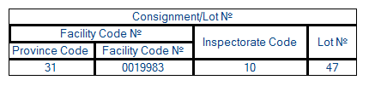  The province code indicates the province where the application for quality controls was made.  The facility code is a code given to each facility registered in MoE’s electronic database.  The inspectorate code identifies which of the 36 MoE inspectorates carried out the controls.  The Lot no. starts with 1 for each facility at the beginning of the year. In this example, Lot no. 47 means that this is the 47th export quality control application made by facility no 0019983 within the current year. | 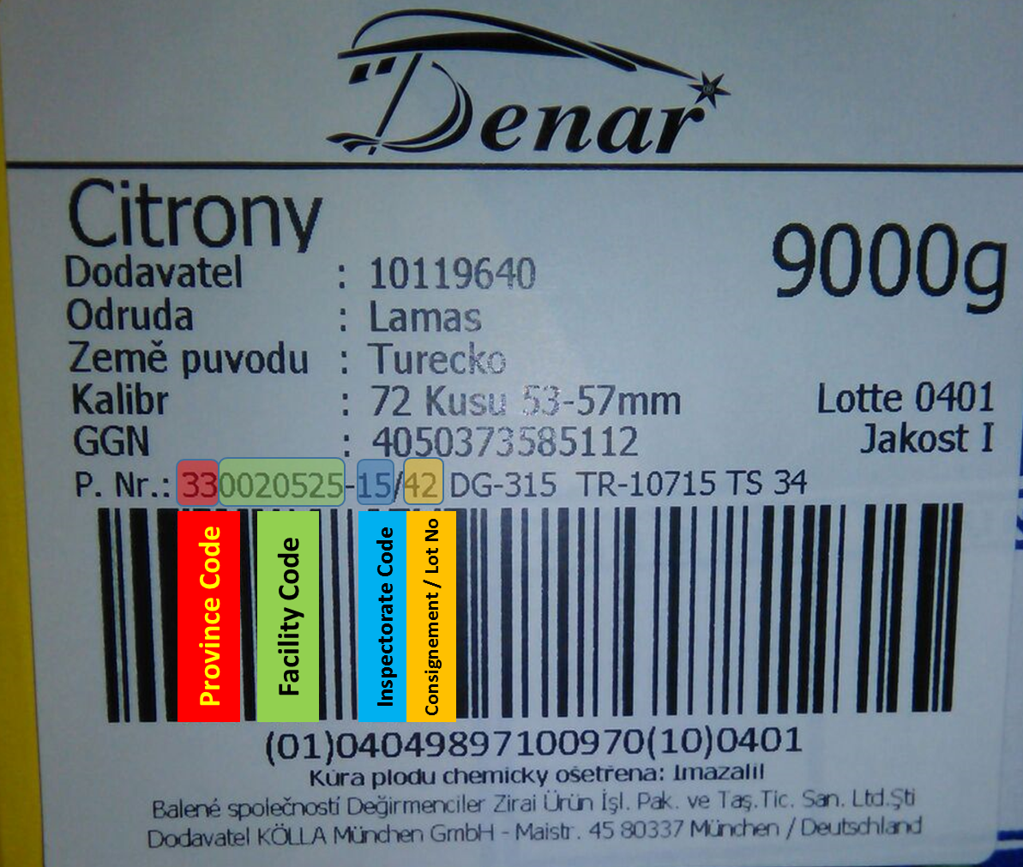  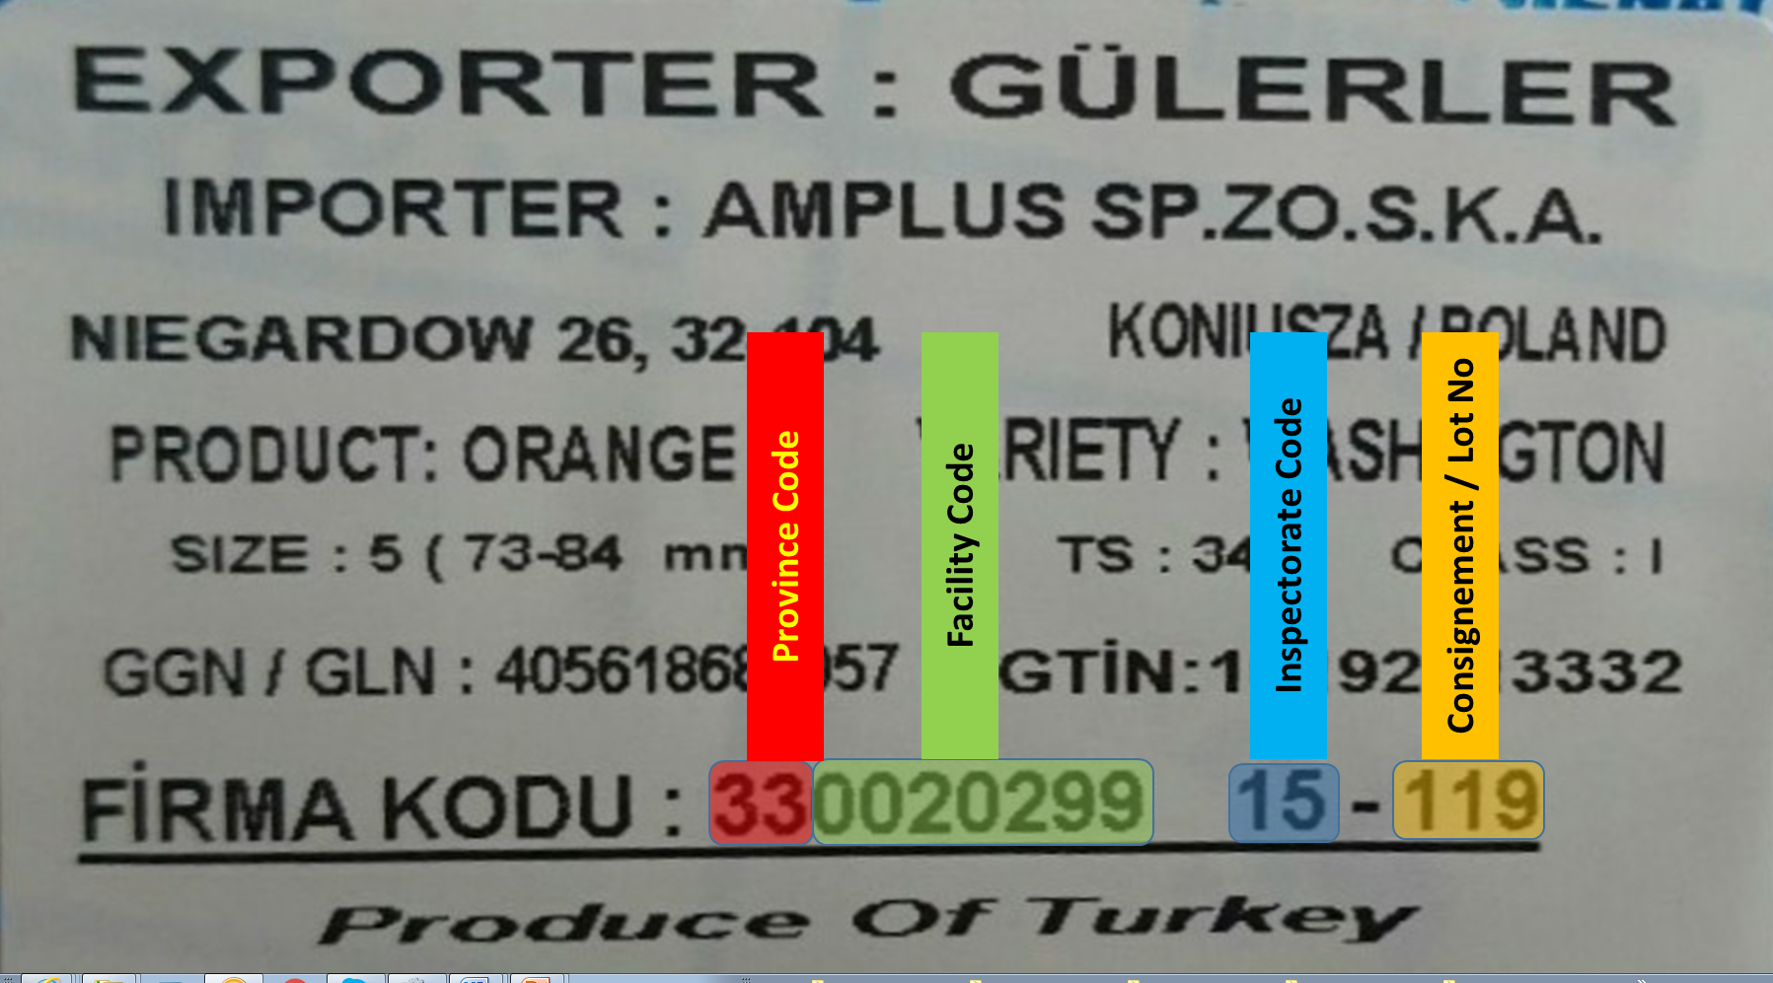
The designations employed do not imply the expression of any opinion whatsoever on the part of the United Nations Secretariat concerning the legal status of any country, territory, city or area or of its authorities, or concerning the delimitation of its frontiers or boundaries. Mention of company names or commercial products does not imply endorsement by the United Nations.

