MOROCCO
The following information was provided and approved by the authorities of the countries listed. The United Nations Economic Commission for Europe (UNECE) is not responsible or liable for the content provided and declines all legal implications related thereto.
Date: January 2018
COMPETENT AUTHORITY | EXPLANATIONS | PHOTO EXAMPLE (IF AVAILABLE)
Etablissement Autonome de Contrôle et de Coordination des Exportations (EACCE)  Adress : EACCE, Route El jadida, Lissassfa Rond-point AZBANE à proximitéde l'Hotel ZENITH - Casablanca – Maroc  Phone: 00212 5 22 30.51.04/30.81.22  Website:http://www.eacce.org.ma  Email: eacce@eacce.org.ma | - In EACCE, there are two central registers for the registration of exporters and packing houses.  - For packing houses, the registration number is a combination of an alphabet letter and a given number, which must be an even number for citrus products and an odd number for other fruits and vegetables.  - For exporters, the registration number is a four-digit code. | 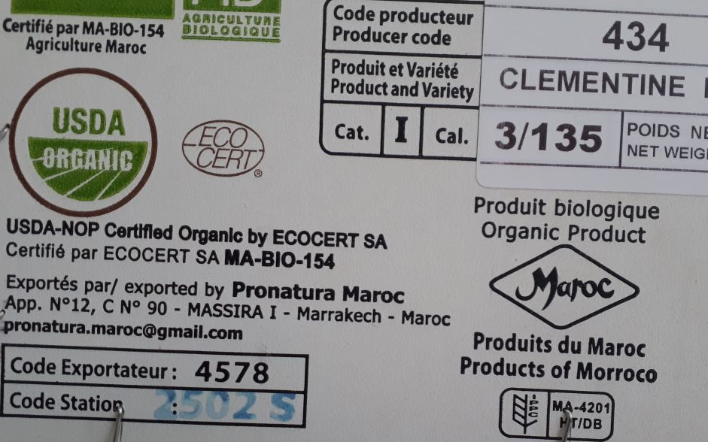

The designations employed do not imply the expression of any opinion whatsoever on the part of the United Nations Secretariat concerning the legal status of any country, territory, city or area or of its authorities, or concerning the delimitation of its frontiers or boundaries. Mention of company names or commercial products does not imply endorsement by the United Nations.

