ANNEX 2

**Annex 2**

Soluciones de tecnologías de la información

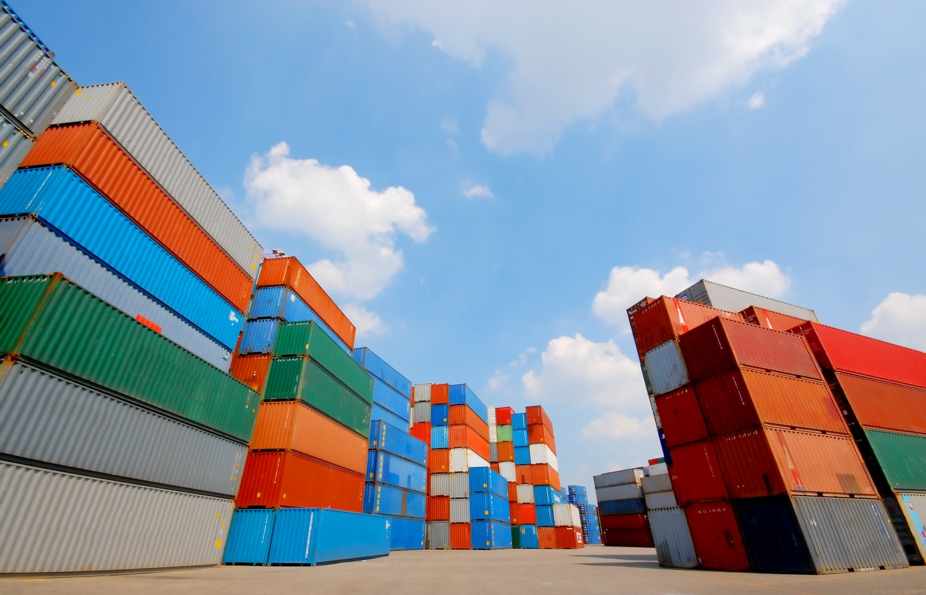

**PORTEL SOLUTIONS FOR PORTS**

**Port Operations Management**

* Port Community System (PCS)
* Port Operating System. Optimization management system of vessel calls, cargo transit, services invoicing, statistics production and customers relationships
* Different business processes that interact to solve the higher level objective of movement of goods and passengers with different roles in each process (Safety and security, Customs and taxes, Payments, Operation and logistics, port services, etc.)

All these aspects have very close relationship with Port Community Systems:

* To support Planning Process to provide quality services and strengthen competiveness,
* Resource Allocation,
* Infrastructures Maintenance (Physical and IT),
* Decision making process, etc.)

**PORTEL PCS for optimization of port operations**

The role of ports as intermodal and distribution centres is crucial to the Global Suppy Chain. Port Clients select individual ports not only based on their cargo handling but also the added values offered. PCS solutions are giving those added value services. To the hole Port Community.

PORTEL PCS solution allows all parties to loads and submit standardized information and documents at a Single Point of Contact (SPOC) to fulfill all trade and transit all administrative and regulatory requirements based on (IAPH, UNECE, UN Single Window Guidelines, etc)

All National Agreements at the Port Process Harmonization Group in Spain are implemented in this solution.

**PORTEL PCS – PORT COMMUNITY SYSTEM (Multiport Approach)**

The Key Features of PORTEL PCS solution are:

* B2G and B2B Electronic exchange of information. Easy, fast and efficient EDI information exchange, re-use and centralisation, available 24/7/365
* Customs declarations
* Electronic handling of all information regarding import and export of containerized, general and bulk cargo
* Status information and control, tracking and tracing through the whole logistics chain
* Processing of dangerous goods
* Processing of maritime and other statistics
* Port Single Window (PSW)

Stakeholders of the PCS:

* Ship Agent/Ship lines
* Freight forwarders
* Cargo Terminal
* Importer / exporters
* Hauliers
* Port Administration
* Maritime Administration
* Coastal Administration
* Customs
* External Trade Ministry
* Ministry of transport, industry, etc
* Police Border
* Etc..

**PORTEL PCS Features**

**MULTI-PORT APPROACH**

PORTEL PCS is an Added Value Network in Maritime and Port Sector.

PORTEL has design the PCS as a Cloud Solution for most of Spanish Ports.

Nowadays we are giving PCS services to 5 Spanish Ports and more than 20 Spanish Ports as a National Maritime Single Window in Spain for ShipCalls and Dangerous Goods.