ENPI Forest Law Enforcement and Governance (FLEG) II

What is the environmental issue and its importance?

The forests of the ENPI East region have a vital function for the global, regional and local environment. Approximately a quarter of the world's forest biomass is situated in Europe and Russia. Russia has the most extensive forest cover of any country in the world, itself housing 20% of the world's forests. Forests and the forest products industry are a source of economic growth and employment, provide habitat for terrestrial biodiversity, and are a major carbon sink regulating global climate. Further benefits from the region’s boreal forests include soil fertility, watershed protection, and protection from natural disasters such as floods and landslides.
Forest degradation in the ENPI Region threatens rural livelihoods, biodiversity, and ecological services. While illegal logging and poor governance are often country-specific, frequently these problems do not respect national boundaries, spilling across poorly secured borders. Despite their differences, the ENPI countries have much to teach each other about best practices for sustainable forest management. The countries face similar challenges including evolving market forces and incomplete sector reforms, inadequate funding for forestry professionals, and low public awareness about the value of forests. Trans-boundary cooperation provides a unique opportunity to improve sustainable forest management within the region.

What is this project about?

In 2005, representatives of 44 governments signed the St. Petersburg Declaration, committing themselves to address illegal logging and improve forest governance. Momentum towards strengthening forest law enforcement and governance in the ENPI region grew when, in 2008, the EC, the World Bank, WWF and IUCN teamed up to implement the first ENPI FLEG Program (2008-2012, 6 million EUR).

The ENPI Forest Law Enforcement and Governance II (FLEG II) Program (2012-2016, 9 million EUR) builds on the first ENPI FLEG I Program to support good forest governance, sustainable forest management and forest protection in the ENPI East region. In particular, the Program supports participating countries to:

- Continue the implementation of the 2005 St. Petersburg FLEG Ministerial Declaration and up-scaling of successes of the ENPI East FLEG I project.
- Formulate and implement sustainable forest policies, including legal and administrative reforms for sustainable forest management and protection increase capacity.
- Demonstrate the best sustainable forest management practices in targeted areas, for further replication.

What are the impacts?

Regionally, the Program has supported dialogue and action through its steering committee meetings that involve focal points from each country and through roundtables, such as one held during European Forest Week. Program Leader Andrew Mitchell said, “The first really important thing is the impact in terms of engagement of the governments and the FLEG focal points. When we work together, we all bring the results of our own different experiences, energy, and enthusiasm.” An ongoing benefit of the FLEG program has been the re-establishment of the forestry professional networks within the region which were lost during the dissolution of the Soviet Union. The deep ownership of the FLEG program by both the FLEG national focal points (usually a high ranking government official such as a Deputy Minister from the Ministry responsible for Forestry) and the National Program Advisory Committees has helped keep FLEG issues high on the national agendas. Activities in one country such as training of youth or developing log tracking systems can be of direct benefit to the other participating countries. As the program evolves more and more cooperative activities are being implemented and knowledge and experience is being transferred.

As this is now the second phase of the FLEG program, there have been many activities implemented and completed. The following examples illustrated below, show some of the impact of some of the FLEG Program’s activities:

Engaging Youth and Adults in Forestry Education

In many countries, addressing poor forest governance requires, amongst other things, the behaviour change of the affected populations – it needs an increased understanding of the consequences of certain actions and the need to develop viable alternatives. In Armenia and Azerbaijan, environmental awareness and education are priority areas. Tutorials and curricula have been developed for graduate technical schools, ministry training institutes, and school children to ensure that the basic principles and advanced techniques for forest management will be better understood and more widely disseminated.
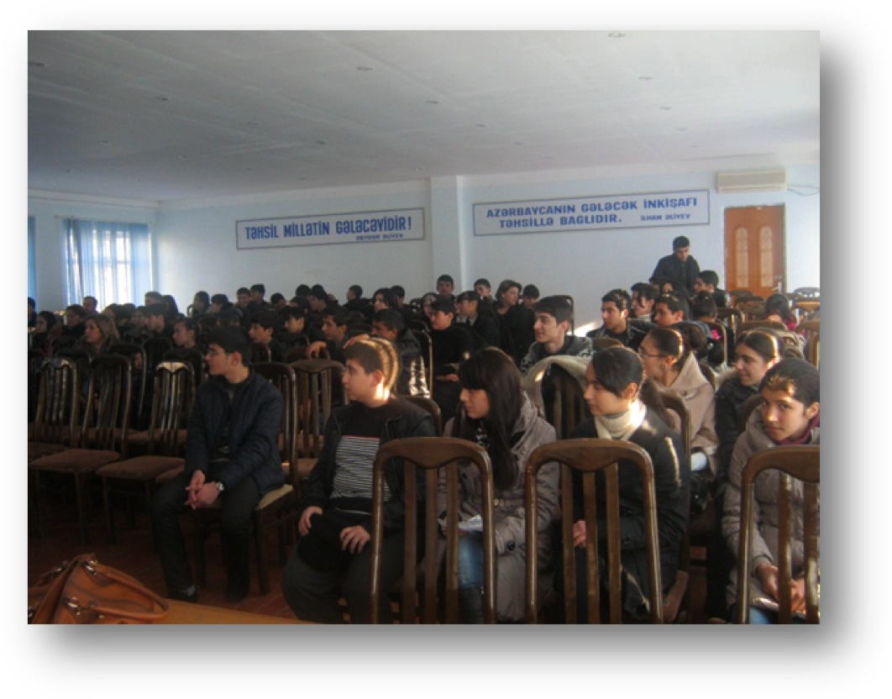
Promoting forest education in Azerbaijan

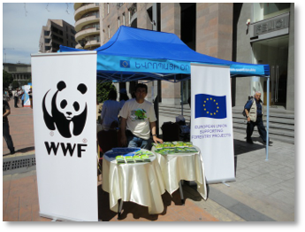

\

Disseminating materials on Europe Day in Armenia

60,000 more hectares Forested in Moldova

In Moldova, the Program established a digital forest map and increased the areas under forest vegetation on degraded community lands by 60 thousand hectares. By improving the mapping and the preparation of management plans supported by the FLEG program allows for a better understanding of the forest resources, of how these forests can be sustainably managed for the benefit of local communities. Involving local communities in the management of forestry resources has been shown to significantly both reduce the illegal consumption by the community themselves but also increase the protection of the forest from uncontrolled access by others.

Making the licensing system work in Georgia

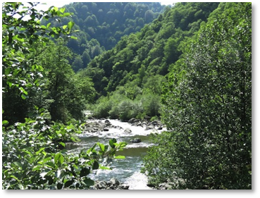

Relict Forests in Kolkheti, Georgia
The ENPI FLEG II Program is seen a catalyst for important behavioural changes and has given further momentum to countries efforts to protect their forests and support sustainable land management. In Georgia, the program is promoting voluntary forest certification.
he FLEG National Focal Point for Georgia, Merab Sharabidze, stated, “The main problem for forests now is a lack of inventory licensing for forestry. The Ministry has begun to check all of the terms and conditions of the license holder’s status and a schedule has been drawn up, which will be gradually implemented to conduct field inspection of license areas.”

Analysis and Consultation provide good basis for National Forestry Policy in Ukraine

Many problems associated with poor forest governance are as a result of poor policy and legislation which create perverse incentives. For example a ban on logging or increased enforcement effort as a response to illegal logging frequently creates more opportunities for corruption. So in many FLEG countries analysis has been undertaken of the policy, legislation and regulations in an effort to address these perverse incentives. For example in Ukraine:
- Analysis of legislation undertaken under the FLEG project has covered a lot of areas including analysis with regard to inadmissibility/prevention of illegal logging, corruption risks associated with regulatory framework, comparative analysis of legislation, guaranteeing rights of local residents and small business for the legal use of forest resources, nature conservation management legislation, regulations on long-term lease of land covered with forests.

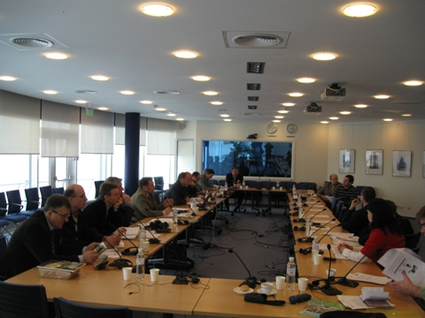

Round table discussion on long-term forest use at the WB, February 2011
- The findings of analytical research have been discussed at a series of round table meetings with different stakeholders. Reports on the findings of research and publications have been handed over to relevant authorities and resulted proposals from FLEG Experts with the State Forestry Resources Agency, the Administration of the President and the Ministry of Agriculture becoming part of the National Action Plan from which National Forestry Policy is being developed.

Leading Russian forestry universities working towards programs for future forest managers
A workshop was held in Pushkino (Moscow Region), 27-28 March 2014 to discuss issues of improving the training system for forest governance and of testing module-based (practical) educational programs designed for use in preparation for bachelors and masters in "Forest management".
World Bank experts from the EU funded FLEG II (ENPI East) Program presented the draft training module programs in four areas. These are related to control and enforcement concerning the use of forests, their reproduction, forest conservation, and fire protection.

The workshop recognized that the training and retraining of qualified personnel is essential to create an effective system of forest management in the Russian Federation (RF). It recommended that the Federal Forestry Agency’s (Rosleskhoz) executive bodies of state power within the Russian Federation consider and promote the training modules from FLEG II, in the preparation of future specialist state forest management.
Most experts and representatives of higher learning institutes agreed that such field forestry training programs should be implemented mainly in the Masters programs, in order to fill the gap in the literacy of training forest managers.
Local Community transformed in Russia
In Russia, under FLEG I the project developed training modules on FLEG for in service training. These modules became part of Russia’s regular training programs, helping Russian officials to improve governance. Under FLEG II, successful local models of sustainable forest management are being replicated. One model of local reserve management has led to increases in household incomes of 15 per cent on average, and local populations becoming more active in counteracting illegal logging, poaching, and uncontrolled industrial berry collection.
Implementing New Compliance Regulations for Forest Practitioners in Ukraine
- As a way to deal with this problem it has been decided to develop guidelines for forest protection service offices which would contain both useful information about relevant legislation and instructions as how to document forest violations in a proper way.
- Thus, guidelines for foresters have been developed with regard to application of the requirements of the administrative law when imposing administrative penalties on violators of forestry law, exercising public control as to the compliance with the requirements provided for by the current legislation in the field of preservation, protection and renewal of forests.
- This work has resulted in 2 publications: a comprehensive manual (about 400 pages) “Administrative Liability for Forest Violations: Practical Application by the State Forest Protection Service of Ukraine” a Guide for Forest Protection Service Staff containing practical advice on how to deal with forest violations. These publications (1500 copies each) have been distributed among all 25 oblast state forestry departments and their respective forestry enterprises.
- The project team has got a very positive feedback from both forest practitioners and officials from the State Forestry Committee which recommended that this material can be further used in retraining programs at the Ukrainian Center for continuous education and retraining of forest sector practitioners (Ukrtsentrkadrylis).
- The project team has approached the educational programs management at Ukrtsentrkadrylis and it has been agreed that the FLEG Consultant, the author of the guide and the manual would hold face to face tutorials on the basis of these publications for groups of forest practitioners during their retraining courses at the Center.
- Tutorials have been developed and tested on groups of forest practitioners. They have been recognized as very useful in improving foresters’ legal competence and as of January 2012 included into the curriculum of the Ukrainian Center for continuous education and retraining of forest practitioners. Thus, the impact of one single activity has proved to be much more significant than was originally anticipated.

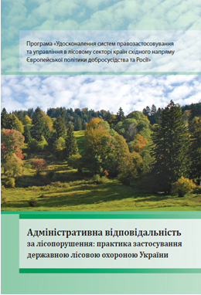
“Administrative Liability for Forest Violations: Practical Application by the State Forest Protection Service of Ukraine”
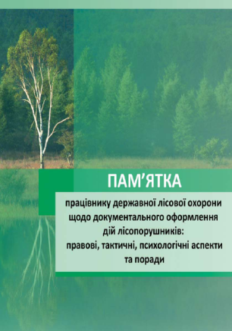

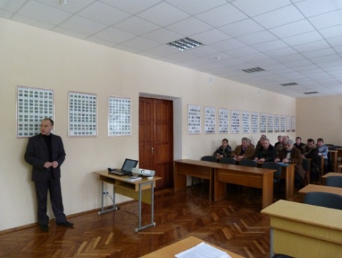
Tutorial at Ukrtsentrkadrylis

Armenia, Azerbaijan, Belarus, Georgia, Republic of Moldova, Russian Federation, Ukraine
ftp://ftp.fao.org/docrep/fao/009/ah231e/ah231e00.pdf
Ibid, table 9.1. Growing stock (volume of living trees) in Europe and Russia in 2005 given as 107.264 million m3, out of a world total of 434.219 million m3.
http://siteresources.worldbank.org/INTFORESTS/Resources/FLEG_brochure_Final.pdf

