Meeting of the Group of Experts on Business Registers
Organised jointly by UNECE, Eurostat and OECD
30 September – 2 October 2019
Geneva, Switzerland

Agne Bikauskaite, August Götzfried
Eurostat

Topic: “Different uses of statistical business registers”
Title of the paper: “Strengthening the EuroGroups Register – for better usage and usefulness”

Abstract

The EuroGroups Register (EGR) is the statistical business register of Multinational Enterprise (MNE) Groups having at least one legal unit in the EU or EFTA countries. The EGR is used for statistical purposes only, with the aim to facilitate the coordination of survey frames in the European Statistical System (ESS) for producing high quality statistics on business and macroeconomics activities.
Currently, the EGR data is an important data source for the production and quality control of Foreign Affiliates Statistics (FATS), Structural Business Statistics (SBS), Gross National Income statistics (GNI) and Foreign Direct Investment statistics (FDI).
The EGR data support the user National Statistical Authorities (NSAs) in:
- the selection of samples (as a sampling frame)
- the production of the official business statistics;
- the identification of statistical survey respondents;
- the better recording of the MNE groups nationally;
- the identification of missing reports and missing enterprises/legal units belonging to the group;
- quality controlling of the microdata from the MNEs as respondents;
- identifying group characteristics, such as Global Group Head, direct parent, economic group information, etc.;
- identifying non-EU legal units of the large groups.
The EGR production cycle is annual with the final EGR frame delivered at t + 15 months. Eurostat is constantly seeking on the users’ needs and working on methodological and process improvements supported by IT developments. Concrete cases are the recording of SPEs or natural persons in the EGR process and timeliness improvements are currently being tested. The paper illustrates the status of the EGR and the improvements planned.
Due to growing interest in information on MNE groups, Eurostat now publishes experimental statistics covering aggregated data on MNE groups. The experimental statistics articles are based on the EGR data solely and have been produced for the reference year 2015 and 2016, with the latest release in June 2019 based on 2017 reference year data.
Keywords: EuroGroups Register (EGR), European Statistical System (ESS), Multinational Enterprise (MNE) Groups, use of statistical business registers
Introduction
Globalisation presents significant statistical challenges, particularly for small and open economies in terms of measuring statistical indicators and communicating the results to users. The European Statistical System allocated high priority to the better measuring of globalisation in the statistical processes and output, in business or macro-economic statistics. Some concrete actions were already undertaken such as setting up of the EuroGroups Register of MNE groups and the putting in place of a so-called Early-warning System for monitoring restructurings of the groups.
This paper focuses on the EuroGroups Register (EGR), the central statistical business register of Eurostat and the EU and EFTA countries' statistical authorities, on it’s use and usefulness in statistics related activities. The EGR is part of the EU statistical infrastructure and has been built up to better capture globalisation effects as well as for improving the consistency of national data on enterprise groups.
The EGR covers MNE groups operating in Europe (EU and EFTA countries). It provides the statistical authorities of the EU and EFTA countries with yearly population frames of MNE groups. The Register's main function is to provide the statistical authorities with a harmonised picture of MNE groups for their national statistics. The EGR has been growing in terms of quality over years and for reference year 2017 covers more than 162 000 MNE groups operating in the EU and EFTA countries. When at least one legal unit of a MNE group is registered in the EU or EFTA country, the group is in the scope of the EGR.
This paper concentrates on the use and the users of the EGR as data source for statistics production, on on-going methodological and processes improvements, as well as on experimental statistical output based on the EGR data and disseminated on the Eurostat website.

The purpose of the EGR
The purpose of the EGR is mainly to store variables on legal units, enterprises and MNE groups.
The EGR provides harmonised information for the users on:
- enterprise groups, enterprises, legal units (identification, demographic and economic characteristics);
- relationships and control;
- shareholdings of at least 10 per cent.
The EGR also have the following purposes:
- to produce coordinated frame population;
- to develop database to derive consistent statistical output;
- to serve as auxiliary source to improve quality of statistical output;
- to serve with input for measuring global activities;
- to maintain database of European enterprises who are part of multinational groups.
EGR users
The EGR is a statistical register with restricted use. The EGR data with the harmonised the multinational groups are only accessible for statisticians producing national statistics in the EU and EFTA NSIs and national central banks.
The EGR data serve only for statistical purposes, i.e. for the production of the official statistics related to globalisation in the EU Member States and EFTA countries, for example:
- Statistics on foreign affiliates (FATS);
- Foreign direct investment statistics (FDI);
- Statistics on small and medium sized enterprises (SBS);
- Statistics on trade by enterprise characteristics (TEC);
- National accounts - statistics on gross national income (GNI);
- Short term statistics (STS).
Currently, 405 statisticians working for NSIs, National Central Banks (NCBs) and Eurostat have access to the EGR output data (EGR frame), as follows:

Figure 1: Registered EGR user and producer
The number of registered users increased in the recent years. All NSIs can use the EGR output for the production and quality assessment of their national statistics. 18 National Central Banks (NCBs) from Member States can access the EGR data as well. In addition, the 10 other NCBs could get access by using the pre-defined access procedures.
EGR use
When gradually year by year improving the EGR quality and completeness of data on the MNE groups, more and more EU and EFTA countries starts using the EGR data in their FATS production and are redesigning their national FATS production processes accordingly.
One of the examples are Sweden, that at the EGR-FATS workshop in June 2019 made a presentation on the EGR quality and use. It has been reported that according analysis performed by Swedish colleagues EGR has reached sufficient quality for national FATS production to be considered as official statistics. Other countries such as Italy, France, etc. also reports on integrating in the national systems the EGR as the main source for FATS production.
Aiming to increase the usage of the EGR within the European FATS community, Eurostat defined and NSIs produces the EGR-FATS quality indicators. The objective of these indicators is to evaluate the asymmetries of the EGR and FATS microdata. In the calculation process, national EGR and FATS populations for the reference year 2016 have been compared on the enterprise record level. The EGR-FATS asymmetry indicators were prepared by the NSIs, which have access to both (EGR and FATS) microdata sets and were delivered to Eurostat. The EGR-FATS indicators being calculated immediately after the completion of the FATS data compilation comparing EGR and FATS populations of the same reference year.

Figure 2: Coverage of MNE groups in the EGR (2014 to 2017)
The EGR is also been reported to be used as a source for the statistics production and quality checks in other statistical domains, such as FDI, GNI, etc. The number of registered users increased in the recent years. All NSIs are users of the EGR output. 18 National Central Banks (NCBs) from Member States have access the EGR data as well and use it as a source for the statistics related purpose.
The FDI statistics compilers reported regarding their use of the EGR as follows (survey results of Q4/2018):
- The EGR data was judged as being useful and easy to access;
- The EGR is useful for identifying missing relationships in the MNE group structures, for identifying extra-EU units and their turnover, NACE and employment;
- The EGR data is useful for quality control of FDI statistics;
- The production process of the EGR should be strengthened (better timeliness);
- More characteristics/variables should be stored in the EGR (e.g. balance sheet data, minority relationships).

EGR methodological and process improvements
The EGR 2.0 system has completed successfully three complete cycles of 2015, 2016 and 2017 reference years and has reached a good level of maturity. The future developments aim at:
- Improvement of the process and output quality;
- Methodological improvements and implementation in the EGR system;
- Reduce the efforts required from the users to produce a reference year frame;
- Increase the performance of the IT system.
Currently the EGR is planning to improve the processing of the SPEs and include new attribute for reporting residence country of the natural country that controls the MNE group.
Eurostat will update the EGR DSDs by introducing an additional variable on the UCI (legal unit or natural person) residence country code.
In general, the UCI country code will be the same as the GGH country code (as well as GDC), because currently all the registered controlling units are legal units and hence the GGH equals the UCI. However, when FRIBS comes into force, a special treatment for an UCI when it is natural person will be needed. Where it is known (and information is available in the NSBR) that the unit on the top of the control chain is a natural person not engaged in economic activity, the residence country of that unit should be reported to the EGR (variables 2.10a in FRIBS GIA).
While the flag for SPEs is already available in the EGR just have to be treated by the reporting countries. According to the current Business Registers Recommendation Manual (released in 2010), units without substantial physical presence and without significant economic activities are not able to be engaged in decisions and to control the subsidiaries within the MNE group. In these cases, the controlling (GGH/UCI) and strategic management (GDC) units should be the unit at the next level in the enterprise group tree structure as real controlling and functional strategic decision centre of the MNE group.
This recommendation had to be applied for all kind of "empty shell" units located e.g. in tax havens and in offshore financial centres, for special purpose entities and for non-profit units, which are on the top of an enterprise group structure.
In order to increase the usefulness of the EGR for the FDI compilers and other concerned EGR users, Eurostat sees an importance of availability of information on SPEs in the EGR. NSIs are constantly being encouraged to flag and deliver the identifier of the SPEs – as described in the draft FRIBS basic act (annex IIIa) – already for the current (2018 reference year) as well as for upcoming EGR data exchange cycles. The new IMF defined definition is recommended to be used when identifying the SPE units in the EGR population.
Eurostat constantly communicates with the EGR users and producers. The EGR incoming files are being monitored and quality checks performed regularly within the EGR process. Compliance to the EC regulations 177/2008 and 192/2009 is annually monitored and countries not performing well being requested to provide with the reasons and action plans for further improvements in data delivery. More consistency between EGR and FATS population is being requested from the countries as well.
Additional sources of information such as crowdsourcing platforms, web crawling and different open data projects are seen as further opportunities to increase the quality of the EGR, its completeness and accuracy namely with the units outside of the EU and EFTA as well as the aggregate indicators on the whole group level.
Eurostat also follows the works of the Global Legal Entity Identifier Foundation (GLEIF) on the globally unique legal entity identifiers as well as on the GLEIF level-2 data on relationships of legal units. The aim is to use the LEI numbers in the EGR data exchange process and little by little introduce it in the EGR system.
Eurostat collaborates with OECD that develops a project on ADIMA database. This cooperation can be mutually beneficial in the future, when ADIMA will reach certain level of maturity.
Eurostat also aims at strengthening the user interaction and increase the use of the EGR by the user domains (FATS, FDI, GNI, etc.). Eurostat proposed grants for countries trying to promote more and more communication in the NSIs, as well as between NSIs and NCBs.
Despite growing interest in the structure of MNE groups, Eurostat does not yet publish any official European statistics on that topic. To meet this information need, Eurostat now publishes experimental statistics on structure of multinational enterprise groups in Europe based on the EGR data.
Experimental statistics
In an effort to better respond to users' needs Eurostat publishes experimental statistics on the related Eurostat website based on the EGR data.
The EGR experimental statistics article focuses on the population of the active multinational enterprise groups in the EU and EFTA countries.
The EGR defines an multinational enterprise group a group that has legal units or enterprises in two or more countries, at least one of them in the EU or EFTA. According to the EGR, 162 466 MNE groups were registered in the EU in 2017, 116 497 of which are from the EU (i.e. their global decision centres were located in the EU Member States).
The remaining EGR MNE groups are from non EU countries, mostly from Switzerland (10 122), the United States (7 614), Turkey (2 933), Canada (2 900) and Norway (2 063). The EGR is a very rich data source, Eurostat and the NSIs are continuously working to improve its quality. Having sufficient quality level in the future, the EGR can be the source of very relevant and valuable European official statistics.
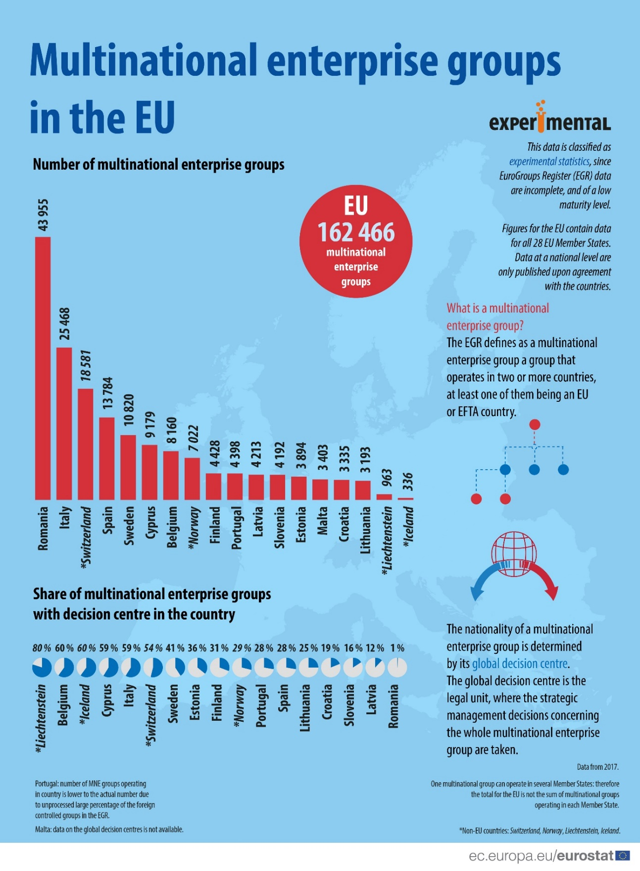
Figure 3: The EGR experimental statistics infographics

Way forward
Eurostat and the NSIs are continuously working to improve the quality of EGR. Further improvements are planned on the EGR processes, on its coverage, accuracy and timeliness. Additional data sources will be analysed and used in the future.
The main goal of Eurostat is to enhance the use of EGR in official statistics. Statistical compilers of the EU and EFTA countries can use EGR as coordinated frame population of multinational enterprise groups and their units to derive consistent statistical output when measuring activities related to globalisation.

