TURKISH BUSINESS REGISTERS SYSTEM
H.Erdem Şahinler, Can Doğan, M.Arda Yılmaz

ABSTRACT
Turkish Business Registers System, an important factor in ensuring consistency between the national accounts and short term/annually business statistics, was firstly built reference year of 2006 based on administrative records. The system, which has been modernized from the reference year of 2017 on, was started to be produced at international standards and presented to the use of Turkish Statistical System as well as researchers and academicians. With the new system, the changes in the units (opening, closing, merging etc.) are reflected in the business registers more timely and the system has been turned into a stronger backbone for the statistics produced. Protocols have been made with other public institutions that produce financial statistics. Therefore the quality of the system in the statistical production has been increased. This paper examines the changes made in the business registers system and the impact of this changes made on the statistics produced. The paper also emphasizes the steps to be taken to develop the system.
- Introduction
Business Registers (BR) System, where identification, demographic and economic variables and ownership information of enterprises contributing to GDP and their local and legal units are kept, is the base database for statistical survey frames. One of the most important features of a BR is its function in the integration of administrative records. General Business Census used for similar purpose was done in 2002 for the last time in Turkey. The BR based mainly on administrative sources was first set up in reference year 2006 and it has been used for producing business demography indicators and generating enterprise groups. With the Turkish Statistical Law (2005), use of administrative data became possible and administrative authorities got the responsibility of providing their data with TurkStat. Within this context, records of Revenue Administration which is the main database for tax obligations of businesses activating in Turkey has been received by TurkStat and used as the central data source. In addition, records of Social Security Institution, Ministry of Treasury and Finance, Ministry of Agriculture and Forestry, Ministry of Health, Ministry of Trade and Ministry of Education are used for update of the system.
In 2016, very comprehensive administrative data was started to be shared by the protocols signed between TurkStat and its main partners, Revenue Administration and Social Security Institution, at the level of businesses and individuals. Exchange of this datasets has been a turning point for TurkStat’s official statistics related to economy. By means of this, correct and up-to-date turnover and employment variables BR needs have been attained. Moreover, by the web services set up for Revenue Administration data, instant data transfer has become possible. Thanks to these developments, new approaches could be applied at building the coverage of BR frame for reference year 2017, delineating the statistical units and increasing the basic variable quality.
Turkish BR Group in TurkStat activates under Register Systems Department with 13 technical, 1 managerial and 1 IT support staff. The group contributes to the working culture of the office while it contributes to the realization of quality, efficiency, timeliness and consistency of the business statistics produced.
- Turkish Statistical System
Turkish Statistical System has been set up based on administrative records and EU norms in 2006 reference year. After the data exchange protocols with administrative authorities, new tables and datasets were able to be accessed while 2017 frame studies was made. Thus, new variables could be added to the system while quality of current variables could be increased. Moreover, the basic approach for delineation of enterprises and coverage methodology has been in need of change. As a result, restructuring of the system was started.
The basic structure of the system is mentioned in this part.
  - Data Source:
Until the 2017 reference year, the main data sources have been Revenue Adminstration’s tax records and Social Security Institution’s declaration records. Besides, TurkStat’s business surveys and other administrative records were used for quality and checks. These data were attained annually once and BR was updated so. After the frame was frozen at the end of year t, the new openings and closures in year t+1 were not known and this structure was not meeting the short term requirements.
With the 2017 reference year and with new BR system, by the help of daily web services setup between TurkStat and Revenue Administration, changes of information of businesses have been transferred daily. Thus, a dynamic system which could be frozen monthly, quarterly or annually was attained. Moreover, access to tax declaration tables by monthly and quarterly became possible.
Similarly, by the broad authorization for accessing the social security records, matching process of them with tax records became more effective and quality of employment variables has been increased.
After these data are transferred to TurkStat database, structural and integrity controls are applied to the units to make them anonym. Also, classification and coding are done.
Besides the external data sources, internal sources are used, too. Although main economic activity codes of enterprises are attained from the main administrative sources, the units which have economic significance are surveyed every month by the teams working in TurkStat Regional Directorates.
Table 1: Administrative Source/Variable Relation
Administrative Source | Delineation Of  Units | Activity | Employment | Turnover | Institutional  Sector | Address
Revenue Administration | X | X | X | X |  | X
Social Security Institution | X | X | X |  |  | X
TurkStat Regional Directorates |  | X |  |  | X
Ministry of Education |  | X |  |  | X
Ministry of Treasury and Finance |  | X |  |  | X
Ministry of Health |  | X |  |  | X
TurkStat Surveys |  | X |  |  | X | X

  - Statistical Units:
The correct delineation of statistical units in BR would affect the whole business statistics production process positively. The legal basis for Turkish BR is “Regulation (EC) no 177/2008 of the European Parliament and of the Council of 20 February 2008 establishing a common framework for business registers for statistical purposes and repealing Council Regulation (eec) no 2186/93” and “Council Regulation (EEC) No 696/93 of 15 March 1993 on the statistical units for the observation and analysis of the production system in the Community”.
By Council Regulation (EEC) No 696/93 of 15 March 1993, statistical units are defined as below:
Legal Unit: Legal persons whose existence is recognized by law independently of the individuals or institutions which may own them or are members of them, natural persons who are engaged in an economic activity in their own right.
Local Unit: The local unit is an enterprise or part thereof (e.g. a workshop, factory, warehouse, office, mine or depot) situated in a geographically identified place. At or from this place economic activity is carried out for which - save for certain exceptions - one or more persons work (even if only part-time) for one and the same enterprise.
In Turkish BR, each branch belonging to a legal unit is assigned a local unit number.
Figure 1: Generating the Local Units
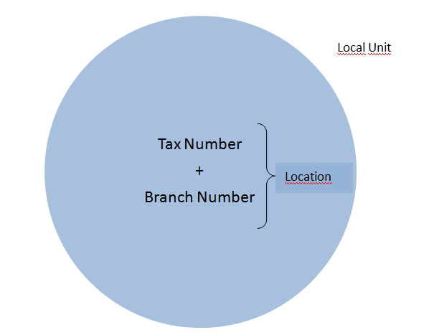
Enterprise: The enterprise is the smallest combination of legal units that is an organizational unit producing goods or services, which benefits from a certain degree of autonomy in decision-making, especially for the allocation of its current resources. An enterprise carries out one or more activities at one or more locations. An enterprise may be a sole legal unit.
In Turkish BR, each legal unit corresponds to one enterprise at the most case. However, there are certain enterprises having more than one legal unit, which are called as complex enterprises.
Figure 2: Legal Unit Enterprise Relationship
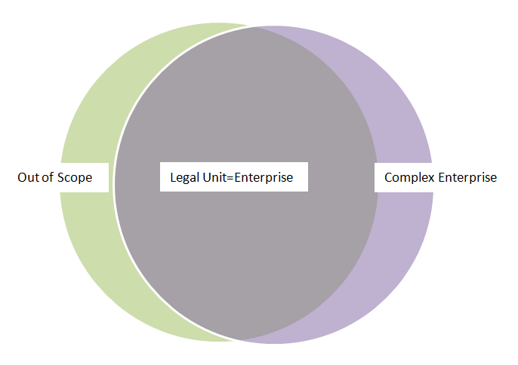
Enterprise groups that gain importance with globalization can be defined as an association of enterprises connected by legal and/or financial links. The enterprise group may be linked to more than one decision center, especially for production, sales and income policy. The decision center can centralize some financial management and taxation issues.
In the Turkish Business Registers System, the information of the enterprise group cannot be produced directly and systematically through administrative records. Therefore, the information is compiled with field work.
As of the 2017 reference year, the use of some previously unreachable administrative records has positively affected the process of establishing complex enterprises and defining the framework of enterprise groups survey and some deficiencies in previous reference years have been completed. In addition, institutional sector assignments at the legal unit level have been made in a systematic and correct manner and institutional units have been established.
Figure 3: Production of Enterprise Group
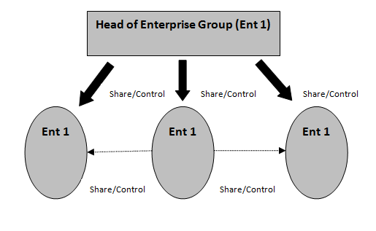

Table 2: Number of local units and enterprises by years
Year | Number of  Legal Unit | Number of Enterprise | Number of  Local Unit
2009 | 3.287.862 | 3.266.911 | 3.787.881
2010 | 3.309.917 | 3.287.412 | 3.857.797
2011 | 3.333.990 | 3.309.859 | 3.963.053
2012 | 3.386.923 | 3.362.086 | 4.060.175
2013 | 3.425.431 | 3.397.724 | 4.134.408
2014 | 3.463.335 | 3.434.912 | 4.259.163
2015 | 3.527.433 | 3.498.586 | 4.318.576
2016 | 3.639.231 | 3.608.470 | 4.465.173
2017 | 3.724.625 | 3.696.004 | 4.586.509

2.3 Variables
According to Regulation No 177/2008, the variables included in the Turkish Business Register System can be summarized as follows;
Figure 4: Retained variables

Until 2017 reference year, due to limited administrative record access, turnover variable could not be kept in the business registers system at all. The employment variable was kept in the system but contained quality problems. In addition, the proportion of address variables conforming to Standardized Address Database of Turkey was low. On the other hand, in TurkStat business statistics production process, there was the problem that the main activity of the enterprises was not followed consistently in different producer units. There were serious deficiencies in determining the institutional sector variable.
Since the 2017 reference year, there have been significant improvements in the quality and type of variables held in the system. The turnover variable, which is calculated by the relevant units of TurkStat (short-term / annual statistics), is integrated into the Business Registers system. The Social Security Institution data, which has been used with wider access, has been improved to be matched with the records of the Revenue Administration and integrated into the Business Registers system as the main source in the calculation of employment.
One of the most important stages of the business register system is the proper assignment of the economic activities of the units. It is not always possible to update the activities that change over time in the register tables via the taxpayer notification form. Through the activity inquiry teams established in TurkStat Regional Offices, the main activities of enterprises whose size is above a certain threshold in the field are controlled and, where necessary, corrections are made and quality improvement is achieved by making corrections. When the enterprises whose main activities are selected according to their size, turnover, etc. are controlled by TurkStat in the field study, it is seen that approximately 8% of main activities of these enterprises change at the section level and approximately 16% of their activities change at NACE Rev.2 two-digit level.
On the other hand, the data obtained from the Revenue Administration since 2017 reference year is used as an aid in determining the main activity. In order to contribute to the controls made by the Revenue Administration, trainings are provided to the registry officers of Revenue Administration by TurkStat.
Institutional sector coding, which is an important tool in determining the position of legal units in the market, was studied in partnership with the National Accounts unit and institutional sector codes were assigned and classified for all units in the system. Address variables received from the Revenue Administration were improved as a result of improvements in the administrative register. This is an important progress that will affect regional statistics. An increase has been achieved in the records of local unit addresses that comply with the national address standard. However, addresses that are still incompatible with standards are made available to national address standards using micro-analysis and text mining methods.
As a result of these improvements, the consistency and integrity of the Business Registers System and role of the system as the backbone of the business statistics has been realized. Thus, standardization can be achieved in terms of common units and variables used in statistical production.
2.4. Scope:
Establishing the scope in the Business Registers System is one of the most important steps in the production process. Until 2017 reference year, due to the lack of administrative data, the definition of economic activity was defined by the tax liability of the enterprises. However, this definition did not meet international standards. Access to the turnover and employment data as of the 2017 reference year, the definition of being active economically was revised in line with the EU standards by using these variables.

2.5. The Role of Business Registers:
With its new structure, Turkish Business Registers System constitutes a backbone model in which the statistical units used by TurkStat business statistics and National Accounts units are produced and the variables of these statistical units are kept in accordance with EU standards. In this way, the inconsistencies between the statistics produced by different units can be minimized.
2.5. Integration of Geographical Information System:
In recent years, interest and need for geocoded data has increased. With the pilot study carried out using the information of Gaziantep, where the MAKS (Spatial Address Registration System) project was completed, business records data were combined with spatial infrastructure. When the MAKS project is completed nationwide, the study will be carried out for the whole country and will be available to the users.
When the study is completed, it will be ensured that the workplaces that may be affected by disasters such as earthquake, flood and fire, the number of employees and the economic cost to be calculated more accurately. Taking into account the distances of complementary sectors, the actual situation will be revealed and, if necessary, geographic based incentives will be provided. Access to some services and commercial activities (e.g pharmacy, market, etc.) needed in the living areas can be calculated and the areas where these are missing will be identified and specific studies will be carried out in these areas. In addition, more modern visualization techniques such as heat map can be used in data presentation.
3. CONCLUSION AND FUTURE STUDIES
For the healthy functioning of the decision-making processes related to the economy; it is needed better quality, timely, consistent data and the integrated statistics created with this data. The business registers system should be considered as the backbone of these integrated statistical systems.
In the process of updating the Turkish Business Registers System, business processes have been documented and the system which was not integrated has been brought together. The institutional sector code was given to each unit in the system and the need of the National Accounts System from ESA 2010 was met. Responsible units were determined for common variables, and the consistency between statistics was increased by avoiding the calculation and use of the same variables by different units.
In the near future, Business Demographic indicators published once a year will be updated and their content will be enriched and fast growing enterprise statistics will be included in the publication process. A separate team will be established to identify the links between the legal units / enterprises under the enterprise groups and to reveal the ownership / partnership structure and profiling will be carried out for these enterprises. Profiling is planned as face to face for large enterprise groups, telephone inquiry for medium sized enterprises and desk inquiry for small enterprises.
In addition, stakeholders' limited online access to the business registers system will be ensured to be realized.

