MERIC RIVER FLOODS AND TURKISH–BULGARIAN COOPERATIONS

Nurullah SEZEN
Hydrologist, Meteorological Eng., nurullahs@dsi.gov.tr,
DSI Genel Mudurlugu Yucetepe- Ankara – Turkey

ABSTRACT:

The lover Meriç River regions have been suffering from floods on Turkish, Bulgarian and Greece territory. In recent years floods frequencies and their magnitudes are getting higher and higher. Floods occurred in the past two years have not been experienced for the last twenty years. Besides of the floods, decreasing of the channel capacity is another difficulty of the region. Every year, channel capacity is dramatically decreasing due to low flows. Edirne City Center is very close to the border and under completely flood risk.
Flood information can not be gathered in time, the only data available is collected on Turkish territory. Because floods occur in the mountainous regions of Meriç river basin and its tributaries which they are on the Bulgarian territory. It is clear that improvement in measures for flood prevention and diminishing of flood hazardous effects can be achieved only through co-operation and use of common information sources.
Turkey and Bulgaria developed three projects; first one for information and real time data exchange and second and third for flood forecasting and warning. These projects are the first common projects which are applied in the region on forecasting.

MERIC RIVER FLOODS AND TURKISH–BULGARIAN COOPERATIONS

The Meriç River is the biggest river on the Balkan peninsula with a catchment area more than 53 000 km2. The Meriç basin has been quite densely populated (more than 2 million people on the Bulgarian territory), highly industrialized and with intensive agriculture. The biggest cities are Plovdiv on the Bulgarian territory, with 650 000 citizens, and the city of Edirne on the Turkish territory, with 230 908 citizens.

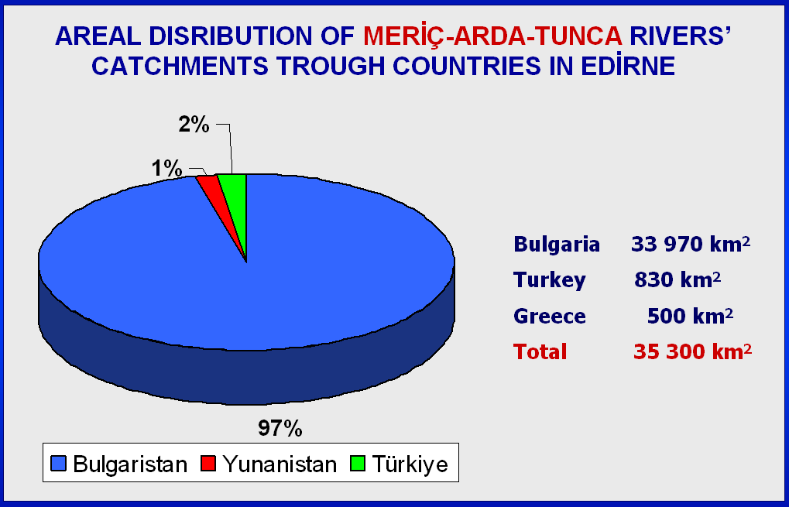
Graphic 1:

The basin area at the upper course of the river has predominantly high-mountain character while the character in the middle and lower river course is plain. The biggest tributaries of Meriç River are Tunca and Arda Rivers. While Arda River does not belong to the Bulgarian-Turkish border area, the Tunca River crosses the border region and marks the border between the two countries for about 9 km.

Tunca River catchments area is about 7884 km2 and the length on the Bulgarian territory is 350 km. Arda and Tunca Rivers converge the main stream of Meriç river on Turkish territory, south of the Bulgarian – Turkish border near the city of Edirne.

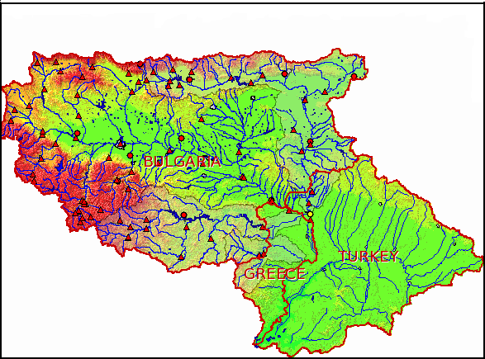
Map 1: Meriç Basin

The climatic and geographical characteristics of Meriç and Tunca River Basins lead to specific run-off conditions: flash floods, high inter-annual variability, heavy soil erosion reducing the channel and reservoirs' capacities through sedimentation, etc. The destructive forces of climatic hazards manifesting themselves in the form of rainstorms, severe thunderstorms, intensive snowmelt, floods and droughts, appear to increase during recent years.

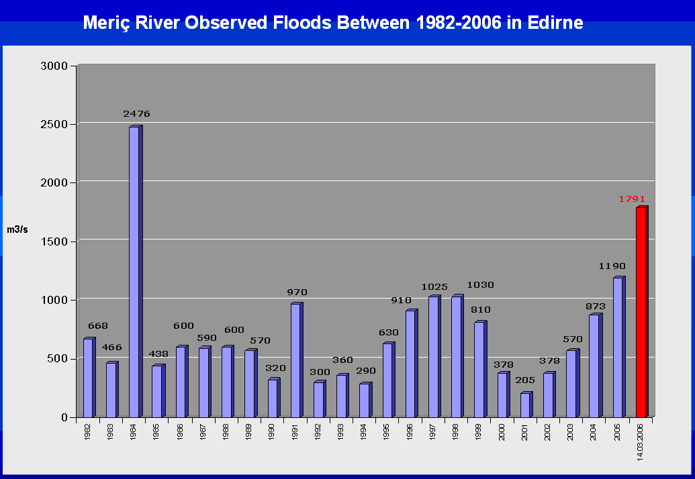
Graphic 2:

Climate change is a causative element in flood disasters but there are other factors. Despite of the significant number of reservoirs and cascades having total capacity for Meriç and Tunca about 2.2x10⁹m³ and for Arda about 1x10⁹m³ in the Bulgarian territory, their retention possibilities are not sufficient to reduce (control) the floods downstream. At the same time it doesn’t mean that dams and cascades don’t have any bad effects on the floods. Better dam operation techniques and rules can do considerable mitigation on the floods.

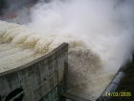

Figure 1: Ivaylovgrad Dam during flood time

The first documented floods are on Bulgarian territory in the region of Plovdiv when the river level on 31.Aug.-01.Sep.1856 was higher than 4 m. The records continue with the following big inundations in 1876, 1894, 1911, 1957. The most sudden and dangerous floods were observed in Arda river basin as a result of Mediterranean cyclones causing intensive precipitation and snow melt during winter. Thus the floods along Arda River and its tributaries Varbitza and Krumovitza in 1956, 1990, and 1996 with wave height more than 6 m occurred. Arda river cascades have generated more than 2000 m³/s and 1400 m³/s peak discharges last two years causing great losses and casualties.

In February 2005 and March 2006, significant flood hazards occurred in Meriç River Basin. A lot of losses in agriculture occurred, in 2006, along the lower part of Tunca, 2500 ha agricultural area were heavily affected and downstream at the city of Edirne flooded area was 37500 ha.

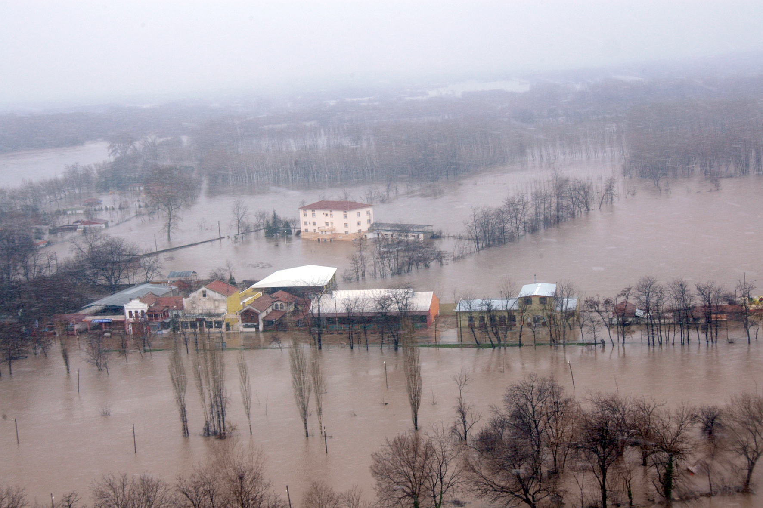
Figure 2: Some part of Edirne City during 2006 flood.

The floods occurred in the Meriç Basin, caused deaths, sufferings and extensive damage to both public and private property and costly social and economic disruption for a time after disaster in the region.

The topography of the lower part of Meriç River is relatively flat and the area is not suitable to built infrastructures to store flood water in order to prevent floods. Consequently, the best practice is to keep the Meriç River in its natural bed by using existing dikes.

When Meriç River flows reaches 1000 m³/s, the capacity of the lower dikes (summer dikes) is not sufficient to hold the flowing water. As a consequence some part of Edirne city and large amount agricultural area is flooding. The higher dykes (winter dikes) protecting Edirne city center were built in 1960’s with a capacity of 4000 – 6000 m3/s. Due to long dry periods, capacity of the river to transport sediments decreased and as a result of this new sand islands occurred in the river and existing islands became larger. Therefore there will be probable damages on winter dykes over 2500 m3/s of flow rate because of the squeezing of river cross section and increased roughness. During the last flood around Edirne city (in Kirişhane flow measurement station), Meriç flows reached 1700 m³/s and Edirne city center was under flooding danger.

Setting up the Flood Forecasting and Early Warning System are foreseen as a necessary step for a sustainable and efficient solution of problems with flood events in the Meriç River Basin. Forecasting of the frequency, magnitude and time of flood and warning the provincial and local authorities and public against an expected flood and activating national and local preparedness and response plans are among the preventive activities in order to reduce the flood damages.

Meriç river’s floods are affecting Turkey, Bulgaria, Greece. Turkey has not required warning time against floods due to shortness of the river length inside the country. Therefore, flood forecasting and required warning time depends on information which comes from Bulgarian site. Until 2003 there was no communications between neighborhood countries about floods. Instutions: State Hydraulic Works (DSI - Turkey) and National Institute of Meteorology and Hydrology (NIMH – Bulgaria) made several meetings to solve (mitigate) Meriç River’s flooding problem.
As a first step both side experts developed sure connection between themselves and exchanged phone numbers and addresses.
As a second step four telemetric hydrometry stations have been established in Bulgarian part of the Meriç catchments, one is on the Arda river, cast after Ivaylovgrad dam (close to Greece border), two stations installed on the main channel of Meriç river, one in Plovdiv city the other one near to Svelengrad town and the forth one established on Tunca River in Elhova village. These stations are recording continuously and supplying real time river data using satellite and GSM communication systems to the both countries.
Turkish and Bulgarian hydrometric technicians measure cross-sections and made several common gauging to develop valid rating curves on these stations.
Established stations and good information system have proved some progress especially during 2005 and 2006 floods but these precautions are not enough. Turkey and Bulgaria submitted three projects to European Commission Cross Border Cooperation program. Accepted projects are:

Project 1 (Cross-Border Co-operation Programme (CBC) between Turkey and Bulgaria):
Floods in the Meriç river basin, risk analysis and evaluation, mobilization of information sources for floods impact decrease.
This project was under the responsibility of Bulgarian and supported by Turkey.

The project is successfully completed. Project region is parts of Meriç river basin on both sides of Bulgarian-Turkish border, suffering from floods.
The main goal of this project is abating risk of floods, which is a part of the negative impact of some environmental elements. The project is evaluating the risk of flooding in the populated areas on both sides of Bulgarian-Turkish border. Tunca and Arda Rivers contribute Meriç main channel near the town of Edirne. On the basis of historical hydro-meteorological information and knowledge about the damage, the project is defining critical water level values for Meriç river and its tributaries that rise a risk for the people and their property, the operational database is created that is including indicative information for floods development, which is accessible through Internet. All gathered information summarized in the project document defining necessary investment about equipment and infrastructure in order to build floods warning system, and a system of measures aimed at decreasing flood’s risk

The specific objectives of the project are:
* effective co-operation between the institutions creating hydro-meteorological information and expertise in the region and decision-making support for the local authorities in case of emergency.;
* reacting a generally accessible source of information about generation and development of natural disasters and floods in the border regions;
* setting a ground necessary for future projects aimed at improving the infrastructure and instruments for operational forecast, prevention and diminishing of damages caused from inundations.

Heavy floods in both countries during last years imposed meetings, getting acquainted with the overall work and responsibilities of both institutions, visiting of hydrologically critical points understanding the specificity of the region, precipitation, and consequences from that.
Specialists from both institutes installed stations on Meriç river and its branches.

At Bulgarian site of Meriç, Arda and Tunca river’s basins there are 71 hydrological stations; 5 of them - automatic, with telemetric data transfers. In Turkey at the project area there are 5 automatic stations, one on Tunca, one on Meriç before branches joining and three after Tunca and Arda branches joining. In the framework of this project two new automatic hydrological stations and one compact meteorological station have been installed on river Byala and on Meriç at Parvomay.

In this project two identical database server installed in both country in Edirne and Plovdiv. MySql and Acces based hydrometric software (HydraHMD) is running in the servers which is developed for this project. HydraHMD software is downloading and uploading the data each other which is collected automatically or manually by using internet base.

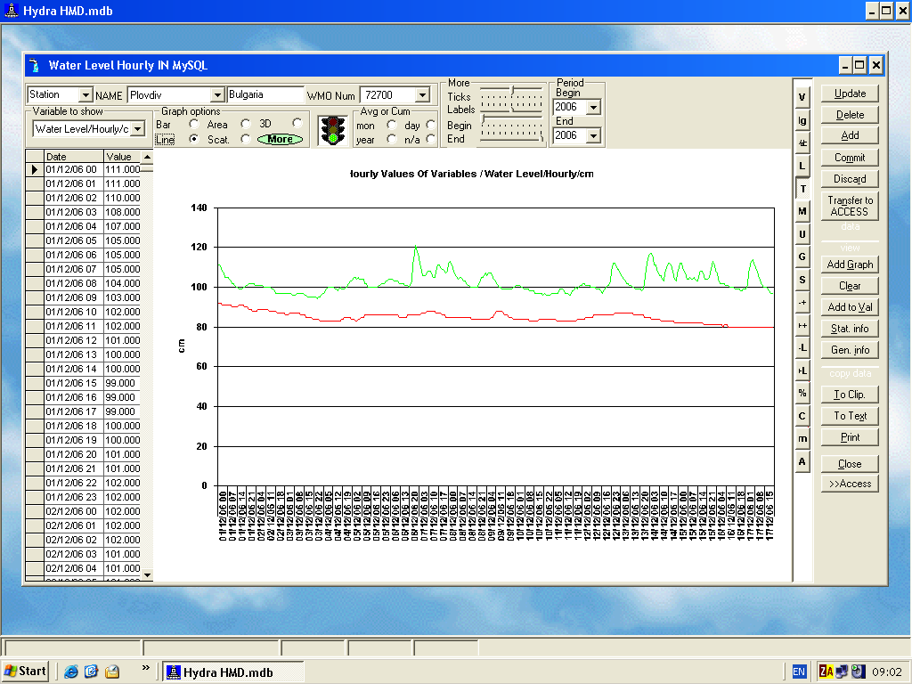
Figure 3: HydraHMD hydro-meteorological software screen.

GIS application made under in this project and elevation, meteorological stations, hydrometric stations, cities, rivers, lakes, catchments, land use, soil type layers digitized and combined in the Arc-GIS environment.

Common WEP pages “ http://plovdiv.meteo.bg/phare/en ” is prepared. The site describes the study, explaining facts of the project and the site also includes WEB based GIS application for the project area.

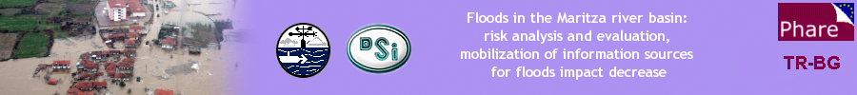
Figure 3: Project WEB Pages header.

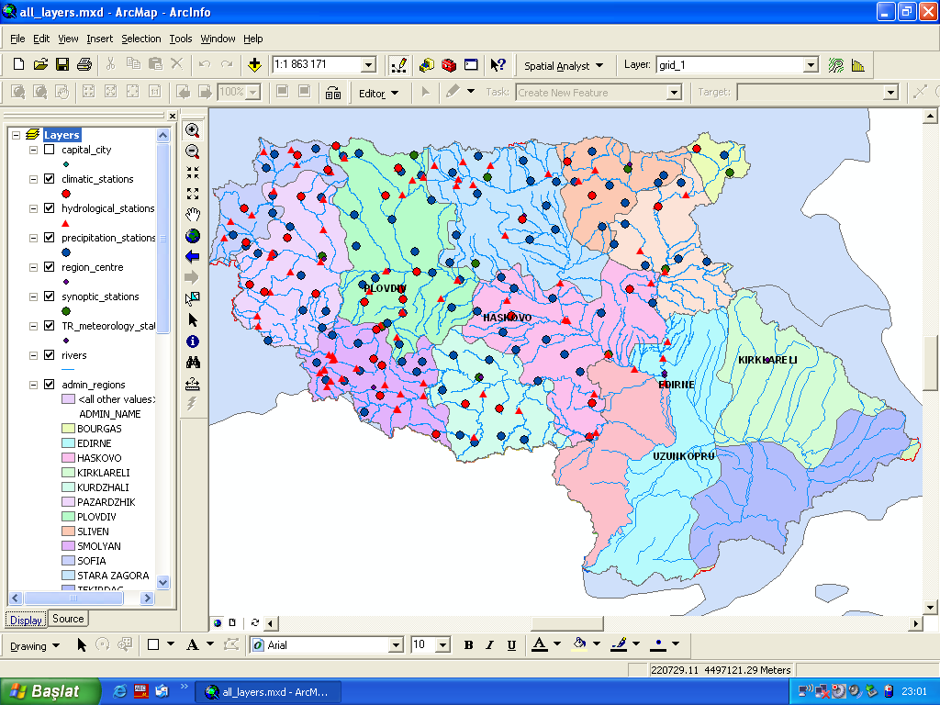
Figure 4: Sample Arc-Map view of the project.

Project 2 (Phare CBC BG-TR Project):
Capacity Improvement of Flood Forecasting in the BG-TR CBC Region.
This project is under the responsibility of Bulgarian side and supported by Turkey.

Project 3 (Phare CBC TR-BG Project):
Capacity Improvement of Flood Forecasting and Flood Control in the TR-BG CBC
Region.
This project is under the responsibility of Turkish side and supported by Bulgaria.

Project 2 and project 3 will be mirror project. They will make possible flood forecasting by using proven technologies. The projects also includes installation some more automatic stations. Bulgarian side established 15 new automatic hydrometric station and 12 meteorological station which they will serve data for common database and flood forecasting projects. Flood forecasting project is under development in Turkey, it will be completed in 2010.

A close cooperation and an intimate friendship have been developed during the studies and meetings between the technicians of both Countries. Relaying upon these assets, we believe that many adversities will be overcome in the future.

