Item 3 .- Promotion and capacity-bulding
- – Coordination mechanisms and synergies:

REPORT BY the CHAIR of the IPRTRCG TO THE MOPP2 PLENARY ON THE INTERNATIONAL PRTR COORDINATING GROUP (ICG)

Thank you very much Mr Chair for giving me the floor and,…
Good morning to everyone, also to the interpreters. Thanks you also to The Nederland for hosting this meeting and for its kind hospitality.

Let me start introducing very briefly what the IPRTRCG (or ICG) is and its main objectives for those who are not very familiar with it:
- The International PRTR Coordinating Group is a platform that brings together key global PRTR players. It is an open group. The United Nations Environment Programme (UNEP), United Nations Institute for Training and Research (UNITAR), UNECE and Spain serve on the Bureau of the International PRTR Coordinating Group. The UNECE Aarhus Convention Secretariat also serves as secretariat.
- The meetings of the International PRTR Coordinating Group usually take place yearly and back to back with the OECD TF on PRTR. Next meeting, the 9th one, will be kindly hosted by the Government of Chile, next October in Santiago de Chile.
- The overall objective of the International PRTR Coordinating Group is to improve coordination among international organizations, Governments, NGOs and other interested parties in their efforts related to the development and implementation of PRTR systems.
Also serves to promote capacity-building for PRTRs in developing countries and countries with economies in transition through intergovernmental coordination.
All the information on the IPRTRCG, objectives, history, meetings, documents, etc is available on the UNECE/PRTR website:

With regard to geographic coverage, ICG participants inform usually on yearly basis, not only about its own progress made in PRTR but also about its PRTR activities and efforts worldwide, for example in Europe, Caucasus, Latin America, central and south east Asia. This means information on a long list of countries such as, Belize, Costa Rica, Dominican Republic, El Salvador, Guatemala, Honduras, / Kazakhstan, Ukraine, Georgia, Ecuador, Cambodia / Thailand / Mongolia / China / South Korea / Columbia / Morocco / Brazil / South Africa, Azerbaijan and other bilateral PRTR-related cooperation.

During its meetings the ICG, for example:
- Promoted PRTR in the major global fora, such as RIO+20, Eye on Earth summit in Abu Dhabi, or the Global-wide round table on PRTR, which took place in 2013 under the auspices of OECD and UNECE.
- Prepared a document, entitled “Pollutant release and transfer register as a reporting mechanism for mercury releases and transfers” which helped to clearly reference PRTRs in the Minamata Convention. (The 1st Conference of the Parties of the Minamata Convention will decide on how to report on mercury emissions and PRTRs system are very well placed in this regards)
- Though not formally affiliated, the ICG reported on PRTR activities to the International Conference on Chemicals Management (ICCM) and the Strategic Approach to International Chemicals Management (SAICM)
- Is working on a world map, the “MAP of PRTR Initiatives”, just to show in a quick view the level of implementation of PRTRs around the world and with the intention to reflect regularly the latest updates. It is not a legal/formal or official PRTR MAP but a friendly way to see how the PRTR family is growing up worldwide.
- Try to identify what we call “PRTR Hot-Topics”. With this it is intended to provide an opportunity for bringing to the discussion any topic that is innovative or considered a priority in the implementation of PRTRs, such us:
  - the role of PRTRs in promoting sustainability and good governance;
  - how the harmonization of PRTR data can be addressed; for example describing what kind of PRTR related resources are available to support PRTR development and seek ways to make existing substantive material available to a broader audience, (e.g. from the OECD TFPRTR)
  - promoting the great potential that PRTRs have for coordination and for building synergies at multiple levels and as a reporting tool to multilateral environmental agreements (like to the Stockholm, Basel, Rotterdam and Barcelona Conventions, or to the Kyoto Protocol) or
  - About the public information, raising questions like what can be done to improve the information for the public, or to generate a greater public´s interest? Or even for a better understanding and use of PRTR data by the public.

In my view, dear delegates, this background is what makes the ICG is well positioned, also for the future, as a mechanism to facilitate cooperation, exchange of information and provide added value to the PRTR initiatives and the ICG participants, avoiding duplications and identifying possible synergies.

I think, Mr. Chair, that’s all from my side. I have tried to give you, an overview on the main activities of the International PRTR Coordinating Group and I would only like to add that you all are invited to participate actively in this group.
Thank you very much for your attention.

Add.1.- Draft “MAP of PRTR Initiatives” (July, 2014):
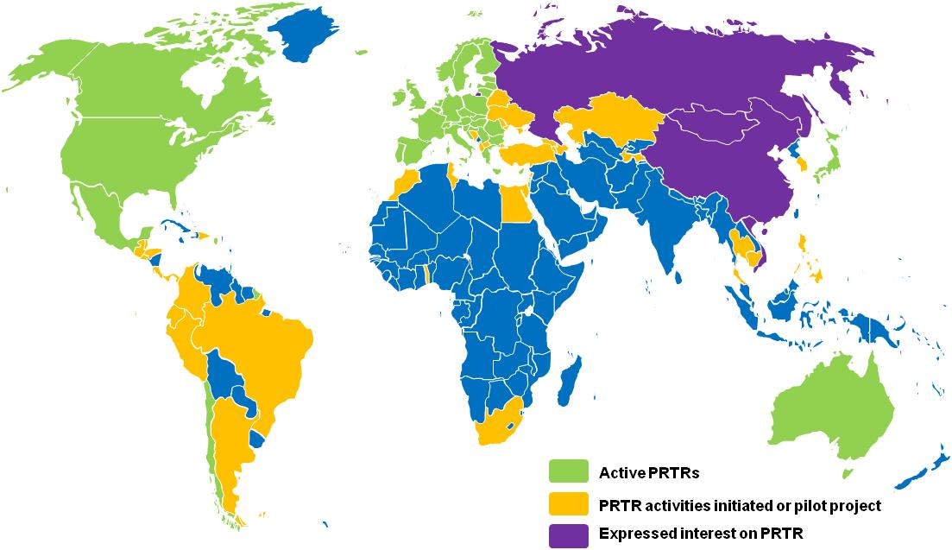
IPRTRCG note: This map is not a legal/formal/official one. The presentation of the material on this map do not imply the expression of any opinion whatsoever concerning the legal status of any country, territory, city or area or of its authorities, or concerning the delimitation of its frontiers or boundaries. Colors are used to illustrate the level of implementation of PRTRs around the world in a friendly way.

