ECE/BATUMI.CONF/2016/6

|  |  |
| --- | --- |
| ENVIRONMENT FOR EUROPE  UN ENVIRONNEMENT POUR L’EUROPE  ОКРУЖАЮЩАЯ СРЕДА ДЛЯ ЕВРОПЫ  გარემო ევროპისათვის | Logo-EfE |
| BATUMI, 8–10 June 2016 |

Eighth Environment for Europe  
Ministerial Conference

Batumi, Georgia  
8–10 June 2016

Pan-European Strategic Framework for Greening the Economy

|  |  |  |  |
| --- | --- | --- | --- |
|  | United Nations | ECE/BATUMI.CONF/2016/6 | |
| _unlogo | **Economic and Social Council** | | Distr.: General  22 March 2016  Original: English |

**Economic Commission for Europe**

Eighth Environment for Europe   
Ministerial Conference

Batumi, Georgia, 8–10 June 2016

Item 4 of the provisional agenda

**Greening the economy in the pan-European region**

Pan-European Strategic Framework for Greening the Economy

Adopted by the Committee on Environmental Policy

Contents

*Page*

Introduction 2

Pan-European Strategic Framework for Greening the Economy 3

A. Mandate 3

B. Aim and scope 3

C. Objectives and focus areas 4

D. Implementing the Strategic Framework 8

E. Contributing to achieving the Sustainable Development Goals 9

F. Monitoring and review 9

Annex

Batumi Initiative on Green Economy 11

**Figures**

1. The green economy in action 5

2. The Strategic Framework at a glance 10

Introduction

1. In response to the commitment made by ministers of the United Nations Economic Commission for Europe (ECE) region in Astana in 2011 to take the lead in the transition to a green economy, the ECE Committee on Environmental Policy mandated ECE, jointly with the United Nations Environment Programme (UNEP) and other relevant international organizations and stakeholders working on green economy, to develop a proposal for a pan‑European strategic framework for greening the economy. The proposal was to be prepared for the Committee’s consideration at its twenty-first session, in October 2015 (ECE/CEP/2014/2, paras. 73 and 98 (ee) (v)).

2. In that regard, the Committee asked that the strategic framework include practical examples, good practices and tools to be used for accelerating the transition to a green economy, while promoting a bottom-up approach, as well as that it build upon existing knowledge products and platforms. The Committee also requested that the framework include in an annex a proposal for a green economy initiative similar to the Astana Water Action.

3. Following up on that mandate, a first draft of the strategic framework was prepared by the ECE secretariat and UNEP in cooperation with the Organization for Economic Development and Cooperation and the European Environment Agency, as a result of a series of brainstorming meetings hosted by ECE and UNEP and by electronic means.

4. At its twenty-first session, the Committee generally agreed the strategic part of the draft Pan-European Strategic Framework for Greening the Economy. The Committee also welcomed the proposal by Switzerland to advance the development of the proposed voluntary actions, and entrusted Switzerland to form and convene a group of experts in green economy to prepare a revised draft of voluntary actions to green the economy for consideration at the Committee’s special session in February 2016 (see ECE/CEP/2015/2, forthcoming).

5. At its February special session, the Committee welcomed the revised draft of the Strategic Framework and adopted it, as amended during the session, for submission to the Conference as an outcome to be endorsed (see ECE/CEP/S/2016/2, forthcoming).

6. Furthermore, the Committee welcomed the Batumi Initiative on Green Economy (BIG-E) included in the annex to the Strategic Framework. In that regard, the Committee expressed its gratitude to Switzerland for its leadership, welcomed the proposed approach for the Initiative, and invited interested Committee members and observers to submit voluntary commitments to it, preferably by Monday, 9 May 2016.

7. The Committee also took note of the draft list of possible green economy actions, to be used as reference only, and invited its members and observers to provide additional examples to be added to the list by 21 March 2016.

8. Ministers at the Eighth Environment for Europe Ministerial Conference will be invited to endorse the Pan-European Strategic Framework for Greening the Economy –– a tool supporting countries’ efforts in transitioning to green economy and at the same time contributing to the implementation of the Sustainable Development Goals –– and to commit to implementing it.

Pan-European Strategic Framework for Greening the Economy

|  |
| --- |
|  |
| **Vision**  *This Strategic Framework envisions the countries of the pan-European region pursuing a development pattern that ensures economic progress, social equity and the sustainable use of ecosystems and natural resources, so as to meet the needs of the present generation without compromising the ability of future generations to meet their own needs. Green economy, as an approach to redirect consumption habits, investments and trade to foster an inclusive green economy towards a shared prosperity, is a promising avenue to achieve sustainable development in the region and beyond.* |
|  |

A. Mandate

9. The Strategic Framework for Greening the Economy in the Pan-European Region[[1]](#footnote-2) responds to a decision by ministers at the Seventh Environment for Europe Ministerial Conference in Astana in September 2011 to take the lead in the transition to a green economy, as well as their invitation to ECE to contribute, together with UNEP and relevant international organizations, to the development of the United Nations Conference on Sustainable Development (Rio+20 Conference) green economy outcomes.[[2]](#footnote-3)

B. Aim and scope

10. The aim of the Strategic Framework is to guide the region in its transition to an inclusive green economy by 2030. Such a transition, with adequate support and incentives, will bring investment in innovation for green technology, products and services, foster the transfer of green technology and stimulate green behaviours by consumers. It will result in the reduction of environmental risks and address ecological scarcities, as well as provide green jobs and minimize the negative consequences of change for enterprises and the vulnerable groups of society.

11. The Strategic Framework will help countries in the development and implementation of their policies, strategies and plans for greening the economy and achieving sustainable development. To do this, the Framework proposes a vision, objectives and focus areas that build on the policy effort that followed from the Rio+20 Conference outcomes and the 2030 Agenda for Sustainable Development, as well as on the knowledge base and good practices developed in the region.

12. To support the implementation of the Strategic Framework, the Batumi Initiative on Green Economy is proposed for the period 2016–2030. The Initiative will comprise voluntary commitments by interested countries and organizations, both public and private, in the form of green economy actions (see section D below and annex).

13. The transition to green economy will require enhanced cooperation among and within countries, as policy measures, including market-based instruments, deliver better results if implemented in a clear, predictable and coordinated manner. Cooperation also allows building on each other’s knowledge, experience and good practices, and helps to engage more effectively the private sector and civil society, whose role and influence increasingly surmount national borders. By building on the knowledge base, policies and actions at both the regional and national levels, and by addressing key constituencies, the Strategic Framework will help to advance such cooperation.

14. The Strategic Framework is expected to serve environment ministers in initiating and sustaining discussions on the green economy transition in their national Governments and, ultimately, in creating an interministerial policy process to bring forward such an agenda involving key constituencies, including the public at large and the private sector.

15. The implementation and monitoring of the Strategic Framework and the Initiative, at both the regional and national levels, could be facilitated by existing intergovernmental policy platforms, namely the ECE Committee on Environmental Policy, with information exchange that could be supported by the Green Growth Knowledge Platform[[3]](#footnote-4) and others, as appropriate.

C. Objectives and focus areas

16. Three main objectives will be attained by greening the economy in the pan‑European region:

(a) **Objective I**: Reduced environmental risks and ecological scarcities.

(b) **Objective II**: Enhanced economic progress.

(c) **Objective III**: Improved human well-being and social equity.

17. The objectives collectively foster prosperity, through economic progress that is environmentally sustainable and socially inclusive. This can be achieved by incentivizing and promoting investment and trade to support economic progress that is more equitable and decoupled from environmental degradation. It can further be achieved by encouraging consumers to change their habits in order to avoid overconsumption and prioritize green goods and services. The resulting maintenance of natural capital, ecosystems and their services will improve the quality of life and contribute to a shared prosperity, while the reduced environmental stress will decrease human health risks and increase well-being (see figure 1).

18. Nine integrated focus areas were identified indicating priorities for achieving the three objectives of the Strategic Framework:

(a) *Focus area 1*: Improve the measurement and valuation of natural capital;

(b) *Focus area 2*: Promote the internalization of negative externalities and the sustainable use of natural capital;

(c) *Focus area 3*: Enhance ecosystems and ecosystem services as part of ecological infrastructure;

(d) *Focus area 4*: Shift consumer behaviours towards sustainable consumption patterns;

(e) *Focus area 5*: Develop clean physical capital for sustainable production patterns;

(f) *Focus area 6*: Promote green and fair trade;

(g) *Focus area 7*: Increase green and decent jobs, while developing the necessary human capital;

(h) *Focus area 8*: Improve access to services, healthy living and well-being;

(i) *Focus area 9*: Promote public participation and education for sustainable development.

# Figure 1

**The green economy in action**

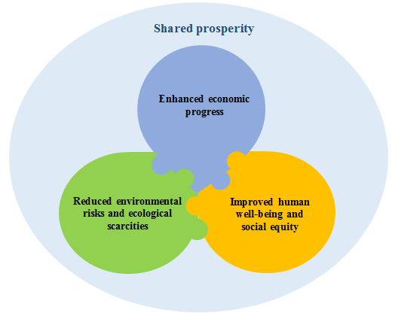

Objective I   
Reduced environmental risks and ecological scarcities

19. Natural capital can be depleted if undervalued and mismanaged in economic activities. Measuring and valuing natural resource stocks and all living organisms from which ecosystem services are derived, as well as the land and the ecosystems themselves, and incorporating those values in national statistics is an essential foundation for the sustainable use of natural resources. In an inclusive green economy, natural capital and its use is properly measured and integrated into national accounts for economic and development planning and assessment. It can then be managed, so that ecosystems and ecosystems services are maintained and enhanced and biodiversity preserved, while externalities caused by economic activities and consumption of goods and services are internalized. The three following focus areas were identified with a view to prioritizing the initiatives and actions necessary to attain objective I.

Focus area 1  
Improve the measurement and valuation of natural capital

20. Green economy allows for economic progress based on the use of countries’ natural capital (as part of inclusive wealth), provided that actions are taken to properly measure and value it. Natural capital accounting provides a system to mainstream the value of natural resources into development planning and national economic accounts. The United Nations System of Environmental-Economic Accounting is an internationally agreed standard countries may use as a basis to monitor the interactions between the economy and the environment and the state of the environment to better inform decision-making.

Focus area 2  
Promote the internalization of negative externalities and the sustainable use of   
natural capital

21. Green economy considers the cost of economic activities on natural capital (directly and indirectly) and takes actions to ensure that any loss or damage to natural capital is accounted for and internalized by setting the right price signals. It discourages pollution, and in this way encourages investment to make economic activities less polluting. By introducing payments for ecosystem services, it further rewards and compensates those who restore and enhance ecosystems and their services. Green economy encourages investments into technology and solutions that help decouple economic progress from environmental degradation. It further informs and promotes behaviour, knowledge and solutions that help maintain natural capital and combat climate change and its impacts.

Focus area 3  
Enhance ecosystems and ecosystem services as part of ecological infrastructure

22. Green economyvalues the services of ecosystems that can be recognized due to the functions they provide — for example, water purification, flood control and climate stabilization by forests — as ecological infrastructure. It provides and informs regulations and incentives to restore and enhance the capacity of ecosystems to deliver their infrastructural functions and to strengthen resilience to hazards and disasters, including those related to climate change.

Objective II  
Enhanced economic progress

23. Long-term prosperity can be put at risk if consumption, production and trade patterns are not sustainable. Green economy encourages consumers to shift towards sustainable consumption patterns, it incentivizes producers to innovate and invest in clean physical capital, products and services, and it promotes fair and green trade in support of sustainable consumption and production. The three following focus areas were identified with a view to prioritizing the initiatives and actions necessary to attain objective II.

Focus area 4  
Shift consumer behaviours towards sustainable consumption patterns

24. Green economy seeks to influence consumption patterns so that they become more sustainable and equitable. Green economy defines green services and products (labels and standards) and promotes shifting to sustainable lifestyles. It favours green procurement as well as consumer behaviour resulting in the efficient use of water, energy and materials, and the minimization of waste generation.

Focus area 5  
Develop clean physical capital for sustainable production patterns

25. Green economy strengthens clean and resource-efficient production processes and infrastructure by promoting green knowledge and technology, and introduces green products and services through the application of the principles of reuse, repair, upgrade, remanufacture and recycle. It incentivizes a shift to clean technologies and encourages closed-loop material cycles and eco-design of products (circular economy approach), as well as resilience and low-carbon infrastructure design. It promotes synergies between sectors and between economic activities aimed at curbing resource use (nexus approach). It facilitates access to capital for investment in research and innovation to improve clean technologies, products and services, including for small and medium enterprises, and encourages clean technology transfer.

Focus area 6  
Promote green and fair trade

26. Green economy ensures that traded products respect the requirements of green and fair trade. It also entails support for market transparency and development, and the simplification of regulations to facilitate the access of locally produced green goods to markets. It further reduces barriers to trade and investment that can place a brake on the development and the diffusion of green technologies, while providing for the effective application of intellectual property rights (such that innovation is stimulated while at the same time technology transfer and access to innovation are secured).

Objective III  
Improved human well-being and social equity

27. Human well-being and social equity can be undermined if people cannot find employment, if they lack access to essential services or are unable to engage meaningfully in the decision-making that concerns them. The green economy helps to create decent and green employment, ensures and improves access to healthy living and well-being, encourages public participation, and promotes education for sustainable development. The three following focus areas were identified with a view to prioritizing the initiatives and actions necessary to attain objective III.

Focus area 7  
Increase green and decent jobs, while developing the necessary human capital

28. Green economy helps to create green and decent jobs and ensures the necessary education and training for the workforce to develop skills needed for those jobs. It incentivizes the creation of incubators for green entrepreneurship. It develops opportunities for new green markets and jobs in these markets. It facilitates access to funds for training and retraining. It incentivizes green apprenticeship programmes for youth.

Focus area 8  
Improve access to services, healthy living and well-being

29. Green economy supports healthy living and well-being, including for low-income and vulnerable groups. It promotes programmes and solutions allowing vulnerable groups to have access to essential services — for example, water and energy utilities, housing, transport and health services — and to use them in an efficient way. It establishes social protection floors to counterbalance the effects of the transition on vulnerable groups. It prioritizes urban spatial planning to ensure healthy living and well-being.

Focus area 9  
Promote public participation and education for sustainable development

30. Green economy promotes access to information and public participation in decision-making as a prerequisite for meaningful green and sustainable governance. It ensures access to education for sustainable development that enables citizens to act responsibly vis-à-vis the environment and other people.

D. Implementing the Strategic Framework

31. Putting the Strategic Framework into practice involves mainstreaming the green economy approach into regional and national policies. In both cases, the transition to an inclusive green economy should adapt and incorporate nationally developed policies and strategies where possible, so as to avoid contradictions or duplication with other existing efforts.

32. At the national level, key drivers of implementation include clear leadership and communication, coordination across ministries and multi-stakeholder engagement, as the transition to a green economy entails numerous activities across multiple sectors. Engaging the private sector, civil society, local authorities and other relevant stakeholders is crucial to ensure ownership, private investment flows, the establishment of partnerships and behavioural changes.

33. At the regional level, the Strategic Framework will anchor national efforts in a set of shared objectives and focus areas, promote coordination in implementation and the monitoring of progress, and will facilitate the provision of technical assistance and capacity-building for countries.

34. Transitioning to a green economy involves a mix of actions that reinforce economic progress and the maintenance of natural capital, ranging from policies targeted at incentivizing the efficient use of natural resources to approaches inclusive of the broader social values of sustainable development.

35. Under the Strategic Framework a voluntary initiative on green economy is proposed with a view to support the Framework’s implementation during the period 2016–2030. The Batumi Initiative on Green Economy or “BIG-E” (see annex) will consist of voluntary commitments by interested countries and organizations, both public and private, in the form of green economy actions.

E. Contributing to achieving the Sustainable Development Goals

36. Greening the economy, as an approach to foster economic progress while ensuring environmental sustainability and social equity, is considered to be a promising avenue towards sustainable development, and has the potential to support the 2030 Agenda for Sustainable Development (Agenda 2030).

37. The Strategic Framework leverages the substantial body of analysis and policy effort that flowed from the 1992 United Nations Conference on Environment and Development, and entails an operational agenda that can help countries in their efforts to achieve the commitments made at the Rio+20 Conference and the Sustainable Development Goals (SDGs) included in Agenda 2030.

38. Within the Strategic Framework, countries and organizations are invited to attribute their green economy actions under the BIG-E to the relevant SDG targets with a view to simultaneously contributing to the attainment of relevant SDGs and their targets. Showing links between the Framework’s objectives, focus areas and committed actions by the BIG-E stakeholders on the one hand, and the SDGs and their targets, on the other, provides countries with a clearer picture of possible avenues to advance the green transition while at the same time making progress on the aspects of Agenda 2030 relevant to their development priorities (see figure 2).

F. Monitoring and review

39. The transition to an inclusive green economy also entails reviewing progress in implementation. In line with Agenda 2030, the time frame suggested for the review of progress in advancing the objectives of the Strategic Framework, through active implementation and monitoring its BIG-E commitments, is 2016–2030. The main implementing actors will be the countries and organizations participating in the BIG-E.

40. The first round of reporting on progress in BIG-E implementation could be in 2018, during the mid-term review of the Batumi Conference main outcomes at the Committee on Environmental Policy’s annual session. The reporting by the BIG-E stakeholders could be carried out by filling in a short template for reporting to be developed in consultation with the Bureau of the Committee (see appendix).

41. Based on the responses submitted, a progress report would be prepared for the Committee’s consideration in 2018. This information would be made available to relevant high-level regional platforms, as appropriate, following a decision by the Committee.

42. Figure 2 below provides a schematic view of the Strategic Framework, including its vision, objectives, focus areas, voluntary green economy actions and linkages to SDGs.

Figure 2

**The Strategic Framework at a glance**

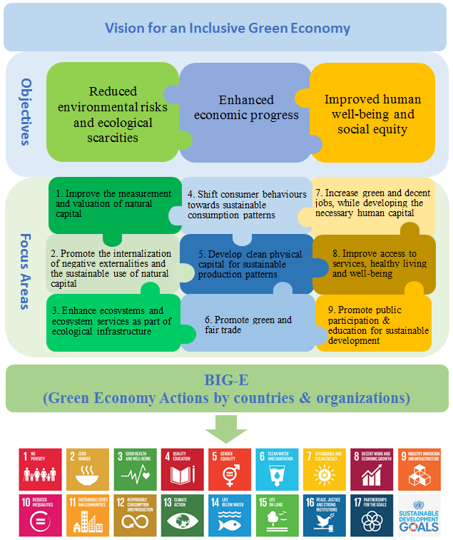

Annex

Batumi Initiative on Green Economy

1. The Pan-European Strategic Framework for Greening the Economy is meant to inspire action and provide state-of-the-art advice for strategies and plans that aim at greening the economy by building upon existing knowledge, policies and practices at the international, regional and national levels — for example, the Green Growth Knowledge Platform, the UNEP 10-Year Framework of Programmes on Sustainable Consumption and Production and the UNEP International Resource Panel.[[4]](#footnote-5)

2. The Batumi Initiative on Green Economy (BIG-E) operationalizes the Strategic Framework during the period 2016–2030. It will comprise voluntary commitments by interested countries and organizations, both public and private (BIG-E stakeholders), in the form of green economy actions.

3. Together, the committed actions will constitute the BIG-E, which will be launched at the Batumi Ministerial Conference. To harmonize the submission of actions, a template is included in an appendix to this annex.

4. Countries and organizations are invited to identify and voluntarily commit green economy actions under one or several focus areas, for instance to incentivize green investments and trade or green consumption habits in order to advance the transition to an inclusive green economy. It is proposed that each BIG-E stakeholder commit about five green economy actions in time for the Batumi Conference.

5. An important criterion for stakeholders in identifying, developing and committing green economy actions for the BIG-E is whether they are expected to deliver economic benefits with environmental and social co-benefits. Other criteria are whether an action: includes a mixture of new and ongoing actions; will make a clear contribution to the achievement of SDG targets; will have a measurable impact over time; and will be a driver for transformation and innovation towards green economy that may be relevant to and inspire other countries in the region.

6. In order to simultaneously contribute to the 2030 Agenda for Sustainable Development, each green economy action within the BIG-E should be linked to the specific SDG targets to which it also contributes.[[5]](#footnote-6) Such an approach will help ensure the advancement of green economy in the region in support of Agenda 2030.

7. The list of committed actions will be organized into the BIG-E in accordance with the nine focus areas. The actions will also be tagged based on their scope, i.e., whether they are economy-wide or sectoral. In addition, since cities also play a key role in the green transition, actions that can help to make cities smarter, more resource efficient and inclusive will be tagged accordingly. A number of sectors were identified as priority sectors for the green economy in the region: agriculture, forestry and fishing; energy and mining; manufacturing; transport; water; waste; tourism; and housing, buildings and construction (see figure below).

8. At the same time, a green economy approach requires combining actions aimed at implementing the traditional command-and-control regulatory instruments with actions aimed at introducing innovative tools — including collective public action to change the patterns of production and consumption, as well as market-based instruments to shift funding towards green investment, clean technology development and improved resource efficiency. In addition to categorizing the actions by their scope and relevance for cities, actions will be tagged according to the types of measures they employ, as follows:

(a) **Legal, regulatory and policy instruments**: Includes actions to implement command-and-control regulatory instruments, to change the patterns of production and consumption, improve efficiency and promote trade of green products. Examples are green procurement legislation and mandatory standards, technology and efficiency requirements;

(b) **Economic and fiscal instruments**: Includes actions that are used to send or adjust price signals in support of a green economy transition. Common examples include environmental taxation, trading permits, subsidy reforms, extended producer responsibility systems, deposit-refund systems and payment for ecosystem services. This type of instrument also includes public expenditure efforts, such as financial support to green investments through soft loans, credit lines, publicly backed guarantees and revolving funds;

(c) **Information, education-based, capacity-building and voluntary instruments** (often referred to as “softer” instruments): Includes actions aimed at driving behavioural changes, with the goal of making consumers and business pursue green options based on knowledge of the benefits and opportunities that can be achieved. They include voluntary certification and labelling schemes, as well as awareness-raising campaigns, educational and capacity-building programmes, and knowledge and skills sharing with a view to building the human capital for green economy.

9. A list of possible green economy actions has been prepared by the group of experts in green economy with a view to inspire BIG-E stakeholders in identifying their actions (see ECE/BATUMI.CONF/2016/INF/21). The list is based on existing national, regional and international instruments and sources. The possible actions are clustered in accordance with the nine focus areas, as well as by the scope and type mentioned above.

10. The proposed deadline to submit the green economy actions to the secretariat (by filling in the template included in the appendix) is Monday, 9 May 2016. Additional actions could be submitted up until the Conference, as well as after the Conference until the mid‑term review in 2018 and beyond, once later milestones have been decided by the Committee.

11. The BIG-E will be launched with a festive ceremony at the Batumi Ministerial Conference during the session on greening the economy in the pan-European region. The ceremony will include the announcement of the voluntary commitments by the BIG-E stakeholders.

12. Green economy actions committed by countries and organizations will be made available on the Green Growth Knowledge Platform to provide user-friendly global access with a view to sharing good practices and experience.

**Green economy actions at a glance**

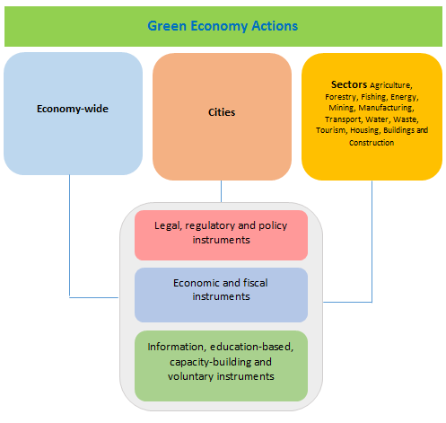

Appendix

Template for submitting voluntary commitments to the Batumi Initiative on Green Economy

The template below should be used to submit actions undertaken by countries and organizations, both private and public,[[6]](#footnote-7) to be included in and contribute to the Batumi Initiative on Green Economy (BIG-E).

Selection criteria to guide the identification of green economy actions are whether they:

(a) Are expected to deliver economic benefits with environmental and social co‑benefits;

(b) Include a mixture of new and ongoing initiatives;

(c) Will make a clear contribution to the achievement of SDG targets;

(d) Will have a measurable impact over time;

(e) Will be a driver for transformation and innovation towards green economy that may be relevant to and inspire other countries in the region.

For each action, please provide information on the following items:

1. Country or organization:

2. Title of the action (referencing in parenthesis the number of the related focus area(s) that the initiative will contribute to):

3. Description of the action:

4. Time frame/milestones, for the action, as appropriate:

5. Type of action:[[7]](#footnote-8)

6. Economic sectors:[[8]](#footnote-9)

7. Reference instruments and sources, as appropriate:

8. Expected co-benefits and impact of the outcome:

9. SDGs target(s) that the action may contribute to implement:

10. Implementation of Environmental Performance Review (EPR) recommendations, as appropriate:

11. Objectively verifiable indicators, as appropriate:

12. Partners:

13. Contact point:

1. The pan-European region under the Environment for Europe Process covers the full membership of ECE, i.e., the 56 ECE member States. [↑](#footnote-ref-2)
2. See the Astana Ministerial Declaration, “Save water, grow green!” (ECE/ASTANA.CONF/2011/2/Add.1), available from [www.unece.org/env/efe/Astana/documents](http://www.unece.org/env/efe/Astana/documents). [↑](#footnote-ref-3)
3. See [www.greengrowthknowledge.org/](http://www.greengrowthknowledge.org/). [↑](#footnote-ref-4)
4. For more details please see www.unep.org/resourcepanel. [↑](#footnote-ref-5)
5. The SDG targets are set out in General Assembly resolution 70/1, available from http://research.un.org/en/docs/ga/quick/regular/70. [↑](#footnote-ref-6)
6. Organizations, both private and public, are invited to submit actions by completing the fields of the template, as appropriate. [↑](#footnote-ref-7)
7. In accordance with the Strategic Framework, the following three types of actions are suggested: (a) legal, regulatory and policy instruments; (b) economy and fiscal instruments; and (c) information, education-based, capacity-building and voluntary instruments. Countries and organizations should refer to any of these three types, as appropriate and relevant. [↑](#footnote-ref-8)
8. In accordance with the Strategic Framework, the following three clusters of sectors are suggested: (a) economy-wide; (b) cities; and (c) sectors, including:agriculture, forestry and fishing; energy; mining; manufacturing; transport; water; waste; tourism; and housing, buildings and construction. [↑](#footnote-ref-9)