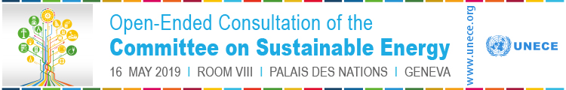

DRAFT for discussion version 6 March 2019

UNECE Sub-programme 5 – Sustainable Energy Strategic Review

Note by the secretariat

SUMMARY

UNECE’s sustainable energy sub-programme works to assist member States in improving access to affordable and clean energy for all and to help reduce greenhouse gas emissions and the carbon footprint of the energy sector in the region.
  - The objective is to make concrete, measurable progress towards the 2030 Agenda for Sustainable Development by ensuring that energy makes an enduring contribution, including reducing energy systems’ CO₂ intensity and meeting quality of life aspirations.
  - UNECE’s energy sub-programme is recognized for its thought leadership on critical energy issues such as reducing the environmental footprint of energy, transforming energy fundamentally to support the 2030 Agenda, enabling sustainable management of resources, and offering countries robust, pragmatic tools for assessing strategic options and for tracking progress to sustainable outcomes. The sub-programme has developed a range of concrete products such as framework classification of resources, best practice guidance for methane management, framework guidelines for energy efficiency in buildings, policy recommendations regarding carbon capture use and storage, and policy recommendations in support of energy for sustainable development.
  - UNECE is the UN regional commission for its member States.

The energy sub-programme offers many opportunities to enhance its contribution to member States’ efforts to attain energy for sustainable development.
  - The UNECE region has the expertise, the management capabilities, the technology, and the financial wherewithal to drive successful transformation across the region and to contribute to global initiatives.
  - The UNECE Committee on Sustainable Energy and its subsidiary bodies are recognized as a neutral platform to engage member States and to seek solutions drawing on a vast network of experts representing the full spectrum of stakeholders needed to deliver sustainable energy.
  - UNECE is a region that is economically and sociologically diverse. Through its regional advisory services the energy subprogramme can provide countries with concrete support for their sustainable energy development and economic growth.
  - The UN Development System is reforming to enhance its effectiveness. UNECE’s energy sub-programme can make important contributions. Reform of the development system can help the energy sub-programme enhance its links to other ongoing efforts, resulting in a stronger positioning within the UN energy sphere and more effective outcomes for the UN on energy issues.
  - UNECE is orienting its work towards concrete outcomes in nexus areas such as energy, food and water or air quality and transport, that require strong support from energy.

The energy sub-programme faces certain challenges.
  - The region is falling short on its sustainable energy objectives. There is a need to accelerate the transformation.
  - Current mandates cannot be served by existing regular budget resources alone, and the regular budget is under pressure.
  - There is a need for extrabudgetary (XB) resources to deliver many parts of the energy sub-programme’s work. No easy structure exists to receive funds efficiently
  - Current XB support from the 56 member States is falling short, so other sources will be essential.
  - There is a significant administrative burden in the current structure of the Committee and its subsidiary bodies, with a strong focus on organizing meetings rather than substantive work.

Given the rapid changes ongoing in lifestyles, technology, and business models and the growing political, societal, and environmental challenges, there is a need to render the Committee and its subsidiary bodies more nimble and focused on concrete and practical outcomes. The strategic consultations that will take place on 16 May 2019 and on 25-27 September 2019 are an opportunity for member States to take advantage of UNECE as their tool for driving energy system transformation. Given the cross-cutting nature of emerging challenges, UNECE’s nexus activities, and in-progress reforms of the UN Development System in support of the 2030 Agenda, there is a need for broad reflection on “purpose” and, possibly, for organizing the energy sub-programme around specific clusters of activity.

Proposal
  - Organise the energy sub-programme around specific clusters of activity that are informed by the outcomes of the policy briefs prepared for the 2030 Agenda’s High-Level Political Forum, the International Fora on Energy for Sustainable Development, the reform of the UN Development System, and other relevant events or processes.
  - Enhance the visibility of UNECE’s work in energy-related activities for example by extending joint work with other organizations (international, national, non-governmental organisations, and other initiatives), presenting and attending key international events (fora, workshops, policy dialogues, meetings of key organizations), collaborative work on energy-related activities with other UN organizations, and supporting work on energy-related activities directly with Member States.
  - Develop terms of reference for the Bureaux, rules of procedure for the Committee itself and its subsidiary bodies (aligned with comparable rules for other UNECE Committees), enhance engagement of energy experts in decision-making at the Committee, and introduce flexibility in the modification, creation, or cessation of groups of experts.
  - Improve comprehensive resourcing of activities through a range of mechanisms.

Introduction

The Committee on Sustainable Energy (Committee) of the United Nations Economic Commission for Europe (UNECE) is mandated to improve access to affordable and clean energy for all and help reduce greenhouse gas emissions and the carbon footprint of the energy sector in the region. The Committee promotes international policy dialogue and cooperation among governments, energy industries and other stakeholders. It undertakes certain specific projects and activities directly and, through its annual meetings, addresses energy security. The Committee works on energy efficiency, renewable energy, transformation of electricity systems, coal mine methane, natural gas, and management and classification of energy and mineral reserves and resources through the work of six subsidiary bodies. The objectives and activities of the groups are set forth in Annex 1, and current activities and concrete outcomes in Annex 2.

At its meeting in September 2018, the Committee noted that the objective of the sustainable energy subprogramme was to support and accelerate delivery of energy for sustainable development and to reconfirm UNECE’s reputation as a credible and relevant partner. The Committee explicitly undertook to review its mandate and activities going forward to ensure strategic alignment with the 2030 Agenda.
This document has been prepared by the Bureau of the Committee with the support of the secretariat in response to the Committee’s requests. Following consultations with member States, a subsequent document will be prepared for decision by the Committee at its 28th meeting on 25-27 September 2019.

In addition to its request to review its mandate and activities, the Committee:
- Requested its Bureau to develop a strategic plan for assisting member States to develop concrete pathways to sustainable energy (a list of priorities based on predefined criteria and needed staff resources are to be included);
- Recommended organising a Committee-wide strategic dialogue at a meeting on 16 May 2019 to explore challenges and opportunities.
- Requested its six subsidiary bodies to play lead roles at the 16 May 2019 event to clarify their expert groups’ roles in addressing the challenges;
- Requested the secretariat to prepare draft procedures for decision-making on predefined topics when the Committee is not in session; and
- Requested that documents developed over the coming year be in line with ongoing reforms in the UN system.

Need for Renewal

Deep transformation of the energy system is an imperative

Results of various studies and assessments indicate that the UNECE region is falling short of its commitments and objectives. It will be possible to meet the objectives, but deep transformation of the energy system is an imperative. All five regional commissions contributed to the 2017 tracking report prepared by the World Bank, the IEA, and UN Statistics Division (UNSD) on progress to sustainable development goal 7 (SDG7: ensure access to affordable, reliable, sustainable and modern energy for all) and each commission prepared its own separate, stand-alone regional report as a deeper dive into the topic of energy for sustainable development. The regional reports examined energy not only from the perspective of SDG7 but also from the broader perspective that energy underpins the entire 2030 Agenda. In the build-up to the 2018 High Level Political Forum review of attainment of SDG7, UNECE prepared or contributed to the preparation of 27 policy briefs under the auspices of the Technical Advisory Group on SDG7. As a UN regional commission with access to a very deep talent pool of expertise, UNECE is well positioned to help member States accelerate their transitions.

A further challenge for member States is the complex dynamic that energy represents. Energy services are critical inputs to all economic sectors as they enable mobility, communications, sanitation, health care, heating and cooling, refrigeration, lighting, education, and so forth, and assuring comprehensive energy security means ensuring that energy makes an optimal contribution to a country’s economy and its people’s quality of life. From that perspective, achieving deep transformation of the energy system requires cross-cutting, nexus approaches for which insular national, regional, or global organizational infrastructures are not well adapted. Further, the pace of change in industrial and societal ecosystems is accelerating with entry of new technology, players, communication methods and platforms, business models, and even cultural norms.

The imperative for deep transformation and the reality of changing circumstances create a need in UNECE’s energy subprogramme for nimble, creative approaches positioned in an intergovernmental structure that is stable, transparent, and understood.

Reform of the UN Development System Reform and other relevant UN processes

The overarching objective of the reform of the UN Development System (UNDS) as outlined in the Secretary General’s December 2017 report is to support member States in achieving the 2030 Agenda for sustainable development. Harnessing all assets (country, regional and global) of the UNDS is critical to achieve this objective. The UNDS includes substantial regional assets, including the regional commissions, that operate as a bridge between the country and the global level and that support regional cooperation and integration efforts of Member States while addressing sub-regional and trans-boundary issues.

In the December 2017 report, the Secretary-General re-affirmed the important role of regional entities in the UNDS and the importance of capturing the regional dimension in the repositioning of the UNDS for Agenda 2030. The Secretary-General’s report recognized the important role that the regional actors can play in: offering a convening platform for both intergovernmental, and multi-stakeholder discussions on key development priorities and in support of multilateralism; exercising thought leadership in the regions and aligning regional agendas and policy frameworks with UN norms, values and global development agendas; delivering integrated policy advice; provide normative support and technical capacity on regional priorities; enhancing the policy and analytical capacities of RCs and UNCTs; and contextualizing country analysis in regional specificities. In May 2018, the General Assembly endorsed the Secretary-General’s vision and called for a two-phased approach to the UNDS regional reform. The first phase is to enhance collaboration between different entities at the regional and sub-regional levels, while the second is to re-align the assets more fundamentally. The second phase of the review targets all the regional assets of the UNDS comprehensively. The Secretary-General’s recommendations will be presented to ECOSOC in May 2019.

The UN Secretary-General has affirmed that the UN 2019 Climate Summit that will take place on 23 September 2019 aims to mobilize action and enhance ambition through a focus on six specific areas: energy transition; industry transition; resilience; local action and cities; finance and carbon pricing; and nature-based solutions. UNECE’s energy sub-programme is engaged particularly in the first 5 of these areas and is well-positioned to contribute.

The UNDS regional reform will affect and benefit from UNECE’s energy sub-programme through more effective alignment with other elements of the development system.

UN Energy and Technical Advisory Group

UNECE’s sustainable energy subprogramme plays a continuing role in both UN Energy and the HLPF’s Technical Advisory Group on SDG7 (SDG7-TAG).

- UN Energy aims to promote system-wide collaboration in energy since there is no single entity in the UN system that has primary responsibility for energy. The group focuses on substantive and collaborative actions on policy development and implementation in the energy area as well as on maintaining an overview of major ongoing initiatives within the system based on the UN-Energy work programmes at global, regional, sub-regional and national levels.

- The SDG7-TAG was set up to seek and facilitate exchange of expert advice on how to strengthen the follow-up and review of SDG7 and its interlinkages with other SDGs leading up to the HLPF in July 2018. More specifically, the Technical Advisory Group was to advise on inclusive processes to support the SDG7 follow-up and review, including on: ways to strengthen multi-stakeholder engagements; deliverables including policy briefs, to inform intergovernmental discussions in regards of SDG7 follow-up and review and its interlinkages with other SDGs; and recommendations to UN DESA, as secretariat for HLPF, on how best to support and coordinate the relevant processes and products development. As noted above, UNECE prepared or contributed to the preparation of 27 policy briefs under the auspices of the Technical Advisory Group on SDG7. Since the 2018 HLPF and in light of the role energy plays in supporting the 2030 Agenda, the SDG7-TAG continues to function in support of the HLPF.

UNECE is closely involved with the processes and products of both of these groups and represents an opportunity for member States to engage across the UN on energy topics.

Nexus Activities in UNECE

The 2030 Agenda provides an ambitious and comprehensive framework that opens new perspectives for policymaking and international cooperation. Its integrated character calls for an assessment of the linkages and complementarities that exist between different goals and targets to make more effective choices. The challenges facing the UNECE region cut across most Sustainable Development Goals and cannot be tackled effectively through an exclusively sectoral focus. Such a narrow focus would ignore the opportunities for enhanced impact and increased efficiency of a more integrated approach. Change is required to ensure that structures, incentives and organizational culture enhance cross-sectoral collaboration and sharpen the focus of our work. Going beyond the efforts made so far by each subprogramme on aligning their activities with the SDGs, UNECE aims to further strengthen its contribution to SDG implementation in the region and enhance the impact of its work by collaborating through a nexus approach. This collaboration does not expand, diminish, or otherwise change the mandates of the sectoral committees, but rather enhances the collective output of UNECE by harnessing the strengths of the committees to address complex challenges.

Such an approach can serve to:
- Concentrate resources to address multifaceted issues;
- Increase communication and cooperation across the organization;
- Facilitate partnerships, including with other organizations of the UN system;
- Give potential access to new constituencies and promote a cross-sectoral dialogue with external clients;
- Provide more visibility to disperse efforts under a common theme.

UNECE has identified four key nexus areas for collaboration among its substantive divisions: 1) sustainable use of natural resources; 2) sustainable and smart cities for all ages; 3) sustainable mobility and smart connectivity; and 4) measuring and monitoring SDGs. The work of the cross-divisional nexus teams will focus on delivering integrated solutions by:
- Defining the need or gap in concrete terms (for example, providing a tool for management of national resources in line with the 2030 Agenda);
- Assembling resources (financial, expert, other) needed to deliver the solution;
- Providing oversight of project delivery among relevant sectors/Divisions;
- Reporting progress and results both internally and to the relevant sectoral committees;
- Disseminating and deploying the solution(s) among member States.

UNECE’s energy sub-programme contributes directly in each of the four nexus areas and in particular can play a leading role in the sustainable use of natural resources. The energy sub-programme could engage in “promotion and marketing” of its achievements and highlight what could be done to attract funding.

Specific challenges for UNECE’s Sustainable Energy Sub-programme

The UNECE energy sub-programme is organized around the Committee and it 6 subsidiary bodies. This structure was agreed by member States during the 2013 review of the 2005 Reform of UNECE. Each of the 6 subsidiary bodies is mandated for a specific period of time, generally two years (but longer in the cases of the Expert Group on Resource Management (5 years) and the Group of Experts on Gas (4 years)), with a set of objectives and agreed activities. Achievement of mandated activities and recommendations for further work are considered by the expert groups themselves, then endorsed by the Committee and approved by UNECE’s Executive Committee (EXCOM). As neither the Committee nor any of the groups of experts have agreed rules of procedure designed for their specific needs, they are run according to the same rules of procedure as apply to UNECE’s parent body, the Economic Commission for Europe. Though the Committee technically is the only intergovernmental body delivering this sub-programme, the expert groups are treated as such as well. Each convenes a meeting once a year with formal agendas, work plans, and documents submitted 10 weeks in advance, and submits its reports and recommendations to the Committee for endorsement and submission to EXCOM for approval. The result is an intergovernmental machinery that consumes itself with meetings and documentation. While substantial results are produced, this document recommends substantial streamlining with greater focus on concrete activities and outputs.

In addition to the heavy administrative overburden that current approaches represent, they also slow decision-making enormously as decisions can only be taken at the annual meetings when the expert group or the Committee is in session. Other nimbler organizations have been able to act promptly on issues identified initially in UNECE and, as UNECE’s contributions are not recognized, resources flow to the other organizations. UNECE’s energy sub-programme has extraordinary access to an outstanding community of experts in energy across the range of relevant topics and, with effective positioning and alignment vis-à-vis other organizations working in energy, could make a much greater contribution to countries’ efforts to secure energy for sustainable development.

A third specific constraint is in fundraising and broader resourcing in a UN context. The UN has instituted a specific financial management infrastructure to ensure proper oversight and reporting of the sources and uses of financial and other resources. UNECE generally and the energy sub-programme specifically often pursues extrabudgetary resourcing on an ad hoc basis based on project opportunities that emerge (n.b., that is not the case for larger, multi-year projects, funding of conventions, or funding of UN Development Account projects). It has been suggested that because of the cost to the organization of processing extrabudgetary funds (both receiving and spending), smaller projects (less than $200 000) should not be pursued. Conversely, it is argued that smaller projects may be all certain donors can afford, are of great value to some member States, or can represent seed funding for bigger endeavors. UNECE can perform small-scale country specific projects that provide practical results. For example, through the renewable energy Hard Talks UNECE is able to provide specific policy advice to member States. Rather than filtering out smaller projects given their cumulative value to the organization, a different approach to funding programmes and projects may be worth consideration.

In terms of challenges for the energy sub-programme, the most notable are its need for resources to achieve its objectives and the constraints it faces as an inter-governmental body.

Proposal (draft)

Committee on Sustainable Energy
The Committee sessions will be separated into a “formal” segment and an “informal” segment. The formal segment of the Committee will be limited to decision-making according to defined rules and procedures (conclusions and recommendations). The remaining, informal segment(s) of the Committee sessions(s) can then be used to advance dialogue on specific energy topics. The formal and informal segments would not necessarily be contemporaneous. For example, the international (or regional) forum on energy for sustainable development could constitute informal segments of the Committee. The Committee will develop terms of reference for its Bureau based on a draft prepared by the Bureau with the support of the secretariat. Each Bureau member will be tasked to guide and possibly lead work on a specific topic or activity, including raising the visibility of the sub-programme and its concrete outcomes.

As requested by the Committee, the secretariat is preparing draft procedures for inter-sessional decision-making on specific topics. The procedures will feature: 1) identification of country focal points empowered to represent the country in decision-making (or to nominate another official for a specific decision) on energy issues; 2) empowerment of the Bureau to determine if an inter-sessional decision is required; 3) preparation of needed documentation; 4) conduct of private (i.e., member State-only) web-casts for presentation and discussion, if needed; 5) recording and transmitting discussions and conclusions; and 6) means of formalizing documents and decisions at the following formal segment of the Committee.

Structure of the Committee and its subsidiary bodies
Figure 1 UNECE Sustainable Energy Sub-programme
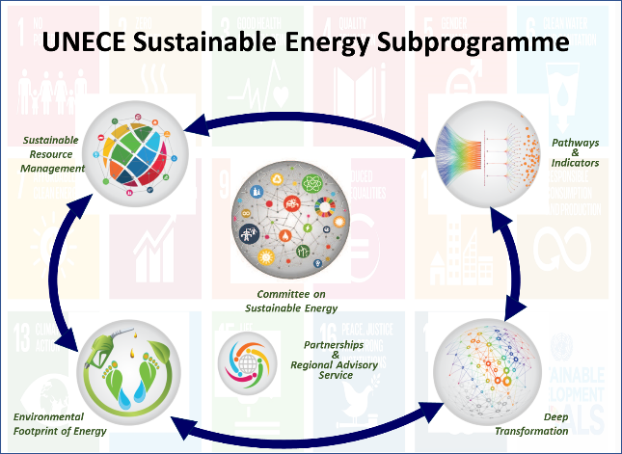
The Committee undertakes activities directly and indirectly through its subsidiary bodies. Many topics require contributions from one or more of the expert groups and from one or more Divisions in UNECE (as noted above). The Bureau recommends that the Committee’s activities be structured along four lines: 1. Sustainable Resource Management; 2. Deep Transformation of the Energy System; 3. Reduction of the Environmental Footprint of Energy; and 4. Tracking progress to energy for sustainable development (see Figure 1). “Partnerships and regional advisory services” reflect fund-raising activities, collaborative arrangements including memoranda of understanding with other organisations, and the central role of the regional adviser in delivering the results of the sub-programme into beneficiary countries.

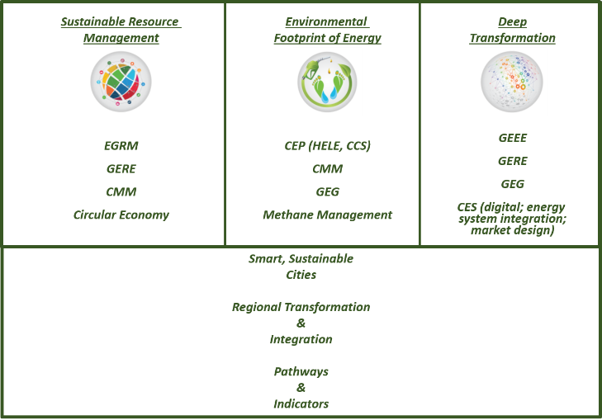
Figure 2 Current Activities in New Clusters
The work of the current groups of experts already fits into the proposed alignment (see Figure 2), but the proposed clustering creates the space for enhanced interaction within the sub-programme and with other UNECE sub-programmes. The number of formal meetings thereby can be reduced from the current seven, with commensurate reductions in administrative overburden. This approach also will reduce the number of work plans to one, to be approved by the Committee during its formal segment. Meeting rooms, interpretation services, and documentation needed by groups of experts, task forces, and teams of specialists can be mandated by the Committee. Groups of Experts can then be modified, created or disbanded more fluidly by the Committee. The number of groups of experts and their subsidiary task forces therefore can be viewed flexibly to address either continuing or new issues (see Figure 3). Activities among the subsidiary bodies would be more inter-connected with one another and with activities in other divisions, other organizations, the private sector, and academia. The stream-lining and flexibility must be balanced against the value of having chairs and bureaux who connect their administrations and budgets to the work of UNECE.

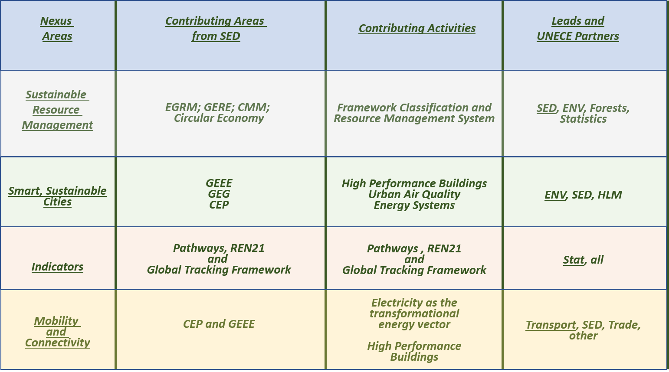
In addition to treating the groups of experts, task forces, and teams of specialists flexibly in order to address evolving challenges flexibly, it is likewise recommended to change how and where meetings of experts are conducted. The objective is to move activities closer to member States, to use information and communication technology to replace physical meetings, and to reduce the procedural requirements for expert group meetings that currently are conducted as if they were intergovernmental meetings operating as the Commission.
Figure 3 Contribution of Sustainable Energy Sub-programme to UNECE Nexus Activities

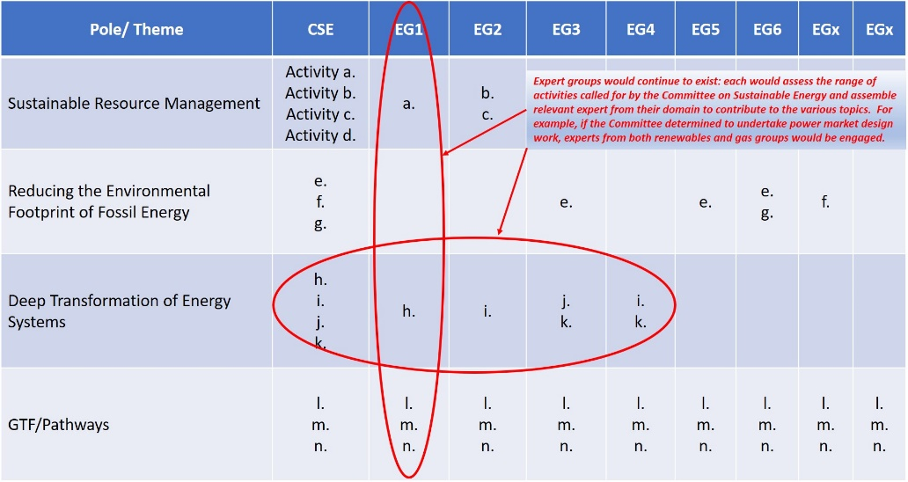
The question emerges whether this proposal means eliminating the existing groups of experts in favor of the four poles of activity. In fact, no. The idea would be to retain the groups of experts as communities of expertise that contribute to thematic challenges raised by the Committee (see Figure 4) and that contribute to the consideration of the challenges that the Committee should address. Groups with Chairs and bureau could then be added as needed to address the evolving issues linked to energy for sustainable development. Notably, the various task forces, the networks of experts, the centres of excellence, and the close collaborations with other organizations and private companies represent an enormous resource for delivering on the range of issues that comprise energy for sustainable develop-ment. It is critically impor-tant for the success of the energy sub-programme that the various communities that work to the energy objectives of UNECE be deeply engaged in the conception of the Committee’s set of activities and in delivering on the requested outcomes. The process would retain as strategic partners the vast expert community upon whom the energy subprogramme depends.
Figure 4 Responding to Thematic Challenges

Resourcing
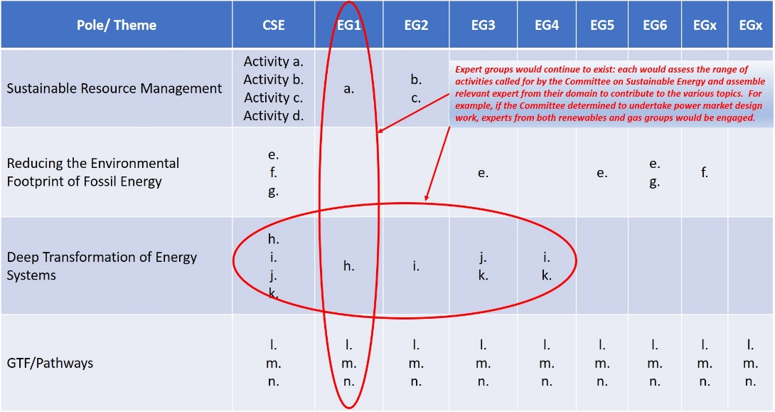
Resources available to the Committee to achieve its objectives, whether at the secretariat or through extrabudgetary projects, are extremely limited. Currently an expert group is supported by one professional staff (some of whom service more than one group), with no technical support or editor and with shared administrative support. Each group of experts, if fully serviced by the secretariat, would have one senior programme officer (P5 or P4) and one junior programme officer (P3 or P2) with commensurate support staff including shared technical support and an editor. In addition, annual funds for travel of participants and for staff $15 000 and for hiring consultants $5 000 are insufficient to meet the demands placed on the secretariat. A number of work plans and the reports of the Committee and the expert groups include tasks that feature the phrase “depending on the availability of resources”, which effectively means that the tasks at hand either linger or are addressed in an incomplete fashion.

The regular programme of technical cooperation (RPTC) serves to support developing countries, least developed countries, countries with economies in transition and countries emerging from conflict in their capacity-development efforts. The funding for the regional advisory services comes from Section 21 of the regular budget, and from extrabudgetary resources, donor countries and countries with economies in transition. These funds are used to hire a P5 regional adviser and to fund technical cooperation activities and advisory missions. Due to limited staff resources, activities are focused on a limited number of countries taking into account their priority areas for development, government support, as well as the availability of extra-budgetary financing.

As noted above, extrabudgetary resourcing is a challenge both because of its current ad hoc nature and because of the complexity of receiving financial contributions, secondees/non-reimbursable loans, and the like. For specific projects, fund-raising will remain largely ad hoc because of their demand-driven character and will follow the prescribed approval process. Other activities are more programmatic in nature with enduring activities and lend themselves to alternative approaches. Producing outputs with a common theme drawing on the range of partnerships that are forged are more likely to have the “mass” to attract funding for implementation either at the member State level or if the scope is regional, from development banks. An important dimension of pursuing innovative funding models will be to ensure transparency and accountability regarding the sources and uses of funds.

One activity of this nature is the combination of the Pathways to Sustainble Energy Project and the range of activities on tracking indicators. This work is pluri-annual and has fundamental implications in that it sets out strategic options for countries, provokes and promotes enduring high-level dialogue among countries, and tracks progress to desired outcomes with regular reporting. This work requires secretariat support (professional and support staff), travel of experts, engagement of consultants, preparation of quality reports and brochures, and so forth. Rather than approaching each phase of the project in piece-meal fashion with unique, one-off project concept notes, a variety of reporting requirements depending on donors, and UNECE Executive Committee (EXCOM) approvals, it would be more efficient to establish a trust fund, vetted by normal EXCOM procedures, to facilitate contributions from a range of sources (e.g., member States, financial institutions, companies, trusts) and project conduct. Another approach could involve institution of a revolving fund that could be used for pilot projects with a stipulation that as the projects prove to be successful the seed money is repaid to the fund. Sources and uses of funds would be overseen by the Bureau and reported to the Committee and hence EXCOM. Other current activities that fall into this category include resource management, industry modernization, and methane management – notably each of the activities overseen directly by the Committee.

A second approach for resourcing activities is to establish subscription-type contributions from various entities. Three current activities are pursuing this approach – coal mine methane, high performance buildings, and sustainable resource management. All involve institution of international centres of excellence whose achievements and work plans are overseen by the relevant expert group and whose budget will include line items for needed secretariat support. Instituting critical masses of centres of excellence will ensure maximum effectiveness in deploying and disseminating the results of the energy sub-programme and will reduce the costs to any individual centre for secretariat support.

Substantive Work
The work plans of the Committee and its expert groups have been endorsed by the Committee and approved by EXCOM. Going forward, with the proposed restructuring of the Committee, the focus on actionable activities would fall into the four areas: 1. Sustainable Resource Management; 2. Deep Transformation of the Energy System; 3. Reduction of the Environmental Footprint of Energy; and 4. Tracking progress to energy for sustainable development. The specific activities to be undertaken would emerge from engaged dialogue among member States and the UNECE’s vast expert communities engaged in its expert groups.

The energy sub-programme is expected to deliver concrete, measurable results that help member States accelerate their attainment of the energy-related SDGs. Achieving this objective will require close engagement at sub-national level (cities and regions). In the medium term, the sub-programme will work to prepare a UN-level ministerial in 2021 at which serious and measurable commitments are made by countries to close the gaps between action and ambition.

Documents presented to the Committee, including those emerging from the international fora on energy for sustainable development (e.g., the Hammamet action agenda and outcome documents from the subsequent fora), the strategic options from the Pathways project, the perspectives of the groups of experts and the range of other global and regional processes will inform decisions and programmes of work for activities undertaken by the energy sub-programme going forward. Priorities for the region and its sub-regions will be based on areas with greatest near-term impact and long-term potential that require engagement of the United Nations through UNECE’s energy sub-programme (in coordination with work undertaken elsewhere).

Annex 1

Objectives and Current Activities of the
Committee on Sustainable Energy’s
Groups of Experts

Current Mandates and Structure

UNECE’s sustainable energy sub-programme is undertaken and overseen by the Committee and its 6 subsidiary groups of experts. The objectives and activities of the groups are set forth below, but can be summarized as follows:

- The Expert Group on Resource Management (EGRM) develops, promotes and supports the implementation of a global tool for sustainable management of natural resources to support attainment of the 2030 Agenda.
- The Group of Experts on Coal Mine Methane (CMM) promotes the reduction of methane and other greenhouse gas emissions from coal mines. Its activities on recovery and use of methane reduce the risks of fires and explosions in coal mines. Annually, methane related explosions in coal producing member states result in serious impacts to the social fabric of the host community and disruptions to the local and regional economy. Release of methane to the atmosphere is ongoing after mine closure and presents a growing source of greenhouse gas emissions.
- The Group of Experts on Gas (GEG) promotes the sustainable and clean production, distribution, and consumption of gas. The areas of work of the Group of Experts are policy dialogue and exchange of information and experiences among UNECE member States on gas-related issues of regional relevance, including the ever-increasing share of gas in the total primary energy supply and its social and environmental impacts.
- The Group of Experts on Energy Efficiency (GEEE) works to improve energy efficiency and energy consumption in the region and to strengthen regional cooperation with a view to reducing greenhouse gas emissions. The GEEE focuses on regulatory and policy dialogue addressing financial, technical and policy barriers and on sharing best practices, including strengthening institutional capacity in the field of energy efficiency and energy conservation. The work done by the GEEE should address and enable other sustainable energy uses, resource conservation and transformation of the energy system.
- The Group of Experts on Renewable Energy (GERE) works to increase the uptake of renewable energy in the region and help achieve the objective of access to energy for all in the UNECE region. The GERE facilitates regulatory and policy dialogue and sharing of best practices.
- The Group of Experts on Cleaner Electricity Production from Fossil Fuels (CEP) works to reduce greenhouse gas (GHG) emissions from fossil fuel-fired electricity generation.
At its 27th meeting, the Committee asked CEP to change its name to Group of Experts on Cleaner Electricity Systems given the critical role electricity will play in the deep transformation of the energy system. The Committee requested CEP to consider technical, social, economic and ecological aspects when assessing taking up the following additional topics, pending available resources:
- Electricity as a primary vehicle for deep transformation of energy systems, including electricity delivery and distribution;
- Synergies between natural gas and renewable energy through properly structured balancing markets, together with GEG and GERE;
- Power market design for the 2030 Agenda (including enabling distributed generation);
- High-efficiency, low-emissions (HELE) technologies; standards for fossil fuel-fired power plants;
- Carbon capture use and storage;
- Digitalization;
- E-mobility;
- Information & communication technology to support high-performance buildings and smart, sustainable cities;
- Decarbonization of electricity production, including reduction of carbon dioxide and methane and the order of merit as defined by economic, environmental, and societal needs; and
- Clean electricity in support of Committee’s activities on “Pathways to Sustainable Energy”.

- Expert Group on Resource Classification, now the Expert Group of Resource Management
The Expert Group on Resource Management is mandated to carry out concrete results-oriented activities to develop, promote and support the implementation of a global system which can be used as a tool for the sustainable management of natural resources to support attainment of the 2030 Agenda for Sustainable Development.

According to its Terms of Reference, the Expert Group concentrates on the development and deployment of a United Nations Resource Management System (UNRMS) grounded in the United Nations Framework Classification for Resources (UNFC) comprising principles, specifications, guidelines, application protocols (procedures and checklists) and best practices to aid sustainable management of energy, raw materials and other resources.
The mandate for the Expert Group is approved until December 2019.

Concrete activities
1. Develop, maintain and promote a comprehensive UNRMS.
2. Provide a UNRMS toolkit.
3. Develop principles, specifications, bridging documents, guidelines and protocols.
4. Elaborate guidelines for competent persons.
5. Support application of UNRMS
6. Promote activities related to empowering women and addressing diversity and inclusion in resource management;

- Group of Experts on Coal Mine Methane
The Group of Experts on Coal Mine Methane is mandated to promote the reduction of greenhouse gas emissions from coal mines by means of concrete, results-oriented activities that may help the recovery and use of methane in order to reduce the risks of explosions in coal mines, mitigate climate change, and support sustainable development.

The Group of Experts focuses on best practices for effective drainage, recovery and usage of coal mine methane.

Concrete activities
- Disseminate and Expand the Best Practice Guidance for Effective Methane Drainage and Recovery in Coal Mines
- Drafting a Best Practice Guidance for Effective Methane Recovery and Use from Abandoned Coal Mines
- Launch and support the work of the International Centres of Excellence on Coal Mine Methane
- Collect and disseminate case studies on the application of best practice guidance in specific coal mines in different regions of the world
- Work to be undertaken:
- Contribute, in cooperation with other Groups of Experts and under the leadership of the Committee on Sustainable Energy, to the work on integrated methane management in the context of sustainable development.
- Continue to cooperate with other Groups of Experts under the leadership of the Committee on Sustainable Energy, to work on energy infrastructure transformation as it relates to modernizing legacy industrial sites.
- Further engage, in cooperation with other Groups of Experts and under the leadership of the Committee on Sustainable Energy, in the work on transition the coal industry in the UNECE region
- Continue to provide advice on coal mine methane related standards to the United Nations Framework Convention on Climate Change (UNFCCC), the International Organization for Standardization (ISO), and other international, national and regional market-based coal mine methane emission reduction mechanisms. Engage and develop robust professional ties with the recognized expert entities operating in the field of fossil-based energy.

3. Group of Experts on Gas
The Group of Experts on Gas is mandated to provide a forum for multi-stakeholder dialogue on promoting the sustainable and clean production, distribution, and consumption of gas in the UNECE region.

The areas of work of the Group of Experts are policy dialogue and exchange of information and experiences among UNECE member States on gas-related issues of regional relevance, including the ever-increasing share of gas in the total primary energy supply and its social and environmental impacts. Concrete activities of the Group of Experts on Gas are intended to help member States deliver on key political commitments, such as the Paris Agreement on climate change and the Sustainable Development Goals.

Concrete activities
- Role of gas in attaining Sustainable Development Goals
- Best practices in managing methane emissions along the gas value chain
- Role of gas in improving urban air quality
- Renewable energy and natural gas as the best combination to enhance the energy efficiency in the whole energy system
- Emerging issues (scoping exercise on the role of biogas and biomethane, synthetic gas, power to gas, hydrogen, and other emerging concepts of the use of gas as part of the future energy system).
- Promoting sustainable and clean production, distribution, and consumption of gas and LNG in the UNECE region

4. Group of Experts on Energy Efficiency
The Group of Experts on Energy Efficiency is mandated to carry out concrete, results-oriented activities that, in line with the “Sustainable Energy for All” (SEforALL) initiative of the United Nations Secretary-General, help significantly improve energy efficiency in the region, thus contributing to climate change mitigation efforts; and strengthen regional cooperation in energy efficiency, with a view to reducing greenhouse gas emissions.

According to its Terms of Reference, the Group of Experts will concentrate on: (a) Regulatory and policy dialogue addressing financial, technical and policy barriers to improve energy efficiency; and (b) Sharing experience and best practices in the field of energy efficiency in the UNECE region, including on strengthening institutional capacity in energy efficiency to reduce greenhouse gas emissions.
The mandate of the Group of Experts has been renewed until December 2019, with the possibility of extension.

Concrete Activities
- Exchange of experience to improve significantly energy efficiency in industry sector
- Exchange of experience on standards and guidelines to improve significantly energy efficiency in buildings
- Regulatory and policy dialogue addressing barriers to improve energy efficiency

5. Group of Experts on Renewable Energy
The Group of Experts on Renewable Energy is mandated to carry out concrete result-oriented activities that, in line with the Sustainable Energy for All initiative of the Secretary-General, help significantly increase the uptake of renewable energy in the region and that help achieve the objective of access to energy for all in the UNECE region.

According to its Terms of Reference, the Group of Experts will focus on a) regulatory and policy dialogue and b) sharing of best practices on various renewable energy sources, including biomass, with a view to increasing the share of renewables in the global energy mix.

The mandate and the Work Plan 2018-2019 of the Group of Experts has been renewed until December 2019, with the possibility of extension.

Concrete activities
- Tracking progress in the uptake of renewable energy sources
- Exchange of experiences and good practices on how to increase the uptake of renewable energy
- Matchmaking activities to support renewable energy investments
- Cross-cutting cooperation to strengthen integration of renewable energy in future sustainable energy systems

6. Group of Experts on Cleaner Electricity Production from Fossil Fuels, now the Group of Experts on Cleaner Electricity Systems
The Group of Experts on Cleaner Electricity Production from Fossil Fuels is mandated to concrete, result-oriented activities that significantly reduce greenhouse gas (GHG) emissions from fossil fuel-fired electricity generation. These activities are developed and implemented with the active participation of UNECE member States, energy companies, financial sector, civil society, academia and independent experts.

The areas of work of the Group of Experts are regulatory and policy dialogue; sharing best practices in the field of cleaner electricity production from fossil fuels in the UNECE region; Carbon Capture, Use and Storage (CCUS); enhanced oil recovery with CO₂; advanced fossil fuels technologies for power generation; and evaluation of efficiency enhancing measures for coal-fired power plants including steam generators, air and flue gas systems, steam turbines, and generators.

On the basis of the outcomes of the implementation of the Work Plan for
2016-2017 and the recommendations from the Group of Experts and its Bureau, the Group of Experts will undertake a number of activities. Among these activities, four represent a continuation, adjusted as needed, of the 2016-2017 work plan. A number of new activities in line with the mandate of the Group of Experts are also indicated. Following the request of the Committee on Sustainable Energy to explore opportunities for closer cooperation among its subsidiary bodies, three of the new activities are cross-cutting in nature. The Group of Experts will also engage, within the scope of its expertise, in joint work on the transition of the energy sector.

The Group of Experts notes that under the current resource constraints successful implementation of the work plan requires institution of dedicated task forces. When deciding on which activities to pursue, the Group therefore has considered the willingness of experts to take an active role in the task forces and other Group of Experts’ work between sessions as one of the key selection criteria success.

Concrete Activities
- Assess a future role for thermal power plants in sustainable electricity systems (continued activity from 2016-2017 work plan)
- Increase flexibility in coal-fired electricity generation (continued activity from 2016-2017 work plan)
- Decrease emissions and increase efficiency from new and existing coal-fired power generation using best practices across the UNECE region (continued activity from 2016-2017 work plan)
- Assess means for development and deployment of carbon capture, use and storage (CCUS) technology and know-how (continued activity from 2016-2017 work plan)
- Opportunities in combined heat and power (CHP), gasification and coal to develop other technologies or products (such as liquids or chemicals)
- Role of fossil fuels in supporting renewable energy deployment
- Role of gas and liquefied natural gas (LNG) in electricity generation (with the Group of Experts on Gas)
- Innovation in the extraction and use of coal mine methane for electricity production and other uses (with the Group of Experts on Coal Mine Methane)
As noted in the main text, the Committee on Sustainable Energy requested that the group change its name to the Group of Experts on Cleaner Electricity Systems and asked that it take up the following activities, pending available resources
- Electricity as a primary vehicle for deep transformation of energy systems, including electricity delivery and distribution;
- Synergies between natural gas and renewable energy through properly structured balancing markets, together with GEG and GERE;
- Power market design for the 2030 Agenda (including enabling distributed generation);
- High-efficiency, low-emissions (HELE) technologies; standards for fossil fuel-fired power plants;
- Carbon capture use and storage;
- Digitalization;
- E-mobility;
- Information & communication technology to support high-performance buildings and smart, sustainable cities;
- Decarbonization of electricity production, including reduction of carbon dioxide and methane and the order of merit as defined by economic, environmental, and societal needs; and
- Clean electricity in support of Committee’s activities on “Pathways to Sustainable Energy”

Annex 2
Activities and Concrete Results Achieved

The Committee undertakes a number of activities directly:
- Energy Security. The outcome of the review of the 2005 reform of UNECE affirmed that the CSE is to continue its energy security dialogue. The dialogue has focused on the following themes:

2018 Accelerating and deepening the transition to sustainable energy systems
2017 Accelerating the delivery of energy for sustainable development; improving the environmental footprint of energy
2016 Meeting the challenge of sustainable energy
2015 Pathways to Sustainable Energy
2014 Energy for Sustainable Development – Must reality conflict with ambition?
2013 Securing Sustainable Energy: Time to Act
2012 Enabling the Shift to Sustainable Energy
2011 Securing Affordable and Sustainable Energy
2010 Energy security and Gas Infrastructure
2009 Energy Security and Financial Crisis
2008 Strategic Alliances for Energy Security
2007 Financing Energy Security Risk Mitigation
2006 Emerging Global Energy Security Risks
2005 Energy Security Caspian Sea Region

- Pathways to Sustainable Energy Project. UNECE member States are assessing pathways for the region to attain sustainable energy. The project has three components: 1) development of policy and technology options for sustainable energy; 2) facilitation of exchanges and dialogues among energy experts and governments; and 3) development of indicators to provide an early warning if objectives are not being met. The project is intended to enhance the collective understanding of sustainable energy policy drivers in the UNECE member States, promote a policy dialogue and provide awareness-raising of different outcomes that could emerge over time. The overall vision of the project is to inform governments in the UNECE region about options on how to attain sustainable energy while meeting international development and climate targets. The project will facilitate a high-level policy dialogue to support governments, energy industries and other private sector, non-governmental and international organizations that are involved in energy in the UNECE region and will develop an instrument for analysis and monitoring of pathways to sustainable energy.

- International Fora on Energy for Sustainable Development. UNECE organizes the annual fora in collaboration with a host government and the other Regional Commissions and in partnership with other organisations and stakeholders such as, in 2018, the United Nations Development Programme (UNDP), United Nations Industrial Development Organization (UNIDO), United Nations Institute for Training and Research (UNITAR), UN Environment, The World Bank, International Energy Agency (IEA), International Renewable Energy Agency (IRENA), International Atomic Energy Agency (IAEA), Global Environment Facility (GEF), Organization for Security and Co-operation in Europe (OSCE), European Commission, International Energy Charter, International Energy Forum (IEF), the Copenhagen Centre on Energy Efficiency, International Institute for Applied Systems Analysis (IIASA), Fraunhofer Institute, Pacific Northwest National Laboratory (PNNL), Dartmouth College, Climate Action Network (CAN), Oil and Gas Climate Initiative (OGCI) and the World Nuclear Association (WNA). The fora build on outcomes from the previous fora and other relevant international meetings. They provide a unique opportunity for stakeholders in the energy sector to reflect on the energy transition and to provide the Committee with expert considerations on how best to accelerate attainment of energy for sustainable development.

- Modernization of Energy Infrastructure. The global community has committed to limiting global warming and the objectives agreed require reducing greenhouse gas emissions in all economic sectors. The energy sector is of particular focus given the scale of its emissions, and there is a critical challenge to find innovative solutions for energy-intensive industries like steel, cement or transport. The Committee has mandated this project to demonstrate how to modernize an industrial complex that has evolved over time to embrace up-stream energy production, industrial facilities, and accompanying residential and urban infrastructure. The work assembles the range of expertise found in UNECE’s energy subprogramme (managing methane accumulations, efficient energy production from coal and gas, improving industrial and end-use energy efficiency, optimizing resource management, and enabling the introduction of renewable energy technology) to enhance the environmental, social, and economic performance of selected site(s) in line with the 2030 Agenda.

- Methane Management. Managing methane is both a challenge and an opportunity for delivering on the Paris Agreement and attaining the Sustainable Development Goals. Available information regarding methane emissions from extractive industries is sporadic and often based on estimates. There is neither a common technological approach to monitoring and recording methane emissions, nor a standard method for reporting them. UNECE has partnered with various prominent institutions and experts operating in the relevant industries to identify, consolidate, and disseminate best practices in these areas.

The sustainable energy sub-programme has and is delivering concrete results from the activities of the Committee and its subsidiary bodies:

- Global dissemination, training and uptake of UNFC as a standardized system of classification of natural resources and its extension to a resource management system to facilitate attainment of the 2030 Agenda.
- Global dissemination and training on UNECE’s best practice guidance on managing accumulations of methane in coal mines with direct climate and coal mine safety benefits; institution of two centres of excellence on coal mine methane (with five more in the development pipeline).
- Widespread uptake of energy efficiency and dissemination of UNECE’s Framework Guidelines for Energy Efficiency Standards in Buildings, including launch of UNECE’s High Performance Buildings Initiative (a consortium of international centres of excellence on high performance buildings and a Global Building Network of academic institutions) to improve building energy performance measurably, reduce GHG emissions and improve indoor air quality, improve the global supply chain for the construction business, and extend both the network and the consortium across the region.
- Renewable Energy Hard Talks are promoting a demand-driven debate directly in the countries on what is needed to change for the private sector to invest in sustainable energy. Major players in the energy field have the opportunity to discuss key issues, identify priorities and propose concrete recommendations for policy changes needed to overcome political, legal, regulatory, technical barriers and take advantage of untapped renewable energy potential.
- Recommendations to the IPCCC on providing policy parity for carbon capture, use, and storage with other low- or no-carbon technology options; Preparation of draft investment guidance for fossil technology to ensure any new investments are net carbon neutral.

****

http://www.ECE.org/fileadmin/DAM/energy/se/pdfs/Comm27/ECE_ENERGY_119__report_Final_submission.pdf
2013 Global Tracking Framework report: https://openknowledge.worldbank.org/handle/10986/16537 2015 Global Tracking Framework report: http://kms.energyefficiencycentre.org/sites/default/files/GTF-2105-Full-Report.pdf 2017 Global Tracking Framework report: http://www.worldbank.org/en/topic/energy/publication/global-tracking-framework-2017 2018 SDG7 Tracking report: https://openknowledge.worldbank.org/handle/10986/29812
http://www.unece.org/fileadmin/DAM/energy/images/CSE/publications/Global_Tracking_Framework_-_UNECE_Progress_in_Sustainable_Energy.pdf
https://sustainabledevelopment.un.org/content/documents/18041SDG7_Policy_Brief.pdf
https://www.un.org/ecosoc/sites/www.un.org.ecosoc/files/files/en/2018doc/Advance%20copy%20of%20the%20Report%20of%20the%20Secretary-General%20on%20the%20UNDS%20repositioning%20%2B%20Annex%20(21%20December%202017rev).pdf
https://www.unece.org/commission/excom/welcome.html
Hammamet action agenda: https://www.unece.org/fileadmin/DAM/energy/se/pdfs/ee21/Forum_November_Tunisia/Joint_Statement_Fifth_International_Forum_Final_All.pdf Yerevan statement of common action: https://www.unece.org/fileadmin/DAM/energy/se/pdfs/eneff/6th_Forum_Yerevan_Sept.2015/IFESD.6_Action.Plan_Joint.Statement.pdf Baku call for action: https://www.unece.org/fileadmin/DAM/energy/se/pdfs/eneff/7th_Forum_Baku_Oct.2016/IFESD7_Baku.2016_CallForAction.pdf Astana key messages: https://www.unece.org/fileadmin/DAM/energy/se/pp/eneff/8th_IFESD_Astana_2017/KeyMessages.pdf Kyiv outcome document: http://www.unece.org/fileadmin/DAM/energy/se/pdfs/eneff/9th_Forum_Kiev_Nov.2018/Outcome_Document_v05.pdf
http://www.ECE.org/fileadmin/DAM/commission/2013/Chapter_IV_Decision_and_Annex_III_Outcome_document.pdf. II. E. 16 a

