DEFINING SUSTAINABLE ENERGY IN THE CONTEXT OF THE PATHWAYS TO SUSTAINABLE ENERGY PROJECT

This document will become part of the larger “Pathways to Sustainable Energy” publication to be written and finalized by the end of 2019. This final project report will present in detail the modeling approach, the UNECE context, as well as the project results including scenarios, the early-warning system and the policy messages.

Introduction

The “Pathways to Sustainable Energy” project (Pathways Project) seeks to provide policy options to the question on “How the UNECE region can attain sustainable energy in the future?“. At the outset of the project, the project team, together with a wide set of stakeholders, worked on the definition of “Sustainable Energy”.
Countries have not yet agreed a common definition of “Sustainable Energy” nor an expedient pathway to achieve it.
This is particularly relevant for the UNECE region. It has a highly diverse membership stretching from Central Asia over Europe to North America. Differences in the stage of economic development, resource availability and energy mix are reflected in national energy strategies. Thus nations set different priorities on how to achieve sustainable energy.
National definitions of “Sustainable Energy” have been, and will continue to be, different for good reason. For some the defined target may be to achieve 100% renewable energy supply, while others seek to identify ways to use their fossil fuel resources in the coming decades while reducing the carbon footprint and the impact on the climate. At the same time, the economic starting points of UNECE member countries differ. Some are facing significant energy demand increases, while others need to optimize, update and/or “clean” their existing energy infrastructure. Others seek to provide access to clean, affordable and reliable energy supply to all of their population.
Global and local uncertainties surrounding future energy prices, climate change impacts, international cooperation, geopolitical tensions, technology development, among many other factors, further complicate the matter by adding economic and technology aspects to the definition.
However, the modelling inherent in the Pathways Project requires that the definition of Sustainable Energy is measurable. Without that, it would be impossible for the modelling to determine if the policy options are improving the situation. Hence the Project Team had to develop a definition that incorporated the elements of ‘Sustainable Energy’ in a quantifiable way, accepting that this would entail a simplification of the issue while still being relevant to policy makers.

Pillars of Sustainable Energy

To develop a clearer picture of “Sustainable Energy” in the context of the Pathways project, workshops and consultations with stakeholders were organized to seek inputs and refine a concept.
Through this process three distinctive components of sustainable energy emerged, namely Energy Security, Energy and Environment, and Energy for Quality of Life. Figure 1 is used to represent the relationship between these three ‘pillars’.
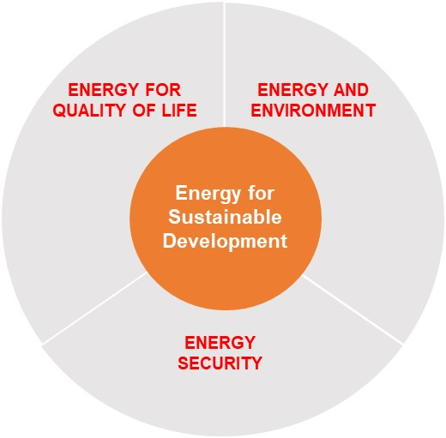
Figure 1: Components of Sustainable Energy.

This type of visualization is useful to highlight the inter-connectedness of definitions of Sustainable Energy.
During the consultation process, Sustainable Energy was described as a moving target interpreted differently by countries and over time. The triangle allows for the fact that countries have different starting points and that the balance of national priorities change over time.
Figure 1 shows the tradeoffs countries face when choosing their path towards Sustainable Energy. Any point in the circle represents a country’s position in the spectrum of Sustainable Energy with its priorities tending towards one of the three goals. The center of the circle describes the equilibrium of all three pillars. For example, a country transitioning to a Sustainable Energy System may find that energy security becomes too expensive and that environmental protection gains attention as a country becomes more prosperous. The overall direction, however, should be towards the inner circle of ‘Energy for Sustainable Development’.
The use of three pillars to describe what Sustainable Energy should entail allows a simple but relevant way to develop quantifiable measures of the concept.
The following policy objectives were assigned to each of the pillars:

Energy Security
‘Securing the energy needed for economic development’
The Energy Security pillar deals with economic aspects of energy supply from a national perspective. It includes accessibility to energy supplies including import and export considerations.
The concept of energy security varies between countries. Some countries define it as independence from any energy imports or their self-sufficiency ratio. Others see energy security in a regional context, with a focus on sub-regional inter-connectivity and trade.

Energy for Quality of Life
‘Provision of affordable energy that is available to all at all times’
The Energy for Quality of Life pillar aligns with the energy-related targets of the 2030 Agenda. It seeks to improve living conditions by providing access to clean, reliable and affordable energy for all. This includes, not only physical access to modern energy and electricity services, but also looks into the quality and affordability of access. Price developments for energy services including electricity, heating, cooling, and transport are important measures.
In relation to bio-energy and its nexus-related considerations, such as competition for resources for food production, food prices can give an indicator to the sustainability of energy as well as food systems.

Energy and Environment
‘Minimize impact of energy system on climate, ecosystems and health’
The third pillar of “Energy and Environment” represents the tradeoffs between meeting the increasing demand for energy supply, providing a healthy environment with clean air, and protecting the environment from climate change.
Energy emissions contribute 60% of total Green House Gas emissions so the energy sector needs to improve its carbon footprint across the energy supply chain and support climate change mitigation efforts.
Beyond climate change and air pollution measures, the Energy and Environmental pillar also includes further nexus topics such as the use of water in energy sector transport emissions and air pollution caused by energy generation and consumption.

Linking the Sustainable Energy Pillars to the 2030 Agenda for Sustainable Development

Recent international agreements for a sustainable future, notably the energy-related Sustainable Development Goals and subsequent pledges made during the Paris climate meetings in December 2015, provide an important context for the Pathways Project. The 2030 Agenda for Sustainable Development (2030 Agenda) requires countries to pursue concerted and accelerated action on Sustainable Energy in their national programmes in order to reconcile the world’s growing need for energy services while mitigating the impacts of energy resource development and use.
Any definition of Sustainable Energy should relate to these overriding international agreements if it is to be of relevance to policy makers. The Sustainable Development Goals (SDGs) are the most relevant in this respect.
Goal 7 of the Sustainable Development Goals has the most direct relevance to Sustainable Energy with a target to “ensure access to affordable, reliable, sustainable and modern energy for all”. However, energy plays an important role in achieving many if not all of the other 16 goals.
Figure 2 shows how the SDGs can help define the concept of “Energy for Sustainable Development”. It summarizes the energy-related links of all the SDGs. More direct links are clustered in the core of the diagram. Indirect links are clustered on the perimeter. Figure 2 also shows how the SDGs align according to the three Sustainable Energy Pillars developed above.
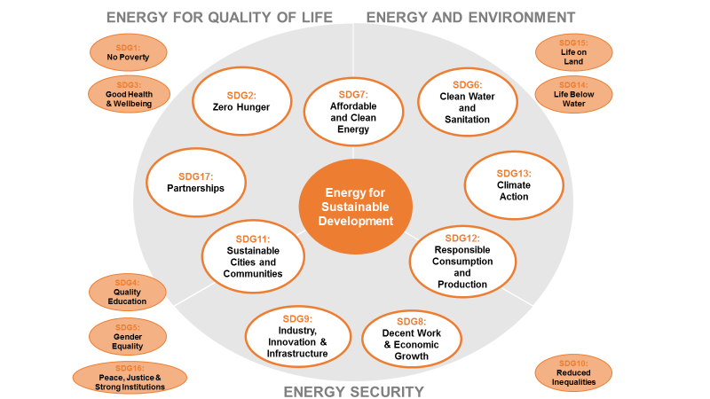

Figure 2: Links to SDGs in defining the pillar of “Energy for Sustainable Development”.

Within the pillar “Energy and Environment”, in addition to SDG 7, three additional SDGs are most prominent: SDG 6 on “Clean Water and Sanitation”, SDG 12 on “Responsible Consumption and Production” and SDG 13 on “Climate Action”.
- SDG 7 is the energy goal among the 17 SDGs. It aims to “ensure access to affordable, reliable, sustainable and modern energy for all”. It has defined targets to substantially increase the share of renewable energy, to double the global rate of improvement in energy efficiency, and to ensure universal access to affordable, reliable and modern energy services. In addition, it calls for international cooperation and investment in sustainable energy research, technology, and infrastructure.

- SDG 13 provides the link to national climate mitigation pledges to be achieved until 2030 - the so called Nationally Determined Contributions (NDCs). The NDCs are the core of the Paris Agreement which is a joint effort in keeping global warming well below 2ºC. The energy sector contributes about two thirds of all greenhouse gas emissions so it is a crucial sector to be included in any climate change mitigation and adaptation actions.

- SDG 6 links with energy because the energy sector consumes a substantial amount of water, for example, through hydropower generation or by using water for cooling in thermal energy generation. The competition for water resources results in a nexus which requires an integrated water and energy approach which in some cases spans national borders.

- SDG 12 aims to increase the importance of the “Circular Economy”. The energy sector plays a critical role in achieving resource efficiency targets. The sustainable use of energy is an important aspect of SDG 12 as well as SDG 7. SDG 12 further includes the phase-out of fossil fuel subsidies which distorts the energy market. This will adversely impact the economics of fossil fuels-based energy generation and hence reduce the impact on the environment through the release of greenhouse gas emissions. An additional linkage is related to the awareness and application of energy saving and energy efficiency measures.

Within the “Energy Security” pillar, the most significant energy-relevant SDGs are SDG 8 on “Decent Work and Economic Growth”, SDG 9 on “Industry, Innovation and Infrastructure”, SDG 11 on “Sustainable Cities and Communities”, and SDG 12 on “Responsible Consumption and Production”.
- SDG 8 & 12 links with energy security as energy is a crucial input factor for economic growth and SDG 12 requires a move towards a more sustainable economic growth model based on improvements in the energy sector. Economic growth needs to decouple from both energy demand and environmental degradation. Key target areas include the reduction of the environmental footprint of the energy sector, an increase in resource and consumption efficiency along the energy value chain, and improved energy intensity across all economic sectors.

- SDG 9 includes the energy industry, energy-intensive industries, energy innovation and the overall energy infrastructure. Achieving SDG 9 needs an energy transition that moves towards a resilient and sustainable energy infrastructure and resource use, as well as the development, dissemination and local adaptation of energy technology.

- SDG 11 relates to the transition and development of a sustainable and resilient urban energy infrastructure, the sustainable energy supply for cities, urban and rural communities, and the electrification of transport and development of sustainable transport fuels. Other important aspects including energy efficient buildings.

Within the “Energy for Quality of Life” pillar, the most significant energy-relevant SDGs are SDG 2 on “Zero Hunger”, SDG 7 on “Affordable and Clean Energy”, SDG 11 on “Sustainable Cities and Communities”, and SDG 17 on “Partnerships”.
- SDG 2 links to the energy sector through the Food-Energy-Water Nexus because of the competition for resources with the food sector. The agriculture sector is both water and energy intensive. Bio-energy may compete with food production as is in the case of maize.

- SDG 7, 11 and 12 links are similar to those in the other two pillars.

Figure 3 summarizes the targets that link with the energy sector for each of the SDGs identified in the core.

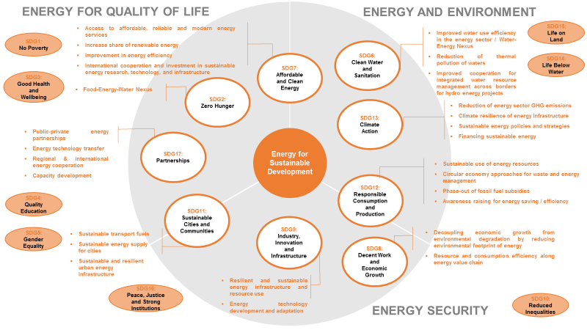
Figure 3: SDG targets relevant for “Energy for Sustainable Development”.

Measuring “Sustainable Energy” in Integrated Assessment Models

One key component of the Pathways Project is the numerical modeling of climate, technology and policy scenarios. A combination of bottom-up and top-down modeling will be applied. The models need numerical input parameters and assumptions for various socio-economic, technological, and climate-related indicators. Also, numerical constraints will be integrated into the models to set specific targets on Sustainable Energy for 2050.
The development of numerical inputs relevant to policy development around Sustainable Energy is not trivial. The models used have confusingly large amounts of input and output parameters which can be selected. It is also not simple to introduce new parameters not already included in the datasets.
The objective of the Pathways Project was to identify a set of the most important indicators that best represent the definition of Sustainable Energy described above. These could be used as Key Performance Indicators (KPIs) within the project. After a broad stakeholder consultation, a list of KPIs was developed that could be used within the models given their various modelling constraints.

Summary of the Pathways Project KPIs for Sustainable Energy

The table below summarizes the KPIs that can be modelled and that will be used for the presentation and analysis of the scenarios to be modelled.

Energy Security
Name | Title | Measurement in the model | Interpretation and Analysis / Relationship to SDGs
ES-M1 | Energy self-sufficiency: net imports | Net imports in each sub-region and overall UNECE region | Relates to SDGs 8 & 9.  Interpreted in the context of regional cooperation and interconnectivity.
ES-M2 | Energy efficiency | Energy intensity: units of energy per unit of GDP (J/US$ PPP)  Rate of improvement in energy intensity (% CAGR)  Conversion efficiency | Relates to SDG 7.3 target to double the rate of improvement in energy efficiency by 2030. Energy intensity is the SDG7.3 indicator.  Interpreted in the context of both thermodynamic conversion efficiency as well as the energy efficiency of the economy.
ES-M3 | Investment requirements to achieve sustainable energy | Energy investment of GDP (% GDP) | Relates to SDG 7.A , SDG 13.A  Interpreted in the context of impacts and ability to finance the investments.
ES-M4 | Diversity of supply: fuel mix in energy and electricity | Share of different fuels in Total Final Energy Consumption (TFC) and Total Primary Energy Supply (TPES), and in electricity (%) | Relates to SDG 7.2 target ‘substantially increase the share of RE in TFC’.  Interpreted in the context of diversification of supply, share of low-carbon / fossil fuel energy supply, etc.

Energy for Quality of Life
Name | Title | Measurement in the model | Interpretation and Analysis / Relationship to SDGs
QL-M1 | Access to energy services | Energy / electricity services per capita (efficiency adjusted energy consumption) (J/capita/year) | Relates to SDG 7.1 target: Universal access by 2030, and SDG1.
QL-M2 | Energy affordability | Total energy expenditures per GDP per capita | Relates to SDG1 and SDG 7.  Interpreted in the context of energy poverty and household income spent on energy expenditures.
QL-M3 | Food security | Share of calories from non-staple food (%)  (GCAM model only) | Relates to SDG 2.4 (sustainable agriculture), 2.3 (reduce food loss), 13.1 (impact of climate change).  Will be interpreted with a focus on the linkages between sustainable bioenergy (solid biomass) generation of food production.

Energy and Environment
Name | Title | Measurement in the model | Interpretation and Analysis / Relationship to SDGs
EE-M1 | GHG emissions from the energy sector | Total global GHG emissions of the energy sector in MtCO2eq | Relates to SDG13.
EE-M2 | Air polluting energy emissions | Emissions from energy sector: Sulphur Dioxide (SO2), Nitrogen Oxides (NOx), Particulate Matter (PM2.5) (ppm or μg/m3) | Relates to SDG 3.9.1.
EE-M3 | Water use efficiency and water stress caused by the energy sector | Cooling water use in electricity generation (l/kWh)  Water use associated with energy resource extraction (GJ liters absolute and/or L/GJ) | Relates to SDG 6.4.1 ‘substantially increase water use efficiency’ and 6.4.2 ‘substantially reduce water scarcity’.  Interpreted in the context of water use of the energy sector: power generation and water consumption from energy extractive industries.

These KPIs will be monitored as output parameters to determine the impact of a policy within a scenario. In addition, some of them can be used as target values (model constraints) in which case the model uses them as a target from which it can be assessed how the other output parameters perform.
Assigning target values can be performed for the following KPIs:
Green House Gas Emissions from the energy sector
Given the COP 21 Paris Agreement, policy scenarios under the Pathways Project should aim to limit global warming to maximum 2ºC. The ‘target’ value or constraint for the model is to limit cumulative total global greenhouse gas emissions of the energy sector over the remainder of the 21st Century to stay below the 2ºC maximum temperature limit.
In addition to this “Paris to 2C” scenario, other scenarios include the “Reference Scenario” based on SSP2 and “Current Policies Scenario” will highlight results without the 2ºC constraint in place. These scenarios will help to assess the gap between the current policies in place and the Sustainable Energy objectives agreed within the project.
Air polluting energy emissions
Emissions from energy and transport sector including Sulphur Dioxide (SO2), Nitrogen Oxides (NOx), and Particulate Matter (PM2.5), among others. These can be integrated in the model as constraints. If desired by the project stakeholders, emission targets can be formulated and implemented when developing the policy scenarios to see their impact on the other KPIs.
Energy affordability
In line with SDG 7 target 7.1, universal access to energy is to be achieved by 2030. The UNECE region has, officially, achieved 100% access to electricity and so the indicator to be used measures affordability of energy services. A desired target of maximum 10% of disposable income spent on energy expenditures has been set. This indicator is not a constraint that can be used to converge the model to a solution, so it can only be calculated along with the other modeling outputs.

Energy choice
Finally, the models have no constraints on the form of energy, type of energy or energy technology used. All are included within the models. However, by applying Sustainable Energy objectives in the form of KPIs and constraints, policy options and the evolution of climate knowledge and energy technology, the output from each scenario will evolve. For example, applying a cost optimization approach will result in a mix of energy technologies which changes as the cost information evolves. The model may exclude certain forms of energy generation if they are not supporting the overall cost optimization approach.

Conclusions

The climate and energy modelling in the Pathways Project requires a definition of Sustainable Energy that can be represented by numerical parameters. Without this, the exploration of the scenarios and policy options would be far too qualitative.
The project has proposed that three pillars of Sustainable Energy can be defined and related directly to the Sustainable Development Goals. These pillars are Energy Security, Energy and Quality of Life, Energy and Environment. For the most part, the relevant SDGs target can be aligned with these pillars and used within the models that the Pathways Project will use.
The integrated assessment and energy models have their own constraints on the use of parameters related to the architecture of each model. It is, therefore, necessary to carefully select the parameters to be used within the project. This has been done with 3 or 4 KPIs selected for the three pillars defining Sustainable Energy.

Baku, October 2016; Astana, June 2017; Geneva, September 2017; Vienna, March 2018; Bishkek, July 2018.
Consultation period on sustainable energy parameters to be used, period: October 2017 to February 2018.
See glossary for explanation on terminology.
The baseline input assumptions are based on the Socio-Economic Pathways (SSPs). The advantage of using the SSPs is that they have been developed through various iterations by an international research community, including IIASA and PNNL, with the objective to provide five narratives describing alternative socio-economic developments and plausible major global developments. SSPs are used to analyse the feedbacks between climate change and socio-economic factors and to develop scenarios for use by the research community. The SSPs include qualitative narratives and quantitative elements. To develop the project scenarios, basic socio-economic assumptions from SSP2 and respective datasets will be used. SSP2 will function as the base case scenario (“No Policy Scenario”) in the Pathways project. It describes a “middle of the road” scenario. See detailed description of SSPs: Riahi K. et al (2017): The Shared Socioeconomic Pathways and their energy, land use, and greenhouse gas emissions implications: An overview. In: Global Environmental Change 42 (2017) 153–168.

