UNITED NATIONS ECONOMIC COMMISSION FOR EUROPE
Joint Task Force on Energy Efficiency Standards in Buildings

Mapping of Existing Technologies to Enhance Energy Efficiency in Buildings in the UNECE Region

Kankana Dubey, Andrey Dodonov
(draft as of 24.09.2018)
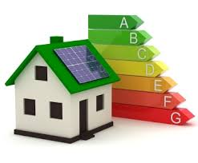
GENEVA, 2018

Table of Contents
List of Tables 3
List of Figures 3
Acronyms and Abbreviations 3
Executive Summary 3
Introduction 3
- Methodology and scope of study 3
- Energy efficiency technologies in buildings in the UNECE region 3
  - Building envelope: insulation and glazing 3
  - Space heating 3
  - Air conditioning 3
  - Water heating and cooling 3
  - Appliances 3
  - Lighting 3
- Current deployment of energy efficient technologies – review and gap analysis 3
  - Application and adaptation 3
  - National level assessment 3
  - Performance outcome 4
Conclusions 4
Gap analysis 4
Barriers of implementation 4
Comparative assessment 4
Recommendations 4
Policy and legislation 4
Investment and Finance 4
Technological adaptation 4
Capacity development / local content 4
Role of Public and Private sector 4
Scope of future studies 4
Annexes 4
References 4

Executive Summary
One of the most important goals of public policy to stimulate the transition to a sustainable energy system is to improve energy efficiency quickly. Indeed, according to (UNECE, 2017a, p. 10), “improving energy efficiency is one of the most cost-effective options for meeting growing energy demand in most countries. It contributes to energy security, a better environment, improved quality of life, and economic well-being”. While it is generally recognized that significant progress is being made, there is still substantial potential for improving energy efficiency worldwide.
Across all countries in the United Nations Economic Commission for Europe (UNECE) region, buildings account for approximately one third of energy consumption, and 40 percent of CO₂ emissions. The buildings sector thus presents a unique opportunity to substantially improve energy efficiency – both via retrofitting existing buildings and requiring higher energy efficiencies on newly-constructed buildings. The public policy toolbox is filled with a variety of tools for meant to encourage increasing building energy efficiency; these include mandatory standards, cash and tax incentives, and consumer information programs.
In a prior study entitled “Mapping of Existing Energy Efficiency Standards and Technologies in Buildings in the UNECE Region”, the UN Committee on Housing and Land Management (CHLM) and the Committee on Sustainable Energy (CSE) commissioned a comparative study on building standards in the UNECE region. The current report follows up on this by analyzing the actual prevalence of specific types of energy-efficient technologies in the buildings sector in the UNECE region, along with the levels and types of public policy interventions supporting their implementations. The study objectives are to evaluate UNECE countries vis-à-vis their adaptation of these technologies, identify implementation gaps and possible causal barriers, and recommend country-specific rectifying actions. We gathered data for this study mainly through desktop research of both internet and print media, including official governmental communiques, NGO-published reports, academic publications, energy databases, and public news outlets. We validated and further augmented these data sources through consultations with various subject-matter experts and organizations.

Gap Analysis
We rated the analyzed UNECE member States - categorized into five subregions named A, B, C, D, and E - on a 3-point scale (Low, Medium, High) for the penetration in their societies of the building energy efficiency technologies listed in the Appendix. For tabulation and analysis, we aggregated the technologies into four high-level categories: “Building Envelope and Glazing”, “Heating of Domestic Hot Water Supply”, “Common Measures”, “Air Conditioning, Ventilation, and Cooling”, “Appliances” and “Lighting”. Where possible, we gathered relevant data separately for retrofitting existing buildings, and implementation in new construction; then further segregated the data into four types of buildings: single-family dwellings, multi-family dwellings, commercial buildings, and public buildings.
The data suggests that some aspects and types of energy efficiency technologies are very consistently required and implemented in the buildings sector across the UNECE member States. For example, efficient building envelope insulation (including windows) are used in all countries, and many member States have made good progress towards net-zero energy impact buildings – at least for those owned/occupied by the public sector. Another example of consistent application is public policy to phase out incandescent bulbs in favor of more efficient lighting technology. Several countries, have gone further, encouraging implementation of more advanced sensor-based lighting control systems to reduce energy consumption. On the other hand, our analysis has found much wider disparities in the prevalence of energy efficient decentralized space heating technologies. For example, Denmark has extensively encouraged the installation of new electrical boilers for building heating during both renovations of existing buildings and construction of new buildings. In Finland, however, oil-burning boilers are more prevalent, though the Finnish Government has various measures in place to encourage switching from oil-heating systems to more efficient alternatives.

Introduction
According to the report “Energy for Sustainable Development in the UNECE Region” released in 2017 by the United Nations Economic Council for Europe (UNECE, 2017a), one of the most important goals of public policy to stimulate the transition to a sustainable energy system is to improve energy efficiency quickly. The report states, “Improving energy efficiency is one of the most cost-effective options for meeting growing energy demand in most countries. It contributes to energy security, a better environment, improved quality of life, and economic well-being” (UNECE, 2017a, p. 10). The UN’s Sustainable Development Goals target 7.3 (SDG7.3) is to “double the global rate of improvement in energy efficiency by 2030” (UNECE, 2017a, p. 1). There is significant potential worldwide for improving energy efficiency, and it is widely recognized that significant progress is indeed being made. According to the Enerdata Global Energy Statistical Yearbook, global energy intensity improved by 1.8% in 2016 and 1.2% in 2017. However, there are still significant barriers hindering this progress, and these recent gains have not been enough to meet a Sustainable Energy for All (SDG7.3) objective (UNECE, 2017b).
Out of all sectors of economic activity, the buildings sector has the largest potential for cost-effective improvement in energy efficiency and emissions reductions. Additionally, focusing on the buildings sector brings significant social co-benefits, such as:
- increasing energy security
- expanding entrepreneurial opportunities
- creating jobs
- reducing energy poverty
- increasing access to energy services
- improving air quality (both indoor & outdoor)
- increasing comfort and& health
Consumption of carbon-emitting energy by buildings can be reduced in three different ways: reducing the demand for energy services, increasing ‘technical’ energy efficiency, and integrating renewable sources of energy; we use the term ‘energy efficiency’ to cover all three reduction methods. This report focuses on the existing technological opportunities and barriers against improving efficiency of energy used for heating, cooling, ventilation, lighting, and electricity in the built environment.
A variety of public policies designed to improve energy efficiency in the buildings sector have been implemented throughout the UNECE region, with varying degrees of success. Another benefit of focusing on energy efficiency in buildings is that the buildings sector is already quite regulated, which enhances dissemination of energy efficiency requirements, further driving progress. Another supporting factor is the role of the public sector. Public buildings often constitute a significant share of a country’s total building stock. Therefore, by choosing energy-efficient designs and materials for their own buildings, governments can exert a powerful influence on the buildings sector, as well as set an example. Many countries have set up official national energy efficiency laws or programmes with quantified energy efficiency targets. These programmes can have a substantial impact on the durability and effective coordination of public policy in favour of energy efficiency but require sufficient political consensus for practical implementation.
Policies, programmes, and technologies can be considered to address energy efficiency in buildings from three perspectives: systems, structure and service. Examples include appliance standards and labels (Energy Star, et al.), building energy codes, utility demand-side management programmes and targets, public-sector energy leadership programmes, energy pricing measures and financial incentives, education and training initiatives, and the promotion of energy service companies (ESCOs) (UNDP, 2009). The level of success of each of these types of policies is dependent upon many factors, and may be hindered by various barriers. In addition, the best approach to improving building energy efficiency in each country may depend upon the maturity of its building sector.
In rapidly developing countries in which the built environment is largely immature, the buildings sector should prioritize improving energy efficiency and reducing future emissions in new construction. Policies and programs targeting existing building stock will likely have a lower magnitude impact on overall improvement in energy efficiency. This is one aspect in which the developing economies can have a disproportionately large impact on reaching global energy efficiency targets, as the marginal cost of increasing building energy efficiency is lowest at construction time. New construction represents a significant opportunity to integrate efficient materials, new technologies, and best practices from the start. During construction, the entire building system can be designed to optimize energy efficiency. Operational energy consumption is affected by location, orientation, structure, layout, construction materials, and included equipment – all design- and construction-time decisions. Some of these factors can be improved upon later during major renovations, but are more capital intensive.
Conversely, in many OECD countries with developed economies and extensive building infrastructure already in place, retrofitting existing buildings to improve energy efficiency and reduce emissions should take priority over new buildings. Consider the built environment in the European Union, which is composed of approximately 35% of buildings 50+ years old; improving their energy efficiencies could reduce the region’s total energy consumption by more than 5% (UNECE, 2017a, p. 8).
Two major factors affect building energy efficiency during its use – performance of major equipment (boilers, AC units, lighting, etc.), and occupant behavior (temperature, timing and use of appliances and lights). Optimizing the energy efficiency of the components of these two factors, with respect to occupant comfort and safety, requires complex building energy systems to monitor and control the buildings internal environment. However, a significant number of companies in the UNECE region don’t currently implement such standardized energy management systems (UNECE, 2017b, p. 27).
Multiple barriers make it difficult to transform the vast potential of energy savings in the buildings sector into a reality. Some of these barriers are general (that is, they apply to all energy efficiency projects in all sectors), while others are specific to the buildings sector.
General barriers to improving energy efficiency include:
- lack of technology
- limited financing
- insufficient awareness and expertise of financiers
- un-adapted or missing regulations
- high costs of reliable information
- greater weight given to upfront costs compared to recurring costs
Effective lobbying capability to counteract the fossil fuel lobby is also a significant barrier; even renewable energy has an extensive lobby (UNDP, 2009). Similarly, most countries lack governmental agencies with a clear mandate and adequate capacity to design and implement policies in favour of building energy efficiency. One significant barrier specific to the buildings sector is structural complexity; a holistic systems perspective, which leads to more thorough optimization of design and operation and hence improved energy efficiency, requires more breadth and depth of expertise (UNDP, 2009).
In the European Union, much attention has been given over the past decade to energy efficiency in the buildings sector, with the following directives:
- directive of 16 December 2002 on the energy performance of buildings
- directive of 6 July 2005 establishing a framework for the setting of eco-design requirements for energy-using products
- directive of 5 April 2006 on energy end-use efficiency and energy services
- directive of 23 April 2009 on the promotion of the use of energy from renewable sources providing for the promotion of energy efficiency
- directive of 21 October 2009 establishing framework for setting of the Ecodesign requirements for energy-related products
- directive of 19 May 2010 on the indication of energy efficiency labelling and standard product information of the consumption of energy and other resources by energy-related products
- directive of 19 May 2010 on the energy performance of buildings
- directive of 25 October 2012 on energy efficiency amending directives 2009/125/EC and 2010/30/EU and repealing directives 2004/8/EC and 2006/32/EC
- directive of 30 May 2018 amending directive 2010/31/EU on energy performance of buildings and directive 2012/27/EU on energy efficiency
To help officials in EU countries implement the Energy Efficiency Directive, the European Commission has published several guidance notes; Article 5, 6, 7, 8, 9-11, 14, 15. Country-level implementation of these directives should induce important changes in energy efficiency in Europe, especially in the buildings sector. In the United States, the Energy Policy Act of 2005 covers almost every aspect of energy generation, distribution, and consumption, along with guidelines on energy efficiency. In 2012, 31 states, by adopting either ASHRAE 90.1.2007 or the ICC Energy Conservation 2000-2015, adopted model codes for residential and commercial buildings. Their provisions concerning energy efficiency in buildings include: energy consumption reduction targets for public buildings, integrating efficient equipment in public procurement, new standards for 14 large appliances, and tax incentives for energy efficiency improvements in homes, commercial buildings, and public buildings. However, some environmental organisations have criticised the act for bringing only limited progress on energy efficiency in buildings.
Chapter 1 documents the objectives and scope of this study. The methodology we used, as well as perceived limitations is also detailed. In Chapter 2, we focus on the energy used in the building during its operational life, and relevant existing energy efficiency technologies in six broad categories: building envelope (insulation and glazing), space heating, air conditioning, water heating and cooling, appliances, and lighting. These technologies are mapped in relation to existing building standards. Chapter 3 documents our review of the application and adaption of the relevant technologies, nation-level assessment, and the gap analysis. Gaps are identified and analyzed with respect to several perspectives, including: knowledge, technical, regulatory, institutional, and financial. We end with Conclusions and Recommendations, which are based on the mapping and gap analysis, focusing on priority actions countries in the UNECE region should take to increase the uptake of technologies to enhance energy efficiency in buildings. Recommendations include, but are not limited to, aspects surrounding policy and legislation, investments and financial incentives, technology adaptation, and capacity development.

CHAPTER 1 - Objective, Scope, Methodology, and Limitations
The objective of this study is to examine and analyze the current status of energy efficiency in buildings in the UNECE region; our broad focus is threefold: relevant technologies, building standards, and supporting public policies. Gap analysis between actual and ideal implementations is used to form a base from which to guide UNECE member states in their efforts to improve building energy efficiency, in support of SDG7.3. The UNECE Committee of Housing and Land Management (CHLM) and Committee on Sustainable Energy (CSE) published an initial report, entitled “Mapping of Existing Energy Efficiency Standards and Technologies in Buildings in the UNECE Region”, towards this goal (UNECE, 2018). This report documented building codes and energy efficiency requirements currently in place. The UNECE published an additional report, entitled “Overcoming Barriers to Investing in Energy Efficiency”, in support of the same goal (UNECE, 2017b). The authors of this report surveyed global energy efficiency experts and practitioners on the narrow topic of barriers which hinder improving building energy efficiency. To further strengthen the understanding of the UNECE member states on the technological impact of energy efficiency technologies in the buildings sector (UNDP, 2009), the current study was commissioned.
We undertake the mapping and clustering of existing technologies to enhance energy efficiency in buildings and identify and analyse the gaps between existing energy efficient technologies in the buildings, and their application and adaptation in the UNECE region. Our analysis complements the reports, which were limited, respectively, to building codes and technical requirements, and various social, policy, and financial barriers (UNECE 2017b, UNECE 2018). Specifically, we extend the initial assessments of energy efficiency technologies in buildings in relation to the existing standards and current barriers. The main method of our study is gap analysis, based on desktop research; our analysis focuses on the following topics relevant to energy efficiency for countries in the UNECE region:
- institutional and legal policy
- building codes and standards
- existing technologies
- local capacity development
- existing availability of materials and equipment
- currently implemented financial and economic mechanisms
This report is based on the principles of Framework Guidelines for Energy Efficiency Standards in Buildings (UNECE 2017c), and thus transcends the incremental, components-based approach of existing building standards analyses. It is well-known that the largest saving potential in energy use occur when a systems perspective is used to implement energy efficiency improvements. This design perspective informs our gap analysis and subsequent recommendations. Furthermore, we analyze the gaps by highlighting the difference in the use of technologies among countries of the UNECE region. Our analysis evaluates the correlation between the strictness and enforcement of existing standards, and the level of applied technologies.
The data collected to measure and analyse the trends and patterns of application of energy efficient technologies is based on the following assessment criteria. The implementation of each technology in each country was evaluated on an impact score as defined below.

Impact Score | Assessment Criteria
10 (High) | The technology is strongly prevalent. There is governmental support and initiative to support promotion of the technology, and there are active measures being undertaken which include financial support and incentives. Application of this technology is mandatory, or in a transition phase to becoming mandatory. There could be fines for non-compliance. This technology might be made affordable and economically feasible through means of incentives and being widely implemented.
6 (Medium) | National legislation (laws, building energy codes etc.) does not require implementation of this technology. There are only some cases when implementation of this technology is supported on the regional level (e.g. in some climate zones etc., but not in the whole country). Some prescriptive recommendations may exist in the legislative documents. This technology is frequently implemented during new construction or retrofits; despite the lack of proper regulatory framework, it may be affordable and widely used. There is a moderate trend of implementation for the technology, but there are still some gap areas which exist. This could be improved with public-private partnerships, government support, push-pull marketing strategies, compliance standards, and financial incentives.
2 (Low) | Existing legislation does not require implementation of this technology. There are also no specific building energy codes that describe at least prescriptive requirements. This technology is only seldom implemented in some regions (including demo-projects, implemented by the international public organizations and co-financed by the various funds). The technology is likely economically inefficient. It is being implemented, but at a stage of infancy; market barriers exist which curtail adaptation. Much is mentioned about it in policies, but there is not substantial applicability and efforts are required to promote the technology.
0 (Non-applicable) | Implementation of this technology is not economically feasible and not mandatory. This technology is not applicable (only in some specific cases).
NI – No Information | No information, as of now, on the data point.

The validity of the conclusions and recommendations in this report is limited by the data which was publicly available through desktop research at the time of compilation. Where appropriate in the remainder of the report, we have documented assumptions which were made; all inferences are likewise dependent upon these assumptions. Finally, unlike the aforementioned report (UNECE 2017b), we did not base our study on data elicited via a structured survey from subject matter experts. To the extent that said experts hold relevant information that is not publicly available, our conclusions and recommendations may be biased.
This study was consulted, and results validated, by the stakeholders from the UNECE region, relevant national authorities, and members of the UNECE Joint Task Force on Energy Efficiency Standards in Buildings. The preliminary findings of the study were validated at the Joint task Force Commission meeting in Geneva on October 3rd, 2018, and the finalized study presented during the Ninth International Forum on Energy for sustainable Development, on 12-15th November in Kyiv.

CHAPTER 2 – Energy Efficient Technologies in Buildings in the UNECE Region
The buildings sector consumes significant amounts of energy to maintain comfortable living conditions, which requires: space heating, water heating, ventilation and air conditioning, and power supply for lighting and other household appliances. There are advanced technical solutions for buildings being integrated in modern architecture which reduce energy consumption, carbon emissions, and energy wastage, while providing maximum thermal comfort and safety of the occupants. In general, such technologies either reduce the energy demand, or increase the efficiency with which energy is used.
Modern building regulations define the requirements of building engineering systems and set building envelope thermal performance limits, which also determines the most optimal energy consumption, in terms of technical and economic conditions.
Building codes provide guidelines for new buildings and for retrofitting existing buildings to create high-performance buildings by applying an integrated, whole-building design process, which increases building life-span, reduces energy consumption, and contributes to a better, healthier, more comfortable environment for people to live and work. Several technological options exist which, along with providing energy efficient solutions, also support sustainability measures, reduce operating costs and environmental impacts, and increase building adaptability, durability, and resiliency. In this Chapter, we focus on how and where energy is consumed in a building during its operational life, and relevant existing energy efficiency technologies in six broad categories:
- building envelope; insulation and glazing
- space heating
- air conditioning
- water heating and cooling
- appliances
- lighting
The following are some energy efficient measures which can be adopted to make buildings efficient and productive.
Thermal protection for enhancing the building envelopes:
- thermal insulation of building envelope
- replacement of obsolete windows and doors with modern energy-efficient ones
Decrease heat loss in buildings
- restoration and sealing of inter-panel joints of the walls and ceilings, in case of panel building reconstruction
- installation of additional entrance groups (tambours) with double doors
- installation of automatic door closers
- installation of heat air recuperators to limit heat loss by the ventilation system, and supply fresh and clean air
Improvement and optimization of internal heat-supply systems, to decrease energy consumption
- thermal insulation of heating system pipelines, hot water risers, and heating system distribution mains
- installation of automatic individual heat points for the heat supply system
- installation of thermostats for the heating system radiators
- installation of balancing valves on the heating system risers
- installation of heat- and water-heating boilers (including biofuel) with weather-compensating controls
- use of circulating pumps for heating systems, hot water supply with built-in or external frequency converter drives
- installation of reflective insulation behind radiators
- hydro-pneumatic or chemical cleaning of heat supply systems, including basic equipment
Reduction or optimization of electricity consumption
- replacement of lamps and bulbs in internal and external lighting systems
- optimization of energy consumption by elevators with installation of frequency converter drives
- use of frequency converters in the engineering building systems to optimize the operation of fans, pumps, and other relevant equipment
- installation of energy-efficient household appliances
- installation of photovoltaic heating and power-generating systems (solar panels)
The energy efficiency measures stated are described in the rest of this chapter, highlighting their impacts on energy consumption and applicability in the UNECE regions.

2.1. Building Envelope: Insulation and Glazing

2.1.а Insulation of building envelope
The building envelope has the greatest impact on buildings performance; it is a prime focus area to consider when energy efficiency measures are planned for existing or new buildings. Considering the functions of the building envelope - security, comfort, shelter, privacy, aesthetics, ventilation etc. - it is imperative to optimize the design of the building envelope to meet the occupants’ requirements while reducing energy consumption and heat loss. Indeed, the energy savings from eliminating heat loss due to poor insulation can be up to 15-35%.
The importance of thermal insulation in buildings is equally relevant for countries in both hot and cold climates. Heat loss through leakage during cold months leads to increased use of heating energy, this is analogous to losing cool air from air conditioning in summer months (both situations resulting in increased consumption and higher carbon emissions). Most building heat loss is through the walls, roofs, and floors. Proper insulation can reduce the heat loss in cold climates and excess heat infiltration in hot climates. The type and amount of insulation varies according to building type and usage. There are many energy efficient building envelope technologies available, which are predominantly applied to new buildings. Some may also be implemented during retrofit upgrades, as applicable.
Insulation layer thickness selection is based on the requirements of the construction and regulatory criteria, climate conditions, current thermal, and other necessary parameters. All of which should be considered in the architectural design stage. There are several types of insulation material available in the market, shown in Figure 1. The key thermal insulation materials primarily used in buildings to promote energy efficiency are shown in Figure 3.

Organic |  | Non-organic
Expanded polystyrene |  | Mineral wool
Frothed non-pressed | Extruded | Fiberglass | Rock wool | Slag wool
Figure 1 - Available types of insulation material
Wall insulation is added to both outside and inside of the building, as shown in the following table.
Internal building insulation | External building insulation
- External walls of the building are exposed to the external pressures of the environment. Atmospheric fluctuations of humidity and external air temperature hence lead to the gradual deterioration of the external walls. On one hand, the problem of internal heat loss is resolved, but on the other hand the problem of protecting the building exterior against weather conditions remains critical  - External walls of the building are subject to inclement weather conditions, such as frost penetration because of the cold external environment. Alternatively, they are subject to intensive solar radiation. Walls that do not have external insulation are incapable of retaining heat in the winter and are subject to excessive heat gai in the summer.  - Despite the dew point being outside the wall, moisture is formed between the insulation layer and the wall, due to the temperature gradient, which can lead to the growth of fungal plaque. To avoid this, it is necessary to use thicker insulation materials, which reduce the usable space inside the building.  - Internal insulation reduces the usable living area of buildings, including living rooms in residential buildings.  - To add insulation to the interior wall of an existing building may require the temporary eviction of residents, which might be a cause of inconvenience for the occupants. | - Insulated external walls are more durable because of sufficient protection from externalities of the environment such as freezing, thawing, etc.  - Due to insulation a uniform temperature is maintained in the walls, thereby eliminating the occurrence of cracks due to uneven thermal deformation.  - There is no impact of moisture on the interior surface of the external wall. The condensation point (dew point) is shifted into the outer layer of insulation, thereby eliminating any possibility of moisture on the inside wall surface, thus creating a favorable condition for its vapor permeability.  - This method of insulation does not reduce the usable space of building.  - Adding insulation to the exterior wall during retrofit of an existing building structure has no impact on the occupants’ living condition No uncomfortable living conditions occur during the insulation installation and the eviction of residents isn`t required.
Table 1 - Wall insulation

The most popular technological solutions for building envelope insulation are the following:
- layering of insulating material between the exterior and interior walls
- insulation on the building exterior with plastic covering
- insulation material between the ground floor or basement and floors above.
The principles of various technical solutions are illustrated in Figure 2.
Proposed technology for exterior wall insulation

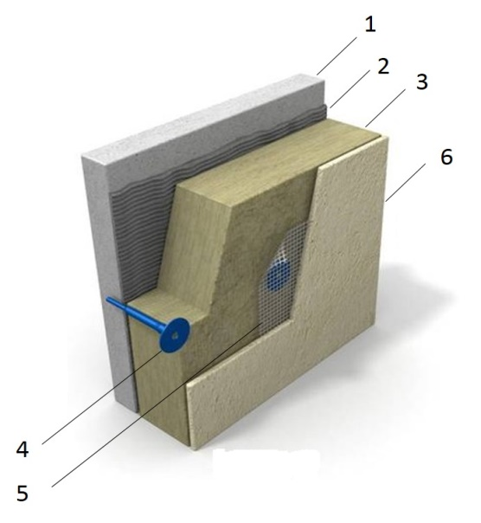 | Key elements of the proposed technology
- The existing concrete slab
- Adhesive composition
- Rigid mineral wool plate based on basalt
- Fixing plug
- Reinforcing fiberglass mesh is applied to the adhesive composition
- Outer protective and decorative coating with preliminary primer layer
Proposed technology for slabs insulation above cold passage

 | Key elements of the proposed technology
- The existing concrete slab
- Cement screed
- Vapor barrier
- Rigid mineral wool plate based on basalt
- Hydroisolation
- Layer of reinforced cement-sand screed
Figure 2 - Technical solutions for insulation

 | Fiberglass | Rock wool | Slag wool | Expanded polystyrene (Frothed non-pressed) | Extruded polystyrene
VIEW | 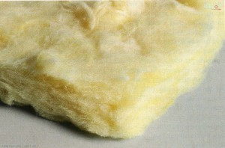 | 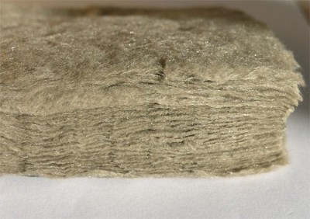 | 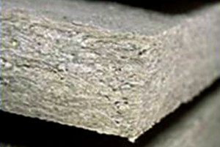 | 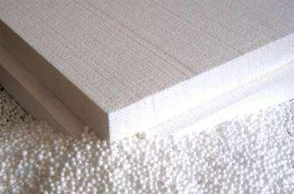
CHARACTERISTIC | Initial raw materials for production of fiberglass are: sand, soda, limestone, drill (or etibor), cullet. Heat conductivity - 0,038-0,046 W/m·K.  Max operational temperature - 450 °C.  Min. operational temperature -60 °C. | The main raw materials for production of stone (basalt) cotton wool are rocks. Heat conductivity - 0,035 — 0,042 W/m•K.  Max operational temperature – up to 1000 °C  (only in case of lack of deformation). | Initial material for production of slag cotton wool are domain slags. Heat conductivity - 0,04 - 0,07 W/m•K.  Max operational temperature - 300 °C. | Expanded polystyrene (or polyfoam) stands for the foam plastic which consists for 98% of air. Heat conductivity - 0,036 - 0,050 W/m•K  Max operational temperature - +70 °C.  Min operational temperature - 50 °C. | Extruded expanded polystyrene consists of the granules of polystyrene formed by an extrusion method Heat conductivity - 0,028 W/m•K  Max operational temperature - +75 °C.  Min operational temperature - 50 °C.
ADVANTAGES | - Lightness  - Elasticity  - Good sound-proofing properties;  - Nonflammable  - High compression for easy transport | - Nonflammable  - High elasticity  - Immunity to mold and fungus  - Resistance to short-term influence of moisture – can be mounted during rain  - Fibers are noncaustic | - Low water absorption – is ideal for work under the open sky in any weather | - Low price  - Excellent flexibility  - High durability on compression at the low density  - Simplicity of installation | - High durability on compression at the low density  - Low water absorption  - Low vapor permeability  - Low coefficient of heat conductivity
DISADVANTAGES | - High fragility of fibers  - High water absorption | - Low compression of material; inconvenient for transport  - High cost | - High fragility of fibers  - Low indicators of heat conductivity | - Group of combustibility G1-G4 (combustible);  - High water absorption  - Repeated transition of temperature through 0ºС leads to destruction | - Group of combustibility G1-G4 (combustible)  - High cost
RESTRICTIONS | It is necessary to use the coveralls made of a dense material, gloves, respirator, and safety glasses during installation. | Requires careful transport and protection against mechanical influences. | Not recommended to use together with metallic facade elements. | Prohibited to use without covering – requires cement and sand or plaster protection from the open environment. | Prohibited to use without covering – requires cement and sand or plaster protection from the open environment.
Figure 3 - Key thermal insulation materials applied in the UNECE region.

2.1.b Installation of modern windows with higher thermal characteristics
Replacement of outdated windows with the latest window technology insulation is much more efficient than repairing them. The energy savings from installing an efficient window system can be up to 15-30%. Building standards in several countries required the installation of energy efficient windows with high thermal characteristics. Modern energy efficient windows are made using multi chamber profiles, which is a more complicated design than traditional wooden-paneled windows. As well as having advanced thermal characteristics, multi chamber windows are stronger, resisting deformation, so can be expected to last longer. Windows made with Polyvinylchloride (PVC) have the highest thermal features, and this is the most common material for energy efficient windows. However, windows with other materials are available, including both aluminum and wood, as seen in Figure 4.
Wooden profile | Aluminum profile | PVC profile
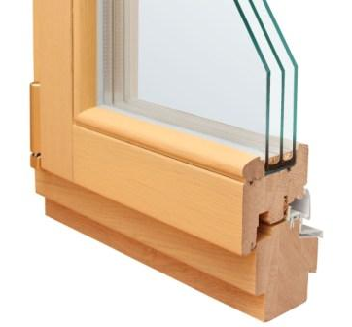 | 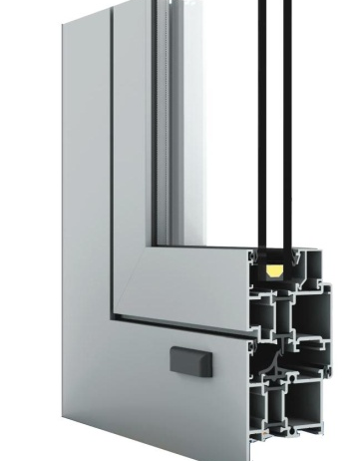 | 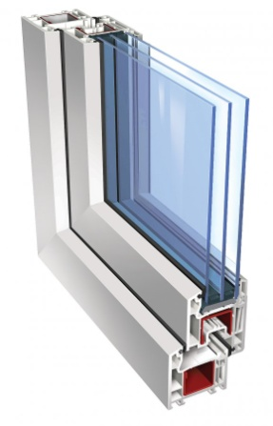
Wooden windows are the most natural and eco-friendly. Made of such breeds of a tree, as oak, pine, ash, and larch.  Advantages:  - Maintainability  - Attractiveness  - Good thermal insulation and frost resistance  - Sound insulation  - Possibility of change of color, as outside, and so inside  Disadvantages:  - Combustibility and hygroscopicity | Aluminum windows are divided into two types: light and warm aluminum.  Windows made of light aluminum are applied for buildings which do not require significant sound and heat isolation. Such windows are very light and small.  Warm aluminum windows consist of two parts: external – cold, and internal – warm. These parts are produced separately and later merged directly on the building.  Advantages:  - Lightness  - Durability  - Resistance to influences of the environment  - Possibility to make a window of any configuration and complexity  Disadvantages:  - Susceptibility to electrochemical corrosion  - High heat conductivity of the aluminum | Are made of polyvinylchloride (PVC); cheapest type of windows.  Advantages:  - Good thermal insulation  - Excellent sound insulation  - Resistance to various atmospheric actions  - Ease in exploitation  - Fire safety  Disadvantages:  - High tightness. As the result, the increased humidity, closeness, condensate at windows indoors can be formed  - Mechanical damages at a plastic window can't be corrected
Figure 4 - Various energy efficient window profiles
The design of a double-glazed window consists of sheets of glass divided by a frame which is hermetically sealed on each end. The glass panes are separated by a vacuum, or filled with gas, to reduce heat transfer.
Depending on the thermal and technical requirements, window profiles can be double-glazed in accordance with the building regulations or to meet requirements, for instance acoustic insulation. In many countries, windows have energy saving glazing, which has a different internal layer coated with a thin layer of silver atoms and filled with argon-gas; this decreases the heat conductivity drastically. This type of single-chamber double-glazed window is warmer than the simple double-chamber ones. At the same time, it weighs about 30% less, which contributes to a longer lifespan. Moreover, due to the silver ions, this type of double-glazed window exhibits the mirror effect. This enhanced reflectivity allows the windows to help a room stay cooler during the summer, and warmer in the winter.
Energy efficient insulation solutions for the building envelope are being applied in all countries. The applicability of the insulation solutions for the building envelope in UNECE countries will be discussed in this report.

2.2. Heating, domestic hot and cold water supply
Different approaches to the design of heat supply system depend largely on the availability of energy resources, price, infrastructure, technological development, and energy policy of the respective country. Heat supply systems technology is in a transition phase, and there are significant technological advancements being made to include renewable energy as a source of heat supply. The following governmental support measures are important for the implementation of the renewable energy:
- legal framework and policy
- establishment of targets for promoting renewable energy sources for use in electricity or heating
- provision of financial / fiscal incentives for investment in renewables
- adoption of medium-term feed-in tariffs for the purchase of renewable energy
- imposition of an obligation on power companies to secure a certain percentage of their supplies from renewable sources
Thus, implementation of the renewable energy solutions can be applied both for centralized and decentralized heat supply systems.

2.2.a Improvement of decentralized heating source
The principle of decentralized heat supply is based on independently-produced heat energy for internal needs. Decentralized heating systems can rely on both non-renewable fuel (e.g. installation of boiler equipment) and renewable energy (installation of roof-top solar collector systems and heat pumps).
Installation of the boiler equipment
One of the most widespread measures for modernization of decentralized heat supply systems is the replacement of outdated boilers with more efficient ones. The efficiency of new boiler equipment is largely determined by the efficiency with which fuel is consumed to produce energy. The coefficient that defines the efficiency of boilers is called efficiency coefficient. A higher coefficient of boiler efficiency means that less fuel input is required to generate a given amount of heat (or hot water supply). Modern boiler equipment has a higher coefficient of efficiency from combusting a similar amount of fuel, compared to traditional boilers.
Additionally, some boilers have the capability to switch over to different fuel types with higher calorific values, along with the additional feature of an automatic heat regulation system coupled with weather compensated controls.
There are different types of boiler equipment, which operate using different fuels, such as: natural gas-fired boilers, diesel, coal, electric and biomass boilers. In some countries, electric or coal boilers are more prevalent, mainly due to higher cost of other fuels (e.g. natural gas).
Installation of the boiler equipment
One of the most widespread measures within the modernization of the decentralized heat supply system is the replacement of the outdated boilers with the more efficient ones. The efficiency of the new boiler equipment can be determined by the efficiency in energy generation from fuel consumed. The coefficient that defines the efficiency of boilers is called efficiency coefficient. The higher coefficient of boiler efficiency means the input of fuel required is less for the heat generation or for hot water supply. The modernized boiler equipment has a higher coefficient of efficiency from combusting similar amount of fuel type as compared to the traditional boilers.
Additionally, the technology allows the boiler to switch over to different fuel type with higher calorific values along with the additional feature, the automatic heat regulation systems coupled with weather compensated control.
There are different types of the boiler equipment, which operate using the various fuel types such as: natural gas-fired boilers, diesel, coal, electric and biomass boilers (see Figure 5). In some countries the electric or coal boilers are more prevalent mainly due to higher cost of fuel intake for example natural gas.
One of the most efficient boiler technologies is condensing boilers, which are more efficient than traditional boilers. Use of the condensation of water vapor, formed as a result of the hydrocarbon combustion process, is considered as the most innovative boiler technology. Condensing boilers operate on this principle.
The European Union adopted the DIRECTIVE 2009/125/EC 21 October 2009 (establishing a framework for the setting of ecodesign requirements for energy-related products) forbidding the sale of non-condensing gas-fired boilers in the entire EU region, barring a few exceptions. The higher efficiency and environmental-friendliness of condensing boilers make them superior to traditional gas-fired boilers. Currently, all European manufacturers are obliged to produce only condensing gas-heating equipment for sale in the EU countries.

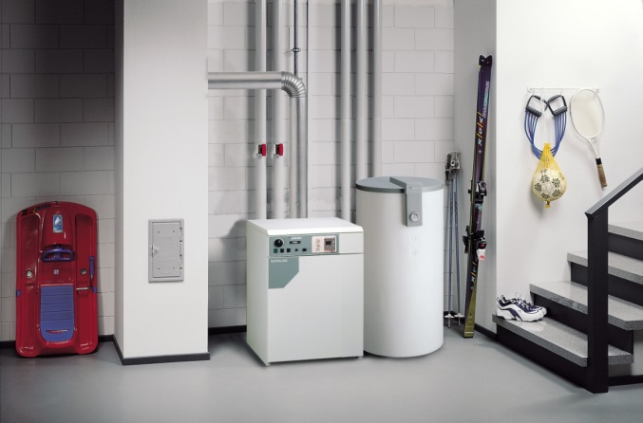 | 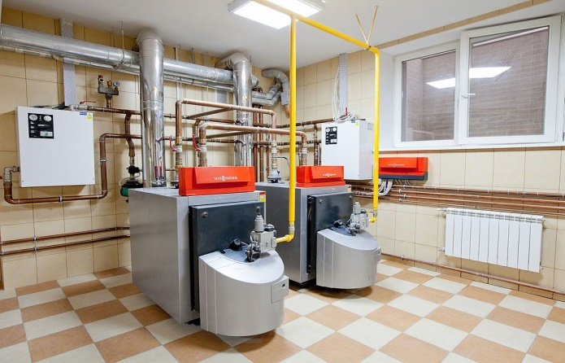
Figure 5 - Examples of modern boilers

Solar collector solutions
Solar heating is one of the most widely-used renewable energy technical solution in the buildings sector. Heat from solar radiation can be used for domestic hot water and internal heating in residential or public buildings. There are two types of solar collectors: flat and vacuum tube collectors. The typical solar collectors generate temperatures of 60-100°C.
Flat solar collectors | Vacuum tube collectors
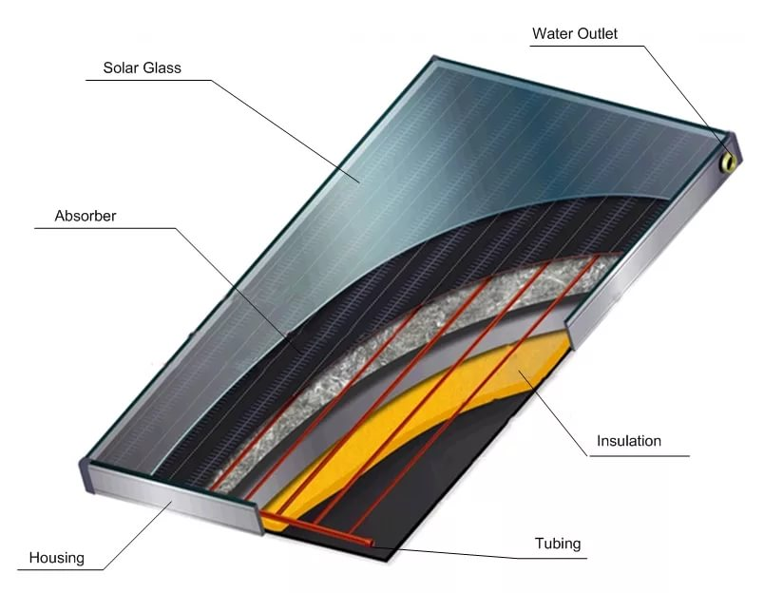 | 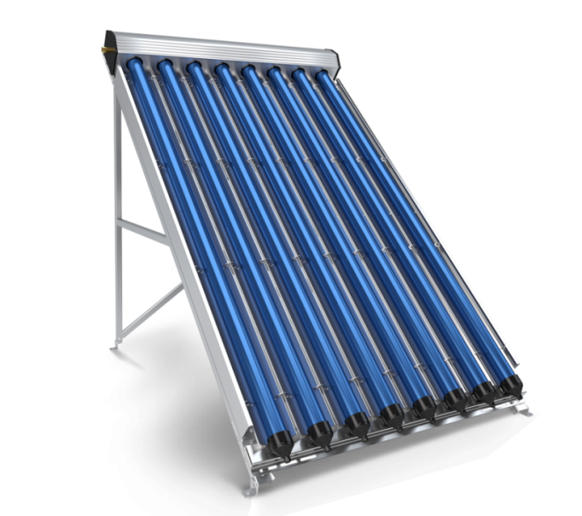
Advantages
- Low cost solution  - Easy to install and maintain  - Simple to operate and generally no other equipment required (such as pumps)  - Proven technology with significant lifetime (more than 25 years)  Ideal for intermittent loads (e.g. houses, restaurants, and small businesses) | - Higher efficiency compared to flat collectors  - Ideal for high and constant loads (hotels, spa, swimming pools and gyms)  - Ideal for solar cooling and heating; Temperatures range from 50°C in winter to 120°C in summer  - Cover winter load, except in extreme conditions  - Not prone to damage from heavy snow or hail
Disadvantages
- Lower efficiency compared to vacuum tube collectors  - Temperature range not ideal for solar cooling; During extended winter periods, cannot accommodate the DHW (domestic hot water) load;  - Sensitive to damage from extreme snowfall or hail |  | - They are a relatively expensive solution  - Not ideal for small DHW loads (such as houses)  - Hot summer conditions may cause glycol pyrolysis if there is no constant consumption or water circulation (temperatures may rise above 130°C)  - Prone to being damaged if used for intermittent loads  - Low electricity consumption due to the need for forced recirculation, especially during the summer
Figure 6 - Types of solar collectors
Solar systems can be divided into two key categories: passive and active (see Figure 7). The passive solar system is installed as one complete rooftop unit comprised of a solar collector and water tank. This system is relatively less expensive but at the same time it is not appropriate for use in the cold climates.
Active solar water heating and heat supply systems include a wide range of engineering equipment: solar collectors, controllers, circulation pump, broad tank, main storage container, and connecting pipes. Active systems are more expensive, but give more benefits, and can be used during the winter season. Electric heating provides for the necessary water temperature, especially during cloudy weather with lower levels of radiation. In general, these systems consume less electricity annually. Active systems can be used not only for water heating, but also for heat supply systems. Further, it is possible to adjust the capacity of active solar systems (within specified limits) by means of adding more solar collectors. For example, in case it is necessary to heat more water or to increase the heating area.
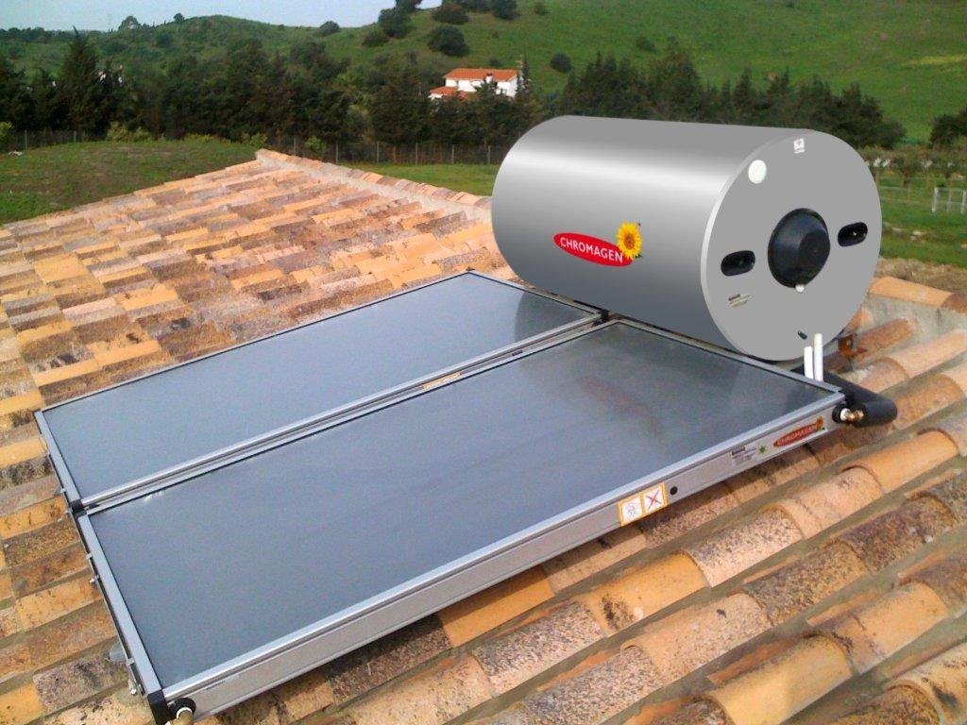 | 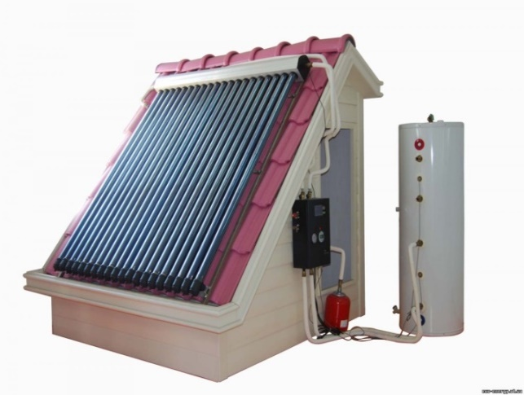
View of passive solar system with flat collectors | View of active solar system with vacuum tube collectors
Figure 7 - Examples of solar heating systems
Heat pumps

A heat pump operates on the principle of vapor-compression cooling, such that heat transfer is carried out from cold low-potential heat power sources to warm high-potential ones. Heat power is carried by means of condensation and evaporation of a coolant (generally, freon circulating within the closed contours). Heat pumps consume electricity to operate the coolant compressor and secondary circuit circulation pumps. There are several key points on installation of heat pumps in the buildings sector:
- Installation of heat pumps systems is economically feasible when installed at the time of construction, as it is easier to make provision for space. During a building retrofit, it may be possible to integrate a heat pump with the existing heat supply system, along with a heat collector.
- In cold climates and warm seasons, heat pumps using a water source can work more effectively than air-based heat pumps, or other air conditioning systems. Heat pumps are much more efficient than other electric heating systems and, depending on fuel prices, they can be also more economic than other heating systems.
- Heat pumps demonstrate outstanding efficiency when daytime temperatures fluctuate drastically.
- Heat pumps are economically feasible in countries where natural gas is relatively expensive compared to electricity, or not available. Heat pump systems have lower energy costs, while the electricity price (for kW) is in 3.5 times higher than the price of traditional fuel (for production of 1 kW).
- In areas where drilling is relatively cheaper, geothermal systems with a vertical soil heat exchanger are the most attractive.
Heat pumps may be classified according to the source of low-potential thermal power, as shown in Figure 8.

TYPE | SOIL - WATER |  | WATER – WATER |  | AIR - WATER
 | Horizontal | Vertical | Horizontal | Vertical
VIEW | 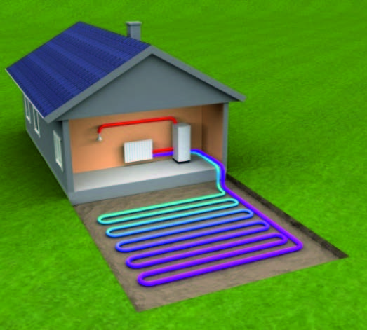 | 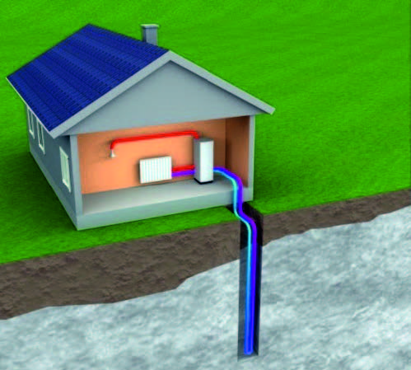 | 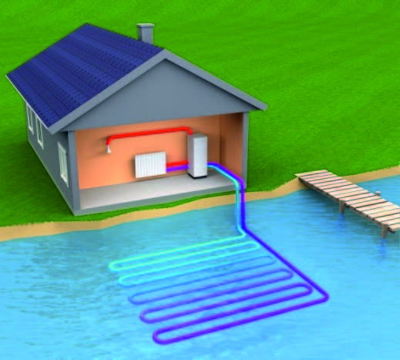 | 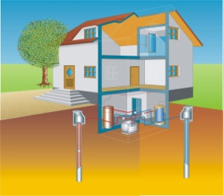 | 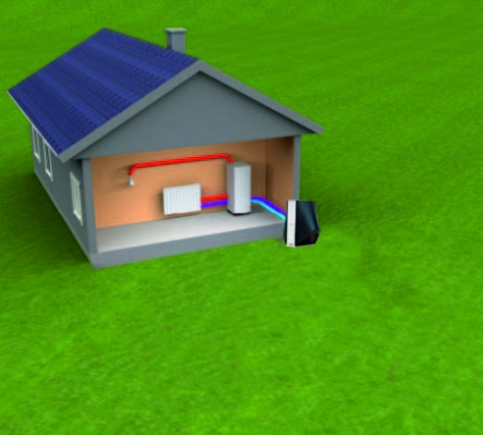
DESIGN | The collector is placed in the form of rings or twisting inside the horizontal trenches lower than the depth of frost penetration into the soil (usually at least 1.20m). | The collector is placed vertically in a well up to 200m in depth. | The collector is placed in the form of rings or twisting in a water reservoir (lake, pond, river) lower than the frost penetration depth. | The collector is placed vertically in a well, and the second well is located in downstream water in an underground layer of 15-20m. | The units consist either of two blocks, which are placed outside and inside the building, or of monoblock, connected with the external space by a flexible air duct.
PRINCIPLE OF OPERATION | Energy is gained by the heat exchanger, which is placed in a vault, and accumulated in the carrier. Afterwards, this carrier is continually supplied to the heat pump evaporator and returned for additional heat power. |  | The principle of operation is equal to the other pump systems. The only difference is that the heat exchanger is place in water.water’sr. | The ground waters gained from the first well and are supplying to the evaporator of the heat pump, that gains the heat power from the water.  Water cooled down for 5 degrees returns to the second well. | The fans supply air into the heat pump evaporator and gains its heat power.
APPLICATION | This method is the most economically feasible for residential buildings, in case of lack of the land area deficit. | Is applied in cases when the land plot area does not allow to place the contour horizontally or there is the threat of landscape damage. | This is the cheapest variant, but there are regional minimum depth and volume requirements for the reservoir. | Is applied in case of a sufficient amount of ground waters and the site size, which allows the placement of two wells. | This variant is applicable and not expensive. Although the capacity of these units is reduced, they are sustainable and operate at temperatures as low as -15°С. Then it is necessary to connect another heat energy source.
Figure 8 - Types of heat pumps

2.2.b Improvement of centralized heating source
The centralized district heating supply consists of a heat energy source, distribution heating network, and an individual heat point of transformation of heat power and its distribution to the consumer – internal heating systems of building. Each of the previously listed items have an important role in reliable and quality heat supply of the buildings; please see Figure 9.
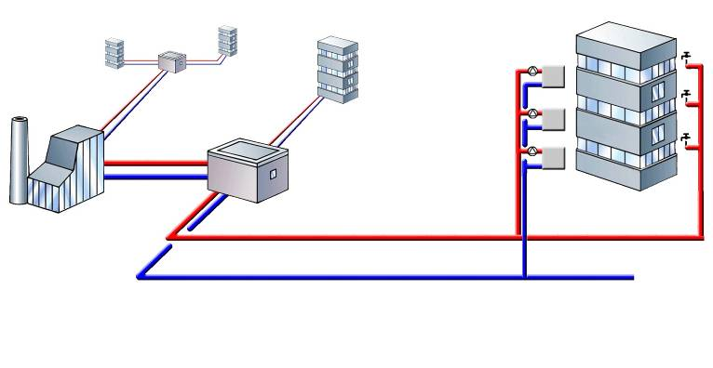
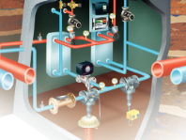
1
2
3
4

View of principal diagram of centralized district heating | Main elements
 | 1 | Central heating plant/central boiler
 | 2 | District heating network
 | 3 | Heat individual point
 | 4 | Internal heating system of building
Figure 9 - Diagram of centralized district heating system
Multi-family residential, public and commercial buildings are usually equipped with engineering systems which include heating, ventilation, and hot water supply. Regardless of the building purpose and size, all engineering systems provide comfort conditions for occupants, safety, and reliability of supply whilst saving energy and reducing CO₂ emissions. The centralized heating system configuration is an intensive operating system; for instance, the load of heating and ventilation systems depend on the outdoor air temperature and heat release in the premises, and the work of domestic hot water supply system.
Implementation of the district heating systems required a complex automation system within the building heat supply systems, covering the heat points and heat consuming systems. In many countries, the centralized heat power supply system uses an automated control system, which is an obligatory measure in new buildings and for retrofits.

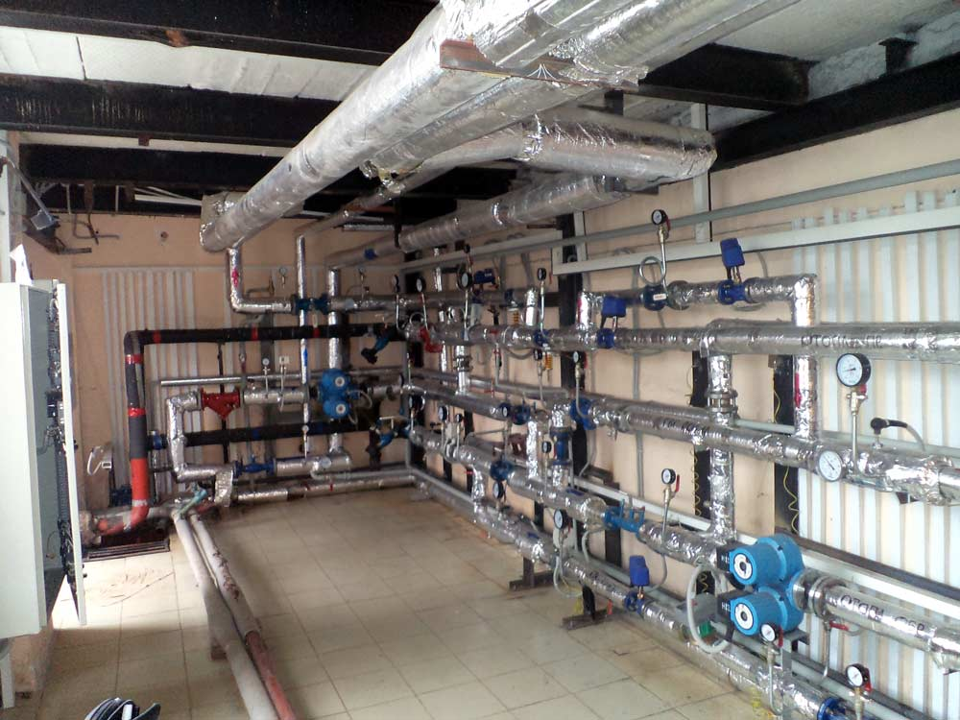 | 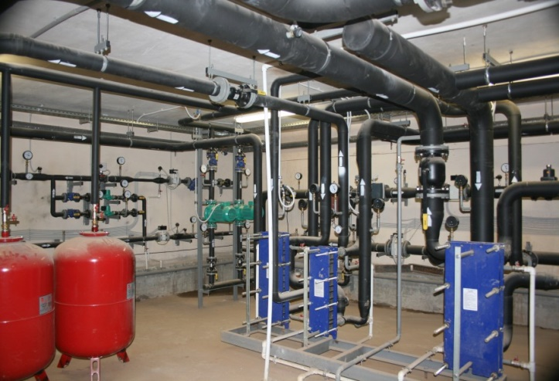
Figure 10 - View of individual automatic heat point with weather compensation control
The most significant energy saving impact from heat consumption systems can be achieved with the application of automatic heating individual point, which have the following basic functions:
- adjustment of the temperature of hot water supplied into the heating system, depending on the outdoor air temperature (weather compensation control)
- adjustment of the temperature of the hot water, which returns from the building’s internal heating system to the district heating network in line with the outdoor air temperature as per the set temperature schedule
- accelerated warming-up of the building after energy saving mode (reduced heat consumption)
- correction of the heat consumption according to the indoor air temperature in the premises
- hot water temperature constraint in the heating supply system pipelines
- adjustment of the heat load in the hot water supply system
- adjustment of the heat load by the ventilation units with the freezing protective function
- adjustment of the heat consumption reduction within the set periods, in accordance with the outdoor air temperature
- adjustment of heat consumption, considering the orientation of the building and its ability to act as a heat sink
In many countries, the hands-on experience in the field of heat points modernization has proved the effectiveness of this measure. Application of modern heat individual points equipped with the automated control systems can reduce heat consumption on the level of 15-30%.

2.2.c Common measures
Insulation of pipes and equipment
Insulation of pipelines – see Figure 11 - for both cold-and heat-power supply systems is a necessary measure in new construction and building retrofits. Insulating pipelines by wrapping with insulation materials not only reduces the heat losses in the pipelines, but also provides the estimated heat carrier temperature at the same level. Insulated pipelines keep their temperatures better, leading to substantial energy savings.

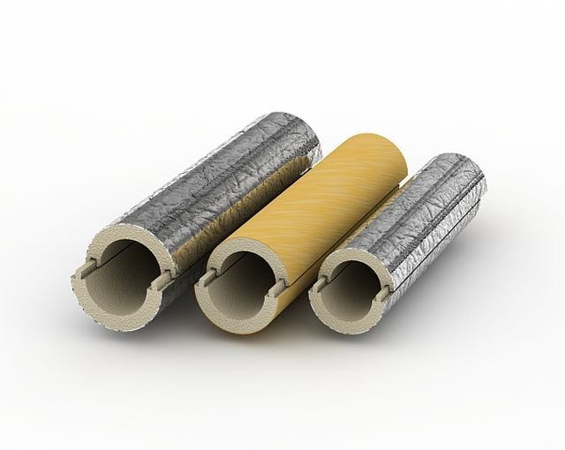 | 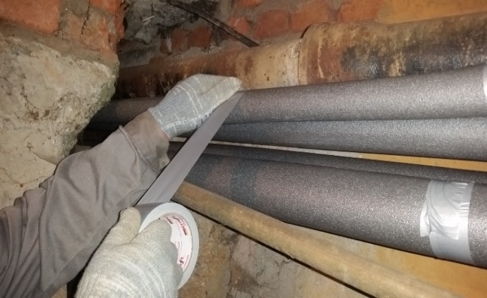
Figure 11 - View of pipe insulation and insulated distribution pipes of HVAC systems

There are several types of thermal insulation materials available for pipelines in the market. The application of thermal insulation for cold and heat power supply systems is an obligatory measure for new construction and also for retrofits in many countries. In case of retrofits, the pipeline insulation should only be performed after pipelines are repaired and pressure-tested, which usually include the following activities:
• dismantling of any existing thermal insulation
• cleaning of the pipeline surface
• replacement of pipeline portions as necessary
• installation of thermal insulation
Installation of thermostatic regulators on radiators
Additional heat saving can be achieved by installing the thermostatic valves on radiators. Thermostatic regulators consist of two parts: a valve and a thermostatic element, as shown in Figure 12.

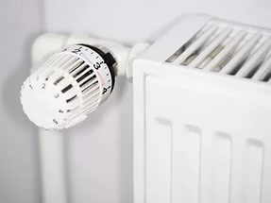 | 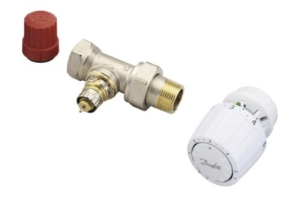
Figure 12 - View of thermostatic radiator control elements

Thermostatic valves are usually installed in the heating system before the radiator. The thermostatic element is a requisite for the radiator. These thermostats can be adjusted by the building occupants according to the desired indoor temperature. The key working element of a thermostat is the thermostatic element, which has a temperature-sensing element inside – the bellow valve. The bellow valve is filled with a substance which changes its state depending on the indoor temperature. The gas inside the bellow condenses as the temperature decreases, affecting in turn the sensing element – bellow valve, which stretches and moves the rod and spool valve in the direction of opening. Once the air temperature exceeds the set value, the liquid phase inside the bellow valve evaporates and compresses the sensing element, and the valve closes.
Thermostats automatically maintain the temperature within the range of 6°С to 26°С. By reducing the excessive heat supply when the ambient temperature is warm, the thermostat prevents over-heating of the premises and maintains ambient comfort. By means of automated regulation of the air temperature, thermostats allow up to 10% savings of power consumed by building heating system.
Installation of thermostats on radiators is coupled with the replacement of outdated heating devices with higher energy efficient systems (higher thermal performance).
Installation of the balancing valves
Balancing valves are part of clearance pipe fittings, intended for circulation of hydraulic balancing rings (risers, branches) of the cold and heat power supply systems, and stabilization of the dynamic regimes of its work. They can be seen in Figure 13.
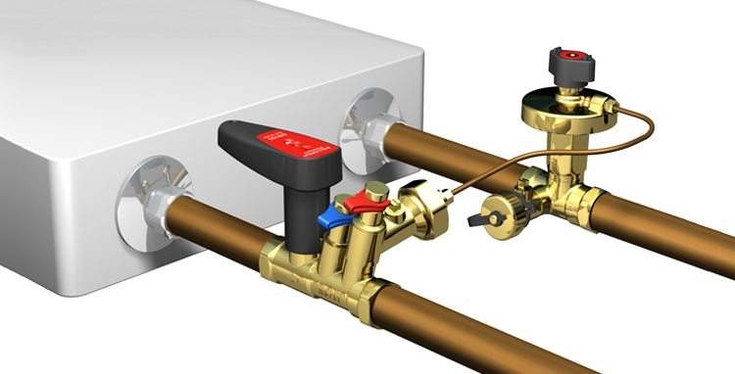 | 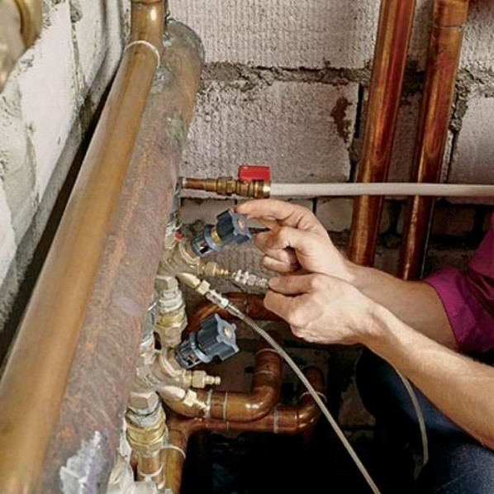
Figure 13 - View of balancing valves for HVAC systems

Application of balancing valves provides the following benefits for systems of cold and heat power supply:
- ensuring hydraulic stability and the optimal operational conditions of the system elements
- reducing the noise level of the different elements operation, for instance radiator thermostats for heat supply system or regulating valves for the fan coils in the cold supply systems, by means of automatically maintained drop pressure at the same level
- reducing the noise level in pipelines and other elements by means of restricting the maximum heat carrier flow
- stabilization of the heat, cold supply, and ventilation systems during periods of extended continual operation by means of compensation increases the resistance of hydraulic elements to corrosion and scum
- simplification of the installation and maintenance of the systems by means of combining the functions of overlapping part, descent of the heat carrier and air, and gives the possibility of computer diagnosis of the heating and ventilation systems
- automatic hydronic system after its modernization (expansion etc.)
- possibility to divide the heat or cooling system of the building into temperature zones, i.e. into floor- or apartment-specific systems (one of the directions of energy saving)
- reduction of energy consumption by circulating pumps
- supply of an additional economic and sanitation / hygiene benefit by preventing diversion of the heat carrier in the heating and ventilation systems
Automated balancing valves are recommended to be installed with the default presets; they should be installed on each riser of the heating systems and only afterwards should their settings be tuned. The implementation of this measure should be done after development of the design documentation, and after the heating system is flushed. By the reparation of heat and cold supply systems, it is reasonable to install balancing valves together with a complex of other measures. During installation of balancing valves, it is necessary to consider the commissioning works, performed by the specialized organization.

2.3 Air conditioning, Ventilation and Cooling

2.3a Application of Frequency converter Drives for the for electric motors of pumps and fans
Modern building engineering systems (heating, ventilation, air conditioning, cooling, hot and cold water supply) have a variable operating mode, allowing for reduction of design parameters of the air, cool, hot or cold water into building engineering systems. These parameters must be optimally set to maintain proper ambient climate conditions, and to more ensure efficient energy consumption. These changes are influenced by the fact that all of engineering systems have a dynamic mode of operation, which adjusts to account for constant changes of factors (outdoor climate conditions which influence the building, indoor heat gain from solar irradiation, equipment or people, occupancy changes, changes of the current level of energy, heat or cold water consumption etc).
The use of frequency converter drives (FCD) for pump and fan electric motors of all engineering systems in buildings helps to optimize and adopt these systems’ operational parameters. As part of adapting the basic parameters of engineering systems, FCD reduce the spinning rate of electric motors, and hence reduce power consumption. This change is typically controlled by pressure, temperature, flow, and CO₂ sensors. FCD are very efficient and extensively applied in many countries. The average savings attributable to implementation of FCD must be more than 40-50% of consumed resources in buildings. As an example, application of FCD for fans of outdoor condenser units of central cooling system can:
- reduce power consumed by compressors
- significantly reduce energy consumption by fan electrical motors
- increase fan resource
- reduce noise
- support the floating condensing pressure function
 | 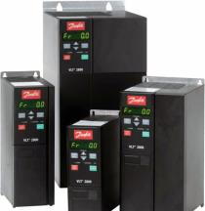
Example of circulation pump, with frequency converter | View of frequency converter
Figure 14 - Frequency converters

2.3.b Application of heat recovery for centralized mechanical inlet and outlet ventilation systems
Heat recovery is a process of extracting heat from air expelled from a building via outlet ventilation, then injecting that heat back into the supply air coming in through inlet ventilation. This reduces energy consumption for space heating, due to the additional (intermediate) heating of air in the recuperator. A recuperator is a heat transfer device whereby cold air is heated by warmer exhaust. The heat transfer occurs across the plates of a heat exchanger, where the two volumes of air are not allowed to mix.
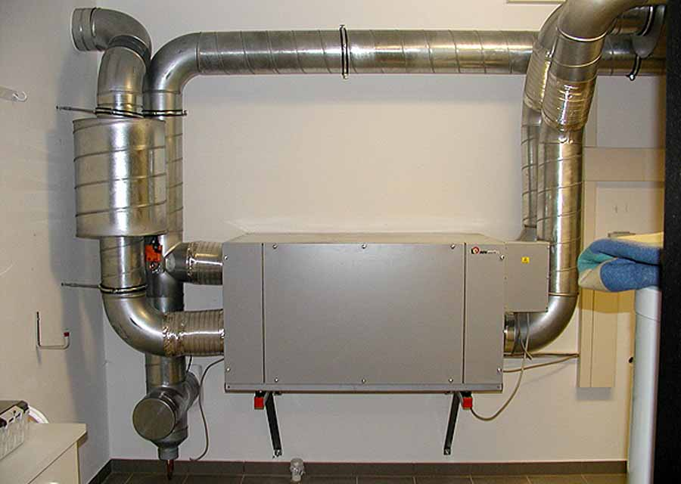 | 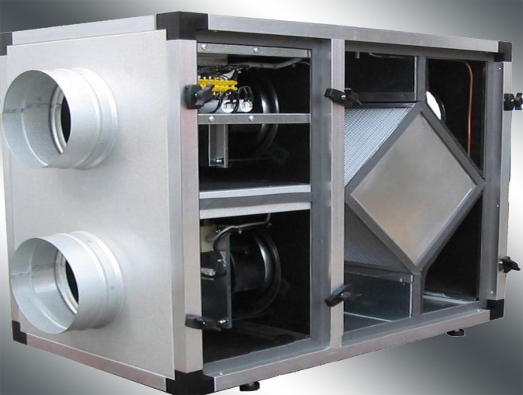
Figure 15 - Views of a heat recuperator for mechanical inlet and outlet ventilation

2.3.c Application of cooling system with variable flow
Modern cooling systems with variable coolant consumption are widely applied in public and governmental buildings, in which the operation of a centralized air conditioning system includes typical air handling units as well as fan coils and other appliances. The hydraulic system of a building cooling system is divided into the primary and secondary contour. The chiller (the cold energy source) is connected to the primary circuit, and the fan coils and air conditioning units are attached to the secondary contour. A group of circulation pumps and the shut off and balancing valves are also part of the hydraulic system. The traditional approach in design and operation of cooling systems is based on systems with a constant consumption of coolant. These schemes are based on the continuous coolant supply from the chiller via distributive pipelines to the consuming devices. At the same group of circulation pumps have constant energy consumption for circulation of cooling water not depending on the current needs of consumers. The application of the systems with a variable consumption of coolant allowed to implement the technical solutions, aimed to reduce the amount of consumed cooling water depending on the needs of the end consumer. Therefore, the operational costs of coolant pumping significantly reduce in the system of cold supply with the subsequent possibility of change (possible decrease up to 20-30%) of the produced cold energy by the chiller. Use of circulation pumps with a variable consumption in a secondary hydraulic contour allows to decrease the energy consumption of pump groups at least for 40%.

2.4 Energy efficient appliances (EE labeling)
Application of energy efficient appliance labeling is one of the measures for reducing internal electrical consumption on the consumer level. Every type of building includes a large number of household or office equipment: copiers, printers, intercoms, kettles, refrigerators, freezers, washing machines, dishwashers, electric stoves etc. Home appliances consume a significant share of household electricity.
The application of household appliances with class of energy efficiency A is an efficient way to reduce energy consumption, as well as contribute to the ecological aspect, as by the production of appliances that are certified according to the European standards ISO 9001 and ISO 14001, which indicate that no hazardous substances harming nature have been used. Thus, the biggest part of large-size household appliances are obliged to be certified and properly labeled in accordance with the energy efficiency class (from G to A++). The class of energy efficiency should be reflected on the special label, an example of which is shown in Figure 16.

Home appliances with the high class of energy efficiency have significantly less electricity consumption. The appliances with the energy efficiency class A, A+ or A++ (the highest) can reduce energy consumption up to 50%, Home appliances in many countries are now labeled.  Labels typically include the following information:  - Title, model, producer  - Class of energy efficiency: color code with alphabetic reference (from А to G), which reflects the level of energy consumption  - Level of energy consumption  - Additional information regarding the type of the appliance, e.g. the internal volume of the refrigerator in liters, the max speed of rotation for washing machines etc.  - Noise level in Decibels |  | 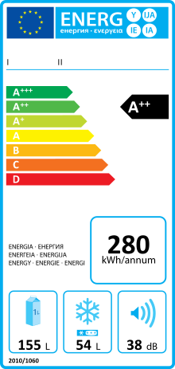
Figure 16 - Energy efficiency labeling

2.5 Modernization of existing lighting system of the building
Modernization of the existing lighting system in residential building is aimed at replacing incandescent lamps with energy efficient lamps or modules. Multifamily residential and municipal public buildings usually use either filament or fluorescent lamps and in some cases LEDs (see Figure 17). There are different opportunities to optimize the lighting systems in public areas of multifamily buildings, e.g.:
- replacing outdated inefficient lamps
- installation of lighting management systems
- accompanying actions
Energy saving lamps can be characterized by their lower energy consumption and longer service life. At the same time these lamps do not require any additional operational cost or maintenance. Bulb replacement can be implemented both on the individual level (installation of the energy saving lighting appliances by inhabitants in their flats) and by the building owners (installation of energy saving lamps and modules in the public areas, such as stairs, entrance tambours, outdoor lighting systems).

There are many types of lighting appliances for internal building lighting systems with various ingress protection classes. The most efficient and at the same time simple and affordable solution is replacement of the existing outdated lamps with the energy efficient ones. Nowadays the most widespread are LED or CFL lighting appliances, equipped with motion sensors. There are also different types of lighting appliances with the built-in devices providing emergency lighting in case of a power outage. Motion sensors turn on light when motion is detected, and turn them off when not required.
In order to enhance the energy efficiency benefit, it is reasonable to implement a lighting management system, preferably automated or by installation of dimmers (reducing the lighting appliances luminescence). It is also possible to adjust the lighting system in accordance with the sunrise and sunset calendar. Based on the assessment, the potential energy saving can reach up to 60% depending on occupancy.

In addition to providing better illumination, the following measures can also be implemented to improve the efficiency of energy consumption for building lighting:
- to maintain the purity of plafonds
- not to curtain and not to block the front windows, to provide its purity
- to use the pale wall colors (better reflects the light)
- to install the lighting modules on the ceiling only, but not on the walls, because this leads to the lighting losing its capacity.
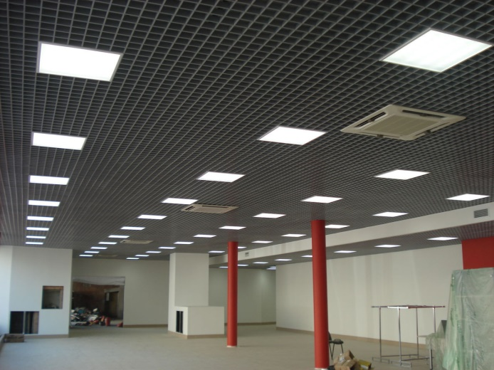 | 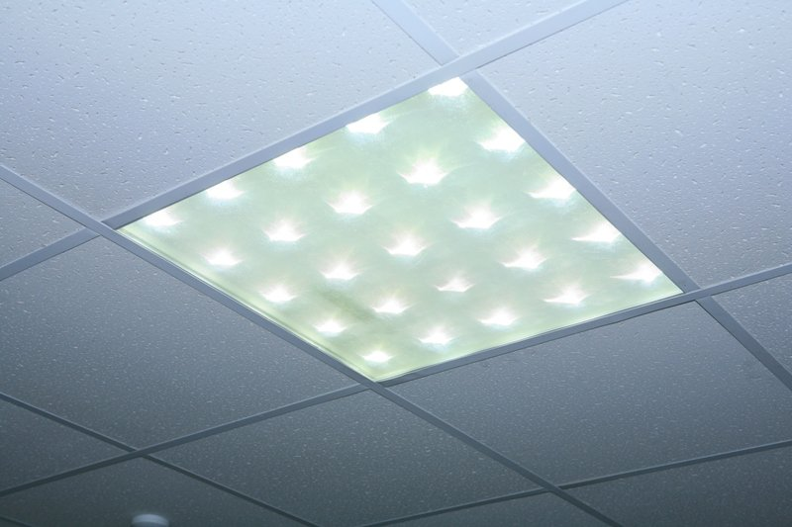
Figure 17 - View of new LED lamps

CHAPTER 3
(work in progress)

Conclusions
(Work in progress)
Much progress has been made globally towards improving energy efficiency in the buildings sector, helped along primarily by three types of public policy tools: legal requirements (such as building standards), financial incentives (rebates, reduced-rate debt, tax deductions), and informational awareness programs. For example, the European Union’s Ecodesign Directive (2009/125/EC) created a framework by which energy-related requirements could be set for relevant consumer products; products covered by the Ecodesign Directive account for approximately 40% of all EU greenhouse gas emissions. In the United States of America, the Internal Revenue Service allows certain types of energy efficiency investments to partially offset federal income tax liabilities; some state governments have similar tax reduction programs. The Canadian government’s online directory of energy efficiency informational and awareness programs lists dozens of entries. Despite all these efforts, energy efficiency in the building sector is improving only incrementally and in disjoint fragments.
This is particularly surprising, given that recent advances in technology design have yielded remarkable advancements in efficiency and this trend is expected to continue. For example, while the typical new gas furnace in the 1970s was only 63% efficient, new gas furnaces are now available with efficiencies around 97%. Consider the evolution of windows: new windows are available with an insulating value of R-8, which is eight times better than the old R-1 specification; R-10 to R-15 rated windows may be available soon. Even the information revolution in which society finds itself has a positive impact on energy efficiency; computerized monitoring and control systems can cut commercial building energy use by 10% to 20%, and improved design can reduce both energy use and construction costs in large office buildings. In these (and other) cases, improved technologies are commercially available yet are inconsistently used – even despite generally attractive payback periods. The substantial gaps between what is available on the market and what is used makes it clear that implementation, rather than just technical advancement, is key to increasing energy efficiency.
In search of these gaps, we have analyzed recent public policy efforts taken, and results achieved, by UNECE member States to identify instructive differences, lessons learned, and best practices in the buildings sector. Our ultimate goal is to understand the current energy efficiency technology trends in the building sector in the UNECE region. Here we briefly summarize our results from Chapters 2 and 3 for the major classifications of energy efficiency technology.

Building Envelope
In the European Union, the Energy Performance of Buildings Directive (2010/31/EU) – further updated in 2012 – has had three major impacts on energy efficiency in the buildings sector, predominantly affecting the building envelope. This directive:
- sets minimum energy performance requirements for new buildings, for the major renovation of existing buildings, and for the replacement or retrofit of building elements
- mandates energy performance certificates (EPCs), which must be provided to prospective buyers and lessors
- stipulates that all new public buildings be nearly zero-energy buildings (NZEB) by the end of 2018, and that all newly-built buildings be NZEBs by the end of 2020
These directives have had far-reaching consequences, one of which is that most countries in subregions A and B are aggressively installing building insulation and windows with high energy-efficiency ratings. In addition, energy performance certificates are generating real economic value for building owners. One study found that residences in the Netherlands with A, B, or C ratings generated a nearly 4% premium. In Ireland, A- and B-rated homes showed premiums of 9% and 5% over D-rated homes, respectively; the market assigned a discount of over 10% to homes with F and G ratings. Building owners are hence able to earn a profit on energy efficiency investments from both reduced energy consumption and increased economic rents.
The final major impact throughout the European Union is the requirement for new buildings to meet the NZEB standard. Nearly zero-energy buildings are designed to be very efficient and use renewable sources to generate the low amounts of energy they consume. In subregion A, Belgium and Germany have taken the NZEB standard one step further and are implementing the Passivhaus standard for both new and existing buildings. This standard has more stringent requirements for space heating/cooling energy consumption, air tightness, and energy generation. This concept is being further extended by a Norwegian energy consortium, who are developing the Powerhouse design concept, in which a building is designed to be net positive for energy over its entire lifecycle – including construction and demolition.
In the North America subregion, both the United States and Canada have extensive building standards – at the federal, state, and local levels – which set minimum energy efficiency requirements for the building envelope. Many US states have codes regulating building renovations as well. An analysis of relevant building standards in the US by Pacific Northwest National Laboratory suggested that residences and commercial buildings would save over $125B between 2012 and 2040, corresponding to 841 million tons of avoided CO₂ emissions. Similar in many ways to the NZEB standard in the European Union, the US Green Building Council introduced the LEED building rating certification. LEED is now the most widely used green building rating system in the world, and a LEED certification demonstrates that a building meets stringent energy consumption requirements.

HVAC and Water Heating / Cooling
After the building envelope, the second most productive area for improving energy efficiency in the buildings sector is the subsystems responsible for ventilation, space heating / cooling, and water heating / cooling. In the European Union, nearly half of energy is consumed for these purposes, much of which is generated from fossil fuels. Acting to curb this energy demand and boost renewables is expected to reduce energy costs substantially and slash harmful carbon emissions. In 2016, the European Commission published its first plan to tackle the massive amount of energy used for heating and cooling in the buildings sector. A major strategy of the plan is to improve integration of the power grid with district heating and cooling systems, so utility-scale renewable power could replace fossil fuel generation for district heating / cooling.
There have been impressive advances in the efficiency of space-conditioning equipment in recent years. A variety of fuels and technologies are used to heat residential buildings in the UNECE region. Natural gas is mainly used for heating, but the impressive gains in energy efficiency technologies in boilers, along with design improvement in vent dampers and HVAC systems are contributing towards energy savings for residential and commercial buildings. Distribution systems and controls are frequently overlooked opportunities for improving the efficiency of space conditioning systems. For example, leaky air distribution ducts can result in significant energy losses, suggesting that greater attention to such simple parts is warranted. Existing building retrofits improve the efficiency of space heating systems already in place, and are usually limited to simple maintenance, such as replacing filters, oiling motors, and cleaning burners.
One strategy to improve the efficiency of space conditioning used in Sweden is to link district heating systems with industry. In some parts of Sweden, a significant proportion (up to 90%) of multi-family residential buildings rely upon district heating that uses waste heat from nearby industrial plants and waste incinerators. Not only does this reduce energy consumption for space heating, but it also reduces industrial waste heat. Finland is another useful example. It is one of the leading countries in the world in the utilization of combined heat-and-power generation. More than 30% of the country’s electricity is generated in connection with the production of district heat. Almost half of Finns live in residences which use district heating.

Appliances and Lighting
Throughout the lifetime of a building, equipment such as appliances, lighting, and electronics are replaced and upgraded. Each time this occurs represents an opportunity to maximize efficiency improvements. Such upgrade opportunities are much more frequent than major retrofits — appliances are replaced several times over the life of a building, electronics and lighting even more often. Each discrete replacement decision has less energy impact than a retrofit, but the aggregate impact is of nearly comparable importance. The primary tool used by policymakers to encourage improvement of energy efficiency in both household and office appliances has been through labeling, though some governments have implemented cash rebate programs. In the USA, the American Recovery and Reinvestment Act has resulted in an unprecedented number of household appliances being replaced with energy efficient upgrades. Other countries with similar programs include Canada, Denmark, and Germany. EU member States are bound by the 2010 EU Energy Labeling Directive (2010/30/EU) and previously-mentioned Ecodesign Directive. These directives require many household appliances to meet minimum energy efficiency standards and to carry energy labels, categorizing the expected energy consumption (similar to the voluntary Energy Star program introduced by the US EPA). However, obtaining the maximal impact of appliance labeling programs requires promotion on the part of EU member State governments; the case of Latvia is instructive of this point. Latvia has failed to realize the expected increased energy efficiency in appliances, as there has been insufficient promotion of labeled products.
A second issue with labeling is the stringency of the efficiency requirements – specifically when minimum requirements are equal, or very close, to the market averages. More stringent regulations that drive technological innovation are needed to induce market changes and improve energy efficiency. Overall, the low-hanging fruits of improved energy efficiency in appliances has probably already been picked; large appliances - such as refrigerators, freezers, and washers - are 35% more efficient than their 1990’s counterparts. Building lighting, however still has much to offer in the way of increased energy efficiency.
The energy efficiency of building lighting can be improved by the application of three main types of technological solutions:
- application of daylighting architectural solutions
- installation of interior & exterior lighting sensors and controls
- installation of newer light bulbs (CF & LED)
Policymakers predominantly use legal constraints, such as building codes and technological standards, and informational programs to drive improvements in lighting energy efficiency. Many countries have phased out inefficient lighting technologies by tightening efficiency standards. Building codes also place requirements on lighting fixtures and control systems to encourage efficiency. While enhanced standards have a big effect, they mostly impact new construction (and buildings undergoing deep retrofits, to a lesser degree). For example, daylighting architectural solutions, which involve designing a building to make maximal use of solar irradiation for internal lighting, can obviously mostly be applied to new construction. In UNECE subegion A, Flemish, Danish, Monegasque, and Norwegian policymakers have substantially encouraged the use of this technology in both new and existing buildings. It is moderately prevalent in Austria, but only for public buildings. In subregion B, only Estonia and Cyprus make much use of daylighting, with Estonia focusing on public and commercial buildings. In addition to reducing energy consumption, there are documented social benefits to using natural lighting.
Lighting sensors and controls is technology that can have a tremendous impact on energy consumption for lighting – both interior and exterior by ensuring that lights are only used when required. Motion- and thermo-sensitive devices can detect the absence/presence of people and turn off/on the lights as appropriate. Ambient-light sensors can do the same, toggling lights in the presence or absence of sufficient ambient light. These kinds of controls can include automatic dimming as well as switch scheduling. The economic attractiveness of sensor-based lighting controls are building specific, depending on operational hours, occupant behavior, electricity prices, etc. It is nearly inconceivable, except perhaps in degenerate cases, that the appropriate application of lighting sensors and control technology could not reduce energy consumption and pay for itself.
Furthermore, sensor-based control technologies are predominantly used in public and commercial buildings. Despite the disproportionately large impact on reducing building energy consumption, sensor-based lighting controls are not widely used. Only Cyprus and Estonia, in subregion B make moderate-to-heavy use of the technology. The technology is significantly prevalent in less than half of the subregion A EU countries. It is clear that public policy and awareness campaigns are necessary to encourage adoption. A French regulation is quite instructive; lighting installations of all non-residential buildings in France must be turned off at night to reduce both light pollution and energy consumption. Indoor lighting which can be seen outside must be switched off at 1 AM or one hour after closing time (whichever is earlier), and can only be switched-on after 7 AM or one hour before opening (whichever is earlier). Outdoor lighting of building facades (shops, monuments, schools, city halls etc.) can only be on between sunset and 1 AM. Needless to say, sensor-based automated control systems are implemented in buildings to meet these lighting regulations.
The simplest, furthest reaching, and most prevalent technology for decreasing lighting energy consumption is energy efficient light bulbs. Compact fluorescent (CF) bulbs and light-emitting diodes (LED) are far superior to both incandescent and halogen bulbs. New energy efficient light bulbs can be used in both new and existing buildings, residences, public buildings, and commercial buildings.
The United States began phasing out incandescent bulbs in 2007, and the Canadian government began banning them in 2014. The European Union voted in 2009 to ban them, with the ban taking full effect September of 2018. In the EU, the incandescent ban is expected to reduce annual energy consumption by 9.4 TWh - equivalent to Portugal’s electricity consumption over 5 years. These savings correspond to a reduction of 3.4 million tonnes of CO₂ emissions every year, as well as a significant reduction in waste. However, simply banning incandescent bubs is not enough, as has been seen by some of the earliest adopters.
The UN member States which implemented relevant policy earliest – such as Denmark and the United Kingdom – have seen sharp reductions in sales of incandescents, as expected. However, much of this market share has inadvertently been shifted to halogen bulbs. Halogen bulbs are only slightly more efficient, so the full potential energy savings that could be achieved through switching to CF bulbs or LEDs has not been realized; there is little sign of LEDs having significantly penetrated the domestic lighting markets.
In subregion A, most countries are relying on energy-efficient lamp replacements to drive reductions in energy consumption for lighting – countries like Germany, Spain, and Switzerland. A few countries are much more diversified, investing in efforts to use all three types of technological solutions. Denmark, Monaco, and Norway exemplify this strategy of diversification. In subregion B, Estonia is diversifying efforts for new construction, with Cyprus focusing on retrofits.

Common Measures
There are several types of energy efficiency technologies that have the potential to impact multiple building subsystems. A good example of technology that enables increased energy efficiency in several different building subsystems is smart metering and smart building systems. In fact, one of the primary objectives of EU energy efficiency directives is to encourage the use of information and communication technology and smart technologies to ensure buildings operate efficiently. The governments of Denmark, Italy, Switzerland, and the United Kingdom in subregion A, and Estonia, Lithuania, and Malta in subregion B have implemented energy efficiency policies promoting the application of such smart systems.
The UK Government, for example, is committed to ensure that every home and small business in the country is offered a smart meter by the end of 2020. Their Smart Metering Programme aims to roll-out over 50 million smart meters (gas and electricity) to all domestic properties and smart / advanced meters to smaller non-domestic sites in Great Britain - impacting approximately 30 million premises. Britian’s Smart Metering Programme is currently in the main installation phase, and there are now over 11 million smart and advanced meters operating across British homes and businesses.
In the United States, cloud-based control systems are extensively used as they obviate the need for on-site staff with expertise in maintaining the building energy systems. Using a third-party firm to monitor the building, for instance checking HVAC equipment or setting lighting schedules, can be a cost-effective way to reduce energy consumption. However, for a multi-tenant office building, split incentives may discourage a building owner from purchasing a cloud-based control system when tenants are responsible for their energy consumption. However, in offices in which the owner is responsible for paying the energy bill and maintaining the building’s primary energy consuming systems, there is more economic incentive to invest in such technology. This suggests that the highest barrier in implementing smart metering and control systems technologies in buildings is the requisite capital expenditure - which most countries believe is the key issue.

Recommendations
Based on our gap analysis of the gathered data, we have several broad recommendations to guide more consistent and accelerated energy efficiency improvements in the buildings sector.

Policy and Legislation
The UNECE region countries should consider going beyond the EU directives and promote energy efficiency policies that are more locally-nuanced. Every country is different, and so are the energy challenges. Energy efficiency policies should be made while considering the local perspectives and challenges.

Investment and Finance
Countries should continue to support incentive schemes for promoting adoption of energy efficient products. It is apparent that a higher level of commitment to policy is needed, as substantial barriers to households taking advantage of energy efficiency opportunities still remain. To help overcome the complexity of investments and lack of capacity at the individual and suppliers level, Energy Service Companies (ESCO) should be more heavily promoted by Governments.

Technological Adaptation
Building simulation software tools can effectively assess the performance of energy efficiency technology – both for new construction and retrofits – from a holistic, performance-based criteria perspective. Such systems can even use localized climate data, utility tariffs, and fuel costs. The information generated by using such models could produce dynamic energy production and consumption simulations to find the optimal energy efficiency solution for each property. Furthermore, incorporating cost calculations into the model would allow engineers to find the most cost-effective renovation solutions, considering a buildings remaining life.
Some countries, such as Andorra, Germany, Norway and the USA, have undertaken initiatives to raise the bar for developing energy efficient technologies in buildings, examples include occupancy sensors and the Passivhaus and Powerhouse standards, discussed earlier in this report. These technological developments will boost economic growth, develop a local competitive market, increase employment, and promote implementation of cheaper and accessible energy efficient technologies.

Capacity Development / Local Content
The concept of energy efficiency as an integral part of all renovations should be emphasized by incorporating it into the curriculum at all levels of construction education. Energy efficiency and renovations are essential elements of lifecycle management, a discipline that has so far been largely neglected in education, in favor of courses focusing on new development. Courses are needed for both young people and mature students, and for both new recruits and professionals. A few observations:
- Material efficiency as part of life cycle management needs to be part of relevant course material.
- Courses focusing on renovation projects need to include lessons on ways to improve energy efficiency, as well as new technologies.
- Virtual learning resources would be invaluable.

Role of Public and Private Sector
Government plays a central role in supporting economic growth. It needs to provide good policy, strong institutions, and efficient public services to ensure the private sector can thrive. Governments must also commit to develop and sustain the institutions that implement, oversee, and regulate those policies. This is the enabling environment that encourages the private sector to invest. The vast majority of constraints to growth identified by the private sector are directly linked to government decisions and action. Government’s policy and legislative decisions determine to a large degree the scale and quality of economic growth and the private sector’s role in it. The private sector is critical to economic growth, but it cannot and does not act alone. This is especially the case when it comes to improving building sector energy efficiency.

REFERENCES
(Work in progress)
DIRECTIVE 2010/31/EU OF THE EUROPEAN PARLIAMENT AND OF THE COUNCIL of 19 May 2010 on the energy performance of buildings (recast). (2010). Official Journal of the European Union, (153), 13-35. Retrieved from http://data.europa.eu/eli/dir/2010/31/oj
UNDP. (2009). Promoting Energy Efficiency in buildings: Lessons Learned from International experience. Retrieved from UNDP website: http://www.undp.org; www.thegef.org/gef/
UNECE. (2015). The Geneva UN Charter on Sustainable Housing.
UNECE. (2017b). Overcoming barriers to investing in energy efficiency. United Nations Publication.
UNECE. (2017a). Energy for sustainable development in the UNECE region. Geneva: United Nations.
United Nations Economic and Social Council. (2017c). Framework guidelines for energy efficiency standards in buildings (ECE/ENERGY/GE.6/2017/4). Retrieved from United Nations website: https://www.unece.org/fileadmin/DAM/energy/se/pdfs/comm26/Room_documents/CSE_26_2017_INF_2.pdf
United Nations Economic Commission for Europe. (2018). Study on Mapping of Existing Energy Efficiency Standards and Technologies in Buildings in the UNECE Region. UNECE, Geneva.

Due to insufficient data, San Marino was excluded from this study
Subregion A = European Union (EU) Member States prior to 2004 (EU15): Andorra, Austria, Belgium, Denmark, Finland, France, Germany, Greece, Iceland, Ireland, Italy, Liechtenstein, Luxembourg, Monaco, Netherlands, Portugal, Spain, Sweden, UK, plus Norway and Switzerland Subregion B = EU enlargement - 13 countries that joined the EU after 2004 (EU13): Bulgaria, Croatia, Cyprus, Czech Republic, Estonia, Hungary, Latvia, Lithuania, Malta, Poland, Romania, Slovakia, Slovenia Subregion C = Eastern Europe, Caucasus and Central Asia: Armenia, Azerbaijan, Belarus, Georgia, Kazakhstan, Republic of Moldova, the Russian Federation, Tajikistan, Turkmenistan, Ukraine, and Uzbekistan. Subregion D = Canada, United States of America Subregion E = South East Europe: Albania, Bosnia and Herzegovina, Montenegro, Serbia, and the former Yugoslav Republic of Macedonia.
Energy intensity is defined as total energy consumption divided by gross world product

