Proposal for amendments to
ECE/TRANS/WP.29/GRVA/2020/8
Note: This informal document is combining the proposed changes of ECE/TRANS/WP29/GRVA/2020/8 with the adopted changes in ECE/TRANS/WP.29/GRVA/2019/24, agreed in the September 2019 GRVA session
I. Proposal
Paragraph 5.6.4.6.4, amend to read:
“5.6.4.6.4. The lateral movement of the vehicle towards the intended lane shall not start earlier than 1 second after the start of the lane change procedure. Additionally, the lateral movement to approach the lane marking and the lateral movement necessary to complete the lane change manoeuvre, shall be completed as one continuous movement.
The lane change manoeuvre shall be initiated either automatically or by a second deliberate action of the driver. A vehicle shall not be equipped with both these means of initiation.
5.6.4.6.4.1. Automatic initiation of the lane change manoeuvre
In case of an automatic initiation the lane change manoeuvre shall commence between 3.0 seconds and 10.0 15.0 5.0 seconds after the manual activation of the procedure as described in paragraph 5.6.4.6.2. and shown in the Figure below. The manoeuvre shall commence at the earliest opportunity when the situation is not deemed critical as defined in 5.6.4.7.
If the ACSF function has not commenced the lane change manoeuvre 10.0 seconds after the deliberate action of the driver, the driver will be notified through an acoustic or visual warning when the manoeuvre is about to commence.
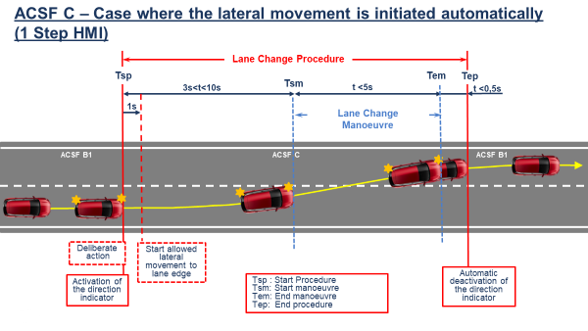
5.6.4.6.4.2. Initiation of the lane change manoeuvre by a second deliberate action
In case of an initiation by a second deliberate action the lane change manoeuvre shall commence between 3.0 and 10.0 7.0 seconds after the manual activation of the procedure as described in paragraph 5.6.4.6.2.
Additionally, the lane change manoeuvre shall commence at the latest 3.0 seconds after the second deliberate action as shown in the Figure below.
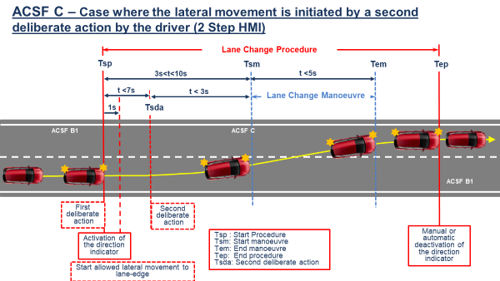
The control to operate the second deliberate action shall be located in the steering control area."
Annex 8, Paragraph 3.5.1.2., amend to read:
“3.5.1.2. The requirements of the test are fulfilled if:
(a) The lateral movement towards the marking does not start earlier than 1 second after the lane change procedure was initiated,
(b) The lateral movement to approach the lane marking and the lateral movement necessary to complete the lane change manoeuvre are completed as one continuous movement,
(c) The recorded lateral acceleration does not exceed 1 m/s²,
(d) The moving average over half a second of the lateral jerk does not exceed 5 m/s³,
(e) The measured time between the start of the lane change procedure and the start of the lane change manoeuvre is not less than 3.0 seconds and not more than 10.0 seconds.:
(i) 5.0 seconds in the case of an automatic initiation,
(ii) 7.0 seconds in the case of an initiation by a second deliberate action
whatever is appropriate.
(f) For systems with an initiation of the lane change manoeuvre by a second deliberate action,
- The measured time between the start of the lane change procedure and the second deliberate action is not more than 7.0 5.0 seconds, and
- The measured time between the second deliberate action and the start of the lane change manoeuvre is not more than 3.0 seconds.
(g) The system provides information to the driver to indicate that the lane change procedure is ongoing,
(h) The lane change manoeuver is completed in less than 5 seconds for M₁, N₁ vehicle categories and less than 10 s for M₂, M₃, N₂, N₃ vehicle categories,
(i) ACSF of Category B1 automatically resumes after the lane change manoeuvre is completed, and
(j) The direction indicator is deactivated not before the end of the lane change manoeuvre and no later than 0.5 seconds after ACSF of Category B1 has resumed.”
Paragraph 5.6.4.6.8.1, amend to read:
"5.6.4.6.8.1. The lane change procedure shall be suppressed automatically by the system when at least one of the following situations occurs before the lane change manoeuvre has started:
(a) The system detects a critical situation (as defined in paragraph 5.6.4.7.);
(b) The system is overridden or switched off by the driver;
(c) The system reaches its boundaries (e.g. lane markings are no longer detected);
(d) The system has detected that the driver is not holding the steering control at the start of the lane change manoeuvre;
(e) The direction indicator lamps are manually deactivated by the driver;
(f) Following the deliberate action of the driver to start the procedure described in paragraph 5.6.4.6.2., the lane change manoeuvre has not commenced:
(i) At the latest after 10.0 5.0 seconds, in the case of an automatic initiation,
(ii) At the latest after 7.0 seconds, in the case of an initiation by a second deliberate action,
(iii) At the latest after 3.0 seconds after the second deliberate action, in the case of an initiation by a second deliberate action,
whatever is appropriate
(g) The system, with an initiation of the lane change manoeuvre by a second deliberate action, has not detected the second deliberate action at the latest 7.0 5.0 seconds after the start of the lane change procedure.
(h) The lateral movement described in paragraph 5.6.4.6.4. is not continuous.
II. Justification
This informal document is a revision of document GRVA-05-08 which aimed to combine the proposed changes of ECE/TRANS/WP29/GRVA/2020/8 with the adopted changes of ECE/TRANS/WP.29/GRVA/2019/24 agreed in the September 2019 GRVA session to provide an overview of the final intended text in the Regulation. This document amends the proposal described in ECE/TRANS/WP29/GRVA/2020/8.
With regard to the ACSF of Category C2 provisions agreed upon in ECE/TRANS/WP.29/GRVA/2019/24, amendments are proposed inspired by OICA as indicated during the fourth GRVA session of September 2019.

