|  |  |  |  |
| --- | --- | --- | --- |
|  | United Nations | ECE/TRANS/WP.29/GRVA/2020/7 | |
| Description: _unlogo | **Economic and Social Council** | | Distr.: General  29 November 2019  Original: English |

**Economic Commission for Europe**

Inland Transport Committee

**World Forum for Harmonization of Vehicle Regulations**

**Working Party on Automated/Autonomous and Connected Vehicles**[[1]](#footnote-2)\*

**Fifth session**

Geneva, 10-14 February 2020

Item 6 (a) of the provisional agenda

**UN Regulation No. 79:  
Automatically Commanded Steering Function**

Proposal for a Supplement to the 03 series of amendments to UN Regulation No. 79 (Steering equipment)

Submitted by the expert from the European Association for Electromobility[[2]](#footnote-3)\*\*

The text reproduced below was prepared by the expert from the European Association for Electromobility (AVERE) introducing an amendment to UN Regulation No. 79. It is aimed at clarifying the text of the Regulation. It is based on ECE/TRANS/WP.29/GRVA/2019/26. The modifications to the existing text of the Regulation are marked in bold for new and strikethrough for deleted characters.

I. Proposal

*Paragraph 5.6.2.1.3.,* amend to read (insert a new provision):

"5.6.2.1.3. The system shall be designed so that excessive intervention of steering control is suppressed to ensure the steering operability by the driver and to avoid unexpected vehicle behaviour, during its operation. To ensure this, the following requirements shall be fulfilled:

(a) The steering control effort necessary to override the directional control provided by the system shall not exceed 50 N;

(b) The specified maximum lateral acceleration aysmax shall be within the limits as defined in the following table:

Table 1  
**For vehicles of Category M1, N1**

|  |  |  |  |  |
| --- | --- | --- | --- | --- |
| *Speed range* | *10 - 60 km/h* | *> 60 - 100 km/h* | *> 100 - 130 km/h* | *> 130 km/h* |
| Maximum value for the specified maximum lateral acceleration | 3 m/s² | 3 m/s² | 3 m/s² | 3 m/s² |
| Minimum value for the specified maximum lateral acceleration | 0 m/s² | 0.5 m/s² | 0.8 m/s² | 0.3 m/s² |

**For vehicles of Category M2, M3, N2, N3**

|  |  |  |  |  |
| --- | --- | --- | --- | --- |
| *Speed range* | *10 - 30 km/h* | *> 30 - 60 km/h* | *> 60 km/h* |  |
| Maximum value for the specified maximum lateral acceleration | 2.5 m/s² | 2.5 m/s² | 2.5 m/s² |  |
| Minimum value for the specified maximum lateral acceleration | 0 m/s² | 0.3 m/s² | 0.5 m/s² |  |

(c) The moving average over half a second of the lateral jerk generated by the system shall not exceed 5 m/s³.

**(d) Special provision for vehicles of category M1 / [N1]**

**Notwithstanding the maximum values given in the table above, the manufacturer may declare a value for the specified maximum lateral acceleration aysmax of up to 4 m/s² for**

**(i) Vehicle speeds up to 80 km/h,**

**(ii) Driving situations without heavy rain (e.g. the wipers are not in use at a permanent stage), and**

**(iii) Ambient air temperatures above [4]°C**

**[The values given in the table above shall apply without exception, for any other condition].**

*Paragraph 5.6.2.3.1.1.,* amend to read:

5.6.2.3.1.1. The conditions under which the system can be activated and the boundaries for operation (boundary conditions). The vehicle manufacturer shall provide values for Vsmax , Vsmin and aysmax for every speed range as mentioned in the table of paragraph 5.6.2.1.3. of this Regulation; **in case the manufacturers declares higher values for aysmax according to 5.6.2.1.3. (d), the vehicle manufacturer shall provide information about how heavy rain and ambient temperature are detected.**

II. Justification

**A. Paragraph 5.6.2.1.3.**

1. We propose to increase maximum lateral acceleration limit values up to 4m/s² for speed categories up to 80 km/h for M1/[N1] category vehicles, provided there is no heavy rain and ambient air temperatures are above 4°C. A limit of 80 km/h still does not encompass all the cases where a vehicle may experience lateral acceleration values above 3 m/s² based on manual driving data that was collected. B1 lane-keeping systems can be used on road infrastructure off highways or connecting with highways (such as interchanges, exits, inter-urban roads, etc.). In many markets, this infrastructure can induce higher lateral acceleration values at road-legal speeds even while manual driving. Specifically challenging situations include curves that become progressively tighter or that lead into a second curve (S-bends). Allowing up to 4 m/s² for speed categories up to 80 km/h is an amendment to the proposal submitted to the 4th session of GRVA where we proposed allowing up to 4 m/s² for speed categories up to 100 km/h. This revision is in response to the feedback received at the 4th session of GRVA.

2. Analysis based on manual driving of a globally distributed set 16.500 vehicles, assessed over the course of 28 days spread over 4 months shows that lateral acceleration values exceed 3m/s² in 3,5% of the turns. A significant majority of lateral acceleration cases above 3m/s² occur at speeds up to 100 km/h as shown on the distribution graph below. (Picture 1 below) For Europe, a similar analysis of 1.250 Model 3s shows lateral acceleration values of 3m/s² being exceeded in 4,8% of the turns, with again a significant majority of the cases above 3 m/s² occurring at speeds up to 100 km/h. (Picture 2 below)

3. The low count of turns however provides a misleading conclusion of the regularity of customers encountering curves with higher lateral acceleration incidents. If we assess how frequently a driver encounters lateral acceleration values above 3 m/s² on a per trip basis, analysis of a global set of 16.500 vehicles indicates this limit being breached at least once in 76,1% of all trips that take place. A trip is defined as a vehicle leaving from a parked position until it parks again. A similar analysis of 1.250 Model 3s in Europe indicate the lateral acceleration limit of 3 m/s² being breached at least once in 80.7% of all trips. (Picture 3 below) This implies that a driver can consistently encounter a curve where lane-keeping behavior will be limited on a daily basis.

4. It should be stressed that an increase of the lateral acceleration limit to 4m/s² is a maximum allowable value and not a target value. A manufacturer will not design the system to reach the 4 m/s² value at all times as this would not be a desirable experience for the driver. The intent of the limit increase is to allow the B1 system to cope with ‘spikes’ of lateral acceleration that are encountered in example situations described above, and to allow the system to maintain a position within, preferably, the centre of the lane.

5. It is extremely unlikely that the system will perform a direct cut from 4 m/s² to 3 m/s² at the limit of 80 km/h, as this would result in unreasonable system behaviour when the vehicle speed is at the threshold. Manufacturers will therefore implement a ramp between 4 m/s² and 3 m/s² at the speeds leading up to the maximum of 80 kph in order to comply with the regulation. In case the maximum vehicle speed limit is limited to 60 km/h, this would result in a ramp leading to this value and as a consequence not leave an increased limit for the system to operate on.

**Picture 1  
Analysis of max lateral acceleration occurrence and related vehicle speed distribution, based on a globally distributed set of 16.500 Tesla vehicles**

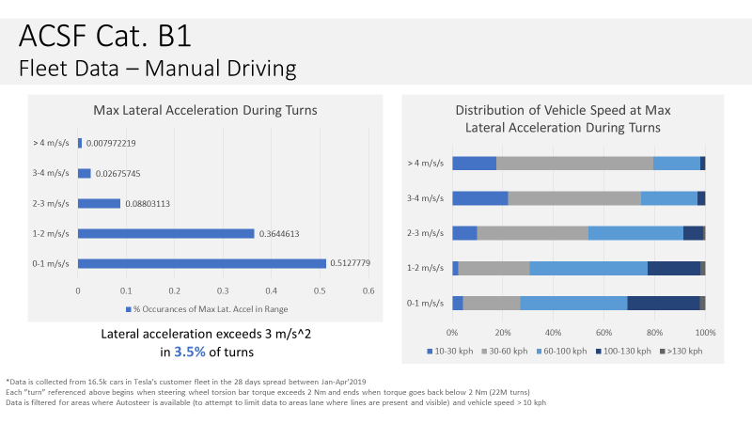

**Picture 2  
Analysis of max lateral acceleration occurrence and related vehicle speed distribution, based on an EU distributed set of 1.250 Model 3s vehicles**

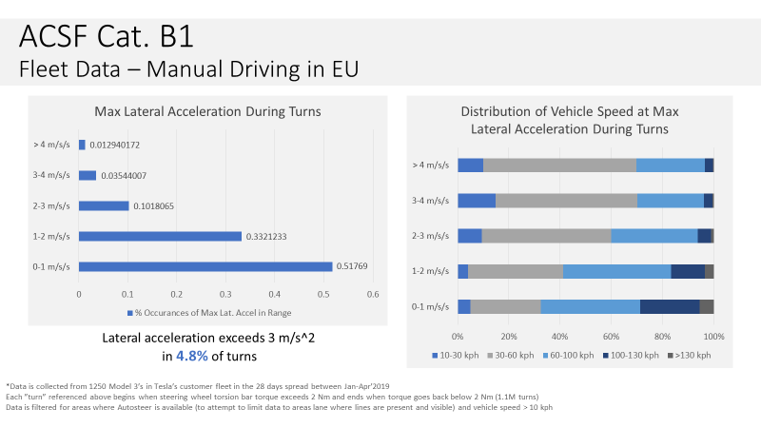

**Picture 3   
Analysis of the maximum lateral acceleration encountered in curves on a per trip basis. Data presented of 16.500 globally distributed Tesla vehicles (left) and 1.250 EU Model 3s (right)**

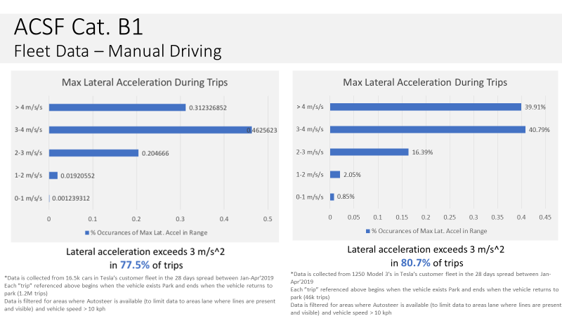

**B. Paragraph 5.6.2.1.3.**

6. Adjustments to reflect changes proposed for the other provisions described in this document.

1. \* Formerly: **Working Party on Brakes and Running Gear (GRRF)**. [↑](#footnote-ref-2)
2. \*\* In accordance with the programme of work of the Inland Transport Committee for 2020 as outlined in proposed programme budget for 2020 (A/74/6 (part V sect. 20) para 20.37), the World Forum will develop, harmonize and update UN Regulations in order to enhance the performance of vehicles. The present document is submitted in conformity with that mandate. [↑](#footnote-ref-3)