Proposal for the 01 series of amendments to UN Regulation No. 35
(ECE/TRANS/WP.29/GRSG/2019/3 on Foot controls)

The text reproduced below was prepared by the expert from the International Organization of Motor Vehicle Manufacturers (OICA) to clarify the measurement method of the lateral distance of the pedals to the nearest "wall" to the left. It is based on informal document GRSG-115-17, presented at the 115th session of the Working Party on General Safety Provisions (GRSG) (see report ECE/TRANS/WP.29/GRSG/94, para. 14). The modifications to the current text of UN Regulation No. 35 are marked in bold characters.

I. Proposal
Paragraph 5.7., amend to read:
"5.7. The distances, respectively shown as "H" and "J" in Annex 4, between the projection of the service-brake pedal on to the reference plane "P" and the intersection of each of the walls with that plane shall be ≥ 130 mm to the right and ≥ 160 mm to the left for vehicles with three pedals, and ≥ 130 mm to the right and ≥ 120 mm to the left for vehicles with two pedals.
In case of a foot rest as declared by the manufacturer, installed for the driver's left foot, the shortest distance between the most left pedal and the wall shall be measured above the foot rest, and the minimum distance between the footrest and the projection of the most left pedal on to the reference plane "P" shall be ≥ 50 mm."
Insert new paragraphs 10. to 10.4., to read:
"10. TRANSITIONAL PROVISIONS
10.1. As from the official date of entry into force of the 01 series of amendments, no Contracting Party applying this Regulation shall refuse to grant or refuse to accept type approvals under this Regulation as amended by the 01 series of amendments
10.2. As from 1 September 2020, Contracting Parties applying this Regulation shall not be obliged to accept type approvals to the preceding series of amendments, first issued after 1 September 2020.
10.3. Contracting Parties applying this Regulation shall continue to accept type approvals issued according to the preceding series of amendments to this Regulation first issued before 1 September 2020.
10.4. Contracting Parties applying this Regulation shall not refuse to grant type approvals according to any preceding series of amendments to this Regulation or extensions thereof."
Paragraph 10. (former), re-number as paragraph 11.
Annex 1, item 5, amend to read:
"5. Brief description of the vehicle type as regards the arrangement of foot controls and foot rest ......................................................................................................"

II. Justification
1. It should be possible to place the left foot normally in a position of rest on the floor surface or foot rest such that it is not trapped by the pedals. It should also be possible to actuate any pedal over its full travel without inadvertently operating floor-switches or other foot controls.
2. This proposal hence clarifies the measurement method for the lateral distances of the pedals to the nearest "wall" to the left. For safety and comfort reasons foot rests are installed for the drivers' left foot. The rest plane of such foot rests can intersect the measurement plane "P". This proposal clarifies that, in such cases, the required clearance for the left foot is measured on top of the foot rest, rather than between the left most pedal and the foot rest itself.
3. To ensure clearance of travel for the left most pedal (either service brake or clutch), an additional minimum distance between this pedal and the foot rest is introduced.
4. The proposal is introduced as a new series of amendments because it may add new constraints to some manufacturers.
Example of possible interpretation when footrest exists under current regulation text:
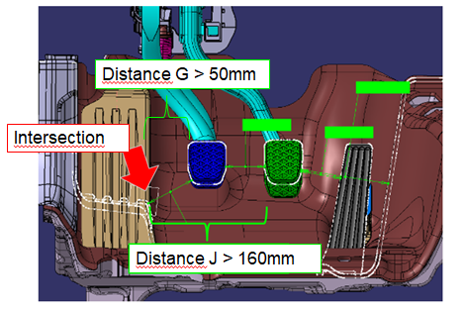
Intersection of plane p with footrest
Wall
Distance

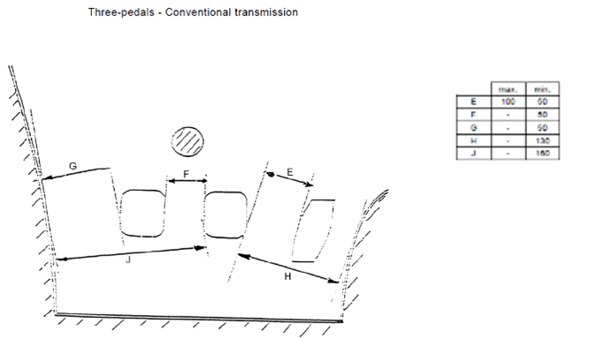
Current Regulation: Three pedals – Conventional transmission

Example of possible interpretation when footrest exists under current regulation text:
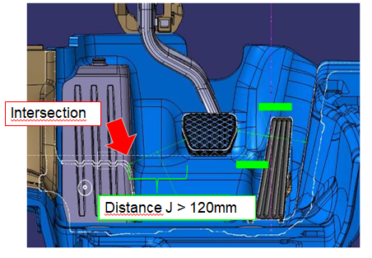
Distance
Intersection of plane P with footrest
Intersection with wall
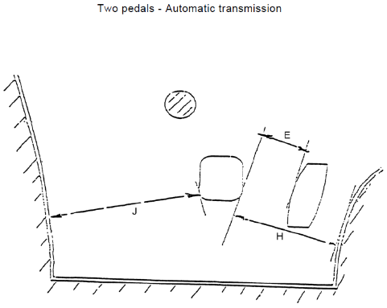
Current Regulation Text: Two pedals – Automatic transmission

