Proposal for amendments to UN Regulation No. 58.03
Rear Underrun Protection Device
The text reproduced below is prepared by the Netherlands to amend the provisions for the position of the Rear Underrun Protection Device. The modifications to the current text of UN Regulation No. 58 are marked in bold characters and in strikethrough for deleted characters.

I. Proposal
Paragraph 16.1 and 25.1., amend to read:
“16.1. For vehicles of the categories N2 with a maximum mass exceeding 8 t, N3, O3 and O4, the ground
clearance with respect to the underside of the protective device, even when the vehicle is unladen, shall
not exceed:

- 450 mm for motor vehicles and trailers with hydropneumatic, hydraulic or pneumatic suspension or a device for automatic levelling according to load. In any case, a departure angle up to 8° according to ISO 612:1978 with a maximum ground clearance of 550 mm shall be deemed to satisfy the requirements.

(b) 500 mm or a departure angle according to ISO 612:1978 of 8°, whichever is less, for vehicles other than those in (a) above. In any case, a departure angle up to 8° according to ISO 612:1978 with a maximum ground clearance of 550 mm shall be deemed to satisfy the requirements.

- 500 mm for vehicles other than those in (a) above. In any case, a departure angle up to 8° according to ISO 612:1978 with a maximum ground clearance of 550 mm shall be deemed to satisfy the requirements.”

II. Justification

Part II point 16.1 and Part III point 25.1 state the same requirements.
Section (a) and (b) state the requirements for ground clearance of the RUPD. Section (a) is for hydro pneumatic, hydraulic or pneumatic suspensions and section (b) for all others. When you illustrate the requirements in an image, you will get the image as shown in figure 1. Beside the height difference (450 to 500 mm) you can clearly see the difference.

According section (b) the maximum ground clearance shall not exceed 500 mm or shall not exceed a departure angle of 8° (whichever is less). This will result in that if you mount the RUPD directly behind the rear axle, the ground clearance will be far less than 500 mm. due to the departure angle of 8°.

The Netherlands believes that this is not the intention of the Regulation.
Amending the paragraphs as suggested lead to the image as shown in figure 2.

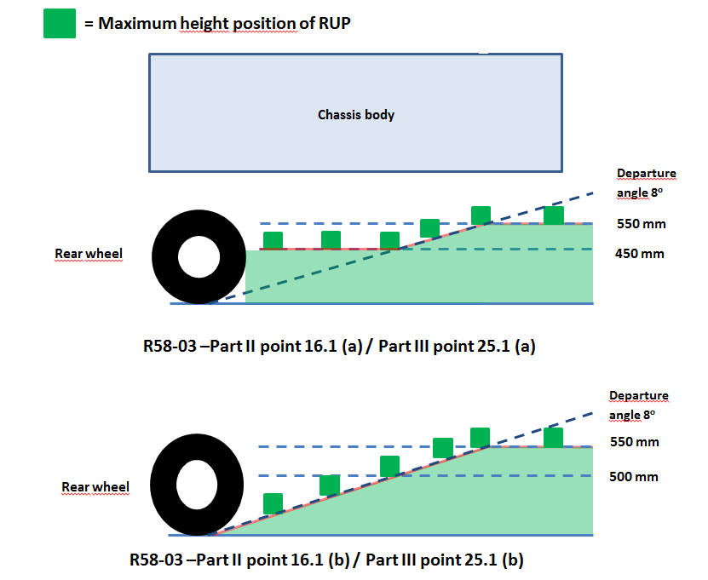
Figure (1) current situation
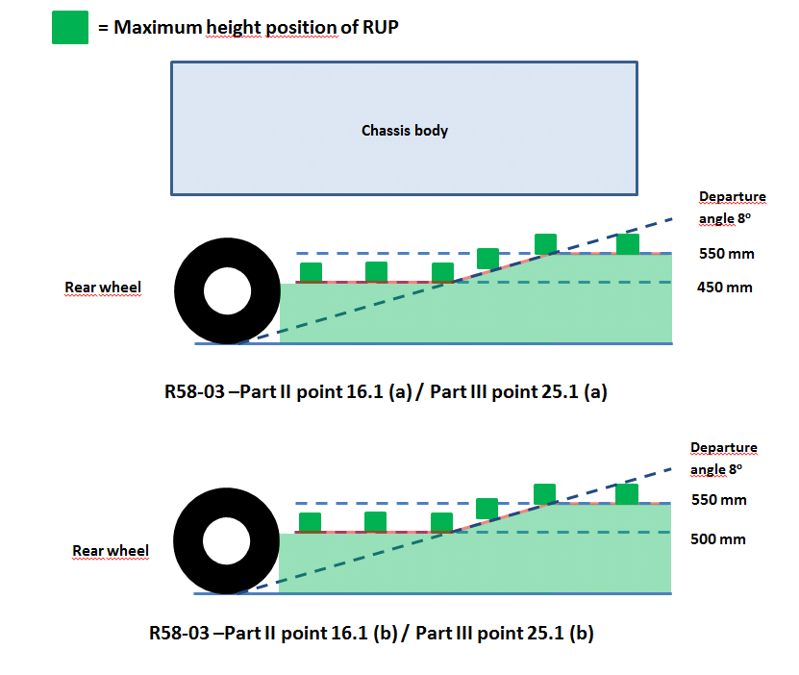
Figure (2) Amended situation

