EQUIVALENCE CRITERIA

GUIDE FOR SPECIFYING LED SUBSTITUTE LIGHT SOURCE CATEGORIES  
AS EQUIVALENTS FOR CORRESPONDING FILAMENT LIGHT SOURCE CATEGORIES

# **1. INTRODUCTION**

At the sixty-ninth (GRE-69-41) and at the seventieth GRE session (GRE-70-47), GTB had presented their motivation and a possible approach for the introduction of LED Substitute light sources as alternative replacement parts in type-approved devices for Regulation No. 37 filament light sources.

Compared to the tungsten filament technology the LED technology offers the opportunity of highly energy efficient light sources in combination with long lifetime values.

To not compromise traffic safety after replacement of a filament light source according to Regulation No. 37 by an LED substitute light source according to Regulation No. 128, criteria for technical equivalence have to be established. This document describes such criteria and gives guidance for the specification of new LED substitute light source categories in Regulation No. 128.

After the 81st GRE session the GRE TF Substitute and Retrofits extended the initial equivalence criteria document GRE-80-02, which was limited to signalling lamps, to light source categories without general restrictions.

# **2. COMPARING FILAMENT LAMPS AND LED LIGHT SOURCES**

Several electrical, geometrical, photometrical and thermal parameters should be specified to describe equivalence between LED substitute light sources and filament light sources of the corresponding Regulation No. 37 category.

2.1. Parameters, which are not inherently linked to the light generation technology, should be the same, for example test voltage, luminous flux, colour and light centre length. The maximum outline dimension is linked to the incandescent technology and should remain the same, too.

2.2. In filament light sources densely coiled tungsten wires form the light emitting area, whereof the shape (≈ cylindrical) and the radiation pattern show limited variations in practice. In LED based solutions the light emitting area can be quite diverse in terms of size and homogeneity; as well the radiation characteristics can significantly vary depending on the individual design. Therefore, this type of parameters of LED substitute light sources should similar to the behaviour of corresponding filament light sources.

2.3. In comparison to filament light sources certain parameters of LED light sources are different due to the distinct principle of light generation. With LED technology the same amount of light is usually generated with significantly less energy compared to incandescent technology, and the spectral composition (infrared versus visible radiation, but also within the visible range) differs between both technologies. The internal electrical circuit is different resulting in different failure modes.

2.4. Further, the different technology of light generation makes it necessary to consider an additional requirement. In case of LED solutions the photometrical values are usually quantified under initial “cold” and stabilized “hot” conditions in order to control the emission behaviour in changing thermal situations.

Based on these facts the parameters to which these equivalence requirements apply are grouped into four sets of criteria (“same”, “similar”, “different” and “additional”) and described in the following section.

# **3. REQUIREMENTS FOR EACH RELEVANT PARAMETER**

3.1. Parameters with the same values

The following parameters of an LED substitute light source category should be the same as in the data sheet of the corresponding Regulation No. 37 light source category, including the tolerances:

3.1.1. Holder (of the LED substitute light source)

The holder design of the LED substitute light source should allow the fitment of its counterpart filament light source. See also 3.1.3. and 3.3.4.

3.1.2. Maximum lamp outline dimensions

3.1.3. Electrical connector (of the LED substitute light source)

The electrical connector design of the LED substitute light source should allow the electrical contact of its counterpart filament light source. See also 3.1.1. and 3.3.4.

3.1.4. Test voltage

3.1.5. Objective luminous flux

In case different luminous flux values are given for 12V- and 24V-version of the counterpart filament light source, the 12V-value should be applied to both versions of the LED Substitute light source.

*Note: The 24V-version of filament light sources have usually a larger filament (longer filament wire), which is compensated by a higher luminous flux value to achieve same beam performance. This is also reflected by the fact that type-approvals of 24V devices are done with 12V standard light sources.*

3.1.6. Colour of emitted light

3.1.7. Light centre length

3.1.8. Distortion free zone (if any)

3.2. Parameters with similar values

The normalized luminous intensity distribution (“far field”) as well as the emission behaviour, the homogeneity of the light-emitting-area and – in case of application in road illumination devices – the contrast (“near field”) of the LED substitute light source should be similar to the characteristic of the filament light source of the corresponding Regulation No. 37 category.

3.2.1. Normalized luminous intensity distribution

The normalized luminous intensity distribution of LED substitute light sources should be specified in directions which are relevant for the light emission of filament light sources of the corresponding Regulation No. 37 category.  
Therefore, minimum and maximum intensity values (in cd/1000 lm) should be given in the category sheet, typically in representative C-planes* and in representative angular steps , excluding the following distorted areas of filament light sources of the corresponding Regulation No. 37 category:

* transition region of the cap;
* proximity of the filament axis;
* area of strong glass distortions (tips);
* shading area of lead-in wires.

All values (intensity limits, relevant directions) should be derived from measurements of homologated filament light source samples of the corresponding Regulation No. 37 category (see Annex 1A for categories used in light signalling devices only and Annex 1B for categories also used in road-illumination devices). The selection of samples should include various possible designs of different manufacturers.

*\* C-planes: see CIE publication 70-1987, "The measurement of absolute intensity distributions".*

3.2.2. Size and position of the light-emitting-area

A similar box definition including the relevant viewing direction(s) of the corresponding data sheet in Regulation No. 37, if any, should apply for the size and position of the (apparent) light-emitting-area of the LED substitute light source. Depending on the geometrical circumstances ~~[~~under which the box is defined in the corresponding data sheet in Regulation No. 37~~]~~ additional viewing directions(s) may need to be introduced.

In case different box dimensions are given for 12V- and 24V-version of the counterpart filament light source, the 12V-dimensions should be applied to both versions of the LED Substitute light source (see also note under 3.1.5.).In addition, a minimum percentage value of the luminous flux emitted from this box into the given viewing direction(s) should be specified in the data sheet (see parameter DFR in Annex 2). This value should be derived from measurements of homologated filament light source samples of the corresponding Regulation No. 37 category (see Annex 2). The selection of samples should include various possible designs of different manufacturers.

3.2.3. Homogeneity of the light-emitting-area

The box defined under 3.2.2. should be split in representative sections with limits for the luminous flux emitted from each section into the given viewing direction(s) should be specified to achieve a level of homogeneity comparable to the filament case, where usually minimum and maximum limits of filament dimension and position per category exist (see Annex 3A for categories used in light signalling devices only and Annex 3B for categories also used in road-illumination devices).

A stricter specification of size/position of Standard filament light sources should be “translated” into a correspondingly stricter specification of the homogeneity of the LED Substitute light source (see the example in Annex 3B).

3.2.4. Contrast of the light-emitting area (only for categories also used in road-illumination devices)

The minimum contrast, specified as the ratio of the luminous flux emitted from the box defined under 3.2.2. and the luminous flux emitted from a representative area at a specified distance should be derived from measurements of homologated filament light source samples of the corresponding Regulation No. 37 category (see Annex 4). The selection of samples should include various possible designs of different manufacturers.

3.3. Parameters with different values

The following properties are inherently different between filament and LED substitute light sources. The equivalence criteria have to be described appropriately:

3.3.1. Maximum electrical power consumption

The maximum electrical power consumption of an LED substitute light source should be limited to a value of about 30% of the maximum power specified in the corresponding data sheet of Regulation No. 37 in order to limit the heat load in the cap at a level comparable to the corresponding filament light source.

This value may be specified more precisely, for example via comparative temperature measurements. When placed in a typical holder and operated at the properly specified maximum power the cap temperature of an LED substitute light source should stabilise at similar (or lower) value as for the corresponding filament light source placed in the same holder and operated at objective power.

3.3.2. The minimum voltage range

The minimum voltage range and the corresponding luminous flux tolerances given in Annex 4 of Regulation No. 128 should be used as a default for electrical and photometrical tests of LED substitute light sources. An additional minimum flux requirement at significant voltage drop should be given in the data sheet to guarantee a minimum light output comparable to filament light sources (e.g. at 9V at least 20% of the objective luminous flux at test voltage for a 12V type).

3.3.3. The spectral content

LED substitute light sources emitting white light and possibly being operated behind red or amber cover lenses should have a colour temperature of maximum 3,000 K.

3.3.4. Functional interlock between light source and application

The LED substitute light source should have a standardised interlock feature that prevents its fitting and/or operation in applications where it was not approved for, if this is technically feasible in relation to the specifications of 3.1.1. and 3.1.3.

3.4. Additional parameters

For all LED light sources one additional requirement should apply to LED substitute light sources:

3.4.1. Thermal behaviour

The thermal behaviour of the emitted luminous flux after one minute of operation and after 30 minutes of operation should be in accordance with Regulation No. 128, annex 4. Because LED substitute light sources can be located in the immediate environment of filament lamps, an elevated ambient temperature is added in the datasheet.

# **4. REQUIREMENTS REGARDING FAILURE**

Due to significantly reduced power consumption of LED technology, LED substitute light sources might trigger some failure detection systems even though the light source is working normally. Besides some mandatory failure tell-tales, vehicles may also optionally be equipped with failure detection systems for other lighting or light signalling functions and on-board diagnostic systems, e.g. short voltage pulses to check the function of filament light sources in the off-state.

Failure detection systems and on-board diagnostic systems are not or hardly specified by regulations or by standards from officially recognised international standardisation organisations. In particular the electrical detection threshold is not publicly known or standardized.

Whereas the equivalent of the internal electrical circuit of a filament lamp is just a temperature dependent resistor with coil side-effects, the LED substitute light source electrical circuit is represented by diodes and resistors and may be capacitors and microchips with intelligence. Typical failures are not limited to simple open- or closed-circuit of the light source, although in rare cases also the filament can be partially short-circuited between windings of the coil.

4.1. Failure detection

In order to support the interface to such systems, a lower and upper limit for the electrical current should be specified per category over a voltage range covering normal application conditions (e.g. 9V-16V DC for a 12V system) and LED substitute light sources should not flash when a short voltage pulses (e.g. 1 millisecond) is applied.

4.2. Failure behaviour

A criterion per category should reflect the situation that a LED substitute light source may consist of more than one light emitting element and a clear detection of malfunction is possible. Example: “Either the LED substitute light source complies with luminous flux and intensity requirements, or it stops emitting light and the electrical current drops below a specified limit”.

# **5. DOCUMENTATION**

The proposal for LED substitute category sheet(s) should be accompanied by information showing the equivalence with the corresponding filament light source category. Measurements of anonymised samples of filament light source to derive equivalent performance should be included. See also annex 5.

# **ANNEXES**

**Annex 1A**

**Clarification of the requirements to the normalized luminous intensity distribution (categories used light-signalling devices)**

The normalized luminous intensity distribution of homologated filament light source samples typically exhibits bulb-to-bulb variations due to the specific design, i.e. due to non-regulated parameters (glass thickness variations, shape of glass bulb, coiling structure of filament, etc.) and/or tolerances (filament position, lead-in wire position). Further, “distorted” areas (design of lead-in wires and their relative position to the filament, proximity of filament axis, transition region of the cap, glass tips) lead to extreme variations in specific angular regions.

However, straight filaments generate quite similar emission patterns in the directions of major light emission, i.e. more or less perpendicular to the filament axis (e.g. +/- 30°).

Therefore, the specification of equivalent radiation characteristics of LED substitute light sources is limited to the directions of relevant light emission of the corresponding filament light source excluding “distorted” areas.

Depending on the specific filament light source category, the excluded areas are different. Figure 1 shows representative examples of transversal and axial filament positions and limitations of the directions where light emission of the LED substitute light source should be specified.

|  |  |  |
| --- | --- | --- |
|  | *Orientation of C-planes* | *Angular limitation of  in C0-plane* |
| *Example P21W* | *top view* |  |
| *Example H21W* | *top view* |  |

**Figure 1: representative examples of filament positions and limitations of the directions where light emission of the LED substitute light source should be specified**

**Annex 1B**

**Clarification of the requirements to the normalized luminous intensity distribution (categories used in road-illumination devices)**

The normalized luminous intensity distribution of homologated filament light source samples typically exhibits bulb-to-bulb variations due to the specific design, i.e. due to non-regulated parameters (glass thickness variations, shape of glass bulb, coiling structure of filament, etc.) and/or tolerances (filament position, lead-in wire position). Further, “distorted” areas (design of lead-in wires and their relative position to the filament, proximity of filament axis, transition region of the cap, glass tips) lead to extreme variations in specific angular regions.

However, straight filaments generate quite similar emission patterns in the directions of major light emission, e.g. +/- 45° around the vertical line to the filament axis.

Therefore, the specification of equivalent radiation characteristics of LED substitute light sources is limited to the directions of relevant light emission of the corresponding filament light source excluding “distorted” areas.

Depending on the specific filament light source category (e.g. axial versus transversal filament alignment or single versus dual filament with or without shield), the excluded areas are different. 

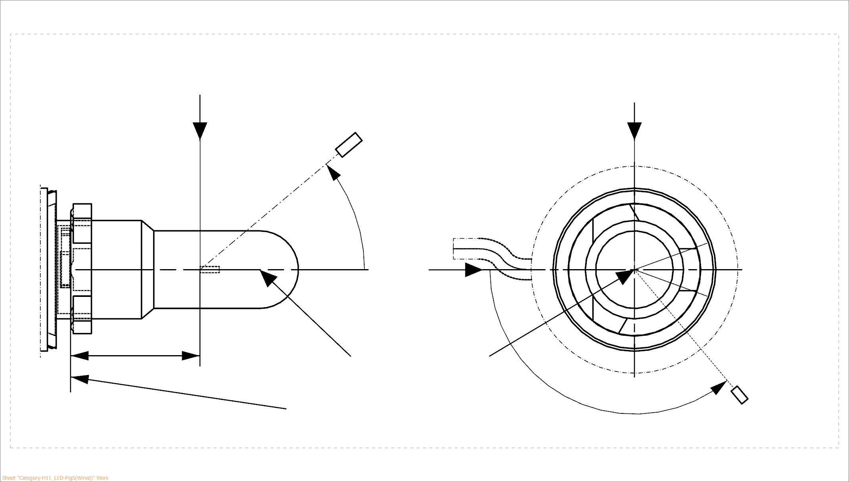

25,0

***View from B***

***View from C***

Reference plane

Reference axis

**B**

**A**

C = 270°

C = 90°

C = 180°

**C**

C = 0°

****

**A**

Photo-Detector of Goniometer

**Figure 2 – Definition of C-Planes and angle  for an example of a** **single filament light source with axial filament alignment**

Figure 2 shows an example of a single filament light source with axial filament alignment. The normalized luminous intensity distribution is specified in three C-planes (C = 0°, C = 90°, C = 270°) in an angular range covering the distortion free area, which is typically given in the category sheet of the corresponding filament light source by the angles 1 and 2 (note: the C-plane oriented to the lead-in wire (C = 180°) is excluded).

Additionally, the normalized luminous intensity distribution is specified at  = 90° in several C-planes separated by e.g. 30° (C = 0°, C = 30°, C = 60°, …) excluding the shading region due to the lead-in wire (C = 180°), which extends typically over a range of +/-30°, when various possible designs of different manufacturers are taken into account.

In case a black top is specified for the corresponding filament light source (typically given by the angle 3 in the category sheet of the corresponding filament light source) an upper limit on the normalized luminous intensity distribution applies, e.g. in the corresponding angular range ( = 0° … 3) of the four C-planes (C = 0°, C = 90°, C = 180°, C = 270°).

If a selection of samples including various possible designs of different manufacturers is measured the values of the normalized luminous intensity typically varies between [80] and [130] cd/1000 lm, due to glass tubular thickness variations and the coiling structure of the corresponding filament light sources. In the same way the normalized luminous intensity in the range of the black-top is typically below [10] cd/1000 lm for the selection of samples.

**Annex 2**

**Clarification of the definition of a minimum light emission of the defined box**

The luminous flux emitted from a filament light source is not solely emitted from the filament. Scattered and reflected light from coatings, lead-in wires, etc. contribute to the emission characteristics.

Therefore, the definition of an equivalent minimum percentage is defined for LED substitute light sources on the basis of measurements of homologated filament light source samples of the corresponding category.

In figure 3 two examples of an amber filament light source (PY21W) are shown. One sample made of amber glass has a high percentage of direct light emission (~ 90%; i.e. only minor reflections due to the lead-in structure and the ghost images) whereas the second sample using an amber coating has a lower percentage of direct light emission (~70%; due to additional haze from the coating material). Hence, based on given examples of PY21W filament light sources in figure 3 the minimum percentage value of the luminous flux emitted from the box into the given viewing direction(s), the so-called Direct-Flux-Ratio DFR, could be set to 80%.

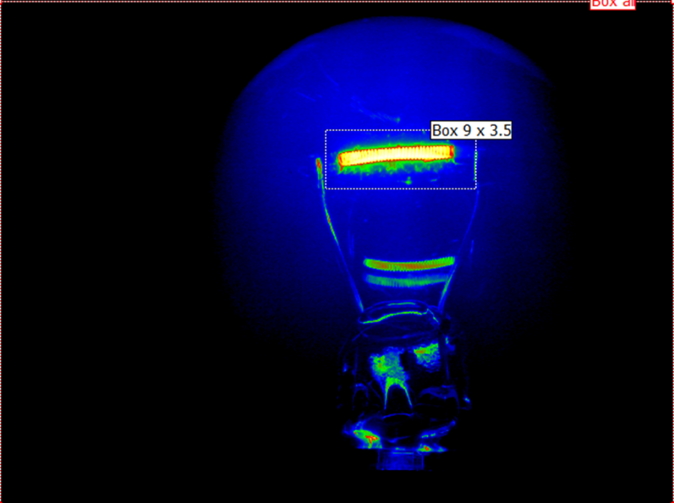

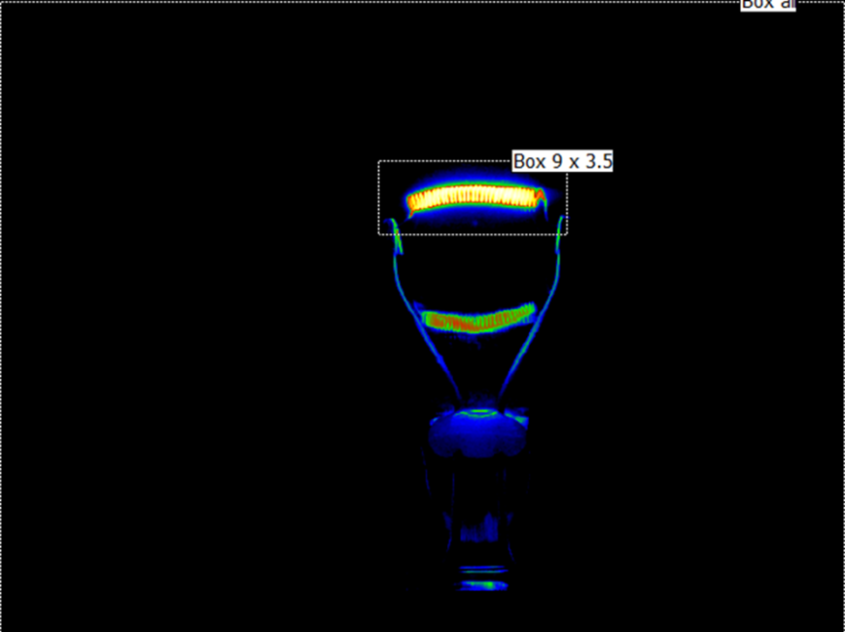

**Figure 3: PY21W-samples with amber glass (left) and with amber coating (right)**

Figure 4 shows an H11 as an example of a single filament Halogen light source with axial filament alignment. Measurements of samples of different manufacturers show that this kind of light sources has high percentage of direct light emission showing only little variations (typical between 85% and 90% for uncoated versions).

Hence, the Direct-Flux-Ratio DFR of LED Substitute light sources being the counterpart light sources of Halogen light sources with an axially aligned, single filament could be set to 90%, in general.

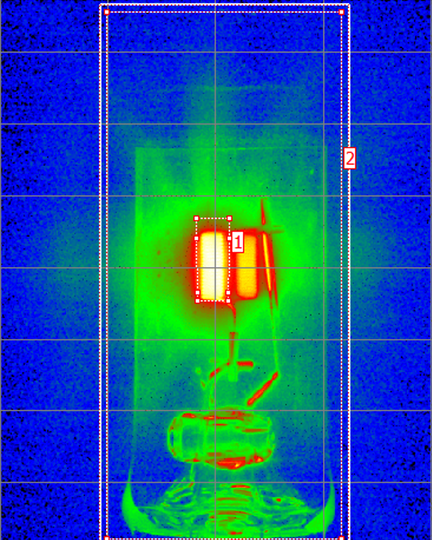

**“A+B+C”**

**“all”**

**Figure 4: H11-sample showing typical situation of a filament light source with axial filament alignment**

**Annex 3A**

**Clarification of the requirements to the homogeneity of the light-emitting-area (categories used in light-signalling devices)**

The explanations in this annex are based on the example of PY21W.

Figure 5 shows that in Regulation No. 37 the box from the front elevation is already defined in three sections. The projection of the filament should lie entirely within the rectangle and the centre of the filament should stay within the inner section of the box.



**Figure 5: Front elevation of the box specification of filament light source category PY21W in Regulation No. 37**

The percentages of the minimum luminous flux emitted from each section into the given viewing direction(s) should be specified based on considerations done with samples of filament light sources of the corresponding category, i.e. including tolerances of typical filament dimensions and filament position and taking into account that part of the light is emitted from outside the box (ref. value of DFR).

Figure 6 describes the outcome for the example of a PY21W LED substitute light source. The lower limit for each section is derived from extreme values of the filament length (f = 5.5 and 7.0 mm), of the filament position (shift of centre k = -1.0 and +1.0 mm) according to the PY21W filament lamp category and the share of direct light emission from the box (“DRF” = 80%, see Annex 2):

* Section B: 2*k/f *DFR= 2.0/7.0*0.8 = 22.9%,  
  rounding up at multiples of 5% to 25% min.
* 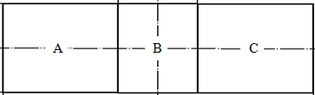Sections A and C: (0.5*f-2*k)/f*DFR = (2.75-2.0)/5.5*0.8 = 10.9%,  
  rounding up at multiples of 5% to 15% min.

*The proportion of the total luminous flux emitted into the viewing direction from the area(s):*

* *A, B and C together should be 80 per cent or more;*
* *B should be 25 per cent or more;*
* *A and C should each be 15 per cent or more.*

**Figure 6: Front elevation of the box specification of LED substitute light source category P21W**

**Annex 3B**

**Clarification of the requirements to the homogeneity of the light-emitting-area (categories used in road-illumination devices)**

The explanations in this annex are based on the example of H11.

Figure 7 shows that in Regulation No. 37 the box, checked from two perpendicular viewing directions, is already defined in three sections. The filament shall lie entirely within the limits shown, while the ends of the filament as defined on sheet shall lie between lines Z1 and Z2 and between Z3 and Z4.

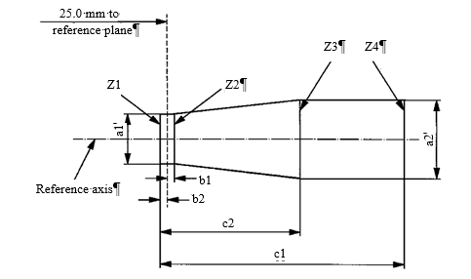

**Figure 7: Box specification of filament light source category H11 in Regulation No. 37**

The size and position of the light emitting area of the LED Substitute light source is based on the specifications of the filament box in the viewing direction(s) specified for the corresponding filament light source.

The homogeneity requirements of the light emitting area of the LED Substitute light source are based on the requirements for the minimum and maximum dimension and the position of the filament specified for the corresponding filament light source. To emphasize the relevance of the central part of the box and typical maximum filament diameter (e.g. 1.4mm given in a footnote of H11 category sheet), the central part is divided in three sub-parts for more equivalent homogeneity specification.

Figure 8 shows the example of the section definition for a trapezoidal box definition as given in the H11, while Table 1 summarizes the resulting requirements to the different luminous flux ratios.

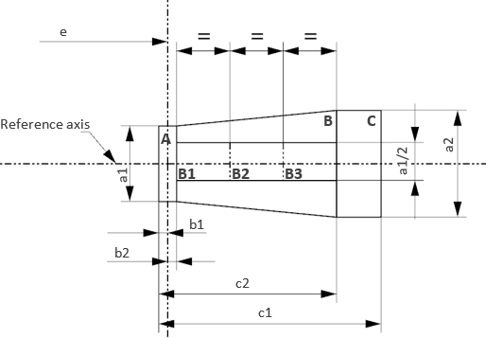

**Figure 8: Box specification of LED Substitute light source category, example H11/LED**

**Table 1: homogeneity requirements of LED Substitute light source category H11/LED**

|  |  |  |  |
| --- | --- | --- | --- |
| Section | Luminous flux ratio limit | Spec. for H11/LED* | Comment |
| A | $$\frac{A}{A+B+C}=\frac{b1+b2}{c2}$$ | <= 10% | Max. value based on shortest filament covering whole A |
| B | $$\frac{B}{A+B+C}=\frac{c2-b1-b2}{c1}$$ | >= 72% | Min. value based longest possible filament |
| C | $$\frac{C}{A+B+C}=\frac{c1-c2}{c1-b1-b2}$$ | <= 22% | Max. value based on shortest filament covering whole C |
| B1, B2, B3 | $$\frac{Bi}{B}=1/3∙\frac{0.5∙a1}{d}∙0.75$$ | >= 15% | Total of B1+B2+B3 is split in three, allowing a certain tolerance (“-25%”) |

* The tighter specification of the filament length of standard H11 filament light sources (4.5 ± 0.1 mm) translates into tighter restriction of certain sections, e.g. a minimum and a maximum limit apply for section B.

**Annex 4**

**Clarification of the requirements to the contrast of the light-emitting-area**

In the case of a filament light source with axial filament alignment (e.g. H11) the contrast is determined from the ratio of the luminous flux emitted from the following areas:

* the area represented by the box “A+B+C”
* the rectangular area D (“glare zone”) positioned parallel to the reference axis with size 1.5 times the length and 1.5 times the largest diameter of box A+B+C

The distance between both areas (d = 0.4mm) is derived from the optical magnification of typical Halogen headlamps, where a minimum contrast in the beam must be achieved between 75R and HV. The location of the area D is diametrically opposite of the lead wire and symmetrically arranged to the box “A+B+C”.

Figure 9 shows the illustration of the box arrangement.

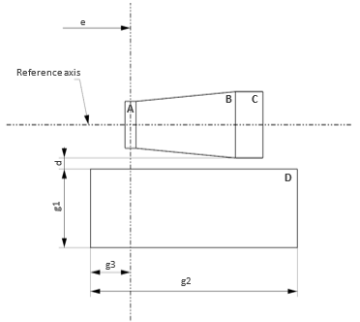

**Figure 9: Box arrangement used for definition and determination of contrast**

In the case of a single-filament light source with axial filament alignment measurements of samples of different manufacturers show contrast values of typically [100]:1 for uncoated versions.

Hence, the minimum contrast of LED Substitute light sources being the counterpart light sources of Halogen light sources with an axially aligned, single filament could be set to [100]:1, in general.

**Annex 5**

**Checklist for equivalence of parameters**

Parameters as in paragraphs described above Check

3.1. Parameters with the same values

3.1.1. Holder O

3.1.2. Maximum lamp outline dimensions O

3.1.3. Electrical connector O

3.1.4. Test voltage O

3.1.5. Objective luminous flux O

3.1.6. Colour of emitted light O

3.1.7. Light centre length O

3.1.8. Distortion free zone (if any) O

3.2. Parameters with similar values

3.2.1. Normalized luminous intensity distribution O

3.2.2. Size and position of the light-emitting-area O

3.2.3. Homogeneity of the light-emitting-area O

3.2.4. Contrast of the light-emitting area (only for categories also used in  
road-illumination devices) O

3.3. Parameters with different values

3.3.1. Maximum electrical power consumption O

3.3.2. The minimum voltage range O

3.3.3. The spectral content O

3.3.4. Functional interlock between light source and application O

3.4. Additional parameters

3.4.1. Thermal behaviour O

4. Requirements regarding failure O

4.1. Failure detection O

4.2. Failure behaviour O