Transmitted by the Russian Federation | Informal document GRBP-70-07  (70th GRBP session, 11-13 September 2019, agenda item 14)

On Emissions of Hazardous Substances and Particulate Matters Caused by Wear of Tyres and Roadway Contaminating Urban Atmosphere

Civilization development in terms of improvement of modern vehicles in order to support comfortable human life and activities is followed not only by improvement of transport conditions for the urban population, but also by rather significant pollution of the air in the human living environment, especially in big cities, up to levels hazardous to human health. As early as 2013, based on the results of the 65th session of GRPE, in Section XVII "Exchange of information on national and international requirements on emissions (agenda item 16)" of the ECE/TRANS/WP.29/GRPE/65 final report, the following was mentioned:
in clause 74. The expert from the Russian Federation introduced document GRPE-65-20, containing an analysis, based on studies carried out in the USA and the Russian Federation, on the role of tyre dust with respect to air pollution and health impacts. He invited GRPE participants to share information on the subject and called for the consideration of regulatory action on it.
in clause 75. GRPE welcomed the presentation by the experts from Japan, the Russian Federation and Sweden and noted the efforts undertaken in the fields addressed. Agreeing with the suggestion of the expert from Switzerland, GRPE recommended forwarding the document GRPE-65-20 to the Working Party on Braking and Running Gear (GRRF).
Furthermore, as it appears from Report No. 161-22 of the Russian Federation at the 161st session of the World Forum for Harmonization of Vehicle Regulations (WP-29), in 2013, it was stated that, while strictly limiting the particulate matter emissions with exhaust gases for diesel engines by introducing standards from Euro-1 to Euro-6 from 1990 up to now, legislators do not pay due attention to other hazardous substances and particulates, emitted by vehicles during operation due to wear of other vehicle systems and units, such as brake systems (pads and discs), clutch plates and especially asphalt roadway, as well as tyre wear.
The attention has been also focused on the research by the World Health Organization (WHO) showing that, according to expert estimations in different countries, at the end of the last century, air pollution in the human living environment caused three million early deaths of people all over the world annually. [1]. The maximum morbidity rates were recorded in Europe and the USA, and the minimum ones were recorded in Eastern countries.
At the regular sessions of GRPE and GRRF in 2014, the delegation from the Russian Federation suggested paying special attention to development of stricter requirements for efficiency of cabin air filters and additional air purifiers removing PM10 and PM2.5 from passenger compartments of vehicles, which are currently absent, as passengers and drivers are the most vulnerable to hazardous impact of these particulates. It should be emphasized that particulate matters caused by wear of tyres and roadway contain very hazardous cancerogenic substances, which are a source of lung cancer.
According to the results of our research, we believe that contemporary environmental problems of big cities are connected to lack of attention to pollution of the city air by particulates caused by wear of tyres and asphalt roadway, which reflected in smog emerging in big European cities after 2010 and in the Russian Federation since 2016.
Based on the research made in the Russian Federation in 2014, the Russian Federation presented a paper at the 162nd session of the World Forum (WP-29) in which attention of the world community has again been drawn to comparison of emissions of particulate matters (PM) with exhaust gases and of those caused by vehicle tyres and brake mechanisms wear and tear.
However, when reviewing paper WP.29-162-39 "On Real Emission of Particulate Matters by Automobile Transport" of the Russian Federation, the European Tyre & Rubber Manufacturers Association (ETRMA) presented its document, in which based on the research made in 2010, dimensions of matters generated as a result of wear on the asphalt pavement were within 4-350 micron range.
Therefore, the ETRMA states that the average dimensions of the particulates caused by wear of tyres and roadway are approximately 80-100 microns. Particulates of this size are residual by their nature and that is why they will mainly be left on the road or alongside it.
In additional response to this ETRMA document, research of PM emissions less than 10 microns carried out in the Russian Federation registered that there is always a background of PM less than 10 microns above the roadway. It should be noted that most PMs are matters with the size of 0.3 to 5 microns (Figure 1).
micron
50 km/h
30 km/h
40 km/h
Background
Amount of particles in 1 m³ sampling, mln pcs

Fig. 1. Dispersion and amounts of PM emissions at different driving speed of motor vehicles

Figure 2 shows results of definition of dispersion and amount of PM emissions less than 10 microns in case of the vehicle driving through the Moscow Third Transportation Ring (Tretye Transportnoye Koltso) asphalt-concrete road at different constant speeds. The results of the research have shown that PM emissions at constant vehicle driving speeds significantly (2 to 10 times) exceed the background values and increase along with the speed increase, while the main PM emission (> 97%) is represented by 0.3 to 5.0 microns matters.
Thus, the most important current period problem is the reduction of PM emissions both with exhaust gases, and from tyre and asphalt roadway wear during vehicle driving in densely populated urban territories.
Highly interesting and important data should be especially noted in the document to which ETRMA refers and in which the results of the PM chemical analysis are shown for the content of polycyclic aromatic hydrocarbons (PAH) in them which contain cancerogenic substances causing human cancer diseases (Table 1).

Table 1

Analysis of polycyclic aromatic hydrocarbons (PAH) content in the matters.
The values are expressed in parts per million (ppm) in the matters mix.

Chemical substance | Road particles (RP) | Tyre wear particles  (TWP) | Tyre (tread) particles (TP)
Acenaphthene | 4.08 | 0.04 | 0.13
Naphthalene | 6.1 | 0.2 | 1.18
Phenantrene | 53.4 | 1.66 | 1.21
Pyrene | 54.84 | 4.77 | 0.06
Acenaphthylene | 0.14 | 0.15 | 1.24
Anthracene | 7.36 | 0.1 | 0.11
Benzanthracene | 38.65 | 0.18 | 2.87
Benzo(a)pyrene | 12.51 | 0.28 | N.D.
Benzo(b)fluoranthene | 7.4 | 0.37 | 0.92
Benzo(g,h,i)perylene | 4.04 | 3.22 | 1.77
Benzo(k)fluoranthene | 7.4 | 0.02 | 0.92
Chrysene | 17.72 | 0.36 | 2.95
Dibenz(a,h)anthracene | 2.56 | 0.1 | 0.87
Fluoranthene | 82.13 | 0.98 | 1.62
Fluorene | 1.76 | 0.07 | 0.25
Indeno-1,2,3(c,d)pyrene | 5.36 | 0.21 | N.D.

This list is not an exhaustive PAH list but it contains PAHs most widely spread in the environment as well as PAHs considered cancerogenic and able to provoke cancerous diseases in people according to the International Agency for Research on Cancer (IARC).
Due to the different approaches to evaluation of values and amounts of PM emissions with exhaust gases and those from tyre wear, and lack of attention to the roadway wear mentioned above, there has risen a global ecological conflict between the transport and natural environment, which by the current time period has become critical both by its level and violent growth. Against the backdrop of intense search (or sometimes its imitation) for the transport ecological problem solution by means of electric vehicles (EV) and alternative fuels, attention to the enormous growth of PM emissions from roadway wear has been weakened. In our opinion, use of electric cars in cities will not ensure an essential decrease in PM emissions since these cars will be driven with the same tyres and on the same asphalt-concrete roadway. This is proven by the materials of research on smaller than 10 microns PM emissions conducted in the Russian Federation by the example of Moscow. Figure 2 shows the materials on comparison of mass emissions of particulate matters (PM) from wear of tyres, brakes and roadway, as well as PM emissions with vehicle exhaust gases.

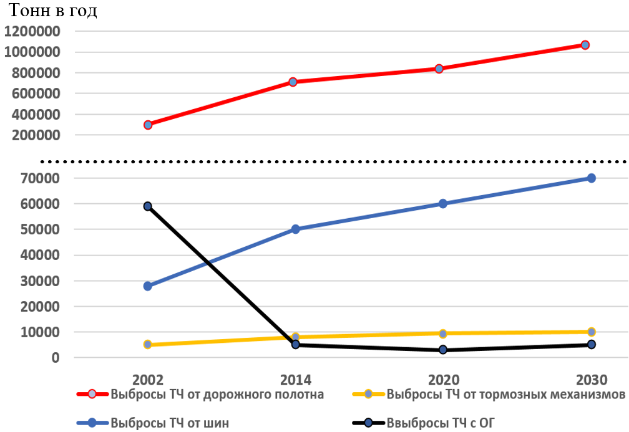
PM emission with exhaust gases
PM emission from brakes
PM emission from tyres
PM emission from roadway
Tons a year

Figure 2. Dynamic and forecast for annual PM emissions with exhaust gases, from wear of tyres, brakes and roadway from 2002 to 2030 in Moscow, in tons.

Thus, in Moscow, within the period from 2002 until now, PM emissions with exhaust gases decreased from 60 thousand tons to 6 thousand tons per year, i.e. almost by 10 times!
In November 2018, at the 48th meeting of the special international group on the Particles Measurement Program and during the 78th GRPE session, documents from the United Kingdom and Japan were presented.
The UK's report, reflecting the point of view of the Department for Transport, states a number of negative influences of the air contamination on the population health. Special emphasis is placed on 2.5 microns matters, which can infiltrate the lungs and blood in the form of smoke, soot or dust, and then move through the body and remain in the human organs thus reducing lifetime.
Figure 3 shows the results of research of the actual amounts of 2.5 microns PM emissions from different road transport systems in the UK.
It is necessary to pay attention to quite representative materials of the UK Department for Transport concerning amounts of PM emissions from wear of tyres, roadway and even brake systems, as in principle they are similar & comparable in terms of level, and correlate with the Russian research materials, which is being denied by the ETRMA position!
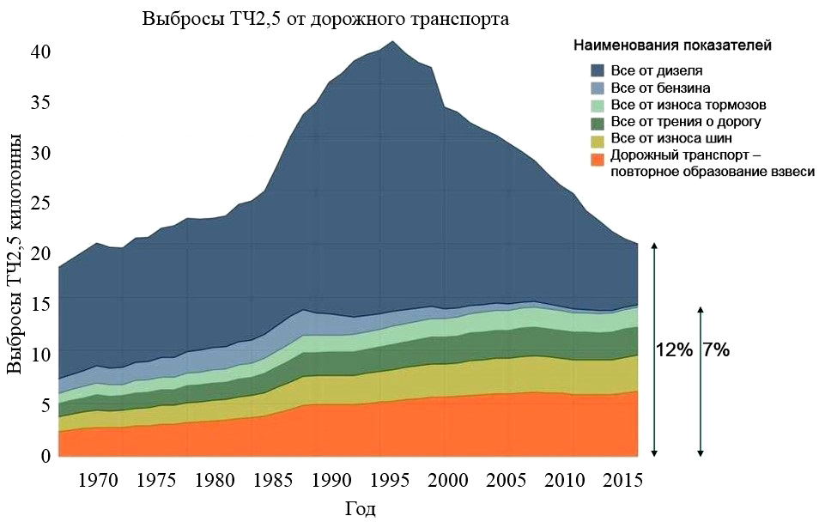
All from diesel
All from gasoline
All from brakes wear
All from road friction
All from tyre wear
Road transport – repeated formation
of suspended matter
Parameter denominations
PM2.5 emission from road transport
PM2.5 emission, kt
Fig. 3 Change of actual 2.5 microns PM emissions from different vehicle sources in the UK.

The materials submitted from Japan side by the Global Automotive Standards Internationalization Center (GASIC) at the 48th meeting on the PM measurement show tyre wear measurement values which are registered within the range of 0.15-0.2 g/km up to 1.2-1.4 g/km, which is well corresponded to and in line with the Russian Federation data submitted earlier in 2013-2017 at the GRPE and GRRF, and at the World Forum (WP-29).
So, based on the abovementioned, we face a question: What shall we do? How can we reduce PM emission and content of cancerogenic substances both in exhaust gases and in tyre and roadway wear products?
It should be noted that tyre manufacturers have actively been searching for new materials to replace the binding raw materials made of oil products containing cancerogenic substances with harmless raw materials.
Thus, within the last 30-40 years, tyre manufacturers have been performing active and intensive activities on tyre life increase and have reached some serious results: the average tyre run was increased almost two times from 30-40 thousand km to 60-90 thousand km which resulted, in our opinion, in a sharp increase in emissions of PM less than 10 microns, mainly from 0.3 to 0.5 micron. It is that dramatic increase in the volume of small suspended particulate matters caused by wear of tyres and asphalt-concrete roadway that can explain the smog emerging in the cities around the world.
Based on the foregoing, there is a need to discuss and propose solutions for the following problems:

  - Since, at the moment, there is a new problem connected to pollution of the urban atmosphere. It is of the same importance as the problem that was there 50 years ago connected to pollution of the urban atmosphere by vehicle exhaust gases, since the growth of the vehicle fleet in the cities of developing countries results in constant increase in emissions of suspended particulate matters smaller than 10 microns caused by wear of tyres and roadway, which are particularly hazardous for the health of population!
  - In the current situation, where the urban atmosphere is polluted by hazardous PM, it is necessary for our Governments to initiate and subsidize serious research works related to reduction of the content of hazardous substances in materials used for production of tyres and roadway, while the international community needs to develop the respective regulatory requirements.
  - Tyre manufacturers and road construction services should revise the whole existing technology for production of tyres and roadway considering the potential of ongoing research and development in terms of new materials and technologies.
  - Vehicle manufacturers should pay special attention to the development of requirements for efficiency of cabin air filters and additional air purifiers removing PM10 and PM2.5 from passenger compartments of vehicles as their passengers and drivers are the most vulnerable to hazardous exposure of fine particulate matters containing cancerogenic substances.

