|  |  |  |  |
| --- | --- | --- | --- |
|  | United Nations | ECE/TRANS/WP.29/2019/37 | |
| Description: _unlogo | **Economic and Social Council** | | Distr.: General  10 April 2019  Original: English |

**Economic Commission for Europe**

Inland Transport Committee

**World Forum for Harmonization of Vehicle Regulations**

**178th session**

Geneva, 25-28 June 2019

Item 4.6.3 of the provisional agenda

**1958 Agreement:  
Consideration of draft amendments to**

**existing UN Regulations submitted by GRSP**

Proposal for Supplement 9 to the original series of amendments to UN Regulation No. 129 (Enhanced Child Restraint Systems)

**Submitted by the Working Party on Passive Safety**[[1]](#footnote-2)\*

The text reproduced below was adopted by the Working Party on Passive Safety (GRSP) at its sixty-fourthsession (ECE/TRANS/WP.29/GRSP/64, paras. 29 and 31). It is based on informal document GRSP-64-02-Rev.1 as reproduced in Annex V to the report and on ECE/TRANS/WP.29/GRSP/2018/28 as amended by Annex V to the report. It is submitted to the World Forum for Harmonization of Vehicle Regulations (WP.29) and to the Administrative Committee AC.1 for consideration at their June 2019 sessions.

Supplement 9 to the original series of amendments to UN Regulation No. 129 (Enhanced Child Restraint Systems)

*Paragraph 4.5*., amend to read:

"4.5. Integral Enhanced Child Restraint Systems that can be used forward and rearward facing, shall have the following label permanently attached on the part hosting the child and visible to the person installing an Enhanced Child Restraint System in the vehicle:

The manufacturer shall be permitted to include the word "months" to explain the symbol "M" in the label. The word "months" should be in a language commonly spoken in the country or countries where the product is sold. More than one language is allowed.

Minimum label size 40 x 40 mm

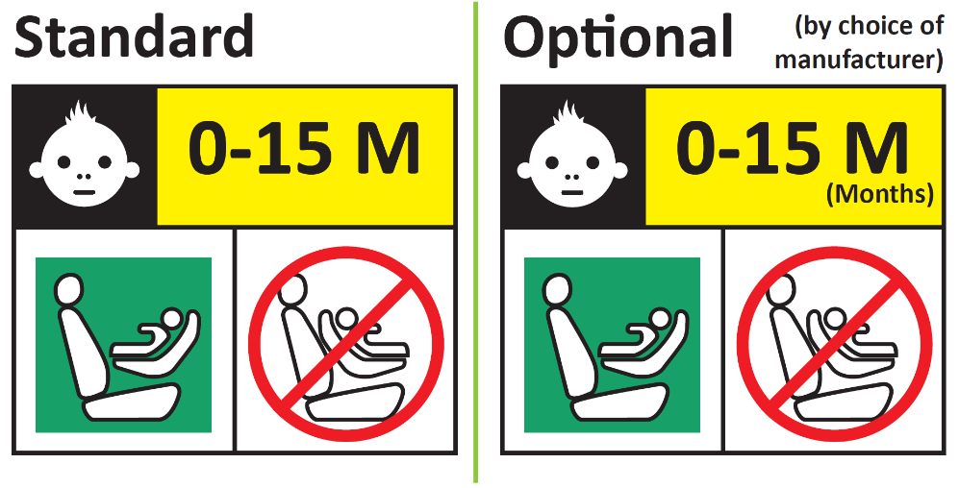

**Forbidden sign – red**

**Label outline, vertical and horizontal lines black**

**Square – green**

**Background white**

**Top symbol white on black background**

**All text black on yellow or amber background**

**Background white**

Integral Enhanced Child Restraint Systems that can be used forward facing only shall have the following label permanently attached on the part hosting the child and visible to the person installing an Enhanced Child Restraint System in the vehicle:

The manufacturer shall be permitted to include the word "months" to explain the symbol "M" in the label. The word "months" should be in a language commonly spoken in the country or countries where the product is sold. More than one language is allowed.

Minimum label size 40 x 40 mm

*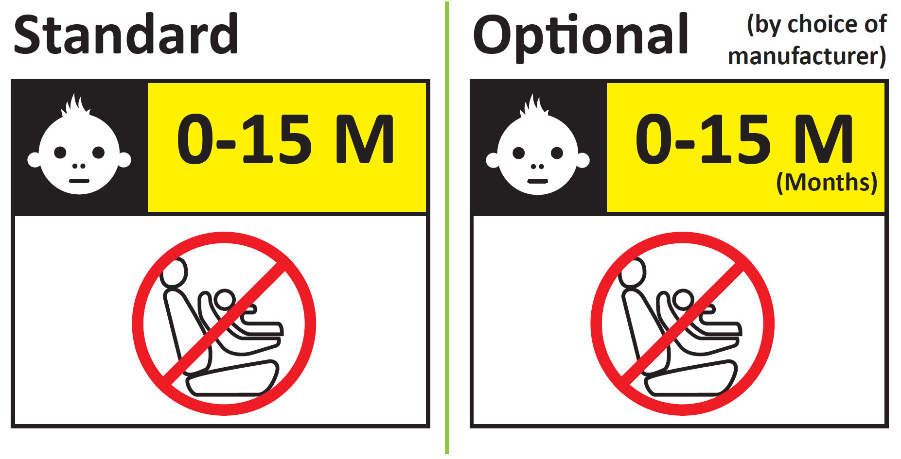***"**

*Paragraph 6.6.4.4.1.1*., amend to read:

"6.6.4.4.1.1. Forward facing Enhanced Child Restraint Systems

Head excursion: No part of the head of the dummy shall pass beyond the planes BA, DA and DE as defined in Figure 1 below. However, the head of the dummy may pass beyond the DE plane, if there is part of the child restraint structure, i.e. head pad or backrest, behind the head of the dummy, at the point the head passes the DE plane.

This shall be judged up to 300 ms or the moment that the dummy has come to a definitive standstill whatever occurs first."

*Paragraph 14.3.3*., amend to read:

"14.3.3. For integral forward facing Enhanced Child Restraint Systems, the following information shall be clearly visible on the exterior of the packing:

"IMPORTANT – DO NOT USE BEFORE THE CHILD’S AGE EXCEEDS 15 MONTHS (Refer to instruction)".

For integral Enhanced Child Restraint Systems that can be used forward and rearward facing, the following information shall be clearly visible on the exterior of the packing:

"IMPORTANT – DO NOT USE FORWARD FACING BEFORE THE CHILD’S AGE EXCEEDS 15 MONTHS (Refer to instruction)".

"

1. \* In accordance with the programme of work of the Inland Transport Committee for 2018–2019 (ECE/TRANS/274, para. 123 and ECE/TRANS/2018/21/Add.1, Cluster 3.1), the World Forum will develop, harmonize and update UN regulations in order to enhance the performance of vehicles. The present document is submitted in conformity with that mandate. [↑](#footnote-ref-2)