|  |  |  |  |
| --- | --- | --- | --- |
|  | United Nations | ECE/TRANS/WP.29/2019/111 | |
| _unlogo | **Economic and Social Council** | | Distr.: General  29 August 2019  Original: English |

**Economic Commission for Europe**

Inland Transport Committee

**World Forum for Harmonization of Vehicle Regulations**

**179th session**

Geneva, 12-14 November 2019

Item 4.8.9 of the provisional agenda

**1958 Agreement:  
consideration of draft amendments to existing   
UN Regulations submitted by GRSP**

Proposal for Supplement 2 to the 01 series of amendments to UN Regulation No. 135 (Pole Side Impact (PSI))

Submitted by the experts from the Working Party on Passive Safety[[1]](#footnote-2)\*

The text reproduced below was adopted by the Working Party on Passive Safety (GRSP) at its sixty-fifth session (ECE/TRANS/WP.29/GRSP/65, para. 37). It is based on ECE/TRANS/WP.29/GRSP/2019/13, as amended by Annex VI to the report. It is submitted to the World Forum for Harmonization of Vehicle Regulations (WP.29) and to the Administrative Committee (AC.1) for consideration at their November 2019 sessions.

Supplement 2 to the 01 series of amendments to UN Regulation No. 135 (Pole Side Impact (PSI))

*Paragraph 5.4.2.1*, amend to read:

"5.4.2.1. The door shall remain latched;

This requirement is deemed to be fulfilled:

(a) if it is clearly visible, that the door lock is latched; or

(b) if the door does not open under a static tractive force of at least 400 N in the y-direction applied to the door, according to the Figure below, as close as possible to the window sill and to the edge of the door opposite to the hinged side, except to the door handle itself.

**Figure**

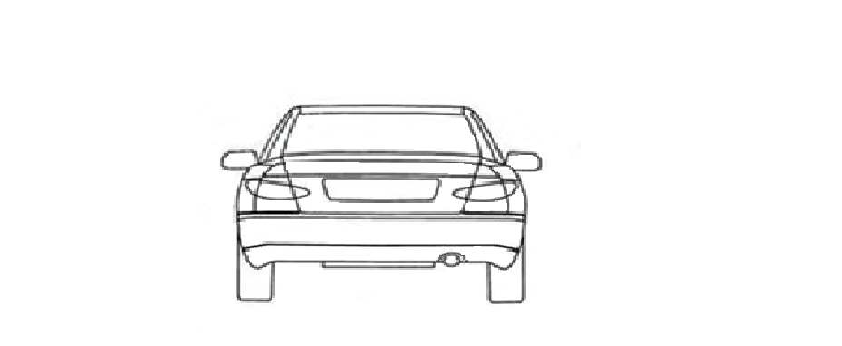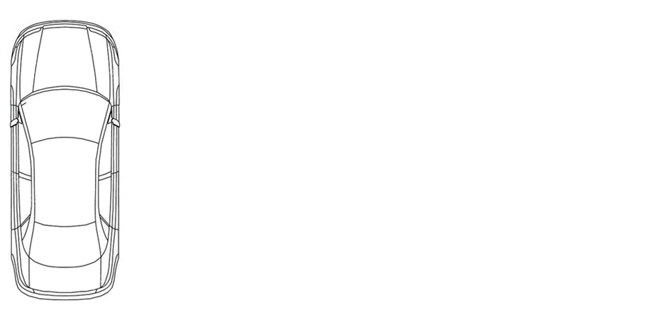

90° +/- 5°

90° +/- 5°

400N

400N

Z

Y

X

Y

"

1. \* In accordance with the programme of work of the Inland Transport Committee for 2018–2019 (ECE/TRANS/274, para. 123 and ECE/TRANS/2018/21/Add.1, Cluster 3.1), the World Forum will develop, harmonize and update UN regulations to enhance the performance of vehicles. The present document is submitted in conformity with that mandate. [↑](#footnote-ref-2)