|  |  |  |  |
| --- | --- | --- | --- |
|  | United Nations | ECE/TRANS/WP.11/2019/12 | |
| _unlogo | **Economic and Social Council** | | Distr.: General  24 July 2019  Original: English |

**Economic Commission for Europe**

Inland Transport Committee

**Working Party on the Transport of Perishable Foodstuffs**

**Seventy-fifth session**

Geneva, 8-11 October 2019

Item 5 (b) of the provisional agenda

**Proposals for amendments to ATP:  
new proposals**

Proposed amendment to Annex 1, Appendix 2, paragraph 6.5

Cool down test, measuring the outside temperature

Transmitted by the Government of Finland

Introduction

|  |
| --- |
|  |
| The text of the proposal itself in this document is almost identical to the text proposed in the document ECE/TRANS/WP.11/2018/15. Based on the comments received from the expert from the Russian Federation the positioning of the outside sensors is clarified. Some parts of the introduction are amended and informal document INF.12 of the seventy-fourth session with some modifications is included as an annex of this document. |
|  |

1. In service verification of the effectiveness of thermal appliances of equipment constructed from 2nd January 2012 is judged based on the table presented in Annex 1, Appendix 2, paragraph 6.2 (i). The table takes into account as well as possible the physical fact that the effectiveness of the mechanically operated refrigerating units decreases and the heat flow through the walls increase due to the rise of the environmental temperature.
2. According to paragraph 6.5 the outside temperature during the test is measured from at least two points and “The final reading shall be from the warmest point inside the body and the coldest point outside.”
3. However, it is not clear what “final reading… coldest point outside” means in this context. Obviously, it is the figure which determines the allowed cool down time read from the table of paragraph 6.2 (i):
4. Does it mean the coldest reading outside when the inside temperature has reached class temperature (e.g -20 °C)?

or

1. Does it mean the coldest reading outside during the whole cool down test?

or

1. Instead, could it mean the average outside temperature of the whole cool down test?
2. During the cool down test the difference between cases a) and b) could be several degrees of C. E.g. in class FRC each °C represents 10 minutes in allowed cool down time. Will the equipment fail or pass the test may depend how the “final reading” is interpreted. The case c) is often between cases a) and b) but the present text of ATP forces to select case a) or b) and not allowing the average. However instead of peak temperature readings the average temperature does much better represent the ambient temperature conditions during the test.
3. Optimum situation is that the ambient temperature stays unchanged, but that is possible only in temperature-controlled test chambers. Also if test is done outdoors the climatic variations during the test might be several degrees.
4. In Finland and probably in several other countries at least during cold time of the year, cool down tests are made indoors where ambient temperature +15 °C or above is possible. Test environments are however not climatic chambers and during the cool down test the outside temperature tends to rise because of the heat load from the refrigerating unit. Depending on the construction of the test site, the rise could be almost 10 °C and virtually in all cases at least some degrees.
5. In addition, the placements of the outside temperature measuring points need to be defined clearly. In the present text, only the minimum distances from the body wall and condenser inlet are defined. If the maximum distances are not defined, it is possible to place the sensors far from the tested equipment so that the readings do not represent the real temperature changes and conditions affecting the equipment.
6. The purpose of the proposal is to make cool down tests and test sites more comparable and fairer to the operators.
7. The proposal has no effect to those cool down tests which are done in stable ambient conditions. The proposed method to measure and report ambient temperature is also applicable to equipment constructed before 2 January 2012, keeping in mind that the maximum cool down time requirement for those is always 6 hours.
8. There is no need for transitional period and no need to amend test report models.

Costs

1. No additional costs are expected. Clear procedure reduces disputes and on the long run reduces also the costs.

Environmental impact

1. No environmental impact.

Text of the proposal

1. It is proposed to amend Annex 1 Appendix 2 paragraph 6.5 last two sentences:

“For measuring the outside temperature of the body (Te), at least 2 temperature measuring points shall be placed at a distance of at least 10 cm from an outer wall of the body and at least 20 cm from the air inlet of the condenser unit.

The final reading shall be from the warmest point inside the body and the coldest point outside.”

To read:

“For measuring the outside temperature of the body (Te), at least 2 temperature measuring points shall be placed at a distance of at least 10 cm **and a maximum of 20 cm** from an outer wall of the body **at a height of 1.5 - 2 m above the ground** and at least 20 cm **and a maximum of 50 cm** from the air inlet of the condenser unit.

The final reading shall be from the warmest point inside the body and ~~the coldest point outside~~ from the outside body the arithmetical mean temperature of all readings from the measuring points over the cool down test from the start until the class temperature has reached.”

Annex 1: Explanatory document

Annex 1

Explanatory document

Proposed amendment to Annex 1, Appendix 2, Paragraph 6.5:

**Cool down test, measuring the outside temperature**

**Unstable outside conditions,** example data and figure:

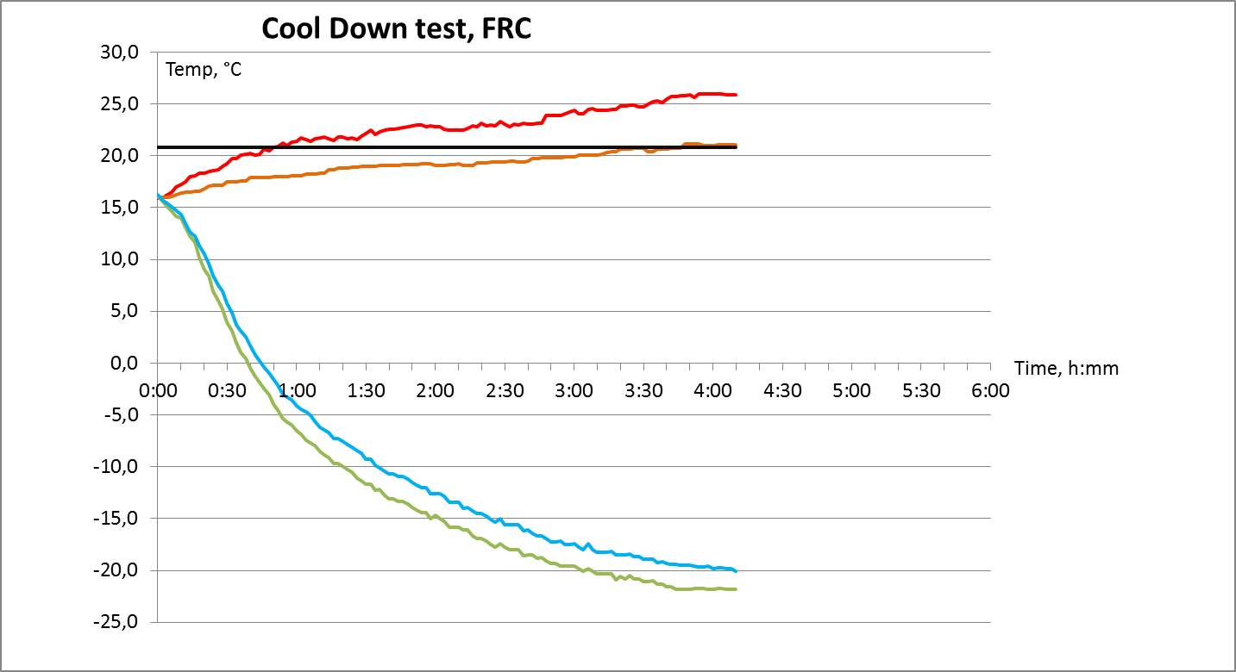

(b)

(a), (c)

Outer wall

Condenser air inlet

(b) 16.0 °C, "coldest point outside"

-20.0 °C, "warmest point inside" at 4:10 (250 min)

(c) Mean outside temperature 20.9 °C over the whole cool down until -20.0 °C inside has been reached

(a) 21.0°C, "coldest point outside" at 4:10 (250 min)

Inside front

Inside rear

Cool down time from the initial temperature 16.0 °C to the class temperature -20.0 °C is 4:10 (250 min)

Three different interpretations:

(a) "Coldest point outside" when class temperature has been reached, 21.0 °C 🡪 max cool down time 4:30 (270 min) 🡪 **PASS**

(b) "Coldest point outside" over the whole cool down, 16.0 °C 🡪 max cool down time to 3:40 (220 min) 🡪 **FAIL**

(c) Mean outside temperature over the whole cool down, 20.9 °C 🡪 max cool down time 4:30 (270 min) (note 20.9 is rounded to 21) 🡪 **PASS**

**Depending on the interpretation, the result could be PASS or FAIL. For example in class FRC each degree of C represents 10 minutes in allowed cool down time.**

**Stable outside conditions**, example data and figure:

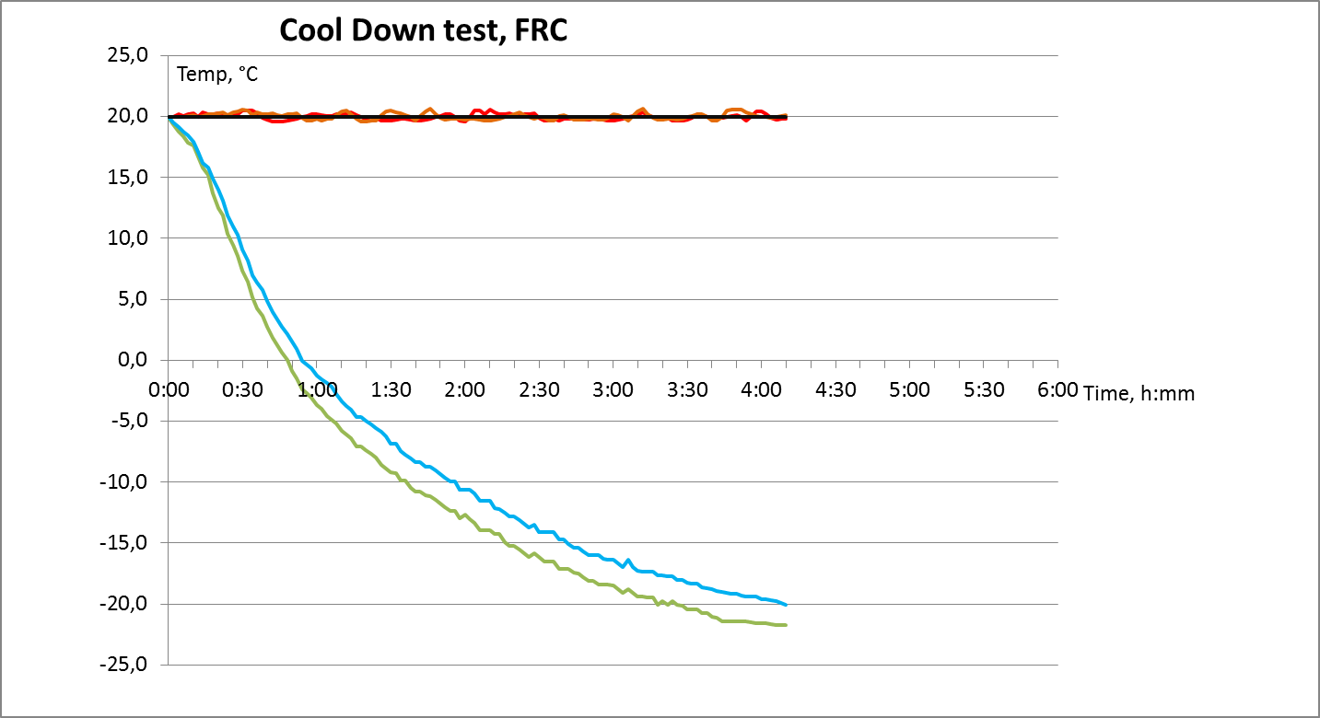

(a) 19.8 °C, "coldest point outside" at 4:10 (250 min)

(a), (b), (c)

(c) Mean outside temperature 20.0 °C over the whole cool down until -20.0 °C inside has been reached

(b) 19.6 °C, "coldest point outside"

Outer wall

Condenser air inlet

-20.0 °C, "warmest point inside" at 4:10 (250 min)

Inside front

Inside rear

Cool down time from the initial temperature 20.0 °C to the class temperature -20.0 °C is 4:10 (250 min)

Three different interpretations:

(a) "Coldest point outside" when class temperature has been reached, 19.8 °C 🡪 max cool down time 4:20 (260 min) (note 19.8 is rounded to 20) 🡪 **PASS**

(b) "Coldest point outside" over the whole cool down, 19.6 °C 🡪 max cool down time to 4:20 (260 min) (note 19.6 is rounded to 20) 🡪 **PASS**

(c) Mean outside temperature over the whole cool down, 20.0 °C 🡪 max cool down time 4:20 (260 min) 🡪 **PASS**

**No remarkable differences between interpretations if outside temperature remains stable.**

Annex 1, Appendix 2 § 6.2 (i). Equipment constructed from 2 January 2012. Maximum cool down time depending on the outside temperature:

|  |  |  |  |  |  |  |  |  |  |  |  |  |  |  |  |  |  |
| --- | --- | --- | --- | --- | --- | --- | --- | --- | --- | --- | --- | --- | --- | --- | --- | --- | --- |
| *Outside*  *temperature* | *30* | *29* | *28* | *27* | *26* | *25* | *24* | *23* | *22* | *21* | *20* | *19* | *18* | *17* | *16* | *15* | *°C* |
| Class C, F | 360 | 350 | 340 | 330 | 320 | 310 | 300 | 290 | 280 | 270 | 260 | 250 | 240 | 230 | 220 | 210 | min |
| Class B, E | 270 | 262 | 253 | 245 | 236 | 228 | 219 | 211 | 202 | 194 | 185 | 177 | 168 | 160 | 151 | 143 | min |
| Class A, D | 180 | 173 | 166 | 159 | 152 | 145 | 138 | 131 | 124 | 117 | 110 | 103 | 96 | 89 | 82 | 75 | min |