|  |  |  |  |
| --- | --- | --- | --- |
|  | United Nations | ST/SG/AC.10/C.3/2019/7 | |
| _unlogo | **Secretariat** | | Distr.: General  2 April 2019  Original: English |

**Committee of Experts on the Transport of Dangerous Goods  
and on the Globally Harmonized System of Classification  
and Labelling of Chemicals**

**Sub-Committee of Experts on the Transport of Dangerous Goods**

**Fifty-fifth session**

Geneva, 1-5 July 2019  
Item 2 (b) of the provisional agenda **Explosives and related matters:  
improvement of test series 8**

Temperature control of energetic samples

Transmitted by the European Chemical Industry Council (CEFIC)[[1]](#footnote-2)\*

Introduction

1. Samples of energetic substances such as self-reactive substances and organic peroxides may be transported under the provisions of 2.4.2.3.2.4 (b) and 2.5.3.2.5.1, respectively.

2. In both cases, one of the essential conditions is that “the available data indicate that the control temperature, if any, is sufficiently low to prevent any dangerous decomposition …”.

3. Temperature control requirements are derived from the self-accelerating decomposition temperature (SADT) (see 2.4.2.3.4 and 2.5.3.4 as well as the Manual of Tests and Criteria, section 28.2.3). In many cases (i.e. new substances) the SADT is not yet available for the transport of those samples. Therefore, the question arises how the provisions of 2.4.2.3.2.4 (b) (iii) and 2.5.3.2.5.1 (c) can be fulfilled under these circumstances.

4. CEFIC proposes a simple and safe method to solve the aforementioned problem based on differential scanning calorimetry (DSC) measurements as mentioned in the Manual of Test and Criteria, section 20.3.3.3.

Discussion

5. Generally, the decomposition energy and the onset of decomposition can be easily determined by DSC methods (see Manual of Tests and Criteria, section 20.3.3.3). This document describes how this information may be used as the basis for a preliminary assessment of the samples with respect to temperature requirements.

6. The so-called “100 K rule” is applied worldwide in chemical plants for safety assessments. Practical experience has shown that a margin of 100 K below the decomposition onset as determined by a screening DSC establishes a safe distance to avoid thermal runaway reactions.

7. According to 2.4.2.3.4 and 2.5.3.4, temperature control is not required if the substance is thermally stable, i.e. SADT ≥ 60 °C for self-reactive substances and SADT ≥ 55 °C for organic peroxides. For reasons of simplification, the more conservative value of 60 °C is henceforth applied for both types of substances.

8. By applying the “100 K rule” described above, sufficient thermal stability may be assumed if the decomposition onset in the screening DSC is 160 °C or above, thus not requiring temperature control.

9. For a conservative approach, the decomposition onset should be taken as the temperature of the first noticeable exothermic effect (i.e. the heat production signal leaves the baseline).

10. Since SADT tests H.1 to H.4 are not designed for small sample amounts, a thermal stress test is suggested as alternative method which can be easily performed by DSC measurements. Such an approach has been successfully applied in establishing temperature limits for the safe operation of chemical plants.

11. The concept is to determine whether the decomposition behavior changes upon the application of thermal stress during a defined period of time. For practical reasons, 24 hours are suggested.

12. A screening DSC (heating rate 2-5 K/min in a closed crucible; see Manual of Tests and Criteria, section 20.3.3.3) is measured of the sample as offered for transport. A second sample is taken, and thermal stress is applied. Practically, this is realized by tempering the sample in a DSC crucible at a defined constant temperature over a certain period of time; see above. Subsequently a DSC of the stressed sample is measured at the same heating rate as before.

13. If the decomposition behavior remains unchanged in terms of decomposition onset, shape of curve, and energy within a measurement uncertainty of 10%, then the sample is stable at the applied stress temperature. If the stress test is passed at 60 °C, no temperature control is required.

14. In case the stress test at 60 °C is not passed, the same procedure should be applied at decreasing temperatures in steps of 10 K until the decomposition behavior remains unchanged. That temperature should be deemed the estimated SADT of the sample, and the control and emergency temperatures may then be derived in accordance with section 28.2.3 and table 28.2 of the Manual of Tests and Criteria.

15. An example of a sample passing the thermal stress test as described above is given in figure 1. It is obvious that the shape, the location of the curve, as well as the energy values remain unchanged within the tolerance of measurement. Also, the endothermic melting peak has not changed. Hence, the sample is stable and does not require temperature control.



Figure 1: Example of a sample passing the thermal stress test

16. An example of a negative outcome of the thermal stress test is given in figure 2: Upon thermal stress, the shape of the curve has changed dramatically. The first peak at about 100 °C has completely disappeared, and the decomposition energy has decreased by about 20%. These findings are clear evidence that a reaction has taken place under the conditions of thermal stress applied, and thus temperature control would be necessary.

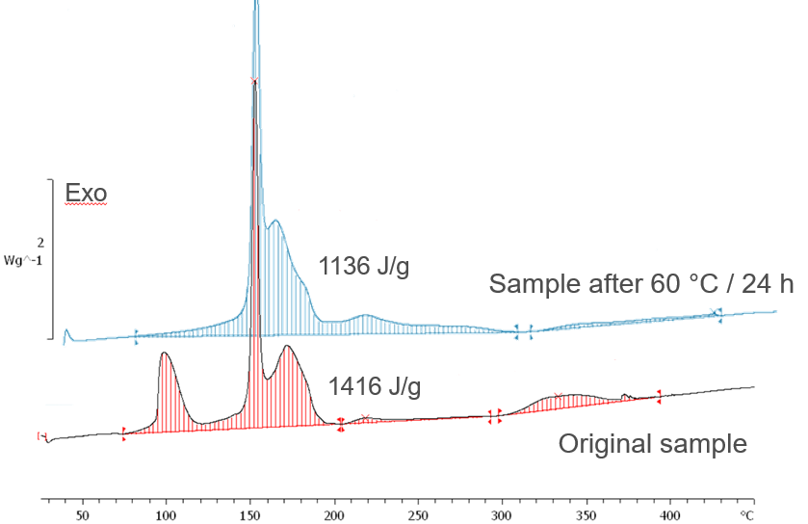

Figure 2: Example of a sample failing the thermal stress test

17. Of course, the question has to be asked whether this procedure is able to establish a safety level comparable to the SADT approach. To answer this question, a sample of a polymerizing mixture was tested using the H.4 (SADT) method, and the thermal stress test was applied for comparison. The compound was deliberately chosen to be of low energy (exotherm of 85 kJ/kg) in order to demonstrate the sensitivity of the method. For the SADT measurement, higher energies usually give more pronounced temperature rises when the thermal decomposition is triggered. The DSC method, however, has a forced temperature profile.

18. The SADT measurement is shown in figure 3. The sample is kept about 10 days at 60 °C, then 4 days at 70 °C. The diagram shows no detectable temperature rise at all.

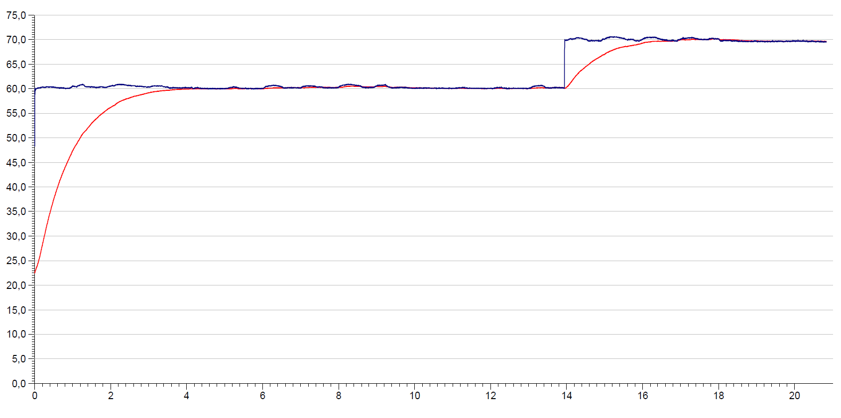

Time (days)

Temperature (°C)

Sample temperature

Oven temperature

Dewar heat loss rate: 36,5 mW/kg\*K

Sample weight: 405,5 g

Sample volume: 400 ml

Figure 3: SADT measurement of polymerizing sample

19. Figure 4 shows the results of the DSC stress test: In the original sample, an exotherm of 85 J/g is found whereas after 4 days at 70 °C (similar to the SADT) the DSC indicates a major deterioration of the product.

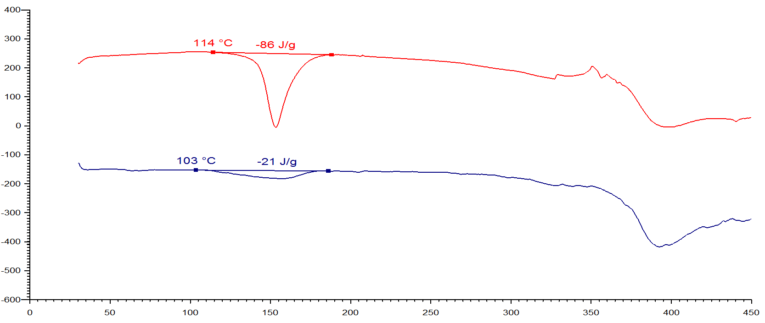

Temperature (°C)

Heat production rate (mW/g)

after thermal stress (4 d @ 70 °C)

original sample

DSC in glass crucible, heating rate 3 K/min

Figure 4: Result of thermal stress test

20. This comparison demonstrates nicely the capability of the stress test: The SADT method will only detect significant temperature rises in the vicinity of the thermal runaway reaction. This means that the heat production has to exceed a certain value before the SADT will show a response. In cases where the decomposition is slow and proceeds at low rates, the SADT has so to say a “blind spot”. Even more to the safe side, the SADT models the heat accumulation of a 50 kg package whereas samples are transported in much smaller receptacles. The DSC stress test, however, has an integral approach, and the difference in the energy values makes any kind of reaction – and that includes decompositions – evident.

21. This example demonstrates that the thermal stress test would not lower the level of safety compared to an SADT measurement.

22. The procedure is displayed in figure 5 below:

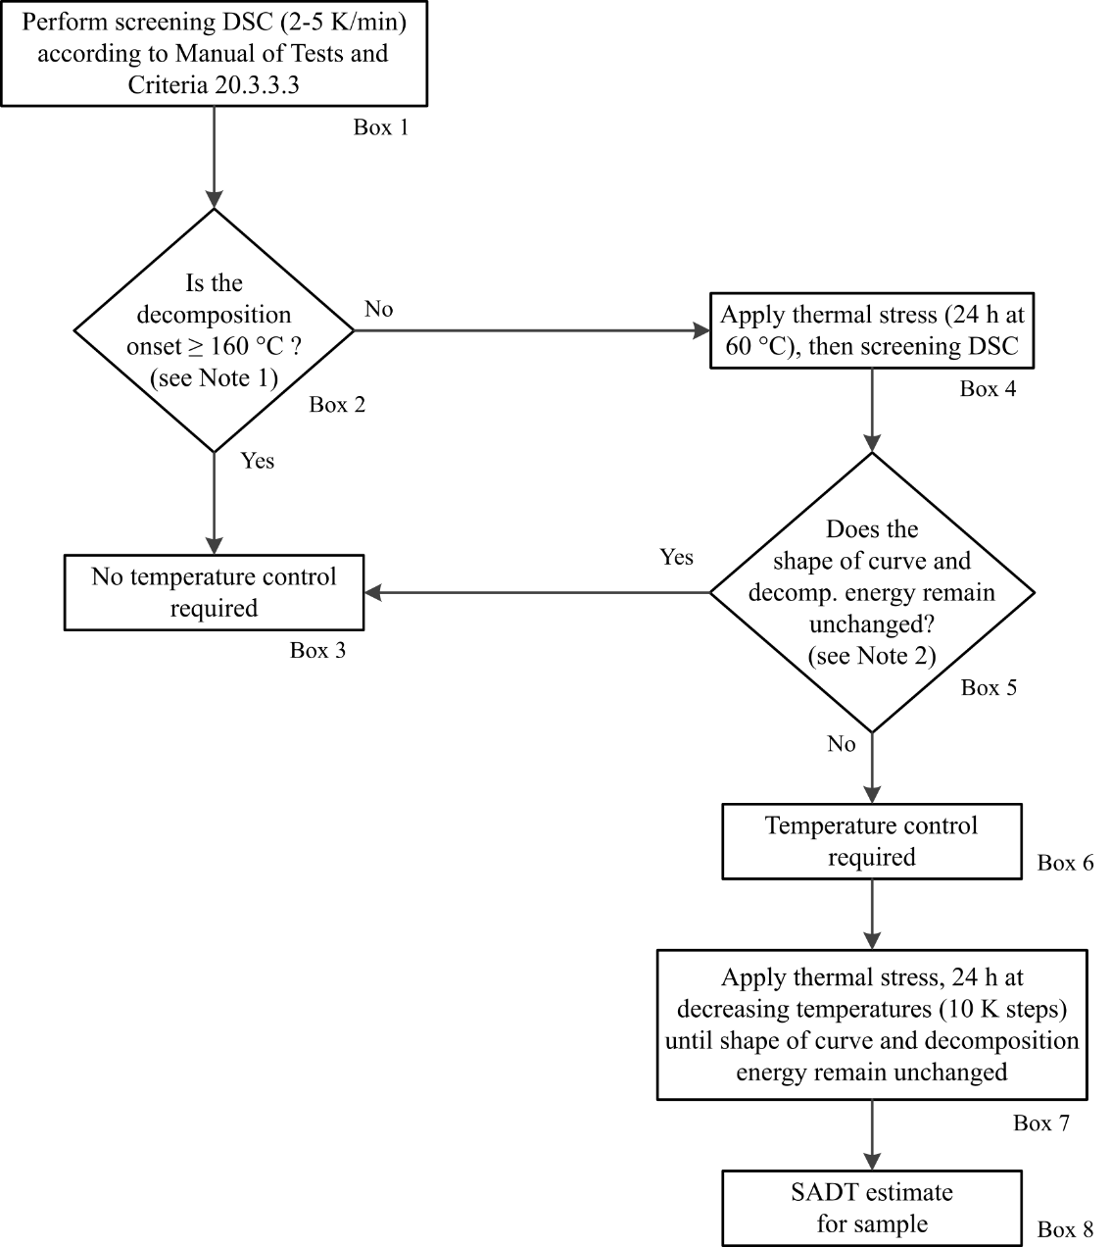

***Note 1:*** *Separate small exotherm (< 20 J/g) preceding the main decomposition may be neglected.*

***Note 2:*** *Within measurement uncertainty of 10%.*

Figure 5: Suggested flowchart for determination of temperature control requirements

Proposal

23. Insert for explanatory purposes “(DSC)” in the first sentence of section 20.3.3.3 in the Manual of Tests and Criteria to read:

“20.3.3.3 Thermal stability may be estimated using a suitable calorimetric technique such as differential scanning calorimetry (DSC) or adiabatic calorimetry.”

24. Modify the last sentence of the same section as follows:

“If differential scanning calorimetry is used, the extrapolated onset temperature is defined as ~~being the point of intersection of the tangent drawn at the point of greatest slope on the leading edge of the peak with the extrapolated baseline~~ the temperature of the first noticeable exothermic effect (i.e. the heat production signal leaves the baseline).

25. Insert a new section 20.3.4 in the Manual of Tests and Criteria to read:

“**20.3.4 Thermal stability of samples and temperature control assessment for transport**

20.3.4.1 The provisions in this section are only applicable to samples of sections 2.4.2.3.2.4 (b) and 2.5.3.2.5.1 in cases where the SADT is not known.

20.3.4.2 If the decomposition onset in a DSC measured in accordance with 20.3.3.3 is found at 160 °C or above, the estimated SADT of the sample may be assumed to be greater than 55 °C. According to 2.4.2.3.4 of the Model Regulations, temperature control is not required in such cases. Separate small exotherms less than 20 J/g preceding the main decomposition may be neglected.

20.3.4.3 For purposes of temperature control, a thermal stress test based on DSC measurements may be applied as follows: A DSC is measured as outlined in 20.3.3.3 for the sample as offered for transport. A second sample is taken, and thermal stress is applied by tempering the sample in the closed DSC crucible at a defined constant temperature over a certain period of time. In standard cases, a 24 hour stress time is deemed sufficient. Subsequently, a DSC is measured of the stressed sample at the same heating rate as before. If the decomposition behavior remains unchanged by comparison of the two DSCs in terms of decomposition onset, shape of curve, and energy within a measurement uncertainty of 10%, the sample is considered stable at the applied stress temperature. If the stress test is passed according to these criteria at 60 °C, no temperature control is required.

20.3.4.4 In case the stress test at 60 °C is not passed, the same procedure should be applied at decreasing temperatures in steps of 10 K until the decomposition behavior remains unchanged. That temperature should be deemed the estimated SADT of the sample, and the control and emergency temperatures may then be derived in accordance with section 28.2.3 and table 28.2 of the Manual of Tests and Criteria.

20.3.4.5 Examples for passing and failing the thermal stress test are shown in figures 20.3.4.5.1 (a) and 20.3.4.5.1 (b), respectively. A flow chart for the procedure is given in figure 20.2.”

26. Insert figure 1 of this proposal as figure 20.3.4.5.1(a) and figure 2 as figure  20.3.4.5.1 (b).

27. Insert figure 5 of this proposal as figure 20.2 at the end of section 20.3.3.4. The caption should read “Flow chart scheme for the assessment of thermal stability of samples according to 20.3.4”

28. Renumber figures 20.2 and 20.3 in subsequent chapters accordingly to figures 20.3 and 20.4.

Justification

29. This proposal constitutes a practical and easily applicable approach to determine thermal stability and possible temperature control requirements without compromising the level of safety. For this purpose, a new section in the Manual of Tests and Criteria suggested.

30. The proposed flow chart guides classifiers through the relevant steps. This is deemed helpful especially for organizations less familiar with dangerous goods regulations.

1. \* In accordance with the programme of work of the Sub-Committee for 2019-2020 approved by the Committee at its ninth session (see ST/SG/AC.10/C.3/108, paragraph 141 and ST/SG/AC.10/46, paragraph 14). [↑](#footnote-ref-2)