|  |  |  |  |
| --- | --- | --- | --- |
|  | United Nations | ST/SG/AC.10/C.3/2019/64 | |
| _unlogo | **Secretariat** | | Distr.: General  12 September 2019  Original: English |

**Committee of Experts on the Transport of Dangerous Goods  
and on the Globally Harmonized System of Classification  
and Labelling of Chemicals**

**Sub-Committee of Experts on the Transport of Dangerous Goods**

**Fifty-sixth session**

Geneva, 2-11 December 2019  
Item 2 (i) of the provisional agenda **Explosives and related matters: energetic samples**

Temperature control of energetic samples

Transmitted by the European Chemical Industry Council (CEFIC)[[1]](#footnote-2)\*

Introduction

1. Samples of energetic substances, such as self-reactive substances and organic peroxides, may be transported under the provisions of sections 2.4.2.3.2.4 (b) and 2.5.3.2.5.1, respectively.
2. In both cases, one of the essential conditions is that “the available data indicate that the control temperature, if any, is sufficiently low to prevent any dangerous decomposition”.
3. Temperature control requirements are derived from the self accelerating decomposition temperature (SADT) (see 2.4.2.3.4 and 2.5.3.4 as well as the Manual of Tests and Criteria, section 28.2.3). In many cases (i.e. new substances) the SADT is not yet available for the transport of those samples. Therefore, the question arises how the provisions of 2.4.2.3.2.4 (b) (iii) and 2.5.3.2.5.1 (c) can be fulfilled under these circumstances.
4. For the July 2019 session, CEFIC had proposed a simple and safe method to solve the aforementioned problem based on differential scanning calorimetry (DSC) measurements as described in the Manual of Test and Criteria, section 20.3.3.3. During the discussions in the Explosives Working Group, the suggested solution was supported in principle. Before endorsing the proposal, the Working Group asked CEFIC to provide further supporting data and examples. Therefore, CEFIC resubmits the proposal along with additional data as requested.

Discussion

Determination of decomposition onset

1. Generally, the decomposition energy and the onset of decomposition can be easily determined by DSC methods (see Manual of Tests and Criteria, section 20.3.3.3). This document describes how such information may be used as the basis for a preliminary assessment of the samples with respect to temperature requirements.
2. The so-called “100 K rule” is applied worldwide in chemical plants for safety assessments. Practical experience has shown that a margin of 100 K below the decomposition onset as determined by a screening DSC establishes a safe distance to avoid thermal runaway reactions.
3. According to 2.4.2.3.4 and 2.5.3.4, temperature control is not required if the substance is thermally stable, i.e. SADT ≥ 60 °C for self-reactive substances and SADT ≥ 55 °C for organic peroxides. For reasons of simplification, the more conservative value of 60 °C is henceforth applied for both types of substances.
4. By applying the “100 K rule” described above, sufficient thermal stability may be assumed if the decomposition onset in the screening DSC is 160 °C or above, thus not requiring temperature control.
5. In this context, the determination of the decomposition onset needs closer consideration. The current provisions in 20.3.3.3 of the Manual of tests and Criteria prescribe that the onset is determined by extrapolation of the tangent at the greatest slope on the leading edge of the peak (see figure I where such onset would result in about 111 °C). This approach is commonly used for the determination of melting points, which generally feature simple DSC-diagrams with a single, symmetrical peak; however, for decomposition reactions, which often show asymmetrical peaks with multiple local maxima and minima (e.g. figure I below), this method is not appropriate.

Figure I: Determination of decomposition onset



Tangent to  
greatest slope

Onset acc. to MTC, 20.3.3.3

Onset at start of  
decomposition

1. Therefore, it is suggested to redefine the decomposition onset as the temperature of the first noticeable exothermic effect (i.e. the heat production signal leaves the baseline) in agreement with common industry practice in safety assessments of plant operations. As the example in figure I demonstrates, this temperature is much lower (about 67 °C in this case) and thus more conservative.

Thermal stress test

1. Since SADT tests H.1 to H.4 are not designed for small sample amounts, a thermal stress test is suggested as alternative method which can be easily performed by DSC measurements. Such an approach has been successfully applied in establishing temperature limits for the safe operation of chemical plants.
2. The concept is to determine whether the decomposition behavior changes upon the application of thermal stress during a defined period of time. For practical reasons, a period of 24 hours is suggested.
3. A screening DSC (heating rate 2-5 K/min in a closed crucible; see Manual of Tests and Criteria, section 20.3.3.3) is measured of the sample as offered for transport. A second sample is taken, and thermal stress is applied. Practically, this is realized by tempering the sample in a DSC crucible at a defined constant temperature over a certain period of time (e.g. the above proposed 24 h). Subsequently, the stressed sample is cooled to room temperature before being subjected to a standard DSC measurement at the same heating rate as before.
4. If the decomposition behavior remains unchanged in terms of decomposition onset, shape of curve, and energy within a measurement uncertainty of 10%, then the sample is stable at the applied stress temperature. If the stress test is passed at 60 °C, then no temperature control is required.
5. In case the stress test at 60 °C is not passed, the same procedure should be applied at decreasing temperatures in steps of 10 K until the decomposition behavior remains unchanged. That temperature should be deemed the estimated SADT of the sample, and the control and emergency temperatures may then be derived in accordance with section 28.2.3 and table 28.2 of the Manual of Tests and Criteria.
6. Several examples of samples passing the thermal stress test as described above are given in annex I, figures VIII to XII. It is obvious that the shape, the location of the curve, as well as the energy values remain unchanged within the tolerance of measurement. Also, the endothermic (melting) peaks have not changed. Hence, the samples are stable and do not require temperature control.
7. In some cases the shape of the curve remains nearly unchanged but the peaks give different integrations for the original and tempered sample such as 83 J/g versus 66 J/g in example 3 and 88 J/g versus 138 J/g in example 5. These discrepancies are caused by a higher error due to integration of small signals over an extended temperature range. Thus, flat peaks need a higher tolerance. From practical experience, a tolerance of 25 % in the temperature range up to 250 °C and 40 % above 250 °C is suggested. It is to be noted that for reasons of chemical reaction kinetics, the decomposition behavior in the latter temperature range is generally not relevant for temperature control anyway.
8. Examples of a negative outcome of the thermal stress test are given in annex B: Upon thermal stress, the shape of the curve in figure XIII (example 6) has changed dramatically. The first peak at about 100 °C has completely disappeared, and the decomposition energy has decreased by about 20%. These findings are clear evidence that a reaction has taken place during the thermal stress, and thus temperature control would be necessary. From this finding, further tests would be initiated at lower temperatures in steps of 10 K until the criteria above would be satisfied.
9. The second example in annex II demonstrates the importance of the peak shape: At a first glance, the original peak and the peak of the stressed sample appear alike, and the tolerance criterion of 10 % is fulfilled (1532 J/g in original, 1438 J/g after 60 °C/24 h). However, as the graphical overlay reveals, the left shoulder of the original peak is missing upon thermal stress. The energy difference is not very large meaning that only moderate heats of reaction are to be expected, yet for safety reasons a lower control temperature needs to be chosen. Indeed, further tests have shown that at 40 °C the sample remains essentially intact (not reproduced in this paper).

Comparison with SADT measurements

1. Of course, the question has to be asked whether the proposed procedure is able to establish a safety level comparable to the SADT approach. To answer this question, a sample of a polymerizing mixture was tested using the H.4 (SADT) method, and the thermal stress test was applied for comparison. The compound was deliberately chosen to be of low energy (exotherm of 86 J/g) in order to demonstrate the sensitivity of the method.
2. For the SADT measurement, higher energies usually give more pronounced temperature rises when the thermal decomposition is triggered. (Note that strictly speaking the wording SAPT would be correct in this context but this difference is not relevant to the current discussion as the test method is the same as for the SADT).
3. The SADT measurement is shown in figure II. The sample is kept about 10 days at 60 °C, then 4 days at 70 °C. The diagram shows no detectable temperature rise at all:

Figure II: SADT measurement of polymerizing sample

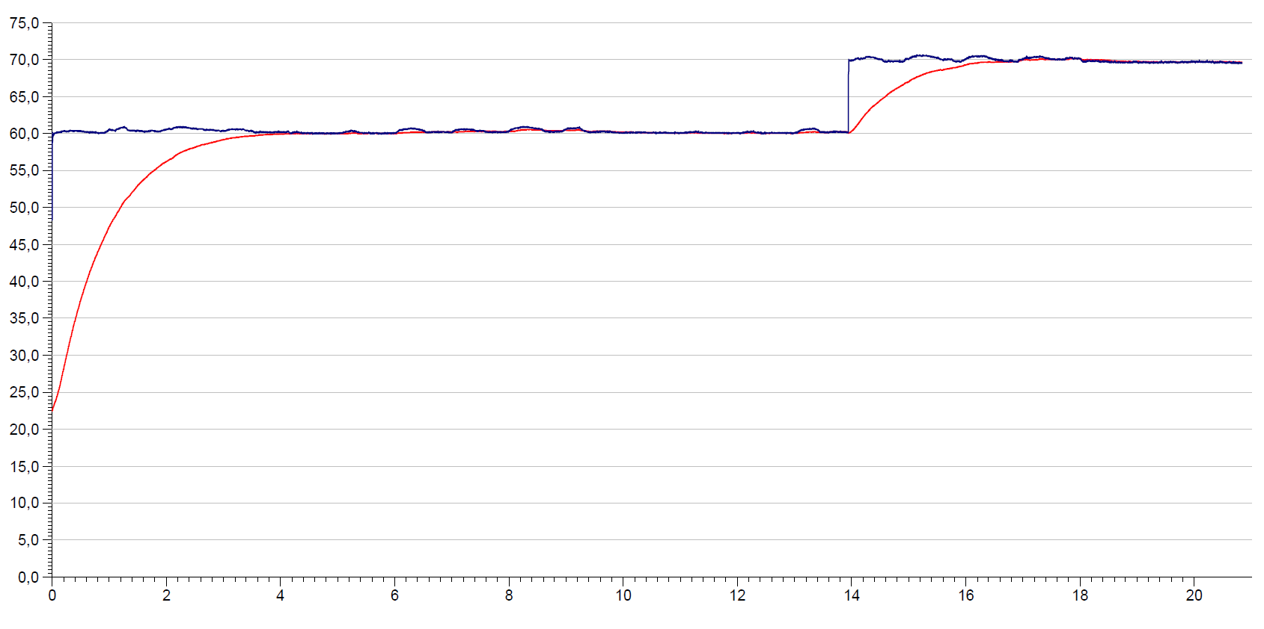

Time (days)

Dewar heat loss rate: 36,5 mW/kg\*K

Sample weight: 405,5 g

Sample volume: 400 ml

Oven temperature

Sample temperature

Temperature (°C)

Figure III: Result of thermal stress test of polymerizing sample

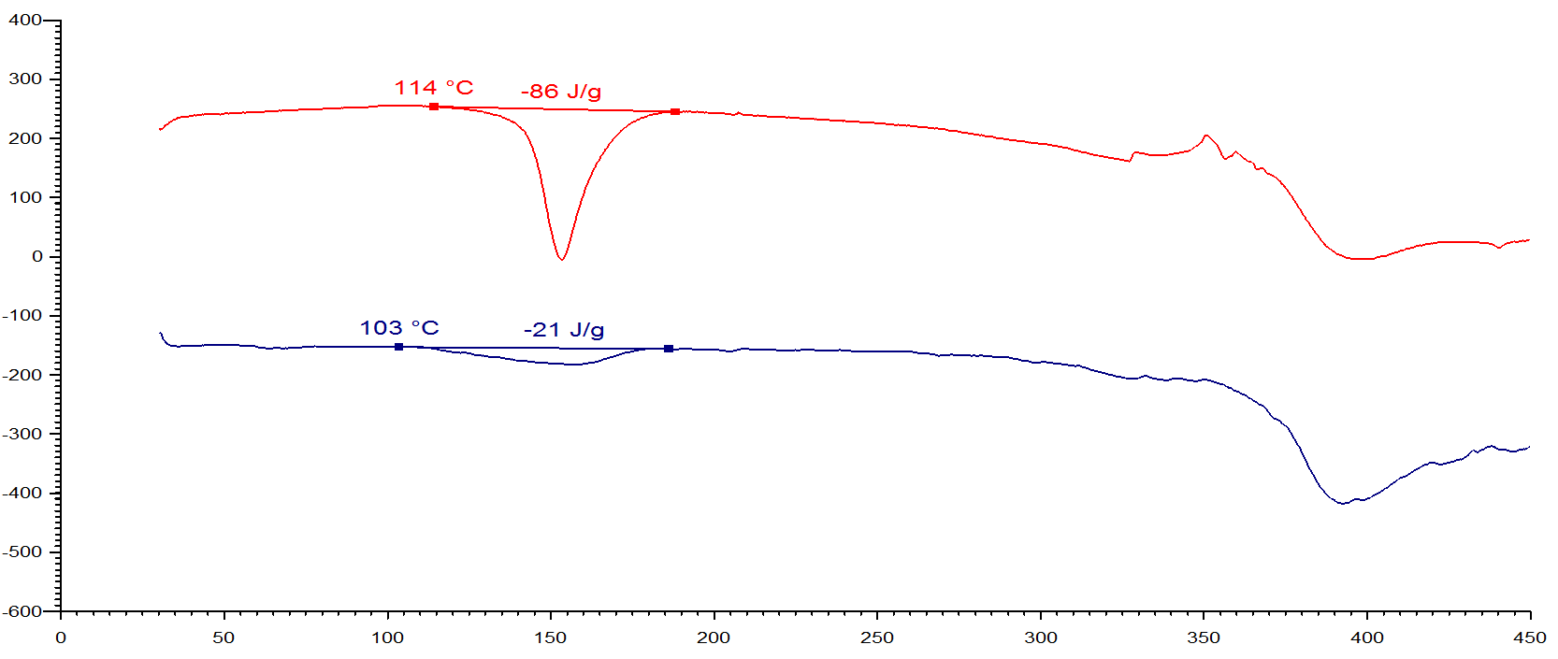

DSC in glass crucible, heating rate 3 K/min

Temperature (°C)

after thermal stress (4 d @ 70 °C)

original sample

Heat production rate (mW/g)

1. Figure III shows the results of the DSC stress test: In the original sample, an exotherm of 86 J/g is found whereas after 4 days at 70 °C (similar to the SADT) the DSC indicates a major deterioration of the product.
2. Another example is given in figures IV and V: The diagrams show the SADT measurements of an organic peroxide at 81 °C and 86 °C. At the lower temperature, only a slight reaction is detected, and at 86 °C the exothermic runaway reaction is observed. According to the criteria of the H.4 test method, an SADT of 85 °C is derived.

Figure IV: SADT test (UN H.4) of dicumyl peroxide at 81 °C

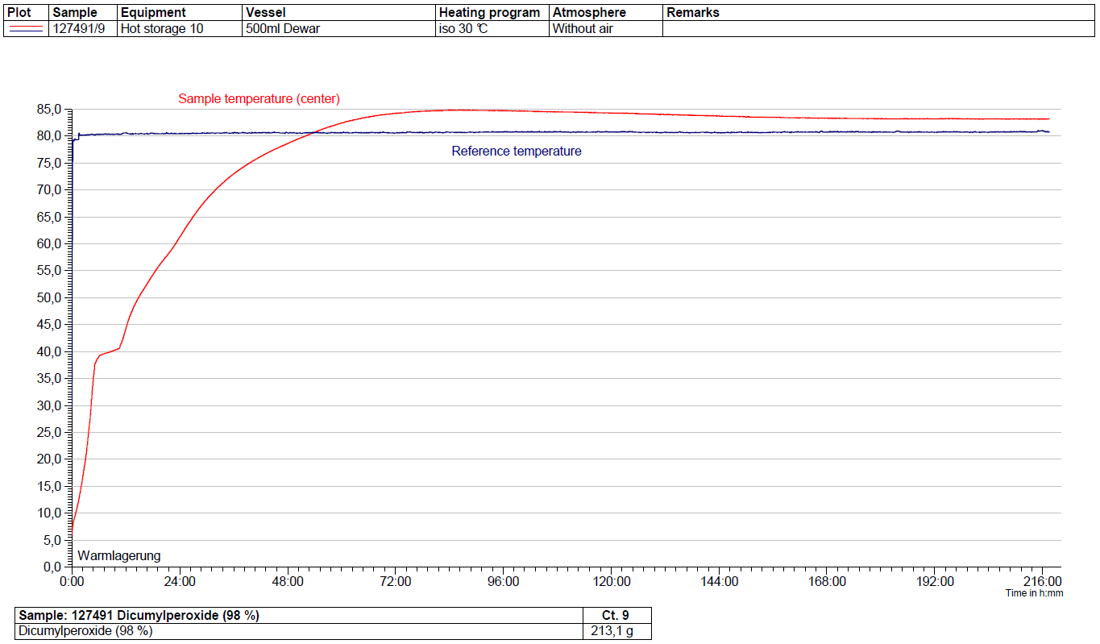

Dewar heat loss rate: 36,0 mW/kg\*K

Sample weight: 213,1 g

Sample volume: 400 ml

Figure V: SADT test (H.4) of dicumyl peroxide at 86 °C

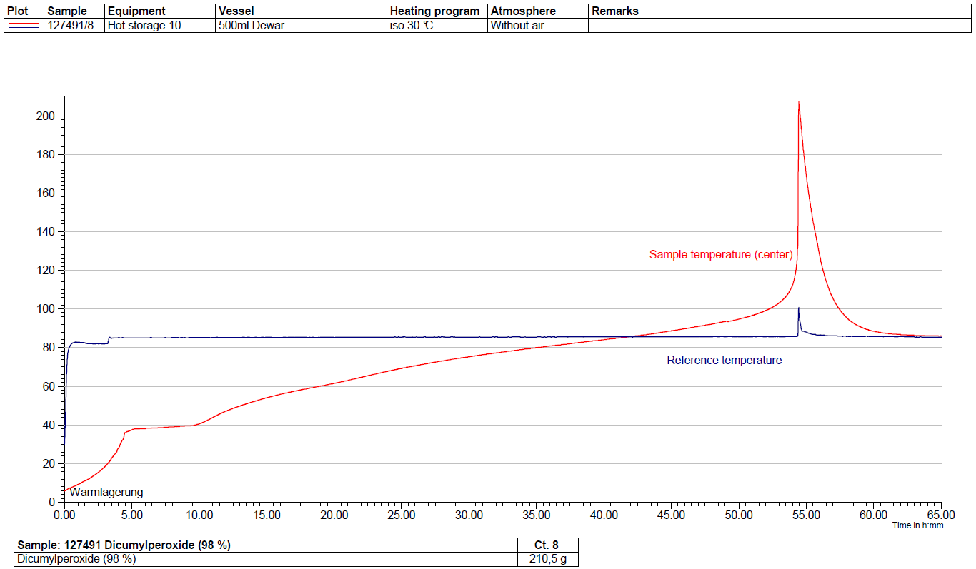

Dewar heat loss rate: 36,9 mW/kg\*K

Sample weight: 209,2 g

Sample volume: 400 ml

1. The results of the thermal stress tests are shown in figure VI. The deterioration of the product as a function of temperature is evident from the decreasing decomposition potential upon exertion of thermal stress. The corresponding degree of deterioration increases from about 5 % at 75 °C through 7 % at 85 °C to 9 % at 90 °C.

Figure VI: Stress test of dicumyl peroxide at different temperatures

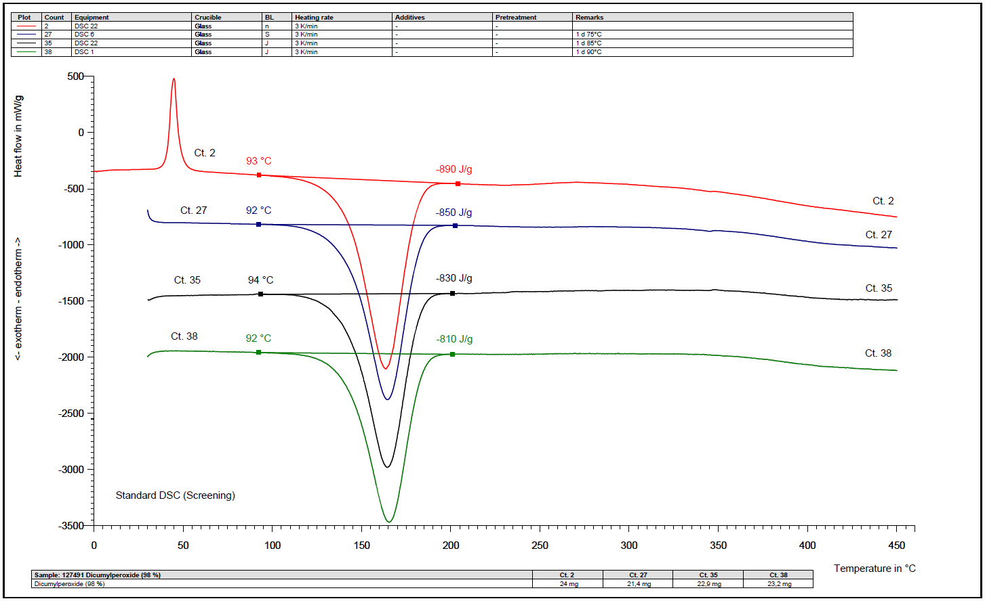

1 d @ 75 °C

Original sample

1 d @ 90°C

1 d @ 85°C

1. This comparison demonstrates the capability of the stress test: The SADT method will only detect significant temperature rises resulting from a strongly exothermic reaction (e.g. a thermal runaway reaction). The heat production has to exceed a certain value before the SADT will show a response. Decompositions with low rates of heat production would generally not be detected, and in these cases the SADT test could have a “blind spot”. On the other hand, the Dewar vessels used to measure the SADT in the above examples model the heat accumulation in a 200 kg package, whereas the smaller samples that would be affected by this amendment would be transported in much smaller receptacles. Since the rate of heat loss is generally higher for smaller packages than for larger packages, the SADT of such small packages are generally about 5 to 10 K above that of a “standard” 50 kg package.
2. The DSC stress test, however, has an integral approach, and the difference in the energy values makes any kind of reaction – and that includes decompositions – evident.
3. The data given prove that the thermal stress test will identify the SADT in a 50 kg package to a precision of roughly 5 K. Considering the much higher heat loss from the smaller packages used for the transport of samples compared to the standard 50 kg package, the suggested approach will not lower the level of safety compared to an SADT measurement.
4. The suggested procedure is displayed in figure VII below:

Figure VII: Suggested flowchart for determination of temperature control requirements

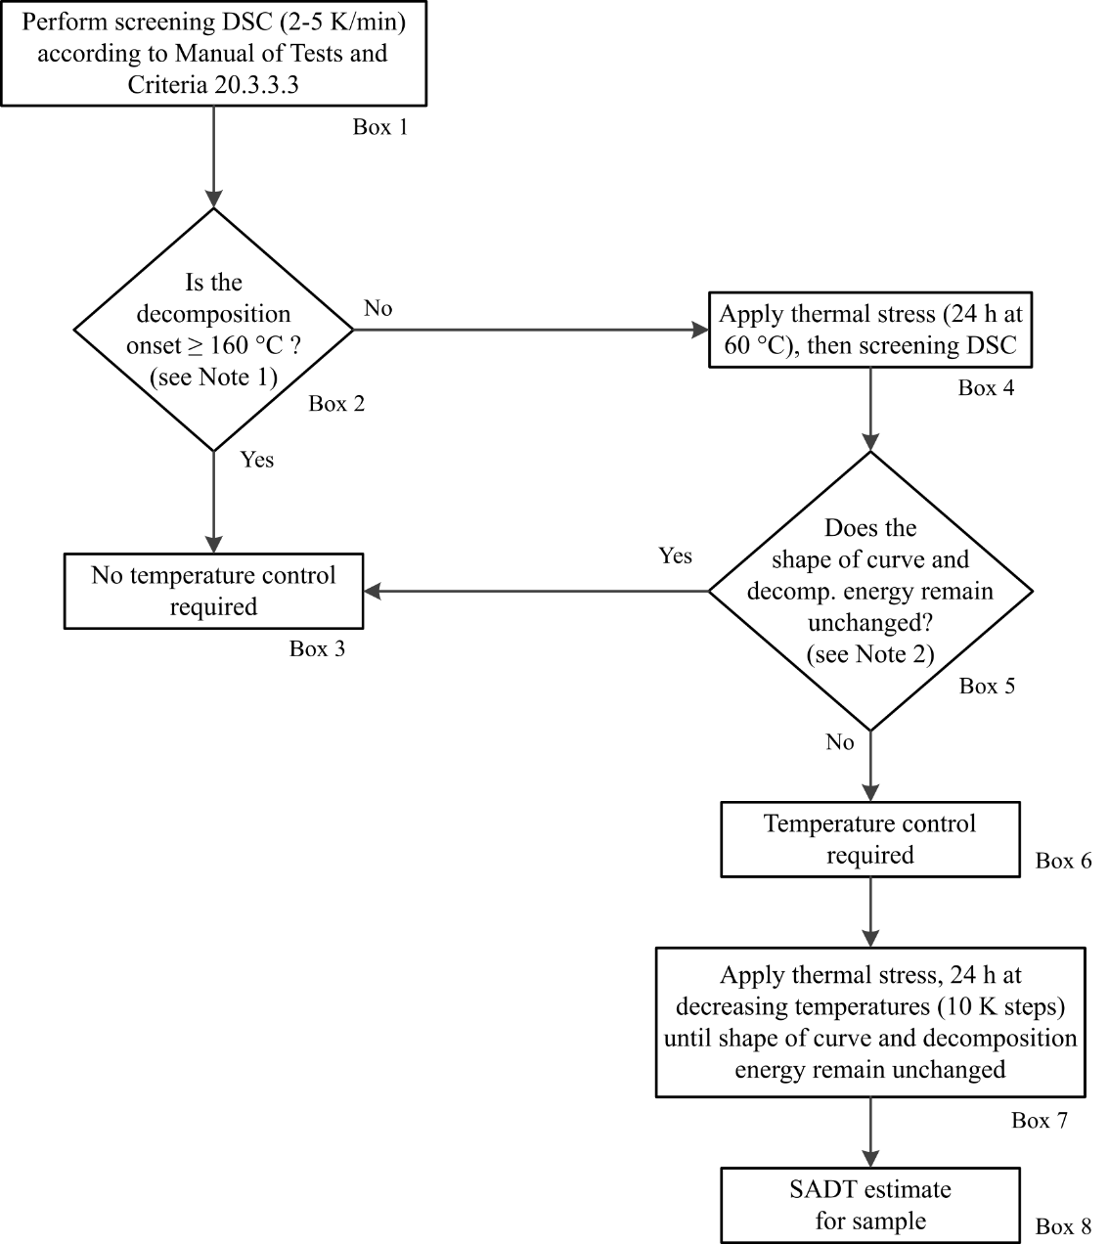

***Note 1:***  *Isolated small exotherm (< 20 J/g) preceding the main decomposition may be neglected;****Note 2:*** *General tolerance for energy comparison due to measurement uncertainty: 10%. For flat peaks with a maximum heat production of 0.2 W/g a deviation of 25 % is tolerable in temperature ranges below 250 °C and 40 % above this limit.*

Proposal

1. Insert for explanatory purposes “(DSC)” in the first sentence of section 20.3.3.3 in the Manual of Tests and Criteria to read:

“20.3.3.3 Thermal stability may be estimated using a suitable calorimetric technique such as differential scanning calorimetry (DSC) or adiabatic calorimetry.”

1. Modify the last sentence of the same section to read:

“If differential scanning calorimetry is used, the extrapolated onset temperature is defined as ~~being the point of intersection of the tangent drawn at the point of greatest slope on the leading edge of the peak with the extrapolated baseline~~ the temperature of the first noticeable exothermic effect (i.e. the heat production signal leaves the baseline).

1. Insert a new section 20.3.4 in the Manual of Tests and Criteria to read:

“**20.3.4 Thermal stability of samples and temperature control assessment for transport**

20.3.4.1 The provisions in this section are only applicable to samples of sections 2.4.2.3.2.4 (b) and 2.5.3.2.5.1 in cases where the SADT is not known.

20.3.4.2 If the decomposition onset in a DSC measured in accordance with 20.3.3.3 is found at 160 °C or above, the estimated SADT of the sample may be assumed to be greater than 55 °C. According to 2.4.2.3.4 of the Model Regulations, temperature control is not required in such cases. Isolated small exotherms less than 20 J/g preceding the main decomposition may be neglected.

20.3.4.3 For purposes of determining the need for temperature control, a thermal stress test based on DSC measurements may be applied as follows: A DSC is measured as outlined in 20.3.3.3 for the sample as offered for transport. A second sample is taken, and thermal stress is applied by tempering the sample in the closed DSC crucible at a defined constant temperature over a certain period of time. In standard cases, a 24 hour stress time is deemed sufficient. The stressed sample is then cooled to room temperature before being subjected to a DSC measurement at the same heating rate as before. If the decomposition behavior remains unchanged by comparison of the two DSCs in terms of decomposition onset, shape of curve, and energy within a measurement uncertainty of 10 %, the sample is considered stable at the applied stress temperature. For flat peaks with a maximum heat production of 0.2 W/g a deviation of 25 % is tolerable in temperature ranges below 250 °C and 40 % above this limit. If the stress test is passed according to these criteria at 60 °C, then no temperature control is required.

20.3.4.4 If the sample fails the stress test at 60 °C, then the same procedure should be applied at decreasing temperatures in steps of 10 K until the decomposition behavior remains unchanged. That temperature should be deemed the estimated SADT of the sample, and the control and emergency temperatures may then be derived in accordance with section 28.2.3 and table 28.2 of the Manual of Tests and Criteria.

20.3.4.5 Examples for passing the thermal stress test are shown in figures 20.3.4.1 (a) and (b). Figure 20.3.4.2 contains examples of samples failing the stress test. A flow chart for the procedure is given in figure 20.2.”

1. Insert combined figures VIII to X in annex I of this proposal as figure 20.3.4.1(a), combined figures XI and XII as figure 20.3.4.1 (b) and combined figures XIII and XIV in annex II of this proposal as figure 20.3.4.2.
2. Insert figure VII of this proposal as figure 20.2 at the end of section 20.3.4. The caption should read “Flow chart scheme for the assessment of thermal stability of samples according to 20.3.4”
3. Renumber figures 20.2 and 20.3 in subsequent chapters accordingly to figures 20.3 and 20.4.

Justification

1. This proposal constitutes a practical and easily applicable approach to determine thermal stability and possible temperature control requirements without compromising the level of safety. For this purpose, a new section in the Manual of Tests and Criteria is suggested.
2. The proposed flow chart guides classifiers through the relevant steps and should be helpful for organizations less familiar with dangerous goods regulations.

Annex I

Examples of samples passing the thermal stress test

Figure VIII: Example 1

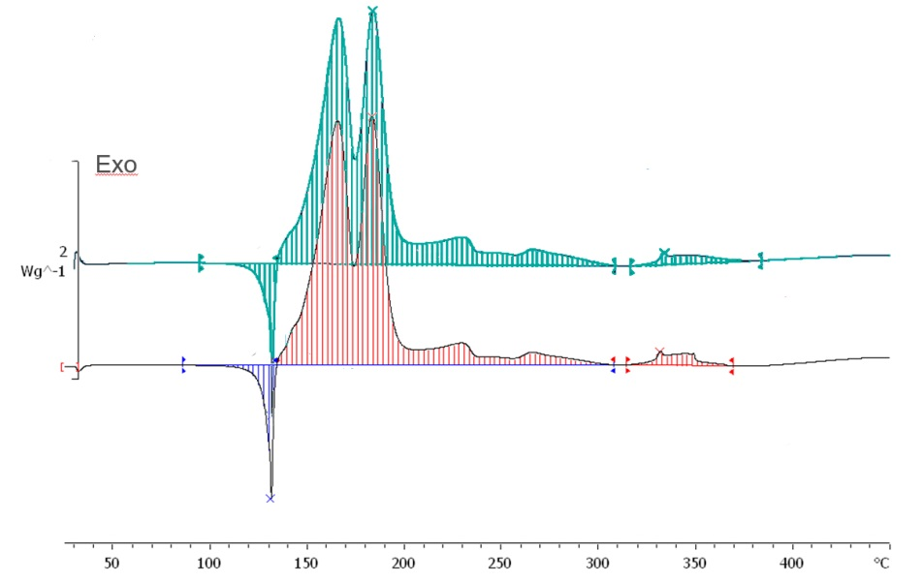

1813 J/g

1703 J/g

95 J/g

106 J/g

Original sample

Sample after thermal stress (60 °C / 24 h)

Figure IX: Example 2

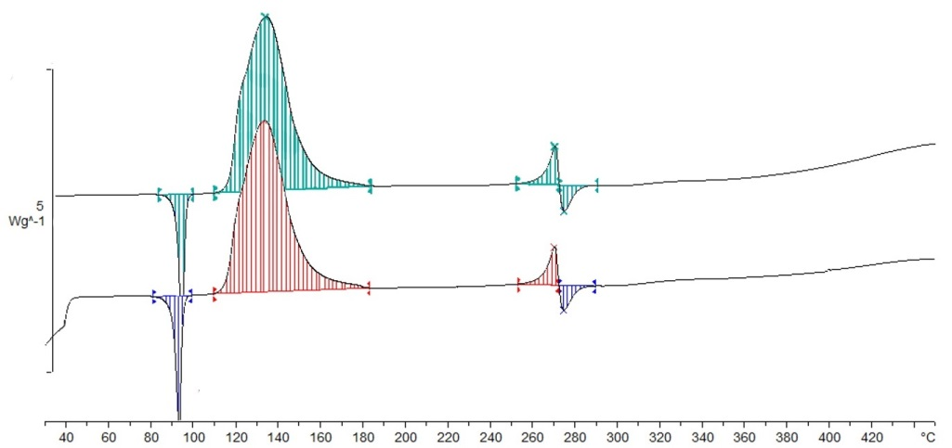

Exo

1414 J/g

1449 J/g

150 J/g

165 J/g

71 J/g

51 J/g

73 J/g

53 J/g

Original sample

Sample after thermal stress (60 °C / 24 h)

Figure X: Example 3

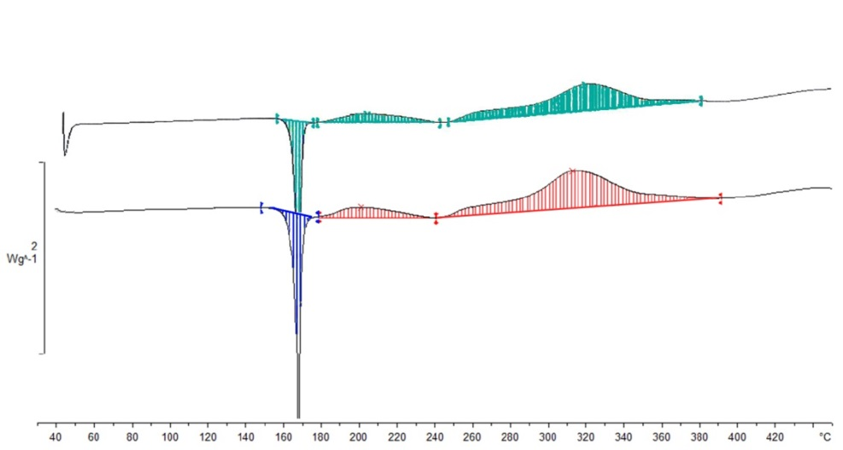

Exo

83 J/g

416 J/g

66 J/g

166 J/g

383 J/g

164 J/g

Original sample

Sample after thermal stress (75 °C / 24 h)

Figure XI: Example 4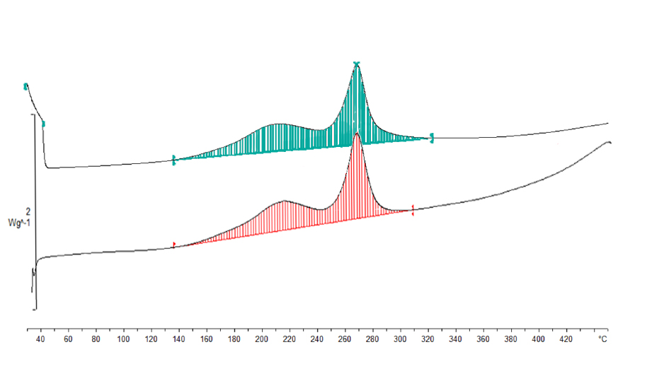

Exo

731 J/g

690 J/g

Original sample

Sample after thermal stress (65 °C / 24 h)

**Figure XII: Example 5**

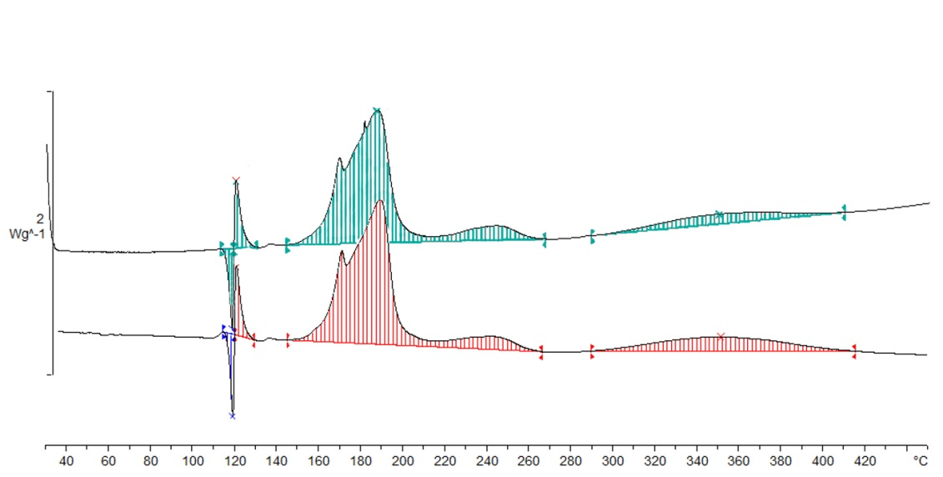

88 J/g

539 J/g

25 J/g

33 J/g

138 J/g

545 J/g

23 J/g

30 J/g

Original sample

Sample after thermal stress (65 °C / 24 h)

Exo

Annex II

Examples of samples failing the thermal stress test

Figure XIII: Example 6

**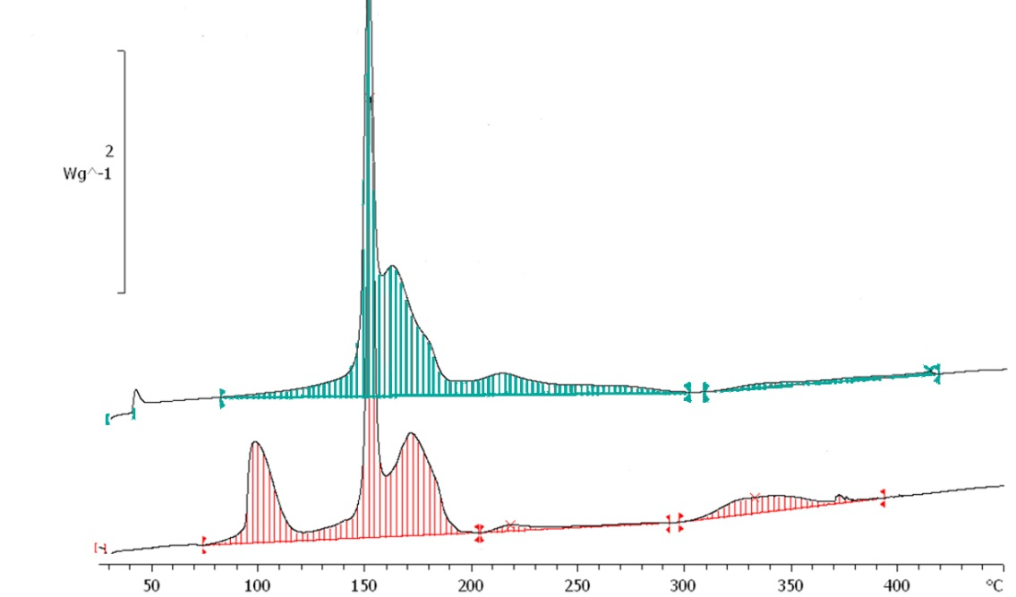**

Fail due to degradation (loss of energy > 10 %)

Fail due to different  
peak shape

Exo

1416 J/g

1136 J/g

Sample after 60 °C / 24 h

Original Sample

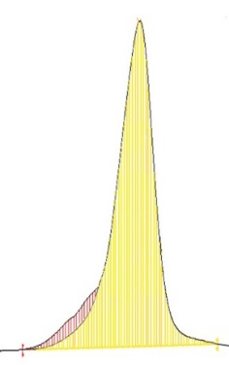Figure XIV: Example 7

Exo

1532 J/g

1438 J/g

Sample after  
60 °C / 24 h

Original Sample

Shoulder of peak missing after thermal stress

**Overlay of graphs**

Fail due to different  
peak shape in spite of tolerable energy loss

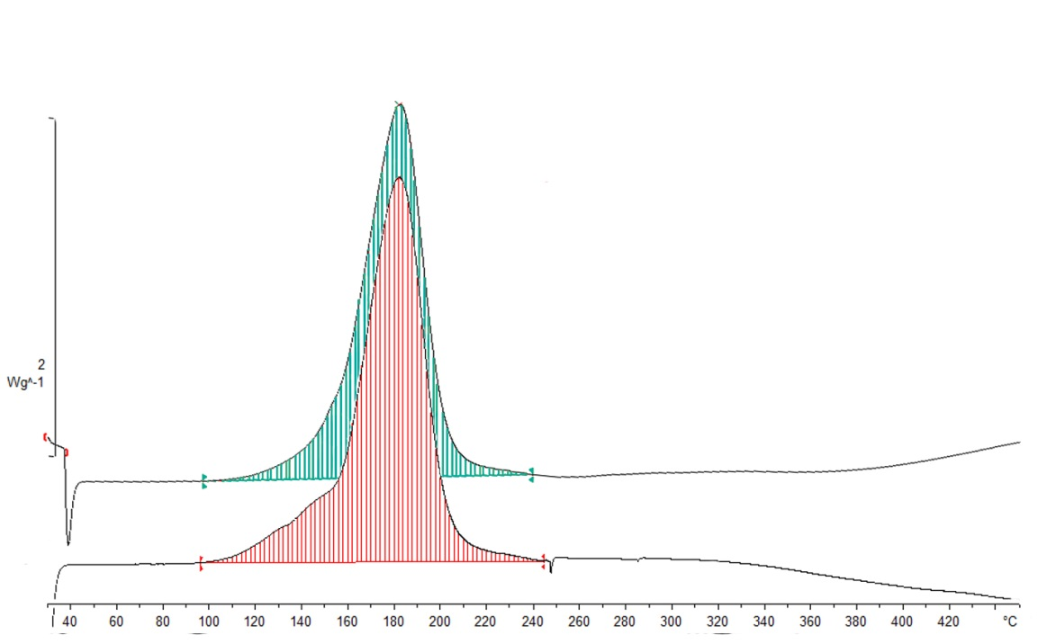

1. \* In accordance with the programme of work of the Sub-Committee for 2019-2020 approved by the Committee at its ninth session (see ST/SG/AC.10/C.3/108, paragraph 141 and ST/SG/AC.10/46, paragraph 14). [↑](#footnote-ref-2)