|  |  |  |  |
| --- | --- | --- | --- |
|  | United Nations | ST/SG/AC.10/46/Add.3 | |
| _unlogo | **Secretariat** | | Distr.: General  18 March 2019  English  Original: English and French |

**Committee of Experts on the Transport of Dangerous Goods  
and on the Globally Harmonized System of Classification  
and Labelling of Chemicals**

Report of the Committee of Experts on the Transport of Dangerous Goods and on the Globally Harmonized System of Classification and Labelling of Chemicals on its ninth session

held in Geneva on 7 December 2018

Addendum

Annex III

Amendments to the seventh revised edition of the Globally Harmonized System of Classification and Labelling of Chemicals (GHS) (ST/SG/AC.10/30/Rev.7)

Chapter 1.1

1.1.2.6.1 After the first sentence, insert the following two new sentences: “However, information on risk management is occasionally provided in the GHS on a case-by-case basis for guidance purposes. Competent authorities are best placed to determine in regulations or standards the appropriate risk assessment procedures and risk management measures.”.

Chapter 1.2

In the Note under the definition of “Oxidizing gas”, replace “ISO 10156:2010” by “ISO 10156:2017”.

Chapter 1.3

1.3.2.3.1 (b) Add the following new second sentence: “Bridging may also be applied when test data conclusively show that no classification is warranted;”.

Chapter 2.1

Figure 2.1.4 Amend to read as follows:

TEST SERIES 8

TEST 8 (a)

Thermal Stability Test

Is the substance/mixture

thermally stable?

TEST 8 (b)

ANE Large scale gap test

Is the substance/mixture  
too sensitive to shock to be accepted  
as an oxidizing liquid or an  
oxidizing solid?

TEST 8 (c)

Koenen test

Is the substance/mixture  
too sensitive to the effect of  
intensive heat under  
confinement?

Classify as unstable explosive

Substance/mixture to be  
considered for classification  
as an explosive other than   
as an unstable explosive;  
If the answer to the question  
“Is it a very insensitive explosive substance/mixture with a mass explosion hazard?” in figure 2.1.3 is “no”, the substance/mixture shall be classified in Division 1.1

Substance/mixture to be considered for classification as an explosive of Division 1.5, proceed with Test Series 5.  
If the answer to the question “Is it a very insensitive explosive substance/mixture with a mass explosion hazard?” in figure 2.1.3 is “yes”, the substance/mixture shall be classified in Division 1.5; if the answer is “no”, the substance/mixture shall be classified in Division 1.1

Did the Koenen  
Test reaction time exceed  
60 seconds, and does the  
substance/mixture have  
 > 14% water?

TEST 8 (e)

MBP Test  
Does the substance/mixture  
have a  
MBP <5.6 MPa?

ANE substance/mixture shall be classified as a Category 2 oxidizing liquid or a Category 2 oxidizing solid (Chapters 2.13 and 2.14)

Yes

Yes

Yes

Yes

Yes

No

No

No

No

No

Chapter 2.2

2.2.4.2.1, 2.2.4.2.4 and 2.2.5 Replace “ISO 10156:2010” by “ISO 10156:2017”.

Chapter 2.3

At the end of the heading of the chapter, insert “AND CHEMICALS UNDER PRESSURE”.

Add a new 2.3.0 to read as follows:

“**2.3.0 Introduction**

This chapter contains the definitions, classification criteria, hazard communication elements, decision logics and guidance for aerosols and chemicals under pressure. Although they present similar hazards, aerosols and chemicals under pressure are separate hazard classes and are covered in separate sections. While the hazards are similar and the classification is based on flammable properties and heat of combustion, they are presented in two different sections due to allowable pressure, capacity and construction of the two kinds of receptacles. A substance or mixture is classified as either an aerosol in accordance with 2.3.1 or a chemical under pressure in accordance with 2.3.2.”.

Add the following new section heading “2.3.1 Aerosols” and insert in this section the text of existing 2.3.1 to 2.3.4.1 as amended below:

2.3.1 Renumber as 2.3.1.1.

2.3.2 Renumber as 2.3.1.2.

2.3.2.1 Renumber as 2.3.1.2.1 and amend as follows:

Amend the first sentence to read:

“Aerosols are classified in one of the three categories of this hazard class, in accordance with Table 2.3.1, depending on:

– their flammable properties;

– their heat of combustion; and

– if applicable, test results from the ignition distance test, the enclosed space ignition test and the aerosol foam flammability test, performed in accordance with sub-sections 31.4, 31.5 and 31.6 of the *Manual of Tests and Criteria*.”.

Insert the following table before Note 1:

**“Table 2.3.1: Criteria for aerosols**

| **Category** | **Criteria** |
| --- | --- |
| **1** | (1)Any aerosol that contains ≥ 85% flammable components (by mass) and has a heat of combustion of ≥ 30 kJ/g;  (2) Any aerosol that dispenses a spray that, in the ignition distance test, has an ignition distance of ≥ 75 cm; or  (3) Any aerosol that dispenses a foam that, in the foam flammability test, has:  (a) a flame height of ≥ 20 cm and a flame duration of ≥ 2 s; or  (b) a flame height of ≥ 4 cm and a flame duration of ≥ 7 s. |
| **2** | (1) Any aerosol that dispenses a spray that, based on the results of the ignition distance test, does not meet the criteria for Category 1, and which has:  (a) a heat of combustion of ≥ 20 kJ/g;  (b) a heat of combustion of < 20 kJ/g along with an ignition distance of ≥ 15 cm; or  (c) a heat of combustion of < 20 kJ/g and an ignition distance of < 15 cm along with either, in the enclosed space ignition test:  - a time equivalent of ≤ 300 s/m3; or  - a deflagration density of ≤ 300 g/m3; or  (2) Any aerosol that dispenses a foam that, based on the results of the aerosol foam flammability test, does not meet the criteria for Category 1, and which has a flame height of ≥ 4 cm and a flame duration of ≥ 2 s. |
| **3** | (1) Any aerosol that contains ≤ 1% flammable components (by mass) and that has a heat of combustion < 20 kJ/g; or  (2) Any aerosol that contains > 1% (by mass) flammable components or which has a heat of combustion of ≥ 20 kJ/g but which, based on the results of the ignition distance test, the enclosed space ignition test or the aerosol foam flammability test, does not meet the criteria for Category 1 or Category 2. |

”.

After Note 1, transfer existing Note under current 2.3.2.2 as new Note 2. Renumber existing Note 2 as Note 3 and, in this Note, replace “chapters 2.2 (flammable gases)” by “chapter 2.2 (flammable gases), section 2.3.2 (chemicals under pressure), chapters”.

2.3.2.2 Delete.

2.3.3 Renumber as 2.3.1.3 and renumber current Table 2.3.1 as Table 2.3.2.

2.3.4 Renumber as 2.3.1.4. In the heading, delete “and guidance”. Amend the first sentence to read “The decision logic, which follows, has been provided here as additional guidance.”.

2.3.4.1 Renumber as 2.3.1.4.1. In the first sentence, delete “of the foam test (for foam aerosols) and” after “the results” and insert “and of the foam test (for foam aerosols)” at the end before “are required”. At the end of the first paragraph, replace “2.3 (a) to 2.3 (c)” by “2.3.1 (a) to 2.3.1 (c)”. Renumber decision logics 2.3 (a) to 2.3 (c) as 2.3.1 (a) to 2.3.1 (c) respectively and amend cross-reference between these decision logics accordingly.

Add the following new section:

“**2.3.2 Chemicals under pressure**

**2.3.2.1 *Definition***

*Chemicals under pressure* are liquids or solids (e.g., pastes or powders), pressurized with a gas at a pressure of 200 kPa (gauge) or more at 20 °C in pressure receptacles other than aerosol dispensers and which are not classified as gases under pressure.

***NOTE:*** *Chemicals under pressure typically contain 50% or more by mass of liquids or solids whereas mixtures containing more than 50% gases are typically considered as gases under pressure.*

**2.3.2.2 *Classification criteria***

2.3.2.2.1 Chemicals under pressure are classified in one of three categories of this hazard class, in accordance with Table 2.3.2, depending on their content of flammable components and their heat of combustion (see 2.3.2.4.1).

2.3.2.2.2 Flammable components are components which are classified as flammable in accordance with the GHS criteria, i.e.:

– Flammable gases (see Chapter 2.2);

– Flammable liquids (see Chapter 2.6);

– Flammable solids (see Chapter 2.7).

**Table 2.3.2: Criteria for chemicals under pressure**

|  |  |
| --- | --- |
| **Category** | **Criteria** |
| **1** | Any chemical under pressure that:  a) contains ≥ 85% flammable components (by mass); and  b) has a heat of combustion of ≥ 20 kJ/g. |
| **2** | Any chemical under pressure that:  a) contains > 1 % flammable components (by mass); and  b) has a heat of combustion < 20 kJ/g;  or that:  a) contains < 85 % flammable components (by mass); and  b) has a heat of combustion ≥ 20 kJ/g. |
| **3** | Any chemical under pressure that:  a) contains ≤ 1% flammable components (by mass); and  b) has a heat of combustion of < 20 kJ/g. |

***NOTE 1:*** *The flammable components in a chemical under pressure do not include pyrophoric, self-heating or water-reactive, substances and mixtures because such components are not allowed in chemicals under pressure in accordance with the Recommendations on the Transport of Dangerous Goods, Model Regulations.*

***NOTE 2:*** *Chemicals under pressure do not fall additionally within the scope of section 2.3.1 (aerosols), chapters 2.2 (flammable gases), 2.5 (gases under pressure), 2.6 (flammable liquids) and 2.7 (flammable solids). Depending on their contents, chemicals under pressure may however fall within the scope of other hazard classes, including their labelling elements.*

**2.3.2.3  *Hazard communication***

General and specific considerations concerning labelling requirements are provided in *Hazard communication: Labelling* (Chapter 1.4). Annex 1 contains summary tables about classification and labelling. Annex 3 contains examples of precautionary statements and pictograms which can be used where allowed by the competent authority.

**Table 2.3.2.1: Label elements for chemicals under pressure**

|  |  |  |  |
| --- | --- | --- | --- |
|  | **Category 1** | **Category 2** | **Category 3** |
| **Symbol** | Flame  Gas cylinder | Flame  Gas cylinder | Gas cylinder |
| **Signal word** | Danger | Warning | Warning |
| **Hazard statement** | Extremely flammable  chemical under pressure: May explode if heated | Flammable  chemical under pressure: May explode if heated | Chemical under pressure: May explode if heated |

**2.3.2.4 *Decision logic***

The decision logic 2.3.2 has been provided as additional guidance. It is strongly recommended that the person responsible for classification studies the criteria before and during use of the decision logic.

2.3.2.4.1 *Decision logic*

To classify a mixture as chemicals under pressure, data on its pressure, its flammable components, and on its specific heat of combustion are required. Classification should be made in accordance with decision logic 2.3.2.

***Decision logic 2.3.2***

Does the mixture contain liquids and/or solids and is the pressure in the receptacle higher than 200 kPa at 20 °C?

Mixture containing liquids or solids (i.e., pastes or powders) and gases, in pressure receptacles other than an aerosol dispenser, which is not classified as a gas under pressure

Not classified   
as chemical under pressure**1**

No

Category 3



Warning

Does the mixture contain ≤1% flammable components   
(by mass) and does it have a heat of combustion < 20 kJ/g?

Does the mixture contain ≥ 85% flammable components (by mass) and does it have a heat of combustion ≥ 20 kJ/g?

Yes

Yes

No

Category 1

 

Danger

Yes

Category 2

 

Warning

No

**1** *should be considered for classification in other physical hazard classes as appropriate.*”.

2.3.4.2 Renumber as 2.3.3 and amend the heading to read “*Guidance* *on specific heat of combustion*”.

2.3.4.2.1 Renumber as 2.3.3.1 and amend to read as follows:

“2.3.3.1 For a composite formulation, the specific heat of combustion of the product is the summation of the weighted specific heats of combustion for the individual components, as follows:

ΔHc(product) =  [ w(i) × ΔHc(i)]

where:

ΔHc(product) = specific heat of combustion (kJ/g) of the product;

ΔHc(i) = specific heat of combustion (kJ/g) of component i in the product;

w(i) = mass fraction of component i in the product;

n = total number of components in the product.

The specific heats of combustion, which are given in kilojoules per gram (kJ/g), can be found in the scientific literature, calculated or determined by tests (see ASTM D 240 and NFPA 30B). Note that experimentally measured heats of combustion usually differ from the corresponding theoretical heats of combustion, since the combustion efficiency normally is less than 100% (a typical combustion efficiency is 95%).”.

2.3.4.2.2 Delete.

Chapter 2.4

2.4.1, Note, 2.4.4.1 and 2.4.4.2 Replace “ISO 10156:2010” by “ISO 10156:2017”.

Chapter 2.5

2.5.2.1 In the Note, insert “and chemicals under pressure” after “Aerosols”.

Chapter 3.2

3.2.1.2 Replace with the following new 3.2.1.2 to 3.2.1.4:

“3.2.1.2 To classify, all available and relevant information on skin corrosion/irritation is collected and its quality in terms of adequacy and reliability is assessed. Wherever possible classification should be based on data generated using internationally validated and accepted methods, such as OECD Test Guidelines or equivalent methods. Sections 3.2.2.1 to 3.2.2.6 provide classification criteria for the different types of information that may be available.

3.2.1.3 A *tiered approach* (see 3.2.2.7) organizes the available information into levels/tiers and provides for decision-making in a structured and sequential manner. Classification results directly when the information consistently satisfies the criteria. However, where the available information gives inconsistent and/or conflicting results within a tier, classification of a substance or a mixture is made on the basis of the weight of evidence within that tier. In some cases when information from different tiers gives inconsistent and/or conflicting results (see 3.2.2.7.3) or where data individually are insufficient to conclude on the classification, an overall weight of evidence approach is used (see 1.3.2.4.9 and 3.2.5.3.1).

3.2.1.4 Guidance on the interpretation of criteria and references to relevant guidance documents are provided in 3.2.5.3.”.

3.2.2 (a) At the end of the existing paragraph, delete “(see Table 3.2.1)” and add a full stop. Add the following two new sub-paragraphs:

“Corrosive substances should be classified in Category 1 where sub-categorization is not required by a competent authority or where data are not sufficient for sub-categorization.

When data are sufficient, and where required by a competent authority, substances may be classified in one of the three sub-categories 1A, 1B or 1C.”.

3.2.2 (b) At the end, delete “(see Table 3.2.2)”.

3.2.2 (c) Delete “(e.g. pesticides)” and, at the end, replace “(see Table 3.2.2)” by “(e.g. for classifying pesticides)”.

Insert the following new 3.2.2.1:

“**3.2.2.1 *Classification based on human data***

Existing reliable and good quality human data on skin corrosion/irritation should be given high weight where relevant for classification (see 3.2.5.3.2) and should be the first line of evaluation, as this gives information directly relevant to effects on the skin. Existing human data could be derived from single or repeated exposure(s), for example in occupational, consumer, transport or emergency response scenarios and epidemiological and clinical studies in well-documented case reports and observations (see 1.1.2.5 (c), 1.3.2.4.7 and 1.3.2.4.9). Although human data from accident or poison centre databases can provide evidence for classification, absence of incidents is not itself evidence for no classification, as exposures are generally unknown or uncertain.”.

Renumber and amend current 3.2.2.1 and subsequent paragraphs as follows:

3.2.2.1 Renumber as 3.2.2.2 and insert the following new paragraph under this heading:

“OECD Test Guideline 404 is the currently available internationally validated and accepted animal test for classification as skin corrosive or irritant (see Tables 3.2.1 and 3.2.2, respectively) and is the standard animal test. The current version of OECD Test Guideline 404 uses a maximum of 3 animals. Results from animal studies conducted under previous versions of OECD Test Guideline 404 that used more than 3 animals are also considered standard animal tests when interpreted in accordance with 3.2.5.3.3.”.

Renumber 3.2.2.1.1 as 3.2.2.2.1.

Renumber 3.2.2.1.1.1 as 3.2.2.2.1.1.

Delete 3.2.2.1.1.2 and 3.2.2.1.1.3.

Renumber 3.2.2.1.1.4 as 3.2.2.2.1.2.

Table 3.2.1 Delete the reference to table note a and corresponding table note.

Renumber 3.2.2.1.2 as 3.2.2.2.2.

Renumber 3.2.2.1.2.1 to 3.2.2.1.2.5 as 3.2.2.2.2.1 to 3.2.2.2.2.5 and in 3.2.2.1.2.5 (renumbered as 3.2.2.2.2.5), in the second sentence, replace “(e.g. for pesticides)” by “(e.g. for classifying pesticides)”.

Table 3.2.2 Delete the reference to table note a and corresponding table note. Renumber table note b as table note a. Renumber table note c as table note b and, at the end, replace “3.2.5.3” by “3.2.5.3.3”. In the last row of the table, delete “from gradings” after “for oedema” and replace “from grades at 24, 48 and 72 hours” by “from gradings at 24, 48 and 72 hours”.

Delete current sub-section 3.2.2.2 and Figure 3.2.1.

Add the following new sub-sections 3.2.2.3 to 3.2.2.7:

“**3.2.2.3 *Classification based on in vitro/ex vivo data***

3.2.2.3.1 The currently available individual *in vitro/ex vivo* test methods address either skin irritation or skin corrosion, but do not address both endpoints in one single test. Therefore, classification based solely on *in vitro/ex vivo* test results may require data from more than one method. For authorities implementing category 3 it is important to note that the currently available internationally validated and accepted *in vitro/ex vivo* test methods do not allow identification of substances classified as category 3.

3.2.2.3.2 Wherever possible classification should be based on data generated using internationally validated and accepted *in vitro/ex vivo* test methods, and the classification criteria provided in these test methods needs to be applied. *In* *vitro/ex vivo* data can only be used for classification when the tested substance is within the applicability domain of the test methods used. Additional limitations described in the published literature should also be taken into consideration.

3.2.2.3.3 *Skin corrosion*

3.2.2.3.3.1 Where tests have been undertaken in accordance with OECD Test Guidelines 430, 431, or 435, a substance is classified for skin corrosion in category 1 (and, where possible and required into sub-categories 1A, 1B or 1C) based on the criteria in Table 3.2.6.

3.2.2.3.3.2 Some *in vitro/ex vivo* methods do not allow differentiation between sub-categories 1B and 1C (see Table 3.2.6). Where sub-categories are required by competent authorities and existing *in vitro/ex vivo* data cannot distinguish between the sub-categories, additional information has to be taken into account to differentiate between these two sub-categories. Where no or insufficient additional information is available, category 1 is applied.

3.2.2.3.3.3 A substance identified as not corrosive should be considered for classification as skin irritant.

3.2.2.3.4 *Skin irritation*

3.2.2.3.4.1 Where classification for corrosivity can be excluded and where tests have been undertaken in accordance with OECD Test Guideline 439, a substance should be considered for classification as skin irritant in category 2 based on the criteria in Table 3.2.7.

3.2.2.3.4.2 Where competent authorities adopt category 3, it is important to note that currently available *in vitro/ex vivo* test methods for skin irritation (e.g. OECD Test Guideline 439) do not allow for classification of substances in category 3. In this situation, if the classification criteria for either category 1 or 2 are not fulfilled, additional information is required to differentiate between category 3 and no classification.

3.2.2.3.4.3 Where competent authorities do not adopt category 3, a negative result in an internationally accepted and validated *in vitro/ex vivo* test for skin irritation, e.g. OECD Test Guideline 439, can be used to conclude as not classified for skin irritation.

**3.2.2.4 *Classification based on other, existing skin data in animals***

Other existing skin data in animals may be used for classification, but there may be limitations regarding the conclusions that can be drawn (see 3.2.5.3.5). If a substance is highly toxic via the dermal route, an *in vivo* skin corrosion/irritation study may not have been conducted since the amount of test substance to be applied would considerably exceed the toxic dose and, consequently, would result in the death of the animals. When observations of skin corrosion/irritation in acute toxicity studies are made, these data may be used for classification, provided that the dilutions used and species tested are relevant. Solid substances (powders) may become corrosive or irritant when moistened or in contact with moist skin or mucous membranes. This is generally indicated in the standardised test methods. Guidance on the use of other existing skin data in animals including acute and repeated dose toxicity tests as well as other tests is provided in 3.2.5.3.5.

**3.2.2.5 *Classification based on chemical properties***

Skin effects may be indicated by pH extremes such as ≤ 2 and ≥ 11.5 especially when associated with significant acid/alkaline reserve (buffering capacity). Generally, such substances are expected to produce significant effects on the skin. In the absence of any other information, a substance is considered corrosive (Skin Category 1) if it has a pH ≤ 2 or a pH ≥ 11.5. However, if consideration of acid/alkaline reserve suggests the substance may not be corrosive despite the low or high pH value, this needs to be confirmed by other data, preferably from an appropriate validated *in vitro/ex vivo* test. Buffering capacity and pH can be determined by test methods including OECD Test Guideline 122.

**3.2.2.6 *Classification based on non-test methods***

3.2.2.6.1 Classification, including the conclusion not classified, can be based on non-test methods, with due consideration of reliability and applicability, on a case-by-case basis. Such methods include computer models predicting qualitative structure-activity relationships (structural alerts, SAR); quantitative structure-activity relationships (QSARs); computer expert systems; and read-across using analogue and category approaches.

3.2.2.6.2 Read-across using analogue or category approaches requires sufficiently reliable test data on similar substance(s) and justification of the similarity of the tested substance(s) with the substance(s) to be classified. Where adequate justification of the read-across approach is provided, it has in general higher weight than (Q)SARs.

3.2.2.6.3 Classification based on (Q)SARs requires sufficient data and validation of the model. The validity of the computer models and the prediction should be assessed using internationally recognised principles for the validation of (Q)SARs. With respect to reliability, lack of alerts in a SAR or expert system is not sufficient evidence for no classification.

**3.2.2.7 *Classification in a tiered approach***

3.2.2.7.1 A tiered approach to the evaluation of initial information should be considered, where applicable (Figure 3.2.1), recognising that not all elements may be relevant. However, all available and relevant information of sufficient quality needs to be examined for consistency with respect to the resulting classification.

3.2.2.7.2 In the tiered approach (Figure 3.2.1), existing human and animal data form the highest tier, followed by *in vitro/ex vivo* data, other existing skin data in animals, and then other sources of information. Where information from data within the same tier is inconsistent and/or conflicting, the conclusion from that tier is determined by a weight of evidence approach.

3.2.2.7.3 Where information from several tiers is inconsistent and/or conflicting with respect to the resulting classification, information of sufficient quality from a higher tier is generally given a higher weight than information from a lower tier. However, when information from a lower tier would result in a stricter classification than information from a higher tier and there is concern for misclassification, then classification is determined by an overall weight of evidence approach. For example, having consulted the guidance in 3.2.5.3 as appropriate, classifiers concerned with a negative result for skin corrosion in an *in vitro/ex vivo* study when there is a positive result for skin corrosion in other existing skin data in animals would utilise an overall weight of evidence approach. The same would apply in the case where there is human data indicating irritation but positive results from an *in vitro/ex vivo* test for corrosion.

**Figure 3.2.1: Application of the tiered approach for skin corrosion and irritationa**

**

**a** *Before applying the approach, the explanatory text in 3.2.2.7 as well as the guidance in 3.2.5.3 should be consulted. Only adequate and reliable data of sufficient quality should be included in applying the tiered approach.*

**b** *Information may be inconclusive for various reasons, e.g.:*

*- The available data may be of insufficient quality, or otherwise insufficient/inadequate for the purpose of classification, e.g. due to quality issues related to experimental design and/or reporting;*

*- The available data may be insufficient to conclude on the classification, e.g. they might be adequate to demonstrate irritancy, but inadequate to demonstrate absence of corrosivity;*

*- Where competent authorities make use of the mild skin irritation category 3, the available data may not be capable of distinguishing between category 3 and category 2, or between category 3 and no classification;*

*- The method used to generate the available data may not be suitable for concluding on no classification (see 3.2.2. and 3.2.5.3 for details). Specifically, in vitro/ex vivo and non-test methods need to be validated explicitly for this purpose.*”.

3.2.3.1.1 and 3.2.3.1.2 Replace by the following new 3.2.3.1.1 to 3.2.3.1.3:

“3.2.3.1.1 In general, the mixture should be classified using the criteria for substances, taking into account the tiered approach to evaluate data for this hazard class (as illustrated in Figure 3.2.1) and 3.2.3.1.2 and 3.2.3.1.3 below. If classification is not possible using the tiered approach, then the approach described in 3.2.3.2 (bridging principles), or, if that is not applicable 3.2.3.3 (calculation method) should be followed.

3.2.3.1.2 *In* *vitro/ex vivo* data generated from validated test methods may not have been validated using mixtures; although these methods are considered broadly applicable to mixtures, they can only be used for classification of mixtures when all ingredients of the mixture fall within the applicability domain of the test methods used. Specific limitations regarding applicability domains are described in the respective test methods, and should be taken into consideration as well as any further information on such limitations from the published literature. Where there is reason to assume or evidence indicating that the applicability domain of a particular test method is limited, data interpretation should be exercised with caution, or the results should be considered not applicable.

3.2.3.1.3 In the absence of any other information, a mixture is considered corrosive (Skin Category 1) if it has a pH ≤ 2 or a pH ≥ 11.5. However, if consideration of acid/alkaline reserve suggests the mixture” may not be corrosive despite the low or high pH value, this needs to be confirmed by other data, preferably from an appropriate validated *in vitro/ex vivo* test.”.

3.2.5.1 Amend Decision logic 3.2.1 to read as follows:

“

”.

Classification not possible

Yes

**Mixture:** Does the mixture as a whole have data/information to evaluate skin corrosion/irritation?

**Substance:** Are there data/information to evaluate skin corrosion/irritation?

See decision logic 3.2.2

for use with similar tested mixtures and ingredients

No

Yes

Yes

Is the **substance or mixture corrosive** (see 3.2.2 and 3.2.3.1), an **irritant** (see 3.2.2 and 3.2.3.1), or a **mild irritant** (see 3.2.2 and 3.2.3.1) in accordance with the tiered approach (see 3.2.2.7 and Figure 3.2.1)?

Category 1



Danger

No

No

Yes, Irritant

Substance: Classification not possible

Mixture: Apply decision logic 3.2.2 for classification based on similar tested mixtures and/or ingredients

Inconclusive

Category 3

*No symbol*

Warning

Category 2



Warning

Classification not possible

**Mixture:** Does the mixture as a whole or its ingredients have data/information to evaluate skin corrosion/irritation?

No

Not classified

Yes, Mild Irritant

Yes, Corrosive

3.2.5.2 Renumber footnotes 3, 4 and 5 as footnotes 1, 2 and 3 respectively.

3.2.5.3 Insert the following new 3.2.5.3.1 to 3.2.5.3.2.5 under heading 3.2.5.3:

“3.2.5.3.1 *Relevant guidance documents*

Helpful information on the strengths and weaknesses of the different test and non-test methods, as well as useful guidance on how to apply a weight of evidence approach, is provided in OECD Guidance document 203 on an integrated approach on testing and assessment (IATA) for skin corrosion and irritation.

3.2.5.3.2 *Guidance on the use of human data for classification as skin corrosion or skin irritation*

3.2.5.3.2.1 Human data generally refers to two types of data: prior human experience (e.g. published case studies from occupational, consumer, transport, emergency response scenarios, epidemiological studies) or from human tests (e.g. clinical trials, dermal patch test). Relevant, reliable and good quality human data is generally given high weight for classification. However, human data may have limitations. Further details on the strengths and limitations of human data for skin irritation/corrosion can be found in OECD Guidance document 203 (section III. A, Part 1, Module 1).

3.2.5.3.2.2 Generally, Human Patch Tests (HPT) are performed to discriminate between irritant and non-irritant substances. Application of a corrosive substance to human skin is generally avoided. Therefore, another test is normally performed in advance to exclude corrosivity. The HPT alone does not normally discriminate between irritant and corrosive substances. In rare circumstances, there may be HPT data that can be used for classification as corrosive (e.g. application of an HPT after a false negative *in vitro* test). However, the combination of an HPT and sufficient other information on skin corrosion can be used for classification within a weight of evidence assessment.

3.2.5.3.2.3 Some competent authorities do not allow HPT testing solely for hazard identification (see 1.3.2.4.7) while some competent authorities recognize the use of HPT for classification as skin irritant.

3.2.5.3.2.4 Specific criteria for HPT results leading to classification as category 2 (skin irritation), category 3 (mild irritation) or not classified, have not been established at the international level. Therefore, the results of an HPT are generally used within a weight of evidence assessment. However, some competent authorities may provide specific guidance. A clearly negative result in an HPT with a sufficient number of volunteers after exposure to the undiluted substance for 4 hours can justify no classification.

3.2.5.3.2.5 Human case reports may be used for classification as corrosive if irreversible damage to the skin was observed. There are no internationally accepted classification criteria for irritation. Therefore, where competent authorities have not provided specific guidance on this matter, expert judgement may be required to evaluate whether the exposure duration and any available long-term follow-up information are sufficient to allow for a conclusion on classification. Cases resulting in irritation or no effects may not be conclusive on their own but can be used in a weight of evidence assessment.”.

Add the following new heading “3.2.5.3.3 *Classification based on standard animal tests with more than 3 animals*”.Transferunderthisheadingcurrent3.2.5.3.1 to 3.2.5.3.3 as follows:

3.2.5.3.1 is renumbered as 3.2.5.3.3.1.

3.2.5.3.2 is renumbered as 3.2.5.3.3.2. In the first sentence, replace “3.2.2.1” by “3.2.2.2”.

3.2.5.3.3 to 3.2.5.3.5 are renumbered as 3.2.5.3.3.3 to 3.2.5.3.3.5.

Insert the following new 3.2.5.3.4 to 3.2.5.3.5.2.6:

“3.2.5.3.4 *Classification criteria based on in-vitro/ex vivo data*

Where *in vitro/ex vivo* tests have been undertaken in accordance with OECD Test Guidelines 430, 431, 435 or 439, the criteria for classification in category 1 (and, where possible and required into sub-categories 1A, 1B or 1C) for skin corrosion and in category 2 for skin irritation are set out in Tables 3.2.6 and 3.2.7.

|  |  |  |  |  |  |  |  |
| --- | --- | --- | --- | --- | --- | --- | --- |
| **Table 3.2.6: Skin corrosion criteria for *in vitro/ex vivo* methods** | | | | | | | |
| **Category** | **OECD Test Guideline 430  ~~(~~Transcutaneous  Electrical Resistance test method~~)~~** | **OECD Test Guideline 431**  **Reconstructed human Epidermis test methods: Methods 1, 2, 3, 4 as numbered**  **in Annex 2 of OECD Test Guideline 431** | | | | **OECD Test Guideline 435**  **Membrane barrier test method** | |
| Using rat skin discs corrosive chemicals are identified by their ability to produce a loss of normal *stratum corneum* integrity. Barrier function of the skin is assessed by recording the passage of ions through the skin. The electrical impedance of the skin is measured using transcutaneous electrical resistance (TER). A confirmatory test of positive results using a dye-binding step that assesses if an increase in ionic permeability is due to the physical destruction of the *stratum corneum* is performed in case of a reduced TER (less than or around 5 kΩ) in the absence of obvious damage.  The criteria are based on the mean TER value in kΩ and sometimes on dye content. | Four similar methods where the test chemical is applied topically to a three-dimensional reconstructed human epidermis (RhE) which closely mimics the properties of the upper parts of human skin. The test method is based on the premise that corrosive chemicals are able to penetrate the *stratum corneum* by diffusion or erosion, and are cytotoxic to the cells in the underlying layers. Tissue viability is assessed by enzymatic conversion of the dye MTT into a blue formazan salt that is quantitatively measured after extraction from the tissues. Corrosive chemicals are identified by their ability to decrease tissue viability below defined threshold values.  The criteria are based on the percent tissue viability following a defined exposure period. | | | | An in vitro membrane barrier test method comprising a synthetic macromolecular bio-barrier and a chemical detection system (CDS). Barrier damage is measured after the application of the test chemical to the surface of the synthetic membrane barrier.  The criteria are based on the mean penetration/breakthrough time of the chemical through the membrane barrier. | |
| Type 1 chemicals (high acid/alkaline reserve) | Type 2 chemicals (low acid/alkaline reserve) |
| **1** | (a) mean TER value ≤ 5 kΩ and the skin discs are obviously damaged (e.g. perforated), or  (b) mean TER value ≤ 5 kΩ, and  (i) the skin discs show no obvious damage (e.g. perforation), but  (ii) the subsequent confirmatory testing of positive results using a dye binding step is positive*.* | Method 1  < 35% after 3, 60 or 240 min exposure | Methods 2, 3, 4  < 50% after 3 min exposure; or  ≥ 50% after 3 min exposure and < 15% after 60 min exposure | | | ≤ 240 min | ≤ 60 min |
| **1A** | Not applicable | Method 1  < 35% after 3 min exposure | Method 2  < 25% after 3 min exposure | Method 3  < 18% after 3 min exposure | Method 4  < 15% after 3 min exposure | 0-3 min. | 0-3 min |
| **1B** | ≥ 35% after 3 min exposure and  < 35% after 60 min exposure  or  ≥ 35% after 60 min exposure and < 35% after 240 min exposure | ≥ 25% after 3 min exposure and fulfilling criteria for category 1 | ≥ 18% after 3 min exposure and fulfilling criteria for category 1 | ≥ 15% after 3 min exposure and fulfilling criteria for category 1 | > 3 to 60 min. | > 3 to 30 min |
| **1C** | > 60 to 240 min. | > 30 to 60 min |
| **Not classified as skin corrosive** | (a) the mean TER value > 5 kΩ, or  (b) the mean TER value ≤ 5 kΩ, and  (i) the skin discs show no obvious damage (e.g. perforation), and  (ii) the subsequent confirmatory testing of positive results using a dye binding step is negative | ≥ 35% after 240 min exposure | ≥ 50% after 3 min exposure and ≥ 15% after 60 min exposure | | | > 240 min. | > 60 min |

**Table 3.2.7 Skin irritation criteria for *in vitro* methods**

|  |  |
| --- | --- |
| **Category** | **Test Guideline 439**  **Reconstructed Human Epidermis test methods** |
| Four similar methods (1-4) where the test chemical is applied topically to a three-dimensional reconstructed human epidermis (RhE) which closely mimics the properties of the upper parts of human skin. Tissue viability is assessed by enzymatic conversion of the dye MTT into a blue formazan salt that is quantitatively measured after extraction from the tissues. Positive chemicals are identified by their ability to decrease tissue viability below defined threshold levels.  The criteria are based on mean percent tissue viability after exposure and post-treatment incubation. |
| **1 or 2** | Mean percent tissue viability (≤) 50%.  Note: The RhE test methods covered by this Test Guideline cannot resolve between GHS categories 1 and 2. Further information on skin corrosion will be required to decide on its final classification [see also the OECD Guidance document 203]. |
| **2** | Mean percent tissue viability ≤ 50% and the test chemical is found to be noncorrosive (e.g., based on TG 430, 431 or 435) |
| **Not classified as skin irritant or category 3** | Mean percenttissue viability > 50%  Note: The RhE test methods covered by this TG cannot resolve between GHS optional category 3 and not classified as skin irritant. Further information on skin irritation is required for those authorities that want to have more than one skin irritation category. |

3.2.5.3.5 *Guidance on the use of other existing skin data in animals for classification as skin corrosion or skin irritation*

3.2.5.3.5.1 General approach

All existing other animal data should be carefully reviewed and only used if they are conclusive for classification. In evaluating other existing skin data in animals, however, it should be recognised that the reporting of dermal lesions may be incomplete, testing and observations may be made in a species other than the rabbit, and species may differ in sensitivity in their responses. In general skin thickness decreases with body weight. However, other factors also affect species variability. In addition, for most of these tests, irritating and corrosive effects need to be avoided. Therefore, these effects may only be observed in range finding studies using a small number of animals with limited observations and reporting.

3.2.5.3.5.2 Other data limitations and consequences for classification

3.2.5.3.5.2.1 Acute dermal toxicity tests, repeated dose animal studies, skin sensitisation studies and skin absorption studies may all differ from the standard in vivo acute dermal irritation/corrosion test (e.g. OECD Test Guideline 404) with regard to exposure duration, area dose, the use of dissolved substances, level of occlusion, patch type, scoring and follow-up of the skin lesions and the test species.

3.2.5.3.5.2.2 Destruction of the skin in any acute dermal toxicity test (e.g. OECD Test Guideline 402) should be considered for classification as corrosive (category 1 or sub-category 1A, 1B or 1C where possible and required). Skin irritation in an acute dermal study in rabbits fulfilling the criteria in Table 3.2.2, should be considered for classification as irritant if the exposure conditions are such that corrosive effects can be excluded. Skin irritation in an acute dermal study in other species should be considered as not conclusive, as these species may be less or more sensitive than rabbits. Such data should be taken into account in a weight-of-evidence assessment. The absence of skin irritation should also be considered as not conclusive and taken into account in a weight-of-evidence assessment.

3.2.5.3.5.2.3 Repeated dose dermal studies (e.g. OECD Test Guidelines 410 and 412) can be used to classify as corrosive when destruction of the skin is observed after the initial exposures. However, normally such exposures are avoided and corrosive effects may only be observed in the range-finding studies. Moreover, sub-categorisation for corrosion will rarely be possible due to a longer time period between start of exposure and first observation. The observation of skin irritation or the absence of skin irritating effects should be considered as not conclusive. Skin effects only observed after multiple exposures may indicate skin sensitisation rather than skin irritation.

3.2.5.3.5.2.4 In skin sensitisation studies in guinea pigs (e.g. OECD Test Guideline 406), severely irritating and corrosive exposure must be avoided. Therefore, such effects are normally only observed in range-finding studies. The range-finding results, with the exception of intradermal exposure in the maximisation test, can be used to classify as corrosive when destruction of the skin is observed. The presence or absence of skin irritation in a skin sensitisation study should be considered as not conclusive by itself as the species tested may be more or less sensitive than rabbits, but signs of irritation should be taken into account in a weight of evidence assessment.

3.2.5.3.5.2.5 Irritation data from the Local Lymph Node Assay (e.g. OECD Test Guidelines 429, 442A and 442B) should normally not be used for classification as the test substance is applied to the dorsum of the ear by open topical application, and in some cases specific vehicles for enhancement of skin penetration are used. Further, due to the proportional increase of skin thickness associated with increased body weight, the skin thickness of mice deviates significantly from that of rabbits and humans.

3.2.5.3.5.2.6 In skin absorption studies (e.g. OECD Test Guideline 427), corrosive exposure conditions are generally avoided as this affects the absorption. Therefore, information on skin effects from these studies does not allow classification directly but may be considered within a weight of evidence approach. However, information on the dermal absorption may be taken into account in a weight-of-evidence assessment as a high dermal absorption in combination with additional evidence for high cytotoxicity may indicate irritation or corrosivity.”.

Chapter 3.8

3.8.1.6 Amend to read as follows:

“3.8.1.6 Specific target organ toxicity following a repeated exposure is addressed in the GHS as described in Chapter 3.9 and is therefore excluded from the present chapter. Substances and mixtures should be classified for single and repeated dose toxicity independently.

Other specific toxic effects, such as acute toxicity, skin corrosion/irritation, serious eye damage/eye irritation, respiratory or skin sensitization, germ cell mutagenicity, carcinogenicity, reproductive toxicity, and aspiration toxicity are assessed separately in the GHS and consequently are not included here.”.

3.8.3.1 Amend the second sentence to read “As with substances, mixtures should be classified for specific target organ toxicity for single and repeated exposure (Chapter 3.9) independently.”.

3.8.3.4.1 In the second sentence, replace “following single exposure, repeated exposure, or both” by “following single exposure” and insert “– single exposure” after “Category 2 specific target organ toxicant”.

3.8.3.4.2 and 3.8.3.4.3 Delete. Renumber current paragraphs 3.8.3.4.4 to 3.8.3.4.6 as 3.8.3.4.2 to 3.8.3.4.4.

3.8.5.2 In decision logic 3.8.2, in the last box on the left, replace “3.8.3.4.5” by “3.8.3.4.3”.

Chapter 3.9

3.9.1.1 At the end of the second sentence, add “and not specifically addressed in chapters 3.1 to 3.7 and 3.10 are included (see also 3.9.1.6)”.

3.9.1.6 Insert the following new second sentence: “Substances and mixtures should be classified for single and repeated dose toxicity independently.”. In the following sentence (current second sentence), replace “serious eye damage/eye irritation, skin corrosion/irritation” by “skin corrosion/irritation, serious eye damage/eye irritation” and replace “carcinogenicity, germ cell mutagenicity” by “germ cell mutagenicity, carcinogenicity”.

3.9.3.1 Amend the second sentence to read as follows: “As with substances, mixtures should be classified for specific target organ toxicity for single exposure (see Chapter 3.8) and repeated exposure independently.”.

3.9.3.4.1 In the second sentence, replace “single exposure, repeated exposure, or both” by “repeated exposure,” and insert “– repeated exposure” after “Category 2 specific target organ toxicant”.

Annex 1

A1.3 In the heading, after “Aerosols”, insert “and chemicals under pressure”. In the table, in column “Hazard class”, after “Aerosols”, add “(section 2.3.1)”. Add the following new rows at the end of the table:

|  |  |  |  |  |  |  |
| --- | --- | --- | --- | --- | --- | --- |
| **Chemicals under pressure**  **(section 2.3.2)** | **1** |  | **Description: Beskrivning: H:\Mina Dokument\KemI Internationellt\GHS\Pictograms\rouge2.tif** | **Danger** | Extremely flammable chemical under pressure: may explode if heated | H282 |
| **2** |  | **Description: Beskrivning: H:\Mina Dokument\KemI Internationellt\GHS\Pictograms\rouge2.tif** | **Warning** | Flammable chemical under pressure: may explode if heated | H283 |
| **3** |  | **Description: Beskrivning: H:\Mina Dokument\KemI Internationellt\GHS\Pictograms\vert.tif** | **Warning** | Chemical under pressure: may explode if heated | H284 |

In table note a, amend the last sentence to read: “The background colour is red for categories 1 and 2 and green for category 3.”.

A1.19 In the table, in column “Hazard category”, in the first line, after “1” add “1A, 1B, 1Ca”. Table note a reads “Sub-categories may be applied where data are sufficient and where required by a competent authority.”. Existing table note a is renumbered as table note b.

A1.23, A1.24 and A1.25 In the table, in column “Hazard category”, in the first line, replace “1 (both 1A and 1B)” by “1, 1A, 1B”.

Annex 3

Section 1, table A3.1.1

Insert the following rows after the row for H281:

| **(1)** | **(2)** | **(3)** | **(4)** |
| --- | --- | --- | --- |
| H282 | **Extremely flammable chemical under pressure: May explode if heated** | Chemicals under pressure (chapter 2.3) | 1 |
| H283 | **Flammable chemical under pressure: May explode if heated** | Chemicals under pressure (chapter 2.3) | 2 |
| H284 | **Chemical under pressure: May explode if heated** | Chemicals under pressure (chapter 2.3) | 3 |

Section 1, table A3.1.2

For code H314, in column (4), before “1A, 1B, 1C”, insert “1,”.

For code H319, in column (4), replace “2A” by “2/2A”.

For codes H340, H350 and H360, in column (4), replace “1A, 1B” by “1, 1A, 1B”.

Section 2

In the heading of the section, insert “AND USE” after “CODIFICATION”.

A3.2.1.1 Before “improper storage” insert “its”.

A3.2.1.2 Delete the second sentence.

A3.2.1.3 Delete.

Transfer current A3.3.1.1 from section 3 to section 2 as a new A3.2.1.3 and amend the first sentence to read “This section provides guidance on the selection and use of precautionary statements for each GHS hazard class and category.”.

Transfer current A3.3.1.2 from section 3 to section 2 as a new A3.2.1.4 and in the second sentence, replace “Chapter 1.4, para. 1.4.6.3” by “1.4.6.3”.

Transfer current A3.3.1.3 from section 3 to section 2 as a new A3.2.1.5.

Transfer current A3.3.1.4 from section 3 to section 2 as a new A3.2.1.6 and amend the text to read “The guidance for assigning the statements in this section has been developed to provide the essential minimum precautionary statements that are linked to relevant GHS hazard classification criteria and type of hazard.”.

Transfer current A3.3.1.5 from section 3 to section 2 as a new A3.2.1.7 and, in the first sentence, delete “Existing” at the beginning and replace “precautionary statements have been used” by “Precautionary statements from existing classification systems were used”. Replace “section” by “Section”.

Transfer current A3.3.1.6 from section 3 to section 2 as a new A3.2.1.8 and, in the first sentence, replace “product” by “substance or mixture”.

Transfer current A3.3.1.7 from section 3 to section 2 as a new A3.2.1.9 and replace “products” by “the substance or mixture”.

Transfer current A3.3.1.8 from section 3 to section 2 as a new A3.2.1.10.

A3.2.3 In the heading, delete “codification”.

A3.2.3.1 At the beginning, replace “Each table” by “Each precautionary statement table”.

After A3.2.3.1, insert the following new heading: “**A3.2.4 Use of precautionary statements**”.

Place current A3.2.3.2 to A3.2.3.7 under this heading with the following modifications:

A3.2.3.2 Renumber as A3.2.4.1. In the first sentence, at the beginning, replace “The tables” by “Tables A3.2.1 to A3.2.5” and, at the end, delete “in column (2)”. At the end of the last sentence, add “(see A3.2.5)”.

A3.2.3.3 Renumber as A3.2.4.2. In the first sentence, replace “[/]” by ““/”” and delete “in column (2)”. Delete “in” before “P280”.

A3.2.3.4 Renumber as A3.2.4.3. In the first sentence, replace “[…]” by ““…”” and delete “in column (2)”. At the end of the second sentence, after “column (5)”, add “of the tables”.

A3.2.3.7 Renumber as A3.2.4.4. At the end of the second sentence, after “column (5)”, add “of the tables”.

A3.2.3.5 Renumber as A3.2.4.5. Insert a comma after “required”. Replace “has to be specified” by “either has to be or may be specified”.

A3.2.3.6 Renumber as A3.2.4.6. In the first sentence, replace “in column (5)” by “in the tables”. In the third sentence, replace “for P241” by “P241,”. Add the following new sentence at the end: “*Text in italics* that starts with “*– if*” or “– *specify*” is an explanatory conditional note for the application of the precautionary statements and is not intended to appear on the label.”.

Add a new A3.2.4.7 to read as follows:

“A3.2.4.7 Where precautionary statements become obsolete, ‘deleted’ is inserted under the existing code in column 1 of the tables in this Section to avoid potential confusion between codes used in different editions of the GHS.”.

Transfer section A3.3.2 from section 3 to section 2 as a new A3.2.5 after new A3.2.4.7. Renumber subsequent paragraphs in this section as indicated below and with the following modifications:

A3.3.2.1 Renumber as A3.2.5.1 and number the paragraph under the heading as A3.2.5.1.1. In the last sentence of this paragraph, before “supplier of the substance”, insert “manufacturer or”.

A3.3.2.2 Renumber as A3.2.5.2. Transfer under this heading current A3.2.3.8 renumbered as A3.2.5.2.1, with the following modifications: At the end of the first sentence, add “(see Tables A3.2.1 to A3.2.5)”. In the two last sentences, replace “additive” by “combined”.

A3.3.2.2.1 Renumber as A3.2.5.2.2. Amend the first sentence to read: “Flexibility in the application of individual, combinations or consolidations of precautionary statements is encouraged to save label space and improve readability.”. At the beginning of the second sentence, replace “The matrix and the Tables in Section 2 of Annex 3” by “The tables in this Section and the matrix in Section 3 of Annex 3”.

A3.3.2.2.2 Renumber as A3.2.5.2.3. Amend the second sentence to read “Examples are P370 + P372+ P380 + P373 “**In case of fire: Explosion risk**. **Evacuate area. DO NOT fight fire when fire reaches explosives**” and P210 + P403 “**Keep away from heat, hot surfaces, sparks, open flames and other ignition sources. No smoking. Store in a well-ventilated place”**.”.

A3.3.2.3, A3.3.2.3.1, A3.3.2.3.2 Renumber as A3.2.5.3, A3.2.5.3.1 and A3.2.5.3.2 respectively.

A3.3.2.4 Renumber as A3.2.5.4.

A3.3.2.4.1 and A3.3.2.4.2 Renumber as A3.2.5.4.1 and A3.2.5.4.2 and amend to read as follows:

“A3.2.5.4.1 Where a substance or mixture is classified for a number of health hazards, this may trigger multiple precautionary statements relating to medical response. In general, the following principles should be applied:

(a) Always combine medical response statements with at least one route of exposure or symptom (“IF” statement). However, this does not apply to P319 “**Get medical help if you feel unwell**” for specific target organ toxicity repeated exposure, or to P317 “**Get medical help**” for gases under pressure (refrigerated liquefied gas) which are not combined with a separate “IF” statement. Relevant “IF” statements describing symptoms (e.g. P332, P333, P337, P342) should be included in full;

(b) Where the same medical response statement is triggered for different routes of exposure, then the exposure routes should be combined. If the same response statement is triggered with three or more routes of exposure then P308, “**IF exposed or concerned:**”, may be used instead. If a route of exposure is triggered multiple times it should only be included once;

(c) Where different medical response statements are triggered for the same route of exposure, then P316 “**Get emergency medical help immediately**” should have priority over P317 “**Get medical help**”; and P317 should have priority over P319 “**Get medical help if you feel unwell**”. P318, “**If exposed or concerned get medical advice**”, should always appear if triggered. To improve clarity and readability when more than one medical statement appears, supplemental text such as ‘additionally’ or ‘also’ should be inserted;

(d) Where different medical response statements are triggered for different routes of exposure, all the relevant precautionary statements for medical response should appear.

For example:

1. Where P301 and P304 “**IF SWALLOWED:**”, “**IF INHALED:**” and P302 “**IF ON SKIN:**” (for acute toxicity oral 2, inhalation 1 and skin corrosion respectively) are triggered with P316 “**Get emergency medical help immediately**”, then P301 + P304 + P302 + P316, “**IF SWALLOWED, INHALED OR ON SKIN: Get emergency medical help immediately**” should appear. Alternatively, “**IF SWALLOWED, INHALED OR ON SKIN:**” may be replaced by P308, “**IF exposed or concerned:**”.

2. Where P301 “**IF SWALLOWED:**” (for both aspiration hazard and for acute toxicity oral 4) is triggered with P316 “**Get emergency medical help immediately**” and P317 “**Get medical help**” respectively, then P301 + P316 “**IF SWALLOWED: Get emergency medical help immediately**” should appear. Where the classification also includes germ cell mutagenicity, carcinogenicity or reproductive toxicity triggering P318 “**If exposed or concerned, get medical advice**”, then “**IF SWALLOWED: Get emergency medical help immediately. Additionally, if exposed or concerned, get medical advice**” should appear.

3. Where P304, P301, P302 and P333 “**IF INHALED:**”, “**IF SWALLOWED:**”, “**IF ON SKIN:**” and “**If skin irritation or rash occurs:**” (for acute toxicity inhalation 2, acute toxicity oral 4 and skin sensitisation respectively) are triggered with P316 “**Get emergency medical help immediately**”, and P317 “**Get medical help**”, then “**IF INHALED: Get emergency medical help immediately**” and “**IF SWALLOWED or if skin irritation or rash occurs: Get medical help**” should appear.

4. Where P302 and P305 “**IF ON SKIN:**” and “**IF IN EYES:**” (for acute toxicity dermal 2 and eye irritation respectively) are triggered with P316 “**Get emergency medical help immediately**”, P317 “**Get medical help**” and P319 “**Get medical help if you feel unwell**” (for specific target organ toxicity repeated exposure), then P302 + P316 “**IF ON SKIN: Get emergency medical help immediately**”, P337 + P317 “**If eye irritation persists: Get medical help**” and P319 “**Get medical help if you feel unwell**” should all appear.

A3.2.5.4.2 Precautionary statements setting out other relevant responses such as P330 to P336, P338, P340, P351 to P354 and P360 to P364 should also appear in full on the label as appropriate.”.

Transfer section A3.3.3 from section 3 to section 2 as a new A3.2.6. Renumber subsequent paragraphs in this section accordingly.

Section 2, table A3.2.1

In the heading of the table, Delete “Codification of”.

For code P103, in column (5), replace “P202” by “P203”.

Section 2, table A3.2.2

In the heading of the table, Delete “Codification of”.

For code P201, in column (1), after “P201” add “Deleted”. Delete all the information in columns (2) to (5).

For code P202, in column (1), after “P202” add “Deleted”. Delete all the information in columns (2) to (5).

After the rows for P202, add the following new rows:

|  |  |  |  |  |
| --- | --- | --- | --- | --- |
| **(1)** | **(2)** | **(3)** | **(4)** | **(5)** |
| P203 | **Obtain, read and follow all safety instructions before use**. | Explosives (chapter 2.1) | Unstable explosive |  |
| Flammable gases (chapter 2.2) | A, B  (chemically unstable gases) |
| Germ cell mutagenicity (chapter 3.5) | 1, 1A, 1B, 2 |
| Carcinogenicity (chapter 3.6) | 1, 1A, 1B, 2 |
| Reproductive toxicity (chapter 3.7) | 1, 1A, 1B, 2 |
| Reproductive toxicity, effects on or via lactation (chapter 3.7) | Additional category |

For code P210, insert the following new row:

|  |  |  |  |  |
| --- | --- | --- | --- | --- |
| **(1)** | **(2)** | **(3)** | **(4)** | **(5)** |
| P210 | **Keep away from heat, hot surfaces, sparks open flames and other ignition sources. No smoking** | Chemicals under pressure (chapter 2.3) | 1, 2, 3 |  |

For code P211, insert the following new row:

|  |  |  |  |  |
| --- | --- | --- | --- | --- |
| **(1)** | **(2)** | **(3)** | **(4)** | **(5)** |
| P211 | **Do not spray on an open flame or other ignition source** | Chemicals under pressure (chapter 2.3) | 1, 2 |  |

For codes P260, P264, P280, hazard class “Skin corrosion (chapter 3.2)”, in column (4), before “1A, 1B, 1C”, insert “1,”.

For codes P264, P280, hazard class “Eye irritation (chapter 3.3)”, in column (4), replace “2A” by “2/2A”.

For code P280, hazard classes “Germ cell mutagenicity (chapter 3.5)”, “carcinogenicity (chapter 3.6)”, “Reproductive toxicity (chapter 3.7)” in column (4), before “1A, 1B, 2”, insert “1,”.

Section 2, table A3.2.3

In the heading of the table, Delete “Codification of”.

For code P302, insert the following new row, after the row for hazard class “Acute toxicity, dermal (chapter 3.1)”.

|  |  |  |  |  |
| --- | --- | --- | --- | --- |
| **(1)** | **(2)** | **(3)** | **(4)** | **(5)** |
| P302 | **IF ON SKIN:** | Skin corrosion (chapter 3.2) | 1, 1A, 1B, 1C |  |

For code P303, delete the row for hazard class “Skin corrosion (chapter 3.2)”.

For code P308, delete the rows for hazard classes “Germ cell mutagenicity (chapter 3.5)”, “Carcinogenicity (chapter 3.6)”, “Reproductive toxicity (chapter 3.7)” and “Reproductive toxicity, effects on or via lactation (chapter 3.7)”.

For code P310, in column (1), after “P310” add “Deleted”. Delete all the information in columns (2) to (5).

For code P311, in column (1), after “P311” add “Deleted”. Delete all the information in columns (2) to (5).

For code P312, in column (1), after “P312” add “Deleted”. Delete all the information in columns (2) to (5).

For code P313, in column (1), after “P313” add “Deleted”. Delete all the information in columns (2) to (5).

For code P314, in column (1), after “P314” add “Deleted”. Delete all the information in columns (2) to (5).

For code P315, in column (1), after “P315” add “Deleted”. Delete all the information in columns (2) to (5).

After the row for code P315, add the following new rows:

| **(1)** | **(2)** | **(3)** | **(4)** | **(5)** |
| --- | --- | --- | --- | --- |
| P316 | **Get emergency medical help immediately.** | Acute toxicity, oral (chapter 3.1) | 1, 2, 3 | Competent Authority or manufacturer / supplier may add, ‘Call’ followed by the appropriate emergency telephone number, or the appropriate emergency medical help provider, for example, a Poison Centre, Emergency Centre or Doctor. |
| Acute toxicity, dermal (chapter 3.1) | 1, 2, 3 |
| Acute toxicity, inhalation (chapter 3.1) | 1, 2, 3 |
| Skin corrosion (chapter 3.2) | 1, 1A, 1B, 1C |
| Respiratory sensitization (chapter 3.4) | 1, 1A, 1B |
| Specific target organ toxicity, single exposure; (chapter 3.8) | 1, 2 |
| Aspiration hazard (chapter 3.10) | 1, 2 |
| P317 | **Get medical help.** | Gases under pressure (chapter 2.5) | Refrigerated liquefied gas |  |
| Acute toxicity, oral (chapter 3.1) | 4, 5 |
| Acute toxicity, dermal (chapter 3.1) | 4, 5 |
| Acute toxicity, inhalation (chapter 3.1) | 4, 5 |
| Skin irritation (chapter 3.2) | 2, 3 |
| Serious eye damage (chapter 3.3) | 1 |
| Eye irritation (chapter 3.3) | 2/2A, 2B |
| Skin sensitization (chapter 3.4) | 1, 1A, 1B |
| P318 | **IF exposed or concerned, get medical advice.** | Germ cell mutagenicity (chapter 3.5) | 1, 1A, 1B, 2 |  |
| Carcinogenicity (chapter 3.6) | 1, 1A, 1B, 2 |
| Reproductive toxicity (chapter 3.7) | 1, 1A, 1B, 2 |
| Reproductive toxicity, effects on or via lactation (chapter 3.7) | Additional category |
| P319 | **Get medical help if you feel unwell.** | Specific target organ toxicity, single exposure; respiratory tract irritation (chapter 3.8) | 3 |  |
| Specific target organ toxicity, single exposure; narcotic effects (chapter 3.8) | 3 |
| Specific target organ toxicity, repeated exposure (chapter 3.9) | 1, 2 |

For code P336, in column (2), insert “Immediately” before “Thaw”.

For code P351, delete the rows for hazard classes “Skin corrosion (chapter 3.2)” and “Serious eye damage (chapter 3.3)”.

For code P353, delete the row for hazard classes “Skin corrosion (chapter 3.2)” and in column (2), replace “skin” by “affected areas”.

After the row for code P353, add the following new rows:

|  |  |  |  |  |
| --- | --- | --- | --- | --- |
| **(1)** | **(2)** | **(3)** | **(4)** | **(5)** |
| P354 | **Immediately rinse with water for several minutes.** | Skin corrosion (chapter 3.2) | 1, 1A, 1B, 1C |  |
| Serious eye damage (chapter 3.3) | 1 |  |

For code P370, insert the following new row:

|  |  |  |  |  |
| --- | --- | --- | --- | --- |
| **(1)** | **(2)** | **(3)** | **(4)** | **(5)** |
| P370 | **In case of fire:** | Chemicals under pressure (chapter 2.3) | 1, 2 |  |

For code P376, insert the following new row:

| **(1)** | **(2)** | **(3)** | **(4)** | **(5)** |
| --- | --- | --- | --- | --- |
| P376 | **Stop leak if safe to do so.** | Chemicals under pressure (chapter 2.3) | 1, 2, 3 |  |

For code P378, insert the following new row:

|  |  |  |  |  |
| --- | --- | --- | --- | --- |
| **(1)** | **(2)** | **(3)** | **(4)** | **(5)** |
| P378 | **Use ... to extinguish.** | Chemicals under pressure (chapter 2.3) | 1, 2 |  |

For code P381, insert the following new row:

|  |  |  |  |  |
| --- | --- | --- | --- | --- |
| **(1)** | **(2)** | **(3)** | **(4)** | **(5)** |
| P381 | **In case of leakage, eliminate all ignition sources.** | Chemicals under pressure (chapter 2.3) | 1, 2 |  |

For code P301 + P310, in column (1), replace “P310” by “P316”. In column (2), replace “Immediately call a POISON CENTER/doctor/…” by “Get emergency medical help immediately.”. Amend the text in column (5) to read “Competent Authority or manufacturer / supplier may add, ‘Call’ followed by the appropriate emergency telephone number, or the appropriate emergency medical help provider, for example, a Poison Centre, Emergency Centre or Doctor.”.

For code P301 + P312, in column (1), replace “P312” by “P317”. In column (2), replace “Call a POISON CENTER/doctor/…if you feel unwell.” by “Get medical help.”. Delete the text in column (5).

For code P304 + P312, in column (1), replace “P312” by “P317”. In column (2), replace “Call a POISON CENTER/doctor/…if you feel unwell.” by “Get medical help.”. Delete the text in column (5).

For code P308 + P311, in column (1), replace “P311” by “P316”. In column (2), replace “Call a POISON CENTER/doctor/...” by “Get emergency medical help immediately.”. Amend the text in column (5) to read “Competent Authority or manufacturer / supplier may add, ‘Call’ followed by the appropriate emergency telephone number, or the appropriate emergency medical help provider, for example, a Poison Centre, Emergency Centre or Doctor.”.

Delete the rows for code P308 + P313.

For code P332 + P313, in column (1), replace “P313” by “P317”. In column (2), replace “Get medical advice/attention.” by “Get medical help.”. In column (5), replace “P313” by “P317”and delete the second sentence.

For code P333 + P313, in column (1), replace “P313” by “P317”. In column (2), replace “Get medical advice/attention.” by “Get medical help.”. Delete the text in column (5).

For code P336 + P315, in column (1), replace “P315” by “P317”. In column (2), at the beginning, replace “Thaw” by “Immediately thaw” and, at the end, replace “Get immediate medical advice/attention.” by “Get medical help.”. Delete the text in column (5).

For code P337 + P313, in column (1), replace “P313” by “P317”. In column (2), replace “Get medical advice/attention.” by “Get medical help.”. In column (4), replace “2A” by “2/2A”. Delete the text in column (5).

For code P342 + P311, in column (1), replace “P311” by “P316”. In column (2), replace “Call a POISON CENTER/doctor/…” by “Get emergency medical help immediately.”. Amend the text in column (5) to read “Competent Authority or manufacturer / supplier may add, ‘Call’ followed by the appropriate emergency telephone number, or the appropriate emergency medical help provider, for example, a Poison Centre, Emergency Centre or Doctor.”.

For code P370 + P378, insert the following new row:

|  |  |  |  |  |
| --- | --- | --- | --- | --- |
| **(1)** | **(2)** | **(3)** | **(4)** | **(5)** |
| P370  +  P378 | **In case of fire, use …. to extinguish.** | Chemicals under pressure (chapter 2.3) | 1, 2 |  |

For code P303 + P361 + P353, in column (2), replace “rinse skin” by “rinse affected areas”. Delete the row for hazard class “Skin corrosion (chapter 3.2)”.

For code P305 + P351 + P338, delete the rows for hazard classes “Skin corrosion (chapter 3.2)” and “Serious eye damage (chapter 3.3)”.

After the rows for code P305 + P351 + P338, insert the following new rows:

|  |  |  |  |  |
| --- | --- | --- | --- | --- |
| **(1)** | **(2)** | **(3)** | **(4)** | **(5)** |
| P305  +  P354  +  P338 | **IF IN EYES: Immediately rinse with water for several minutes. Remove contact lenses, if present and easy to do. Continue rinsing.** | Skin corrosion (chapter 3.2) | 1, 1A, 1B, 1C |  |
| Serious eye damage (chapter 3.3) | 1 |

For codes P301, P304, P305, P321, P330, P331, P338, P340, P361, P363, P304 + P340 and P301 + P330 + P331, hazard class “Skin corrosion (chapter 3.2)”, in column (4), before “1A, 1B, 1C”, insert “1,”.

For codes P305, P337, P338, P351 and P305 + P351 + P338, hazard class “Eye irritation (chapter 3.3)”, in column (4), replace “2A” by “2/2A”.

Section 2, table A3.2.4

In the heading of the table, Delete “Codification of”.

For code P403, insert the following new row:

|  |  |  |  |  |
| --- | --- | --- | --- | --- |
| **(1)** | **(2)** | **(3)** | **(4)** | **(5)** |
| P403 | **Store in a well-ventilated place.** | Chemicals under pressure (chapter 2.3) | 1, 2, 3 |  |

For code P405, hazard class “Skin corrosion (chapter 3.2)”, in column (4), before “1A, 1B, 1C”, insert “1,”.

For code P405, hazard classes “Germ cell mutagenicity (chapter 3.5)”, “carcinogenicity (chapter 3.6)”, “Reproductive toxicity (chapter 3.7)” in column (4), before “1A, 1B, 2”, insert “1,”.

For code P410, insert the following new row:

|  |  |  |  |  |
| --- | --- | --- | --- | --- |
| **(1)** | **(2)** | **(3)** | **(4)** | **(5)** |
| P410 | **Protect from sunlight.** | Chemicals under pressure (chapter 2.3) | 1, 2, 3 | *– May be omitted for chemicals under pressure filled in transportable cylinders in accordance with packing instruction P200 or P206 of the UN Recommendations on the Transport of Dangerous Goods, Model Regulations, unless those chemicals under pressure are subject to (slow) decomposition or polymerization, or the competent authority provides otherwise.* |

For code P410 + P403, insert the following new row:

| **(1)** | **(2)** | **(3)** | **(4)** | **(5)** |
| --- | --- | --- | --- | --- |
| P410  +  P403 | **Protect from sunlight. Store in a well-ventilated place.** | Chemicals under pressure (chapter 2.3) | 1, 2, 3 | *– P410 may be omitted for chemicals under pressure filled in transportable cylinders in accordance with packing instruction P200 or P206 of the UN Recommendations on the Transport of Dangerous Goods, Model Regulations, unless those chemicals under pressure are subject to (slow) decomposition or polymerization, or the competent authority provides otherwise.* |

Section 2, table A3.2.5

In the heading of the table, Delete “Codification of”.

For code P501, hazard class “Skin corrosion (chapter 3.2)”, in column (4), before “1A, 1B, 1C”, insert “1,”.

For code P501, hazard classes “Germ cell mutagenicity (chapter 3.5)”, “carcinogenicity (chapter 3.6)”, “Reproductive toxicity (chapter 3.7)” in column (4), before “1A, 1B, 2”, insert “1,”.

Section 3

Amend the heading of the section to read “MATRIX OF PRECAUTIONARY STATEMENTS BY HAZARD CLASS / CATEGORY”.

*Note: A3.3.1.1 to A3.3.1.8, Section A3.3.2 and Section A3.3.3 are transferred under section 2. See above.*

Delete the heading of section A3.3.4.

Transfer paragraphs A3.3.4.1 and A.3.3.4.2 under A.3.3.1 with the following modifications:

A3.3.4.1 Renumber as A3.3.1.1. At the end of the first sentence, replace “(see A3.2.2.1)” by “(see A3.2.1.2 and A3.2.2.1) except for general precautionary statements that do not have specific hazard class or categories”. At the end of the last sentence, replace “A3.3.3” by “A3.2.6”.

A3.3.4.2 Renumber as A3.3.1.2.

A3.3.4.3 to A3.3.4.5 Delete.

Transfer paragraph A3.3.4.6 under A.3.3.1 and renumber it as A.3.3.1.3.

Section 3, matrix tables

For the table applicable to “Explosives (Chapter 2.1)”, for “Hazard category Unstable explosive”, in column “Prevention”, replace “P201 **Obtain special instructions before use.**” by “P203 **Obtain, read and follow all safety instructions before use.**”.

For the table applicable to “Flammable gases (Chapter 2.2) (Chemically unstable gases)”, in column “Prevention”, replace “P202 **Do not handle until all safety precautions have been read and understood.**” by “P203 **Obtain, read and follow all safety instructions before use.**”.

For the tables applicable to “Aerosols (Chapter 2.3), in the heading, after “Chapter 2.3”, add “, section 2.3.1”.

Insert the following new tables after the tables applicable to “Aerosols (Chapter 2.3)”:

“**Chemicals under pressure**

**(Chapter 2.3, section 2.3.2)**

|  |  |  |  |  |  |  |  |  |  |
| --- | --- | --- | --- | --- | --- | --- | --- | --- | --- |
| **Hazard category** | **Symbol** | |  |  | **Signal word** | | **Hazard statement** | | |
| 1 | Flame and gas cylinder | |  |  | Danger | | H282 | Extremely flammable chemical under pressure: May explode if heated | |
| 2 | Flame and gas cylinder | | Warning | | H283 | Flammable chemical under pressure: May explode if heated | |
| **Precautionary statements** | | | | | | | | | |
| **Prevention** | | **Response** | | | | **Storage** | | | **Disposal** |
| P210 **Keep away from heat, hot surfaces, sparks open flames and other ignition sources. No smoking.**  P211 **Do not spray on an open flame or other ignition source.** | | P381 **In case of leakage, eliminate all ignition sources.**  P376 **Stop leak if safe to do so.**  P370 + P378 **In case of fire, use …. to extinguish.** | | | | P410 + P403  Protect from sunlight. Store in a well-ventilated place.  *P410 may be omitted for chemicals under pressure filled in transportable cylinders in accordance with packing instruction P200 or P206 of the UN Recommendations on the Transport of*  *Dangerous Goods, Model Regulations,*  *unless those chemicals under pressure are subject to (slow)decomposition or polymerisation, or the competent authority provides otherwise.* | | |  |

**Chemicals under pressure**

**(Chapter 2.3, section 2.3.2)**

|  |  |  |  |  |  |  |  |  |  |
| --- | --- | --- | --- | --- | --- | --- | --- | --- | --- |
| **Hazard category** | **Symbol** | |  |  | **Signal word** | | **Hazard statement** | | |
| 3 | Gas cylinder | |  | | Warning | | H284 | Chemical under pressure: May explode if heated | |
| **Precautionary statements** | | | | | | | | | |
| **Prevention** | | **Response** | | | | **Storage** | | | **Disposal** |
| P210 Keep away from heat, hot surfaces, sparks open flames and other ignition sources. No smoking. | | P376 Stop leak if safe to do so. | | | | P410 + P403  Protect from sunlight. Store in a well-ventilated place.  *P410 may be omitted for chemicals under pressure filled in transportable cylinders in accordance with packing instruction P200 or P206 of the UN Recommendations on the Transport of Dangerous Goods, Model Regulations, unless those chemicals under pressure are subject to (slow) decomposition or polymerization, or the competent authority provides otherwise.* | | |  |

”

For the table applicable to “Gases under pressure (Chapter 2.5)”, for “Hazard category Refrigerated liquefied gas”, amend the text in column “Response” to read “P336 + P317 **Immediately thaw frosted parts with lukewarm water. Do not rub affected area. Get medical help.**”.

For the table applicable to “Flammable liquids (Chapter 2.6)”, for “Hazard category 1 2 3”, in column “Response”, for “P303 + P361 + P353”, replace “Rinse skin” by “Rinse affected areas”.

For the table applicable to “Acute toxicity – oral (Chapter 3.1)”, for “Hazard category 1 2 3”, in column “Response”, for “P301 + P310”, replace “P310” by “P316” and amend the corresponding text to read “**IF SWALLOWED: Get emergency medical help immediately.**Competent Authority or manufacturer / supplier may add, ‘Call’ followed by the appropriate emergency telephone number, or the appropriate emergency medical help provider, for example, a Poison Centre, Emergency Centre or Doctor.”.

For the table applicable to “Acute toxicity – oral (Chapter 3.1)”, for “Hazard category 4” and for “Hazard category 5”, in column “Response”, for “P301 + P312”, replace “P312” by “P317” and amend the corresponding text to read “**IF SWALLOWED: Get medical help.**”.

For the table applicable to “Acute toxicity – dermal (Chapter 3.1)”, for “Hazard category 1 2”, in column “Response”, replace “P310” and corresponding text by “P316 **Get emergency medical help immediately.** Competent Authority or manufacturer / supplier may add, ‘Call’ followed by the appropriate emergency telephone number, or the appropriate emergency medical help provider, for example, a Poison Centre, Emergency Centre or Doctor.”.

For the table applicable to “Acute toxicity – dermal (Chapter 3.1)”, for “Hazard category 3”, in column “Response”, replace “P312” and corresponding text by “P316 **Get emergency medical help immediately.** Competent Authority or manufacturer / supplier may add, ‘Call’ followed by the appropriate emergency telephone number, or the appropriate emergency medical help provider, for example, a Poison Centre, Emergency Centre or Doctor.”.

For the table applicable to “Acute toxicity – dermal (Chapter 3.1)”, for “Hazard category 4”, in column “Response”, replace “P312” and corresponding text by “P317 **Get medical help.**”.

For the table applicable to “Acute toxicity – dermal (Chapter 3.1)”, for “Hazard category 5”, in column “Response”, for “P301 + P312”, replace “P312” by “P317” and amend the corresponding text to read “**IF ON SKIN: Get medical help.**”.

For the table applicable to “Acute toxicity – inhalation (Chapter 3.1)”, for “Hazard category 1 2”, in column “Response”, replace “P310” and corresponding text by “P316 **Get emergency medical help immediately.** Competent Authority or manufacturer / supplier may add, ‘Call’ followed by the appropriate emergency telephone number, or the appropriate emergency medical help provider, for example, a Poison Centre, Emergency Centre or Doctor.”.

For the table applicable to “Acute toxicity – inhalation (Chapter 3.1)”, for “Hazard category 3”, in column “Response”, replace “P311” and corresponding text by “P316 **Get emergency medical help immediately.** Competent Authority or manufacturer / supplier may add, ‘Call’ followed by the appropriate emergency telephone number, or the appropriate emergency medical help provider, for example, a Poison Centre, Emergency Centre or Doctor.”.

For the table applicable to “Acute toxicity – inhalation (Chapter 3.1)”, for “Hazard category 4”, in column “Response”, replace “P312” and corresponding text by “P317 **Get medical help.**”.

For the table applicable to “Acute toxicity – inhalation (Chapter 3.1)”, for “Hazard category 5”, in column “Response”, for “P304 + P312”, replace “P312” by “P317” and amend the corresponding text to read “**IF INHALED: Get medical help.**”.

For the table applicable to “Skin corrosion/irritation (Chapter 3.2)”, for “Hazard category 1A to 1C”, replace “1A to 1C” by “1, 1A to 1C”. In column “Response”: replace “P303 + P361 + P353” by “P302 + P361 + P354” and amend corresponding text to read “**IF ON SKIN: Take off immediately all contaminated clothing. Immediately rinse with water for several minutes.”.**; replace “P310” and corresponding text by “P316 **Get emergency medical help immediately.** Competent Authority or manufacturer / supplier may add, ‘Call’ followed by the appropriate emergency telephone number, or the appropriate emergency medical help provider, for example, a Poison Centre, Emergency Centre or Doctor.”; for “P305 + P351 + P338”, replace “P351” by “P354” and in the corresponding text, replace “Rinse cautiously” by “Immediately rinse”.

For the table applicable to “Skin corrosion/irritation (Chapter 3.2)”, for “Hazard category 2” and for “Hazard category 3” in column “Response”, for “P332 + P313”, replace “P313” by “P317” and amend the corresponding text to read “**If skin irritation occurs: Get medical help.** *– may be omitted when P333+P317 appears on the label*”.

For the table applicable to “Eye damage/irritation (Chapter 3.3)”, for “Hazard category 1” in column “Response”: for “P305 + P351 + P338”, replace “P351” by “P354” and in corresponding text, replace “Rinse cautiously” by “Immediately rinse”; replace “P310” and corresponding text by “P317 **Get medical help.**”.

For the table applicable to “Eye damage/irritation (Chapter 3.3)”, for “Hazard category 2A”, replace “2A” by “2/2A”. In column “Response”, for “P337 + P313”, replace “P313” by “P317” and amend the corresponding text to read “**If eye irritation persists: Get medical help.”.**

For the table applicable to “Eye damage/irritation (Chapter 3.3)”, for “Hazard category 2B”, in column “Response”, for “P337 + P313”, replace “P313” by “P317” and amend the corresponding text to read “**If eye irritation persists: Get medical help.”.**

For the table applicable to “Sensitization – respiratory (Chapter 3.4)”, in column “Response”, for “P342 + P311”, replace “P311” by “P316” and amend the corresponding text to read “**If experiencing respiratory symptoms: Get emergency medical help immediately.**Competent Authority or manufacturer / supplier may add, ‘Call’ followed by the appropriate emergency telephone number, or the appropriate emergency medical help provider, for example, a Poison Centre, Emergency Centre or Doctor.”.

For the table applicable to “Sensitization – skin (Chapter 3.4)”, in column “Response”, for “P333 + P313”, replace “P313” by “P317” and amend the corresponding text to read “**If skin irritation or rash occurs: Get medical help.”.**

For the table applicable to “Germ cell mutagenicity (Chapter 3.5)”, for “Hazard category 1”, replace “1” by “1, 1A, 1B”. Amend the text in column “Response” to read “P318 **IF exposed or concerned, get medical advice.**”.

For the table applicable to “Carcinogenicity (Chapter 3.6)”, for “Hazard category 1”, replace “1” by “1, 1A, 1B”. Amend the text in column “Response” to read “P318 **IF exposed or concerned, get medical advice.**”.

For the table applicable to “Reproductive toxicity (Chapter 3.7)”, for “Hazard category 1”, replace “1” by “1, 1A, 1B”. Amend the text in column “Response” to read “P318 **IF exposed or concerned, get medical advice.**”.

For the table applicable to “Reproductive toxicity (Chapter 3.7) (effects on or via lactation)”, amend the text in column “Response” to read “P318 **IF exposed or concerned, get medical advice.**”.

For the table applicable to “Specific target organ toxicity (single exposure) (Chapter 3.8)”, for “Hazard category 1”, in column “Response”, replace “P308 + P311” and corresponding text by “P308 + P316 **IF exposed or concerned: Get emergency medical help immediately.** Competent Authority or manufacturer / supplier may add, ‘Call’ followed by the appropriate emergency telephone number, or the appropriate emergency medical help provider, for example, a Poison Centre, Emergency Centre or Doctor.”.

For the table applicable to “Specific target organ toxicity (single exposure) (Chapter 3.8)”, for “Hazard category 2”, amend the text in column “Response” to read “P308 + P316 **IF exposed or concerned: Get emergency medical help immediately.** Competent Authority or manufacturer / supplier may add, ‘Call’ followed by the appropriate emergency telephone number, or the appropriate emergency medical help provider, for example, a Poison Centre, Emergency Centre or Doctor.”.

For the table applicable to “Specific target organ toxicity (single exposure) (Chapter 3.8)”, for “Hazard category 3”, in column “Response”, replace “P312” and corresponding text by “P319 **Get medical help if you feel unwell.**”.

For the table applicable to “Specific target organ toxicity (repeated exposure) (Chapter 3.9)”, for “Hazard category 1” and for “Hazard category 2”, in column “Response”, replace “P314” and corresponding text by “P319 **Get medical help if you feel unwell.**”.

For the table applicable to “Aspiration hazard (Chapter 3.10)”, for “Hazard category 1 2”, in column “Response”, replace “P301 + P310” and corresponding text by “P301 + P316 **IF SWALLOWED: Get emergency medical help immediately.** Competent Authority or manufacturer / supplier may add, ‘Call’ followed by the appropriate emergency telephone number, or the appropriate emergency medical help provider, for example, a Poison Centre, Emergency Centre or Doctor.”.

For the tables applicable to “Germ cell mutagenicity (Chapter 3.5)”, “Carcinogenicity (Chapter 3.6)”, “Reproductive toxicity (Chapter 3.7)”, “Reproductive toxicity (Chapter 3.7) (effects on or via lactation)” in column “Prevention”, replace “P201 **Obtain special instructions before use***. - omit for consumer products where P202 is used.*P202 **Do not handle until all safety precautions have been read and understood.**” by “P203 **Obtain, read and follow all safety instructions before use.**”.

Section 4

In the heading of the section, insert “HAZARD” before “PICTOGRAMS”.

Section 5

Add the following new section A3.5.2:

“**A3.5.2 Precautionary pictograms “Keep out of reach of children”**

The following examples convey the meaning of precautionary statement P102 "Keep out of reach of children" and may be used to convey information in more than one way in accordance with sections 1.4.4.1 (a) and A3.2.1.10.

**A3.5.2.1 *International* *Association for Soaps, Detergents and Maintenance Products (AISE) precautionary pictogram “Keep out of reach of children”***

The pictogram was developed by AISE and has been in use since 2004 in Europe and other jurisdictions for household care products.

Comprehensibility tests were carried out on the AISE Precautionary pictogram "Keep out of reach of children". The studies conducted in several countries in accordance with Annex 6 of the GHS demonstrated that this icon was adequately understood by 88.6% of the respondents, and that critical confusion about the icon was only sporadic (<1%).



**A3.5.2.2 *Japan Soap and Detergent Association (JSDA) precautionary pictogram “Keep out of reach of children”***

The pictogram was developed by JSDA for voluntarily use on the label/packaging of consumer detergents products in Japan.

The JSDA safe use icon was tested in accordance with the Japanese standard JIS S 0102: "Testing procedure for graphical warning symbols for consumers". The icon passed the JIS S 0102 success criteria (comprehension >85%) with 96% correct understanding and only 1.7% of critical confusion.

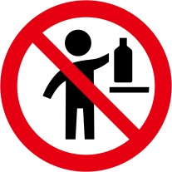”.

Annex 4

Section 2, A4.3.2.3

Replace the last sentence with the following: “To communicate combustible dust hazards, and thus a potential risk of dust explosions under the approach described in Annex 11 in a standardized manner, competent authorities may allow the use of the phrases identified in A11.2.7.3 on labels, SDSs and/or in operating instructions or may leave the choice to the manufacturer or supplier.”.

Section 9, Table A4.3.9.1

In the entry for “Vapour pressure”, amend the last item of the list to read as follows:

“- the saturated vapour concentration (*SVC*) in ml/m3 or in g/m3 (=mg/l) may be indicated in addition. The saturated vapour concentration can be estimated as follows:

*SVC* in ml/m3:

*SVC* in g/m3:

where

• *VP* is the vapour pressure in hPa (=mbar)

• *MW* is the molecular weight in g/mol and

• c1 and c2 are conversion factors where c1 = and c2 = ”

In the entry for “Relative vapour density”, amend the last item of the list to read as follows:

“- for liquids, the relative density (*Dm*) of the vapour/air-mixture at 20 °C (air = 1) may be indicated in addition. It can be calculated as follows:

$$D_{m}=1+\left({VP}_{20}∙\left(MW-{MW}_{air}\right)∙c_{3}\right)$$

where

• *VP*20 is the vapour pressure at 20 °C in hPa (=mbar)

• *MW* is the molecular weight in g/mol

• *MWair* is the molecular weight of air, *MWair* = 29 g/mol

• c3 is a conversion factor, c3 = ”

Section 9, Table A4.3.9.2

In the entry for “2.3 Aerosols”, in the first column, add “, section 2.3.1” after “2.3”. In the third column, at the end, replace “the Note in Chapter 2.3, paragraph 2.3.2.2” by “Note 2 in Chapter 2.3, paragraph 2.3.1.2.1”.

Add the following new row after the row for “2.3 Aerosols”.

|  |  |  |
| --- | --- | --- |
| **Chapter** | **Hazard Class** | **Property/Safety characteristic/ Test result and Remarks/Guidance** |
| 2.3, section 2.3.2 | Chemicals under pressure | − indicate the total percentage (by mass) of flammable components  − indicate the specific heat of combustion (generally in kJ/g) |

In the third column of the entry for “2.8”, in the first item of the list, replace “decomposition energy” by “decomposition temperature”.

Annex 7

Add the following new example:

“Example 10: Labelling of - sets or kits

A set or kit is a combination packaging intended for defined applications. Generally a set or kit contains two or more small removable inner containers. Each inner container contains different products which can be hazardous or not hazardous substances or mixtures.

This example illustrates ways to label sets or kits where the manufacturer/supplier or competent authority has determined there is insufficient space to place together on each inner container within the kit, the GHS pictogram(s), signal word and hazard statement(s) in accordance with 1.4.10.5.4.1. This may occur when, for example, the inner containers are small, or there are a large number of hazard statements assigned to the chemical, or the information needs to be presented in multiple languages, so all the information cannot be printed on the label in a size that is easily legible. Two different scenarios where this may arise are illustrated, together with ways to provide the necessary GHS information.

Scenario A

The set or kit comprises an outer packaging containing the following inner containers: four cuvettes, each filled with the same substance or mixture (reagent 1) and two larger containers each filled with another substance or mixture (reagent 2).

The approach is to provide minimum information on each of the inner containers containing hazardous substances or mixtures, and to provide the full GHS label information for each hazardous substance or mixture on the outer packaging. For clarity, the full label information for each hazardous substance or mixture is grouped together on the outer packaging.

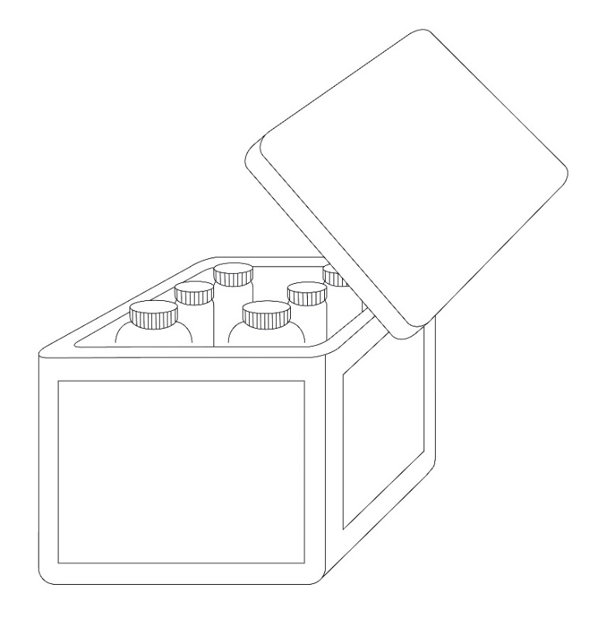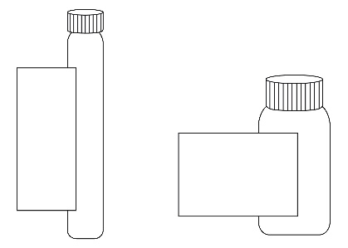

Inner containers

Outer packaging

Inner container label

As the area available for a label on the inner containers is not sufficient to include all the required GHS label elements, the following minimum information is included on the label of each hazardous substance or mixture:

- Product identifier[[1]](#footnote-2)1, and an identifier for each substance or mixture matching the identifier used on the outer packaging label and SDS for that substance or mixture, e.g., “Reagent 1” and “Reagent 2”

- Pictogram(s)

- Signal word

- The statement “Read full label”

- Supplier identification (i.e. name and telephone number)

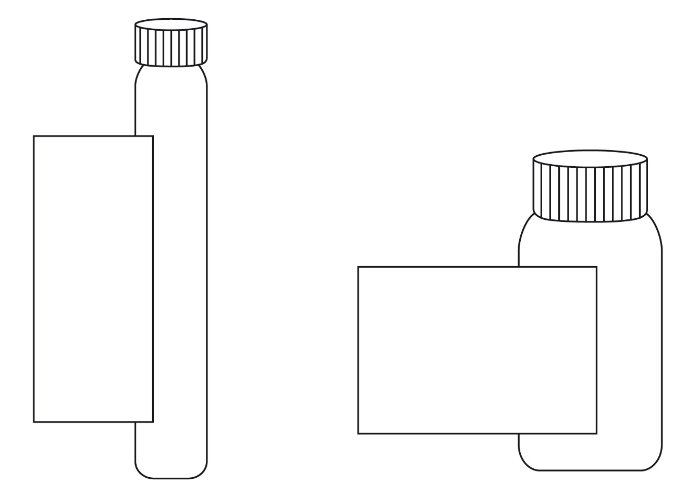

**Reagent 2**

**Product ident. (see 1.4.10.5.2 (d)(ii)) 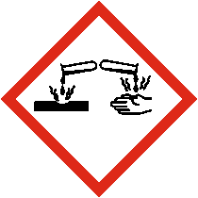**

**Signal word (see1.4.10.5.2(a))**

**Read full label**

**Company XYZ Phone +000000**

**number**

**Reagent 1**

**Product ident.**

**(see 1.4.10.5.2 (d) (ii))**

**Signal word**

**(see 1.4.10.5.2 (a))**

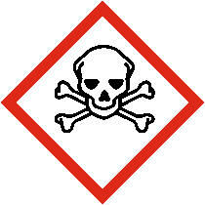 ****

**Read full label**

**Company XYZ Phone +000000**

Outer packaging label

In addition to the set or kit identifier, in this case Reagent Kit for water analysis (see below), all the required GHS label elements appear on the outer packaging for each hazardous substance or mixture.

The label elements for each substance or mixture on the outer packaging are grouped together in order to distinguish clearly which label elements are assigned to which substance or mixture.

However, the supplier identification need appear only once on the outer packaging. Where possible any supplemental information may also be included on the outer packaging.

When a large number of precautionary statements are required, the precautionary statements may be located separately from the rest of the label elements, though general precautionary statements (Table A3.2.1) and precautionary statements for storage need only appear once (see also A3.2.5 in Annex 3 on flexibility in the use of precautionary statements) to avoid inappropriate statements, taking into account the nature of the user (e.g. consumers, employers and workers) the quantities supplied, and the intended and foreseeable circumstances of use. In these circumstances, the precautionary statements for each substance or mixture should be grouped together on the same side of the outer packaging and on a surface that is visible under normal conditions of use.

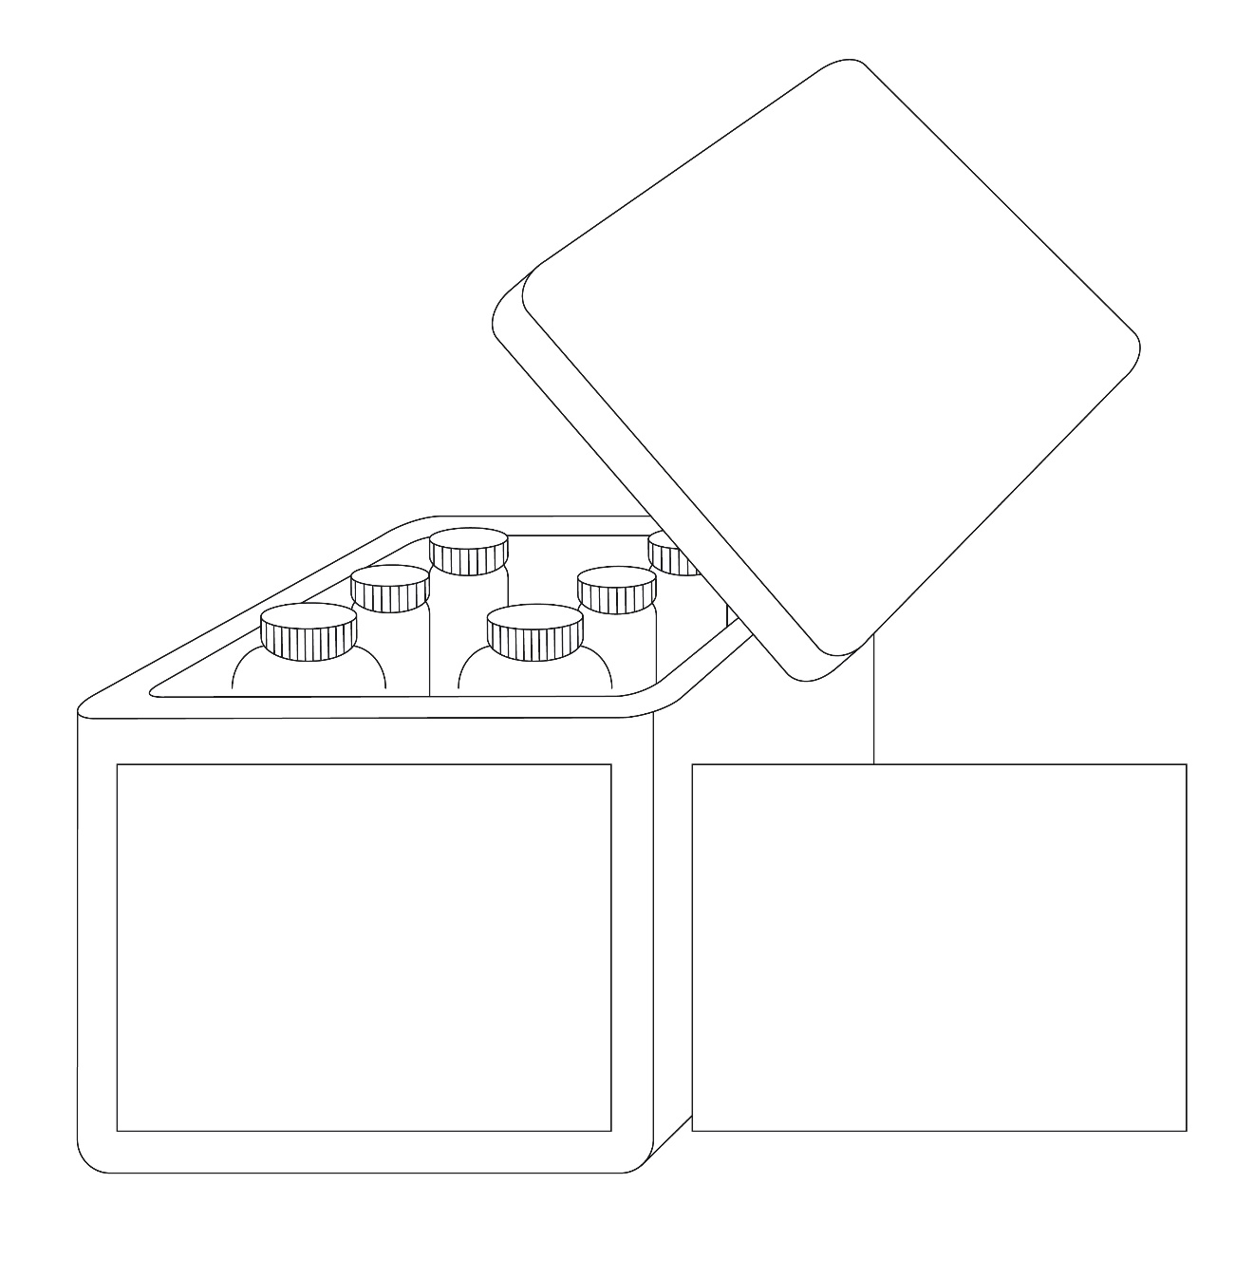

**Reagent kit for water analysis**

**Supplier identification** (see 1.4.10.5.2(e))

**Reagent 1**

  
**Signal word**(see 1.4.10.5.2(a))

**Hazard statements**(see 1.4.10.5.2 (b))

**Product identifier**(see 1.4.10.5.2 (d)(ii))

**Reagent 2**

  
**Signal word**  
(see 1.4.10.5.2(a))

**Hazard statements**  
(see 1.4.10.5.2 (b))

**Product identifier**(see 1.4.10.5.2 (d)(ii))

**Reagent 1**

**Precautionary statements (see 1.4.10.5.2 (c))**

**Storage conditions and general precautionary statements**

**Reagent 2**

**Precautionary statements (see 1.4.10.5.2 (c))**

Scenario B

This scenario addresses the situation where it is not possible to affix all appropriate GHS labelling elements for each hazardous substance or mixture in the kit directly on the outer packaging label (due to technical reasons such as the size and shape of this packaging).

This scenario presents a sample kit used for marketing purposes which consist of a large number of different substances or mixtures in individual containers (sample bottles) presented in an outer packaging (e.g. a box). Depending upon the contents of each bottle, some or all of the different substances or mixtures may be classified as hazardous. The individual inner containers (e.g. bottles) are stored in the outer packaging throughout the lifecycle of the sample kit. Customers may select individual bottles and remove them from the box to check clarity, colour or odour and then replace them into the open slot within the outer packaging.

**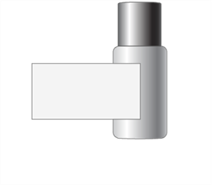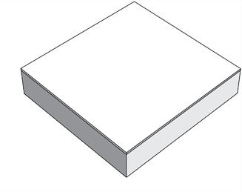**

Individual container

(Sample bottle)

Outer packaging

Individual container label

As the area available for a label on the different individual containers is not sufficient to include all required GHS label elements, the following minimum required information should be required:

- supplier identification (i.e. name and telephone number);

- product identifier[[2]](#footnote-3)2;

- pictogram(s);

- signal word;

- the statement “Read full label enclosed”.



**Sample 1**

**Product ident.**

**(see 1.4.10.5.2 (d) (ii))**

**Signal word**

**(see 1.4.10.5.2 (a))**

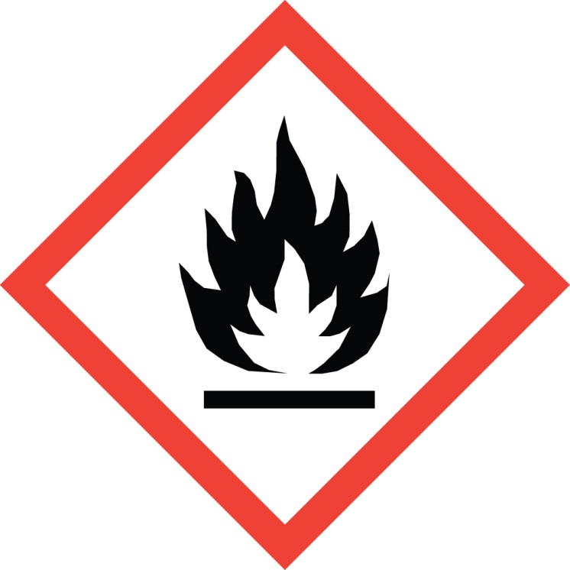****

**Company XYZ**

**Phone +000000**

**Read full label enclosed**

Example of individual container label

Full label information

Attached to the inside of the outer packaging is the full GHS label information for each individual container containing a hazardous substance or mixture. The individual product identifiers on the label align with the product identifier on the individual container label. An example of the content of the full label information is shown below.

| Product identifier  (see 1.4.10.5.2 (d) (ii)) | Pictogram(s) (see 1.4.10.4) | Signal word (see 1.4.10.5.2 (a)) | Hazard statement(s) (see 1.4.10.5.2 (b)) | Precautionary statement(s) (see 1.4.10.5.2 (c)) | Supplemental information  (see 1.4.10.5.4.2) |
| --- | --- | --- | --- | --- | --- |
| 123 |  | Warning | Flammable liquid and vapour.  Causes skin irritation.  Toxic to aquatic life with long lasting effects. | Keep away from heat, hot surfaces,sparks,open flames and other ignition sources. No smoking.  Keep container tightly closed.  Use explosion-proof equipment.  Use non-sparking tools.  Take action to prevent static discharge.  Avoid release to the environment.  Wear protective gloves.  IF ON SKIN (or hair): Take off immediately all contaminated clothing. Rinse affected areas with water.  In case of fire: Use dry sand, dry chemical or alcohol-resistant foam for extinction.  Store in a well-ventilated place. Keep cool. |  |

Although the contents of each inner container may not be classified as hazardous in accordance with the GHS, and thus would not need to be identified, it may be identified with a statement such as “Not meeting classification criteria” or “Not classified as hazardous” so as to eliminate confusion on the part of the user if the contents of an inner container is omitted from the full label information.

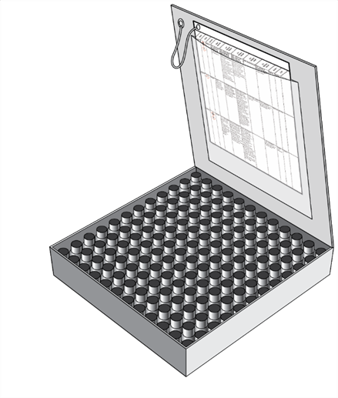The document containing the full GHS label information should be organized and printed in a format that allows the user to readily identify the information for each individual container. The visibility of the label elements should be ensured without the aid of any device other than corrective lenses. The approach of this scenario may become infeasible if, given the number of samples, required languages, and precautionary statements, the document grows so large it becomes difficult to locate quickly the label information for a particular inner container.

As shown to the right, full label information regarding each inner container is contained within the outer packaging.

The sheets of full label information are permanently connected to the inside of the combination packaging using a secure method of attachment   
(e.g. fold out label adhered to box tie or tag as shown)

Outer packaging label

The outer box, given the limited area for labelling, will display:

- kit identifier (name of kit);

- supplier identification (see 1.4.10.5.2(e));

- storage and general precautionary statements for the kit as a whole;

- pictograms for each single hazardous substance or mixture, without duplication;

- signal word (the most stringent assigned to any component);

- the statement “Read full label enclosed”.

**MARKET KIT**

**Product ident. (see 1.4.10.5.2 (d) (ii))**

**Signal word (see 1.4.10.5.2 (a))**

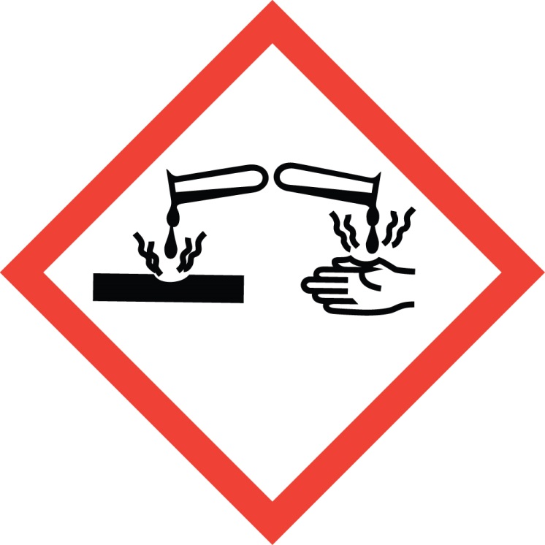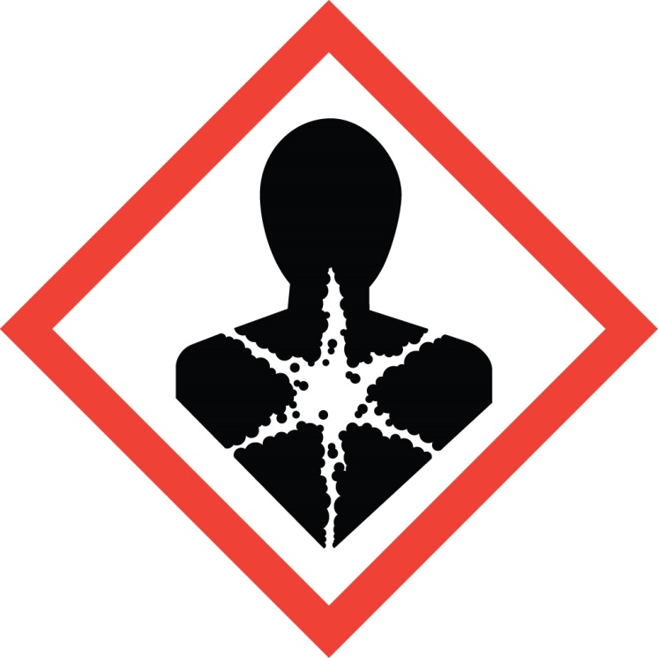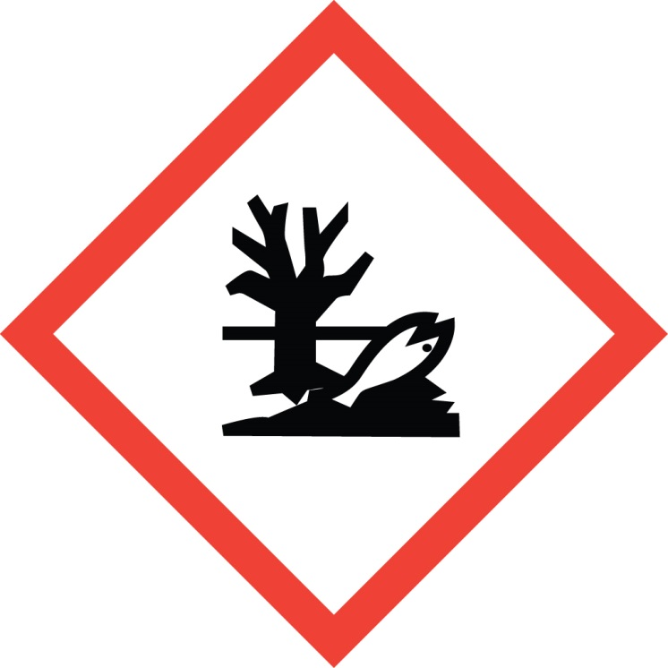

Precautionary Storage Statements (see 1.4.10.5.2 (c))

Read full label enclosed

Supplier identification (see 1.4.10.5.2 (e))

”.

Annex 11

Add the following new Annex 11:

“Annex 11

GUIDANCE ON OTHER HAZARDS NOT RESULTING IN CLASSIFICATION

A11.1 Introduction

This guidance aims to provide information that facilitates the identification of hazards which do not result in classification, but which may need to be assessed and communicated.

A11.2 Dust explosions

This section provides guidance on the factors that contribute to a dust explosion hazard and on hazard identification and the need for risk assessment, prevention, mitigation, and communication.

A11.2.1 *Scope and applicability*

A11.2.1.1 Any solid substance or mixture, which is combustible, may pose a dust explosion risk when in the form of fine particles in an oxidizing atmosphere such as air. A risk assessment may be needed for many substances, mixtures, or solid materials, not just those classified as flammable solids in accordance with Chapter 2.7. In addition, dusts may be formed (intentionally or unintentionally) during transfer or movement, or in a facility during handling or mechanical processing (e.g., milling, grinding) of substances/mixtures/solid materials (e.g., agricultural commodities, wood products, pharmaceuticals, dyes, coal, metals, plastics). Thus, the possibility of the formation of small particles and their potential accumulation should also be assessed. Where a dust explosion risk is identified, effective preventive and protective measures should be implemented as required by national legislation, regulations, or standards.

A11.2.1.2 This guidance identifies when combustible dusts may be present and thus, when the risk of a dust explosion should be considered. The guidance:

(a) Gives a flow chart specifying the key steps to identify a possible combustible dust;

(b) Identifies the factors contributing to a dust explosion;

(c) Sets out principles of hazard and risk management; and

(d) Indicates where expert knowledge is required.

A11.2.2 *Definitions*

In this annex, the following terms, specific to dust explosion hazards and risks, are used:

**Combustible dust*:*** Finely divided solid particles of a substance or mixture that are liable to catch fire or explode on ignition when dispersed in air or other oxidizing media;

**Combustion*:*** Energy releasing (exothermic) oxidation reaction of (or with) combustible substances/mixtures/solid materials;

***Dispersion:*** Distribution of fine dust particles in the form of a cloud;

**Dust deflagration index (Kst)*:*** A safety characteristic related to the severity of a dust explosion. The larger the value for $K_{st}$, the more severe the explosion. *Kst* is dust specific and volume independent, and is calculated using the cubic law equation:

$${\left({d_{p}}/{d_{t}}\right)}_{max}∙V^{1/3}=const.=K_{st}$$

where:

(dp/dt)max = maximum rate of pressure rise

V = volume of testing chamber

Dusts are classified into dust explosion classes in accordance with their Kst value:

St 1: 0 < Kst ≤ 200 bar m s-1

St 2: 200 < Kst ≤ 300 bar m s-1

St 3: Kst > 300 bar m s-1

The Kst value and the maximum explosion pressure are used to design appropriate safety measures (e.g. pressure relief venting).

**Explosible dust atmosphere*:*** A dispersion of a combustible dust in air which after ignition results in a self-sustaining flame propagation;

**Explosion*:*** Abrupt oxidation or decomposition reaction producing an increase in temperature, pressure, or both simultaneously;[[3]](#footnote-4)1

**Limiting oxygen concentration (LOC)*:*** maximum oxygen concentration in a mixture of a combustible dust and air and an inert gas, in which an explosion will not occur, determined under specific test conditions;

**Maximum explosion pressure*:*** Highest pressure registered in a closed vessel for a dust explosion at optimum concentration;

**Minimum Explosible Concentration (MEC)/Lower Explosible Limit (LEL):** The minimum concentration of a combustible dust dispersed in air measured in mass unit per volume that will support an explosion;

**Minimum ignition energy (MIE):** Lowest electrical energy stored in a capacitor, which upon discharge is sufficient to ignite the most sensitive dust/air mixture under specific test conditions;

**Minimum ignition temperature (MIT) of a dust cloud*:*** Lowest temperature of a hot surface on which the most ignitable mixture of a dust with air is ignited under specified test conditions;

**Particle size*:*** Smallest sieve aperture through which a particle will pass if presented in the most favourable orientation;[[4]](#footnote-5)2

A11.2.3 *Identification of combustible dust*

A11.2.3.1 The purpose of this section is to identify whether a combustible dust is present. If there is applicable data from a recognized and validated test method that supports a conclusion that the substance or mixture is or is not a combustible dust (see considerations in A11.2.3.2.10) then a decision can be made without the application of figure A11.2.1. Otherwise, figure A11.2.1 presents a flow chart that helps to identify whether a substance or mixture is a combustible dust and hence whether the risk of a dust explosion has to be assessed. Section A11.2.3.2 contains detailed explanations and guidance on the interpretation of each box used in the flow chart.

**Figure A11.2.1: Flow chart for decision on combustible dusts**

Is there available data, evidence or experience confirming that the solid is a combustible dust?

Do test results show that the solid is a combustible dust?

Is the substance or mixture a solid?

Is the solid completely oxidized?

Does the solid include particles of a nominal size ≤ 500 µm?

Is there a potential to form particles of a nominal size ≤ 500 µm in supply and transfer operations?

Choose to test the solid for dust explosibility?

Combustible dust

Not a combustible dust

No

Yes

Yes

No or unknown

No or unknown

Yes

Yes

No

Yes

No

Yes

No

Yes

1

2

3

4

5

6

No

A11.2.3.2 Explanations to figure A11.2.1

A11.2.3.2.1 Care has to be taken when using available data, because the behaviour of combustible dusts is very sensitive to conditions such as particle size, moisture content etc. If the conditions under which available data were generated are not known, or are not applicable to the substance, mixture, or solid material under investigation, the data might not be relevant and a conservative approach is recommended when going through the flow chart.

Box 1: *Is there available data, evidence or experience confirming that the solid is a combustible dust?*

A11.2.3.2.2 Clear evidence for a combustible dust may be obtained from publicly available incident reports relevant to the substance, mixture, or solid material in question. Similarly, if experience has shown that the substance, mixture, or solid material is combustible in powder form, a dust explosion risk can be assumed. If a substance, mixture, or solid material is not classified as flammable, it may still have the potential to form an explosible dust-air mixture. Specifically any organic or metallic material handled in powder form or from which a powder may be formed in processing, should be assumed to be a combustible dust unless explicit evidence to the contrary is available.

A11.2.3.2.3 The following are examples of available data indicating a combustible dust:

(a) Classification of the substance or one of the components of the mixture as pyrophoric or flammable solid.

(b) Availability of relevant information such as MIE, Kst values, flammability limits, ignition temperatures.

(c) Results from screening tests (such as Burning index in accordance with VDI 2263, Hartmann tube in accordance with ISO IEC 80079-20-2).

A11.2.3.2.4 In the absence of data, it is common practice to assume the presence of a combustible dust and to apply appropriate risk management measures (see A11.2.6).

Box 2: Is the solid completely oxidized?

A11.2.3.2.5 When a solid substance or mixture is completely oxidized, e.g. silicon dioxide, further combustion will not occur. Consequently, the solid substance or mixture will not ignite, even if it is exposed to a source of ignition. However, if a solid substance or mixture is not entirely oxidized, combustion of the solid substance or mixture is possible if it is exposed to a source of ignition.

Box 3: Does the solid include particles of a nominal size ≤ 500 µm?

A11.2.3.2.6 When evaluating materials in relation to box 3, users should consider whether the material includes fine particles which might be released during normal or foreseeable conditions of use.

A11.2.3.2.7 When assessing the particle size with regard to the risk of dust explosions, only the fine particles with a size ≤ 500 µm are relevant[[5]](#footnote-6)3, even if the median particle size of the whole sample is larger than 500 µm. Hence, only the dust fraction itself, and not the mixture of coarse and fine particles, has to be considered to evaluate the risk of forming explosible dust atmospheres. However, a lower concentration limit for the dust particles in a solid (e.g., by weight percent) that will not lead to such a risk cannot be defined and therefore also small fractions of fine particles are relevant. For further explanation see A11.2.4.1.

Box 4 Is there a potential to form particles of a nominal size ≤ 500 µm in supply and transfer operations?

A11.2.3.2.8 At this stage in the flow chart the solid, as presented, does not include particles smaller than 500 µm. In that form it is not a combustible dust. However, it is not completely oxidized and fine particles could form during supply and transfer operations. Therefore, such conditions should be critically reviewed in detail, especially with respect to foreseeable effects which may lead to the formation of fine particles, e.g., mechanical stress such as abrasion during transport or transfer operations, or desiccation of moisturized material. If such effects cannot be excluded, expert opinion should be sought. See section A11.2.6.2.1 for considerations related to the generation of fine particles during operations and processing.

Box 5 Choose to test the solid for dust explosibility?

A11.2.3.2.9 If testing for dust explosibility is carried out, it should be done in accordance with recognized and validated testing standards, such as those listed in A11.2.8.1. Where a solid is tested, and the solid as presented does not consist of particles ≤ 500 µm, it has to be ground for the purposes of testing for dust explosibility.

Box 6 Do test results show that the solid is a combustible dust?

A11.2.3.2.10 Properties such as particle size, chemistry, moisture content, shape, and surface modification (e.g., oxidation, coating, activation, passivation) can influence the explosion behaviour. Standard tests determine whether a dust is actually able to form explosible mixtures with air.

A11.2.4 *Factors contributing to a dust explosion*

A dust explosion may occur when there is a combustible dust, air or another oxidizing atmosphere, an ignition source, and the concentration of the combustible dust dispersed in air or another oxidizing atmosphere is above the minimum explosible concentration. The relationship between these factors is complex. The following sections give further information on the specific factors that contribute to a dust explosion hazard. In some cases, expert advice may be needed.

A11.2.4.1 Particle characteristics (size and shape)

A11.2.4.1.1 The 500 μm size criterion is based on the fact that particles of greater size generally have a surface-to-volume ratio that is too small to pose a deflagration hazard. However, this criterion should be used with care. Flat platelet-shaped particles, flakes, or fibres with lengths that are large compared to their diameter usually do not pass through a 500 μm sieve, yet could still pose a deflagration hazard. In addition, many particles accumulate electrostatic charge in handling, causing them to attract each other, forming agglomerates. Often agglomerates behave as if they were larger particles, yet when they are dispersed they can present a significant hazard. In such cases, a conservative approach is recommended and the material should be treated as a combustible dust.

A11.2.4.1.2 The particle size influences the explosion severity as well as the ignition sensitivity. A decrease in particle size tends to lower the MIE and the MIT of a dust cloud while the maximum explosion pressure and KSt value will rise.

A11.2.4.1.3 A concentration limit for the fraction of small dust particles in a combustible solid substance or mixture (e.g., by weight percent) that will not lead to a combustible dust hazard cannot be defined because:

(a) Small amounts of dust are sufficient to form an explosible dust-air mixture. Assuming the lower explosion limit of a combustible dust is 30 g/m³, an amount of 0.3 g dispersed in 10 *l* of air would be sufficient to form a hazardous explosible dust atmosphere. Therefore, a (combustible) dust cloud with a volume of 10 *l* has to be considered as hazardous even when unconfined.

(b) Dust may not be equally distributed in a substance or mixture and may accumulate and/or separate.

A11.2.4.2 Concentration of combustible dust

A11.2.4.2.1 A dust explosion may occur if the concentration of combustible dust dispersed in air reaches a minimum value, the MEC/LEL[[6]](#footnote-7)4. This value is specific for each dust.

A11.2.4.2.2 The MEC/LEL of many materials have been measured, varying from 10 to about 500 g/m³. For most combustible dusts it may be assumed that 30 g/m³ is the MEC/LEL (it has to be taken into account that 30 g dispersed in 1 m³ of air~~,~~ resembles a very dense fog).

A11.2.4.3 Air or other oxidizing atmospheres

Generally air is the oxidizing agent in dust explosions, however, if combustible dusts are handled in other oxidizing gases or gas mixtures dust explosions may also occur.

A11.2.4.4 Ignition sources

A11.2.4.4.1 Dust explosions will occur when an effective ignition source is present in an explosible dust-air mixture (explosible atmosphere). The effectiveness of a potential source of ignition reflects the ability to ignite an explosible atmosphere. It depends not only on the energy of the ignition source, but also on its interaction with the explosible atmosphere.

A11.2.4.4.2 The assessment of ignition sources is a two-step procedure: First, possible ignition sources are identified. In the second step, each possible ignition source is assessed with respect to its ability to ignite the explosive atmosphere. The ignition sources identified as effective in this procedure then require appropriate preventive measures within the explosion protection concept (see A11.2.6.1).

A11.2.4.4.3 Potential sources of ignition include:

(a) Hot surfaces;

(b) Flames and hot gases;

(c) Mechanically generated sparks;

(d) Electric apparatus;

(e) Stray electric currents and cathodic corrosion protection;

(f) Lightning;

(g) Static electricity;

(h) Radio frequency electromagnetic waves (104 Hz - 3×1012 Hz) ;

(i) Electromagnetic waves (3×1011 Hz - 3×1015 Hz);

(j) Ionizing radiation;

(k) Ultrasonics;

(l) Adiabatic compression and shock waves;

(m) Exothermic reactions, including self-ignition of dusts, smouldering/glowing particles or dusts, and thermite reactions (e.g., between aluminium and rusty steel).

A11.2.5 *Other factors impacting the severity of a dust explosion*

In addition to the factors explained in A11.2.4, other conditions also influence how severe a dust explosion can be. The more significant of these are environmental factors and confinement, which are explained below. Since the list of factors presented in this section is not complete, expert advice should be sought as appropriate when assessing the risks in a given situation.

A11.2.5.1 Influence of temperature, pressure, oxygen availability, and humidity

A11.2.5.1.1 Safety relevant data are frequently given under the tacit assumption of atmospheric conditions and are usually valid in the following range (“standard atmospheric conditions”):

(a) Temperature –20 °C to +60 °C;

(b) Pressure 80 kPa (0.8 bar) to 110 kPa (1.1 bar);

(c) Air with standard oxygen content (21 % v/v).

A11.2.5.1.2 An increase in temperature may have multiple effects such as a decrease in MEC and MIE, thus increasing the likelihood of a dust explosion.

A11.2.5.1.3 An increase in pressure tends to lower the MIE and the MIT of a dust cloud while the maximum explosion pressure will rise. The effect is increased sensitivity, thus increasing the likelihood and severity of a dust explosion.

A11.2.5.1.4 Higher oxygen content can significantly increase the sensitivity of an explosible atmosphere and the severity of an explosion due to higher explosion pressures. Equally lower oxygen concentration can reduce the risk of an explosion. The LEL may also rise. Such a situation can occur when a process is undertaken under an inert atmosphere.

A11.2.5.1.5 Low or high humidity (of air, gas phase) may influence the occurrence of electrostatic discharges.

A11.2.5.1.6 Therefore, the risk and severity of dust explosions under non-standard atmospheric conditions should be evaluated by expert consideration of the actual process conditions.

A11.2.5.2 Confinement

Confinement means the dust is in an enclosed or limited space. A combustible dust (as defined above) can react without confinement or when confined. When confined, the explosion pressure is likely to be higher than when unconfined, as confinement allows pressure to build up, increasing the severity of an explosion. Using suitably sized and located explosion relief allows the burning dust cloud and hot products of a dust explosion to vent to safe places outside the confined area, reducing the potential for the pressure to increase, and so limiting the potential explosion severity. Expert advice may be needed on the possible application and design of explosion relief venting based upon the physical and chemical properties and potential health/physical hazards of the substance, mixture, or solid material.

A11.2.6 *Hazard prevention, risk assessment and mitigation*

A11.2.6.1 General explosion protection concept for dusts

A11.2.6.1.1 Table A11.2.1 shows the principles of explosion protection. The table presents both preventive and mitigative measures, and identifies which safety characteristics are most relevant to the measures proposed. For guidance on safety characteristics, refer to Annex 4, Table A4.3.9.3.

A11.2.6.1.2 The first priority should involve preventive measures such as substitution and application of dust-free processes to avoid where possible the presence of combustible dusts, as shown in the column “Avoidance of combustible dusts”.

A11.2.6.1.3 Where the presence of combustible dusts cannot be avoided, measures such as exhaust ventilation should be taken to prevent the concentration of combustible dusts reaching the explosible range; see the column “Avoidance of reaching the explosion range”. Good housekeeping practices are important to prevent the formation of dust clouds or – if that is not achieved - the propagation of pressure waves and fireballs from an initial explosion, e.g. inside equipment or enclosures, dispersing and igniting dust accumulations into a work area. Such secondary explosions can often be more destructive than the primary explosion. A written housekeeping plan with regular inspection for excessive dust levels, including emphasis on priority areas, is strongly recommended. Housekeeping should be conducted concurrently with operations.

A11.2.6.1.4 Where measures cannot be taken to avoid or reduce explosible dust atmospheres, then, ignition sources should be assessed and avoided where possible (see A11.2.4.4 and Table A11.2.2). Ignition sources can include fires and heat caused by the frictional energy of mechanical equipment. Heat or arcing caused by the failure of or the use of improper electrical equipment, such as lighting, motors, and wiring, have also been identified as ignition sources. Improper use of welding and cutting equipment can be a factor. Periodic inspections, lubrication, and adjustment of equipment can be a major tool to prevent ignitions which can lead to explosions. Additional examples of what to consider when evaluating ignition sources are in the column “Avoidance of ignition sources”.

A11.2.6.1.5 Where ignition of an explosible dust atmosphere cannot be excluded, the effects should be mitigated by protective measures. When containment is used as a mechanism to reduce the risk or when the dust is confined, then explosion-proof design or relief venting should be considered. Equipment and buildings with known combustible dusts should be equipped with devices or systems designed to prevent an explosion, minimize its propagation, or limit the damage it causes. Explosion relief venting is one of the most common approaches taken to reduce the explosion pressure. Examples of other mitigating measures are shown in the column “Minimizing effects of a dust explosion”.

A11.2.6.1.6 Section A11.2.8.2 contains a list of regulations and guidance documents on prevention and mitigation of dust explosions, including those discussing explosion prevention systems and the use of deflagration venting.

A11.2.6.1.7 Every facility where there is a potential for dust explosions should have a safety program and an established emergency action plan. A communication system is needed to notify everyone at the plant when there is an emergency and they might be at risk. A central alarm system, page system or horn can be used to signal the need for evacuation. All workers should be trained in the hazards of combustible dust, the risk of explosions, and proper preventive measures.

**Table A11.2.1: General concept to prevent and mitigate dust explosions**

|  |  |  |  |  |
| --- | --- | --- | --- | --- |
| **Prevention** | | |  | **Mitigation** |
|  |  |  |  |  |
| **Avoidance or reduction of explosible dust atmospheres** |  | **Avoidance of ignition sources** |  | **Minimizing effects of a dust explosion** |
|  |  |  |  |  |
| *Relevant safety characteristics*   * *Dust explosibility*   **Avoidance of combustible dusts by [examples below]**   * Substitution * Passivation * Application of dust-free processes * … |  | **Identification of relevant ignition sources**   * Identification of relevant areas and activities (zoning) * Identification of potential ignition sources * Determination of relevant safety characteristics (see below) |  | *Relevant safety characteristics*   * *Maximum explosion pressure* * *Deflagration index (Kst)*   **Explosion pressure proof design by [examples below]**   * Venting (reduction of explosion pressure) * Explosion resistance * … |
|  |  |  |  |  |
| *Relevant safety characteristics*   * *Lower explosible limit (LEL)/* *Minimum Explosible Concentration (MEC)*   **Avoidance of reaching the explosible range by [examples below]**   * Good house keeping * Exhaust ventilation * Dust reduced procedures * … |  | *Relevant safety characteristics*   * *Minimum ignition energy* * *Minimum ignition temperatures (dust clouds and dust layers)* * *Self-ignition behaviour*   **Prevention of effective ignition sources by [examples below]**   * Avoidance of open fire or flames * No smoking * Limitation of surface temperatures * Use of approved electrical and mechanical equipment (in accordance with respective zone) * Prevention of electrostatic discharges (e.g., grounding, dissipative materials) * Prevention of mechanical heating or sparks (e.g., temperature monitoring, misalignment monitoring of moving parts, …) * Spark detection and extinguishing * … |  | **Explosion suppression by [examples below]**   * Explosion detection and dispersion of extinguishing media (powder, water, …) * … |
|  |  |  |  |
| *Relevant safety characteristics*   * *Limiting oxygen concentration (LOC)*   **Oxygen reduction by [examples below]**   * Inerting (N2, CO2, argon, flue gas, water vapour, …) |  |  | **Explosion isolation  by [examples below]**   * Ignition and flame resistant components (rotary valves, double acting valves, quick acting gate valves, …) * Extinguishing barriers * … |
|  |  |

A11.2.6.2 Considerations for dust explosion protection during operations and processing

A11.2.6.2.1 Processing operations may change the physical form of substances, mixtures, and solid materials such that smaller particles are formed (e.g., sieving, milling, grinding). When substances, mixtures, and solid materials that are not completely oxidized are subjected to such operations, this may result in the formation of combustible dusts. In such cases, the principles of this guidance apply equivalently, and the measures for hazard prevention, risk assessment and mitigation described in A11.2.6.1 should be considered. The responsible party (e.g., manufacturer, employer) at a facility performing processing operations has the best knowledge about the operation that is necessary to conduct an appropriate dust explosion risk assessment and determine the proper measures for hazard prevention and risk mitigation.

A11.2.6.2.2 Table A11.2.2 presents potential ignition sources that may be present during operations and that should be considered. The table uses ignition sources as an example when evaluating potential dust explosion protection measures during operations. Expert advice may be needed to develop and apply appropriate preventive and mitigative measures.

Table A11.2.2: Potential ignition sources during operations

|  | **Facility  management** | **Storage** | **Transfer-operations** | | | **Formulation and packaging** | | | | **Reaction and downstream processing** | | | | | |
| --- | --- | --- | --- | --- | --- | --- | --- | --- | --- | --- | --- | --- | --- | --- | --- |
| **Type of ignition source**  **[see A11.2.4.4.3]** | **Construction work, repair, maintenance** |  | **Conveying (solids)** | **Pumping (liquids)** | **Other transfer operations** | **Mixing (no reaction)** | **Sieving/milling/grinding** | **Formulation operations** | **Packaging** | **Reaction** | **Off-gas handling / scrubbing** | | **Work-up (phase  separation; crystallization; filtration, isolation)** | **Distillation** | **Drying** |
| **Hot surfaces** | Caused by friction of moving parts at bearings, shaft seals, etc. | | | | | Heated equipment, pipes, heat exchangers | | | | | | | | | |
| **Flames and hot gases** | Hot work: welding, cutting, etc. | Generally not relevant | | | | | | | | Possible formation of hot gases | Generally not relevant | | | | |
| **Mechanically generated sparks** | Sparks generated by use of tools  (e.g., hammering, drilling, grinding) | | Sparks generated due to grinding, friction or impact (frequently caused by  mechanical failures or entrainment of foreign parts into moving equipment or machinery) | | | | | | | | Generally not relevant | | | | Sparks generated due to grinding, friction or impact |
| **Electric apparatus** | Machines, process control technology installations, motors, switches, cables, lighting | | | | | | | | | | | | | | |
| **Stray electric currents and cathodic corrosion protection** | Stray currents, e.g., from welding or faulty equipment | Relevant in some cases, e. g.: backflow to electricity generation plants, train tracks, vicinity of electric system with high current | | | | | | | | | | | | | |
| **Lightning** | Relevant in some cases, e. g.: thunderstorm even with invisible lightning bolts, activities near lightning protection systems | | | | | | | | | | | | | | |
| **Static electricity** | Generally not  relevant | Relevant in some cases | Frequently generated by flow or separation processes | | | | | | | | | | | | |
| **Radio frequency electromagnetic waves** | Relevant in some cases, e. g.: radio transmitting station, high frequency generators for heating, curing, welding, cutting | | | | | | | | | | | | | |
| **Electromagnetic waves** | Relevant in some cases, e. g.: insolation, powerful light source, laser radiation | | | | | | | | | | | | | |
| **Ionizing radiation** | Relevant in some cases, e. g.: X-ray machine, radioactive materials | | | | | | | | | | | | | |
| **Ultrasonics** | Relevant in some cases, e. g.: ultrasound scanner, ultrasonic testing, sonic driller | | | | | | | | | | | | | |
| **Adiabatic compression and shock waves** | Generally not relevant | | Compression of gases, rapidly shutting valves when conveying / pumping material | | | Generally not relevant | | | | Relevant in some cases, e. g.: relaxation of high-pressure gases in pipelines, hammer blow | | | | | |
| **Exothermic reactions** | Generally not relevant | Pyrophoric and self-heating  substances | Transfer of smouldering nests into other areas | | | Pyrophoric and self-heating substances | | | | Strongly exothermic reaction | Self-heating and ignition of charcoal absorbers | Activated  catalysts or residues | | Possible  decomposition of residue | Self-ignition of dust layers (esp. spray drying) |

A11.2.7 *Supplemental information for hazard and risk communication*

A11.2.7.1 As explained in 1.4.6.3, there are many communication elements which have not been standardized in the harmonized system. Some of these clearly need to be communicated to the downstream user. Competent authorities may require additional information, or suppliers may choose to add supplementary information on their own initiative. Each party producing or distributing a product that is determined to be hazardous, including if it becomes hazardous during downstream processing, should create and provide their downstream user with appropriate information, in the form of a Safety Data Sheet (SDS) or another format as appropriate, to alert the user to the hazards and risks.

A11.2.7.2 For substances, mixtures, or solid materials, sections 2, 5, 7, and 9 of the SDS, at a minimum, should provide information on combustible dusts. Annex 4 provides further guidance on each section of the SDS. For example, section 2 (A4.3.2) addresses hazards that do not result in classification; section 5 (A4.3.5) covers requirements for fighting a fire; section 7 (A4.3.7) provides guidance on safe handling practices and section 9 (A4.3.9) describes the physical and chemical properties of a substance, mixture, or solid material.

A11.2.7.3 To communicate combustible dust hazards, and thus a potential risk of dust explosions under the approach described in this annex in a standardized manner, competent authorities may require the use of the following phrases on labels, SDSs and/or in operating instructions or may leave the choice to the manufacturer or supplier:

(a) In the case where a substance or mixture is identified as a combustible dust in accordance with Figure A11.2.1: “May form explosible dust-air mixture if dispersed”; or

(b) In the case where a substance, mixture, or solid material is to be further processed in such a manner that the processing creates a combustible dust in accordance with A11.2.6.2.1, in combination with Figure A11.2.1: “May form explosible dust-air mixture if small particles are generated during further processing, handling, or by other means.”;

(c) In addition, the phrase “Warning” may be used in conjunction with items (a) or (b).

A11.2.8 *References*

A11.2.8.1 Test methods

Recognized and scientifically validated testing methods and standards, such as those listed below, should be used when evaluating dust explosibility.

International standards

ISO/IEC 80079-20-2, "Explosive atmospheres - Part 20-2: Material characteristics ‒ Combustible dusts test methods"

National standards

ASTM E1226, “Standard Test Method for Explosibility of Dust Clouds”

VDI[[7]](#footnote-8)\* 2263-1, "Dust Fires and Dust Explosions; Hazards ‒ Assessment ‒ Protective Measures; Test Methods for the Determination of the Safety Characteristics of Dusts"

A11.2.8.2 Regulations and guidance on prevention and mitigation

There are a number of documents available providing guidance on preventive and mitigation measures to minimize or eliminate dust explosions. A partial list is provided below. The use of country-specific documents, including those addressing specific hazards and risks associated with materials such as wood, coal, sulfur, combustible metals, and agricultural and food, is encouraged where available.

(a) Directive 1999/92/EC of the European Parliament and of the Council (ATEX), Annex 1

(b) U.S. OSHA’s Combustible Dust Directive (Combustible Dust National Emphasis Program)

(c) Health and Safety Executive, UK, HSG 103, Safe Handling of Combustible Dusts: Precautions Against Explosions

(d) U.S. National Fire Protection Association (NFPA)

NFPA 652: Standard on the Fundamentals of Combustible Dust

NFPA 654: Standard for the Prevention of Fire and Dust Explosions from the Manufacturing, Processing, and Handling of Combustible Particulate Solids

NFPA 68: Standard on Explosion Protection by Deflagration Venting

NFPA 69: Standard on Explosion Prevention Systems”.

\_\_\_\_\_\_\_\_\_\_\_\_\_\_\_\_

1. 1 Where hazardous components are required to be identified on the label, they are displayed in the appropriate languages on the outer packaging label. [↑](#footnote-ref-2)
2. 2 Where hazardous components are required to be identified on the label they are displayed in the appropriate languages as part of the full label information attached to the inside of the kit. [↑](#footnote-ref-3)
3. 1 Explosions are divided into deflagration and detonation depending on whether they propagate with subsonic velocity (deflagration) or supersonic velocity (detonation). The reaction of a combustible dust which is dispersed in air and ignited normally propagates with subsonic speed, i.e. as a deflagration. Whereas explosive substances ("Explosives"; see Chapter 2.1) have the intrinsic potential for highly energetic decomposition and react in the condensed phase, combustible dusts need to be dispersed in the presence of an oxidizing atmosphere (generally oxygen) to create an explosible dust atmosphere. [↑](#footnote-ref-4)
4. 2 For further information on particle size see A11.2.4.1. [↑](#footnote-ref-5)
5. 3 Use of ≤ aligns with NFPA 652, Standard on the Fundamentals of Combustible Dust. However, this notation implies a precision which this parameter does not have in practice. [↑](#footnote-ref-6)
6. 4 Although there is an Upper Explosive Limit (UEL) for dusts in air, it is difficult to measure and imprecise. Furthermore, in practice it is not generally possible to consistently maintain a dust-in-air concentration above the UEL; tests in a blender showed dust explosibility even when 75% filled. In consequence, and in contrast to gases and vapours, seeking to maintain safety by operating with dust concentrations above the UEL is not generally a viable approach. [↑](#footnote-ref-7)
7. \* VDI stands for "Verein Deutscher Ingenieure" [↑](#footnote-ref-8)