|  |  |  |  |
| --- | --- | --- | --- |
|  | United Nations | ECE/TRANS/WP.29/GRSP/2018/29 | |
| _unlogo | **Economic and Social Council** | | Distr.: General  26 September 2018  Original: English |

**Economic Commission for Europe**

Inland Transport Committee

**World Forum for Harmonization of Vehicle Regulations**

**Working Party on Passive Safety**

**Sixty-fourth session**

Geneva, 11-14 December 2018

Item 19 of the provisional agenda

**UN Regulation No. 129 (Enhanced Child Restraint Systems)**

Proposal for the 04 series of amendments to UN Regulation No. 129

Submitted by the expert from the European Association of Automotive Suppliers[[1]](#footnote-2)\*

The text reproduced below was prepared by the expert from the European Association of Automotive Suppliers (CLEPA) to include booster cushion category into the scope of UN Regulation No. 129. The modifications to the current text of the UN Regulation are marked in bold for new or strikethrough for deleted characters.

**I. Proposal**

*Table of contents*, *insert the references to new Annexes 25 and 26*, to read:

"**25.** **Measurement device for booster cushion height check**

**26.** **Lower torso body block test** "

*Text of the Regulation,*

*Paragraph 1*., amend to read:

**"1. Scope**

This Regulation applies ~~(in Phases 1, 2 and 3)~~ to the following child restraint system for child occupants of power driven vehicles:

…

(f) Integral Specific vehicle Belted Enhanced Child Restraint Systems;

**(g) Non-integral Universal Enhanced Child Restraint Systems with no backrest (i-Size booster cushion);**

**(h) Non-integral Specific vehicle Enhanced Child Restraint Systems with no backrest (Specific vehicle booster cushion).**"

*Insert a new paragraph 2.3.4*., to read:

"**2.3.4. "i-Size booster cushion" (Non-Integral Universal Enhanced Child Restraint System with no backrest) is a category of Enhanced Child Restraint System with no backrest and stowable ISOFIX attachments if any, primarily designed for use in all i-Size seating positions of a vehicle.**"

*Insert a new paragraph 2.7.4*., to read:

"**2.7.4. "Specific vehicle booster cushion" is a category of Non-Integral Enhanced Child Restraint System, with no backrest, for use in specific vehicle types, with vehicle anchorages approved according to UN Regulation No. 14 or UN Regulation No. 145. This category includes "Built-in booster cushions".**"

*Paragraph 2.17.2*., amend to read:

"2.17.2. "i-Size booster ~~seat~~ fixture" means a fixture, of the dimensions given in figure 1 of Annex 17, Appendix 5 of Regulation No. 16 and used by an Enhanced Child Restraint System manufacturer to determine the appropriate dimensions of an i-Size booster seat **or i-Size booster cushion** and its compatibility with most vehicle seating positions and, in particular, those which have been assessed without ISOFIX attachments, according to Regulation No. 16 as being compatible with such a category of an Enhanced Child Restraint System."

*Paragraph 3.2.2., amend to read:*

"3.2.2. The applicant shall indicate the kind of application:

(a) Application for an i-Size Enhanced Child Restraint Systems; or

(b) Application for a specific vehicle ISOFIX; or

(c) Application for a i-Size booster seat Enhanced Child Restraint System; or

(d) Application for a specific vehicle booster seat Enhanced Child Restraint System;

(e) Application for a Universal Belted Enhanced Child Restraint Systems; or

(f) Application for Specific vehicle Belted Enhanced Child Restraint Systems; or

**(g) Application for an i-Size booster cushion Enhanced Child Restraint Systems; or**

**(h) Application for a Specific vehicle booster cushion Enhanced Child Restraint Systems; or**

**(i)** Any combination of (a), (b), (c), (d), **(g) and (h)** as long as they fulfil paragraph 5.4.2.2., 6.1.2. and 6.1.3. provided there is only one belt route or

**(j)** Any combination of (c), (d), (e), (f), **(g) and (h)** as long as they fulfil paragraphs 5.4.2.2., 6.1.2. and 6.1.3. provided there is only one belt route and that the booster seat is not equipped with ISOFIX connectors."

*Insert a new paragraphs 4.8.3. to 4.8.5.,* to read:

"**4.8.3. i-Size booster cushion Enhanced Child Restraint Systems shall have a permanently attached label of the i-Size logo according to paragraph 4.7.1. visible to the person installing the Enhanced Child Restraint System in the car.**

**4.8.4. Specific vehicle booster cushion Enhanced Child Restraint System (except built-in) shall have a permanently attached label with the following information visible to the person installing the Enhanced Child Restraint System in the car:**

**Specific vehicle booster cushion **

**4.8.5. Booster cushion Enhanced Child Restraint Systems shall have the following label (Minimum size: 60 x 40 mm) ~~a~~ permanently attached and visible to the person installing the Enhanced Child Restraint System in the car. The limit X shown on the label represents the lower stature of the size range the Enhanced Child Restraint System is approved to. If the booster cushion is approved in combination with a booster seat the label shall be visible only when the ECRS is used as a booster cushion.**

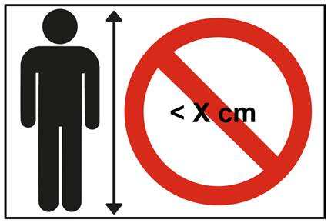"

*Paragraph 5.4.2.1*., amend to read:

"5.4.2.1. The words "i-Size universal ISOFIX", or "i-Size booster seat", or **"i-Size booster cushion", or** "specific vehicle ISOFIX" or "specific vehicle booster seat" or **"specific vehicle booster cushion", or** "Universal (belted)", or Specific vehicle (belted)" depending on the category of Enhanced Child Restraint System;"

*Paragraph 6.1.1*., amend to read:

"6.1.1. …

Enhanced Child Restraint Systems in the i-Size booster seat **or in the i-Size booster cushion** category are primarily designed for use in all i-Size seating positions.

Enhanced Child Restraint Systems in the specific vehicle ISOFIX category are for use in all ISOFIX positions and also in the luggage area, if the restraints are fitted in conformity with the vehicle manufacturer's instructions.

Enhanced Child Restraint Systems in the specific vehicle booster seat **or specific vehicle booster cushion** category are to be used according to manufacturer's instructions."

*Paragraphs 6.1.3.1. to 6.1.3.3.,* amend to read:

"6.1.3. According to the category as defined by Table 2, the Non-Integral Enhanced Child Restraint System and the child shall be secured in a vehicle seating position:

6.1.3.1. For the i-Size booster seat **and i-Size booster cushion** categor~~y~~**ies**, by means of the adult safety seat belt and possibly with optional ISOFIX attachments, if these are stowable (see Regulation No. 16, Annex 17, Appendix 5, Figure 1, Detail B).

6.1.3.2. For the specific vehicle booster seat **and specific vehicle booster cushion** categor~~y~~**ies**, by means of the adult safety seat belt and possibly with attachments designed by the manufacturer of the Enhanced Child Restraint System, secured to anchorages as designed by the vehicle manufacturer. Only ISOFIX attachments shall be used in conjunction with ISOFIX anchorage system.

Table 2

**Possible configurations of Non-Integral Enhanced Child Restraint Systems for type approval**

|  | *Orientation* | *Category* | | | |
| --- | --- | --- | --- | --- | --- |
| Non-integral |  | i-size booster seat | **i-size booster cushion** | Specific vehicle booster seat (built in included) | **Specific vehicle booster cushion (built in included)** |
| Forward Facing | A | **A** | A | **A** |
| Rearward Facing  **Lateral Facing** | N/A  **N/A** | **N/A**  **N/A** | N/A  **N/A** | **N/A**  **N/A** |

**A: Applicable**

**N/A. Non-applicable**"

*Insert a new paragraph 6.1.3.6*., to read:

"**6.1.3.6 For booster cushions, type approval shall not be granted for a stature below 125 cm. Booster cushions shall not be declared for use below a stature of 125 cm.**

**Booster cushions shall ensure that the top of the child's head is at or above a horizontal plane at 770 mm vertically from Cr when seated on the test bench described in Annex 6.**

**The procedure to check if a booster cushion fulfils this requirement is outlined as follows (See figure 1 below):**

**Figure 1  
Sitting height check measurement device**

**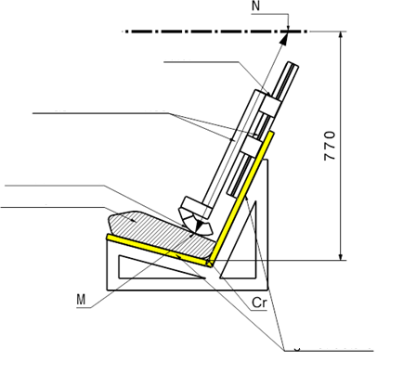**

Rigid structure

Booster cushion

Contact surface

Measurement device

Ruler

1. **A rigid mock-up of the test bench, as defined in Annex 25, is used for this check. The mock-up shall have the same geometry as the R129 test bench with enough rigidity. For the rest of the text the mock-up is called simulated test bench.**
2. **A rigid structure is attached to the simulated test bench and holds a sliding part. A horizontal plane that is located at a vertical distance of 770 mm from Cr is defined.**
3. **The booster cushion shall be placed on the simulated test bench with its centreline aligned with the centreline of the test bench and the rear surface of the booster cushion contacting the backrest of the test bench.**
4. **If ISOFIX attachments are present these shall be latched with the test bench lower ISOFIX anchorages. An additional force of 135 +/-15N shall be applied in a plane parallel to the surface of the simulated test bench. The force shall be applied along the centreline of the Enhanced Child Restraint System and at a height of no more than 100 mm above the simulated test bench seat surface.**
5. **The measurement device is extended downwards parallel to the simulated test bench backrest, until it is stopped by the booster seat cushion.**

**Figure 2  
Ruler of measurement device:**

**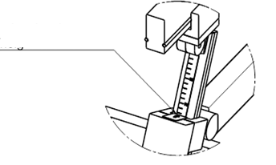**

Ruler showing sitting height of child

1. **The measured distance between the two points M and N represents the sitting height of a child who will use the cushion represented in Figure 1. The corresponding value is displayed by a ruler that is provided with the device as shown in Figure 1.**
2. **Using the data in Table 3, the sitting height is utilized to determine the corresponding minimum stature of the child that can be accommodated by the booster cushion. Example: A sitting height of 70,2 cm shall correspond to a child minimum stature of 125 cm; a sitting height of 81,1 cm shall correspond to 150 cm.**

**In case the value obtained for the sitting height is between two integer values always round up to the next integer value (e.g. Measured sitting height = 72,9 cm ► resulting stature = 132.25 cm ► Smallest stature allowed = 133cm)**

1. **The stature determined in this procedure shall be compared to the lower limit of the approval stature range. The requirement is fulfilled if the lower approval stature is greater or equal than the obtained minimum stature.**

Table **3  
Sitting heights with corresponding minimum statures (as indicated in Table 1 Annex 18)**

| *Minimum Sitting Height 95% [cm]* | *Stature [cm]* |
| --- | --- |
| **70,2** | **125** |
| **72,3** | **130** |
| **74,4** | **135** |
| **76,5** | **140** |
| **78,6** | **145** |
| **81,1** | **150** |

**Note: For statures in between the displayed values the respective sitting height needs to be calculated by means of a linear interpolation."**

*Paragraph 6.1.3.4*., amend to read:

"6.1.3.4. Enhanced Child Restraint Systems of the booster seat **and booster cushion** categories shall have a main load-bearing contact point, between the Enhanced Child Restraint System and the adult safety belt. This point shall not be less than 150 mm from the Cr axis when measured with the Enhanced Child Restraint System on the dynamic test bench installed in accordance with paragraph 7.1.3.5.2.2. of this Regulation, without a dummy. This shall apply to all adjustment setups and variable belt paths."

*Paragraph 6.2.1.5., amend to read*

"6.2.1.5. …to excessive stresses …

In the case of **booster seat and booster cushion categories**, the lap portion of the adult safety-belt shall be positively guided on both sides to ensure that the loads transmitted by the adult lap belt are transmitted through the pelvis.

…"

*Paragraph 6.3.2.1. amend to read*

"6.3.2.1. Internal geometric characteristics

….by the manufacturer.

**Booster cushions shall fulfill the minimum dimensions of hip breadth for the largest stature of the size range declared by the manufacturer. No other internal dimensions are applicable for booster cushions provided the booster cushions meets the requirements of paragraph 6.1.3.6.**"

*Insert a new paragraph 6.3.2.2.3.,* to read:

"**6.3.2.2.3. Booster Cushions**

The maximum external dimensions for the width, height and depth of the Enhanced Child Restraint System and the locations of the ISOFIX anchorages system if any, with which its attachments shall engage, shall be defined by the i-Size booster ~~seat~~ fixture as defined in paragraph 2.17.2. of this Regulation.

**(a) i-Size booster cushion Enhanced Child Restraint Systems shall fit within the ISO/B2 size envelope,**

**(b)** **Specific vehicle booster cushion** Enhanced Child Restraint Systems shall fit:

(i) In vehicle(s) specified in a list; or

(ii) At least in one of ISO/B2 or ISO/B3 size envelope as described in Annex 17, Appendix **5** of regulation No. 16."

*Paragraph 6.3.3.1., the reference to figure 0(a) and figure 0(a)*, renumber as figure 3(a)

*Paragraph 6.3.3.2., the reference to figure 0(b) and figure 0(b)*, renumber as figure 3(b)

*Paragraph 6.3.4.1., the reference to figure 0(c) and figure 0(c)*, renumber as figure 3(c)

*Paragraph 6.3.4.2.3., the reference to figure 0(c) and figure 0(c)*, renumber as figure 3(c)

*Paragraph 6.3.5.3., the reference to figure 0(d) and figure 0(d)*, renumber as figure 3(d)

*Paragraph 6.3.5.4., the reference to figure 0(e) and figure 0(e)*, renumber as figure 3(e)

*Paragraph 6.6.4.1., the reference to table 2 and table 2*, renumber as table 3

*Insert a new paragraph 6.6.4.1.3.1*., to read:

"**6.6.4.1.3.1.** **The dynamic test shall be performed on Enhanced Child Restraint Systems which have not previously been under load. The Enhanced Child Restraint System of the i-Size booster cushion category shall be tested on the test bench described in Annex 6, and in conformity with paragraph 7.1.3.1. below**."

*Paragraph 6.6.4.4.1.1., amend to read:*

"6.6.4.4.1.1. Forward facing Enhanced Child Restraint Systems

Head excursion: No part of the head of the dummy shall pass beyond the planes BA, DA and DE as defined in Figure 1 below. This shall be judged up to 300 ms or the moment that the dummy has come to a definitive standstill whatever occurs first. Except for **booster seats and booster cushions** when testing using Q10 dummy the following apply:

(a) The value in relation to the DA plane is 840 mm; and

(b) The value in relation to the BA plane is 550 mm; and

(c) The rebound phase is not considered for the assessment of the plane DA and DE.

**For booster cushions the following also apply when testing with a Q6:**

**(d) The rebound phase is not considered for the assessment of the plane DE.**

…

"

*Paragraph 6.4.4.1.1.1., figure 1*, renumber as figure 4

*Paragraph 6.4.4.1.2.1., figure 2*, renumber as figure 5

*Paragraph 7.1.3., amend to read:*

"7.1.3. Dynamic testing for frontal, rear and lateral impact:

(a) Frontal impact test shall be performed on i-Size (Integral Universal ISOFIX Enhanced Child Restraint Systems), Specific vehicle ISOFIX Enhanced Child Restraint Systems and to non-integral Enhanced Child Restraint Systems i-Size booster seats, specific vehicle booster seats, **i-Size booster cushions and specific vehicle booster cushions;**

…"

*Paragraph 7.1.3.5.2.2., the reference to figure 1 and figure 1,* renumber as figure 6 andamend to read:

"7.1.3.5.2.2. Installation of a non-integral Enhanced Child Restraint Systems on the test bench.

The unoccupied **non-integral Enhanced Child Restraint System** shall be placed on the test bench.

…

Figure **6**

**Load cell positions**

…

Fit load cell 1 to the outboard position as shown Figure **6** …"

*Insert a new paragraph 7.1.3.7., to read:*

"**7.1.3.7. Restraint of booster cushions**

**Place a cotton cloth on the seating surface of the test bench. Position the booster cushion on the test bench, position the lower torso body block as described in Annex 26, Figure 1, on the seating surface, fit and apply the 3-point adult safety-belt and tension as prescribed in paragraph 7.1.3.5.2.2. With a piece of 25 mm width webbing or similar tied round the booster, apply a load of 250 ± 5 N in the direction of arrow A, see Annex 26, Figure 2, in line with the seating surface of the test bench.**

**It should not be allowed that the booster cushion is completely pulled out under the lower torso body block**."

*Paragraph 7.2.8.5.,* *figure 3*, renumber as figure 7

*Paragraph 7.2.9.1., the reference to figure 4 and figure 4*, renumber as figure 8

*Insert a new paragraph 8.5*., to read:

"**8.5. For all categories of ECRS the following results shall be included in the test report:**

1. **The minimum and maximum approved stature range;**
2. **The internal dimensions according to Annex 18;**
3. **The minimum stature with corresponding sitting height according to paragraph 6.1.3.6.**"

*Paragraph 14.2.1*., amend to read:

"14.2.1.For i-Size Enhanced Child Restraint Systems **(incl. i-Size booster seats and i-Size booster cushions)** the following label shall be clearly visible on the exterior of the packing:

*Notice*

|  |
| --- |
| This is an i-Size Enhanced Child Restraint System. It is approved according to UN Regulation No.129, for use in, i-Size compatible vehicle seating positions as indicated by vehicle manufacturers in the vehicle users’ manual. |
| If in doubt, consult either the Enhanced Child Restraint System manufacturer or the retailer. |

*Annex 2,* amend to read:

"Annex 2

1. Arrangements of the approval mark

… according to which the approval has been granted.( the below paragraph is to be inserted after the section covering Specific Vehicle ISOFIX

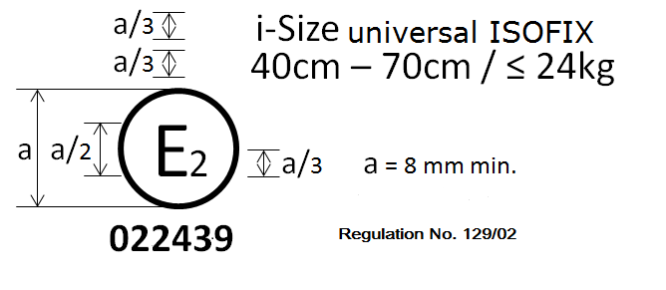

**Regulation No. 129/04**

**042439**

i-Size Booster cushion

125 cm - 150 cm

**The Enhanced Child Restraint System bearing the above approval mark can be fitted in any i-Size seating position and used for the 125 cm - 150 cm size range; it is approved in France (E 2) under the number 042439. The approval number indicates that the approval was granted in accordance with the requirements of the Regulation concerning the approval of Enhanced Child Restraint Systems used on-board of motor vehicles as amended by the series of amendments. In addition, the name of the regulation is to be identified on the approval mark followed by the series of amendment according to which the approval has been granted.**



**Regulation No. 129/04**

**042450**

Specific vehicle booster cushion

125 cm - 150 cm

**The Enhanced Child Restraint System bearing the above approval mark is a device not capable of being fitted in every vehicle but capable of being used for the 125 cm - 150 cm size range; it is approved in France (E 2) under the number 042450. The approval number indicates that the approval was granted in accordance with the requirements of the Regulation concerning the approval of specific vehicle booster cushion Enhanced Child Restraint Systems used on-board of motor vehicles as amended by the 04 series of amendments. In addition the name of the Regulation needs to be identified on the approval mark followed by the series of amendment according to which the approval has been granted.**

In case the Enhanced Child Restraint System is equipped with a module, the size range and the mass limit **shall be** on the module mark.

…"

*Annex 6 – Appendix 3,*

*Paragraph 1*, *Figure 2*, shall be deleted

*Insert new figures 2A and 2b,* to read:

Figure 2A   
Door panel geometry for testing integral ECRS with ISOFIX – side view (tolerance general: ±2 mm and ±1 degree)

**This door panel shall be used when the Integral ECRS under test is installed with ISOFIX.**

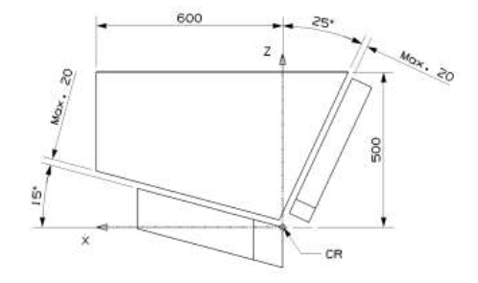

Figure 2B  
Door panel geometry for testing non-integral ECRS – side view (tolerance general: ±2 mm and ±1 degree)

**This door panel shall be used when the ECRS under test is installed with the adult seat belt.**

**Tests to extend the type-approval of Integral ISOFIX ECRS may also use this door, provided it was used for the original type-approval.**

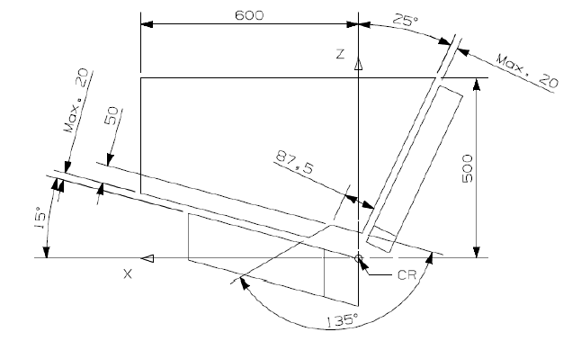

*Annex 20*, amend to read:

"Annex 20

**Minimum list of documents required for** approval

|  | *i-Size or i-Size booster seat or i-Size booster cushion Enhanced Child Restraint System* | *Specific vehicle ISOFIX or booster seat or booster cushion Enhanced Child Restraint System* | *Paragraph* |
| --- | --- | --- | --- |
| General documents | Application letter/request | Application letter/request | 3.1. |
| … | … | … | … |

"

*Insert new Annex 25*, to read:

**"Annex 25**

Measurement device for booster cushion height check



View D

**Calibration of the measurement scale**

**The calibration of the ruler is based on an idealized measurement in Computer-Aided design (CAD) using the frame of the measurement device on the rigid test bench simulating R129 test bench and a digital Q10 dummy. The dummy is raised so that its head is aligned with the horizontal bar at 770 mm and its back is in contact with the backrest of the test bench. In this position the distance from the dummy’s bottom to the seat cushion of the test bench is measured. This distance is added to the sitting height of the digital Q10 and the result is the calibration value. In our case the value is 81,1 cm.**

**To calibrate the ruler of the measurement device its structure has to contact the supporting surface (Detail A). In this configuration the scale has to show the calibration value – 81,1 cm (Detail B).**

**Detail B**

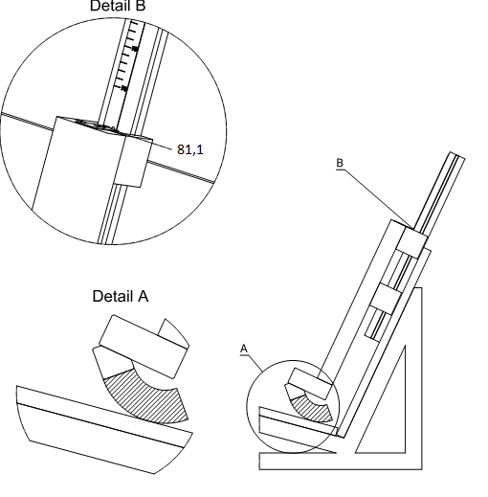

**Detail A**

*Insert new Annex 26,* to read:

"Annex 26

**Lower torso body block test**

Figure 1

**Manikin block (based on truncated P10)**

**Material: Expanded polystyrene (EPS) (40 to 45 g/l)**

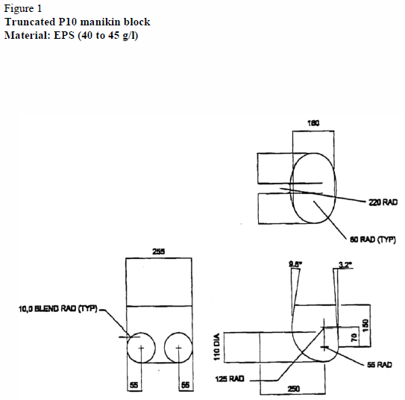

Figure 2

**Booster pull test using manikin block**

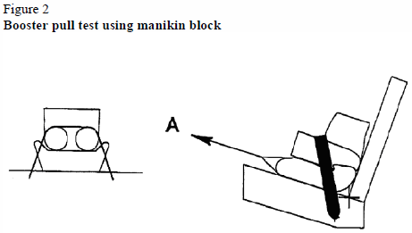

**"**

II. Justification

1. The present proposal aims at establishing provisions to allow Enhanced Child Restraint Systems of the booster cushion category to be included in the scope of UN Regulation No. 129.
2. To further improve the safety of booster cushion child restraint systems a new requirement for a minimum height of a child’s head was added. By this means it is assured that children can also benefit from the side impact protection equipment provided by vehicles.
3. The 01 series of amendments to UN Regulation No. 129 amended the door panel geometry to create a small opening, close to the seat bight. This was done to protect the panel from interaction with the anchorage of the adult seat belt on the test bench (which would be added later in the 02 series). Integral ISOFIX Enhanced Child Restraint Systems (ECRS) were also required to use this new door panel geometry, despite the belt not being used for these ECRS.
4. This proposal amends the 02 series of amendments (and all the following series) to UN Regulation No. 129 to require Integral ISOFIX ECRS to use the original door panel geometry with no opening (except during extensions of approvals in which the new panel geometry was used).
5. The proposal will ensure that ISOFIX ECRS designs cannot use the opening to mitigate loads to the ECRS and dummy. Integral belted and non-integral ECRS will continue to use the panel with an opening.

1. \* In accordance with the programme of work of the Inland Transport Committee for 2014–2018 (ECE/TRANS/240, para. 105 and ECE/TRANS/2014/26, programme activity 02.4), the World Forum will develop, harmonize and update UN Regulations in order to enhance the performance of vehicles. The present document is submitted in conformity with that mandate. [↑](#footnote-ref-2)