Proposal for amendments
to the 04 series of UN Regulation No.41
(Noise Emissions of motorcycles)

The text reproduced below was prepared by the expert from IMMA to clarify definitions provided in Regulation No. 41. The proposed amendments to the current Regulation are incorporated into the consolidated text and marked in bold for new or strikethrough for deleted characters.
- Proposal
Paragraph 2. Definitions, amend to read:
“2.1. "Approval of a motor cycle" means the approval of a motor cycle type with regard to noise;
2.2. "Type of motor cycle as regards its sound level and exhaust system" means motor cycles which do not differ in such essential respects as the following:
2.2.1. The type of engine (two-stroke or four-stroke, reciprocating piston engine or rotary-piston engine, number and capacity of cylinders, number and type of carburettors or injection systems, arrangement of valves, rated maximum net power and corresponding engine speed). For rotary-piston engines the cubic capacity should be taken to be double of the volume of the chamber;
2.2.2. Transmission system, in particular the number and ratios of the gears;
2.2.3. Number, type, arrangement and internal geometry of exhaust or silencing systems, as defined in 2.3 and 2.4.
2.3. "Exhaust or silencing system" means a complete set of components necessary to limit the noise caused by a motorcycle engine and its exhaust.
2.3.1. "Original exhaust or silencing system" means a system of a type fitted to the vehicle at the time of type approval or extension of type approval. It may also be the vehicle manufacturer's replacement part.
2.3.2. "Non-original exhaust or silencing system" means a system of a type other than that fitted to the vehicle at the time of type approval or extension of type approval.
2.4. "Exhaust or silencing systems of differing types" means systems which are fundamentally different in one of the following ways:2.4.1. Systems comprising components bearing different factory or trademarks;
2.4.2. Systems comprising any component made of materials of different characteristics or comprising components which are of a different shape or size;
2.4.3. Systems in which the operating principles of at least one component are different;
2.4.4. Systems comprising components in different combinations. “
II. Justification
The current type definition language, in its strictest sense, does not allow for multiple configurations, such as different exhausts, intakes or engine displacements, to be listed on the same approval certificate. A separate approval number and document must be generated for each unique configuration. As R41 approvals are utilized by more and more countries around the world, the increase in approval numbers and documentation burden associated with one configuration per approval can grow to the point becoming unmanageable and burdensome for the manufacturers and Type Approval Authorities. The proposed change to the Section 2.2.3 language clarifies that multiple exhaust versions’ results may be listed on a single R41 approval certificate and in which cases. This will reduce redundancy and minimize the chances for documentation errors.

2.2.3 – Examples of multiple exhaust versions which may be covered by one approval.
A. Exhaust versions with fundamentally identical internal geometries (same noise emission, different mounting brackets)

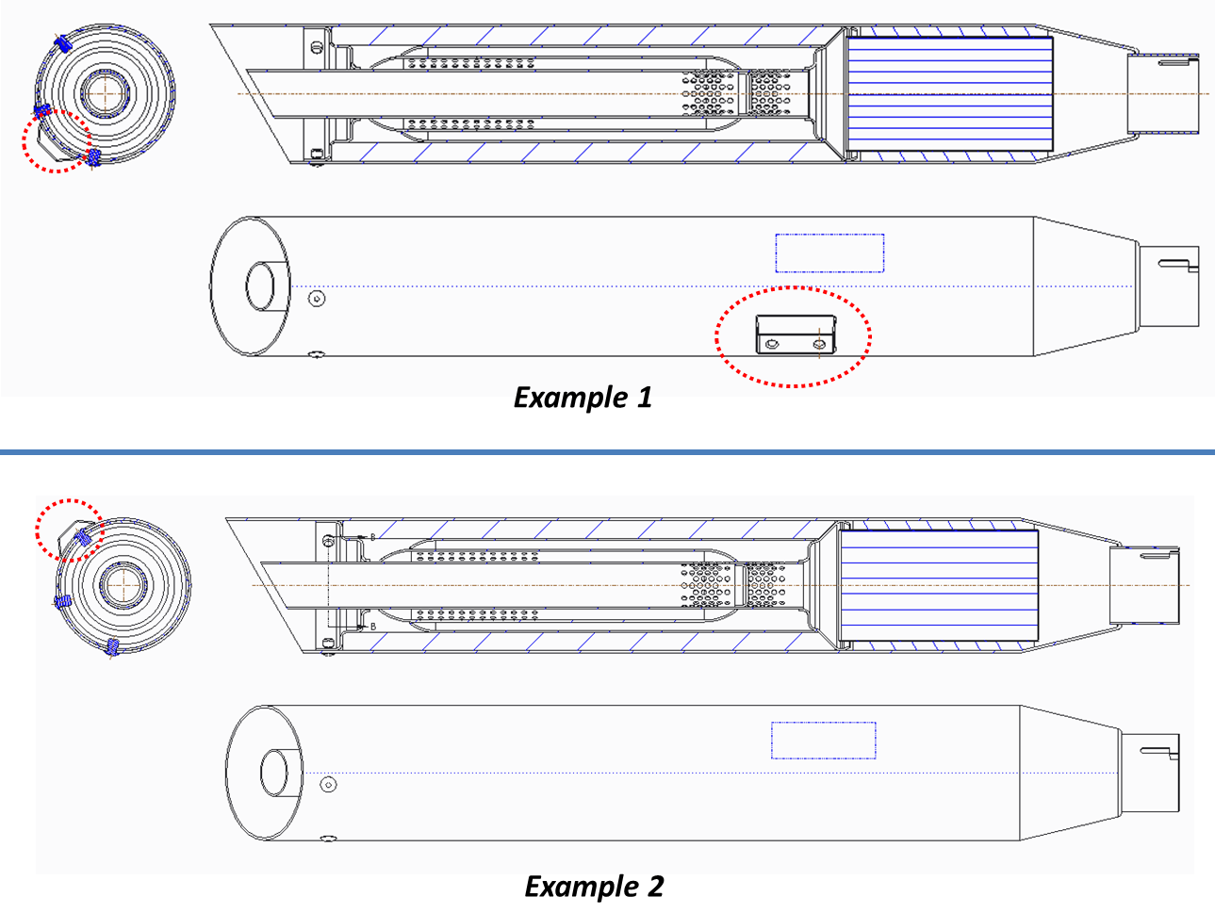

B. Exhaust versions with different shell materials or cosmetic finish (e.g. black painted versus chrome)

______________________

