|  |  |  |  |
| --- | --- | --- | --- |
|  | United Nations | ECE/TRANS/2018/2 | |
| _unlogo | **Economic and Social Council** | | Distr.: General  12 December 2017  Original: English |

**Economic Commission for Europe**

Inland Transport Committee

**Eightieth session**

Geneva, 20-23 February 2018  
Item 4 (a) of the provisional agenda  
**Strategic questions of a horizontal policy nature**

Status of accessions to United Nations transport agreements and conventions under the purview of the Inland Transport Committee

Note by the secretariat

|  |
| --- |
| *Summary* |
| This document presents the status of accessions by ECE and non-ECE member States to the United Nations transport agreements and conventions administered by ECE. |
| On 1 December 2017, the total number of contracting parties to the 58 United Nations legal instruments in the field of transport administered by ECE was 1733, with eight new contracting parties to seven legal instruments. |
| The Committee may wish to invite countries, which have not yet done so, to accede to the United Nations conventions and other legal instruments in inland transport administered by the Committee and its subsidiary bodies. |
|  |

I. Overview

1. Figure 1 below shows the growth of the total number of contracting parties to legal instruments on inland transport concluded under the purview of the Inland Transport Committee (ITC). On 1December 2017, the total number of contracting parties to the 58 United Nations legal instruments in the field of transport administered by the United Nations Economic Commission for Europe (ECE) was 1,733, with eight new contracting parties to seven legal instruments (see annex for details). Out of these 58 legal instruments, nine have not yet entered into force. The summary tables on the status of signatures, ratifications and accessions for all legal instruments are available at www.unece.org/trans/conventn/intro.html.

Figure 1

**An increasing annual growth of contracting parties to legal instruments on inland transport concluded under the purview of the ITC**

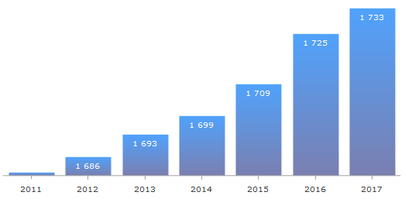

*Source*: ECE

2. Figure 2 below illustrates the evolution of accessions by ECE and non-ECE member States since 1950:

Figure 2

**Number of ECE and non-ECE member State accessions to legal instruments on inland transport concluded under the purview of the ITC, per year**



*Legend:* Solid line: ECE member States - Dotted line: non-ECE member States

*Source*: ECE

3. Of the 193 United Nations Member States, 145 States (75 per cent) are contracting parties to at least one legal instrument on inland transport. Nine per cent of the United Nations Member States are contracting parties to at least 30 legal instruments, but 24 per cent of countries are not contracting parties to a single legal instrument.

4. The accessions of China (2016) India (2017) and Pakistan (2015) to the Customs Convention on the International Transport of Goods under Cover of TIR Carnets (TIR Convention), of 14 November 1975, confirmed the ever-growing importance of transport facilitation and the strong need for a globally harmonized framework to promote international trade and transport. The three new contracting parties account for 40 per cent of global population. It is expected that the TIR system will be operational in the three countries in 2018.

**II. Geographical distribution of contracting parties**

5. The total number of contracting parties to the 58 transport conventions is 1,733 (as of 1 December 2017). Of these, 1,345 are ECE contracting parties and 388 are non-ECE contracting parties.

6. Of the 145 United Nations Member States that are contracting parties, 89 (61 per cent) are non-ECE member States.

7. Out of the 58 legal instruments under the purview of the ITC, 49 are in force. Non-ECE member States are contracting parties to 29 transport conventions. This means that about 60 per cent of United Nations transport conventions serviced by ECE and in force have a geographical coverage beyond the territory of the ECE. On average, each ECE member State is party to 23 legal instruments, while each non-ECE member State is party to 13 legal instruments.

Figure 3

**ECE and non-ECE member States   
Contracting parties to at least one United Nations transport convention**

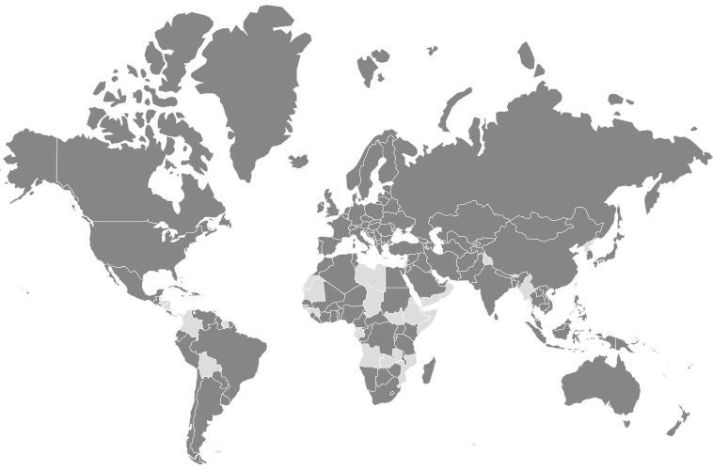

*Legend:* Dark grey: contracting parties - Light grey: non-contracting parties

*Source:* ECE

8. The European Union is a contracting party to seven legal instruments. In the future, other regional integration initiatives may likely seek to become contracting parties as well.

9. Forty-eight United Nations Member States are not contracting parties to any legal instruments on inland transport concluded under the purview of the ITC: Angola, Belize, Bhutan, Bolivia (Plurinational State of), Brunei Darussalam, Cabo Verde, Chad, Colombia, Comoros, Democratic People's Republic of Korea, Djibouti, Dominica, Equatorial Guinea, Eritrea, Ethiopia, Gabon, Gambia, Grenada, Guinea, Guinea-Bissau, Honduras, Kiribati, Libya, Maldives, Marshall Islands, Mauritania, Micronesia (Federated States of), Mozambique, Myanmar, Nauru, Nicaragua, Oman, Palau, Panama, Saint Kitts and Nevis, Saint Lucia, Saint Vincent and the Grenadines, Samoa, Sao Tome and Principe, Somalia, South Sudan, Suriname, Swaziland, Timor-Leste, Tuvalu, Vanuatu, Yemen, Zambia.

10. The Committee may wish to consider this information and provide guidance to the Working Parties and the secretariat on ways to increase the number of new accessions to the legal instruments under its purview.

**Annex**

**Accessions registered from 1 January - 1 December 2017**

| *Date* | *Contracting party* | *Convention* |
| --- | --- | --- |
| 8 November 2017 | Iran (Islamic Republic of) | Protocol to the Convention on the Contract for the International Carriage of Goods by Road (CMR) |
| 15 August 2017 | Slovenia | Additional Protocol to the CMR concerning the electronic consignment note (e-CMR), 2008 |
| 13 July 2017 | Slovenia | Convention on Road Traffic, 1949 |
| 15 June 2017 | India | Customs Convention on the International Transport of Goods under Cover of TIR Carnets (TIR Convention), of 14 November 1975 |
| 28 March 2017 | Ukraine | [Protocol amending article 1 (a), article 14 (1) and article 14 (3) (b) of the European Agreement of 30 September 1957 concerning the International Carriage of Dangerous Goods by Road (ADR)](http://www.unece.org/trans/conventn/legalinst_54_tdg_padr.html) |
| 17 March 2017 | Poland | European Agreement on Main Inland Waterways of International Importance (AGN), of 19 January 1996 |
| 1 February 2017 | Iraq | [Convention on Road Traffic, of 8 November 1968](http://www.unece.org/trans/conventn/legalinst_08_rtrss_rt1968.html) |
| 31 January 2017 | Croatia | Protocol to the Convention on the Contract for the International Carriage of Goods by Road (CMR) |