UN/SCETDG/54/INF.42

Committee of Experts on the Transport of Dangerous Goods
and on the Globally Harmonized System of Classification
and Labelling of Chemicals 23 November 2018
Sub-Committee of Experts on the
Transport of Dangerous Goods
Fifty-fourth session

Geneva, 26 November-4 December 2018
Item 2 (d) of the provisional agenda
Recommendations made by the Sub-Committee on its fifty-first, fifty-second and fifty-third sessions and pending issues: electric storage systems
Hazard based classification of lithium cells and batteries
First elements of a classification scheme in complement to document UN/SCETDG/53/INF.37 prepared for the Working group meeting 5-6 December 2018 in Geneva
Transmitted by the expert from France and RECHARGE
Introduction
- Two lunchtime working groups where held last session (26 and 27 June 2018) in Geneva on this issue. Their reports can be found in document UN/SCETDG/53/INF.66. It was also agreed that a new meeting of the intersessional working group would take place after the session of the Sub-Committee, on 5 and 6 December 2018 hosted by IATA in Geneva.
- In preparation of this new meeting of the working group, ideas to address the classification of batteries are submitted in this document. An actualized flowchart is proposed. This document has been prepared to help the discussions in the working group, but is also presented to the sub-committee for information, in order to the Sub-Committee to be able to give some last recommendations for the working group to consider if necessary.
- Some hypotheses and principles considered in the present document are similar to the one already presented in informal document INF.37 (53rd session). Other have been modified or added following the discussions reported in informal document INF.66 (53rd session). They may be modified after further discussions, data presented by other attendees during IWG and possible additional experimental testing. However, they are based on current knowledge and experience gained from testing.
- Some modifications have been drafted in order to offer answers to questions and comments listed in informal document INF.66 (53rd session) as mentioned under the following points (a) to (h) where the references to the modified procedures and paragraphs in the following parts of the document appear in bold underlined text after each question :
(a) A definition of propagation must be established: see annex 1.3.
(b) The group must consider how the temperature of propagation should be evaluated: see par 26 and 27.
(c) The method for initiation needs to be better defined: see par 15. The heating protocol is not yet precisely defined but general considerations can be stated:
(i) The aim of the heating is to induce a reaction of the abused cell;
(ii) Heating device should be small enough to minimize the influence on the other cells;
(iii) Heating device should trigger the thermal runaway of the abused cell as fast as possible to minimize the influence on the other cells.
(d) The issue of projection hazard should be considered and placed either in the flow chart or as a general condition of concern: see par 16.
(e) When considering GAS HAZARD, differentiation may be needed to determine toxicity and explosive atmosphere of gas as well as volume. See par 23 and 25.
(f) The group should determine how to address bias of test methodology regarding the size of the cell. (i.e. is the hazard represented by larger cells or batteries overly emphasized due to size alone): The IWG should discuss this point. Presentation of concrete examples during the session might help the group reasoning.
(g) How does cell propagation relates to battery propagation? : General principle of categorization should remain the same. Above a given weight (10-20 kg) consequences of a single battery thermal runaway can be considered serious whether it propagates or not. Propagation test might not be appropriate anymore. For batteries below this weight, propagation-based classification and testing seems both appropriate and feasible.
(h) At which point is it possible to stop testing and assign classification by reasoning? similar to question g.

Proposals for a hazard-based classification for Li-ion cells
- Actualized proposition of classification for Li-ion cells:
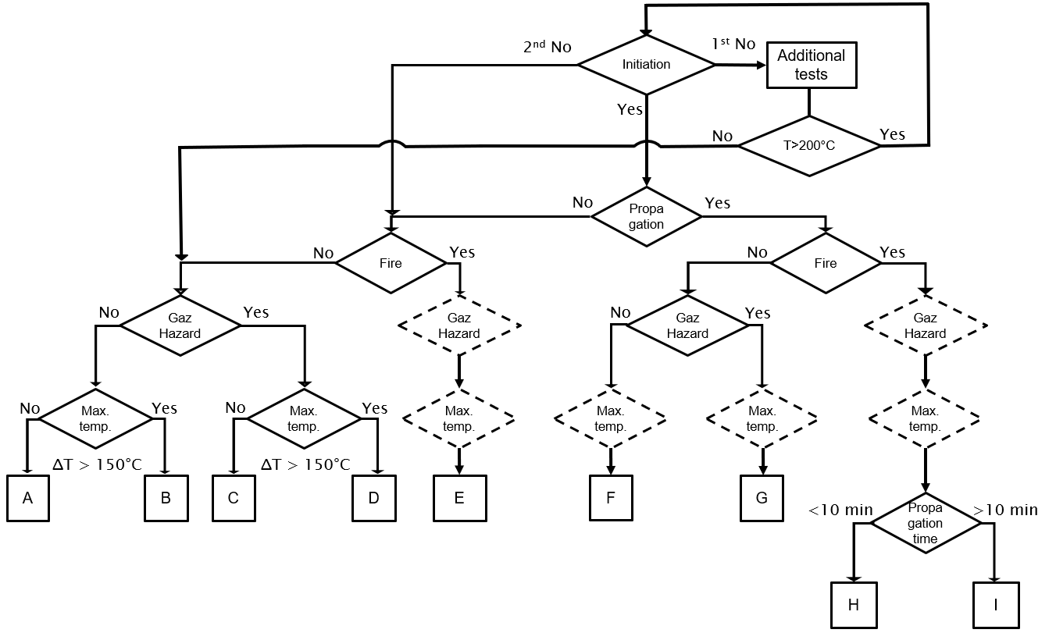
- As for now, the proposed classification differentiates 9 categories:
- For practical reasons, the 9 categories have been assigned a letter from “A” to “I”. However, categories are currently purely descriptive and should not be seen as a hierarchy of hazard.
- A: benign hazard
- B: high temperature hazard
- C: gas hazard
- D: high temperature and gas hazard
- E: high temperature and gas hazard with the presence of flames
- F: propagation and high temperature hazard
- G: propagation, high temperature and gas hazard
- H: propagation, high temperature and gas hazard with the presence of flames
- I: propagation, violent reaction, high temperature and gas hazard with the presence of flames
- For the sake of simplicity, and to limit the complexity of the classification diagram, some hypotheses were considered:
- When there is propagation between cells, the temperature is generally higher than 170°C and the hazard coming from high temperature is therefore systematically considered in the diagram for boxes F, G, H and I.
- In the presence of fire, the high temperature hazard is systematically considered and therefore, directly assumed for box E.
- In the presence of fire, the gas hazard is difficult to assess due to possible incomplete combustion and possible presence of toxic or suffocating gas. The hazard is systematically considered high in this case and is assumed for boxes E, H and I.
- When there is propagation between cells without fire, the reaction is propagating through thermal conduction and is usually less violent. Therefore, at this point the propagation time has not been introduced in the diagram for boxes F and G.
- Each point where the diagram requires a decision to be made shall be based from data coming from tests. Some existing standards may provide some of those tests. However, the thermal propagation test is specific and should be developed. Once solid data will be gained by experience it could be possible to establish conservative default classification values to minimize the cost of testing.
- At this point, cells are considered to be tested at a state of charge (SOC) of 100%.
Initiation and propagation criteria
- The thermal propagation test proposed is a thermal abuse inspired by the test method of SAE AS6413 standard, currently under discussion, and is described in annex 2. This apparatus allows the characterization of three hazards: the propagation behavior, the presence of flame and the gas hazard.
- Other apparatus (in open atmosphere) and initiation method (nail penetration, short circuit…) are possible for the determination of thermal propagation. The responsible test organization should be able to run the test in similar conditions (sealed box, thermal insulation …) and prove that the abuse leads to effects equivalent of thermal abuse as described in annex 2.
- In the test proposed in annex 2, thermal runaway of the abused cell is demonstrated if at some point the cell temperature increases at a higher rate than the thermal pad temperature.
- In the test proposed in annex 2, thermal propagation is demonstrated if at least one of the following events happens:
- The witness cell vents, leaks or goes in thermal runaway
- The temperature of the witness cell increases abruptly
- The temperature of the witness cell is higher than 170°C
- If the abused cell does not react when exposed at the standard abuse protocol (annex 2), additional tests should be run. This procedure adds extra work and cost but is limited to a small minority of cells.
- An abusive test, equivalent to an internal short circuit should be run on a single cell.
- If the maximal temperature (Tmax) reached during this test is lower than 200°C, and the cell is not subject to thermal runaway when exposed to 200°C for 1h, propagation and fire hazard are not considered, and classification continues with evaluation of gas hazard.
- If the maximal temperature (Tmax) reached during this test is higher than 200°C, the standard thermal propagation test should be reproduced increasing the temperature of the thermal abuse up to Tmax for 1h.
- If after the procedure presented in 17.c. the abused cell does not present a thermal runaway, propagation and fire hazard are not considered, and classification continues with evaluation of fire hazard based on test used in 17.a.
- If during the test proposed in annex 2, at least one of the cell is subject to violent disassembly, the test is considered invalid and should be done again. To validate the protocol, the disassembly should be reproducible (happen on three tests in a raw). The violent disassembly is determined by visual means (fragments ejected). One solution would be to assign a specific category to those cells, signaling a general condition of concern. This point must be discussed within the IWG and data or studies about this phenomenon are welcome.
Fire hazard
- The fire hazard can be determined by observation during the thermal propagation test described in annex 2. Fire means that flames are emitted from the cell (as defined in the UN Manual of Test and Criteria, paragraph 38.3.2.3)
- If the observation of flame is obstructed by the apparatus used in the thermal propagation test, an alternative thermal runaway test, run on a single cell in open atmosphere, can also be used to assess fire hazard.
Gas hazard
- The criterion for gas hazard determination relates to the total volume of gas emitted and all the gases emitted are considered potentially harmful to human and flammable. This volume threshold, in absence of fire, should be further discussed. Several options are potentially possible:
- A critical volume of emitted gas can be defined (example: Xl/cell)
- A critical volume per kWh of cell can be defined (example: Xl/kW)
- In analogy with the recommendations for transport of water-reactive material (Vol 1, 2.4.4.3), a gas emission rate of 20 liter per gram of battery and per hour can be proposed.
- An opacity criterion (which is often used in official reaction to fire testing of materials that can be used in rolling stock and air transportation). In addition and to some extends this criterion will be bounded to toxicity and total volume of gas emitted.
To make a choice between those options, data and bibliographical work are welcome.
- The gas hazard could be assessed also during the thermal propagation test described in annex 2. An alternative thermal runaway test, run on a single cell, can also be used to assess the volume of gas emitted. The test must be performed in a set-up allowing the measurement of the total volume of emitted gas. For example, an airtight box equipped with temperature and pressure sensors can be used.
- Gases emitted may include, but are not limited to:
(a) Carbon dioxide (CO₂)
(b) Carbon monoxide (CO)
(c) Carbonates
(d) Hydrogen (H₂)
(e) Hydrogen fluoride (HF)
(f) Oxygen (O₂)
They are considered a priori harmful to human, flammable and corrosive.
- If the volume of emitted gases is higher than the non-hazardous criterion, the responsible organization can prove that emitted gases are not hazardous in the expected concentration by using advanced characterization method (FTIR, gas analyzer, GC-MS …). Those cells can then be considered as non-hazardous regarding to the gas hazard.
- In most cases, gas emitted are a mix of toxic and flammable gas. In some specific cases there might be non-flammable emissions. If the IWG validate this approach, the inflammability of the gas emissions could be tested by implementing an additional device and procedure in the test protocol described in annex 2 (for example using an electric arc generator).
- Even if the gas is demonstrated nontoxic and non-flammable, limit quantities should still be imposed to avoid asphyxia.
- Explosion hazard that might be caused by emission of fine dust or mist is not considered since (a) it is an extremely marginal phenomena during cell thermal runaway and (b) the inflammation energy is much higher for dust than gas (10-100 mJ for dust versus few mJ for gas).
High temperature hazard
- The temperature threshold considered as hazardous is 170°C. It has been chosen to be under the melting point of metallic Li (170°C) and under auto-ignition temperature of paper (218°C). This temperature is also harmonized with criterion in the recommendation on the transport of dangerous goods UN Manual of Test and Criteria, paragraph 38.3.4 (6th revised edition).
- The high temperature hazard is considered if (Tmax-Tignition) of the abused cell is higher than 150°C
Propagation time
- The threshold for propagation time has been fixed at 10 min between two neighbors cells experiencing a thermal runaway. It is estimated that above this lapse of time the thermal runaway of a single cell can not lead to a massive thermal runaway event where a large amount of cell is simultaneously involved. This time threshold must be discussed during the IWG.
Next steps
- The following actions are already identified to elaborate a concrete categorization of Li-ion batteries:
- For cell assembly (modules and packs) the same categorization can be applied. For some large batteries, it should be nonetheless possible to avoid testing. For example, a pack verifying some construction requirements and being composed of class A cells can be considered safe for transportation.
- At this point, cells are considered to be tested at a state of charge (SOC) of 100%. In further work, it must be assessed how the SOC could lead to other classifications. Introducing this consideration in the test scheme would lead to the introduction of other regulation modifications to ensure that the battery is transported at the specified SOC.
- The packaging requirements associated to the risk in transport of the different categories identified in this document should be considered in a later stage.

Annex 1
Classification criteria definitions
- Fire: Fire means that flames are emitted from the cell (as defined in UN Manual of Test and Criteria, paragraph 38.3.2.3).
- Gaz hazard: a volume of gas above at the threshold value, and with a composition presenting either flammability risks or toxicity risks.
- Propagation: Transfer of heat energy from a cell experiencing thermal runaway that results in thermal runaway in one or more adjacent cells or batteries. The criteria for propagation is defined in annex 2 as: The witness cell vents, leaks or goes into thermal runaway; the temperature of the witness cell increases abruptly; the temperature of the witness cell is higher than 170°C.
- T_{ignition}: the temperature (°C) at which the temperature of the cell starts to increase faster than the temperature set by the thermal pad.
- Thermal runaway: Uncontrolled increase in the temperature of a cell or battery driven by exothermic processes.

Annex 2
First draft of a thermal propagation test protocol
- To evaluate thermal propagation, more than two cells must be on test. To avoid heat dispersion through multiple cell, the number of “neighbor” cell should be minimized. The optimal number of cell for thermal propagation test is then 3 cells.
- To ensure reproducibility of results, the test should be performed three times in the same conditions and result in the same conclusion.
- Setup proposed for cylindrical and prismatic cells:

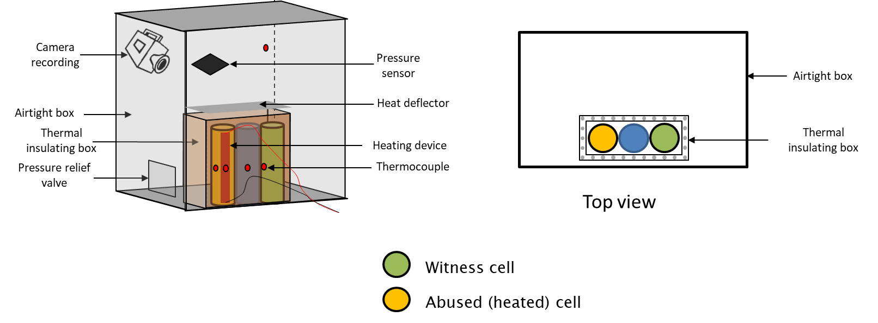

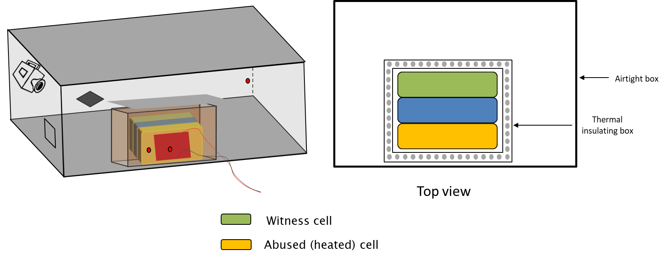
- The cells are placed into the test chamber in a way to maximize contact surface.
- The cells are contained in a thermal insulated box (opened on top) allowing heat dissipation only in the direction of the witness cell side. To minimize heat dissipation during fire or venting events, a heat deflector is placed above the insulated box
- At the beginning of the test, the temperature in the test chamber should be between 15 and 30°C.
- The volume of the chamber has to be defined.
- The heating device should be capable of increasing the cell temperature at a rate of 5 to 20°C per minute, up to 200°C.
- The heating device is placed on a side of the heated cell to avoid heating other cells. Other initiation source and configurations are possible depending on the characteristics of the cells. The heating device in covered by an insulating layer to avoid heat loss.
- The set up allows to record the test and visualize smoke and flame emissions.
- Thermocouples are placed on each cell and in the chamber. A control thermocouple is placed on the heating device.
- A pression sensor is placed in the chamber to calculate the total volume of gas emitted during the test. If the gas hazard is assessed during another test, the chamber does not have to be equipped with a pressure sensor.
- The testing protocol consist to heat the abused cell up to 200°C and maintain this temperature for 1h.
- The abused cell is considered to enter in thermal runaway when its skin temperature is increasing at a higher rate than the heating device.
- When the abused cell enters in thermal runaway, the heating device is stopped.
- Propagation criteria are:
- The witness cell vents, leaks or goes into thermal runaway
- The temperature of the witness cell increases abruptly
- The temperature of the witness cell is higher than 170°C
- Propagation criteria (temperature, venting, leaking or runaway) are evaluated on the witness cell because:
- The abused cell parameters are not representative of thermal propagation
- The first neighbor cell parameters are variable, and non-reliable due to its proximity with the heater. It is then difficult to use these results for classification purpose.
- The device is kept under observation 6 hours after the end of the procedure

