UN/SCETDG/54/INF.21
UN/SCEGHS/36/INF.12

Committee of Experts on the Transport of Dangerous Goods
and on the Globally Harmonized System of Classification
and Labelling of Chemicals 31 October 2018
Sub-Committee of Experts on the  Transport of Dangerous Goods | Sub-Committee of Experts on the Globally Harmonized System of Classification and Labelling of Chemicals
Fifty-fourth session | Thirty-sixth session
Geneva, 26 November-5 December 2018  Item 2 (b) of the provisional agenda  Recommendations made by the Sub-Committee on its fifty-first, fifty-second and fifty-third sessions and pending issues: explosives and related matters | Geneva, 5-7 December 2018  Item 3 (a) of the provisional agenda  Classification criteria and related hazard communication: work of the Sub-Committee of Experts on the Transport of Dangerous Goods (TDG) on matters of interest to the GHS Sub-Committee
Recommendations for Test Series 8:
Background for information supporting ST/SG/AC.10/C.3/2018/67−ST/SG/AC.10/C.4/2018/17
Transmitted by the expert from Canada and the Institute of Makers of Explosives (IME)
Background
- This paper summarizes the research on the limitations of the Koenen test as applied to ammonium nitrate emulsions, suspensions, and gels (ANEs), specifically emulsions, and supports the working paper ST/SG/AC.10/C.3/2018/67−ST/SG/AC.10/C.4/2018/17.
Introduction
- The Koenen Test is featured extensively in the Manual of Tests and Criteria (MTC), appearing in Test Series 1, 2, 8, and E.1. It is a very useful test when determining the effect of heating under confinement, as these Test Series aim to cover.
- In a comprehensive discussion on this test, presented at the 39th session (informal document INF.53 (59th session)), the Australian Explosives Industry Safety Group (AEISG) analyzed the research of Koenen and Ide in 1956 that led to the refinement and subsequent inclusion of the Koenen Test in the MTC. The principal criterion of this test is the fragmentation pattern of the steel tube which is used to establish whether a substance has passed or failed.
- The fragmentation photographs (Figure 1) in Koenen and Ide’s 1956 paper depict patterns F and G as fail, i.e. they show a positive. In the MTC the positives are shown as artist’s sketches (Figure 2), and in the most recent revision, photographs of the fragmented tube.

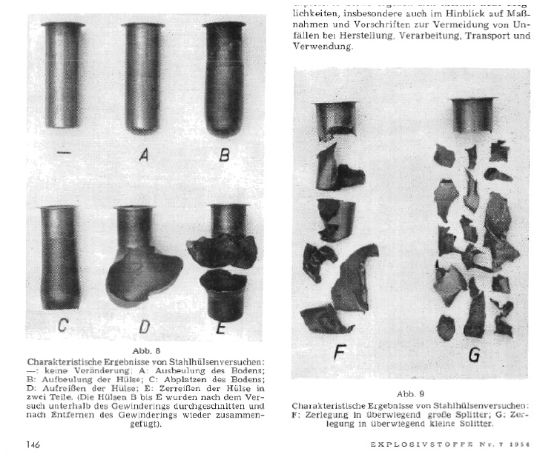
Figure 1. Tube deformation, fragmentation patterns and effect levels reproduced from Koenen and Ide’s 1956 papers (UN/SCETDG/39/INF.53)
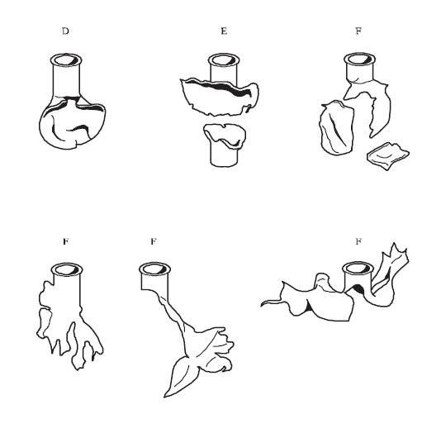
Figure 2. Tube deformation, fragmentation patterns and effect levels reproduced from Figure 18.6.1.3 of MTC6.

- In informal document INF.53 (39th session), it is presented that the type F, defined in paragraph 18.6.1.3.4 is where the “tube fragmented into three or more mainly large pieces which in some cases may be connected with each other by a narrow strip”; and further argued that the second row of sketches in Figure 2. “are more consistent with tearing apart of a weakened tube, and bear little resemblance to any original Koenen and Ide photographs.” This indicates that the original criteria of fragmentation has been made more restrictive by including patterns from a ‘tearing apart of a weakened tube’, which is the pattern typically obtained with an ANE.
Useful temperature range and time
- Koenen and Ide, in their 1956 paper, showed that the bursting pressure of the tube was relatively constant until 300oC, which transposed on their temperature-time chart gives a maximum usable time of approximately 25 seconds, as depicted in Figure 3. (from Figure 1 of informal document INF.53 (39th session)). The ranges identified are those created by the author of the INF paper.
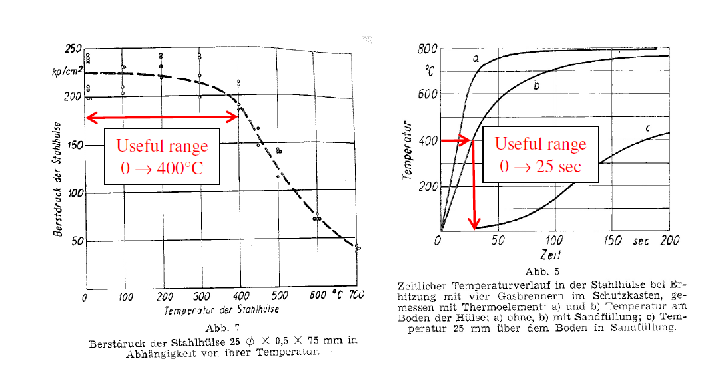
- (ii)
Figure 3. Calibration data reproduced from UN/SCETDG/39/INF.53. (i) Bursting pressure versus temperature; (ii) Temperature versus time
- The significance of Koenen and Ide’s charts is that heating times longer than 25 seconds increase the temperature of the tube, which weakens the tube construction and results in the bursting pressure of the tube decreasing with time. At 500oC, the bursting pressure is half that of the original steel, and from Chart (ii) above that corresponds to approximately 40 seconds, for the curve (b), which shows the temperature measured in a tube filled with sand.
- In the 1950s, ANEs were non-existent so this substance was not tested by Koenen and Ide. Unlike the substances tested, ANEs are significantly less reactive, requiring times of reaction that start at 73 seconds (excluding cases where the orifice was blocked), and can extend to over 300 seconds. Such prolonged times are clearly outside the useful range for the Koenen Test, and will also result in steel that is a fraction of the original strength due to its higher temperature. For example, at 200 seconds, the temperature of the steel is ~750ºC, which corresponds to a bursting pressure of ~40 kp/cm², which is less than 1/5th of the original pressure.
- The reaction times of ANEs and the substances tested by Koenen and Ide, and other researchers, are reproduced in Figure 4.
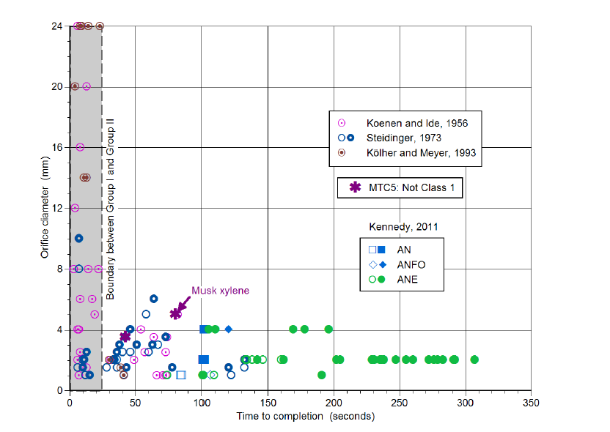
Figure 4. Orifice diameters versus times to completion in the Koenen test.
10. Open symbols refer to tests that terminated in tube rupture. While closed symbols refer to tests where the tube did not rupture. [The greyed zone represents Group I, with the distinction between Group I and Group II being discussed in Part of informal document INF.53 (39th session))]
11. The use of the Koenen Test for relatively unreactive substances was highlighted in informal document INF.53 (39th session) using the test results for musk xylene. In the process of its classification, there arose a contradiction: “so while TS2(b) Koenen test placed musk xylene provisionally into Class 1, the other thermal tests TS 1(c), TS 2(c), TS 3(c), TS 3(d), TS 6(a) and TS 6(c) all returned negative results, subsequently moving it out of Class 1.”
12. The reason cited for such an observation was that musk xylene had a total reaction time to completion of 79 seconds, as depicted on Figure 4.
13. A subsequent paper by AEISG and the Institute of Makers of Explosives (IME) (informal document INF.3 (47th session)) provided further evidence, both from modelling and experimentation, that “the multiple fragments formed in prolonged Koenen tests are the result of the steel tube having weakened substantially, rather than being diagnostic of ‘explosion’.”
14. At the forty-ninth session, AEISG submitted a paper on the parametric analysis of Test Series 8 and ANE bulk transport containers (informal document INF.60 (49th session)). The analysis shows the absorbed heat flux as a function of the heated surface area to volume ratio. The chart is reproduced below in Figure 5.
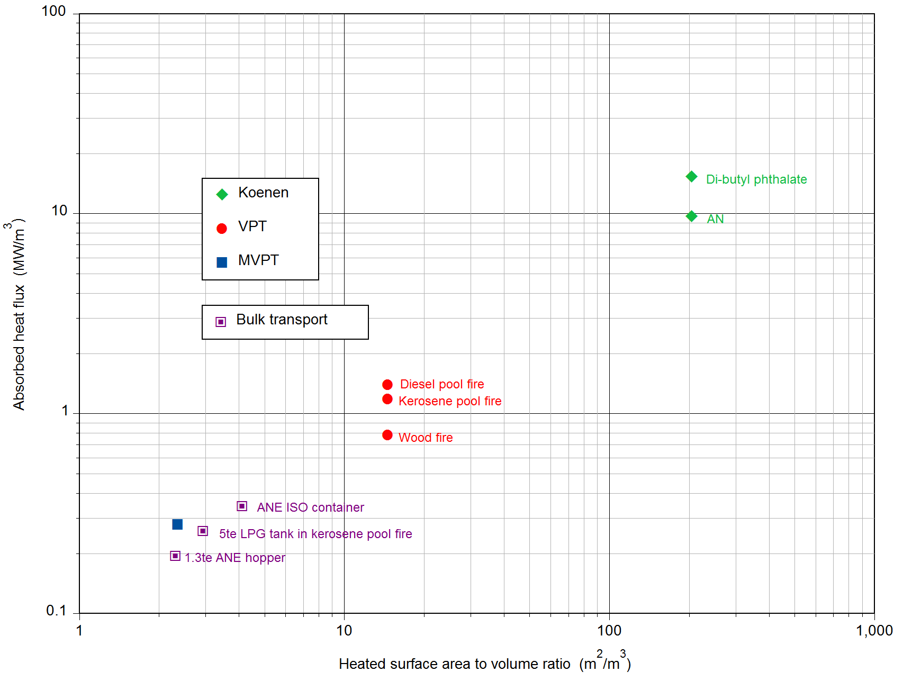
Figure 5. Absorbed Heat Flux versus Heated Surface Area to Volume Ratio
15. It is seen that the Koenen Test parameters identified: absorbed heat flux and heated surface area to volume ratio are two orders of magnitude higher than those for commercial transport means such as an ISO container, or an ANE hopper. The Koenen Test therefore is of a significantly higher severity than the substance would ever be exposed to in transport.
16. A comparison was also made of the burst pressures of the portable tanks used for ANE transport and the containment used for the Koenen test and the Vented Pipe Test (VPT), which is effectively a large scale Koenen test. The chart is reproduced in Figure 5. The current specification of 30 ± 3 MPa (300 ± 30 bar) for the burst pressure of the Koenen vessel refers to its strength at ambient temperature. Figure 5 includes measurements by Koenen and Ide of the variation of burst pressure with temperature for the original vessels manufactured from corrosion-resistant steel. Burst pressures predicted by the finite element hydrocode LS-DYNA based on the variation of yield strength with temperature for this type of steel (…/49/INF.60) are also shown in Figure 5 for the Koenen steel tube as well as vessels used for the VPT and modified VPT (MVPT). As seen in Figure 6 the burst pressure for the Koenen test steel tube is approximately two orders of magnitude higher than the minimum burst pressure specified for T1/T2 Portable Tanks, the range of which extends from 1.5bar to 6 bar.
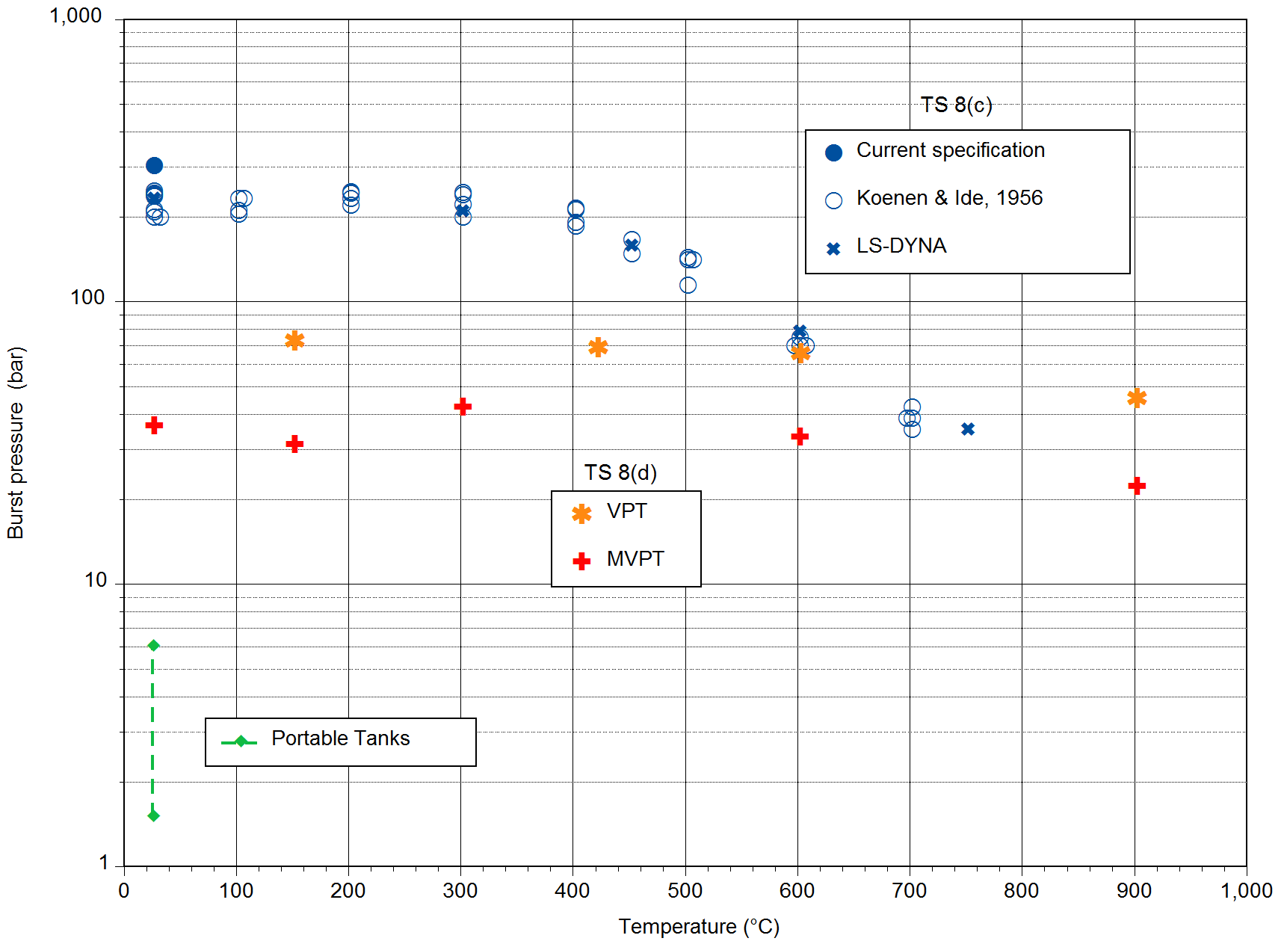
Figure 6. Burst Pressure versus Temperature
Concluding Remarks
17. It was agreed by the Explosives Working Group at the 47th session that the Koenen Test, as specified in Test Series 8 was inappropriate for ANEs, and specifically emulsions. The papers discussed above highlight the limitations of the Koenen test for ANEs, since their relative low reactivity requires a prolonged heating time for reaction. This prolonged heating reduces the bursting pressure due to the increase in temperature of the steel tube.
18. The substances tested by Koenen and Ide in the development of this test, and subsequent researchers, were those that ignite while the bulk of the substance is still cool and in its original form, i.e. with little decomposition. This ignition propagates through the cold bulk material and over pressurizes the steel tube with a bursting pressure over 20MPa. As such, these substances tested in the 1950s most probably had minimum burning pressures (MBP) close to ambient.
19. In contrast, ANEs have MBPs in the range 5 – 15 MPa, largely due to the presence of up to 15 percent water. Hence for some ANEs the use of the MBP test is a suitable alternate, as is being proposed in ST/SG/AC.10/C.3/2018/67−ST/SG/AC.10/C.4/2018/17 from the Expert from Canada and the IME.

Informal document INF.53 (forty-seventh session), para. 6.

