|  |  |  |  |
| --- | --- | --- | --- |
|  | United Nations | ST/SG/AC.10/C.3/2018/79 | |
| _unlogo | **Secretariat** | | Distr.: General  3 September 2018  Original: English |

**Committee of Experts on the Transport of Dangerous Goods  
and on the Globally Harmonized System of Classification  
and Labelling of Chemicals**

**Sub-Committee of Experts on the Transport of Dangerous Goods**

**Fifty-fifth session**

Geneva, 26 November-4 December 2018  
Item 2 (c) of the provisional agenda  
**Recommendations made by the Sub-Committee on its fifty-first,   
fifty-second and fifty-third sessions and pending issues:**

**Listing, classification and packing**

Exemptions for polymerizing substances

Transmitted by the European Chemical Industry Council (CEFIC)[[1]](#footnote-2)\*

Introduction

1. In the nineteenth edition of the Model Regulations, the Sub-Committee of Experts on the Transport of Dangerous Goods introduced new criteria and UN numbers for polymerizing substances in Division 4.1.

2. The definition of section 2.4.2.5.1 describes polymerizing substances as “substances which, without stabilization, are liable to undergo a strongly exothermic reaction resulting in the formation of larger molecules or resulting in the formation of polymers under conditions normally encountered in transport.”

3. However, the text does not contain any provisions about exemptions.

4. Based on the experience with the transport of polymerizing substances over the last years industry believes it would be helpful to introduce some criteria for exemptions for small packages in analogy to Class 1 articles in packages (see Annex I). Although the polymerizing substances are not articles, the criteria laid down for the packages can be applied also for the less dangerous polymerizing substances. The criteria have been slightly changed to adapt for polymerizing substances. During the discussions with experts from the competent authorities two values for the temperature on the outside of the package have been proposed. Both are mentioned in the proposed text.

5. Based on the comments from experts from the competent authorities a note was added to explain what the term “in hazardous amounts” means.

6. In response to the suggested testing for the effect of heating under confinement (Koenen-Test), CEFIC thinks that this test shouldn’t be applied for small packages for several reasons:

(a) The products will polymerize in the test apparatus, and as a result, the lab equipment would be damaged beyond repair;

(b) Products of high viscosity will clog the orifice of the test apparatus and lead to a false positive result because of mechanical overpressure and not explosive pressure build-up due to gaseous decomposition products;

(c) The proposed criteria rather refer to the damage that the package would suffer itself, so the substance under confinement is taken into account by the tests proposed for this exemption (see 2.4.2.5.3 (b) in the proposal below).

7. CEFIC suggests the described proposal in analogy to 2.1.3.6.4 (a) and (b) of the Model Regulations (see Annex I) to include an exemption based on the maximum temperature on the surface and criteria for minor damage of the packaging:

8. In addition, to meet the concerns of some delegations, the new proposal is limited to small packages, so IBCs and tanks are excluded from the exemption in the first step, to gain experience. The packages are tested as used for the transport and not combined to a certain amount.

Proposal

9. In the Model Regulations, insert a new section 2.4.2.5.3 to read as follows:

“2.4.2.5.3 Any substance packed in small packages shall be exempted from classification as a polymerizing substance of Division 4.1 in that package, provided that upon thermal initiation of the polymerization:

(a) The temperature on the surface of the package does not exceed 100 °C;

(b) There is no effect outside the package, except that the package might open without release of its contents; and

(c) No toxic or flammable gases are released in dangerous amounts (see notes 1 and 2).

The assessment shall be based on evidence obtained either by experiment in a 1:1 scale on the package size used for transport or by a model derived from experimental kinetic data in consideration of the heat loss of the package.

***NOTE 1:*** *Dangerous amounts of toxic gases mean: less than 1% of the gas inside the package is toxic and/or the gas mixture inside the package, when toxic gas is released during the polymerization, should not be classified as toxic based on the criteria in 2.2.3.*

***NOTE 2:*** *Dangerous amounts of flammable gases mean: an evolution of a flammable gas at a rate greater than 1 liter per kilogram of the polymerizing substance per hour.”*

Justification

10. The 1% value in Note 1 is the cut-off limit used in GHS for mentioning a toxic ingredient in the Safety Data Sheet. The “gas mixture inside the package” refers to the mixture of air and gases emitted during polymerization.

11. The evolution rate referred to in Note 2 is taken from paragraph 33.4.1.4.4.1 (b) of the Manual of Test and Criteria used for substances which in contact with water emit flammable gases”.

12. The above proposed criteria are supported by the following test:

An epoxy adhesive classified as UN3240, Self-Reactive Solid Type F, temperature controlled, packaged in sheet form with 80 individual sheets with a net weight of 14.56 kg, exhibiting a heat of polymerization of 345J/g determined by differential scaling calorimetry (DSC), was determined to have a Self-accelerating polymerization temperature (SAPT) of 55 °C. The package exhibited swelling due to the product design which is intended to expand upon curing.



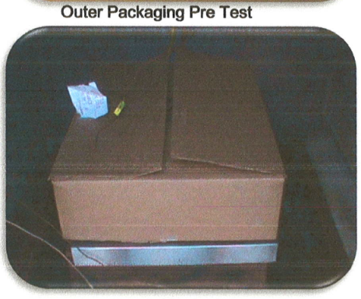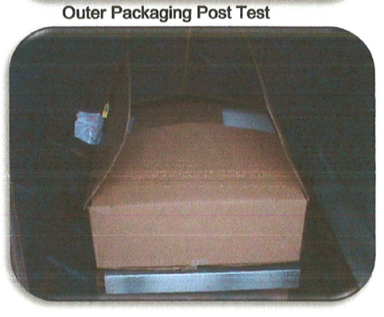

13 Prior to the test, the package had been opened to place the thermocouples into the middle of the material. In spite of this weakening effect, no product could escape, as it was fully polymerized. The package was not damaged by the heat that developed during the test. Therefore, the criteria that are proposed are fulfilled:

(a) The temperature on the surface of the package did not exceed 100/75 °C,

(b) There was no effect outside the package except that the packages might open without release of its contents*, there is no effect like spillage outside the package and the package itself is not damaged, just open, and*

(c) No gases had been released at all.

14. There was also a package tested with only 7 sheets of the above described product. The 7-sheet package configuration was also tested at 55 °C and that package passed the test. The package never exceeded a 6 °C rise in temperature. There was no change in the package after testing. Therefore, it makes sense for these products, to test the package used for transport instead of a 50 kg package.

Annex I

Text of paragraph 2.1.3.6.4 in the Model Regulations:

“2.1.3.6.4 An article may be excluded from Class 1 when three unpacked articles, each individually activated by its own means of initiation or ignition or external means to function in the designed mode, meet the following test criteria:

**(a) No external surface shall have a temperature of more than 65°C. A momentary spike in temperature up to 200°C is acceptable.**

**(b) No rupture or fragmentation of the external casing or movement of the article or detached parts thereof of more than one metre in any direction.**

(c) No audible report exceeding 135 dB (C) peak at a distance of one metre

(d) No flash or flame capable of igniting a material such as a sheet of 80 ± 10 g/m² paper in contact with the article; and

No production of smoke, fumes or dust in such quantities that the visibility in a one cubic metre chamber equipped with appropriately sized blow out panels is reduced more than 50% as measured by a calibrated light (lux) meter or radiometer located in one metre from a constant light source located at the midpoint on the opposite walls. […].”

1. \* In accordance with the programme of work of the Sub-Committee for 2017–2018 approved by the Committee at its eighth session (see ST/SG/AC.10/C.3/100, paragraph 98 and ST/SG/AC.10/44, para. 14). [↑](#footnote-ref-2)