|  |  |  |  |
| --- | --- | --- | --- |
|  | United Nations | ST/SG/AC.10/C.3/2018/53 | |
| _unlogo | **Secretariat** | | Distr.: General  4 April 2018  Original: English |

**Committee of Experts on the Transport of Dangerous Goods  
and on the Globally Harmonized System of Classification  
and Labelling of Chemicals**

|  |
| --- |
| **Sub-Committee of Experts on the Transport of Dangerous Goods** |
| **Fifty-third session** |
| Geneva, 25 June-4 July 2018  Item 2 (j) of the provisional agenda **Explosives and related matters:  miscellaneous** |

A method for transporting controlled shipments of explosives that are not yet classified (≤ 25 grams)

Transmitted by the Sporting Arms and Ammunition Manufacturers’ Institute (SAAMI)[[1]](#footnote-2)

Introduction

1. This working paper is a follow-up to working paper ST/SG/AC.10/C.3/2017/51 which was endorsed by the Explosives Working Group (EWG) with recommendations for consideration. There was general agreement of the EWG that these proposed shipping methods would be of value for those that are involved in international round robin testing and their adoption into the Model Regulations was desirable. It was also noted by the EWG that the shipping methods described in ST/SG/AC.10/C.3/2017/51 provide a safe way to transport as yet unclassified explosives for testing and product development (Refer to informal document INF.53 (52nd session)). The proposal below reflects the recommendations of the EWG.
2. The description of the specialized container has been augmented with additional design specification, technical references, and pictorial engineering control options for ensuring the explosives are cantered in the container.
3. In addition to the 2014 test results for these containers provided in the previous paper, this paper has been updated to include a summary of the test results from 2014, 1983, and 1977 which form the technical basis for this proposal.

Description of a specialized container for solids

4. The US Special Permit 8451 (DOT-SP 8451 38th Revision) describes the currently approved shipping containers and configurations that can be used to safely transport up to 25 grams of solid or powdered explosives comparable to the energy of Pentaerythritol tetranitrate (PETN). These include the following inner packagings:

(a) Design Type 1: A 4-inch x 14-inch Schedule 80 seamless steel pipe nipple (per ASTM A106 Grade B) closed at both ends with 4-inch diameter forged steel end caps (3,000 psi per ASTM 105); or

(b) Design Type 2: A 6-inch x 12 to 14-inch Schedule 80 seamless steel pipe nipple (per ASTM A106 Grade B) closed at both ends with 6-inch diameter forged steel end caps (3,000 psi per ASTM 105); or

(c) Design Type 3: A 8-inch x 30-inch Schedule 80 seamless steel pipe nipple (per ASTM A106 Grade B) closed at both ends with 8-inch diameter forged steel end caps (3,000 psi per ASTM 105); or

(d) Design Type 4: Bartle’s device; or

(e) Design Type 5: Los Alamos Model LD-2250” (may only be used if the net mass of explosives contained within does not exceed 15 grams).

5. The explosive sample is sealed in a bag or other leak-proof receptacle and centered inside the container so as to not be next to the walls or caps. The container is then placed in an outer package comprised of fiberboard, plywood, or metal. The outer package is to facilitate handling and has no bearing on the containment of an explosive event in the container.

It is suggested that engineering controls are instituted to ensure that the leak-proof receptacles are cantered in the container. The following photos are visual representations of possible engineering controls.

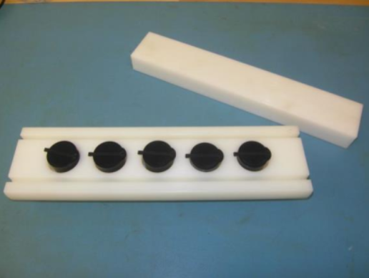 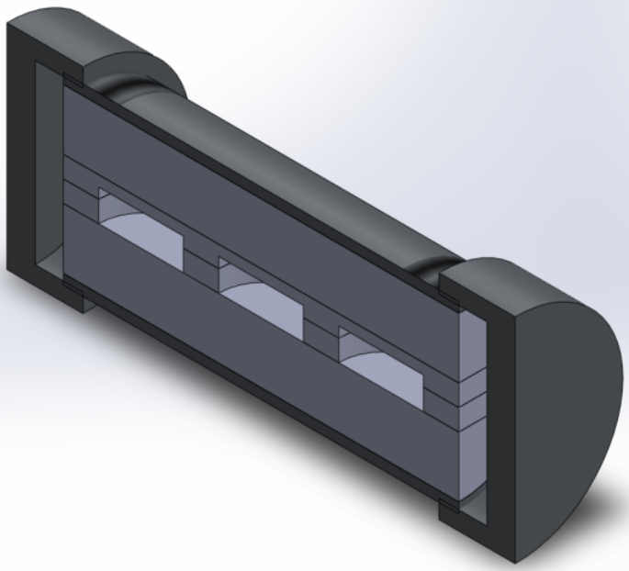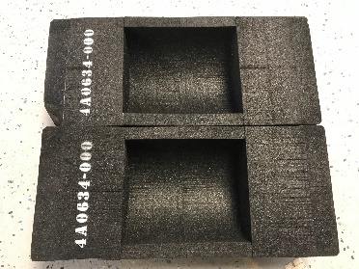

6. The suggested container to be used for transport of solid or powdered explosive samples is the same as that outlined in DOT-SP 8451, 38th Revision, Design Type 1. A 4-inch shipping pipe and example outer packaging is pictured below.

|  |  |
| --- | --- |
| S:\0-PROJECT\0013 - Shipping Containers\0008 - Shipping Container Photos\4inPipe_I.png |  |

Summary of test results from 2014, 1983 and 1977

7. Test data has shown that 35 grams (a 40% overcharge) of dry PETN and 52.5 grams (a 210% overcharge) of LX-10 (95% HMX, 5% binder) does not result in any hazardous effects outside of the pipe of Design Type 1 and Design Type 2. All of the explosives effects are contained within the pipe.

8. Testing was performed in 2014 on the DOT-SP 8451, 38th revision, Design Type 1 shipping pipe to verify that 35 grams (a 40% overcharge) of dry PETN does not result in breaching or fragmenting the pipe and to determine the maximum pressure effect outside of the shipping pipe. 35 grams of PETN was placed inside the pipe with a blasting cap. Wires to the cap were feed through a sealed insulated port to significantly limit the escape of gases. Over pressure probes were used to record the maximum overpressure and video of the test was also recorded.

9. An external fire test was also completed to verify that 25 grams of dry PETN does not result in fragmentation or damage to the pipe. Table 1 contains the test results for both tests.

# Table 1

# **Test results (2014)**

| **Net explosive weight (g)** | **Test description** | **Result** |
| --- | --- | --- |
| 35.0 | Single Package Test – initiated with standard #8 blasting cap | No hazardous effects were observed outside of the shipping pipe. The pipe was not breached, cracked or fragmented. No discernible blast overpressure or pressure pulse waveforms. |
| 25.0 | External Fire Test | No rupture, no external damage to outer package, no damage to pipe nipple or end caps. |

10. Tests were performed in 1983 using a 6-inch x 14-inch seamless schedule 80 pipe. The explosive charge used was LX-10 (95% HMX, 5% binder). Table 2 contains the test results.

# Table 2

# **Test results (1983)**

| **Net explosive weight (g)** | **Test description** | **Result** |
| --- | --- | --- |
| 52.5 | Single Package Test - -initiated with SE-1 Detonator (0.25 g PETN & 0.38 9407 PBX). End caps contained ¾-inch plug weld to increase end cap rating to approximately 2500 psi. | No rupture, no external damage to outer package, no damage to pipe nipple/end caps. |
| 52.5 | Single Package Test - 28mg EBW Detonator. 250 psi malleable iron end caps were used (what was readily available at the time) | No rupture, no external damage to outer package, no damage to pipe nipple/end caps. |

11. The following Table 3 contains the original test results from testing performed in 1977 at Sandia National Laboratories. A 4-inch x 14-inch seamless schedule 80 pipe was used with 3,000 psi rated end caps (per ASTM A 105). The explosive charge used was LX-10 (95% HMX, 5% binder).

# Table 3

# **Original test results (1977)**

| **Net explosive weight (g)** | **Test description** | **Result** |
| --- | --- | --- |
| 26.2 | Single Package Test - 28mg EBW Detonator | No rupture, slight pipe bulge |
| 26.0 | Single Package Test - 28mg EBW Detonator | No rupture, slight pipe bulge |
| 26.0 | Single Package Test - 28mg EBW Detonator | No rupture, slight pipe bulge |
| 25.8 | Single Package Test - 28mg EBW Detonator | No rupture, slight pipe bulge |
| 26.2 | Single Package Test - 28mg EBW Detonator | No rupture, slight pipe bulge |
| 26.0 | External Fire Test | No detonation, no damage to pipe |
| 26.0 | External Fire Test | No detonation, no damage to pipe |
| 26.0 | External Fire Test | No detonation, no damage to pipe |
| 26.2 | Single Package Test - 28mg EBW Detonator | No rupture, slight pipe bulge |
| 33.0 | Single Package Test - 28mg EBW Detonator | No rupture, slight pipe bulge |
| 50.8 | Single Package Test - 28mg EBW Detonator | No rupture, slight pipe bulge |

Proposal

12. SAAMI proposes the following system for discussion:

* Create a new UN number for shipment of solids
* Create a new UN number for shipment of liquids
* Create an annex with specifications for the containers
* Add sub-section 2.1.3.4.X of the Model Regulations to detail the use of these UN numbers, with a reference to the specifications annex
* Assign a special provision to these UN numbers. The special provision would reference sub-section 2.1.3.4.X and the annex, and require a competent authority approval document to accompany the shipment.

1. In accordance with the programme of work of the Sub-Committee for 2017–2018 approved by the Committee at its eighth session (see ST/SG/AC.10/C.3/100, paragraph 98 and ST/SG/AC.10/44, paragraph 14). [↑](#footnote-ref-2)