|  |  |  |  |
| --- | --- | --- | --- |
|  | United Nations | ST/SG/AC.10/C.3/2018/45 | |
| _unlogo | **Secretariat** | | Distr.: General 5 April 2018  Original: English |

**Committee of Experts on the Transport of Dangerous Goods  
and on the Globally Harmonized System of Classification  
and Labelling of Chemicals**

**Sub-Committee of Experts on the Transport of Dangerous Goods**

**Fifty-third session**

Geneva, 25 June-4 July 2018  
Item 6 (b) of the provisional agenda

**Miscellaneous proposals for amendments to the   
Model Regulations on the Transport of Dangerous Goods:  
packagings**

Composite Intermediate Bulk Containers (IBCs): inner receptacle marking

Transmitted by the expert from Belgium[[1]](#footnote-2)

Introduction

1. In accordance with 6.5.2.2.4, the inner receptacle of composite IBCs shall be identified by the application of the marks indicated in 6.5.2.1.1 (b), (c), (d) where this date is that of the manufacture of the plastics inner receptacle, (e) and (f). The UN packaging symbol shall not be applied. The marks shall be applied in the sequence shown in 6.5.2.1.1. It shall be durable, legible and placed in a location so as to be readily visible when the inner receptacle is placed in the outer casing.
2. Most of the composite IBCs with a rigid inner plastic receptacle are made by assembling a pallet as base, a metal open glitter cage and a plastic inner receptacle (see pictures in the annex to this document). After assembling the mark on the inner receptacle is readily visible.
3. Beside the above described IBCs, composite IBCs with full external walls (metal shelfs or plastic shelves) also exist (see picture in the annex to this document). These IBC’s are mostly used for conditioning chemicals requesting high purity.
4. The full outer shelf construction is to prevent the products from any external environmental influence (such as light, dust…) and to cover also the upper side of the inner receptacle.
5. After assembling the inner receptacle (marked in accordance with 6.5.2.2.4) into the full outer shelf of the IBC, the mark of the inner receptacle is not readily visible.
6. The part of the sentence “…. when the inner receptacle is placed in the outer casing.” leaves room for different interpretations: Must the mark be visible only during the assembling or remain visible also after assembling?
7. We are of the opinion that the importance of having the mark on the inner receptacle is to have a traceable system which assures, that in accordance with the prototype, the correct inner receptacle has been used during the assembling.

Proposal

8. Amend the first paragraph of 6.5.2.2.4 to read as follows: (new text underlined, ~~deleted text stricken trough~~)

“6.5.2.2.4 Inner receptacles that are of composite IBC design type shall be identified by the application of the marks indicated in 6.5.2.1.1 (b), (c), (d) where this date is that of the manufacture of the plastics inner receptacle, (e) and (f). The UN packaging symbol shall not be applied. The marks shall be applied in the sequence shown in 6.5.2.1.1. It shall be durable, legible and placed in a location so as to be readily visible ~~when~~ during the assembling of the inner receptacle ~~is placed~~ in the outer casing.”.

Annex

Composite IBCs with glitter cage

[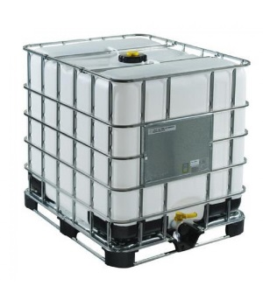](https://www.google.be/url?sa=i&rct=j&q=&esrc=s&source=images&cd=&cad=rja&uact=8&ved=0ahUKEwi7_bby3vnVAhVBLFAKHaY4CEUQjRwIBw&url=https://www.amphorea.co.uk/IBC-1000-Litre-SM13&psig=AFQjCNFB98amkm9Lu1GP0ua06Zdw-d8_cQ&ust=1504003255462539)[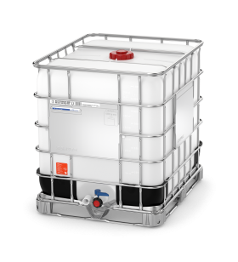](https://www.google.be/url?sa=i&rct=j&q=&esrc=s&source=images&cd=&cad=rja&uact=8&ved=0ahUKEwj17byZ3_nVAhVEEVAKHeR_AJIQjRwIBw&url=https://www.schuetz-packaging.net/schuetz-benelux/nl/SOLUTIONS/de-ibc-als-logistiek-hulpmiddel/&psig=AFQjCNE_gG8gj7HWL7VV6qSWq9NK6-Vbnw&ust=1504003337127384)[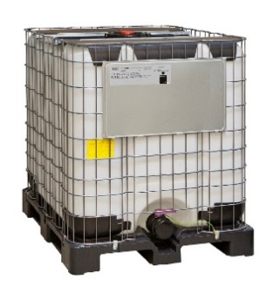](http://www.google.be/url?sa=i&rct=j&q=&esrc=s&source=images&cd=&cad=rja&uact=8&ved=0ahUKEwiktpji3_nVAhXHJlAKHWiJDZgQjRwIBw&url=http://emballage.sotralentz.com/index.php/de/emballages-industriels-en-pehd-4/ibc&psig=AFQjCNHYrSCYif34Mu1mK7mLVLZ2Ct1vdw&ust=1504003494459974)

Composite IBCs with full external walls

[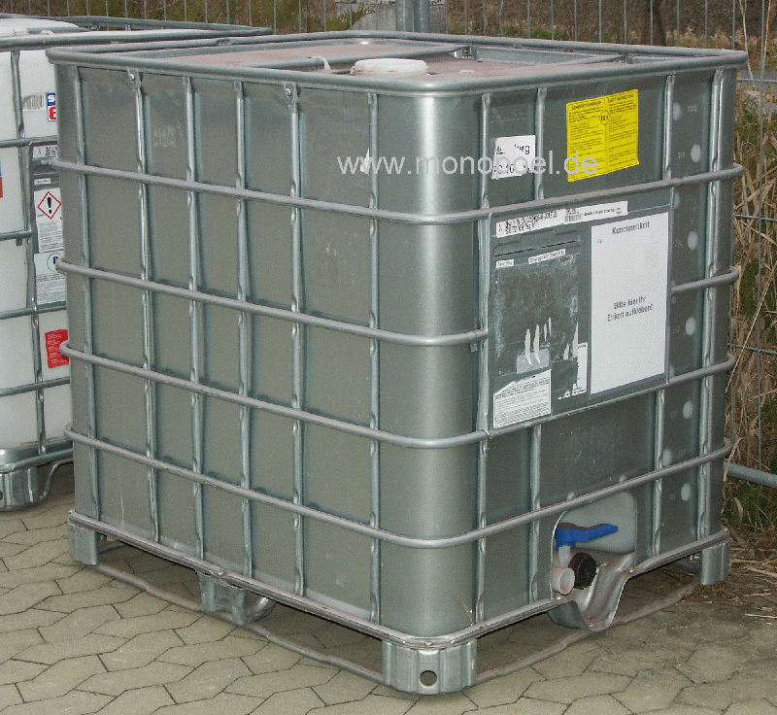](http://www.monopoel.de/catalog/images/ibc-1000-stun-800.gif) 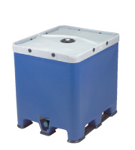 [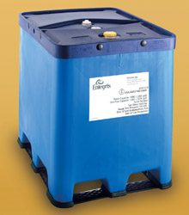](http://www.google.be/url?sa=i&rct=j&q=&esrc=s&source=images&cd=&cad=rja&uact=8&ved=0ahUKEwju8ceZ4PnVAhWCKVAKHZs8CtEQjRwIBw&url=http://www.entegrisfluidhandling.com/Default.asp?G%3D1685&psig=AFQjCNE9t9MaZdjIUXT0MAeB-lLAj0GoqQ&ust=1504003602458104) 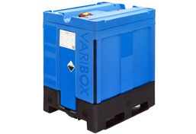

1. In accordance with the programme of work of the Sub-Committee for 2017–2018 approved by the Committee at its eighth session (see ST/SG/AC.10/C.3/100, paragraph 98 and ST/SG/AC.10/44, para. 14). [↑](#footnote-ref-2)