|  |  |  |  |
| --- | --- | --- | --- |
|  | United Nations | ECE/TRANS/WP.29/GRRF/2017/12 | |
| Description: _unlogo | **Economic and Social Council** | | Distr.: General  7 July 2017  Original: English |

**Economic Commission for Europe**

Inland Transport Committee

**World Forum for Harmonization of Vehicle Regulations**

**Working Party on Brakes and Running Gear**

**Eighty-fourth session**

Geneva, 19-22 September 2017

Item 3(c) of the provisional agenda

**Regulations Nos. 13 and 13-H: Clarifications**

**Proposal for amendments to Regulation No. 13 (Heavy vehicle braking)**

**Submitted by the experts from France and Germany**[[1]](#footnote-2)\*

The text reproduced below was prepared by the experts from France and Germany to simplify the verification of the sufficient movement on the balancer without having to take measurements underneath the trailer in a potentially unsecure position. The modifications to the existing text of the Regulation are marked in bold for new or strikethrough for deleted characters.

I. Proposal

*Annex 12,*

*Paragraphs 2.3.10. and 2.3.11.,* shall be deleted.

*Paragraph 2.3.12. (former),* amend to read and renumber:

"2.3.10. scd **Maximum** **d**ifferential travel ~~at~~ the compensator **is capable to accommodate due to its geometric and constructive properties** when only one brake operates in the forward direction and the other in reverse direction **while allowing equal tension in both cables/rods.**

~~Where  s~~cd ~~= s~~~~cr~~ ~~– s~~~~cf~~(see Figure 5A of appendix 1)"

*Footnote 1*, shall be deleted.

*Paragraph 8.1.2.,* amend to read:

"8.1.2. Drawing details are to be provided to demonstrate that the compensator articulation is sufficient to ensure equal cable tension is applied to each of the rear cables. The compensator needs to have sufficient distance across the width to facilitate the differential travels left to right. The jaws of the yokes also need to be deep enough relative to their width to make sure that they do not prevent articulation when the compensator is at an angle.

Differential travel at compensator (scd) shall be derived from:  
 ~~S~~~~cd~~ ~~>= 1.2 • (S~~~~cr~~ ~~– S~~~~c~~~~’)~~

**Scd ≥ 1.2 • Sr**

~~Where:  
S~~~~c~~~~’ = S’/i~~~~H~~ ~~(travel at compensator – forward operation) and S~~~~c’~~ ~~= 2\*S~~~~B~~~~/i~~~~g~~~~S~~~~cr~~ ~~= S~~~~r~~~~/i~~~~H~~ ~~(travel at compensator – reward operation)~~"

*Annex 12, Appendix 1,**Figure 5A*, amend to read:

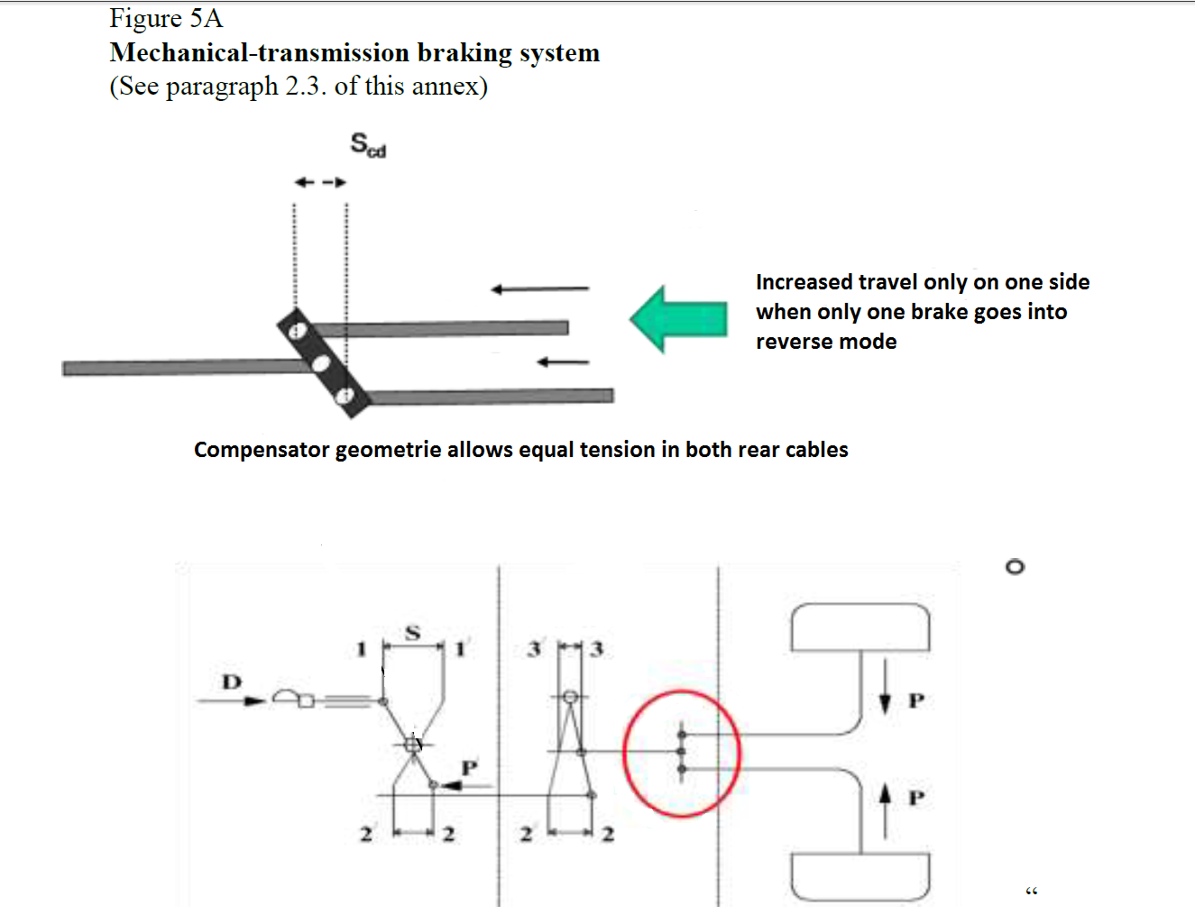

*Annex 12, Appendix 4,*

*Paragraphs 6.1.1. to 6.1.3.,* shall be deleted

*Insert new paragraphs 6.1.1. and 6.1.2.,* to read:

**"6.1.1. Maximum possible differential compensator travel capacity   
scd= mm**

**6.1.2. Ratio 1.2 \* sR = \_\_\_\_\_\_\_\_\_\_\_ mm  
 (shall not be greater than scd)"**

II. Justification

1. The history of the formula in para. 8.1.2. of Annex 12 may be summed up as follows.

1. Regulation No. 13, since Supplement 5 to the 11 series of amendments (ECE/TRANS/WP29/GRRF/2010/5)

2. The aim of the supplement is to ensure sufficient articulation of the compensator in a situation when the vehicle is stationary, uncoupled and the parking brake applied while a lateral push is exerted on the drawbar. This causes a positive moment on the wheels of one side of the vehicle and a negative one on those of the other side. Following the nature of auto reverse brake assemblies different brake lever travel will occur depending on the direction of the moment:

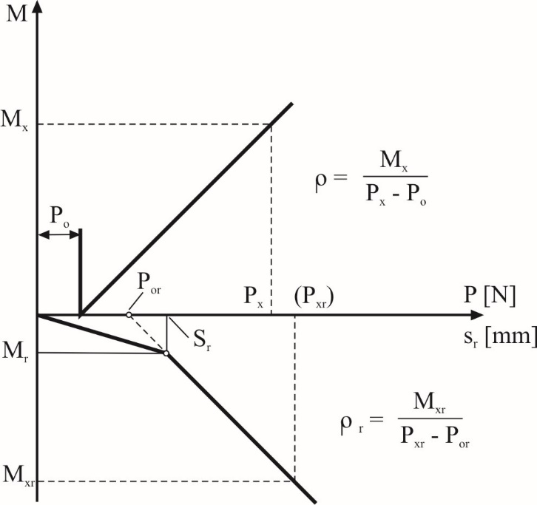

3. The compensator itself must provide enough articulation capacity to compensate for the difference in travel (scd) plus a twenty per cent safety margin otherwise the cable tension of the wheel with negative braking moment might drop such that this wheel turns freely causing a moment around the vertical vehicle axis if it is situated on a slope. It goes without saying that this is dangerous and in fact the background of the supplement is an accident with lethal aftermath.

4. Unfortunately the formula in para. 8.1.2. leads to not very plausible results:

*"*

*Where:*

*Sc' = S'/iH (travel at compensator - forward operation) and Sc' = 2 • SB/ig*

*Scr = Sr/iH (travel at compensator - rearward operation)"*

5. S´ is the travel at the control itself. By dividing it by iH the intention is to calculate the travel at the compensator Sc´.

6. Sr is already the travel at the brake lever and as such at the compensator. Dividing it by iH makes Scr here "some other value" than the travel at the compensator, thus, unfit to be a part of the bracket term. When inserting values all the same his leads to small values for "Scr" and thus to negative values for Scd.

7. This, however, leads to the situation that the inspector will have to go underneath the vehicle to make measurements of the compensator travel while another one pushes the drawbar sideways.

8. The measurement method is not described, difficult and open to many interpretations. Furthermore, it imposes a safety risk for the persons to make those measurements. It should be possible to verify the requirements by simple comparison of the trailer with drawing and by calculation.

2. Proposal in ECE/TRANS/WP.29/GRRF/2016/26

9. In the proposal submitted by the expert from France the minimum required compensation travel of the balancer is related to sr, which is given in the brake laboratory test report according Annex 12, Appendix 3. So there is no need to take measurements under the trailer.

10. While the approach appears to be logical, some implausible results occur when inserting values for the variables:

With the formula being **scd ≥ scr - scf ≥ sr – sB x ig**

and values from the technical report to Annex 12, Appendix 3 of a product from a notable manufacturer being sB = > 1.6 mm, ig =15.55 and sr = 27mm we find for **scd ≤ 2.12mm**.

11. Another example from another notable manufacturer states sB = > 1.52 mm, ig = 14 and sr = 28 mm and the result being **scd ≤ 6.72mm**.

12. In another example from the manufacturer of the first example it is sB = > 2.1, ig =16.4 and sr = 27 mm the result being **scd ≤ -7.44mm.**

13. The results for the expected articulation **scd** appear too small*resp.* not realistic.

14. A reason for this may lie in the circumstance that sB and sr have different preconditions as to the actuation force they occur under. While the condition for sB x ig the actuation force to reach the prescribed deceleration (0.49g x G) is conceived it is only the actuation force to reach max. 0.08g x G to reverse in case of sr.

15. In a situation where the parking brake is applied (0.18g x G) we have yet different actuation forces. The illustration below shows a practical example of the situation at the compensator:



3. This proposal

16. The general idea of both documents has been grasped in this document.

17. The illustration above suggests equal tension in both cables and as such equal travel due to elasticity, thus scd **≥** 1.2 (sr – slack). Determining the slack is extra effort, subject to measuring tolerances and assumed to be not very big. Therefore the plead is to waive it, consider it an extra safety margin and say scd **≥**1.2 x sr.

1. \* In accordance with the programme of work of the Inland Transport Committee for 2016–2017 (ECE/TRANS/254, para. 159 and ECE/TRANS/2016/28/Add.1, cluster 3.1), the World Forum will develop, harmonize and update Regulations in order to enhance the performance of vehicles. The present document is submitted in conformity with that mandate. [↑](#footnote-ref-2)