Economic Commission for Europe
Inland Transport Committee
Working Party on the Transport of Dangerous Goods
Joint Meeting of the RID Committee of Experts and the
Working Party on the Transport of Dangerous Goods 26 September 2017
Geneva, 19–29 September 2017
Item 5 (a) of the provisional agenda
Proposals for amendments to RID/ADR/ADN:
pending issues
Amendment of 1.6.1.30
Transmitted by the Government of France
At the request of a professional transport using high quality labels (semi-rigid laminated support), it is requested to study the possibility to extend the transitional period so the stock relatively important and costly could be used until 30 June 2021.
A first request had been validated in March 2016 in the Joint Meeting.
Proposal
[EN]
Chapter 1.6
1.6.1.30 Amend to read as follows: “1.6.1.30 Labels which meet the requirements of 5.2.2.2.1.1 applicable up to 31 December 2014, may continue to be used until 30 June 2021.”.
Proposition
[FR]
Chapitre 1.6
1.6.1.30 Modifier pour lire comme suit: «1.6.1.30 Les étiquettes répondant aux prescriptions du 5.2.2.2.1.1 applicables jusqu’au 31 décembre 2014 pourront encore être utilisées jusqu’au 30 juin 2021.».

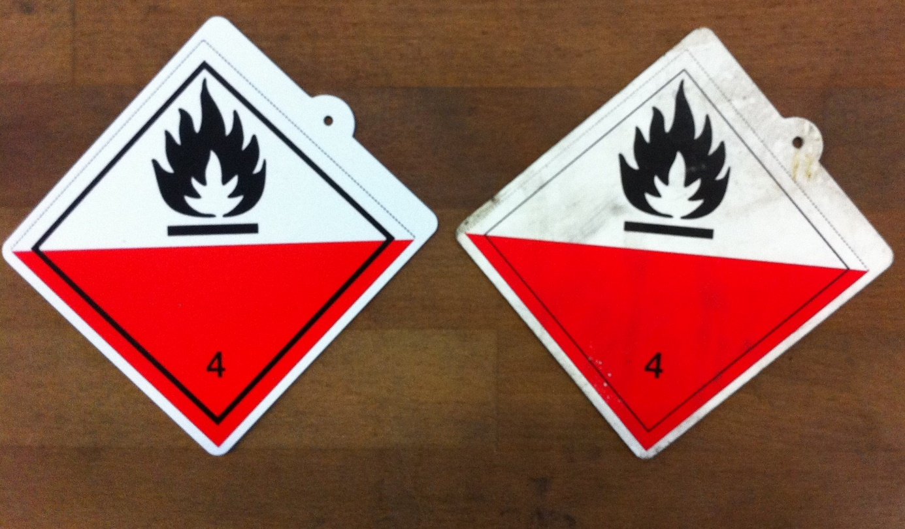
New Model Old model

