UN/SCEGHS/33/INF.10
Committee of Experts on the Transport of Dangerous Goods
and on the Globally Harmonized System of Classification
and Labelling of Chemicals
Sub-Committee of Experts on the Globally Harmonized
System of Classification and Labelling of Chemicals 29 June 2017

Thirty-third session
Geneva, 10-12 July 2017
Item 4 (b) of the provisional agenda
Implementation of the GHS: reports on the status of implementation
Global GHS implementation: explaining the implementation gap
Transmitted by the expert from Sweden
1. The Globally Harmonized System for Classification and Labelling of Chemicals (GHS) is a system for classifying and labelling chemicals according to different hazards. The GHS is one of the cornerstones of sound chemicals management, an issue consistently on the international sustainable development agenda since 1992. In 2002, it was agreed under the United Nations Johannesburg Plan of Implementation that all countries should implement GHS by 2008. However, this goal has not been accomplished.
2. The aim of this study was to provide a global overview of current GHS implementation status using primary and secondary data, and explain differences between countries based on theory on motivational and capacity-related factors for implementation of international standards. Finally, strategies for closing the widening gap among high-income and low-income countries in pursuing sound chemicals management were discussed.
3. The study was carried out during 2016 and 2017 by researchers at the Stockholm Environment Institute (SEI) and Wageningen University with funding from the Swedish International Development Cooperation Agency.
4. The results of the mapping of global GHS implementation showed that 65 countries had, as of 1 April 2017, passed legislation that is aligned with the GHS, either for all GHS sectors (classified in this study as full implementation) or for at least one of the sectors (classified in this study as partial implementation). 128 countries had not yet to our knowledge passed such legislation. Some of these countries may have voluntary approaches to uptake of GHS by producers, as well as other legislation on classification and labelling which is not aligned with the GHS.
5. Examining the GHS implementation pattern and its possible explanatory factors revealed both barriers and drivers for GHS implementation. The study found a significant correlation between a high human development index score and the GHS having been implemented in a country. A low gross domestic product (GDP) per capita as well as a low score on the KOF index of political globalization were correlated to GHS not yet being implemented in a country.
6. A commitment of a country to international collaboration on occupational safety in the field of chemicals was positively correlated to GHS being implemented, whereas there was no significant correlation between the trade open-ness index score of a country and the GHS implementation.
7. It was concluded that there seems to be broad general support from countries of all income levels for enhanced international collaboration in the field of sound chemicals management. However, there is a clear positive correlation between the level of income of countries and their GHS implementation status (Figure 1).
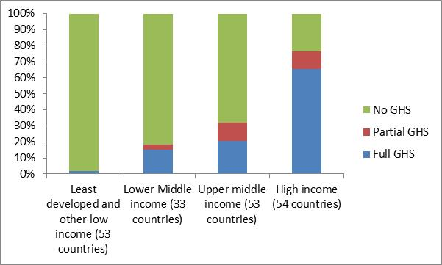
Figure 1: GHS implementation per category of country
8. However, the collected data suggested that it is possible also for low-income countries to incorporate GHS in national legislation under certain conditions. These conditions include capacity related factors such as long term bilateral engagement from a collaborating donor country as well as motivational factors such as the interest of a country to become member of a regional trading bloc which requires legislation aligned with the GHS.
9. Possible strategies identified for increased GHS implementation in low income countries include; more focus on long-term capacity building efforts and making more use of the potential in regional collaboration around GHS implementation.
10. In addition, it was noted that the setting in place of a system for monitoring global progress on GHS implementation would serve the purpose of enabling continuous analysis of the global GHS coverage and allow stakeholders to identify reinforced strategies for increased implementation.
11. The results of the study will be submitted for publication in a scientific journal. Meeting participants are welcome to give feedback on the presented study at the 33rd session or by email directly to Dr Linn Persson at linn.persson@sei-international.org.
______________

