UN/SCETDG/51/INF.7/Add.1
UN/SCEGHS/33/INF.3/Add.1

Committee of Experts on the Transport of Dangerous Goods
and on the Globally Harmonized System of Classification
and Labelling of Chemicals 17 May 2017
Sub-Committee of Experts on the  Transport of Dangerous Goods | Sub-Committee of Experts on the Globally Harmonized System of Classification and Labelling of Chemicals
Fifty-first session | Thirty-third session
Geneva, 3 – 7 July 2017  Item 10 (d) of the provisional agenda  Issues relating to the Globally Harmonized System of Classification and Labelling of Chemicals: Use of the Manual of Tests and Criteria in the context of the GHS | Geneva, 10 – 12 July 2017  Item 2 (a) of the provisional agenda  Work of the TDG Sub-Committee on matters of interest to the GHS Sub-Committee
Revision of the Manual of Tests and Criteria:
Part I: Section 10
Transmitted by the Chairman of the Working Group on Explosives on behalf of the Working Group

Note by the secretariat:
This document takes account of the amendments to the 6th revised edition of the Manual of Tests and Criteria adopted by the Committee at its eighth session (see ST/SG/AC.10/44/Add.2).

PART I
CLASSIFICATION PROCEDURES,
TEST METHODS AND CRITERIA
RELATING TO EXPLOSIVES

CONTENTS OF PART I

NOTE 1: The country or organization of origin of each test method is indicated in brackets after each test name.

NOTE 2: The test method recommended for use with each test type is indicated in bold and by an asterisk (see sub-section 1.6 of the General Introduction).

Section Page

10. INTRODUCTION TO PART I
10.1 PURPOSE
10.2 SCOPE
10.3 ACCEPTANCE PROCEDURE
10.3.1 General description
10.3.2 Test types
10.3.3 Application of the test methods
10.4 PROCEDURE FOR ASSIGNMENT TO A DIVISION OF THE CLASS OF EXPLOSIVES
10.4.1 General description
10.4.2 Test types
10.4.3 Application of the test methods
10.5 EXAMPLES OF TEST REPORTS

11. TEST SERIES 1
11.1 INTRODUCTION
11.2 TEST METHODS
11.3 TEST CONDITIONS
11.4 SERIES 1 TYPE (a) TEST PRESCRIPTION
11.4.1 Test 1 (a) * UN gap test (UN)
11.5 SERIES 1 TYPE (b) TEST PRESCRIPTION
11.5.1 Test 1 (b) * Koenen test (D)
11.6 SERIES 1 TYPE (c) TEST PRESCRIPTIONS
11.6.1 Test 1 (c) (i) * Time/pressure test (GB)
11.6.2 Test 1 (c) (ii) Internal ignition test (USA)

12. TEST SERIES 2
12.1 INTRODUCTION
12.2 TEST METHODS
12.3 TEST CONDITIONS
12.4 SERIES 2 TYPE (a) TEST PRESCRIPTION
12.4.1 Test 2 (a) * UN gap test (UN)
12.5 SERIES 2 TYPE (b) TEST PRESCRIPTION
12.5.1 Test 2 (b) * Koenen test (D)
12.6 SERIES 2 TYPE (c) TEST PRESCRIPTIONS
12.6.1 Test 2 (c) (i) * Time/pressure test (GB)
12.6.2 Test 2 (c) (ii) Internal ignition test (USA)

CONTENTS OF PART I (continued)

Section Page

13. TEST SERIES 3
13.1 INTRODUCTION
13.2 TEST METHODS
13.3 TEST CONDITIONS
13.4 SERIES 3 TYPE (a) TEST PRESCRIPTIONS
13.4.1 Test 3 (a) (i) Bureau of Explosives impact machine (USA)
13.4.2 Test 3 (a) (ii) * BAM Fallhammer (D)
13.4.3 Test 3 (a) (iii) Rotter test (GB)
13.4.4 Test 3 (a) (iv) 30 kg Fallhammer test (F)
13.4.5 Test 3 (a) (v) Modified type 12 impact tool (C)
13.4.6 Test 3 (a) (vi) Impact sensitivity test (RUS)
13.4.7 Test 3 (a) (vii) Modified Bureau of Mines impact machine test
13.5 SERIES 3 TYPE (b) TEST PRESCRIPTIONS
13.5.1 Test 3 (b) (i) * BAM friction apparatus (D)
13.5.2 Test 3 (b) (ii) Rotary friction test (GB)
13.5.3 Test 3 (b) (iii) Friction sensitivity test (RUS)
13.5.4 Test 3 (b) (iv) ABL friction machine test
13.6 SERIES 3 TYPE (c) TEST PRESCRIPTION
13.6.1 Test 3 (c) ) (i) * Thermal stability test at 75 °C (F/USA)
13.6.1 Test 3 (c) ) (ii) SBAT thermal stability test at 75 °C
13.7 SERIES 3 TYPE (d) TEST PRESCRIPTION
13.7.1 Test 3 (d) * Small-scale burning test (F/USA)

14. TEST SERIES 4
14.1 INTRODUCTION
14.2 TEST METHODS
14.3 TEST CONDITIONS
14.4 SERIES 4 TYPE (a) TEST PRESCRIPTIONS
14.4.1 Test 4 (a) * Thermal stability test for unpackaged articles
and packaged articles (USA)
14.5 SERIES 4 TYPE (b) TEST PRESCRIPTIONS
14.5.1 Test 4 (b) (i) * The steel tube drop test for liquids (F)
14.5.2 Test 4 (b) (ii) * Twelve metre drop test for unpackaged articles,
packaged articles and packaged substances (USA)

15. TEST SERIES 5
15.1 INTRODUCTION
15.2 TEST METHODS
15.3 TEST CONDITIONS
15.4 SERIES 5 TYPE (a) TEST PRESCRIPTION
15.4.1 Test 5 (a) * Cap sensitivity test (D/USA)
15.5 SERIES 5 TYPE (b) TEST PRESCRIPTIONS
15.5.1 Test 5 (b) (i) French DDT test (F)
15.5.2 Test 5 (b) (ii) * USA DDT test (USA)
CONTENTS OF PART I (continued)

Section Page

15.5.3 Test 5 (b) (iii) Deflagration to detonation transition test (RUS)
15.6 SERIES 5 TYPE (c) TEST PRESCRIPTION
15.6.1 Test 5 (c) * External fire test for Division 1.5 (UN)
16. TEST SERIES 6
16.1 INTRODUCTION
16.2 TEST METHODS
16.3 TEST CONDITIONS
16.4 SERIES 6 TYPE (a) TEST PRESCRIPTION
16.4.1 Test 6 (a) * Single package test (UN)
16.5 SERIES 6 TYPE (b) TEST PRESCRIPTION
16.5.1 Test 6 (b) * Stack test (UN)
16.6 SERIES 6 TYPE (c) TEST PRESCRIPTION
16.6.1 Test 6 (c) * External fire (bonfire) test (UN)
16.7 SERIES 6 TYPE (d) TEST PRESCRIPTION
16.7.1 Test 6 (d) * Unconfined package test (UN)

17. TEST SERIES 7
17.1 INTRODUCTION
17.2 TEST METHODS
17.3 TEST CONDITIONS
17.4 SERIES 7 TYPE (a) TEST PRESCRIPTION
17.4.1 Test 7 (a) * EIS cap test (D/USA)
17.5 SERIES 7 TYPE (b) TEST PRESCRIPTION
17.5.1 Test 7 (b) * EIS gap test (USA)
17.6 SERIES 7 TYPE (c) TEST PRESCRIPTIONS
17.6.1 Test 7 (c) (i) Susan impact test (USA)
17.6.2 Test 7 (c) (ii) * Friability test (F)
17.7 SERIES 7 TYPE (d) TEST PRESCRIPTIONS
17.7.1 Test 7 (d) (i) * EIS bullet impact test (USA)
17.7.2 Test 7 (d) (ii) Friability test (F)
17.8 SERIES 7 TYPE (e) TEST PRESCRIPTION
17.8.1 Test 7 (e) * EIS external fire test (UN)
17.9 SERIES 7 TYPE (f) TEST PRESCRIPTION
17.9.1 Test 7 (f) * EIS slow cook-off test (USA)
17.10 SERIES 7 TYPE (g) TEST PRESCRIPTION
17.10.1 Test 7 (g) * 1.6 Article (or component level) external fire test (UN)
17.11 SERIES 7 TYPE (h) TEST PRESCRIPTION
17.11.1 Test 7 (h) * 1.6 Article slow cook-off test (USA)
17.12 SERIES 7 TYPE (j) TEST PRESCRIPTION
17.12.1 Test 7 (j) * 1.6 Article bullet impact test (USA)
17.13 SERIES 7 TYPE (k) TEST PRESCRIPTION
17.13.1 Test 7 (k) * 1.6 Article stack test (UN)
CONTENTS OF PART I (continued)

Section Page

17.14 SERIES 7 TYPE (l) TEST PRESCRIPTION
17.14.1 Test 7 (l): * 1.6 Article (or component level) fragment impact test

18. TEST SERIES 8
18.1 INTRODUCTION
18.2 TEST METHODS
18.3 TEST CONDITIONS
18.4 SERIES 8 TYPE (a) TEST PRESCRIPTION
18.4.1 Test 8 (a): * Thermal stability test for ammonium nitrate emulsions,
suspensions or gels
18.5 SERIES 8 TYPE (b) TEST PRESCRIPTION
18.5.1 Test 8 (b): * ANE Gap Test
18.6 SERIES 8 TYPE (c) TEST PRESCRIPTION
18.6.1 Test 8 (c): * Koenen test
18.7 SERIES 8 TYPE (d) TEST PRESCRIPTIONS
18.7.1 Test 8 (d) (i): * Vented pipe test
18.7.2 Test 8 (d) (ii): * Modified vented pipe test

SECTION 10
INTRODUCTION TO PART I

10.1 Purpose
                - 10.1.1 Part I of the Manual presents the United Nations scheme for the classification of explosives. It includes a description of the procedures and test criteria considered to be the most useful for providing the necessary information to arrive at a proper classification of explosive substances and articles.. It should be used in conjunction with the classification flow charts in figures 10.1, 10.2, 10.3, 10.4 and 10.5, the general conditions for testing in sub-section 1.5 and the appropriate test prescriptions in sections 11 to 18 of this Manual.
                - 10.1.2 Explosives, other than unstable explosives, are assigned to one of six divisions, depending on the type of hazard they present (see Chapter 2.1, paragraph 2.1.1.4 of the Model Regulations and Chapter 2.1, paragraph 2.1.2 of the GHS) and, for some regulatory purposes (e.g. transport), to one of the thirteen compatibility groups that identify the kinds of explosives that are deemed to be compatible. The general scheme for classifying a substance or article which is to be considered for inclusion in the class of explosives is illustrated in Figure 10.1. The assessment is in two stages. In the first stage, the potential of a substance or article to explode is ascertained and its stability and sensitivity, both chemically and physically, are also determined. In order to promote uniform assessments by competent authorities, it is recommended that, using the flow chart in Figure 10.2, data from suitable tests is analyzed systematically with respect to the appropriate test criteria. If the substance or article is provisionally accepted into the class of explosives , it is then necessary to proceed to the second stage and assign it to the correct division by use of the flow chart of Figure 10.3 and 10.5. With the exception of Compatibility Groups N and S, for which test data is necessary, assignment to a compatibility group, when required, is usually made without reference to testing. In the case of Compatibility Group S, the tests may be waived by the competent authority if classification by analogy is based on test results for a comparable article.
                - 10.1.3 The test procedures allow assessment of the hazard of explosive substances and articles so that an appropriate classification can be assigned. When appropriate this is done by the competent authority.
10.2 Scope
                - 10.2.1 New products which are considered as having explosive properties or are intended to function as explosives should first be considered for inclusion in the class of explosives . For substances such as self-reactive substances or organic peroxides, refer to Part II of this Manual. In this context a new product is one which, in the opinion of the competent authority, involves any of the following:
(a) A new substance, intended to function as an explosive or pyrotechnic, which is considered to be significantly different from other substances already classified;
(b) A new substance, not intended for explosive use, which has, or is suspected of having, explosive properties (see Chapter 2.1, paragraph 2.1.3.1.2 of the Model Regulations and Chapter 2.1, paragraph 2.1.1.2 of the GHS);
Note by the secretariat: The reference in the list amendments reads: “2.1.3.1”. The Sub-Committee is invited to confirm the correct reference to be used.
(c) A new design of article containing an explosive substance or an article containing a new explosive substance; or
(d) A new design of package for an explosive substance or article including a new type of inner packaging or a new arrangement of articles. (A relatively minor change to an inner or outer packaging can be critical and can convert a lesser hazard into a mass explosion hazard or vice versa).

10.2.2 The producer, or other applicant for the classification of a new product, should provide adequate information concerning the names and characteristics of all explosive substances in the product and should furnish the results of all relevant tests which have been done.
10.3 Acceptance procedure
10.3.1 General description
10.3.1.1 The acceptance procedure is used to determine whether or not a substance or articleis a candidate for the class of explosives. This is decided by determining whether a substance provisionally accepted into the class of explosives is either too insensitive for inclusion in the class of explosives or is accepted as an unstable explosive (and considered too dangerous for transport); or whether articles or packaged articles are accepted as an unstable explosive (and considered too dangerous for transport).

10.3.2 Test types

                - 10.3.2.1 The test methods used for deciding provisional acceptance into the class of explosives are grouped into four series, numbered 1 to 4, and designed to provide the information necessary to answer the questions in Figure 10.2.

10.3.2.2 The question "Is it an explosive substance?" (box 4, Figure 10.2) is answered on the basis of national and international definitions of an explosive substance and the results of three types of Series 1 tests to assess possible explosive effects. The three types of test used are:

Type 1 (a): a shock test with defined booster and confinement to determine the ability of the substance to propagate a detonation;
Type 1 (b): a test to determine the effect of heating under confinement; and
Type 1 (c): a test to determine the effect of ignition under confinement.

10.3.2.3 Series 2 tests are used to answer the question "Is the substance too insensitive for acceptance into the class of explosives?" (box 6, Figure 10.2). In general the basic apparatus used is the same as that for Test Series 1 but with less stringent criteria, e.g. in the case of gap tests, the gap used is greater than zero. The following three types of test are used:

Type 2 (a): a shock test with defined initiation system and confinement to determine sensitivity to shock;
Type 2 (b): a test to determine the effect of heating under confinement; and
Type 2 (c): a test to determine the effect of ignition under confinement.

Figure 10.1: OVERALL SCHEME OF THE PROCEDURE FOR CLASSIFYING A SUBSTANCE OR ARTICLE IN THE CLASS OF EXPLOSIVES
SUBSTANCE, OR ARTICLE
FOR CLASSIFICATION
ACCEPTANCE PROCEDURE
REJECT
Not an explosive
CLASSIFY AS AN EXPLOSIVE
HAZARDOUS DIVISION
ASSIGNMENT
COMPATIBILITY GROUP ASSIGNMENT
DIVISION
1.1, 1.2, 1.3, 1.4, 1.5 or 1.6
CLASSIFICATION CODE
COMPATIBILITY GROUP
A, B, C, D, E, F, G, H, J, K, L, N or S
CLASSIFY AS AN UNSTABLE EXPLOSIVE
Figure 10.2: PROCEDURE FOR PROVISIONAL ACCEPTANCE OF A SUBSTANCE OR
ARTICLE INTO THE CLASS OF EXPLOSIVES
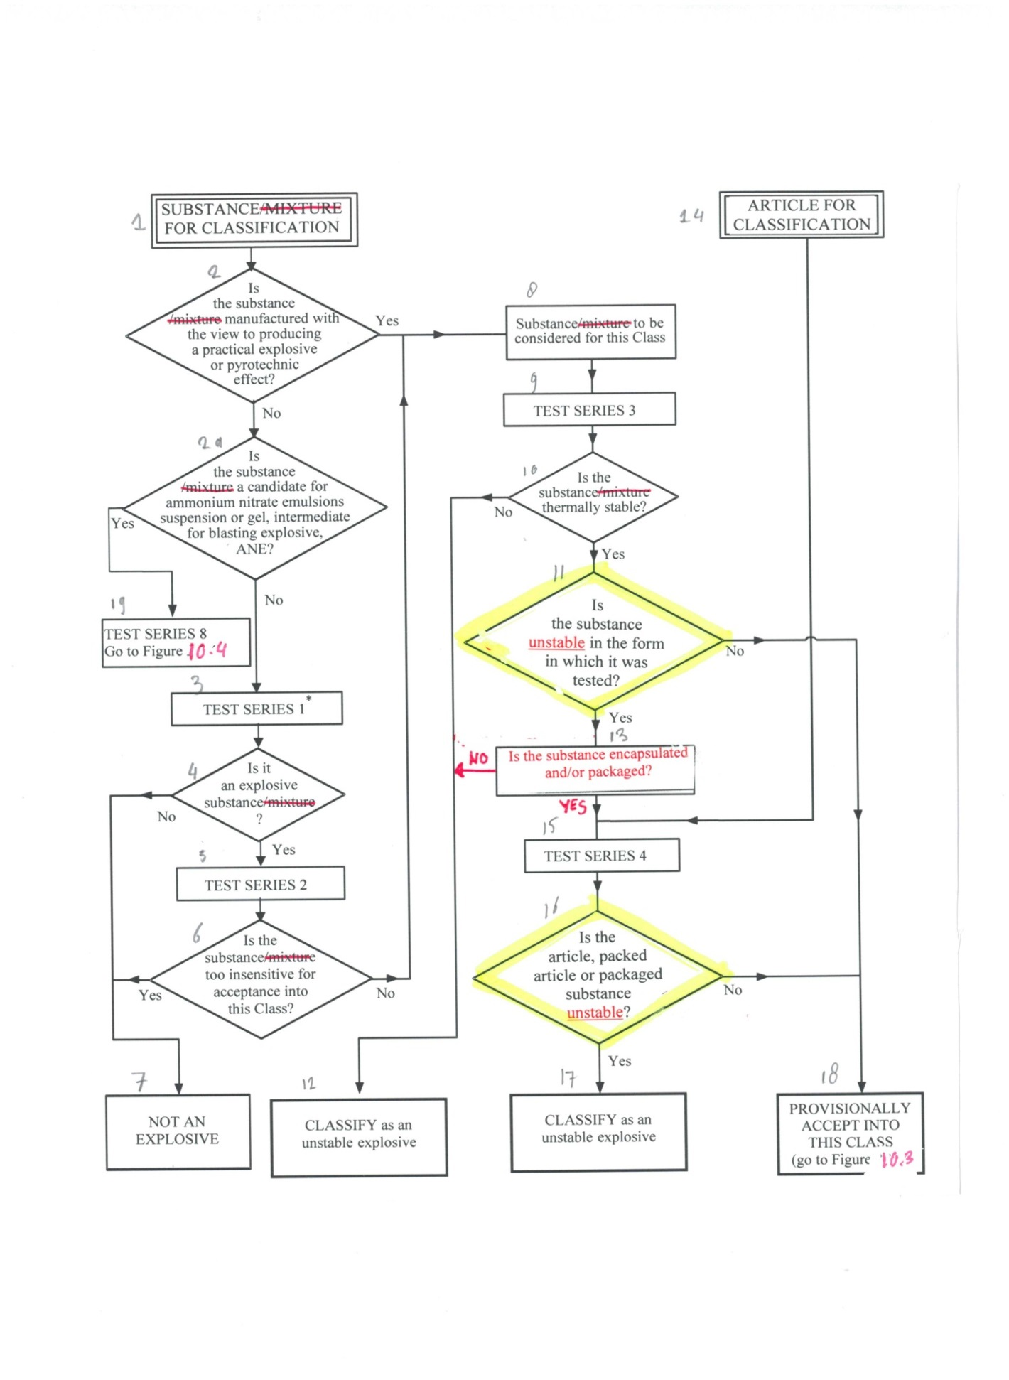
* For classification purposes, start with test series 2.
10.3.2.4 Test series 3 is used to answer the questions "Is the substance thermally stable?" (box 10, Figure 10.2) and "Is the substance unstable in the form in which it was tested?" (box 11, Figure 10.2). This involves tests for determining the sensitiveness of the substance to mechanical stimuli (impact and friction), and to heat and flame. The following four types of test are used:

Type 3 (a): a falling weight test to determine sensitiveness to impact;
Type 3 (b): a friction, or impacted friction, test to determine sensitiveness to friction;
Type 3 (c): an elevated temperature test to determine thermal stability; and
Type 3 (d): an ignition test to determine the response of a substance to fire.

10.3.2.5 Series 4 tests are intended to answer the question "Is the article, packaged article or packaged substance unstable?" (box 16, Figure 10.2). Typical conditions which may be encountered include high temperature and high relative humidity, low temperature, vibration, bumping and dropping. The two types of test to be carried out are:

Type 4 (a): a test of thermal stability for articles; and
Type 4 (b): a test to determine the hazard from dropping.

10.3.3 Application of the test methods

10.3.3.1 The numbering of test series 1 to 4 relates to the sequence of assessing the results rather than the order in which the tests are conducted. It may be important for the safety of experimenters that certain preliminary tests, using small amounts of material, be conducted first before proceeding to experiment with larger quantities. The results of these preliminary tests may also be used in the classification procedure.

10.3.3.2 The acceptance procedure for substances designed to have a practical explosive or pyrotechnic effect starts with the application of test series 3 to determine if the substance is too sensitive for transport in the form in which it is tested. If the substance passes all tests, the procedure for the assignment to the appropriate division is applied. If the substance fails any of the tests, it is forbidden for transport in the form tested. A substance which fails test type 3 (c) may be altered and resubmitted to test type 3(c). A substance which fails test types 3 (a), 3 (b) or 3 (d) may be encapsulated or packaged to reduce sensitiveness to external stimuli and submitted to test type 4(b).

10.3.3.3 All articles as presented for transport (packaged or unpackaged) should be subjected to test series 4. However, if there is sufficient information to indicate that the article would not be too dangerous for transport, the competent authority may decide to waive all or part of these tests for the article. If the product passes all the required tests in test series 4, the procedure for assignment to the appropriate division is applied. If the product fails any of the required tests, it is forbidden for transport in the form tested, but may be modified or repackaged and resubmitted to test series 4. If the competent authority suspects that the product may be subject to stimuli other than those specified in test series 4 resulting in potentially dangerous effects, additional information or tests may be required (see note under paragraph 2.1.3.3.1 of the Model Regulations).

10.3.3.4 Although test series 1 indicates whether a substance, not designed to have an explosive effect, has in fact potentially explosive properties, again it is more appropriate to start the testing procedure with test series 3. These tests involve relatively small sample sizes, which reduces the risk to test personnel. If test series 3 indicates that a substance is too sensitive for transport in the form in which it is tested, then the procedures for reducing its sensitiveness to external stimuli, outlined in 10.3.3.2, should be applied. If test series 3 indicates that the substance is not too sensitive for transport, the next step is the application of test series 2 which determines whether the substance is too insensitive for inclusion in Class 1. There is no real need to perform test series 1 at this point in the acceptance procedure since test series 2 answers the pertinent question regarding the degree of insensitiveness of the substance. Test series 1 is concerned with the resolution of questions relating to the explosive nature of the substance. The procedure for assignment to a division of Class 1 should be applied to substances which fail test series 2 but pass test series 3 i.e. they are not too insensitive for acceptance into Class 1 nor are they thermally unstable or too dangerous to transport in the form in which they are tested. It is important to note that a substance which fails test series 2 may still, if properly packaged, leave Class 1 provided that the product is not designed to have an explosive effect and does not exhibit any explosive hazard in test series 6 of the assignment procedure.

10.3.3.5 If articles contain expensive, inert, control components, for testing purposes these may be replaced by inert components having a similar mass and volume.

10.4 Procedure for assignment to a division of the class of explosives

10.4.1 General description

10.4.1.1 Unless classified as unstable, explosives are assigned to one of six divisions, depending on the type of hazard they present (see paragraph 2.1.1.4 of the Model Regulations and 2.1.2 of the GHS). The assignment procedure (Figure 10.3 and 10.5) applies to all substances and/or articles that are candidates for this class except those declared from the outset to be in Division 1.1. A substance or article is assigned to the division which corresponds to the results of the tests to which it has been subjected. Other test results, and data assembled from accidents which have occurred, may also be taken into account. As indicated in box 36 of Figure 10.3, there is authority to exclude an article from the class of explosives by virtue of test results and the “explosives” definition (see paragraph 2.1.1.1(b) of the Model Regulations and paragraph 2.1.1.2 (b) of the GHS). Specific criteria by which articles may be excluded from the class of explosives (for transport) may be found in the Model Regulations (see paragraph 2.1.3.6.4).

Note by the secretariat: The secretariat notes that the reference “(for transport)” is missing in the list of amendments. The Sub-Committee is invited to clarify whether this text should be kept or deleted.

Note by the secretariat: The secretariat notes that the reference “(for transport)” is missing in the list of amendments. The Sub-Committee is invited to clarify whether this text should be kept or deleted.

10.4.2 Test types

10.4.2.1 The test methods used for assignment to a division are grouped into three series - numbered 5 to 7 - designed to provide the information necessary to answer the questions in Figure 10.3. The tests in series 5, 6 and 7 should not be varied unless the competent authority is prepared to justify such action internationally.

10.4.2.2 The results from three types of series 5 tests are used to answer the question "Is it a very insensitive explosive substance with a mass explosion hazard?" (box 21, Figure 10.3). The test types are:

Type 5 (a): a shock test to determine the sensitivity to intense mechanical stimulus;
Type 5 (b): thermal tests to determine the tendency for transition from deflagration to detonation; and
Type 5 (c): a test to determine if a substance, when in large quantities, explodes when subjected to a large fire.

Figure 10.3: PROCEDURE FOR ASSIGNMENT TO A DIVISION OF THE CLASS OF EXPLOSIVES
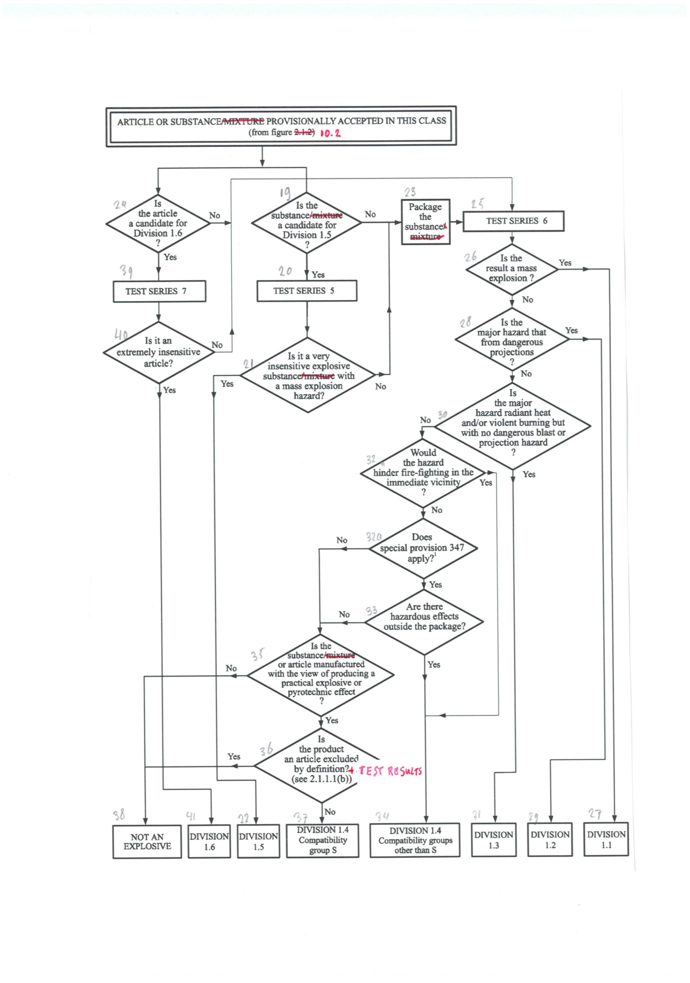
Figure 10.4: PROCEDURE FOR AMMONIUM NITRATE EMULSION, SUSPENSION OR GEL, INTERMEDIATE FOR BLASTING EXPLOSIVES
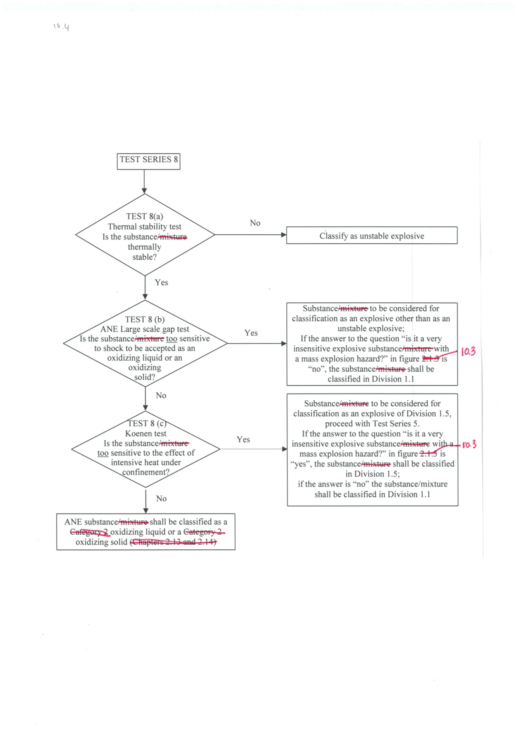
Figure 10.5: PROCEDURE TO DETERMINE REQUIRED SUBSTANCE TESTING FOR DIVISION 1.6

Is the substance
in a component of a fuze
with two or more independent effective protective features or in a boostering component?
Undertake and meet acceptance criteria of extremely insensitive substance tests
Type 7 (a) to 7 (f)
Each explosive substance in a Division 1.6 candidate article design
Undertake and meet acceptance criteria of explosive substance tests
Type 7 (c) (ii) and 7(e)
No
2
1
4
3
Yes
Yes
Yes
6

Is the substance in
a boostering component that exceeds
a cross-sectional dimension of 50 mm or 5% volume when compared to its main explosive load?
No
9
No
5
7
Type 7 (a) to 7 (f)
testing not required
Reject from Division 1.6
Yes
Is the substance
in an isolated auxiliary explosive component of the article, which when ignited or initiated
does not cause any reaction
of the main explosive loads?
Is the substance
in a main explosive load of a component within the article?
No
8

10.4.2.3 The results from four types of series 6 tests, as appropriate, are used to determine which division, amongst Divisions 1.1, 1.2, 1.3 and 1.4, corresponds most closely to the behaviour of a product in a certain configuration if it is involved in a fire resulting from internal or external sources or an explosion from internal sources (boxes 26, 28, 30, 32, 32a and 33 of Figure 10.3). The results are also necessary to assess whether a product in a certain configuration can be assigned to Compatibility Group S of Division 1.4 and whether or not it can be excluded from the class of explosives (boxes 35 and 36 of Figure 10.3). The four types of test are:

Type 6 (a): a test on a single package to determine if there is mass explosion of the contents;
Type 6 (b): a test on packages of an explosive substance or explosive articles, or non-packaged explosive articles, to determine whether an explosion is propagated from one package to another or from a non-packaged article to another;
Type 6 (c): a test on packages of an explosive substance or explosive articles, or non-packaged explosive articles, to determine whether there is a mass explosion or a hazard from dangerous projections, radiant heat and/or violent burning or any other dangerous effect when involved in a fire; and
Type 6 (d): a test on an unconfined package of explosive articles to which special provision 347 of Chapter 3.3 of the Model Regulations applies, to determine if there are hazardous effects outside the package arising from accidental ignition or initiation of the contents.
10.4.2.4 The question "Is it an extremely insensitive explosive article?" (box 40, Figure 10.3) is answered by series 7 tests and any candidate for Division 1.6 shall pass one of each of the eleven types of test comprising the series. The protocol for determining the test requirements is given in Figure 10.5. The first six types of test (7(a) to 7(f)) are used to establish if a substance is an Extremely Insensitive Substance (EIS). The purpose of these tests is to develop an understanding of the sensitivity of substance(s) contained within the article, which informs and provides confidence in the article tests. The remaining five types of test (7(g), 7(h), 7(j), 7 (k) and 7 (l)) are used to determine if an article predominantly containing an EIS may be assigned to Division 1.6. The eleven test types are:

Type 7 (a): a shock test to determine the sensitivity to intense mechanical stimulus;
Type 7 (b): a shock test with a defined booster and confinement to determine the sensitivity to shock;
Type 7 (c): a test to determine the sensitivity of the explosive substance to deterioration under the effect of an impact;
Type 7 (d): a test to determine the degree of reaction of the explosive substance to impact or penetration resulting from a given energy source;
Type 7 (e): a test to determine the reaction of the explosive substance to an external fire when the material is confined;
Type 7 (f): a test to determine the reaction of the explosive substance in an environment in which the temperature is gradually increased to 365 °C;
Type 7 (g): a test to determine the reaction to an external fire of an article which is in the condition as presented for classification;
Type 7 (h): a test to determine the reaction of an article in an environment in which the temperature is gradually increased to 365 °C;
Type 7 (j): a test to determine the reaction of an article to impact or penetration resulting from a given energy source;
Type 7 (k): a test to determine whether the detonation of an article will initiate a detonation in an adjacent, like, article; and
Type 7 (l): a test to determine the sensitivity of an article to shock directed at vulnerable components.

10.4.2.5 The question "Is the substance a candidate for "ammonium nitrate emulsion or suspension or gel, intermediate for blasting explosives (ANE)?" (box 2(a), Figure 10.2) is answered by series 8 tests and any candidate should pass each of the three tests comprising the series. The three test types are:

Type 8 (a): a test to determine the thermal stability;
Type 8 (b): a shock test to determine sensitivity to intense shock;
Type 8 (c): a test to determine the effect of heating under confinement;

Test series 8 (d) has been included in this section as one method to evaluate the suitability of ANEs for containment in portable tanks as an oxidizing substance.

10.4.3 Application of the test methods

10.4.3.1 Explanations of certain terms used in the assignment of divisions and compatibility groups are given in the Glossary in Appendix B of the Model Regulations (e.g. mass explosion, pyrotechnic substance, entire load, total contents, explode, explosion of the total contents).

10.4.3.2 Test series 5 should be used to determine whether a substance can be assigned to Division 1.5. Only those substances which pass all three types of test may be assigned to Division 1.5.

10.4.3.3 Test series 6 should be applied to packages of explosive substances and articles in the condition and form in which they are offered for classification. The geometrical arrangement of the products should be realistic in regard to the packing method and should be such as to produce the most severe test results. Where explosive articles are classified without packaging, the tests should be applied to the non-packaged articles. All types of packaging containing substances or articles should be subjected to the tests unless:

(a) The product, including any packaging, can be unambiguously assigned to a division by the competent authority on the basis of results from other tests or of available information; or

(b) The product, including any packaging, is assigned to Division 1.1.

10.4.3.4 Test types 6 (a), 6 (b), 6 (c) and 6 (d) are normally performed in alphabetical order. However, it is not always necessary to follow this order or to conduct all four types of test.

(a) Test type 6 (a) may be waived if explosive articles are classified without packaging or when only one article is in the package, (see also section 10.4.3.4.(d));

(b) Test type 6 (b) may be waived if, in each type of 6 (a) test, (see also section 10.4.3.4 (d))

(i) The exterior of the package is undamaged by internal initiation; or

(ii) The contents of the package fail to explode, or explode so feebly as would exclude propagation of the explosive effect from one package to another in test type 6 (b).

(c) Test type 6 (c) may be waived if, in a type 6 (b) test, there is a practically instantaneous explosion of virtually the total contents of the stack. In such cases the product is assigned to Division 1.1.

(d) Test type 6 (d) is a test used to determine whether a 1.4S classification is appropriate and is only used if special provision 347 of Chapter 3.3 of the Model Regulations applies. When testing articles to which special provision 347 applies, test type 6 (d) may be performed first. If the results of test type 6(d) indicate that a 1.4S classification is appropriate, then test types 6 (a) and 6 (b) may be waived.

10.4.3.5 If a substance gives a "-" result (no propagation of detonation) in the Series 1 type (a) test, the 6 (a) test with a detonator may be waived. If a substance gives a "-" result (no or slow deflagration) in a Series 2 type (c) test, the 6 (a) test with an igniter may be waived.

10.4.3.6 Tests types 7 (a) to 7 (f) are used to establish that an explosive is an extremely insensitive substance and then test types 7 (g), 7 (h), 7 (j), 7 (k) and 7 (l) are used to establish that articles predominantly containing EIS(s) may be assigned to Division 1.6.

10.4.3.7 Tests of types 7 (g), 7 (h), 7 (j), 7 (k) and 7(l) are performed to determine if an article with EIS main explosive load(s) and appropriately insensitive boostering components may be assigned to Division 1.6. These tests are applied to articles in the condition and form in which they are offered for classification, except that non-explosive components may be omitted or simulated if the competent authority is satisfied that this does not invalidate the results of the tests. The procedure detailing testing requirements is given in Figure 10.5 and some points of explanation are given below.
(a) Complex articles may contain multiple substances and test types 7(a) to (f) shall be completed for all main explosive load and boostering component substances, as appropriate, within the article to be classified in Division 1.6.
(b) The question "Is the substance in a main explosive load of a component within the article?" (Box 2 of Figure 10.5) is answered by examining the design of the article. Main explosive load substances are those loaded into components within the article that are not fuze, boostering, or isolated auxiliary explosive components. All substances in main explosive loads must "Undertake and meet acceptance criteria of extremely insensitive substance tests, Type 7 (a) to 7 (f)" (Box 3 of Figure 10.5). If a ‘+’ result is obtained for any main explosive load substance to any Type 7 (a) to 7 (f) test, the substance is not an EIS and the answer to the question in Box 24 of Figure 10.3 is "No". The article is not a candidate for Division 1.6.
(c) Answering the question "Is the substance in an isolated auxiliary explosive component of the article, which when ignited or initiated does not cause any reaction of the main explosive loads?" (Box 4 of Figure 10.5) requires knowledge of the design of the article plus the explosive effects that occur when such components are initiated or ignited, either in their design mode or accidentally. Typically these will be small explosive actuators or pyromechanical devices that produce movement, cutting or opening functions. If the answer is ‘yes’ to this question, Type 7 (a) to 7 (f) testing is not required for substances in isolated auxiliary explosive components and the article remains a candidate for Division 1.6.
(d) The question "Is the substance in a boostering component that exceeds a cross-sectional dimension of 50 mm or 5% volume when compared to its main explosive load?" (Box 6 of Figure 10.5) is answered by examining the design of the article. All substances in such larger boostering components, including those contained in explosive components of dual-protected fuzes in an article, must "Undertake and meet acceptance criteria of explosive substance tests, Type 7 (c) (ii) and 7 (e)" (box 7 of Figure 10.5). If a ‘+’ result is obtained for any such larger boostering component substance to either Type 7 (c) (ii) and 7 (e) tests, the answer to the question in Box 24 of Figure 10.3 is "No". The article is not a candidate for Division 1.6.
(e) The question "Is the substance in a component of a fuze with two or more independent effective protective features or in a boostering component" (Box 8 of Figure 10.5) is answered by an understanding of the design and development of the article. If the answer is ‘no’, the article is not considered to have suitable intrinsic safety characteristics and the answer to the question in Box 24 of Figure 10.3 is ‘No’ the article is not a candidate for Division 1.6.
NOTE: Knowledge of the design and explosive effects can be obtained by modelling or indicative tests etc.

10.4.3.8 Test types 8 (a) to 8 (c) should be used to establish whether an ammonium nitrate emulsion or suspension or gel, intermediate for blasting explosives (ANE) may be accepted as an oxidizing solid or liquid. Substances failing any of the tests may be considered as a candidate for the class of explosives in accordance with Figure 10.4.

10.5 Examples of test reports

10.5.1 Examples of test reports, with an illustration of the use of the flow charts on the application of the class of explosives acceptance and assignment procedures to hexanitrostilbene (UN0392), are given in figures 10.6 to 10.9.

10.5.2 An example proforma for a test report on articles is given in Figure 10.10.

Figure 10.6: RESULTS FROM APPLICATION OF THE CLASS OF EXPLOSIVES ACCEPTANCE PROCEDURE

1. Name of substance: | Hexanitrostilbene
2. General data
2.1 Composition: | hexanitrostilbene
2.2 Molecular formula: | C₁₄H₆N₆O₁₂
2.3 Physical form: | powder
2.4 Colour: | yellow orange
2.5 Apparent density: | 1700 kg /m³
2.6 Particle size: | 0.1 – 0.3 mm
3. Box 2: | Is the substance manufactured with the view to producing a practical explosive or pyrotechnic effect?
3.1 Answer: | Yes
3.2 Exit | Go to Box 8
4. Box 8: | Substance to be considered for the class of explosives
5. Box 9: | Test Series 3
5.1 Thermal stability: | 75 °C/48 hour test (test 3 (c))
5.2 Sample conditions: | 100 g of substance at 75 °C
5.3 Observations: | No ignition, explosion, self-heating or visible decomposition
5.4 Result: | "-", thermally stable
5.5 Impact sensitivity: | BAM fallhammer test (test 3 (a) (ii))
5.6 Sample conditions: | as received
5.7 Observations: | Limiting impact energy 5 J
5.8 Result: | "-", not unstable in form tested
5.9 Friction sensitivity: | BAM friction test (test 3 (b) (i))
5.10 Sample conditions: | as received
5.11 Observations: | Limiting load > 240 N
5.12 Result: | "-", not unstable in form tested
5.13 Ease of deflagration to detonation transition | Small scale burning test (test 3 (d))
5.14 Sample conditions: | Ambient temperature
5.15 Observations: | Ignites and burns
5.16 Result: | "-", not unstable in the form in which it was tested
5.17 Exit: | Go to box 10
6. Box 10: | Is the substance thermally stable?
6.1 Answer from test 3(c): | Yes
6.2 Exit: | Go to box 11
7. Box 11: | Is the substance unstable in the form in which it was tested?
7.1 Answer from Test Series 3: | No
7.2 Exit: | Go to box 18
8. Conclusion: | PROVISIONALLY ACCEPT INTO THE CLASS OF EXPLOSIVES
8.1 Exit: | Apply assignment procedure for the class of explosives

Figure 10.7: PROCEDURE FOR PROVISIONAL ACCEPTANCE OF HEXANITROSTILBENE IN THE CLASS OF EXPLOSIVES
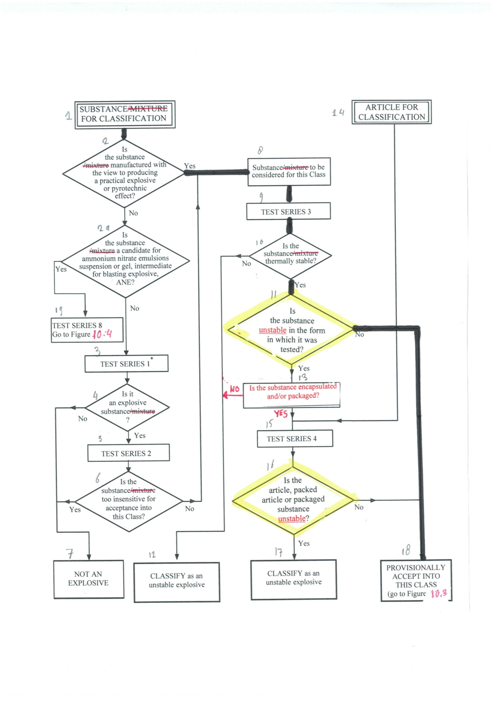

Figure 10.8: RESULTS FROM APPLICATION OF THE CLASS OF EXPLOSIVES ASSIGNMENT PROCEDURE

1. Box 19: | Is the substance a candidate for Division 1.5?
1.1 Answer: | No
1.2 Result: | Package the substance (box 23)
1.3 Exit: | Go to box 25
2. Box 25: | Test Series 6
2.1 Effect of initiation in the package: | Test 6(a) with detonator
2.2 Sample conditions: | Ambient temperature, 50 kg fibreboard drum
2.3 Observations: | Detonation, crater
2.4 Result: | Mass explosion
2.5 Effect of ignition between packages: | Test 6(b) with detonator
2.6 Sample conditions: | Ambient temperature, 3 fibreboard drums
2.7 Observations: | Detonation, crater
2.8 Result: | Mass explosion
2.9 Effect of fire engulfment: | Test 6(c) not required
3. Box 26: | Is the result a mass explosion?
3.1 Answer from Test Series 6 | Yes
3.2 Exit | Go to box 27
4. Conclusion | Assign to Division 1.1
Figure 10.9: PROCEDURE FOR CLASSIFICATION OF HEXANITROSTILBENE IN THE CLASS OF EXPLOSIVES

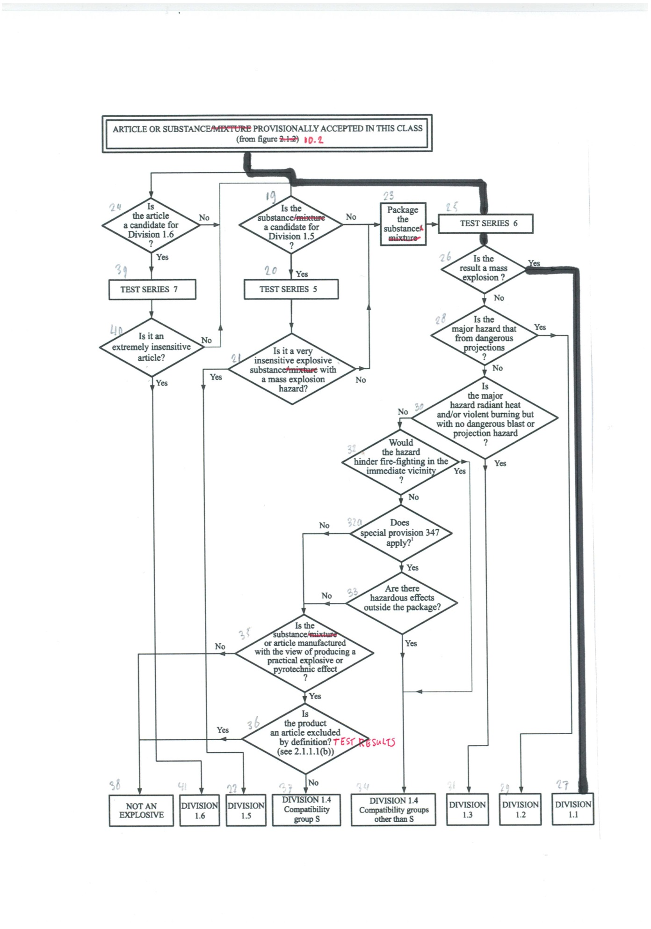
Figure 10.10: EXAMPLE OF A PROFORMA FOR A TEST REPORT FOR ARTICLES

Test method |  | Date of report |  | Data reference
Product name |  | Lot number |  | Date of manufacture

CONSTRUCTION AND CONTENTS (attach drawings)

PACKAGING (if any)

PRETREATMENT OR CONDITIONING (if any)

TEST CONFIGURATION (including any variations or deviations from procedures described in the Manual)

TEST CONDITIONS

Ambient temperature: °C Relative humidity: %

OBSERVATIONS

TEST RESULT

CONCLUSION

