|  |  |  |  |
| --- | --- | --- | --- |
|  | United Nations | ST/SG/AC.10/C.3/2017/46 | |
| _unlogo | **Secretariat** | | Distr.: General 5 September 2017  Original: English |

**Committee of Experts on the Transport of Dangerous Goods  
and on the Globally Harmonized System of Classification  
and Labelling of Chemicals**

**Sub-Committee of Experts on the Transport of Dangerous Goods**

**Fifty-second session**

Geneva, 27 November-6 December 2017

Item 6 (d) of the provisional agenda **Miscellaneous proposals for amendments to the Model Regulations   
on the Transport of Dangerous Goods: other miscellaneous proposals**

Proposal of amendments to section 5.5.3

Transmitted by the experts from the Russian Federation and Austria[[1]](#footnote-2)

Introduction

1. Section 5.5.3 defines special provisions applicable to cargo transport units presenting a risk of asphyxiation due to dangerous goods such as UN 1845 Dry ice, UN 1977 Nitrogen, refrigerated liquid or UN 1951 Argon, refrigerated liquid, which are used for cooling or conditioning purposes.

2. In the Russian Federation and other CIS countries, large capacity universal containers with liner bags are used for the transport of terephthalic acid (non-dangerous goods). The existing technology for transport of terephthalic acid loaded into liner bags in order to exclude the risk of explosion and the formation of clouds of acidic dust, uses compressed nitrogen as a protective agent. After transport, a certain amount of nitrogen may remain, since at the top of the liner-bag, during transport, nitrogen may penetrate the walls of the liner bag in the cargo space of large universal containers.

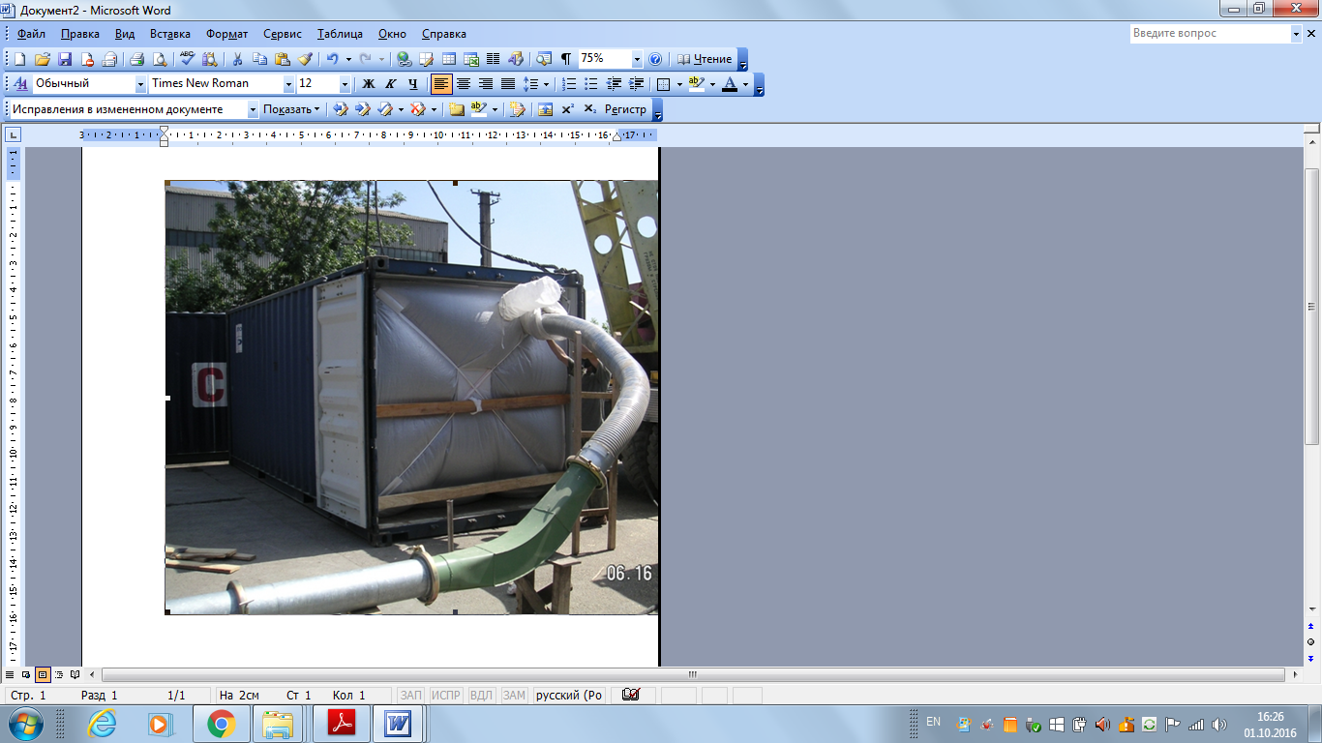

3. Since no warning mark as specified in 5.5.3.6.2 is prescribed for large capacity universal containers, there is no information about the presence of a dangerous concentration of nitrogen in the cargo space and people entering it may be asphyxiated. Nitrogen may pose an asphyxiation risk even when it is not compressed and “protection” is normally to avoid reactions while conditioning seems to be used for intentionally modifying (improving) the transported substances (e.g. pH with Carbon dioxide). Nevertheless a note can be used to define that this is included.

Proposal

Option 1 (minimum change)

4. Amend 5.5.3, as follows:

"5.5.3 Special provisions applicable to packages and cargo transport units containing substances presenting a risk of asphyxiation when used for cooling or conditioning purposes (such as dry ice (UN 1845) or nitrogen, refrigerated liquid (UN 1977) or argon, refrigerated liquid (UN 1951) or nitrogen, compressed (UN 1066))”

5. Add a Note after 5.5.3:

*“NOTE:* In the context of this paragraph the term “conditioning” may be used in a broader scope and includes protection.*”*

6. Amend 5.5.3.4 to read as follows (delete the strikeout text):

“5.5.3.4 *Marking of packages containing a coolant or conditioner*

5.5.3.4.1 Packages containing dangerous goods used for cooling or conditioning shall be marked with the proper shipping name of these dangerous goods ~~followed by the words “AS COOLANT” or “AS CONDITIONER” as appropriate~~.”

7. Amend 5.5.3.6 to read as follows (new text underlined, delete the strikeout text):

“5.5.3.6 *Marking of cargo transport units*

5.5.3.6.1 Cargo transport units presenting a risk of asphyxiation ~~containing dangerous goods used for cooling, conditioning purposes~~ shall be marked with a warning mark, as specified in 5.5.3.6.2, affixed at each access point in a location where it will be easily seen by persons opening or entering the cargo transport unit. This mark shall remain on the cargo transport unit until the following provisions are met:

(a) The cargo transport unit has been well ventilated to remove the asphyxiation risk ~~harmful concentrations of the asphyxiation risk coolant, or conditioner~~ and

(b) The cooled or conditioned goods have been unloaded.

5.5.3.6.2 The warning mark shall be as shown in Figure 5.5.2.

**Figure 5.5.2**

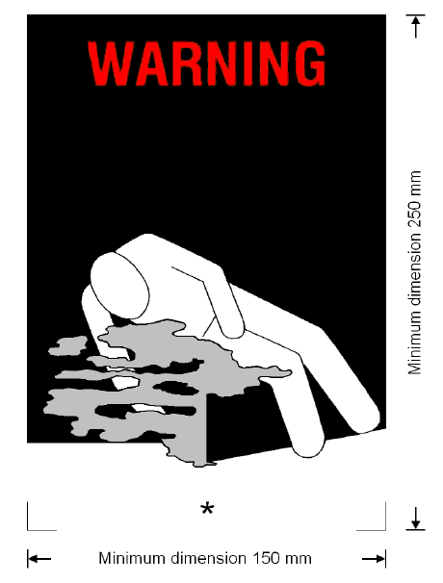

Asphyxiation warning mark ~~Coolant/conditioning warning mark~~ for cargo transport units

\* Insert proper shipping name of the coolant/conditioner. The lettering shall be in capitals, all be on one line and shall be at least 25 mm high. If the length of the proper shipping name is too long to fit in the space provided, the lettering may be reduced to the maximum size possible to fit. For example: CARBON DIOXIDE, SOLID.

~~\*\* Insert "AS COOLANT" or "AS CONDITIONER" or "AS PROTECTIVE AGENT" as appropriate. The lettering shall be in capitals, all be on one line and be at least 25 mm high.~~

The mark shall be a rectangle. The minimum dimensions shall be 150 mm wide × 250 mm high. The word "WARNING" shall be in red or white and be at least 25 mm high. Where dimensions are not specified, all features shall be in approximate proportion to those shown.

***NOTE:*** The provisions of 5.5.3.6.2 from the twentieth revised edition of the Recommendations on the Transport of Dangerous Goods, Model Regulations may continue to be applied until 31 December 2020.

Option 2 (a more comprehensive solution)

8. Most of the incidents and accidents were related to cooling and conditioning agents.

9. Nevertheless there are cases where an asphyxiation hazard exists due to other reasons like protecting agent or from such substances as cargo.

10. The release rate of dry ice as cargo and dry ice as cooling agent might be identical. Similar the release rate of nitrogen, refrigerated liquid from cryogenic vessels with cooled material for artificial insemination or of cryogenic vessels for the refill of detectors for gamma spectroscopy.

11. The warning mark should prevent that somebody enters the cargo transport unit and gets asphyxiated. In cases where nobody can enter the cargo transport unit (e.g. MEGC, Tanks) no warning is required.

12. The situation has some similarity with fumigated cargo transport units with the significant difference that for fumigation highly toxic substances are used that are often much more difficult to remove. Venting in the case of asphyxiating gases is much easier.

13. Amend 5.5.3 to read as follows (new text underlined, delete the strikeout text):

**5.5.3 Special provisions applicable to packages and cargo transport units presenting a risk of asphyxiation ~~when used for cooling or conditioning purposes~~ due to substances such as dry ice (UN 1845) or nitrogen, refrigerated liquid (UN 1977) or argon, refrigerated liquid (UN 1951) that are often used for cooling or conditioning\* purposes**

***NOTE*: In the context of this paragraph the term “conditioning” may be used in a broader scope and includes protection.**

**5.5.3.1 Scope**

This section is not applicable to

* Cargo transport units that cannot be entered
* Cargo transport units open or ventilated such that no asphyxiation risk exists
* Cargo transport units where the release rate of asphyxiating gases is so small, that there is no hazard

~~5.5.3.1.1 This section is not applicable to substances which may be used for cooling or conditioning purposes when transported as a consignment of dangerous goods. When they are transported as a consignment, these substances shall be transported under the relevant entry of the Dangerous Goods List in Chapter 3.2 in accordance with the associated conditions of transport.~~

~~5.5.3.1.2 This section is not applicable to gases in cooling cycles.~~

~~5.5.3.1.3 Dangerous goods used for cooling or conditioning portable tanks or MEGCs during transport are not subject to this section.~~

5.5.3.1.1 Cargo transport units presenting a risk of asphyxiation ~~containing substances used for cooling or conditioning purposes~~ include cargo transport units containing substances used for cooling or conditioning purposes inside packages as well as cargo transport units with unpackaged substances.

**5.5.3.2  *General***

5.5.3.2.1 Cargo transport units presenting a risk of asphyxiation ~~containing substances used for cooling or conditioning purposes~~ (other than fumigated CTU) during transport but do not contain regulated dangerous goods as cargo are not subject to any provisions of these Regulations other than those of this section.

5.5.3.2.2 When dangerous goods are loaded in cargo transport units containing substances used for cooling or conditioning purposes any provisions of these Regulations relevant to these dangerous goods apply in addition to the provisions of this section.

5.5.3.2.3 For air transport, arrangements between consignor and operator shall be made for each consignment, to ensure that ventilation safety procedures are followed.

5.5.3.2.4 Persons engaged in the handling or transport of cargo transport units containing substances used for cooling or conditioning purposes shall be trained commensurate with their responsibilities.

**5.5.3.3 *Packages containing a coolant or conditioner***

5.5.3.3.1 Packaged dangerous goods requiring cooling or conditioning assigned to packing instructions P203, P620, P650, P800, P901 or P904 of 4.1.4.1 shall meet the appropriate requirements of that packing instruction.

5.5.3.3.2 For packaged dangerous goods requiring cooling or conditioning assigned to other packing instructions, the packages shall be capable of withstanding very low temperatures and shall not be affected or significantly weakened by the coolant or conditioner. Packages shall be designed and constructed to permit the release of gas to prevent a build-up of excess pressure that could rupture the packaging. The dangerous goods shall be packed in such a way as to prevent movement after the dissipation of any coolant or conditioner.

5.5.3.3.3 Packages containing a coolant or conditioner shall be transported in well ventilated cargo transport units.

**5.5.3.4  *Marking of packages containing a coolant or conditioner***

5.5.3.4.1 Packages containing dangerous goods used for cooling or conditioning shall be marked with the proper shipping name of these dangerous goods followed by the words “AS COOLANT” or “AS CONDITIONER” as appropriate.

5.5.3.4.2 The marks shall be durable, legible and placed in such a location and of such a size relative to the package as to be readily visible.

**5.5.3.5  *Cargo transport units containing unpackaged dry ice***

5.5.3.5.1 If dry ice in unpackaged form is used, it shall not come into direct contact with the metal structure of a cargo transport unit to avoid embrittlement of the metal. Measures shall be taken to provide adequate insulation between the dry ice and the cargo transport unit by providing a minimum of 30 mm separation (e.g. by using suitable low heat conducting materials such as timber planks, pallets etc).

5.5.3.5.2 Where dry ice is placed around packages, measures shall be taken to ensure that packages remain in the original position during transport after the dry ice has dissipated.

**5.5.3.6**  ***Marking of cargo transport units***

5.5.3.6.1 Cargo transport units containing dangerous goods used for cooling or conditioning purposes shall be marked with a warning mark, as specified in 5.5.3.6.2 affixed at each access point in a location where it will be easily seen by persons opening or entering the cargo transport unit. This mark shall remain on the cargo transport unit until the following provisions are met:

(a) The cargo transport unit has been ventilated to remove harmful concentrations of coolant or conditioner; and

(b) The cooled or conditioned goods have been unloaded.

5.5.3.6.2 The warning mark shall be as shown in Figure 5.5.2

**Figure 5.5.2**



Asphyxiation warning mark ~~Coolant/conditioning warning mark~~ for cargo transport units

\* Insert proper shipping name of the coolant/conditioner. The lettering shall be in capitals, all be on one line and shall be at least 25 mm high. If the length of the proper shipping name is too long to fit in the space provided, the lettering may be reduced to the maximum size possible to fit. For example: CARBON DIOXIDE, SOLID.

~~\*\* Insert "AS COOLANT" or "AS CONDITIONER" or "AS PROTECTIVE AGENT" as appropriate. The lettering shall be in capitals, all be on one line and be at least 25 mm high.~~

The mark shall be a rectangle. The minimum dimensions shall be 150 mm wide × 250 mm high. The word "WARNING" shall be in red or white and be at least 25 mm high. Where dimensions are not specified, all features shall be in approximate proportion to those shown.

***NOTE*:** The provisions of 5.5.3.6.2 from the twentieth revised edition of the Recommendations on the Transport of Dangerous Goods, Model Regulations may continue to be applied until 31 December 2020. “

5.5.3.7 *Documentation*

5.5.3.7.1 Documents (such as a bill of lading or cargo manifest) associated with the transport of cargo transport units containing or have contained substances used for cooling or conditioning purposes and have not been completely ventilated before transport shall include the following information:

(a) The UN number preceded by the letters “UN”; and

(b) The proper shipping name followed by the words such as “AS COOLANT”, ~~or~~ “AS CONDITIONER” or “…” as appropriate.

*For example: UN 1845, CARBON DIOXIDE, SOLID, AS COOLANT.*

5.5.3.7.2 The transport document may be in any form, provided it contains the information required in 5.5.3.7.1. This information shall be easy to identify, legible and durable.

Justification

14. This amendment ensures safe working conditions for persons involved in the processing of goods in the presence of a protective agent.

Enforceability

15. The use of this proposal does not imply any difficulties.

1. In accordance with the programme of work of the Sub-Committee for 2017–2018 approved by the Committee at its eighth session (see ST/SG/AC.10/C.3/100, paragraph 98 and ST/SG/AC.10/44, paragraph 14). [↑](#footnote-ref-2)