|  |  |  |  |
| --- | --- | --- | --- |
|  | United Nations | ST/SG/AC.10/C.3/2017/39 | |
| _unlogo | **Secretariat** | | Distr.: General  6 September 2017  Original: English |

**Committee of Experts on the Transport of Dangerous Goods  
and on the Globally Harmonized System of Classification  
and Labelling of Chemicals**

**Sub-Committee of Experts on the Transport of Dangerous Goods**

**Fifty-second session**

Geneva, 27 November-6 December 2017

Item 4 (c) of the provisional agenda  
**Electric storage systems: transport provisions**

Harmonization of the proper shipping names of UN 3481 and UN 3091

Transmitted by the European Association for Advanced Rechargeable Batteries (RECHARGE) and PRBA The Rechargeable Battery Association (PRBA)[[1]](#footnote-2)

Introduction

1. In the power tool industry, packages often contain a combination of lithium batteries contained in equipment together with additional spare lithium batteries packed with the equipment. The photo shows an example:

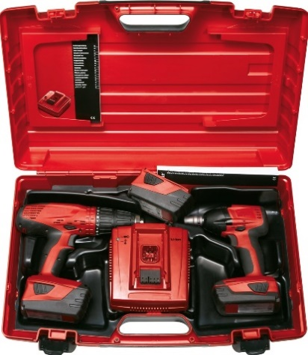

2. According to the-Model Regulations, the classification in this example requires the indication of the UN member and both proper shipping names for package marking and transport documentation purposes, i.e:

“UN 3481 Lithium ion batteries packed with equipment,

UN 3481 Lithium ion batteries contained in equipment;” or

“UN 3091 Lithium metal batteries packed with equipment;

UN 3091 Lithium metal batteries contained in equipment, respectively.

3. According to the ICAO Technical Instructions, however, the dangerous goods classification in this example simplifies these indications to

“UN 3481 Lithium ion batteries packed with equipment;” or

“UN 3091 Lithium metal batteries packed with equipment”, respectively.

4. This is because Special Provision A181[[2]](#footnote-3)1 clarifies, that a package containing a combination of lithium batteries contained in equipment with lithium batteries packed with equipment is to be marked only as „lithium (metal or ion) batteries packed with equipment”.

5. The marking requirements according to the Model Regulations under 2. and to the ICAO Technical Instructions under 3. above are not harmonized. This makes the marking unpractical when such products are transported in a combination of sea, road and air transport. It would be meaningful to harmonise the marking, based on the air transport special provision A181 clarification.

6. As this type of clarification is in principle introduced in an ad-hoc Special Provision, we propose to introduce a new sub-paragraph in Special Provision 230, which would be applicable to both UN 3091 and UN 3481.

Proposal

7. It is proposed to add a new subparagraph at the end of Special Provision 230, describing a similar simplification as in the ICAO TI Special Provision A 181, paragraphs (b) and (c):

Special Provision 230

Lithium cells and batteries may be transported under this entry if they meet the provisions of 2.9.4.

When a package contains a combination of lithium batteries contained in equipment and lithium batteries packed with equipment, the following requirements apply:

(a) The package shall be marked UN 3091 Lithium metal batteries packed with equipment, or UN 3481 Lithium ion batteries packed with equipment as appropriate. If a package contains both lithium ion batteries and lithium metal batteries packed with and contained in equipment, the package shall be marked as required for both battery types. However, button cell batteries installed in equipment (including circuit boards) need not be considered.

(b) The transport document shall indicate UN 3091 Lithium metal batteries packed with equipment or UN 3481 Lithium ion batteries packed with equipment, as appropriate. If a package contains both lithium metal batteries and lithium ion batteries packed with and contained in equipment, then the transport document shall indicate both UN 3091 Lithium metal batteries packed with equipment and UN 3481 Lithium ion batteries packed with equipment.

1. In accordance with the programme of work of the Sub-Committee for 2017–2018 approved by the Committee at its eighth session (see ST/SG/AC.10/C.3/100, paragraph 98 and ST/SG/AC.10/44, paragraph 14). [↑](#footnote-ref-2)
2. 1 **ICAO Special Provision A 181**

   When a package contains a combination of lithium batteries contained in equipment and lithium batteries packed with equipment, the following requirements apply:

   (a) the shipper must ensure that all applicable parts of both packing instructions are met. The total weight of lithium batteries contained in any package must not exceed the limits for passenger aircraft or cargo aircraft, as applicable;

   (b) the package must be marked UN 3091 Lithium metal batteries packed with equipment, or UN 3481 Lithium ion batteries packed with equipment as appropriate. If a package contains both lithium ion batteries and lithium metal batteries packed with and contained in equipment, the package must be marked as required for both battery types. However, button cell batteries installed in equipment (including circuit boards) need not be considered.

   (c) the Shipper’s Declaration must indicate UN 3091 Lithium metal batteries packed with equipment or UN 3481 Lithium ion batteries packed with equipment, as appropriate. If a package contains both lithium metal batteries and lithium ion batteries packed with and contained in equipment, then the dangerous goods transport document must indicate both UN 3091 Lithium metal batteries packed with equipment and UN 3481 Lithium ion batteries packed with equipment. [↑](#footnote-ref-3)